Graph 1 Inhibited percentage of S. mutans by P. amboinicus extract
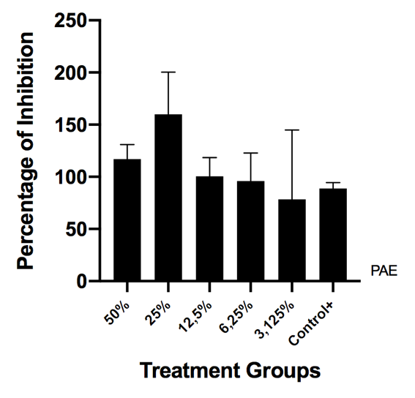

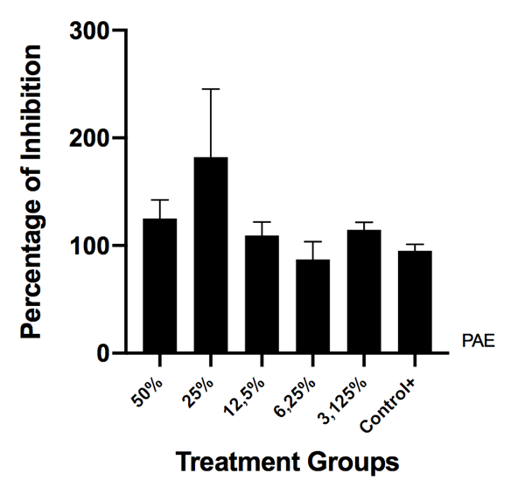
Graph 2. Inhibited percentage S. sanguinis by P. amboinicus extract (PAE)

