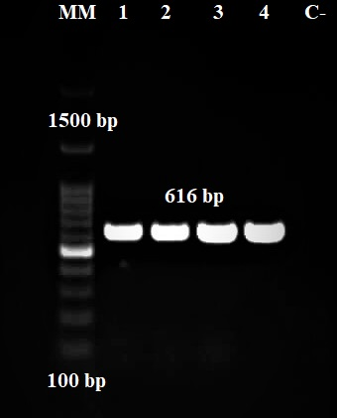

Supplementary Fig. 2. Treatment-sensitive and resistant samples based on the NR1 gene (MM: molecular marker, numbers 1 and 2: sensitive cases, numbers 3 and 4: resistant cases, C-: negative control).

