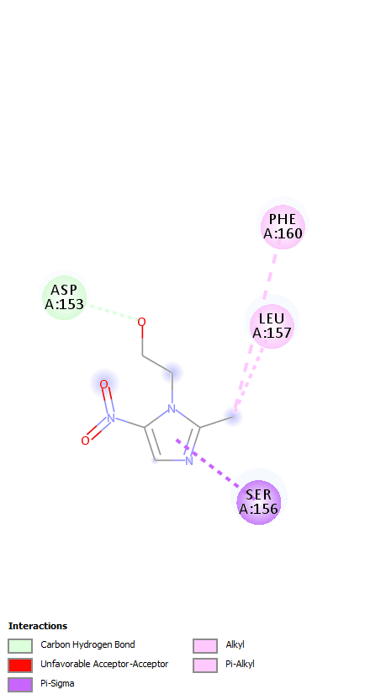

Supplementary Fig. 10. Intermolecular bonding of metronidazole with 11-NR1 model.

