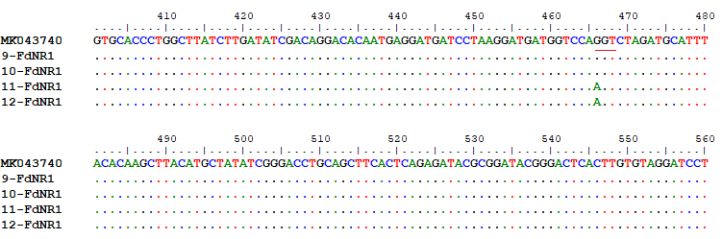

Supplementary Fig. 6. The DNA sequences of the sensitive reference sample (MK043740) along with the treatment-sensitive (9 and 10) and the resistant samples (11 and 12) of the current study, based on the NR1 gene.

