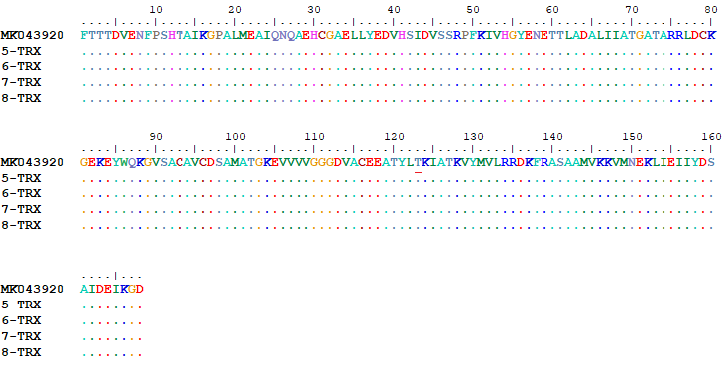

Supplementary Fig. 5. Protein translations of reference sample along with treatment-resistant (5 and 6) and sensitive samples (7 and 8) based on the TrxR gene. It is clear that no amino acid changes were made in the sequences. Position 123 of the reference sample, which is threonine amino acid (ACA=ACG), is marked with a red line.

