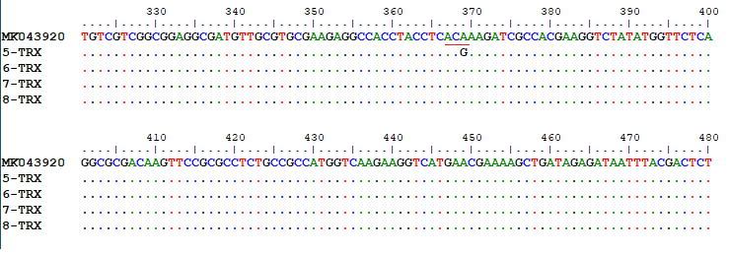
Supplementary Fig. 4. DNA sequences of reference sample along with treatment-resistant (5 and 6) and treatment-sensitive samples (7 and 8) based on the TrxR gene. According to the reference sample, in one of the resistant samples, a nucleotide change (A to G) occurred, which did not change the amino acid (ACA=ACG=Threonine).

