Supporting information
Cyanine-based fluorescent probe for cyanide ion detection
Mahesh Gosi, Nagaraju Marepu, and Sunandamma Yeturua*

Department of Chemistry, Acharya Nagarjuna University, Nagarjunanagar, Guntur-522510, Andhra Pradesh, India.
†E-mail address: yeturuasnu7@gmail.com

Contents:
- ¹H NMR, ¹³C NMR and HRMS spectra of synthesized compounds

(Fig. S1 to Fig. S6) 2-7
2. Fig.S7 Benesi-Hildebrand plot of PI with CN⁻ ion 8

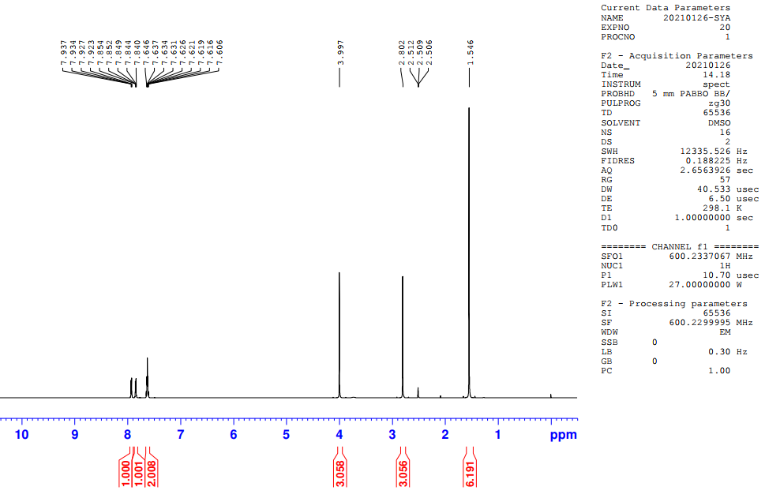
Fig. S1. ¹H NMR of 1,2,3,3-tetramethyl-3H-indolium iodide

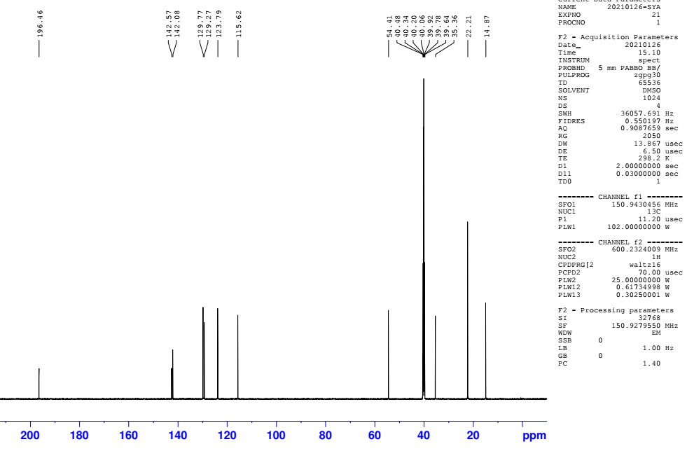
Fig. S2. ¹³C NMR of 1,2,3,3-tetramethyl-3H-indolium iodide

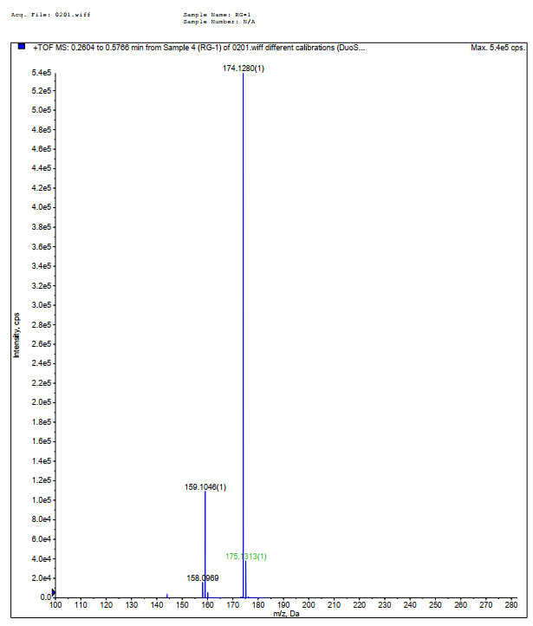
Fig. S3. HRMS of 1,2,3,3-tetramethyl-3H-indolium iodide

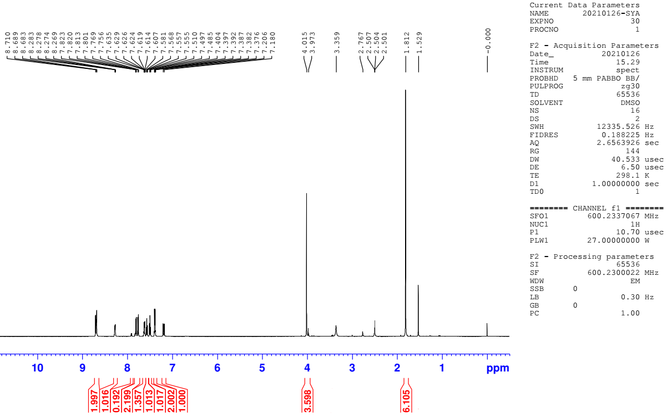
Fig. S4. ¹H NMR of 2-(2-(1H-indol-3-yl)vinyl)-1,3,3-trimethyl-3H-indol-1-ium iodide

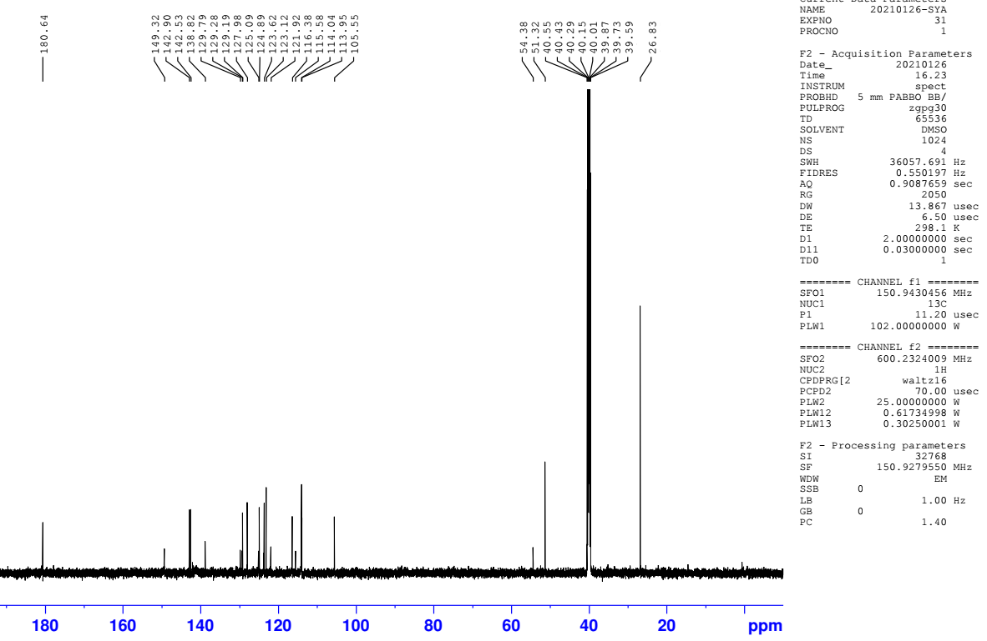
Fig. S5. ¹³C NMR of 2-(2-(1H-indol-3-yl)vinyl)-1,3,3-trimethyl-3H-indol-1-ium iodide
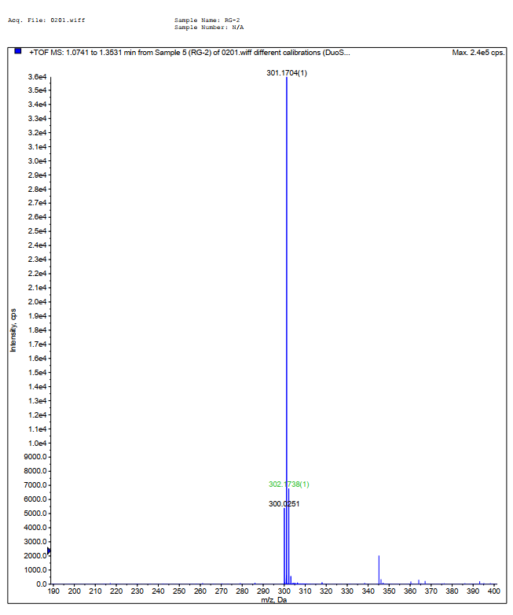
Fig. S6. HRMS of 2-(2-(1H-indol-3-yl)vinyl)-1,3,3-trimethyl-3H-indol-1-ium iodide

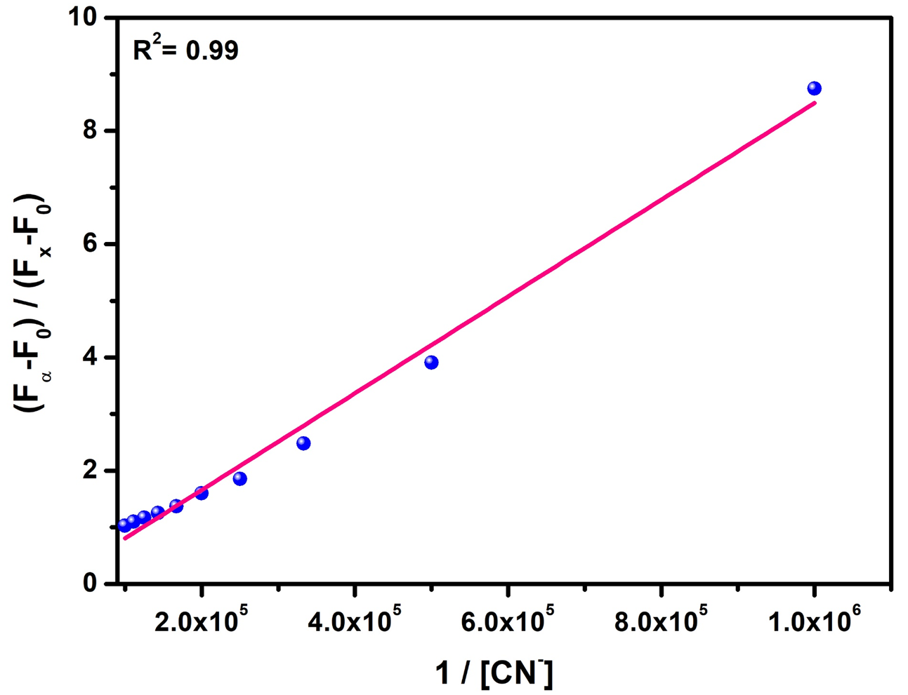

Fig. S7. Benesi-Hildebrand plot of PI with CN⁻ ion

