Table S1. Details of 36 long-term conditions (LTCs) used in the latent class analysis (LCA).
Abbreviation: COPD, Chronic obstructive pulmonary disease; ITA, Transient Ischemic Attack; ICD, International Classification of Diseases.
LTC | R regular expression for Hospitalization ICD-10
Hypertension | I10
Depression | F3[2-3]
Pain Syndrome | G89|I8381|M255|(M54[5-6])|(M796[0-7])|(N508[12])|(N94)|R07|R10
Asthma | J45
Coronary Artery Disease | I2[0-5]
Indigestion | K30
Diabetes | (E0[89])|(E1[0-5])
Thyroid Disorders | C73|(E0[1-7])
Rheumatoid Disease | (M0[5678])|(M1[0A])|M350|(M33[01])|M32
Deafness | (H9[01])|Q16
COPD | J4[1-4]
Anxiety Disorders | F41
Irritable Bowel Syndrome | K58
Newly Diagnosed Cancer | C
Substance Abuse | F1[13]
Stroke and TIA | G45|G46|I6
Chronic Kidney Disease | N18
Constipation | K590
Atrial Fibrillation | I48[01]
Peripheral Vascular Disease | I70|I73|I75|I80|I82|I83
Heart Failure | I50
Prostate Diseases | C61|D075|(N4[0-2])
Glaucoma | H40
Epilepsy | G40
Dementia | F015|F028|F039|G310|G3183|(F1(02|09|32|39|81|82|89|91|92|99)7)
Mental Disorders | (F2[01])|(F31)
Psoriasis | L40
Migraine | G43
Blindness | H54
Sinusitis | J32
Anorexia | F500
Bronchiectasis | J47
Parkinson's Disease | G2[01]
Multiple Sclerosis | G35
Viral Hepatitis | B18
Chronic Liver Disease | K70|(K71[345])|K721|K73|K74|K76

Table S2. Details of Extracting variables from UK BioBank database.
Variables | Extracting methods
Smoking status | Field No.: 20116
Drinking status | Field No.: 20117
Body mass index | Field No.: 21001
Townsend deprivation index | Field No.: 189
Age | Field No.: 21022
Gender | Field No.: 31
Ethnic | Field No.: 21000
Education | Field No.: 845
Ulcerative colitis | Hospitalization ICD-10: K51
Crohn’s disease | Hospitalization ICD-10: K50
Major Adverse Cardiac Events | Hospitalization ICD-10: (I6[0-9])|(I2[1-5])  OR  Death ICD-10: (I[0-6][0-9])|(I7[0-8])|(G4[56])
IBD-related operations | OPCS4: G49|G58|G69|(H0[4-9])|(H1[01])|H32|H33|H55

Figure S1. Model fit indices for latent class analysis models with 1-20 classes. Top: UC; Bottom: CD.
Notes: AIC, Akaike Information Criterion; BIC, Bayesian Information Criterion; ssBIC, sample size-adjusted Bayesian Information Criterion; Nclass, number of the class in LCA models. Left picture, indices for CD; Right picture, indices for UC.
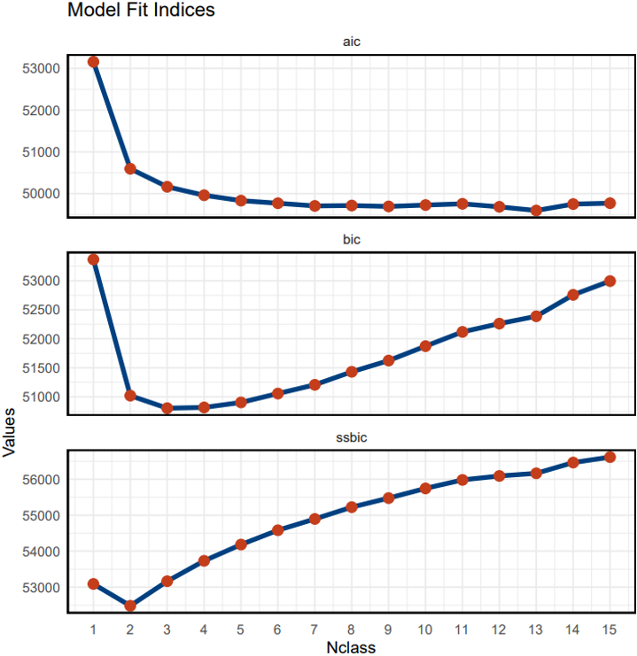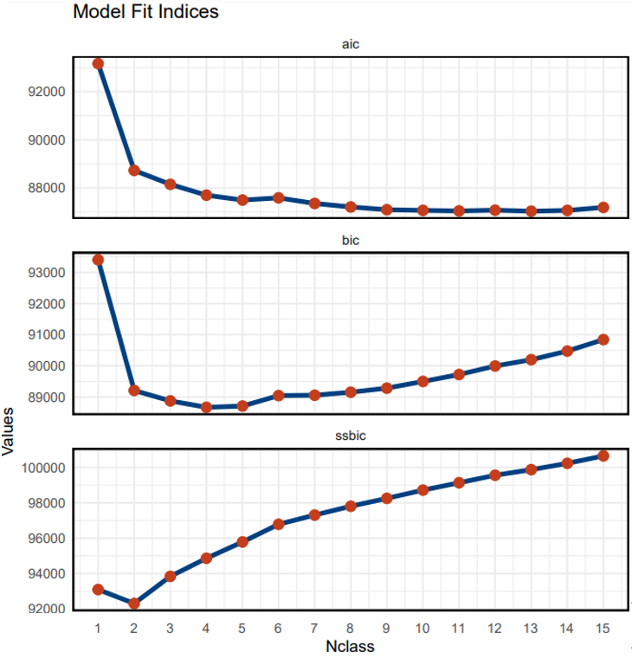

Figures S2. Upset plots for Class 1 in CD LCA models.
Abbreviation: COPD, Chronic Obstructive Pulmonary Disease; PVD, Peripheral Vascular Disease; TIA, Transient Ischemic Attack; CAD, Coronary Artery Disease; CKD, Chronic Kidney Disease; CLD, Chronic Liver Disease; IBS, Irritable Bowel Syndrome.
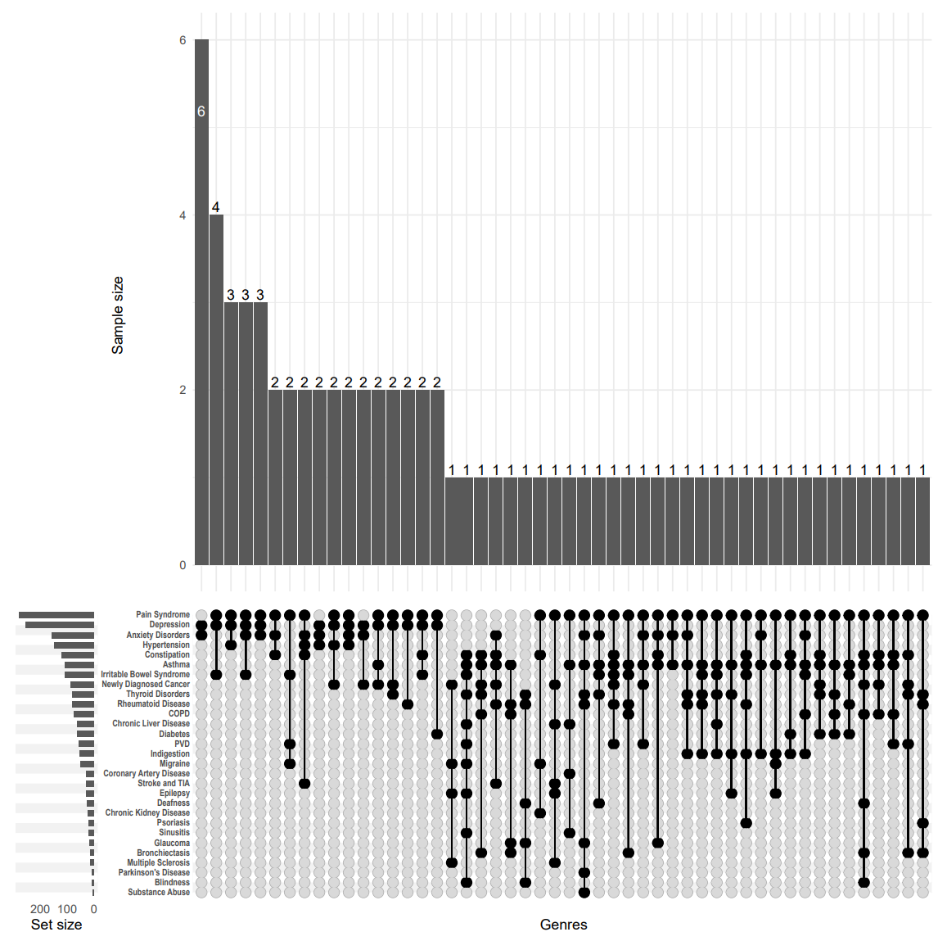

Figures S3. Upset plots for Class 2 in CD LCA models.
Abbreviation: COPD, Chronic Obstructive Pulmonary Disease; PVD, Peripheral Vascular Disease; TIA, Transient Ischemic Attack; CAD, Coronary Artery Disease; CKD, Chronic Kidney Disease; CLD, Chronic Liver Disease; IBS, Irritable Bowel Syndrome.
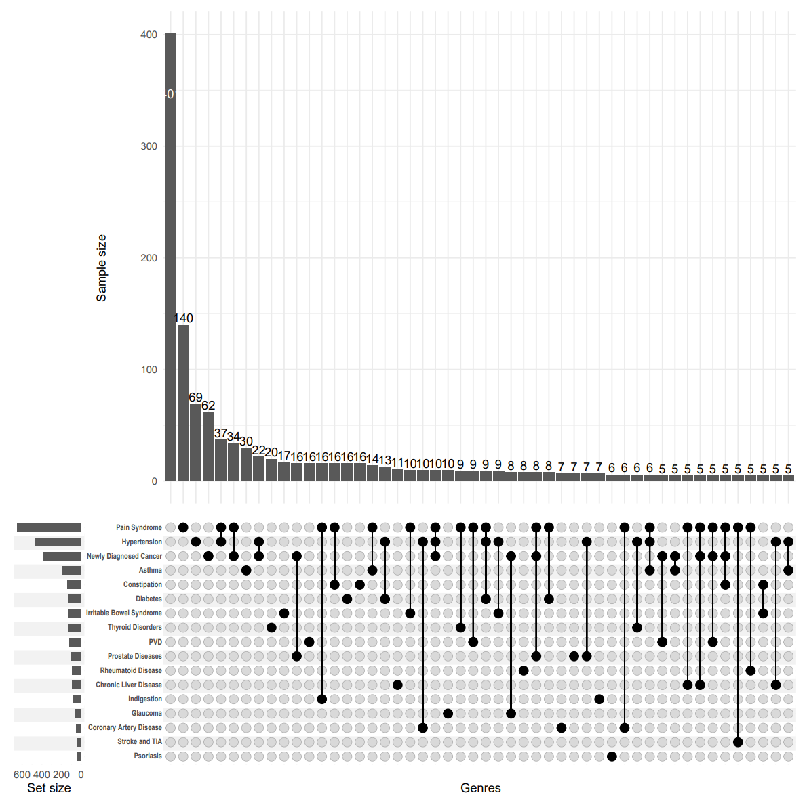

Figures S4. Upset plots for Class 3 in CD LCA models.
Abbreviation: COPD, Chronic Obstructive Pulmonary Disease; PVD, Peripheral Vascular Disease; TIA, Transient Ischemic Attack; CAD, Coronary Artery Disease; CKD, Chronic Kidney Disease; CLD, Chronic Liver Disease; IBS, Irritable Bowel Syndrome.
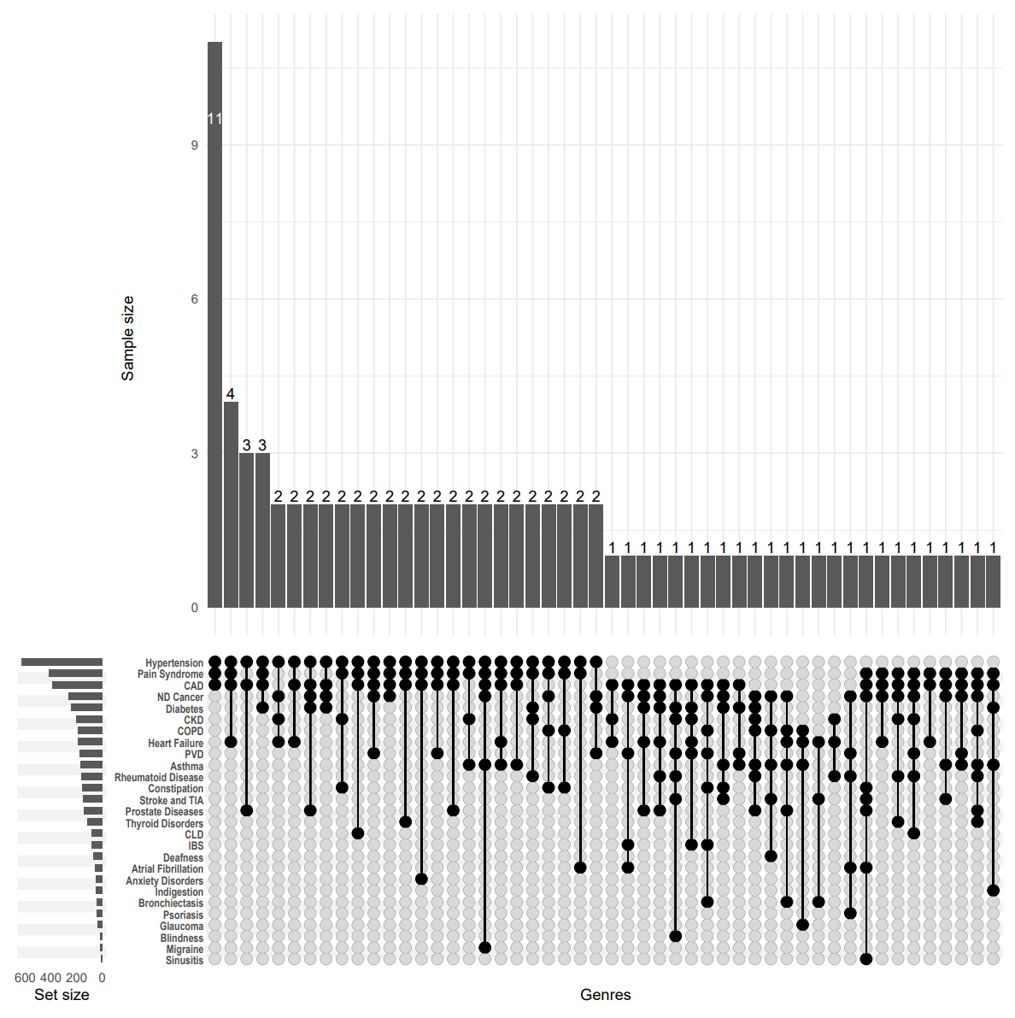

Figures S5. Upset plots for Class 1 in UC LCA models.
Abbreviation: COPD, Chronic Obstructive Pulmonary Disease; PVD, Peripheral Vascular Disease; TIA, Transient Ischemic Attack; CAD, Coronary Artery Disease; CKD, Chronic Kidney Disease; CLD, Chronic Liver Disease; IBS, Irritable Bowel Syndrome.
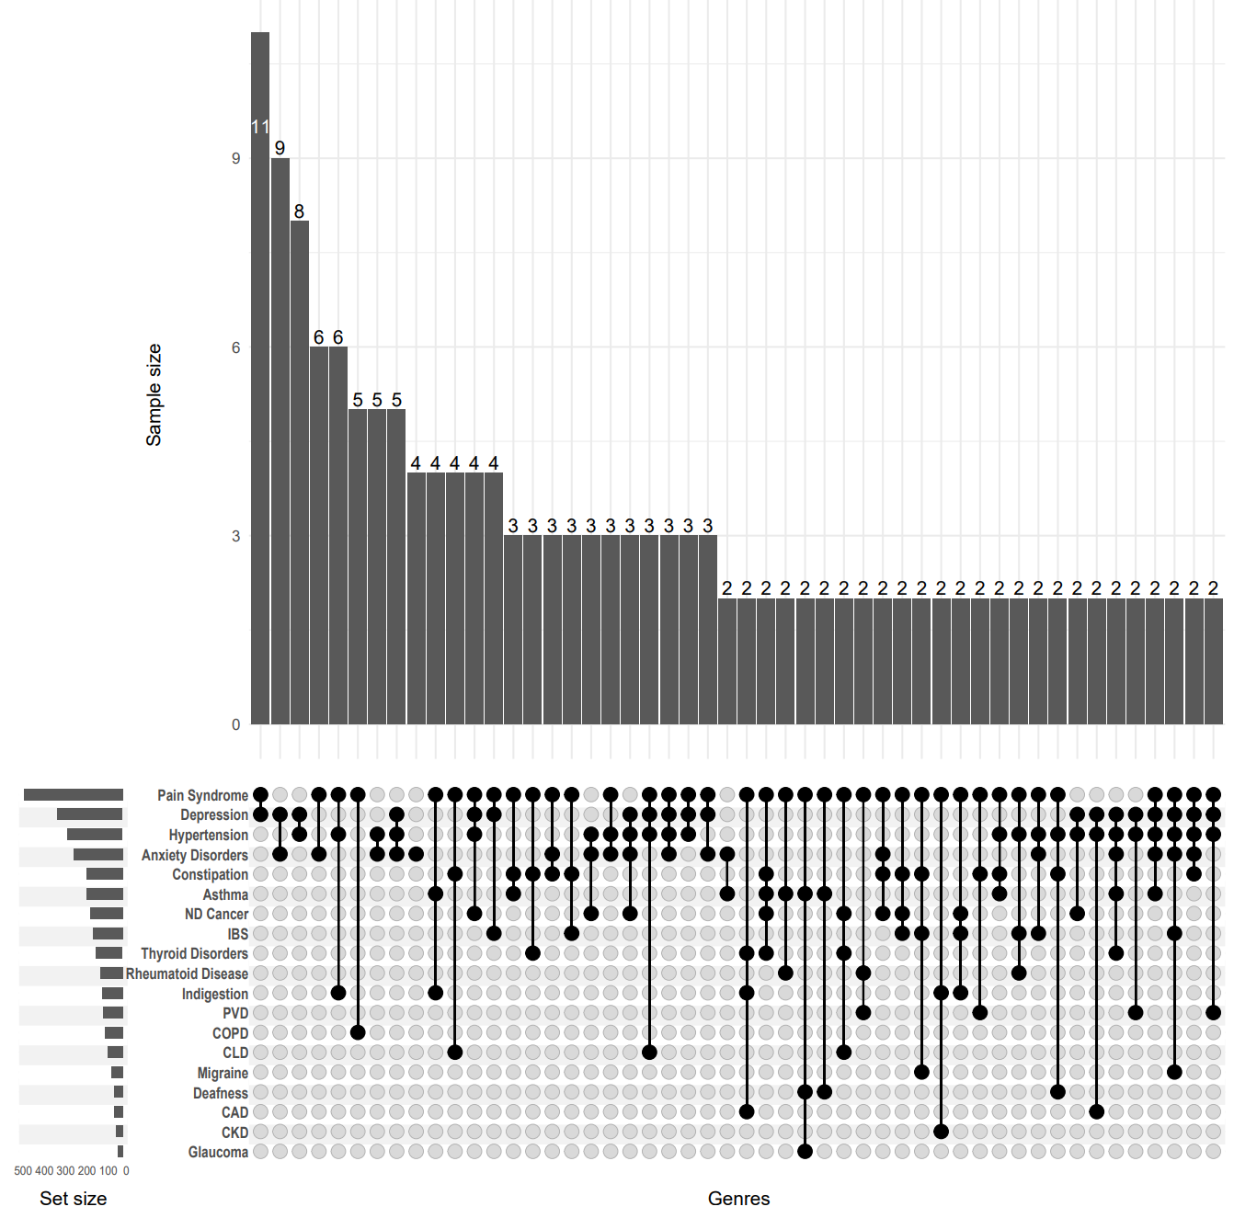

Figures S6. Upset plots for Class 2 in UC LCA models.
Abbreviation: COPD, Chronic Obstructive Pulmonary Disease; PVD, Peripheral Vascular Disease; TIA, Transient Ischemic Attack; CAD, Coronary Artery Disease; CKD, Chronic Kidney Disease; CLD, Chronic Liver Disease; IBS, Irritable Bowel Syndrome.
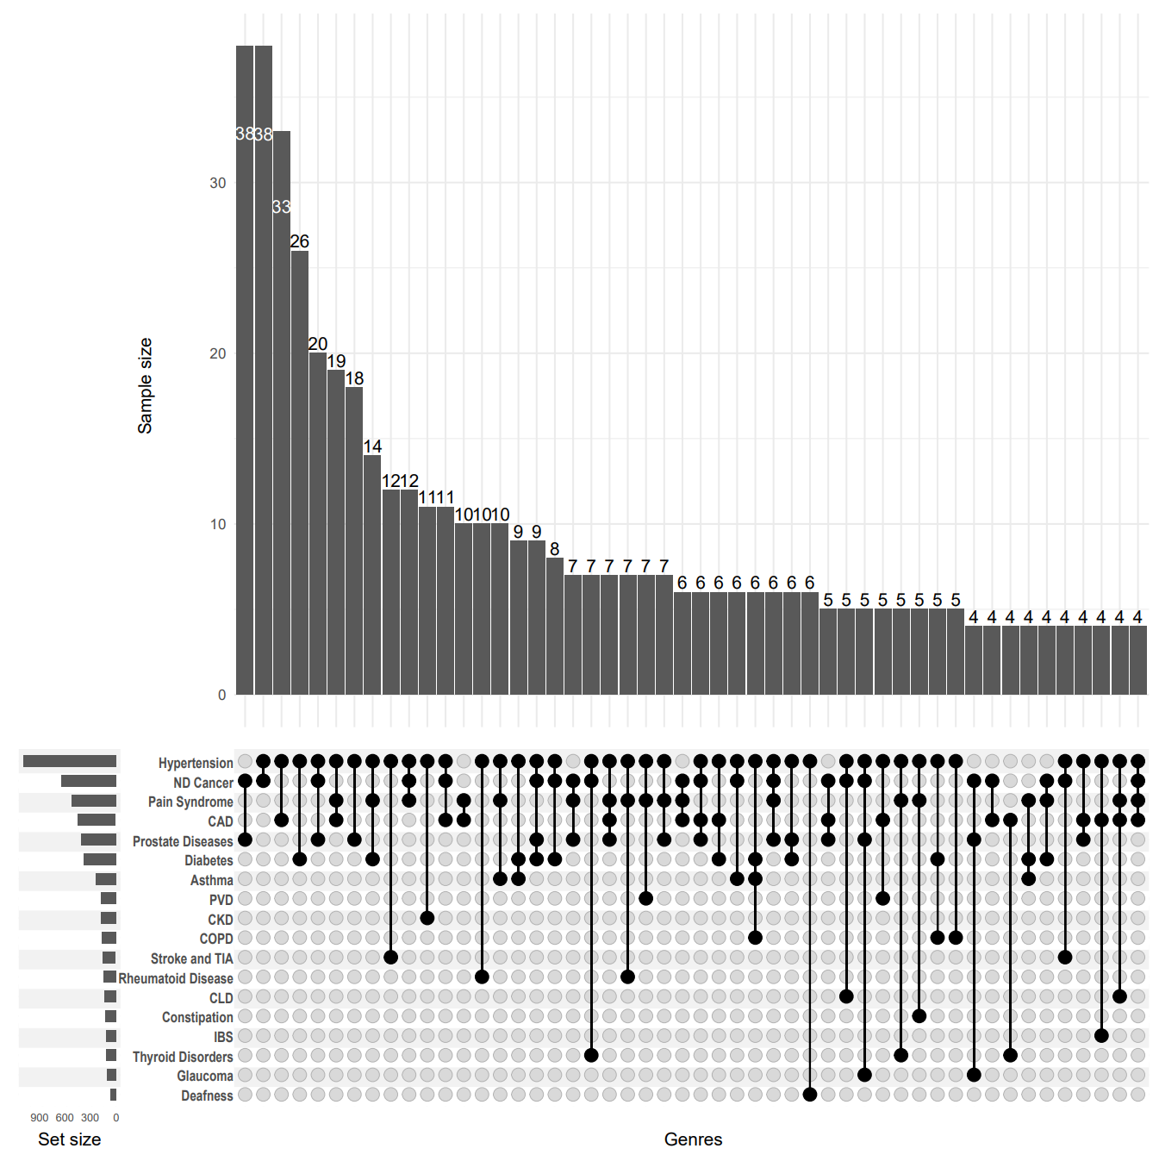

Figures S7. Upset plots for Class 3 in UC LCA models.
Abbreviation: COPD, Chronic Obstructive Pulmonary Disease; PVD, Peripheral Vascular Disease; TIA, Transient Ischemic Attack; CAD, Coronary Artery Disease; CKD, Chronic Kidney Disease; CLD, Chronic Liver Disease; IBS, Irritable Bowel Syndrome.
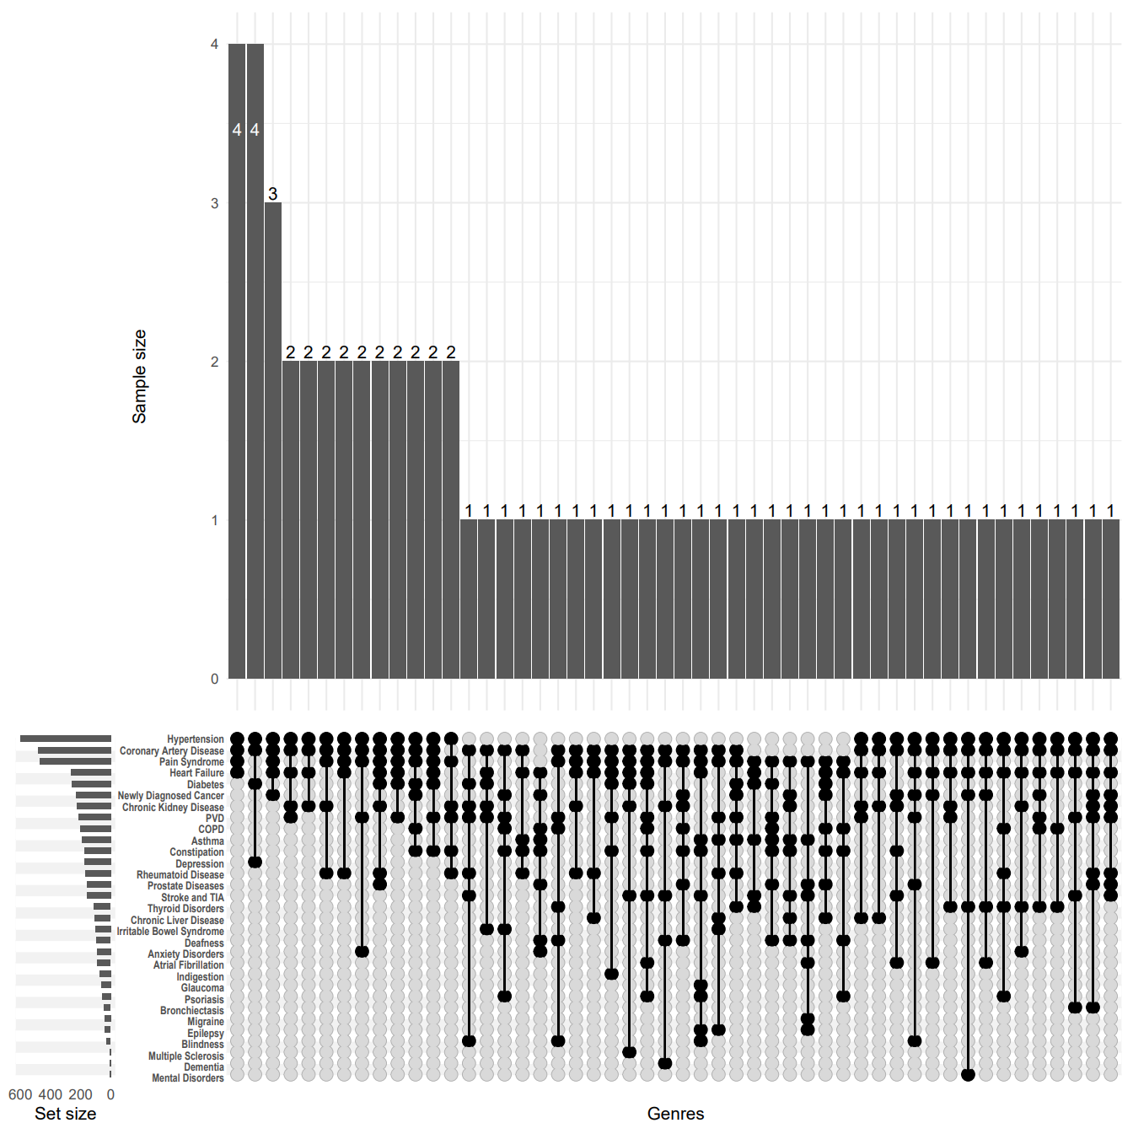

Figures S8. Upset plots for Class 4 in UC LCA models.
Abbreviation: COPD, Chronic Obstructive Pulmonary Disease; PVD, Peripheral Vascular Disease; TIA, Transient Ischemic Attack; CAD, Coronary Artery Disease; CKD, Chronic Kidney Disease; CLD, Chronic Liver Disease; IBS, Irritable Bowel Syndrome.
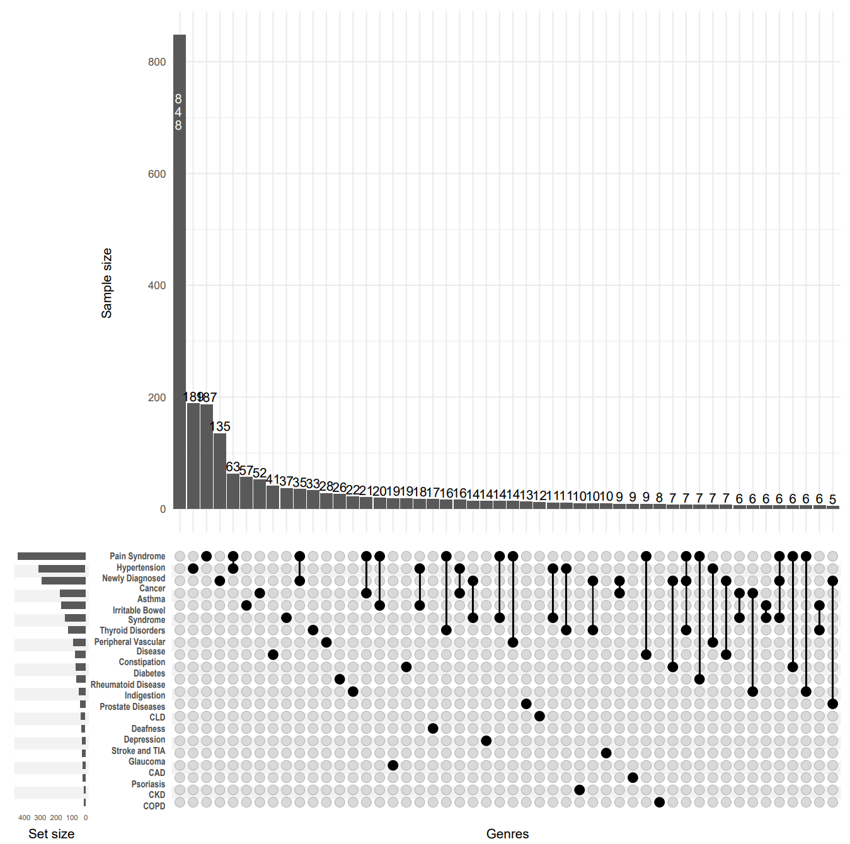

Table S3. Prevalence of long-term conditions (LTCs) in IBD patients, rates for patients with 1 additional LTC, and rates for patients with >2 additional LTCs, and prevalence rates for each LTC within each latent class.
Characteristic | CD, N = 2,926 | Number of LTCs in CD patients |  | Latent Class of CD |  |  | UC, N = 5,379 | Number of LTCs in UC patients |  | Latent Class of UC
Characteristic | CD, N = 2,926 | =1, N = 474 | ≥2, N = 2,051 | C1, N = 360 | C2, N = 1,896 | C3, N = 670 | UC, N = 5,379 | =1, N = 965 | ≥2, N = 3,566 | C1, N = 1,554 | C2, N = 636 | C3, N = 754 | C4, N = 2,435
Hypertension | 1,239 (42%) | 69 (15%) | 1,170 (57%) | 148 (41%) | 464 (24%) | 627 (94%) | 2,349 (44%) | 189 (20%) | 2,160 (61%) | 1,138 (73%) | 601 (94%) | 288 (38%) | 322 (13%)
Depression | 344 (12%) | 4 (0.8%) | 340 (17%) | 254 (71%) | 24 (1.3%) | 66 (9.9%) | 542 (10%) | 17 (1.8%) | 525 (15%) | 0 (0%) | 175 (28%) | 341 (45%) | 26 (1.1%)
Pain Syndrome | 1,341 (46%) | 140 (30%) | 1,201 (59%) | 278 (77%) | 650 (34%) | 413 (62%) | 1,999 (37%) | 187 (19%) | 1,812 (51%) | 545 (35%) | 471 (74%) | 516 (68%) | 467 (19%)
Asthma | 469 (16%) | 30 (6.3%) | 439 (21%) | 109 (30%) | 189 (10.0%) | 171 (26%) | 810 (15%) | 52 (5.4%) | 758 (21%) | 252 (16%) | 194 (31%) | 189 (25%) | 175 (7.2%)
Coronary Artery Disease | 473 (16%) | 7 (1.5%) | 466 (23%) | 30 (8.3%) | 55 (2.9%) | 388 (58%) | 1,015 (19%) | 19 (2.0%) | 996 (28%) | 466 (30%) | 484 (76%) | 44 (5.8%) | 21 (0.9%)
Indigestion | 188 (6.4%) | 7 (1.5%) | 181 (8.8%) | 52 (14%) | 85 (4.5%) | 51 (7.6%) | 289 (5.4%) | 26 (2.7%) | 263 (7.4%) | 46 (3.0%) | 73 (11%) | 108 (14%) | 62 (2.5%)
Diabetes | 440 (15%) | 16 (3.4%) | 424 (21%) | 63 (18%) | 132 (7.0%) | 245 (37%) | 787 (15%) | 41 (4.2%) | 746 (21%) | 397 (26%) | 262 (41%) | 57 (7.6%) | 71 (2.9%)
Thyroid Disorders | 323 (11%) | 20 (4.2%) | 303 (15%) | 82 (23%) | 126 (6.6%) | 115 (17%) | 509 (9.5%) | 37 (3.8%) | 472 (13%) | 117 (7.5%) | 112 (18%) | 139 (18%) | 141 (5.8%)
Rheumatoid Disease | 339 (12%) | 8 (1.7%) | 331 (16%) | 80 (22%) | 94 (5.0%) | 165 (25%) | 507 (9.4%) | 19 (2.0%) | 488 (14%) | 153 (9.8%) | 171 (27%) | 116 (15%) | 67 (2.8%)
Deafness | 131 (4.5%) | 2 (0.4%) | 129 (6.3%) | 25 (6.9%) | 39 (2.1%) | 67 (10%) | 237 (4.4%) | 12 (1.2%) | 225 (6.3%) | 66 (4.2%) | 95 (15%) | 46 (6.1%) | 30 (1.2%)
COPD | 325 (11%) | 5 (1.1%) | 320 (16%) | 74 (21%) | 62 (3.3%) | 189 (28%) | 479 (8.9%) | 8 (0.8%) | 471 (13%) | 172 (11%) | 204 (32%) | 94 (12%) | 9 (0.4%)
Anxiety Disorders | 233 (8.0%) | 3 (0.6%) | 230 (11%) | 158 (44%) | 24 (1.3%) | 51 (7.6%) | 364 (6.8%) | 4 (0.4%) | 360 (10%) | 13 (0.8%) | 93 (15%) | 258 (34%) | 0 (0%)
Irritable Bowel Syndrome | 316 (11%) | 17 (3.6%) | 299 (15%) | 108 (30%) | 126 (6.6%) | 82 (12%) | 547 (10%) | 57 (5.9%) | 490 (14%) | 124 (8.0%) | 102 (16%) | 155 (21%) | 166 (6.8%)
Newly Diagnosed Cancer | 740 (25%) | 62 (13%) | 678 (33%) | 87 (24%) | 392 (21%) | 261 (39%) | 1,377 (26%) | 135 (14%) | 1,242 (35%) | 670 (43%) | 233 (37%) | 170 (23%) | 304 (12%)
Substance Abuse | 4 (0.1%) | 0 (0%) | 4 (0.2%) | 4 (1.1%) | 0 (0%) | 0 (0%) | 7 (0.1%) | 0 (0%) | 7 (0.2%) | 2 (0.1%) | 3 (0.5%) | 2 (0.3%) | 0 (0%)
Stroke and TIA | 218 (7.5%) | 4 (0.8%) | 214 (10%) | 29 (8.1%) | 38 (2.0%) | 151 (23%) | 395 (7.3%) | 14 (1.5%) | 381 (11%) | 159 (10%) | 158 (25%) | 53 (7.0%) | 25 (1.0%)
Chronic Kidney Disease | 290 (9.9%) | 2 (0.4%) | 288 (14%) | 22 (6.1%) | 65 (3.4%) | 203 (30%) | 457 (8.5%) | 10 (1.0%) | 447 (13%) | 183 (12%) | 228 (36%) | 34 (4.5%) | 12 (0.5%)
Constipation | 417 (14%) | 16 (3.4%) | 401 (20%) | 119 (33%) | 141 (7.4%) | 157 (23%) | 583 (11%) | 28 (2.9%) | 555 (16%) | 134 (8.6%) | 176 (28%) | 190 (25%) | 83 (3.4%)
Atrial Fibrillation | 65 (2.2%) | 1 (0.2%) | 64 (3.1%) | 8 (2.2%) | 2 (0.1%) | 55 (8.2%) | 117 (2.2%) | 1 (0.1%) | 116 (3.3%) | 24 (1.5%) | 89 (14%) | 3 (0.4%) | 1 (<0.1%)
Peripheral Vascular Disease | 351 (12%) | 16 (3.4%) | 335 (16%) | 55 (15%) | 120 (6.3%) | 176 (26%) | 626 (12%) | 33 (3.4%) | 593 (17%) | 188 (12%) | 216 (34%) | 104 (14%) | 118 (4.8%)
Heart Failure | 206 (7.0%) | 1 (0.2%) | 205 (10.0%) | 7 (1.9%) | 11 (0.6%) | 188 (28%) | 333 (6.2%) | 0 (0%) | 333 (9.3%) | 66 (4.2%) | 264 (42%) | 3 (0.4%) | 0 (0%)
Prostate Diseases | 277 (9.5%) | 7 (1.5%) | 270 (13%) | 25 (6.9%) | 110 (5.8%) | 142 (21%) | 658 (12%) | 22 (2.3%) | 636 (18%) | 425 (27%) | 158 (25%) | 30 (4.0%) | 45 (1.8%)
Glaucoma | 124 (4.2%) | 10 (2.1%) | 114 (5.6%) | 18 (5.0%) | 68 (3.6%) | 38 (5.7%) | 219 (4.1%) | 10 (1.0%) | 209 (5.9%) | 108 (6.9%) | 62 (9.7%) | 25 (3.3%) | 24 (1.0%)
Epilepsy | 65 (2.2%) | 2 (0.4%) | 63 (3.1%) | 28 (7.8%) | 16 (0.8%) | 21 (3.1%) | 122 (2.3%) | 3 (0.3%) | 119 (3.3%) | 24 (1.5%) | 39 (6.1%) | 36 (4.8%) | 23 (0.9%)
Dementia | 6 (0.2%) | 0 (0%) | 6 (0.3%) | 1 (0.3%) | 2 (0.1%) | 3 (0.4%) | 18 (0.3%) | 0 (0%) | 18 (0.5%) | 3 (0.2%) | 7 (1.1%) | 7 (0.9%) | 1 (<0.1%)
Mental Disorders | 29 (1.0%) | 0 (0%) | 29 (1.4%) | 23 (6.4%) | 1 (<0.1%) | 5 (0.7%) | 36 (0.7%) | 1 (0.1%) | 35 (1.0%) | 8 (0.5%) | 6 (0.9%) | 21 (2.8%) | 1 (<0.1%)
Psoriasis | 100 (3.4%) | 6 (1.3%) | 94 (4.6%) | 20 (5.6%) | 36 (1.9%) | 44 (6.6%) | 135 (2.5%) | 9 (0.9%) | 126 (3.5%) | 37 (2.4%) | 44 (6.9%) | 34 (4.5%) | 20 (0.8%)
Migraine | 80 (2.7%) | 2 (0.4%) | 78 (3.8%) | 49 (14%) | 13 (0.7%) | 18 (2.7%) | 118 (2.2%) | 3 (0.3%) | 115 (3.2%) | 7 (0.5%) | 41 (6.4%) | 60 (8.0%) | 10 (0.4%)
Blindness | 35 (1.2%) | 0 (0%) | 35 (1.7%) | 9 (2.5%) | 8 (0.4%) | 18 (2.7%) | 56 (1.0%) | 0 (0%) | 56 (1.6%) | 10 (0.6%) | 28 (4.4%) | 18 (2.4%) | 0 (0%)
Sinusitis | 48 (1.6%) | 3 (0.6%) | 45 (2.2%) | 19 (5.3%) | 17 (0.9%) | 12 (1.8%) | 94 (1.7%) | 5 (0.5%) | 89 (2.5%) | 24 (1.5%) | 14 (2.2%) | 41 (5.4%) | 15 (0.6%)
Anorexia | 0 (0%) | 0 (0%) | 0 (0%) | 0 (0%) | 0 (0%) | 0 (0%) | 2 (<0.1%) | 0 (0%) | 2 (<0.1%) | 0 (0%) | 0 (0%) | 2 (0.3%) | 0 (0%)
Bronchiectasis | 82 (2.8%) | 1 (0.2%) | 81 (3.9%) | 14 (3.9%) | 22 (1.2%) | 46 (6.9%) | 159 (3.0%) | 4 (0.4%) | 155 (4.3%) | 43 (2.8%) | 57 (9.0%) | 49 (6.5%) | 10 (0.4%)
Parkinson's Disease | 36 (1.2%) | 2 (0.4%) | 34 (1.7%) | 9 (2.5%) | 12 (0.6%) | 15 (2.2%) | 74 (1.4%) | 2 (0.2%) | 72 (2.0%) | 18 (1.2%) | 23 (3.6%) | 23 (3.1%) | 10 (0.4%)
Multiple Sclerosis | 22 (0.8%) | 0 (0%) | 22 (1.1%) | 13 (3.6%) | 5 (0.3%) | 4 (0.6%) | 37 (0.7%) | 3 (0.3%) | 34 (1.0%) | 0 (0%) | 7 (1.1%) | 24 (3.2%) | 6 (0.2%)
Viral Hepatitis | 10 (0.3%) | 0 (0%) | 10 (0.5%) | 3 (0.8%) | 4 (0.2%) | 3 (0.4%) | 12 (0.2%) | 1 (0.1%) | 11 (0.3%) | 4 (0.3%) | 4 (0.6%) | 0 (0%) | 4 (0.2%)
Chronic Liver Disease | 242 (8.3%) | 11 (2.3%) | 231 (11%) | 63 (18%) | 93 (4.9%) | 86 (13%) | 362 (6.7%) | 13 (1.3%) | 349 (9.8%) | 139 (8.9%) | 106 (17%) | 81 (11%) | 36 (1.5%)

Table S4. Characteristics of participants assigned to different latent classes.
Abbreviation: SD, Standard deviation; IQR, Interquartile Range; BMI, Body Mass Index.
Characteristic | Latent Class of CD |  |  | Latent Class of UC
Characteristic | 1, N = 360 | 2, N = 1,896 | 3, N = 670 | 1, N = 1,554 | 2, N = 636 | 3, N = 754 | 4, N = 2,435
Sex, n (%)
Female | 262 (73%) | 1,068 (56%) | 290 (43%) | 546 (35%) | 237 (37%) | 516 (68%) | 1,321 (54%)
Male | 98 (27%) | 828 (44%) | 380 (57%) | 1,008 (65%) | 399 (63%) | 238 (32%) | 1,114 (46%)
Age (years), Mean (SD) | 55.1 (8.3) | 55.4 (8.1) | 61.4 (6.3) | 60.4 (6.5) | 61.7 (6.2) | 56.0 (7.9) | 54.9 (8.0)
Ethnicity, n (%)
European | 335 (94%) | 1,819 (96%) | 633 (95%) | 1,483 (96%) | 598 (96%) | 705 (94%) | 2,280 (94%)
Mixed-race | 2 (0.6%) | 4 (0.2%) | 0 (0%) | 5 (0.3%) | 2 (0.3%) | 7 (0.9%) | 16 (0.7%)
Asian | 9 (2.5%) | 35 (1.9%) | 18 (2.7%) | 32 (2.1%) | 17 (2.7%) | 18 (2.4%) | 67 (2.8%)
African | 4 (1.1%) | 20 (1.1%) | 6 (0.9%) | 13 (0.8%) | 2 (0.3%) | 10 (1.3%) | 27 (1.1%)
Chinese | 0 (0%) | 2 (0.1%) | 2 (0.3%) | 2 (0.1%) | 0 (0%) | 0 (0%) | 4 (0.2%)
Others | 7 (2.0%) | 8 (0.4%) | 6 (0.9%) | 9 (0.6%) | 7 (1.1%) | 10 (1.3%) | 24 (1.0%)
Missing | 3 | 8 | 5 | 10 | 10 | 4 | 17
Townsend deprivation index, Mean (SD) | -0.1 (3.5) | -1.2 (3.1) | -0.6 (3.3) | -1.1 (3.2) | -0.5 (3.4) | -0.8 (3.2) | -1.4 (3.1)
Missing | 0 | 4 | 1 | 2 | 0 | 0 | 0
Education level, Median (IQR) | 16.0 (2.0) | 16.0 (2.0) | 15.0 (1.0) | 16.0 (2.0) | 15.0 (1.0) | 16.0 (2.0) | 16.0 (3.0)
Missing | 84 | 581 | 124 | 360 | 108 | 186 | 782
Smoking status, n (%)
Never | 144 (40%) | 904 (48%) | 235 (35%) | 655 (43%) | 209 (33%) | 337 (45%) | 1,237 (51%)
Previous | 136 (38%) | 702 (37%) | 317 (48%) | 749 (49%) | 351 (56%) | 303 (41%) | 996 (41%)
Current | 77 (22%) | 280 (15%) | 115 (17%) | 137 (8.9%) | 72 (11%) | 108 (14%) | 188 (7.8%)
Missing | 3 | 10 | 3 | 13 | 4 | 6 | 14
Alcohol drinking, n (%)
Never | 36 (10%) | 97 (5.1%) | 52 (7.8%) | 74 (4.8%) | 42 (6.7%) | 56 (7.5%) | 110 (4.5%)
Previous | 40 (11%) | 89 (4.7%) | 52 (7.8%) | 65 (4.2%) | 55 (8.7%) | 71 (9.5%) | 87 (3.6%)
Current | 281 (79%) | 1,706 (90%) | 561 (84%) | 1,407 (91%) | 534 (85%) | 620 (83%) | 2,230 (92%)
Missing | 3 | 4 | 5 | 8 | 5 | 7 | 8
BMI, Median (IQR) | 27.5 (7.3) | 26.1 (5.5) | 28.0 (6.5) | 27.6 (5.8) | 28.9 (7.1) | 26.9 (5.6) | 26.1 (5.1)
Missing | 3 | 8 | 8 | 12 | 14 | 14 | 8

