Table S1 Basic characteristics of the male and female.
Baseline characteristics | Male |  | p | Female |  | p
Baseline characteristics | Low (n=926) | High (n=750) | p | Low (n=736) | High (n=912) | p
Age (%) |  |  | 0.231 |  |  | 0.197
<45 year | 645 (69.7) | 501 (66.8) |  | 455 (61.8) | 593 (65.0)
≥45 year | 281 (30.3) | 249 (33.2) |  | 281 (38.2) | 319 (35.0)
BMl (%) |  |  | 0.549 |  |  | <0.001
Normal | 279 (30.1) | 215 (28.7) |  | 281 (38.2) | 237 (26.0)
Abnormal | 647 (69.9) | 535 (71.3) |  | 455 (61.8) | 675 (74.0)
Race(%) |  |  | <0.001 |  |  | <0.001
Mexican American | 145 (15.7) | 113 (15.1) |  | 104 (14.1) | 184 (20.2)
Other Hispanic | 75 (8.10) | 76 (10.1) |  | 74 (10.1) | 124 (13.6)
Non-Hispanic White | 278 (30.0) | 311 (41.5) |  | 248 (33.7) | 347 (38.0)
Non-Hispanic Black | 249 (26.9) | 111 (14.8) |  | 182 (24.7) | 123 (13.5)
Non-Hispanic other | 179 (19.3) | 139 (18.5) |  | 128 (17.4) | 134 (14.7)
Education level (%) |  |  | 0.436 |  |  | 0.804
Less than high school degree | 177 (19.1) | 154 (20.5) |  | 121 (16.4) | 161 (17.7)
High school degree | 226 (24.4) | 196 (26.1) |  | 158 (21.5) | 195 (21.4)
More than high school degree | 523 (56.5) | 400 (53.3) |  | 457 (62.1) | 556 (61.0)
Drinking status (%) |  |  | 0.26 |  |  | 0.782
Never drinker | 99 (10.7) | 73 (9.73) |  | 143 (19.4) | 165 (18.1)
Ever drinker | 738 (79.7) | 587 (78.3) |  | 514 (69.8) | 649 (71.2)
Current drinker | 89 (9.61) | 90 (12.0) |  | 79 (10.7) | 98 (10.7)
Smoking Status (%) |  |  | 0.003 |  |  | 0.36
Never smoker | 546 (59.0) | 392 (52.3) |  | 510 (69.3) | 622 (68.2)
Ever smoker | 200 (21.6) | 214 (28.5) |  | 123 (16.7) | 175 (19.2)
Current smoker | 180 (19.4) | 144 (19.2) |  | 103 (14.0) | 115 (12.6)
Physical activity (%) |  |  | 0.301 |  |  | 0.039
<100min MVPA | 570 (61.6) | 481 (64.1) |  | 545 (74.0) | 716 (78.5)
≥100 min MVPA | 356 (38.4) | 269 (35.9) |  | 191 (26.0) | 196 (21.5)
Sedentary (%) |  |  | 0.441 |  |  | 0.542
<360min | 452 (48.8) | 351 (46.8) |  | 355 (48.2) | 425 (46.6)
≥360min | 474 (51.2) | 399 (53.2) |  | 381 (51.8) | 487 (53.4)
Nutrient Intakes
Energy (%) |  |  | 0.083 |  |  | 0.054
<2050 kcal | 316 (34.1) | 265 (35.3) |  | 448 (60.9) | 606 (66.4)
2050-3050 kcal | 362 (39.1) | 256 (34.1) |  | 225 (30.6) | 245 (26.9)
≥3051 kcal | 248 (26.8) | 229 (30.5) |  | 63 (8.56) | 61 (6.69)
Protein (%) |  |  | 0.474 |  |  | 0.378
<51.5 gm | 123 (13.3) | 113 (15.1) |  | 210 (28.5) | 273 (29.9)
51.5-91.5 gm | 331 (35.7) | 252 (33.6) |  | 339 (46.1) | 434 (47.6)
≥91.6 gm | 472 (51.0) | 385 (51.3) |  | 187 (25.4) | 205 (22.5)
Carbohydrate (%) |  |  | 0.241 |  |  | 0.127
<282 gm | 466 (50.3) | 397 (52.9) |  | 543 (73.8) | 711 (78.0)
282-457.5 gm | 341 (36.8) | 247 (32.9) |  | 170 (23.1) | 174 (19.1)
≥457.6 gm | 119 (12.9) | 106 (14.1) |  | 23 (3.12) | 27 (2.96)
Fat (%) |  |  | 0.001 |  |  | 0.192
<45.5 gm | 112 (12.1) | 118 (15.7) |  | 169 (23.0) | 216 (23.7)
45.5-101.5 gm | 459 (49.6) | 304 (40.5) |  | 399 (54.2) | 521 (57.1)
≥101.6 gm | 355 (38.3) | 328 (43.7) |  | 168 (22.8) | 175 (19.2)
SII (10³/μL) | 304 (239,369) | 605 (507,761) | <0.001 | 322 (262,380) | 628 (522,772) | <0.001

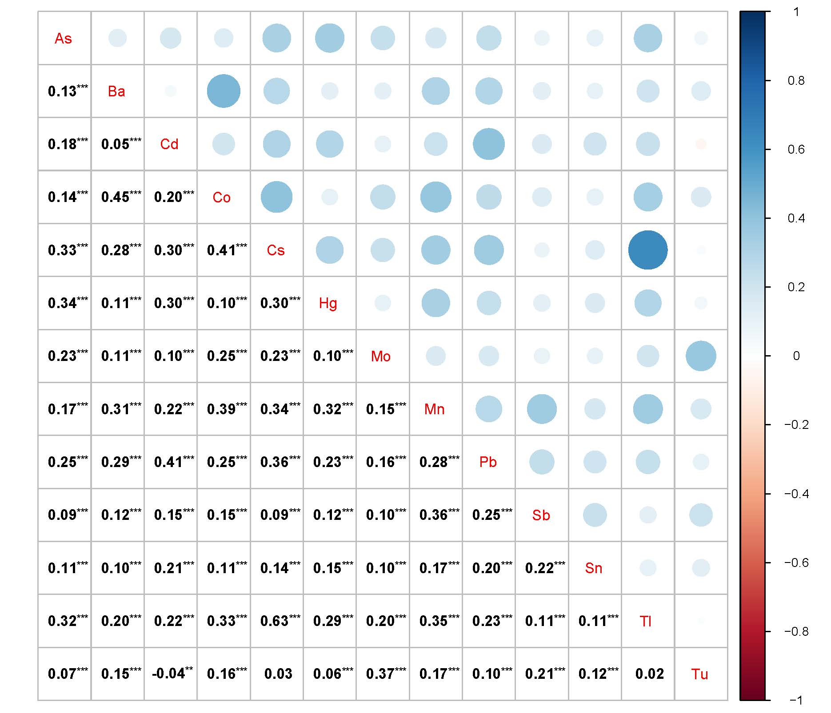
Fig.S1 Correlation analysis between the log-transform level of urinary metals. ***<0.001; **<0.05.

Table S2 The logistic regression of metals and TOFAT in NHANES.
Metals | model | Q1 | Q2 | Q3 | Q4 | P for trend
 |  |  | OR (95%CI) | OR (95%CI) | OR (95%CI)
Sn | Model 1 | Ref. | 1.22(1.02,1.459) | 1.229(1.021,1.48) | 1.669(1.364,2.042) | <0.001
 | Model 2 | Ref. | 1.038(0.858,1.254) | 0.935(0.766,1.141) | 1.166(0.938,1.449) | 0.411
 | Model 3 | Ref. | 1.035(0.853,1.255) | 0.936(0.764,1.146) | 1.143(0.915,1.428) | 0.509
Tl | Model 1 | Ref. | 1.23(1.012,1.494) | 1.121(0.921,1.364) | 1.073(0.879,1.308) | 0.793
 | Model 2 | Ref. | 1.225(0.997,1.505) | 0.961(0.777,1.19) | 0.895(0.717,1.116) | 0.089
 | Model 3 | Ref. | 1.222(0.99,1.508) | 0.967(0.777,1.204) | 0.914(0.728,1.148) | 0.146
Tu | Model 1 | Ref. | 0.98(0.809,1.186) | 0.888(0.732,1.077) | 0.97(0.8,1.177) | 0.54
 | Model 2 | Ref. | 0.94(0.768,1.15) | 0.861(0.702,1.056) | 0.949(0.773,1.164) | 0.453
 | Model 3 | Ref. | 0.925(0.754,1.135) | 0.842(0.684,1.036) | 0.954(0.774,1.176) | 0.491
Model 1: no covariates were adjusted; Model 2: age, gender, and race were adjusted; Model 3: age, gender, race, education, smoking, drinking, physical activity, sedentary, and nutrient intakes were adjusted.

Table S3 Multivariate logistic analysis of SII and TOFAT in different groups.
Group | Model | Q1 | Q2 | Q3 | Q4 | P for trend
 |  |  | OR (95%CI) | OR (95%CI) | OR (95%CI)
Total | Model 1 | Ref. | 1.323 (1.091, 1.605) | 1.731 (1.430, 2.097) | 2.134 (1.753, 2.597) | <0.001
 | Model 2 | Ref. | 1.313 (1.071, 1.611) | 1.726 (1.407, 2.119) | 2.003 (1.624, 2.469) | <0.001
 | Model 3 | Ref. | 1.309 (1.064, 1.611) | 1.744 (1.416, 2.148) | 1.931 (1.560, 2.390) | <0.001
Male | Model 1 | Ref. | 1.292 (0.988, 1.691) | 1.408 (1.074, 1.846) | 1.596 (1.201, 2.119) | <0.001
 | Model 2 | Ref. | 1.328 (1.009, 1.747) | 1.451 (1.097, 1.920) | 1.567 (1.171, 2.097) | 0.002
 | Model 3 | Ref. | 1.280 (0.964, 1.698) | 1.499 (1.123, 2.001) | 1.542 (1.139, 2.089) | 0.005
Female | Model 1 | Ref. | 1.236 (0.925, 1.652) | 1.842 (1.382, 2.456) | 2.253 (1.684, 3.015) | <0.001
 | Model 2 | Ref. | 1.295 (0.954, 1.758) | 2.037 (1.502, 2.761) | 2.609 (1.917, 3.552) | <0.001
 | Model 3 | Ref. | 1.344 (0.985, 1.834) | 2.090 (1.534, 2.847) | 2.509 (1.835, 3.429) | <0.001
Model 1: no covariates were adjusted; Model 2: age, gender, and race were adjusted; Model 3: age, gender, race, education, smoking, drinking, physical activity, sedentary, and nutrient intakes were adjusted.

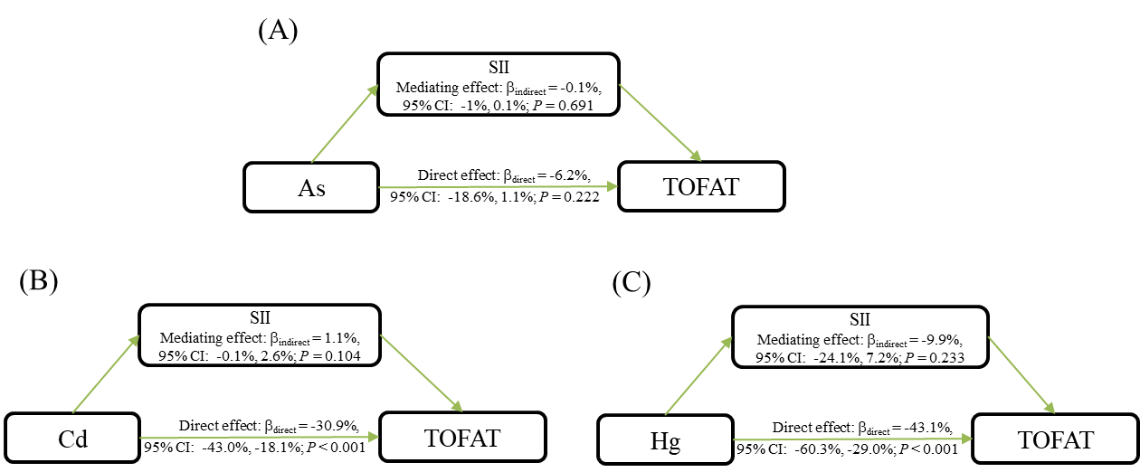
Fig.S2 Estimated proportion of the association between As, Cd, Hg, and TOFAT mediated by SII in male. Models were adjusted for age, race, education, smoking, drinking, physical activity, sedentary, and nutrient intakes.
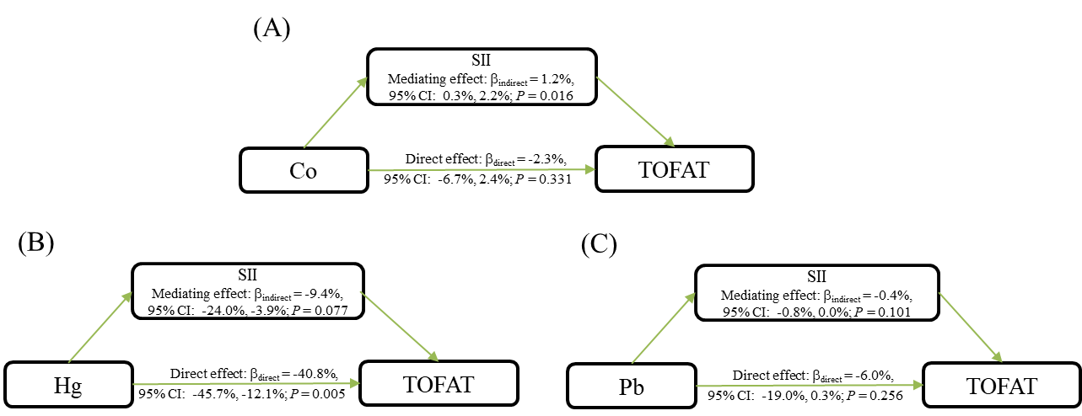
Fig.S3 Estimated proportion of the association between Co, Hg, Pb, and TOFAT mediated by SII in female. Models were adjusted for age, race, education, smoking, drinking, physical activity, sedentary, and nutrient intakes.

