Figure S1. Cloning and selection of a cold-responsive TPP gene of A. arguta.
Figure S2. Multiple alignment of AaTPPA, PtrTPPA, AtTPPA, and OtsB (the E. coli TPP) protein sequences.
Figure S3. IPTG-induced expression of the His6-tagged AaTPPA and OtsB proteins in E. coli BL21(DE3) and their purification using Ni-affinity chromatography.
Figure S4. Tre6P contents and transcriptional levels of several A. thaliana endogenous genes in AaTPPA or OtsB-OE lines.
Figure S5. Developmental and morphological characteristics of AaTPPA and OtsB-OE A. thaliana lines.
Figure S6. Cold tolerance of AaTPPA-OE A. thaliana in comparison with OtsB-OE lines.
Figure S7. Construction of the plant expression vector (GVloxP/DsRed) with the red fluorescence protein marker.
Figure S8. Cloning of the AaTPPA promoter region.
Figure S9. Construction of GUS expression vectors with different promoter sections, and preparation of their transgenic A. thaliana to verify the AaTPPA promoter activity.
Figure S10. Identification and classification of AaERF64 transcription factor.
Figure S11. IPTG-induced expression and purification of the recombinant GST-AaERF64 protein.
Figure S12. The accumulation of soluble sugars and proline in different tissues of A. arguta in autumn, and the effects of phytohormones on the expression of AaERF64 and AaTPPA.

Table S1. Functional motif prediction in the AaTPPA promoter region.
Table S2. Differential expression of AaTPPA promoter-interacting ERFs under normal and low temperature conditions.
Table S3. Primers used for cloning cold-responsive TPP genes of A. arguta.
Table S4. Primers used for RT-qPCR.
Table S5. Primers used for cloning the AaTPPA promoter.

Appendix S1. Coding sequence of AaTPPA.
Appendix S2. Promoter region and 5'-UTR of AaTPPA.
Appendix S3. Coding sequence of AaERF64.

Figure S1. Cloning and selection of a cold-responsive TPP gene of A. arguta.
(a) PCR amplification of TPP genes of which expressions were upregulated in response to low temperature. (TPP#3&5 was amplified using common primers designed on the conservative sequences between TPP#3 and TPP#5. TPP#8&9 was amplified using the forward primer of TPP#8 and the reverse primer of TPP#9.)
(b) Phylogenetic tree of the cloned cold-responsive TPP gene sequences.
(c) Identity between the cold-responsive TPP genes of A. arguta.

Figure S2. Multiple alignment of AaTPPA, PtrTPPA, AtTPPA, and OtsB (the E. coli TPP) protein sequences. (NLS: nuclear localization signal peptide, HAD: L-2-haloacid dehalogenase motif).

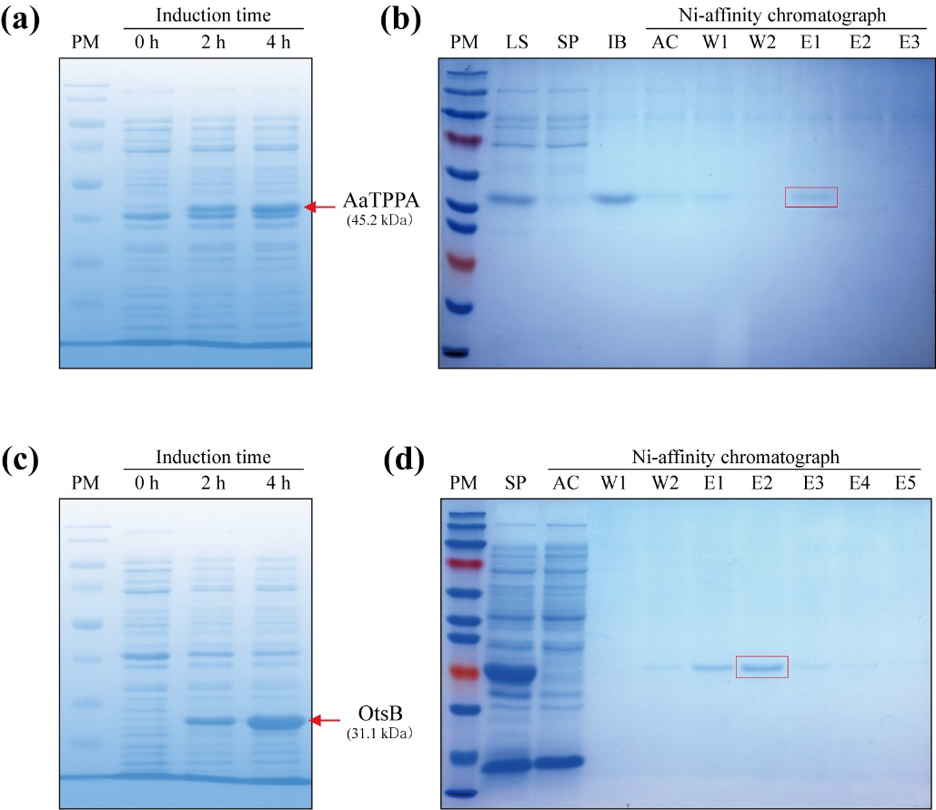
Figure S3. IPTG-induced expression of the His6-tagged AaTPPA and OtsB proteins in E. coli BL21(DE3) and their purification using Ni-affinity chromatography.
(a, c) Polyacrylamide gel electrophoresis (PAGE) images of the recombinant AaTPPA and OtsB proteins expressed by IPTG-induction.
(b, d) PAGE images of Ni-affinity chromatograph of the recombinant AaTPPA and OtsB proteins. (PM: protein molecular weight marker, LS: bacterial cell lysate, SP: supernatant of the lysate, IB: precipitate of the lysate, AC: flow-through of Ni-affinity column, W1: 20 mM imidazole wash, W2: 80 mM imidazole wash, E: elution fractions)
Figure S4. Tre6P contents and transcriptional levels of several A. thaliana endogenous genes in AaTPPA or OtsB-OE lines.
(a, b) Relative expression levels of AaTPPA and OtsB in screened transgenic A. thaliana lines. (n=3)
(c) Trehalose contents of AaTPPA or OtsB-OE lines. (n=3), P-values are calculated by Student’s t-test.
(d) Transcriptional levels of AtTPS1. (n=3, EV: A. thaliana line transformed with GV1300 empty vector)
(e) Transcriptional levels of several Arabidopsis SnRK1 marker genes. (n=3)
All data are shown as mean ± SD, and Duncan’s multiple comparison is employed at significance levels of P < 0.05.

Figure S5. Developmental and morphological characteristics of AaTPPA and OtsB-OE A. thaliana lines.
(a) Seed germination rate of AaTPPA and OtsB-OE lines. (n=10)
(b, c) Seedling morphology and size of AaTPPA and OtsB-OE lines grown for 12 d on MS medium. (n=10)
(d) Photos of AaTPPA and OtsB-OE lines grown for 28 d show different leaf shapes.
(e) Leaf chlorophyll content of AaTPPA and OtsB-OE lines grown for 21 d. (n=3)
(f, g) Plant height and silique count of adult AaTPPA and OtsB-OE lines. (n=10)
All data are shown as mean ± SD, and Duncan's multiple comparison is employed at significance levels of P < 0.05.

Figure S6. Cold tolerance of AaTPPA-OE A. thaliana in comparison with OtsB-OE lines.
(a, b, c) Survival rate and ion leakage of AaTPPA and OtsB-OE A. thaliana seedlings after freezing treatment at -10°C for different periods.
(d, e, f, g) NBT and DAB staining images and relative average staining intensity of AaTPPA and OtsB-OE lines after freezing treatment at -10°C for different periods.
(h, i, j) SOD, POD, and CAT antioxidant enzyme activities of AaTPPA and OtsB-OE lines under normal conditions and after cold stress treatment at -2°C for 2 h.
All data are shown as mean ± SD (n=3), and Duncan's multiple comparison is employed at significance levels of P < 0.05.

Figure S7. Construction of the plant expression vector (GVloxP/DsRed) with the red fluorescence protein marker.
GVloxP/DsRed has the scaffold of GV1300 vector. It contains a loxP construct which can be discarded by Cre recombinase. The expression cassette of the red fluorescence protein, DsRed, which was cloned from MtPT4-p3 vector, has been inserted at the site between loxP sequences.

Figure S8. Cloning of the AaTPPA promoter region.
(a, b) PCR amplification of P1 and P2 regions using the conventional PCR with homologous primers designed based on the genome data of other Actinidia species.
(c, d, e, f, g) Cloning of other promoter regions by TAIL-PCR. (AP1~4: arbitrary primers provided in Takara genome walking kit)
(h) Structural annotation of the promoter region and 5'-UTR of TPPA gene in A. chinensis cv. RED5 genome, and assembly diagram of the cloned fragments of the AaTPPA promoter region.
Figure S9. Construction of GUS expression vectors with different promoter sections, and preparation of their transgenic A. thaliana to verify the AaTPPA promoter activity.
(a, b) Schematic diagram of the AaTPPA promoter sections introduced into the GUS expression vector, pCAMBIA1303.
(c, d, e, f) PCR-amplified products from each section of the AaTPPA promoter region and 5'-UTR.
(g, h, i, j) Genotyping of the transgenic A. thaliana T₁ lines with the different AaTPPA promoter section-driven GUS expression cassettes.

Figure S10. Identification and classification of AaERF64 transcription factor.
(a) Phylogenetic tree of AaERF64 and AdERF64 with the ERF family genes of A. thaliana.
(b) 3D structure of the AaERF64 protein. (blue: nuclear localization signal peptide, red: AP2 DNA binding domain, dark pink: CMV-2 motif).
(c) Multiple alignment of AaERF64, AdERF64, and AtERF#003 protein sequences.
Figure S11. IPTG-induced expression and purification of the recombinant GST-AaERF64 protein.
(a) Expression patterns of the GST-tagged AaERF64 in E. coli Rosetta-gami(DE3)pLysS depending on culture temperature conditions. (PM: protein molecular weight marker, BI: before IPTG-induction, AI: after IPTG-induction, P: precipitate of bacterial cell lysate, S: supernatant of bacterial cell lysate)
(b) Purification of the recombinant GST-AaERF64 protein using GST-tag affinity chromatography. (F: flow-through of GST-tag affinity column, W: filtrate after column washing, E1~4: elution fractions)

Figure S12. The accumulation of soluble sugars and proline in different tissues of A. arguta in autumn, and the effects of phytohormones on the expression of AaERF64 and AaTPPA.
(a, b) The contents of soluble sugars and proline in mature leaves, lateral buds, stem cambium, and roots in late autumn compared to in mid-summer.
(c) Induction of AaTPPA and AaERF64 expression in response to several stress-related phytohormones.
All data are presented as mean ± SD (n=3). *P < 0.05, **P < 0.01, and ***P < 0.001 by Student’s t-test.

