Supplementary material

Table 1. Cochrane risk-of-bias tool for randomized trials (RoB 2)

Table 2. Newcastle-Ottawa scale for observational studies. Quality assessment of the included observational studies.
Study (Author/Year) | Newcastle-Ottawa Scale
Study (Author/Year) | Representativeness | Selection | Ascertainment of  exposure | Outcome of  interest was not present at start of study | Comparability | Assessment  of outcome | Follow-up long  enough | Adequacy of  follow-up | Quality score
Al Radi 2005 | * | * | * | * | * | * | * | * | 8
Borger 2007 | * | * | * | * | * | * | - | * | 7
Fattouch 2012 | * | * | * | * | ** | * | * | * | 9
Furukawa 2021 | * | * | * | * | * | * | * | * | 8
Harmel 2019 | * | * | * | * | * | * | - | * | 7
Langer 2009 | * | * | * | * | * | * | * | * | 8
Lorusso 2013 | * | * | * | * | ** | * | * | * | 9
Magne 2009 | * | * | * | * | ** | * | * | * | 9
Mihaljevic 2007 | * | * | * | * | ** | * | * | * | 9
Milano 2008 | * | * | * | * | * | * | * | * | 8
Roshanali 2013 | * | * | * | * | * | * | * | * | 8
Shudo 2010 | * | * | * | * | * | * | - | * | 7
Thourani 2003 | * | * | * | * | ** | * | * | * | 9
Wakasa 2015 | * | * | * | * | * | * | * | * | 8
It is assigned a maximum score of one star for each category, except for comparability that can be awarded to a maximum of two stars.

Table 3. All-cause late mortality, network characteristics
|Characteristic |Value |
|:-----------------------------------------------------|:-----|
|Number of Interventions |5 |
|Number of Studies |21 |
|Total Number of Patients in Network |4458 |
|Total Possible Pairwise Comparisons |10 |
|Total Number of Pairwise Comparisons With Direct Data |4 |
|Is the network connected? |TRUE |
|Number of Two-arm Studies |21 |
|Number of Multi-Arms Studies |0 |
|Total Number of Events in Network |1378 |
|Number of Studies With No Zero Events |19 |
|Number of Studies With At Least One Zero Event |2 |
|Number of Studies with All Zero Events |1 |
|Mean person follow up time |4.44 |

Table 4.All-cause late mortality, intervention characteristics

|Treatment | n.studies| n.events| n.patients| person.time.fup| min.event.rate| max.event.rate| events.per.person| overall.event.rate|
|:--------------- |---------:|--------:|----------:|---------------:|--------------:|--------------:|-----------------:|------------------:|
|CABG | 6| 40| 322| 1069| 0.0102564| 0.0625000| 0.1242236| 0.0374181|
|MV-rpl+CABG | 6| 601| 1421| 11884| 0.0210041| 0.1160000| 0.4229416| 0.0505722|
|RMA | 6| 30| 184| 459| 0.0000000| 0.1000000| 0.1630435| 0.0653595|
|RMA+CABG | 15| 662| 2210| 16272| 0.0125000| 0.1000000| 0.2995475| 0.0406834|
|RMA+SPM-r+/-CABG | 9| 45| 321| 1016| 0.0000000| 0.1046512| 0.1401869| 0.0442913|

Table 5. All-cause late mortality, comparison characteristics

|comparison | n.studies| n.patients| n.outcomes| patient_time| proportion| event.rate|
|:----------------------------|---------:|----------:|----------:|------------:|----------:|----------:|
|CABG vs. RMA+CABG | 6| 698| 96| 27920| 0.1375358| 0.0034384|
|MV-rpl+CABG vs. RMA+CABG | 6| 3083| 1183| 277470| 0.3837172| 0.0042635|
|RMA vs. RMA+SPM-r+/-CABG | 6| 371| 55| 11872| 0.1482480| 0.0046327|
|RMA+CABG vs. RMA+SPM-r+/-CABG | 3| 306| 44| 7344| 0.1437908| 0.0059913|

Figure 1. All-cause late mortality, model choice
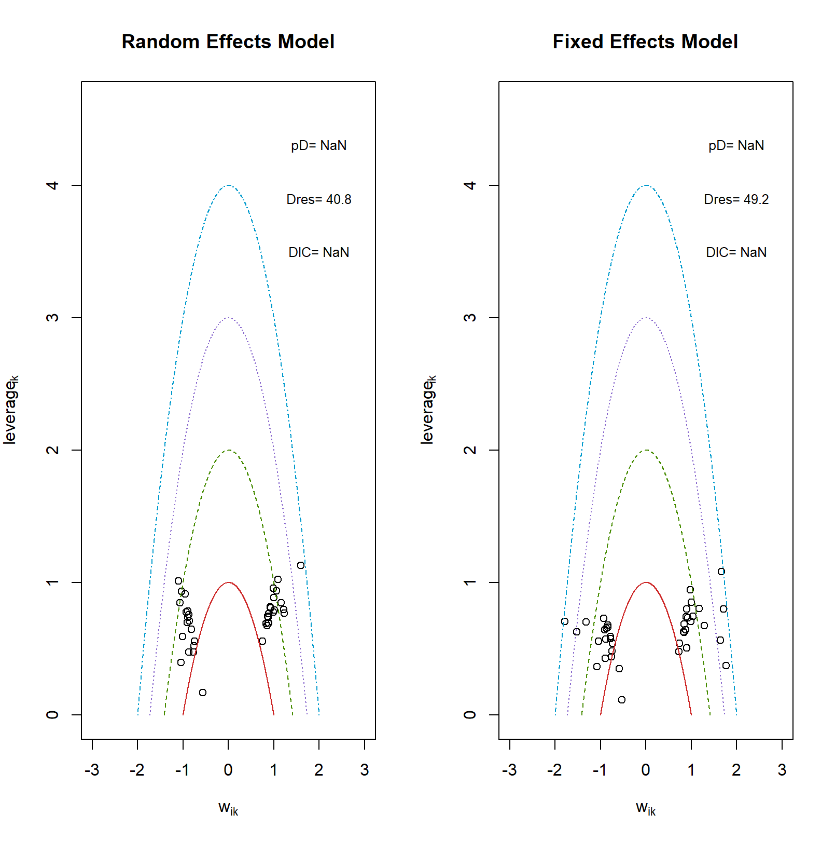
Figure 2. All-cause late mortality, consistency check

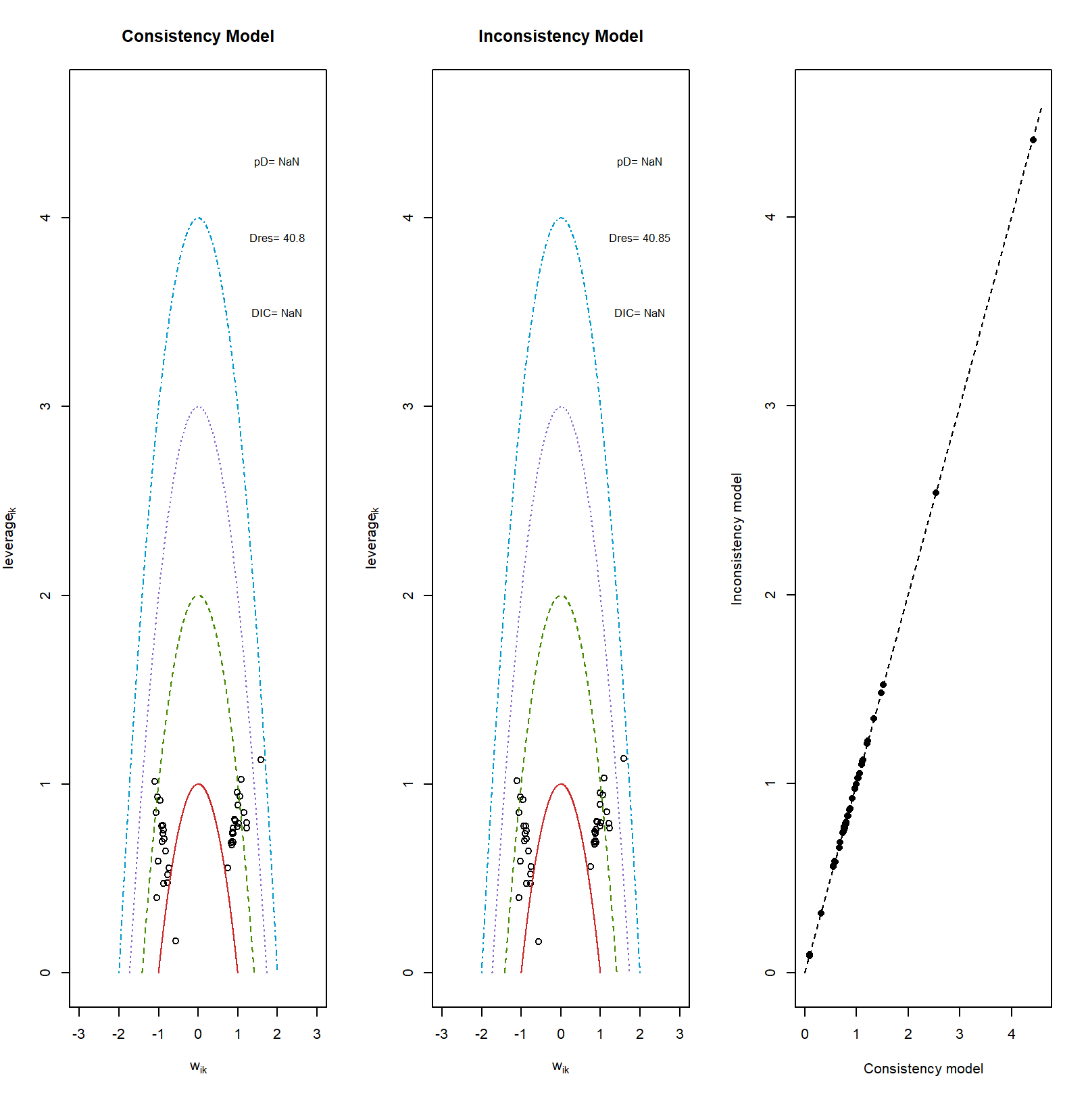

Figure 3. All-cause late mortality, treatment ranking

Table 6. All-cause late mortality, treatment ranking

| rank| CABG| MV-rpl+CABG| RMA| RMA+CABG| RMA+SPM-r+/-CABG|
|----:|-----:|---------: |-----:|--------:| ---------------:|
| 1| 43.65| 1.29 | 14.60| 12.12| 28.34|
| 2| 18.53| 4.81 | 16.77| 34.39| 25.50|
| 3| 18.88| 19.77 | 12.69| 29.52| 19.14|
| 4| 12.20| 27.09 | 16.43| 22.80| 21.48|
| 5| 6.74| 47.03 | 39.51| 1.17| 5.54|

Figure 4. All-cause late mortality, pairwise meta-analysis with direct comparisons

Table 7. All-cause late mortality, SUCRA analysis

|rank |CABG |MV-rpl+CABG |RMA |RMA+CABG |RMA+SPM-r+/-CABG |
|:-----|:-----|:--------- |:-----|:--------| :---------------|
|1 |43.65 |1.29 |14.6 |12.12 | 28.34 |
|2 |62.18 |6.1 |31.37 |46.51 | 53.84 |
|3 |81.06 |25.87 |44.06 |76.03 | 72.98 |
|4 |93.26 |52.96 |60.49 |98.83 | 94.46 |
|5 |100 |99.99 |100 |100 | 100 |
|SUCRA |70.04 |21.56 |37.63 |58.37 | 62.41 |

Figure 5. All-cause late mortality, check convergence
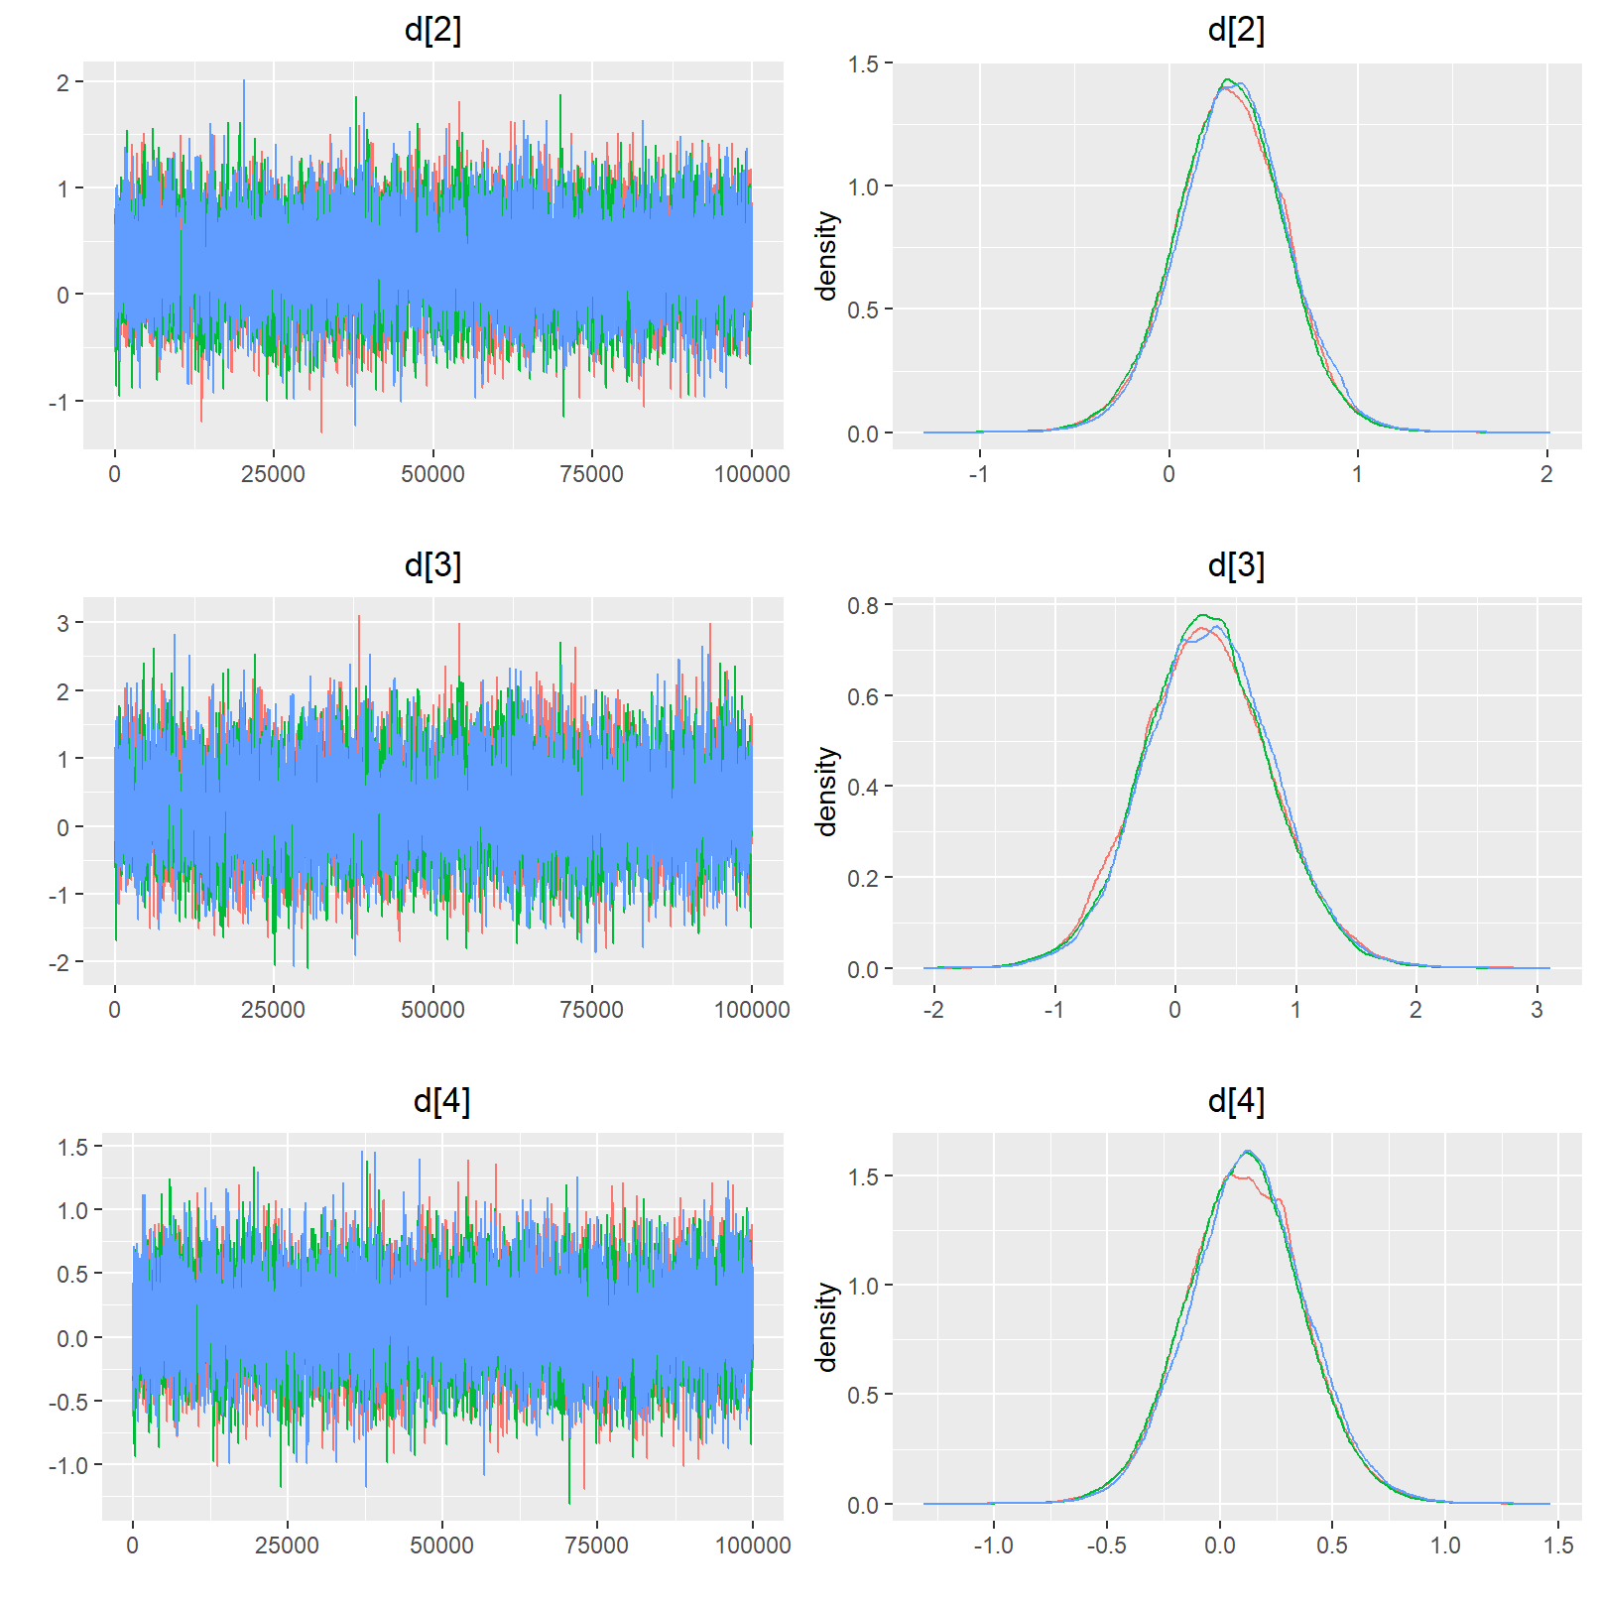
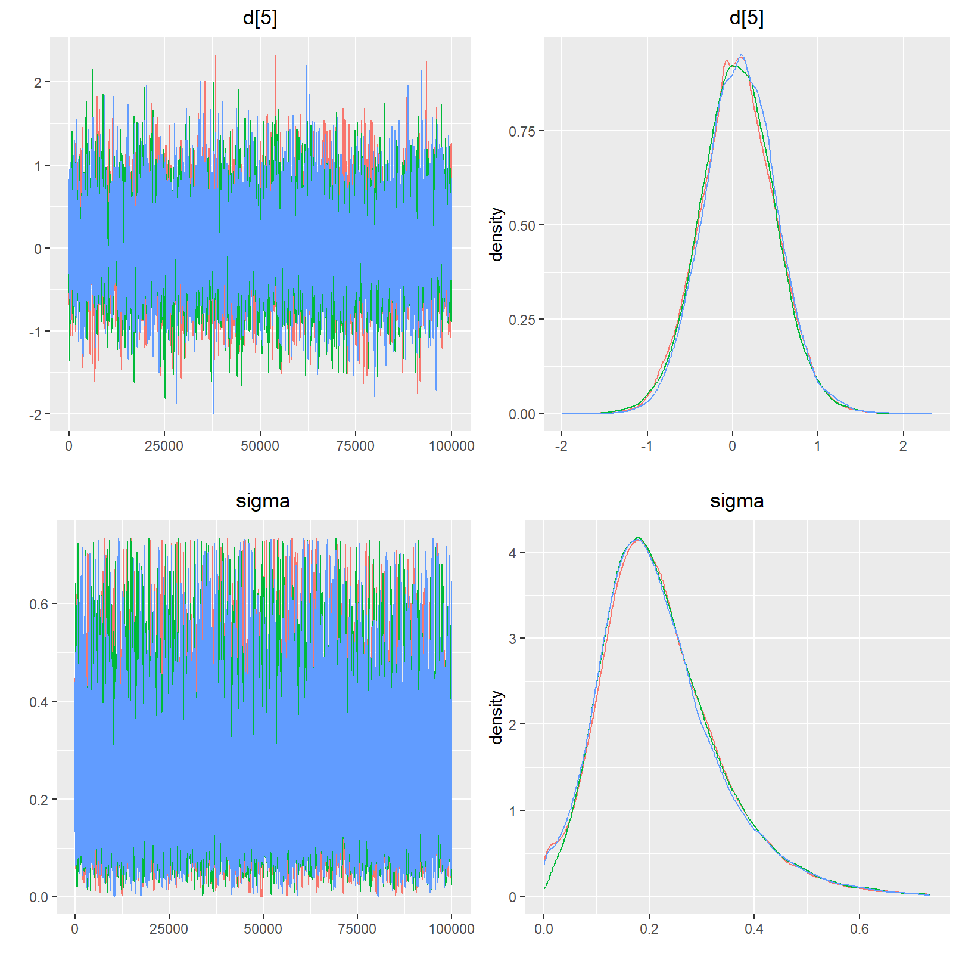

Table 8. Early mortality, network characteristics
|Characteristic |Value |
|:-----------------------------------------------------|:-----|
|Number of Interventions |5 |
|Number of Studies |21 |
|Total Number of Patients in Network |4458 |
|Total Possible Pairwise Comparisons |10 |
|Total Number of Pairwise Comparisons With Direct Data |4 |
|Is the network connected? |TRUE |
|Number of Two-arm Studies |21 |
|Number of Multi-Arms Studies |0 |
|Total Number of Events in Network |301 |
|Number of Studies With No Zero Events |16 |
|Number of Studies With At Least One Zero Event |5 |
|Number of Studies with All Zero Events |1 |

Table 7. Early mortality, intervention characteristics

|Treatment | n.studies| n.events| n.patients| min.outcome| max.outcome| av.outcome|
|:--------------- |---------:|--------:|----------:|-----------:|-----------:|----------:|
|CABG | 6| 4| 322| 0.0000000| 0.0370370| 0.0124224|
|MV-rpl+CABG | 6| 145| 1421| 0.0400000| 0.2169811| 0.1020408|
|RMA | 6| 14| 184| 0.0000000| 0.1333333| 0.0760870|
|RMA+CABG | 15| 121| 2210| 0.0153846| 0.1033654| 0.0547511|
|RMA+SPM-r+/-CABG | 9| 17| 321| 0.0000000| 0.1153846| 0.0529595|

Table 8. Early mortality, comparison characteristics

|comparison | n.studies| n.patients| n.outcomes| proportion|
|:---------------------------- |---------:|----------:|----------:|----------:|
|CABG vs. RMA+CABG | 6| 698| 17| 0.0243553|
|MV-rpl+CABG vs. RMA+CABG | 6| 3083| 244| 0.0791437|
|RMA vs. RMA+SPM-r+/-CABG | 6| 371| 24| 0.0646900|
|RMA+CABG vs. RMA+SPM-r+/-CABG | 3| 306| 16| 0.0522876|

Figure 6. Early mortality, model choice
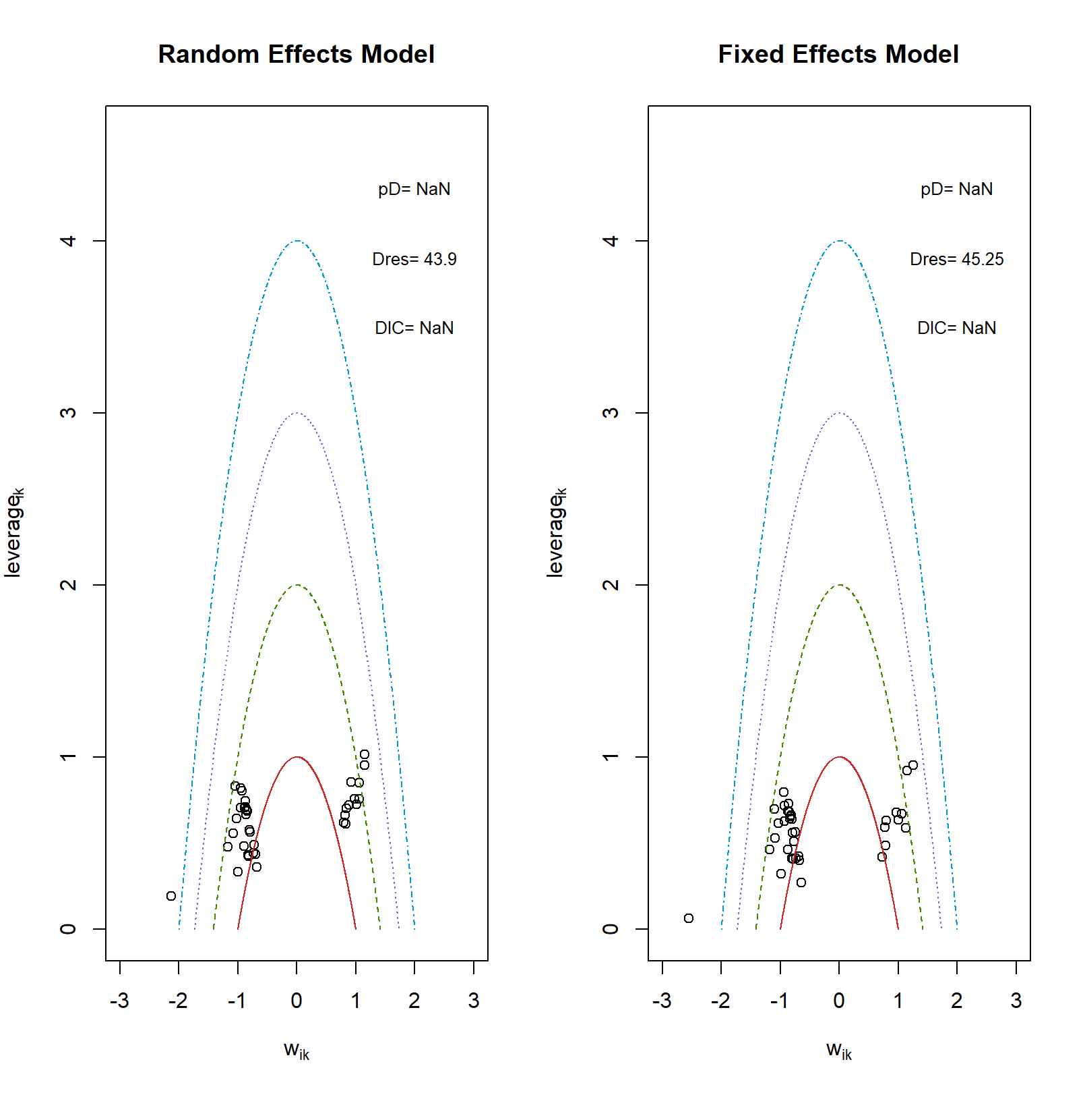

Figure 7. Early mortality, consistency check

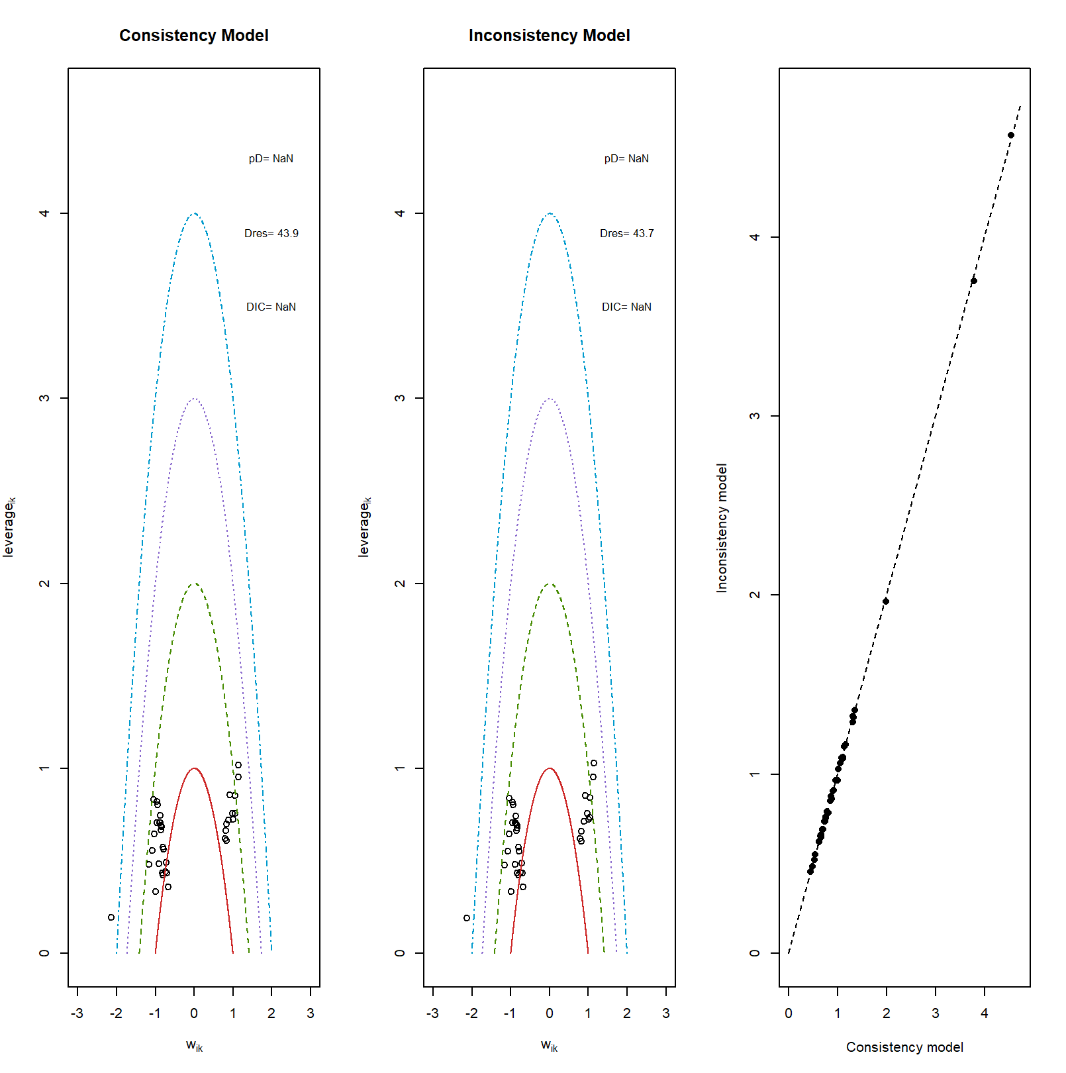
Figure 8. Early mortality, treatment ranking

Table 9. Early mortality, treatment ranking

| rank| CABG| MV-rpl+CABG| RMA| RMA+CABG| RMA+SPM-r+/-CABG|
|----:|-----:| ---------:|-----:|--------:|---------------:|
| 1| 26.32| 0.02| 3.21| 11.46| 59.00|
| 2| 22.29| 0.23| 21.61| 33.21| 22.65|
| 3| 25.39| 3.16| 16.96| 38.42| 16.08|
| 4| 21.92| 25.29| 33.66| 16.91| 2.21|
| 5| 4.08| 71.30| 24.55| 0.01| 0.06|

Table 10. Early mortality, SUCRA table

|rank |CABG |MV-rpl+CABG |RMA |RMA+CABG |RMA+SPM-r+/-CABG |
|:-----|:-----| :---------|:-----|:--------| :---------------|
|1 |26.32 0.02 |3.21 |11.46 | 59 |
|2 |48.61 |0.25 |24.82 |44.67 | 81.65 |
|3 |74 |3.41 |41.78 |83.09 | 97.73 |
|4 |95.92 |28.7 |75.44 |100 | 99.94 |
|5 |100 |100 |99.99 |100.01 | 100 |
|SUCRA |61.21 |8.1 |36.31 |59.8 | 84.58 |

Figure 9. Early mortality, check convergence
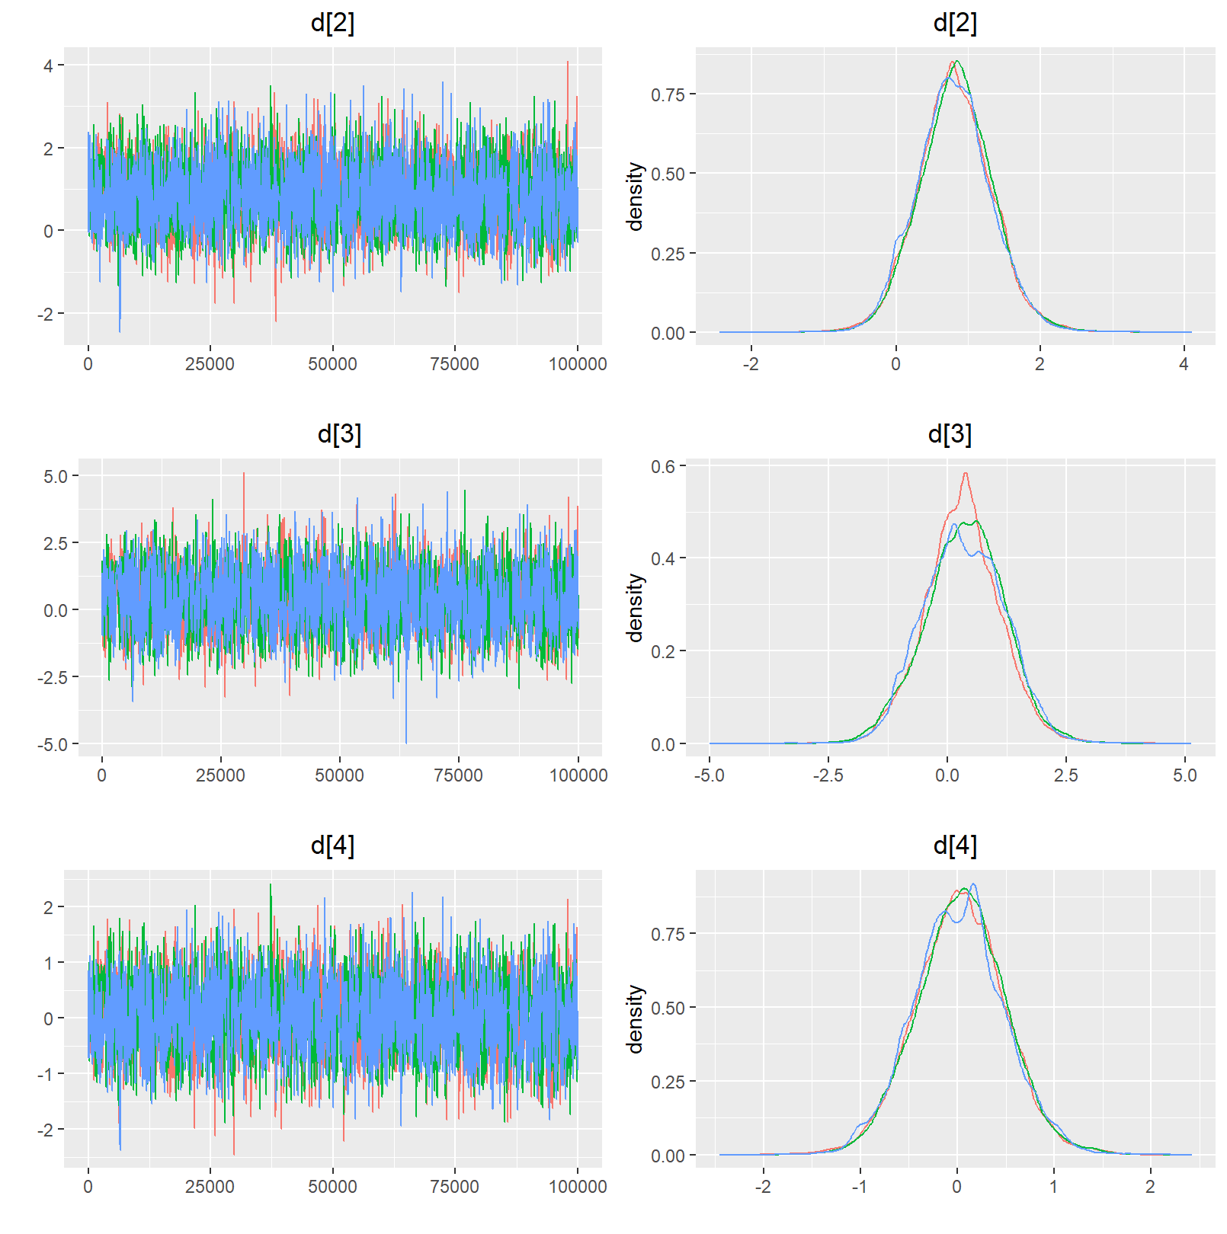
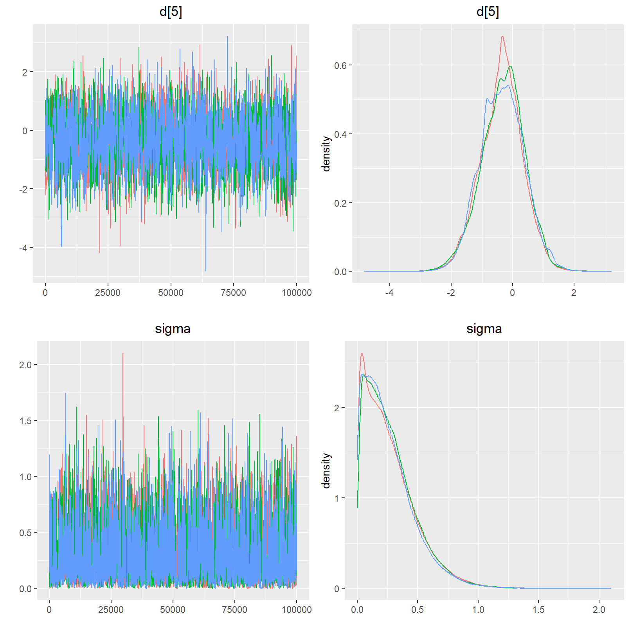

Table 11. Reoperation, network characteristics

|Characteristic |Value |
|:-----------------------------------------------------|:-----|
|Number of Interventions |5 |
|Number of Studies |15 |
|Total Number of Patients in Network |3433 |
|Total Possible Pairwise Comparisons |10 |
|Total Number of Pairwise Comparisons With Direct Data |4 |
|Is the network connected? |TRUE |
|Number of Two-arm Studies |15 |
|Number of Multi-Arms Studies |0 |
|Total Number of Events in Network |250 |
|Number of Studies With No Zero Events |11 |
|Number of Studies With At Least One Zero Event |4 |
|Number of Studies with All Zero Events |0 |
|Mean person follow up time |4.59 |

Table 12. Reoperation, intervention characteristics

|Treatment | n.studies| n.events| n.patients| person.time.fup| min.event.rate| max.event.rate| events.per.person| overall.event.rate|
|:--------------- |---------:|--------:|----------:|---------------:|--------------:|--------------:|-----------------:|------------------:|
|CABG | 4| 4| 117| 497| 0.0000000| 0.0625000| 0.0341880| 0.0080483|
|MV-rpl+CABG | 5| 84| 1237| 10780| 0.0032441| 0.0255630| 0.0679062| 0.0077922|
|RMA | 5| 11| 170| 410| 0.0054054| 0.0779221| 0.0647059| 0.0268293|
|RMA+CABG | 10| 143| 1696| 14104| 0.0000000| 0.0364583| 0.0843160| 0.0101390|
|RMA+SPM-r+/-CABG | 6| 8| 213| 571| 0.0000000| 0.0392157| 0.0375587| 0.0140105|

Table 13. Reoperation, comparison characteristics

|comparison | n.studies| n.patients| n.outcomes| patient_time| proportion| event.rate|
|:---------------------------- |---------:|----------:|----------:|------------:|----------:|----------:|
|CABG vs. RMA+CABG | 4| 289| 10| 7514| 0.0346021| 0.0013308|
|MV-rpl+CABG vs. RMA+CABG | 5| 2713| 214| 211614| 0.0788795| 0.0010113|
|RMA vs. RMA+SPM-r+/-CABG | 5| 335| 16| 8375| 0.0477612| 0.0019104|
|RMA+CABG vs. RMA+SPM-r+/-CABG | 1| 96| 10| 768| 0.1041667| 0.0130208|

Figure 9. Reoperation, model choice
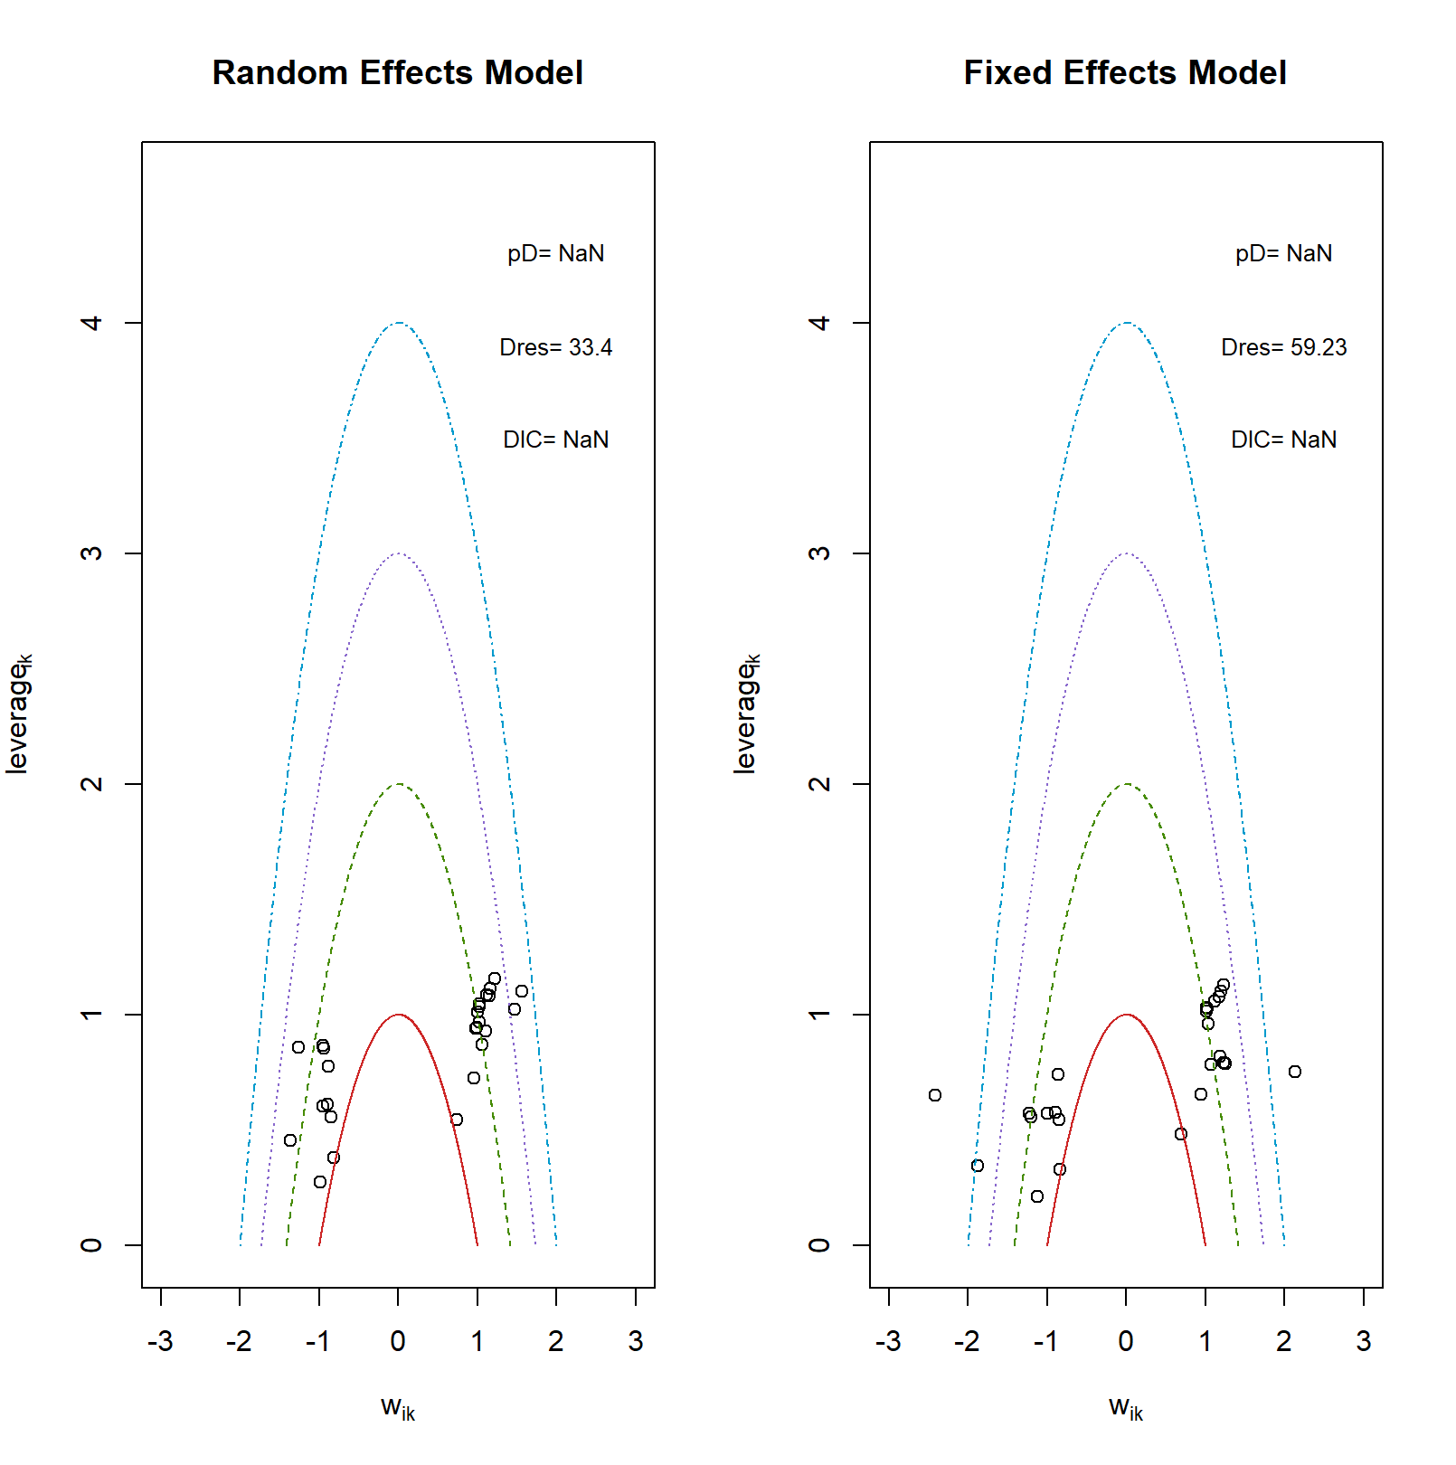

Figure 10. Reoperation, consistency check
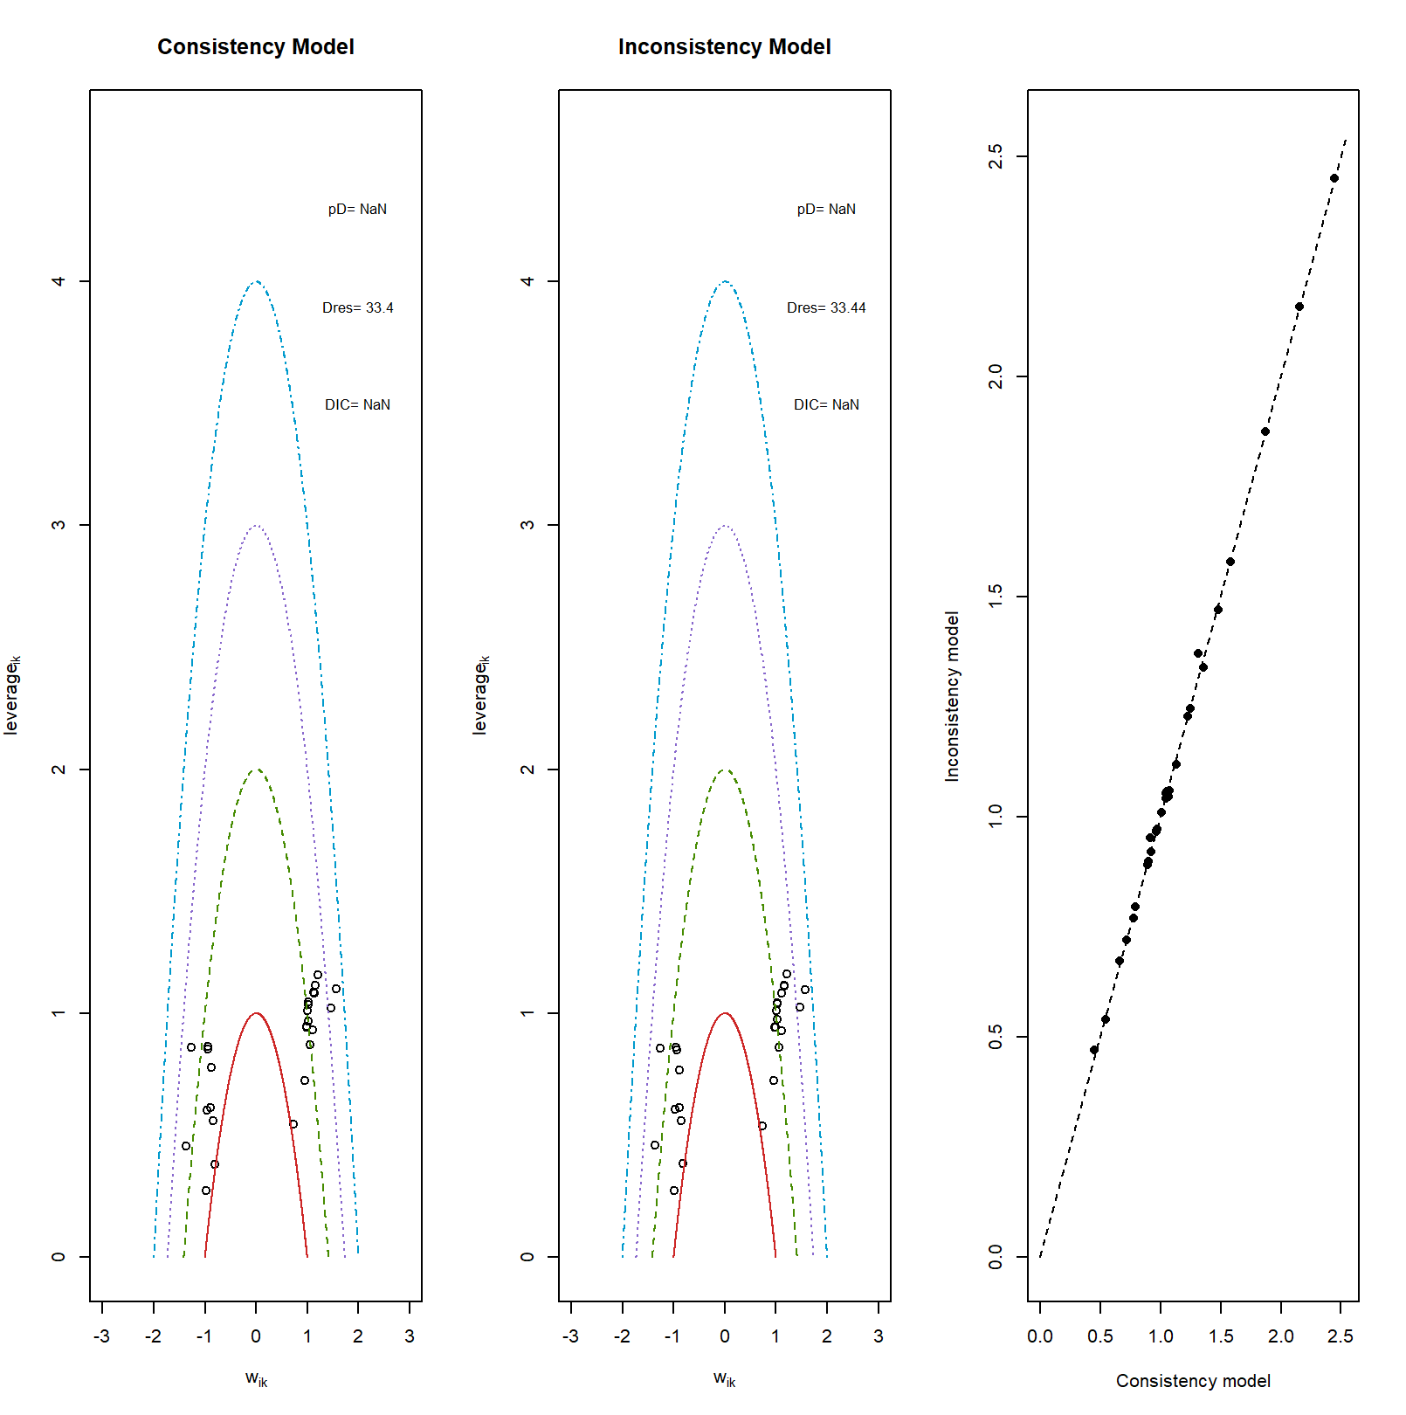
Figure 11. Reoperation, treatment ranking
Table 14. Reoperation, treatment ranking

| rank| CABG| MV-rpl+CABG| RMA| RMA+CABG| RMA+SPM-r+/-CABG|
|----:|-----:| ---------:|-----:|--------:| ---------------:|
| 1| 16.15| 11.18| 5.16| 1.05| 66.47|
| 2| 16.58| 24.37| 32.54| 8.50| 18.00|
| 3| 19.24| 34.49| 12.93| 26.04| 7.30|
| 4| 17.16| 22.47| 12.50| 40.18| 7.69|
| 5| 30.87| 7.49| 36.88| 24.23| 0.54|

Table 15. Reoperation, SUCRA table

|rank |CABG |MV-rpl+CABG |RMA |RMA+CABG |RMA+SPM-r+/-CABG |
|:-----|:-----| :---------|:------|:--------| :---------------|
|1 |16.15 |11.18 |5.16 |1.05 |66.47 |
|2 |32.73 |35.55 |37.7 |9.55 |84.47 |
|3 |51.97 |70.04 |50.63 |35.59 |91.77 |
|4 |69.13 |92.51 |63.13 |75.77 |99.46 |
|5 |100 |100 |100.01 |100 |100 |
|SUCRA |42.49 |52.32 |39.16 |30.49 |85.54 |

Figure 16. Reoperation, check convergence
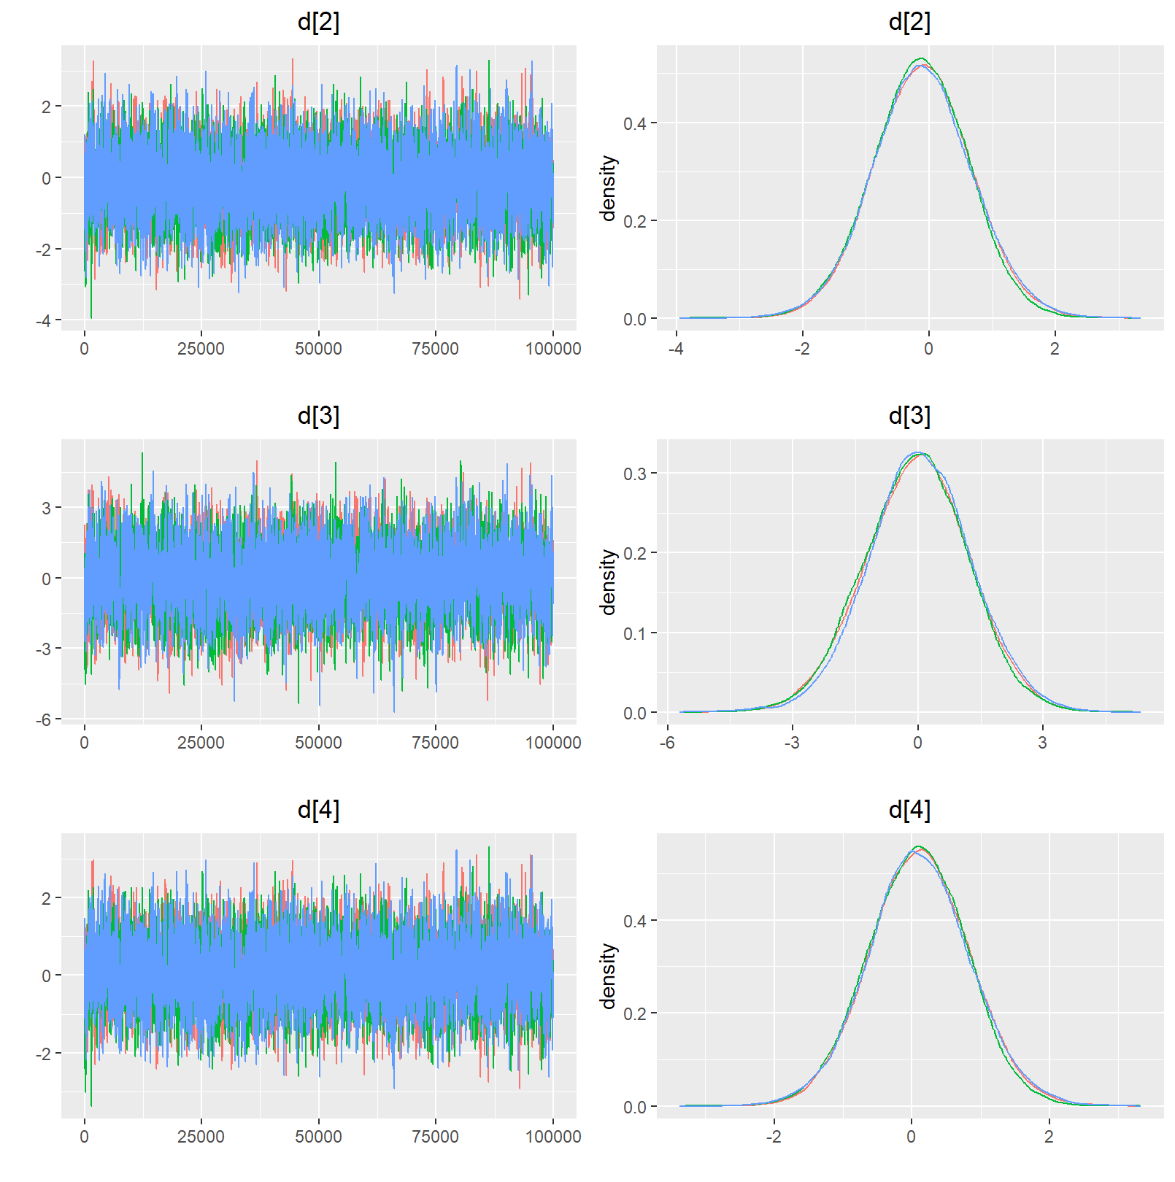
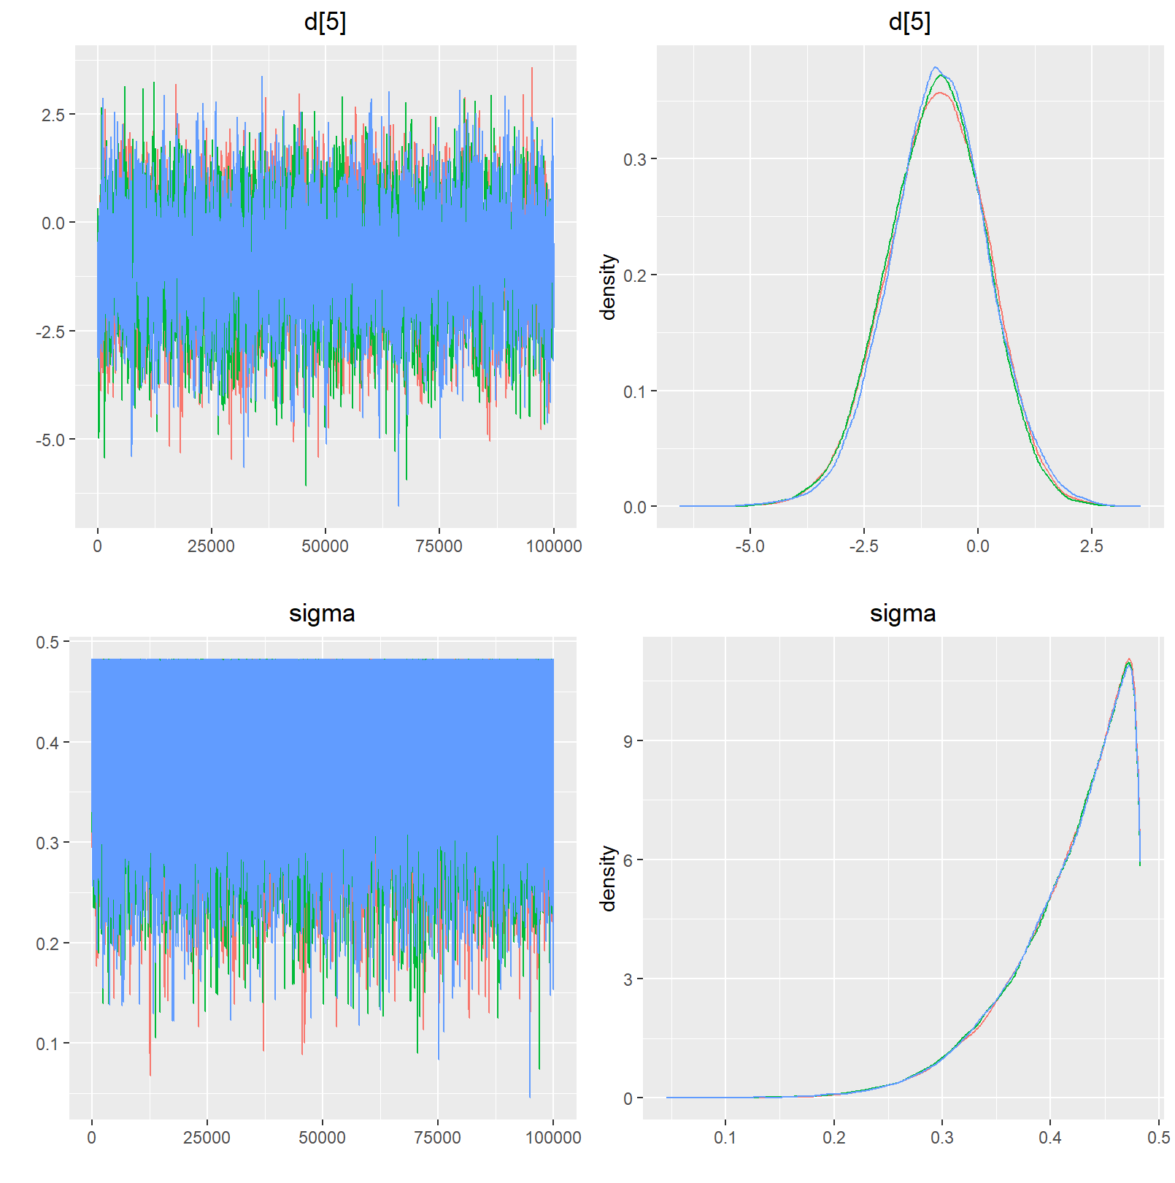

Table 16. Re-hospitalization for heart failure, network characteristics

|Characteristic |Value |
|:-----------------------------------------------------|:-----|
|Number of Interventions |5 |
|Number of Studies |13 |
|Total Number of Patients in Network |3511 |
|Total Possible Pairwise Comparisons |10 |
|Total Number of Pairwise Comparisons With Direct Data |4 |
|Is the network connected? |TRUE |
|Number of Two-arm Studies |13 |
|Number of Multi-Arms Studies |0 |
|Total Number of Events in Network |808 |
|Number of Studies With No Zero Events |13 |
|Number of Studies With At Least One Zero Event |0 |
|Number of Studies with All Zero Events |0 |
|Mean person follow up time |4.67 |

Table 17. Re-hospitalization for heart failure, intervention characteristics

|Treatment | n.studies| n.events| n.patients| person.time.fup| min.event.rate| max.event.rate| events.per.person| overall.event.rate|
|:--------------- |---------:|--------:|----------:|---------------:|--------------:|--------------:|-----------------:|------------------:|
|CABG | 3| 73| 206| 513| 0.0051282| 0.2350993| 0.3543689| 0.1423002|
|MV-rpl+CABG | 5| 304| 1237| 10780| 0.0121655| 0.0880000| 0.2457559| 0.0282004|
|RMA | 3| 7| 91| 127| 0.0200000| 0.0779221| 0.0769231| 0.0551181|
|RMA+CABG | 10| 401| 1778| 14289| 0.0176471| 0.2133333| 0.2255343| 0.0280635|
|RMA+SPM-r+/-CABG | 5| 23| 199| 600| 0.0072727| 0.1142857| 0.1155779| 0.0383333|
Table 18. Re-hospitalization for heart failure, comparison characteristics
|comparison | n.studies| n.patients| n.outcomes| patient_time| proportion| event.rate|
|:---------------------------- |---------:|----------:|----------:|------------:|----------:|----------:|
|CABG vs. RMA+CABG | 3| 405| 141| 6480| 0.3481481| 0.0217593|
|MV-rpl+CABG vs. RMA+CABG | 5| 2713| 608| 211614| 0.2241062| 0.0028732|
|RMA vs. RMA+SPM-r+/-CABG | 3| 187| 13| 1496| 0.0695187| 0.0086898|
|RMA+CABG vs. RMA+SPM-r+/-CABG | 2| 206| 46| 3708| 0.2233010| 0.0124056|

Figure 17. Re-hospitalization for heart failure, model choice
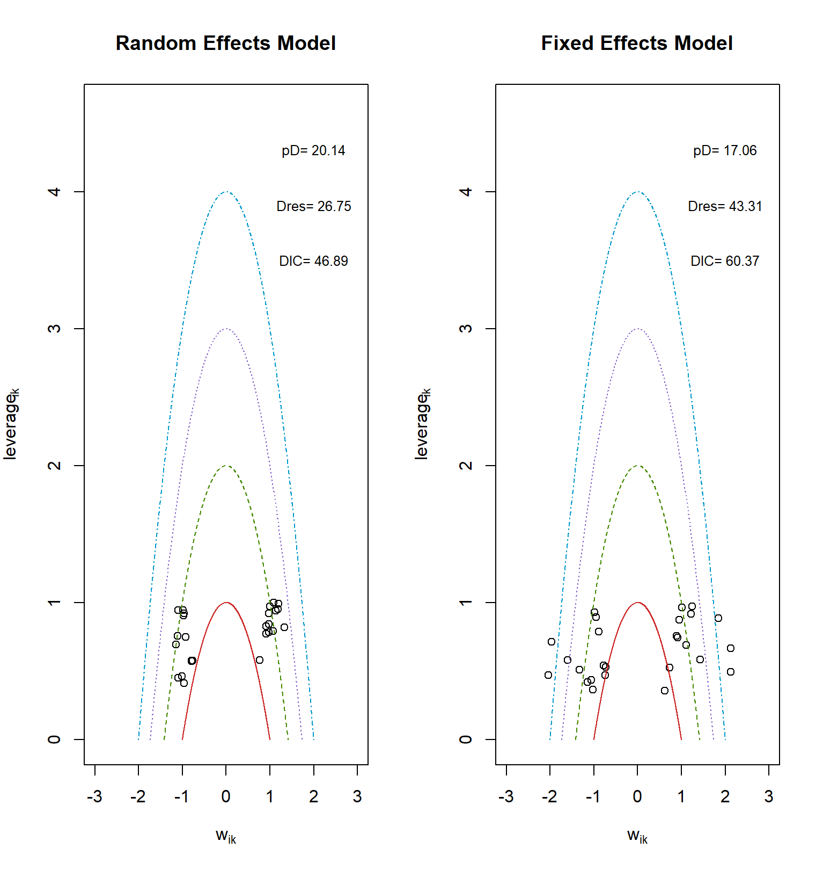

Figure 18. Re-hospitalization for heart failure, consistency check
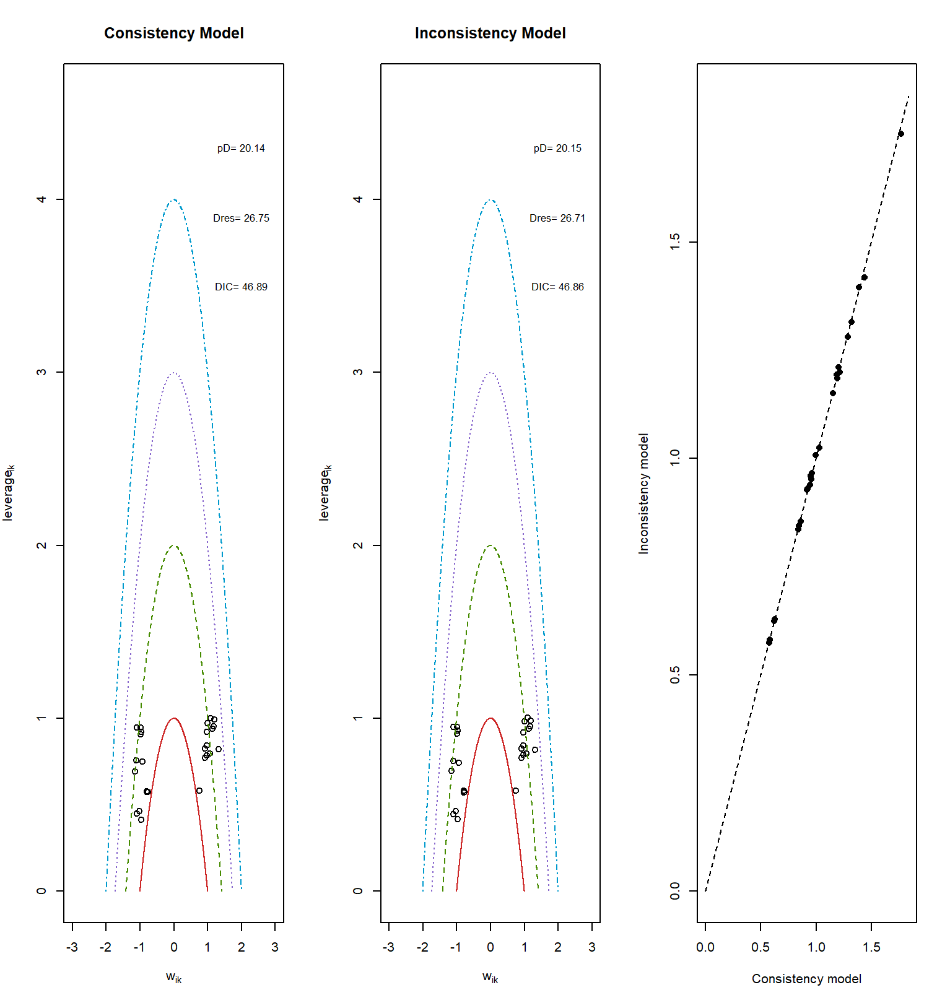
Figure 19. Re-hospitalization for heart failure, treatment ranking
Table 19. Re-hospitalization for heart failure, treatment ranking

| rank| CABG| MV-rpl+CABG| RMA| RMA+CABG| RMA+SPM-r+/-CABG|
|--------- ---------------------- ---------------
| 1| 8.03| 2.76| 29.38| 1.25| 58.58|
| 2| 14.64| 9.82| 32.84| 10.00| 32.70|
| 3| 26.68| 25.40| 8.77| 34.23| 4.92|
| 4| 18.22| 31.56| 7.58| 39.70| 2.94|
| 5| 32.43| 30.46| 21.43| 14.82| 0.86|

Table 20. Re-hospitalization for heart failure, SUCRA table

|rank |CABG |MV-rpl+CABG |RMA |RMA+CABG |RMA+SPM-r+/-CABG |
|:-----|:-----| :---------|:-----|:--------|:--------------- |
|1 |8.03 | 2.76 |29.38 |1.25 |58.58 |
|2 |22.67 | 12.58 |62.22 |11.25 |91.28 |
|3 |49.35 | 37.98 |70.99 |45.48 |96.2 |
|4 |67.57 | 69.54 |78.57 |85.18 |99.14 |
|5 |100 | 100 |100 |100 |100 |
|SUCRA |36.91 | 30.71 |60.29 |35.79 |86.3 |

Figure 20. Re-hospitalization for heart failure, check convergence
