Fig. S1: The expression difference of O-glycosylation genes between HCC tissues and adjacent normal tissues.

Fig. S2: O-glycosylation genes predict prognosis of HCC patients.

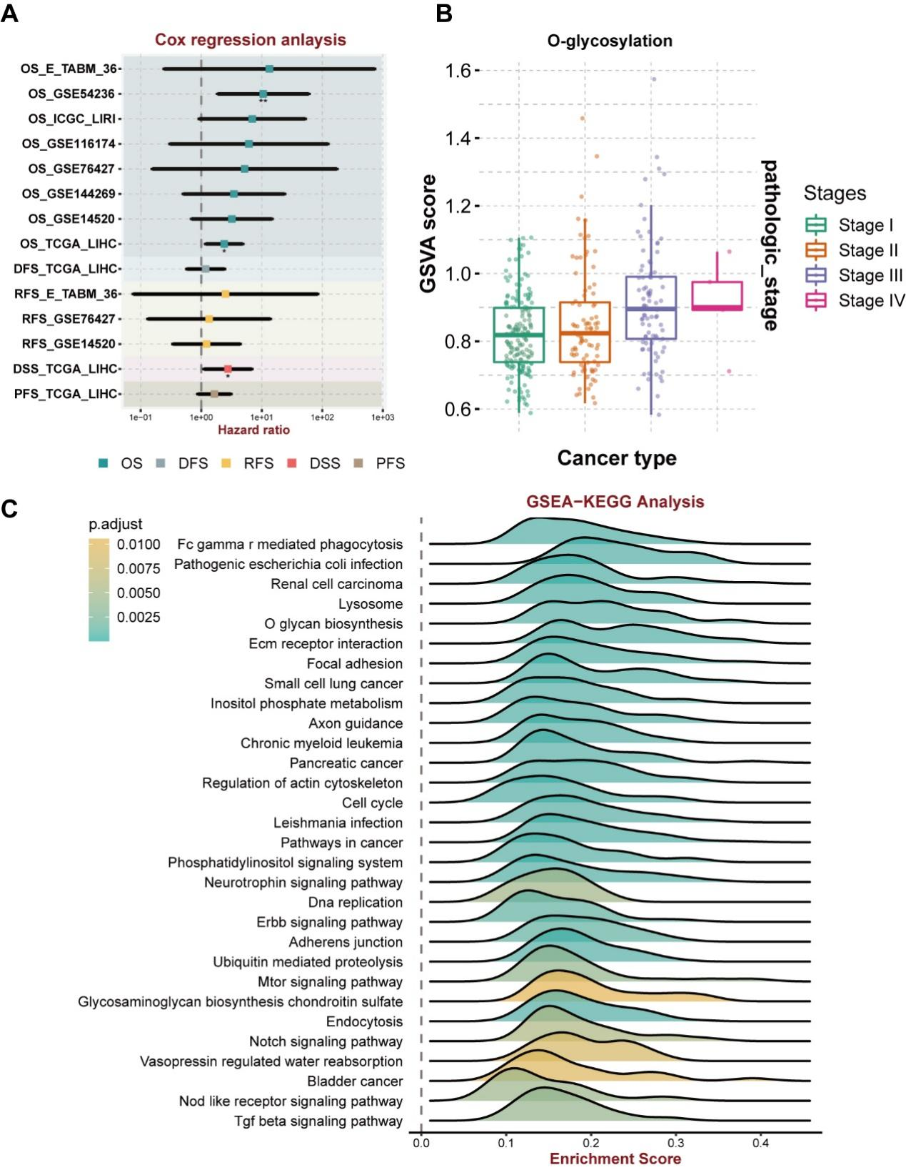Fig. S3: Bulk-seq landscape of O-glycosylation genes in expression and functional. (A) Univariate COX regression analysis was performed in multiple cohorts based on GSVA scores of O-glycosylation genes. (B) The correlation between O-glycosylation GSVA scores and clinical staging of HCC patients in the TCGA-LIHC cohort. (C) KEGG enrichment analysis of O-glycosylation gene set.

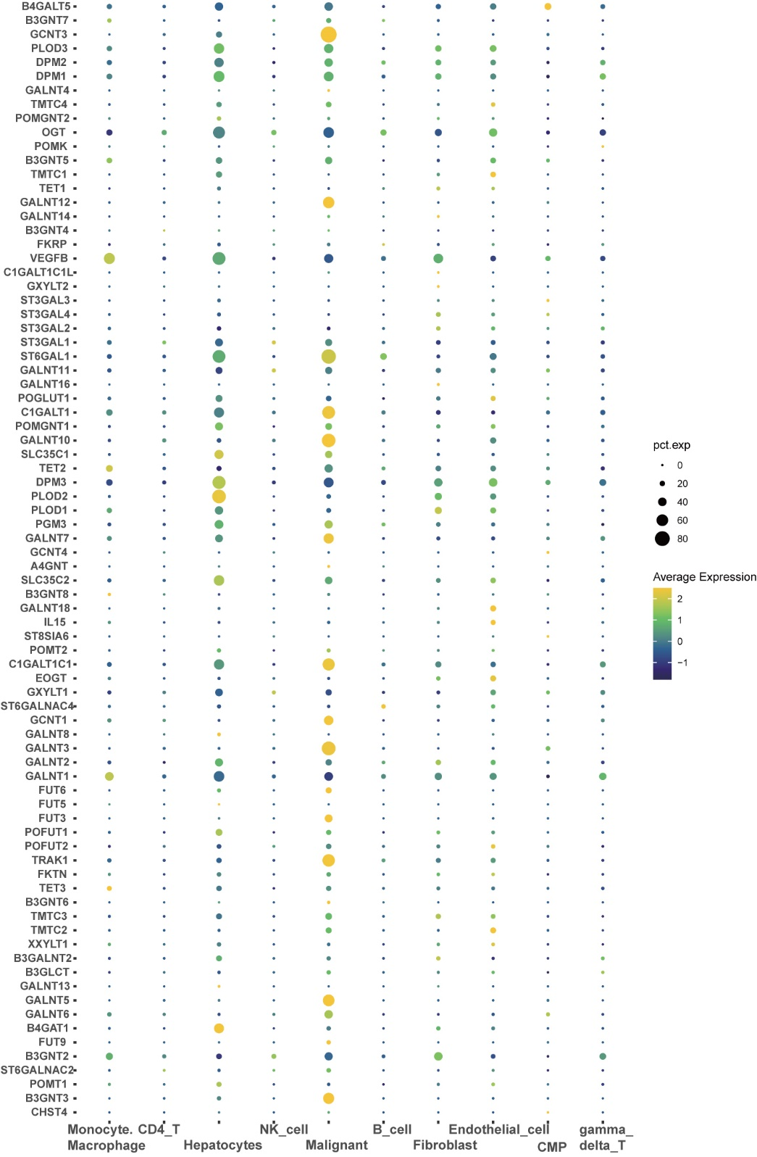
Fig. S4: The expression of the O-glycosylation genes in distinct cellular subpopulations.

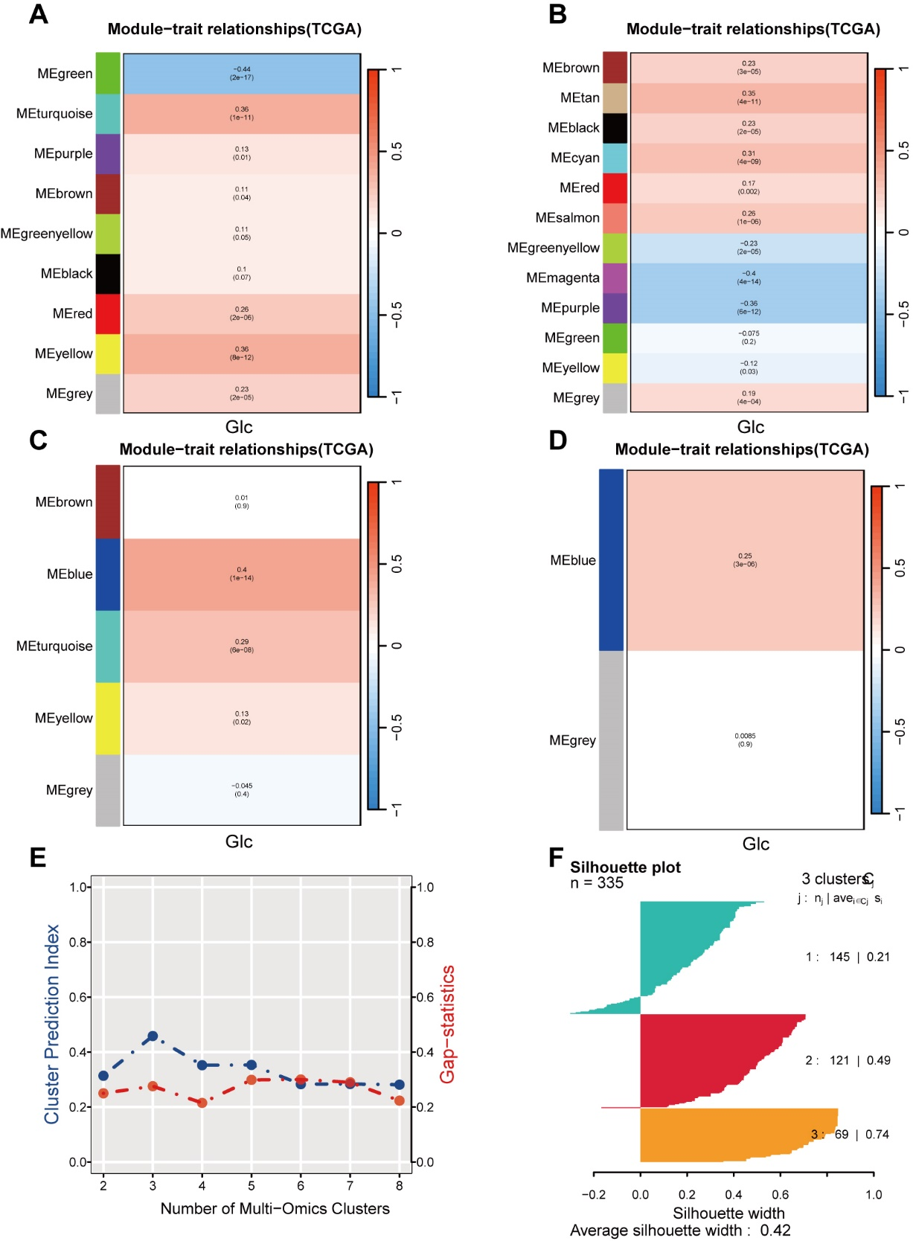 Fig. S5: Identification the optimal number K for multiomics consensus ensemble clustering. (A-D) Correlation analysis between gene modules (mRNA, lncRNA, miRNA, methylation) and O-glycosylation score. (E) The Cluster Prediction Index and Gap Statistical Analysis of the integrative consensus clustering. (F) The silhouette statistic of consensus clustering for CS1、CS2 and CS3.
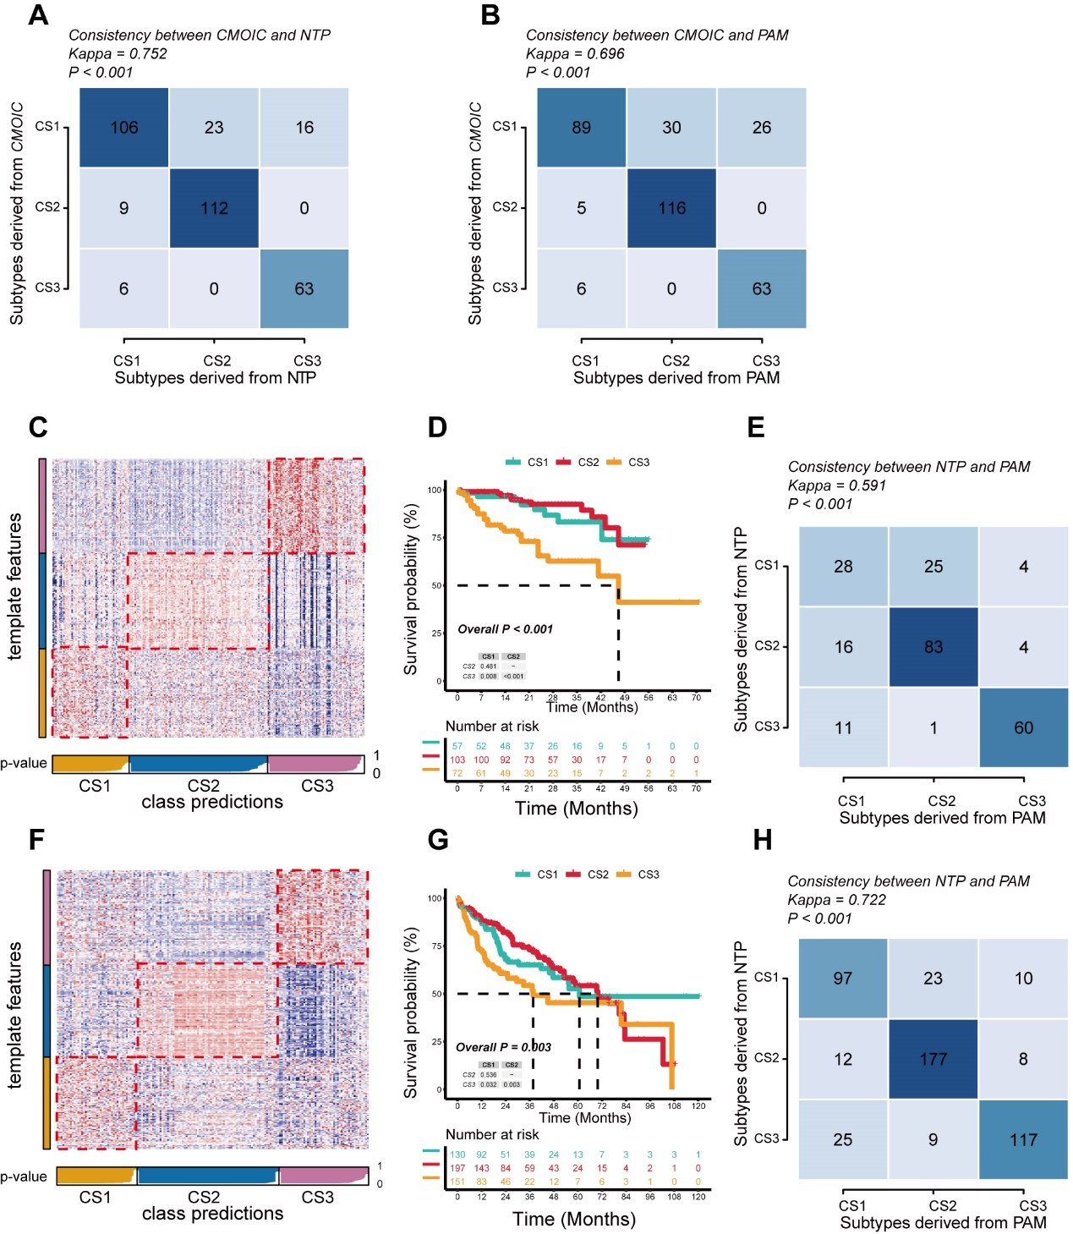Fig. S6: Validation of HCC CSs subtypes by NTP and PAM approach in external cohort. (A) The consistency of CSs with NTP in the TCGA-LIHC cohort. (B) The consistency of CSs with PAM in the TCGA-LIHC cohort. (C) Validation of HCC CSs in the nearest template of the ICGC_LIRI cohort. (D) Survival analysis of HCC CSs in the ICGC_LIRI cohort. (E) The consistency of NTP with PAM in the ICGC_LIRI cohort. (F) Validation of HCC CSs in the nearest template of the Meta cohort. (G) Survival analysis of HCC CSs in the Meta cohort. (H) The consistency of NTP with PAM in the Meta cohort
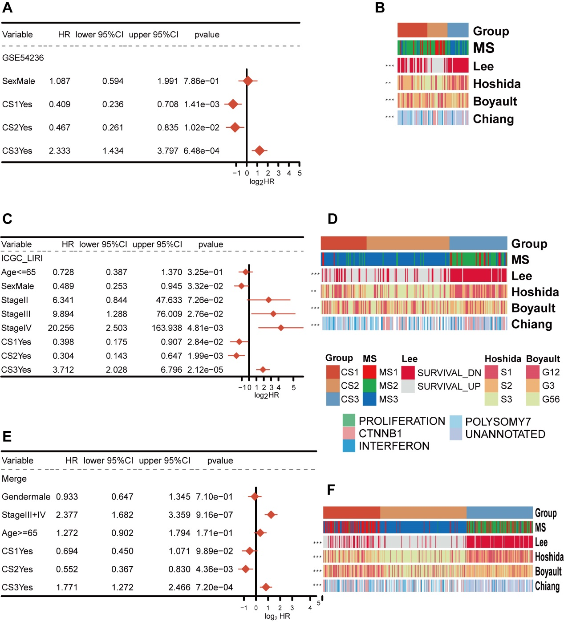Fig. S7: The clinical characterization of our CSs subtypes in multiple cohort. (A) Multivariate Cox regression analysis of overall survival (OS) in GSE54236 dataset. (B) Correlations of HCC subtypes of GSE54236 with clinical features and previous HCC classifcations. (C) Multivariate Cox regression analysis of overall survival (OS) in ICGC_LIRI dataset. (D) Correlations of HCC subtypes of ICGC_LIRI with clinical features and previous HCC classifcations. (E) Multivariate Cox regression analysis of overall survival (OS) in Meta dataset. (F) Correlations of HCC subtypes of Meta with clinical features and previous HCC classifcations.
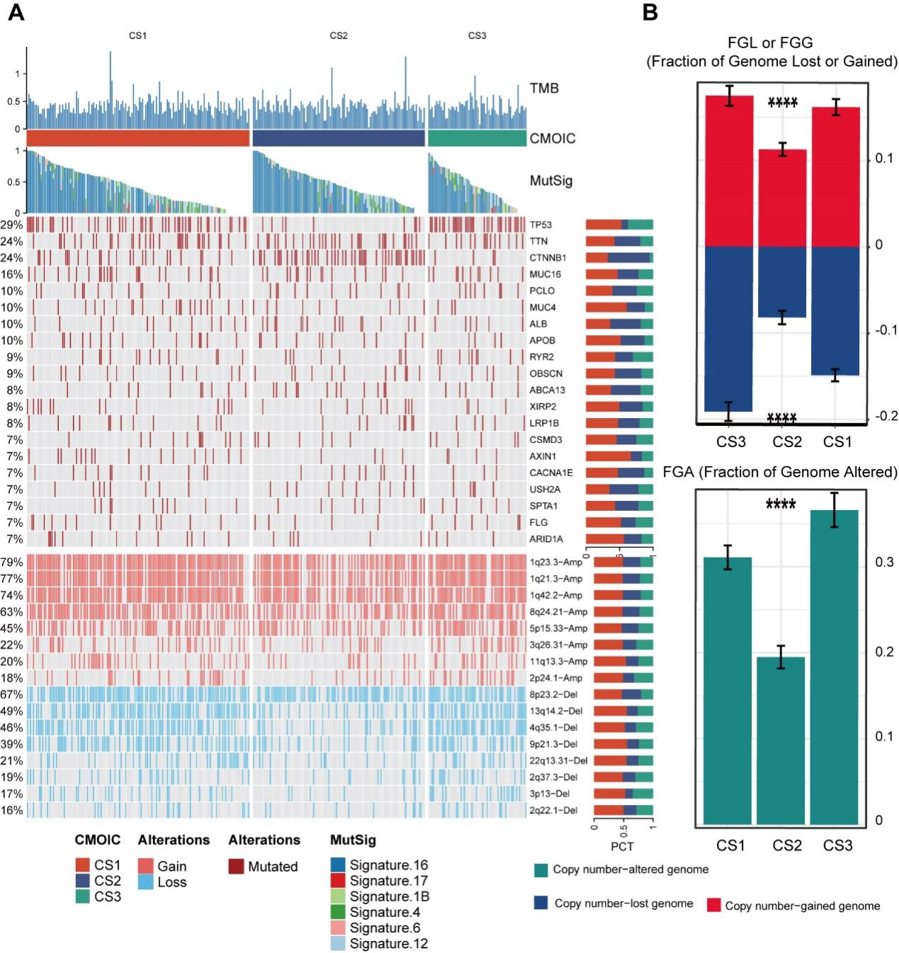Fig. S8: The landscape of genomic alternations of HCC subtypes. (A) The somatic mutational landscape of the top 20 frequently mutated genes and the CNVs landscape of the top 20 AMP and Homdel chromosome fragments for HCC subtypes. The proportion of these variants in the HCC subtypes was denoted on the right. (B) Distributions of fraction of genome alteration (FGA), fraction of genomic gained (FGG), and fraction of genome lost (FGL) among HCC subtypes.
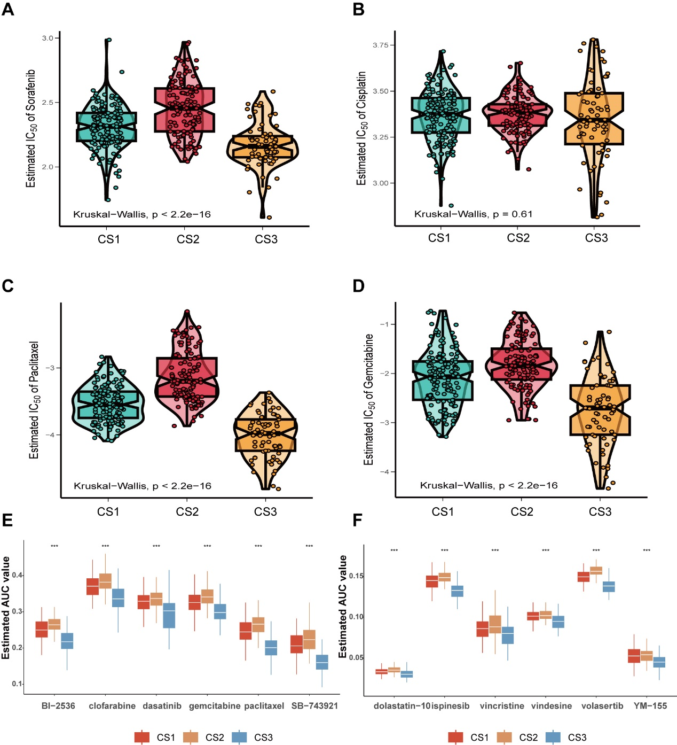Fig. S9: The half maximal inhibitory concentration(IC50) of clinical first and second-line drugs for HCC subtypes. (A-D) Differences in sensitivity of HCC subtypes to sorafenib, cisplatin, paclitaxel, and gemcitabine. (E-F) Drug sensitivity to chemotherapy in patients from the TCGA dataset based on the CTRP2.0 and PRISM database.
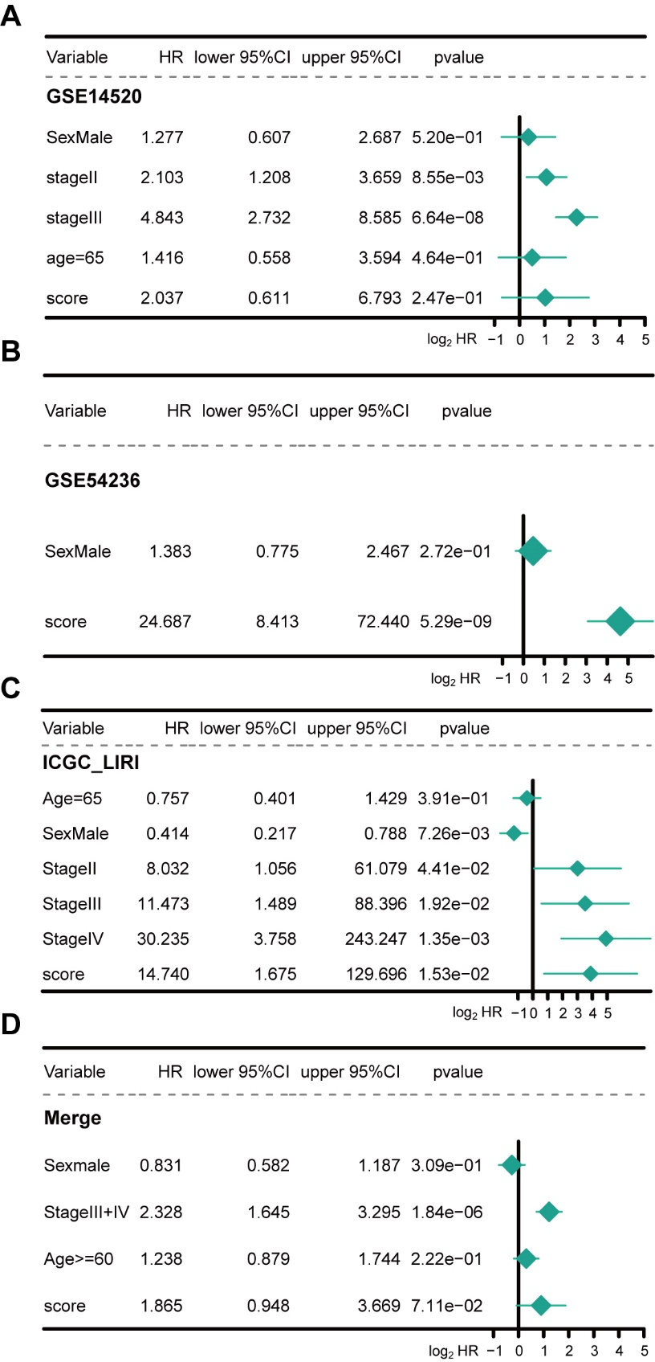
Fig. S10: The survival curves of high and low score group patients and the correlation between CMLS and CMOIC subtypes in the external validation cohorts (GSE14520, GSE54236, ICGC_LIRI, Merge).
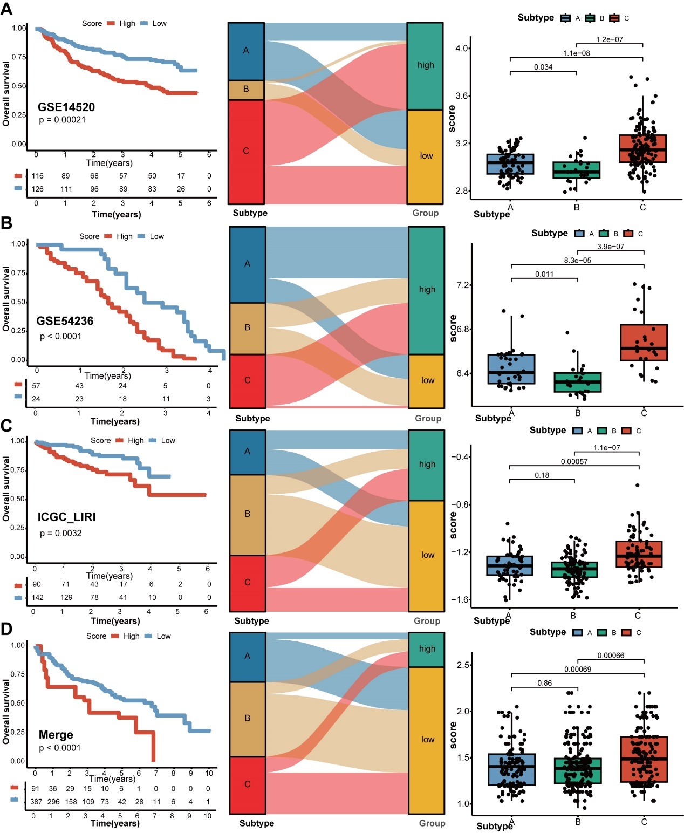Fig. S11: Multivariate cox regression analysis of CMLS scores in external validation cohorts (GSE14520, GSE54236, ICGC_LIRI, Merge)
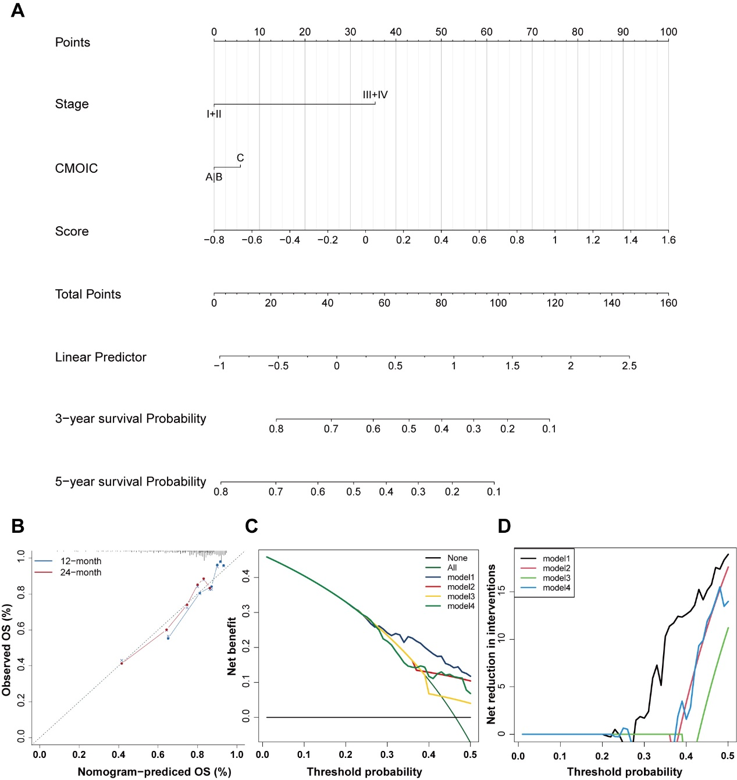
Fig. S12: Clinical practice value of CMLS. (A) A comprehensive nomogram constructed based on CMLS, stage and CMOIC subtype. (B) Calibration curve for the comprehensive nomogram. (C-D) Net decision curve analyses demonstrating the benefit for the comprehensive nomogram in clinical practice for HCC patients.
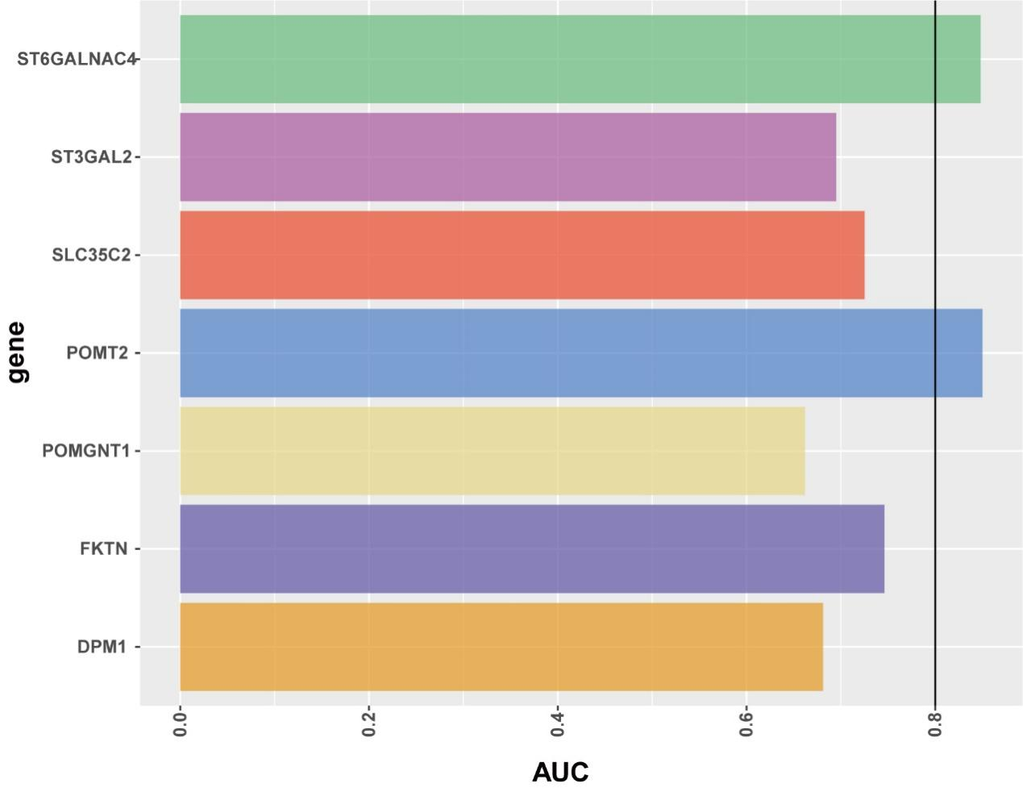
Fig. S13: We selected SuperPC model characteristic genes with HR>1.5, and displayed its C-index for identifying the CMOIC C subtype.
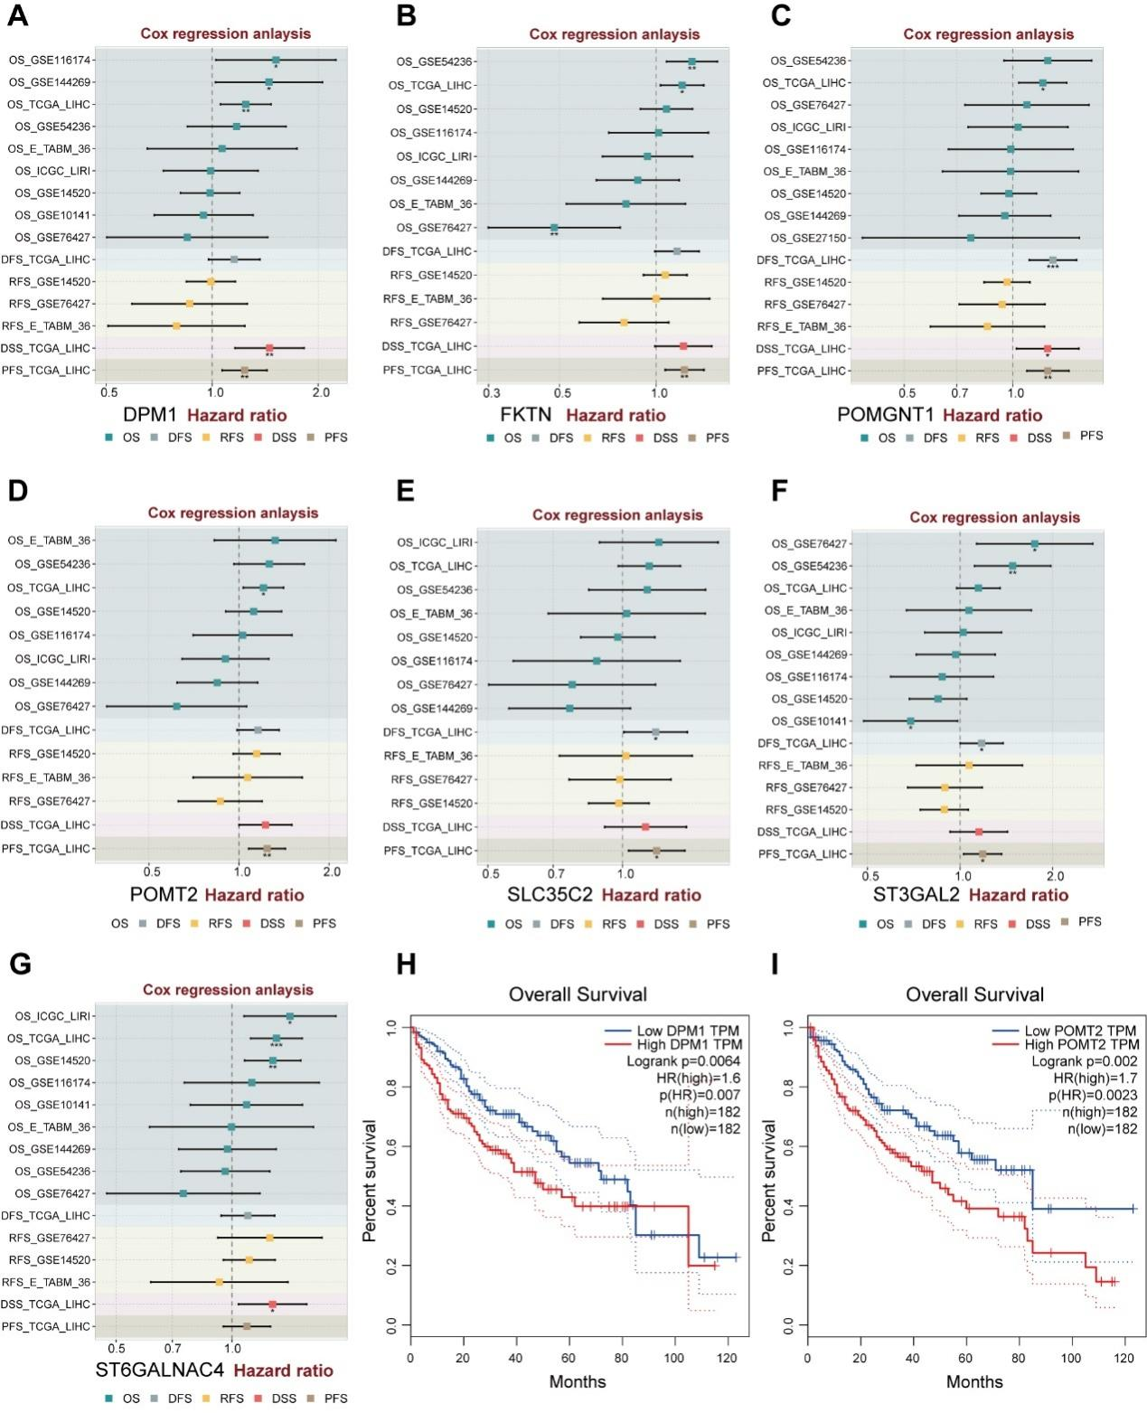Fig. S14: The public databases, BEST (https://rookieutopia.com/app_direct/BEST/) and GEPIA (http://gepia.cancer-pku.cn/), were used to analyze the prognostic hazard ratio (HR) and survival curve of O-glycosylated genes.

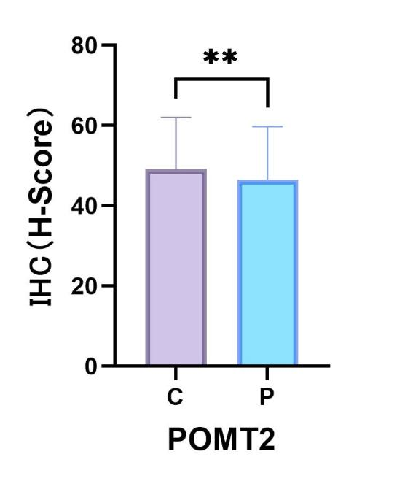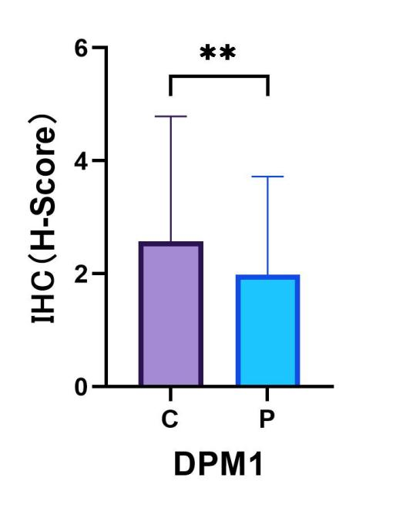 Fig. S15-16: Immunohistochemistry statistical analysis of HUB genes DPM1 and POMT2 were conducted on 134 cases of HCC patients in our center, including tumor and normal tissues.

