Supplementary Information

Title: Agile robotic fish based on direct drive of continuum body

Authors:
Keisuke Iguchi¹, Daiki Shimooka², Hiroto Tanaka², Yusuke Ikemoto³, Jun Shintake¹*

Affiliations:
¹Department of Mechanical and Intelligent Systems Engineering, The University of Electro-communications, 182-8585 Tokyo, Japan.
Email: shintake@uec.ac.jp
²Department of Mechanical Engineering, Tokyo Institute of Technology, 152-8550 Tokyo, Japan.
³Department of Mechanical Engineering, Meijo University, 468-8502 Nagoya, Japan.

This PDF file includes:
Supplementary Note 1. Driving signals of the robot
Supplementary Note 2. Control gain of the motor drive
Supplementary Note 3. Geometry selection for the tail fin
Supplementary Note 4. Thrust force measurement for different values of motor angle command
Supplementary Note 5. Calculation of resonance frequency of the robot

Supplementary Fig. 1. Dimensions of the robot.
Supplementary Fig. 2. Fabrication process of the flexible body.
Supplementary Fig. 3. Gasket for waterproofing in the head.
Supplementary Fig. 4. Diagram of the control system of the robot.
Supplementary Fig. 5. Driving signals and resulting performance of the robot.
Supplementary Fig. 6. Dimensions of tested tail fins and result of thrust force measurement.
Supplementary Fig. 7. Measured thrust force as a function of tail beat frequency for different values of motor angle command (i.e., swing angle of the body).
Supplementary Fig. 8. Schematics of the model approximating the robot body and tail as a cantilever composite beam in the fixed-free boundary condition.

Supplementary Table 1. Parameter values used for the calculation of resonance frequency of the robot.
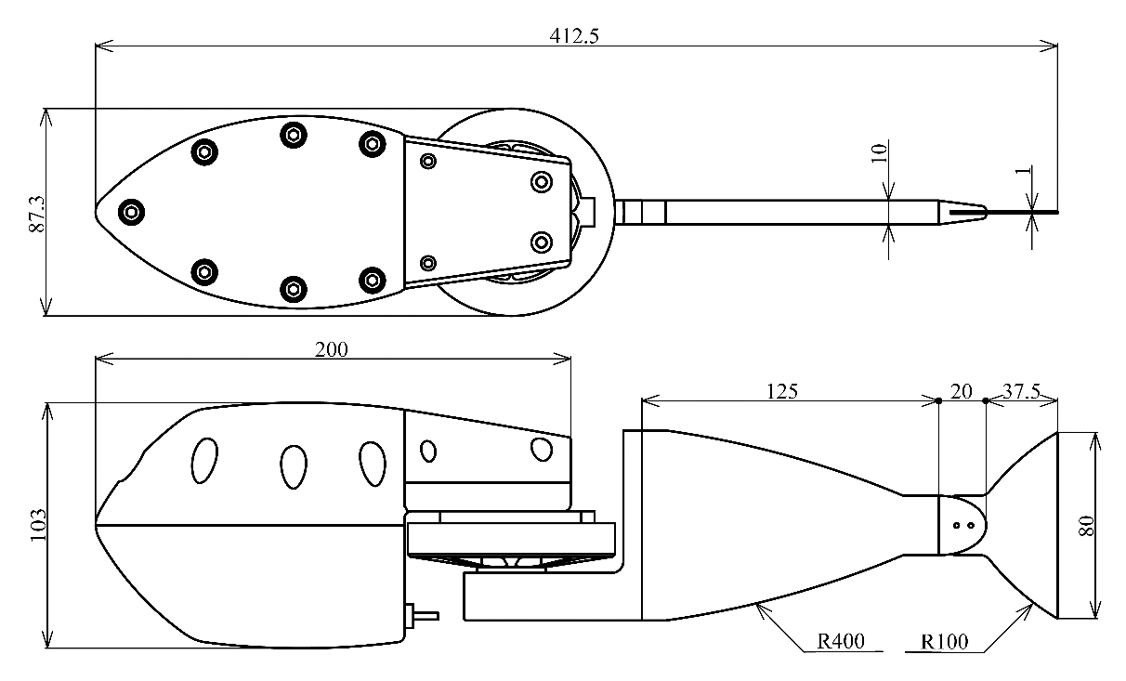
Supplementary Fig. 1. Dimensions of the robot. The robot’s shape was designed by integrating components according to images of fish.
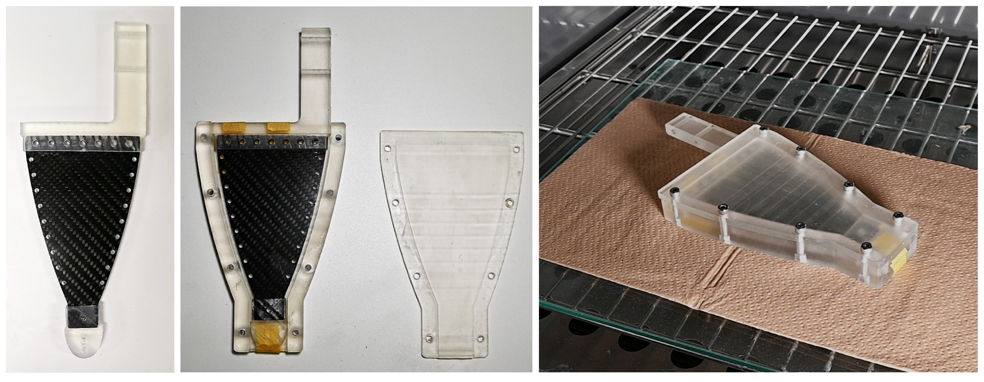
Supplementary Fig. 2. Fabrication process of the flexible body. The CFRP plate with attached parts produced by a 3D printer (left) is secured to a mold using masking tape (center). Silicone rubber is then poured into it, and after closing the lid, it is cured for over 3 h at 60 °C (right). Finally, the excess parts are trimmed with a design knife to shape the flexible body.
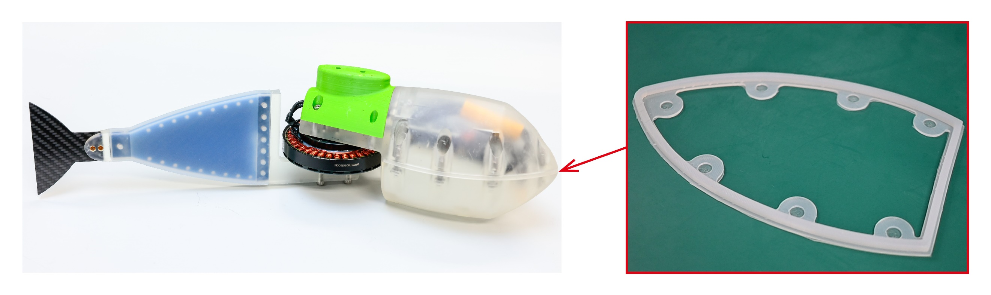
Supplementary Fig. 3. Gasket for waterproofing in the head. After pouring silicone rubber into the mold, it is left to cure for over 12 h at room temperature, and the excess parts are trimmed with a design knife. The gasket has a convex shape in the central part and is fixed in place by fitting it into a groove provided on the upper side of the robot.
Supplementary Note 1. Driving signals of the robot
Supplementary Fig. 4 shows a schematic diagram of the control system of the robot. The underwater robot responds to signals sent from land using an R/C transmitter–receiver module (transmitter: ProBo, receiver: RX-100, SANWA) operating in the 27-MHz band, which has relatively low attenuation in water. Upon receiving a signal, the robot performs predefined swimming motions programmed in advance. The microcontroller board installed on the robot communicates with the driver via CAN-BUS communication, with a communication speed of 500 kbps. CAN-BUS communication is a method that uses the potential difference between two signal lines for communication; it is robust against noise and allows high-speed communication over short distances.

In this study, two types of position control commands were used for square- and sine-wave signals. The commanded angles of the motor’s rotation and the robot’s tail beat frequency are associated with the amplitude and period of the waves, respectively. The signals are transmitted from the microcontroller board to the motor driver, and the robot’s propulsion is achieved by vibrating the BLDC motor according to this signal.

The sine wave is divided into 100 points per second, and the angle at each point is used as the target value for position commands (Supplementary Fig. 5 right). The use of sine-wave driving is based on its widespread use in traditional robot control and suitability for experiments involving the deformation of a flexible body by applying vibrations, such as in this study. The square wave is used to move without interpolating the angles between the peaks (Supplementary Fig. 5 left). The square-wave driving is adopted owing to its simplicity and the smaller movement constraints for each tail command compared to sine waves when considering interactions between the underwater environment and the robot.
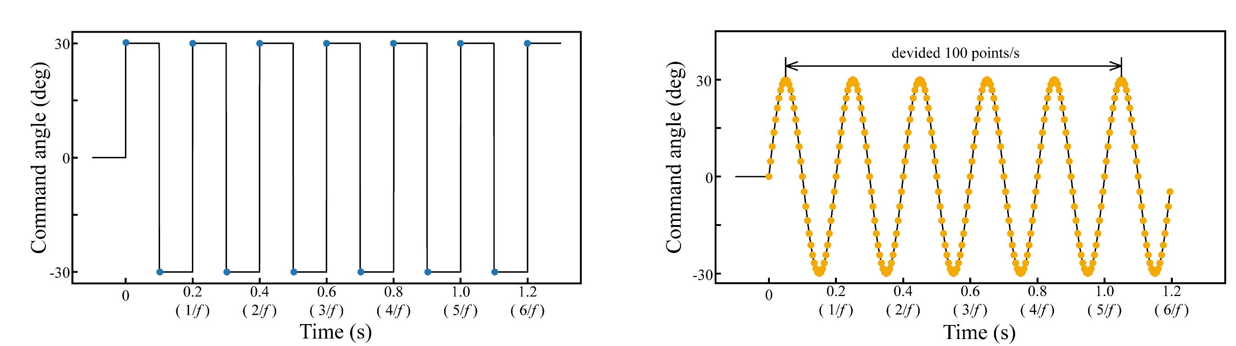
Supplementary Fig. 5. Driving signals and resulting performance of the robot. Method of providing position control commands. Both square wave (left) and sine wave (right) are associated in terms of amplitude and frequency with command angles and drive frequencies. In these graphs, signals are shown for a drive frequency of 5 Hz and a command angle of ±30°. The black solid line represents the original wave, and the blue and orange dots represent the values of command angles from the microcontroller board over time.
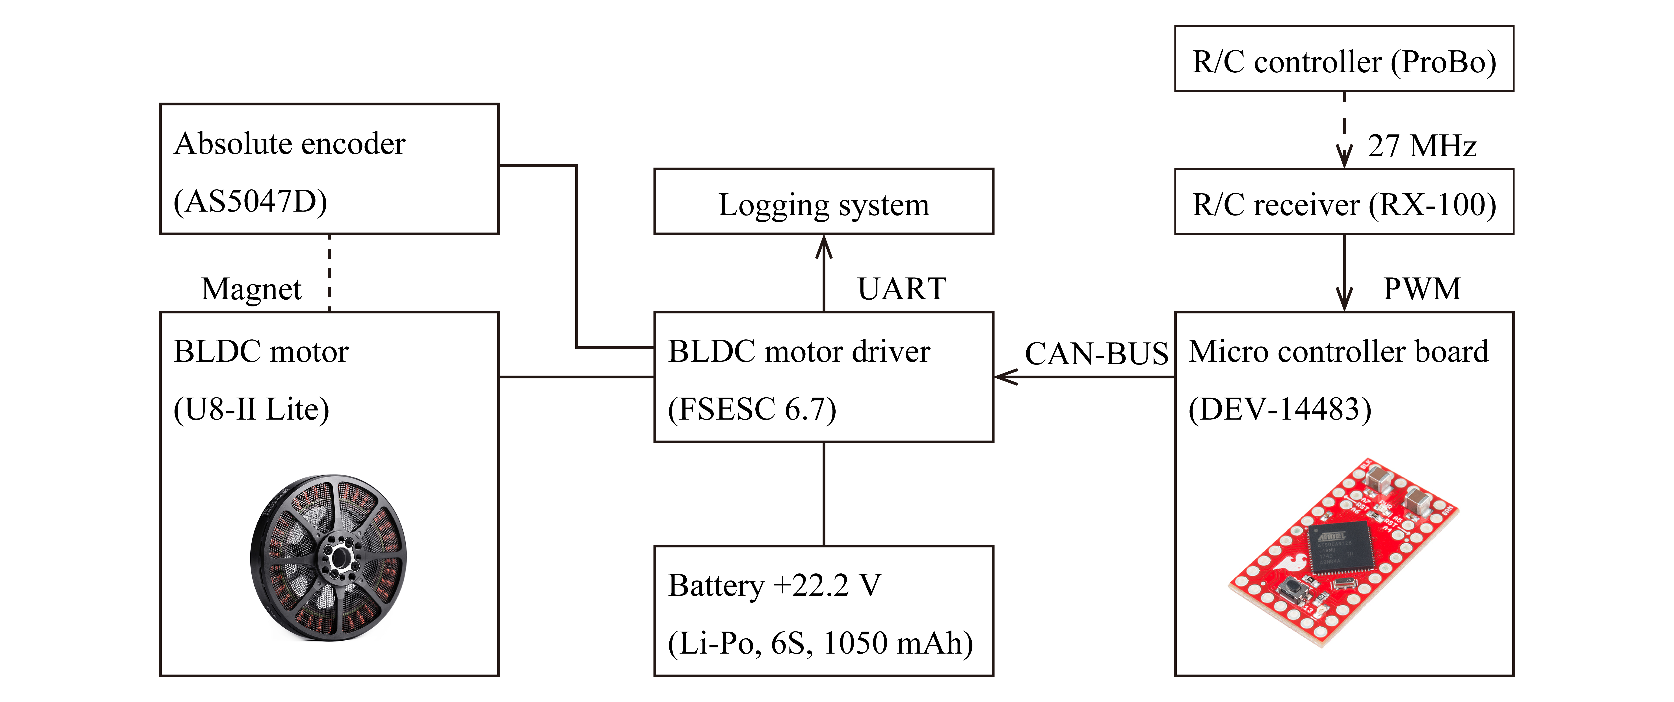
Supplementary Fig. 4. Diagram of the control system of the robot. Dashed lines represent wireless connections, while solid lines represent wired connections.
Supplementary Note 2. Control gain of the motor drive
The BLDC motor was driven by position control using a proportional derivative (PD) control scheme. The PD gains were provided as internal variables within the motor driver, allowing adjustments through dedicated software (VESC-tool) by establishing communication between a PC and the motor driver. In this study, adjustments were made to achieve suitable gains for the robot by analyzing the relationship between changes in PD gains and motor output angles, aiming at improving tracking performance underwater. Experiments were conducted using the same experimental setup as that depicted in Fig. 2A-iii. The robot was commanded with a 30° target angle at a driving frequency of 10 Hz, and the encoder values were recorded on the PC with VESC-tool. The data communication rate between the PC and the motor driver was set to 80,000 bps. From the experiments, the values for the proportional gain (Kp) and derivative gain (Kd) were determined as Kp = 0.5 and Kd = 0.04, respectively.
Supplementary Fig. 6. Dimensions of tested tail fins and results of thrust force measurement. (A) The two types of tail fins used in this experiment. The one with a lower aspect ratio (AR = 1.49, left) and the one with a higher aspect ratio (AR = 3.65, right) are easily interchangeable and attached to the flexible body using screws. (B) Experimental results of thrust and speed measurements for the tail fin selection. Comparison of thrust when using each type of tail fin. In both cases, the trends and values of thrust are nearly identical.

Supplementary Note 3. Geometry selection for the tail fin
As mentioned in the main text, two types of tail fins were prepared for the robot, with aspect ratios of 1.5 and 3.5 (Supplementary Fig. 6A). Thrust and swim speed measurements were conducted using these tail fins. An examination of the thrust measurement results revealed no significant differences between the two types, and both exhibited a similar trend with a peak at a driving frequency of 19 Hz (Supplementary Fig. 6B). Therefore, at this stage, it was determined that the aspect ratio of the tail fin did not have a substantial impact on swimming performance. Consequently, for this study, the tail fin with an aspect ratio of 3.5, which aligns with the robot’s unique capability of high-speed swimming, was adopted.
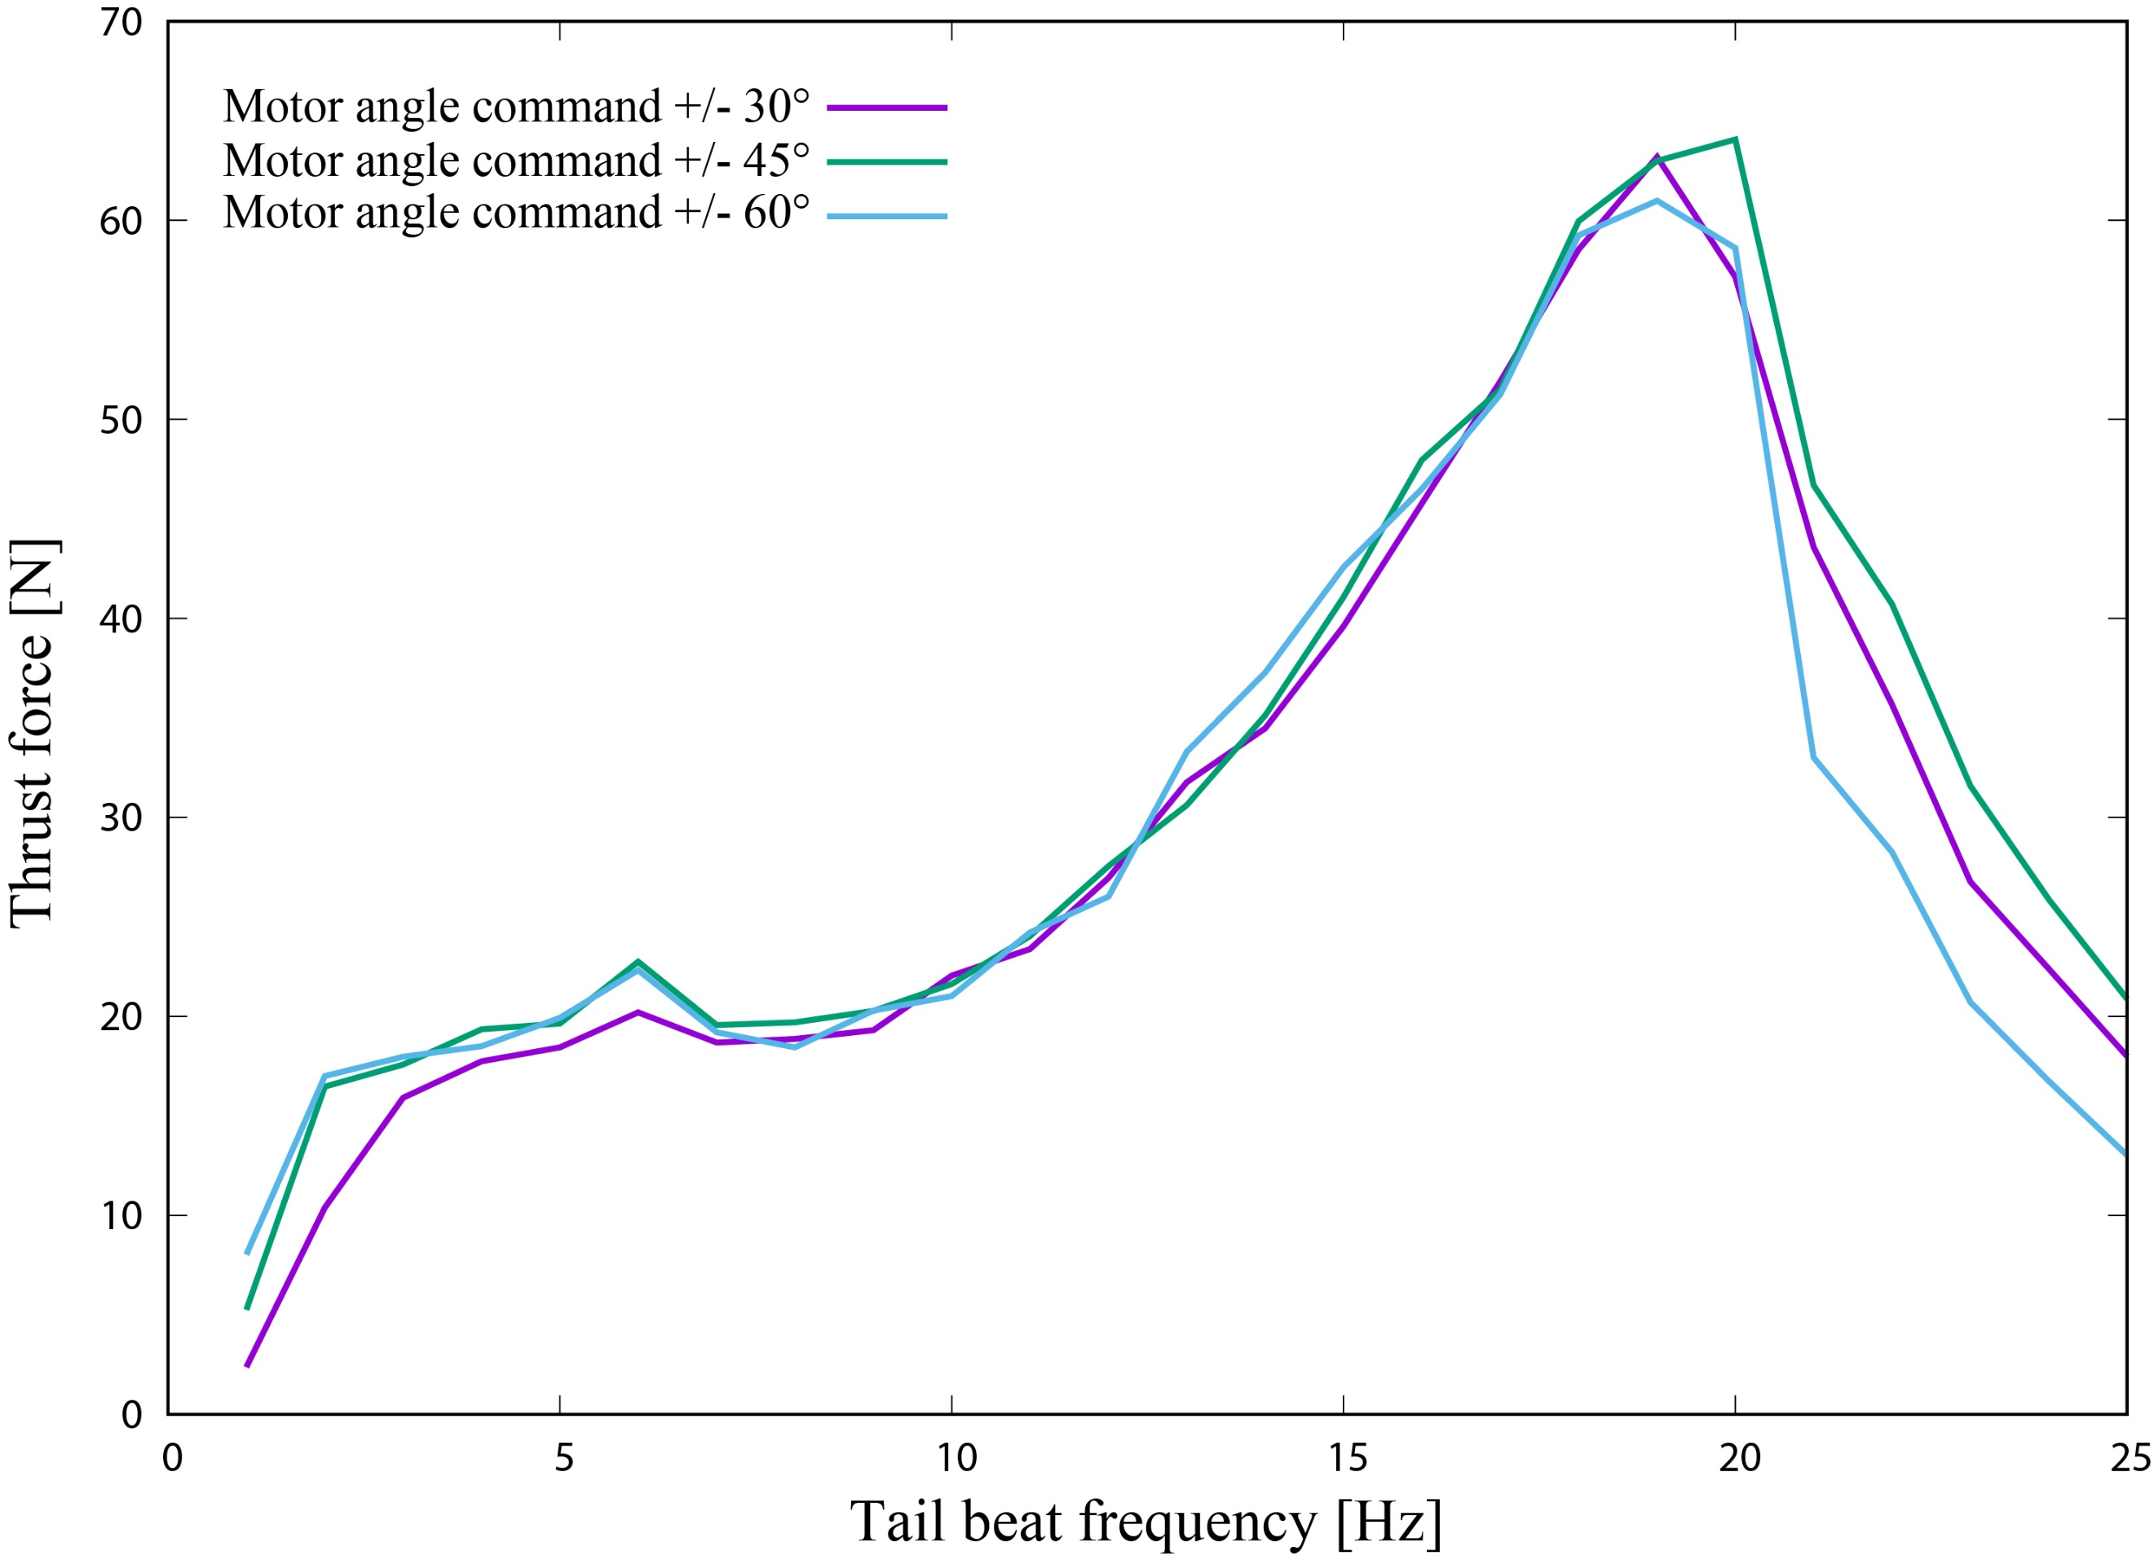
Supplementary Fig. 7. Measured thrust force as a function of the tail beat frequency for different values of motor angle command (i.e., swing angle of the body).

Supplementary Note 4. Thrust force measurement for different values of motor angle command
With the experimental setup shown in Fig. 3A, thrust force was measured for different values of motor angle command (±30°, 45°, 60°). The result is plotted in Supplementary Fig. 7, where the data show similar trend regardless of the angle value and take almost the same value. Eventually, we decided to employ ±30°, as it could consume lower power than the other conditions.

Supplementary Note 5. Calculation of resonance frequency of the robot
To calculate the resonance frequency (natural frequency) of the robot, the geometries of the body and tail were approximated to a cantilever with a rectangular shape as shown in Supplementary Fig. 8. Here, the width is given as the average. Moreover, for the sake of simplicity, the silicone part was uniform on the entire surface and the body was eventually approximated as a composite comprising the CFRP sheet sandwiched between the silicone layers, which had a fixed-free boundary condition. In the rest of the text, we refer to this cantilever as body. The calculation of resonance frequency requires taking into account the surrounding water. For this purpose, we employed a formula available in the literature¹:
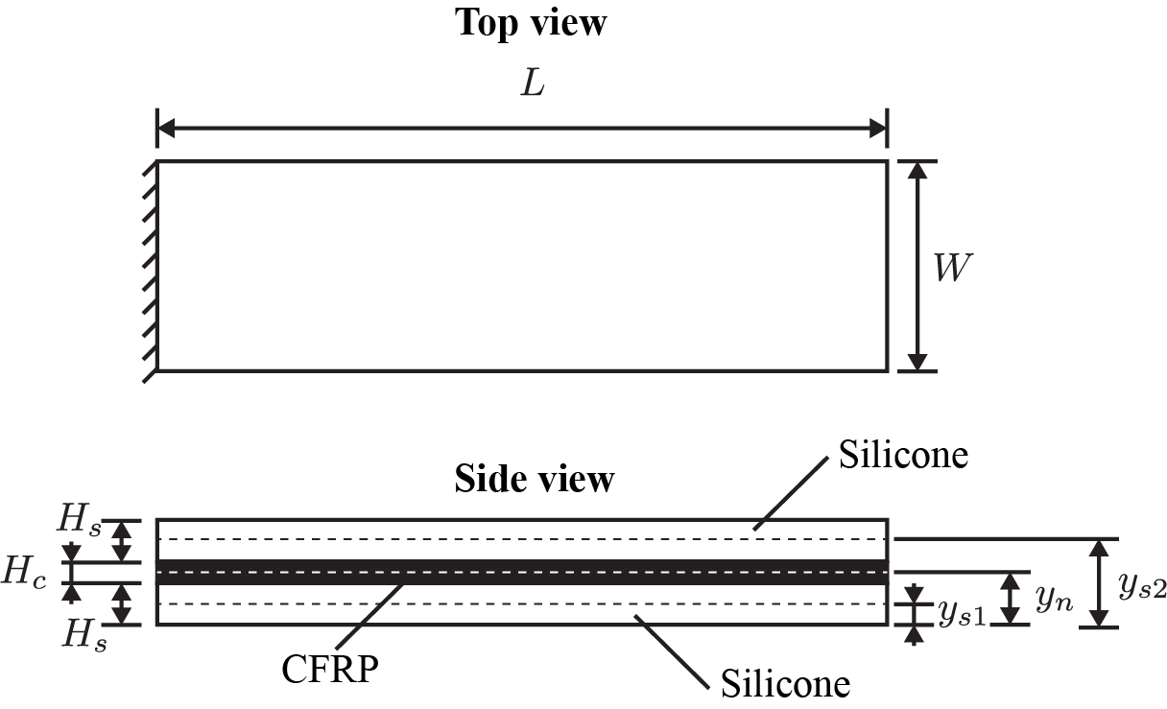
Supplementary Fig. 8. Schematics of the model approximating the robot body and tail as a cantilever composite beam in the fixed-free boundary condition.
$$\frac{f_{wi}}{f_{ai}}={\left[1+\frac{πρ_{w}W}{4ρ_{b}H_{b}}Γ_{f}\left(k_{i}\right)\right]}^{-\frac{1}{2}}\text{, (1)}$$
where $f_{wi}$ is the $i$th-order natural frequency in water, $f_{ai}$ is the $i$th-order natural frequency in air, $ρ_{w}$ denotes the density of water, $W$ represents the width of the body, $ρ_{b}$ is the density of the body, $H_{b}$ is the thickness of the body, and $Γ_{f}\left(k_{i}\right)$ is the hydrodynamic function. $ρ_{b}$ is obtained as
$$ρ_{b}=\frac{2ρ_{s}H_{s}+ρ_{c}H_{c}}{2H_{s}+H_{c}}\text{, (2)}$$
where$ρ_{s}$ and $H_{s}$ are the density and thickness of the silicone layer, respectively. Similarly, $ρ_{c}$ and $H_{c}$ are the density and thickness of the CFRP sheet, respectively. $H_{b}$ denotes the total thickness of the body:
$$H_{b}=2H_{s}+H_{c}\text{. (3)}$$
$f_{air_i}$ can be given by the following equation:
$$f_{air_i}=\frac{1}{2π}\frac{λ_{i}^{2}}{L^{2}}\sqrt{\frac{{EI}_{b}}{ρ_{b}A_{b}}}\text{, (4)}$$
where $λ_{i}$ represents the solutions of the characteristic equation $\cos{λ_{i}}\cosh{λ_{i}}=1$, $L$ is the length of the body, ${EI}_{b}$ denotes the bending stiffness of the body, and $A_{b}$ is the cross-section of the body. The first few values of $λ_{i}$ are 1.875, 4.694, and 7.855. further, ${EI}_{b}$ is given as
$${EI}_{b}=E_{s}\left\{I_{s}+{\left(y_{s1}-y_{n}\right)}^{2}A_{s}\right\}\text{+ }E_{c}\left\{I_{c}+{\left(y_{n}-y_{n}\right)}^{2}A_{c}\right\}+E_{s}\left\{I_{s}+{\left(y_{s2}-y_{n}\right)}^{2}A_{s}\right\}\text{, (5)}$$
where $E_{s}$, $I_{s}$, and $A_{s}$ are the Young’s modulus, second moment of area, and cross-sectional area ($WH_{s}$) of the silicone layer, respectively. Similarly, $E_{c}$, $I_{c}$, and $A_{c}$ are the Young’s modulus, second moment of area, and cross-sectional area ($WH_{c}$) of the CFRP sheet, respectively. $y_{n}$ is the height of the neutral bending plane, $y_{s1}$ is the height of the central position of the bottom silicone layer, and $y_{s2}$ is the height of the central position of the upper silicone layer from the bottom of the body (Supplementary Fig. 8). The second moment of area of the silicone layer and CFRP sheet is obtained as
$$I_{s}=\frac{WH_{s}^{3}}{12}\text{, }I_{c}\text{= }\frac{WH_{c}^{3}}{12}\text{. (6)}$$
The hydrodynamic function $Γ_{f}\left(k_{i}\right)$ is expressed as
$$Γ_{f}\left(k_{i}\right)=\frac{1+0.74273k_{i}+0.14862k_{i}^{2}}{1+0.74273k_{i}+0.35004k_{i}^{2}+0.058364k_{i}^{3}}\text{, (7)}$$
where $k_{i}$ is the normalized mode number given as follows:
$$k_{i}=λ_{i}\frac{W}{L}\text{. (8)}$$
Substituting Eq. (4) and Eq. (7) into Eq. (1) gives the resonance frequency $f_{wi}$ of the robot in water. Accordingly, $f_{w1}$, $f_{w2}$, and $f_{w3}$ were calculated as 3.3, 21.9, and 66.4 Hz, respectively. Supplementary Table 1 summarizes the values of parameters used for the calculation.
The above calculation is for the case where the head of the robot is fixed. To estimate the resonance frequency of the robot under free swimming, we assumed that the mass of the robot was distributed on the body as added mass. This could be achieved by recalculating the density of the body using the following equation:
$$ρ_{b}=\frac{M}{V_{b}}\text{, (9)}$$
where $M$ is the mass of the robot and $V_{b}$ is the volume of the body ($LWH_{b}$). Substituting Eq. (9) into Eq. (1) gives the resonance frequencies of the robot under free swimming $f_{w1}^{'}$, $f_{w2}^{'}$, and $f_{w3}^{'}$ as 1.8, 11.6, and 33.3 Hz, respectively. Supplementary Table 1 summarizes the values of parameters used for the calculation.

Supplementary Table 1. Parameter values used for the calculation of resonance frequency of the robot.
Parameter | Value | Note
Length of the body ($L$) | 182.5 mm | Length between the root of the body and end of the tail.
Width of the body ($W$) | 52.5 mm | Average through the root of the body to tail end of the robot.
Thickness of the silicone layer ($H_{s}$) | 3.08 mm | Approximated as a uniform layer on the area $LW$.
Thickness of the CFRP sheet ($H_{c}$) | 1.0 mm
Thickness of the body ($H_{b}$) | 7.16 mm
Density of water ($ρ_{w}$) | 1000 kg/m³
Density of the silicone layer ($ρ_{s}$) | 1080 kg/m³ | Value is taken from the datasheet of Dragon Skin 30 (Smooth-On)².
Density of the CFRP sheet ($ρ_{c}$) | 1461.5 kg/m³ | Obtained experimentally by measuring the mass of a sample with a surface area of 120 mm × 26 mm.
Density of the body ($ρ_{b}$) | 1133.3 kg/m³
Density of the body ($ρ_{b}$) | 1603.5 kg/m³ | For calculation considering free swimming.
Mass of the robot ($M$) | 1.1 kg
Volume of the body ($V_{b}$) | 6.86 × 10⁻⁶ m³
Young’s modulus of the silicone layer ($E_{s}$) | 0.73 MPa | Value is taken from reference³.
Young’s modulus of the CFRP sheet ($E_{c}$) | 21.47 GPa | Obtained experimentally by measuring the tip displacement of a sample with planar dimensions of 100 mm × 26 mm under the fixed-free boundary condition and tip loading of 0.04 N.
Bending stiffness of the body (${EI}_{b}$) | 0.0951 Nm²
Height of the neutral bending plane ($y_{n}$) | 3.58 mm
Height of the central position of the bottom silicone layer ($y_{s1}$) | 1.54 mm
Height of the central position of the upper silicone layer ($y_{s2}$) | 5.62 mm

Supplementary References
- Van Eysden, C. A. & Sader, J. E. Resonant frequencies of a rectangular cantilever beam immersed in a fluid. J. Appl. Phys. 100, (2006).
- Smooth-on Inc. Dragon Skin™ Series-Datasheet, https://www.smooth-on.com/tb/files/DRAGON_SKIN_SERIES_TB.pdf
- Marechal, L. et al. Toward a Common Framework and Database of Materials for Soft Robotics. Soft Robot. 8, (2021).

