Supplementary material
To further assess the role of ERK in the phosphorylation of tau protein following Al(mal)₃ treatment, we selected ERK inhibitors to treat PC12 cells. We first examined the effect of U0126 on cell viability using the CCK8 kit. Different concentrations of U0126 were used to treat PC12 cells (10 μmol/L, 20 μmol/L, 30 μmol/L, 40 μmol/L, 50 μmol/L, and 60 μmol/L), and a CCK8 kit was used to detect cell viability after 25 hours. We observed that when cells were treated with U0126 at doses ranging from 10 to 50 μM, cell viability was above 80% in all groups. Therefore, to achieve the highest inhibition rate, we used 50 μM U0126 for the subsequent experiments (Figure S1).
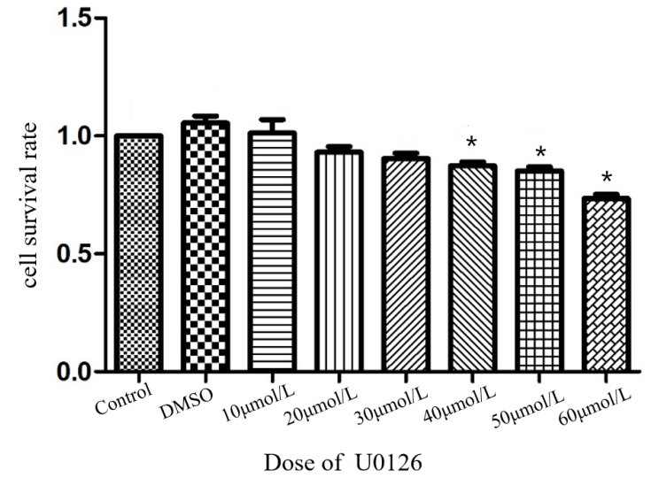
Figure S1 Cell viability after treatment with different U0126 concentrations. *P < 0.05 versus the control group.
The difference in the P-ERK level between the DMSO treatment and control groups did not reach statistical significance (P>0.05). Compared with the control group, the protein expression levels of tau5, PHF and NFT in the DMSO treatment group were unchanged. Compared with the control group, the protein expression levels of tau5, PHF, and NFT in the blank plasmid group were unchanged.
First, we set up miRNA-195-5p overexpression groups with different transfection times. We analyzed the expression of miRNA-195-5p by qPCR, and the results demonstrated that miRNA-195-5p overexpression reached its highest level when transfected for 36 hours (Figure S2). Therefore, we chose a transfection time of 36 hours for the subsequent experiments.
Figure S2 Expression level of miRNA-195-5p after overexpression in PC12 cells. *P < 0.05 versus the control group.

