Supplemental Figure 1. LC-MS analysis of total lipid extracts from E. coli grown in the presence of various PUFAs. Each PUFA corresponds to separate cultures, but all have been overlain onto one figure for comparison. (A) Extracted ion chromatograms of [M-H]– ions showing incorporation of all PUFAs, except 22:6, into the phosphatidylethanolamine structure in which sn-1 is occupied by 16:0. (B) High cone voltage (50 V) mass spectrum with parent ion [M-H]– at m/z 712 and cone fragments at m/z 255 and 277 corresponding to PE 16:0/18:3α eluted at 7.8 min. (C) High cone voltage (50 V) mass spectrum with parent ion [M-H]– at m/z 714 and cone fragments at m/z 255 and 279 corresponding to PE 16:0/18:2 eluted at 8.2 min.

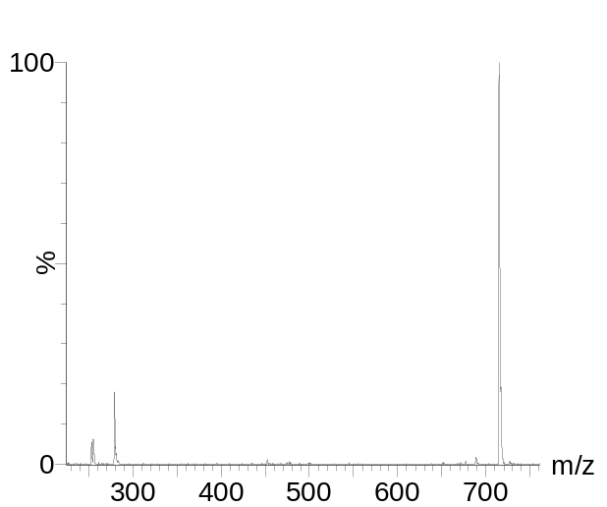
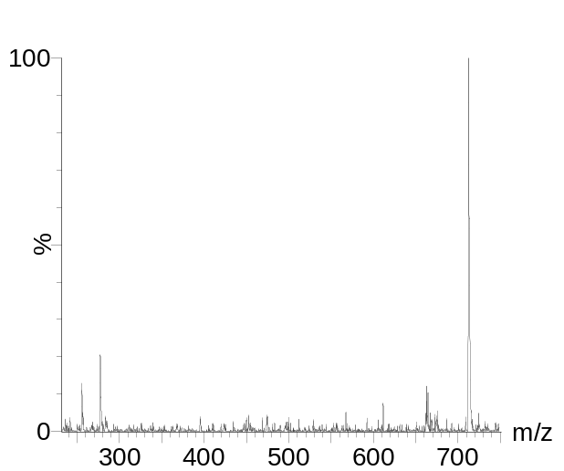
PE 16:0/18:2
[M-H]–
m/z 714
279
255
(C)
[M-H]–
m/z 712
277
PE 16:0/18:3α
255
(B)

(A)

Supplemental Table 1.

 | No FA | 18:2 | 18:3α | 18:3γ | 20:3 | 20:4 | 20:5 | 22:6
CFU/ml  at hour 7 | 2.8e9 | 3.2e9 | 3e9 | 2.9e9 | 3.2e9 | 2.8e9 | 2.7e9 | 2.9e9
Growth Curve (Figure 1A)

All standard deviations < 2.7e8

 | No FA | 18:2 | 18:3α | 18:3γ | 20:3 | 20:4 | 20:5 | 22:6 | Glu | EtOH
CFU/ml  at hour 7 | 4.5e7 | 1.1e8 | 7e7 | 5e7 | 5.5e7 | 5.5e7 | 5.5e7 | 6e7 | 1e9 | 4.4e7
Sole Carbon Growth Curve (Figure 1B)

All standard deviations < 8e6

