Supplementary Fig. S1 Sequence alignment and coding protein analysis of two alternative splicing events.
A DNA sequence alignment of two transcripts.
B Sequence alignment of amino acids encoded by SiAAP9L and SiAAP9S.
C, D Coding sequences of SiAAP9L and SiAAP9S are subjected to the TMHMM-2.0 website for transmembrane domain prediction.
E, F Swiss Model website for predicting the protein tertiary structure of the SiAAP9L and SiAAP9S.

Supplementary Fig. S2 SiAAP9 is widely expressed in Arabidopsis by GUS staining analysis.
Representative images from 20 individual transgenic lines expressing SiAAP9 pro:GUS are shown: 4-DAG seedling (A), magnifications of the cotyledons (B) and root tips (C) of 4-DAG seedling, leaf from 21-DAG plants (D), epidermal cells (E), inflorescence (F), mature pistil (G), root (H), developing anther (I), developing seed (J). Bars = 2 mm for (A), (D), and (F), 100 μm for (B), (C), (E), (G), (H), (I) and (J).

Supplementary Fig. S3 Quantification of the expression levels in transgenic Arabidopsis that were grown on 1/2 MS medium.
A, B Detection of expression levels of WT, LOX-1#, LOX-2#, SOX-1# and SOX-2# through RT-qPCR and immunoblotting. Data represent means ± SD (n=3). Significant difference is analyzed based on one-way ANOVA by Duncan test, lowercase letters at p < 0.05.

Supplementary Fig. S4 Amino acid concentration analyze of seeds at mature stage in WT, LOX-1#, LOX-2#, SOX-1# and SOX-2# lines grown in vermiculite. Data represent the mean ±SD (n=3). Asterisks indicate significant differences based on one-way ANOVA followed by Duncan test: * p < 0.05, ** p < 0.01.

Supplementary Fig. S5 The phenotype analyze of SiAAP9 overexpressing in Arabidopsis under 7 mM NO₃⁻.
A, E WT, LOX-1#, LOX-2#, SOX-1# and SOX-2# were vertically cultivated on 0 mM NO₃⁻ for 4 days (upper panels), then were transferred to 7 mM NO₃⁻ and allowed to grow for an additional 8 days (lower panels). The experiments were biologically repeated at least three times, yielding consistent results. Scale bar = 1 cm.
B, F Primary root length was measured of WT and SiAAP9-overexpressing plants at 12 days. Data represent the mean ± SD (n = 20).
C, G Primary root length was measured of WT and SiAAP9-overexpressing plants after transferring the plate at 8 days. Data represent the mean ± SD (n = 20).
D, H Fresh weight was measured of WT and SiAAP9-overexpressing plants at 12 days. Data represent the mean ± SD (n = 20).
B-D, F-H Significant difference is analyzed based on one-way ANOVA by Duncan test, lowercase letters at p < 0.05.

Supplementary Fig. S6 Overexpression of SiAAP9 in Arabidopsis has no significant response to nine amino acids.
A-I Nine amino acids are Ala (A), Gly (B), Val (C), Pro (D), Leu (E), Ile (F), Ser (G), Thr (H) and Asp (I).

Supplementary Fig. S7 Overexpression of SiAAP9 in Arabidopsis has no significant response to eight amino acids.
A-H Eight amino acids are Met (A), Cys (B), Phe (C), Try (D), Asn (E), Gln (F), Lys (G) and Arg (H).

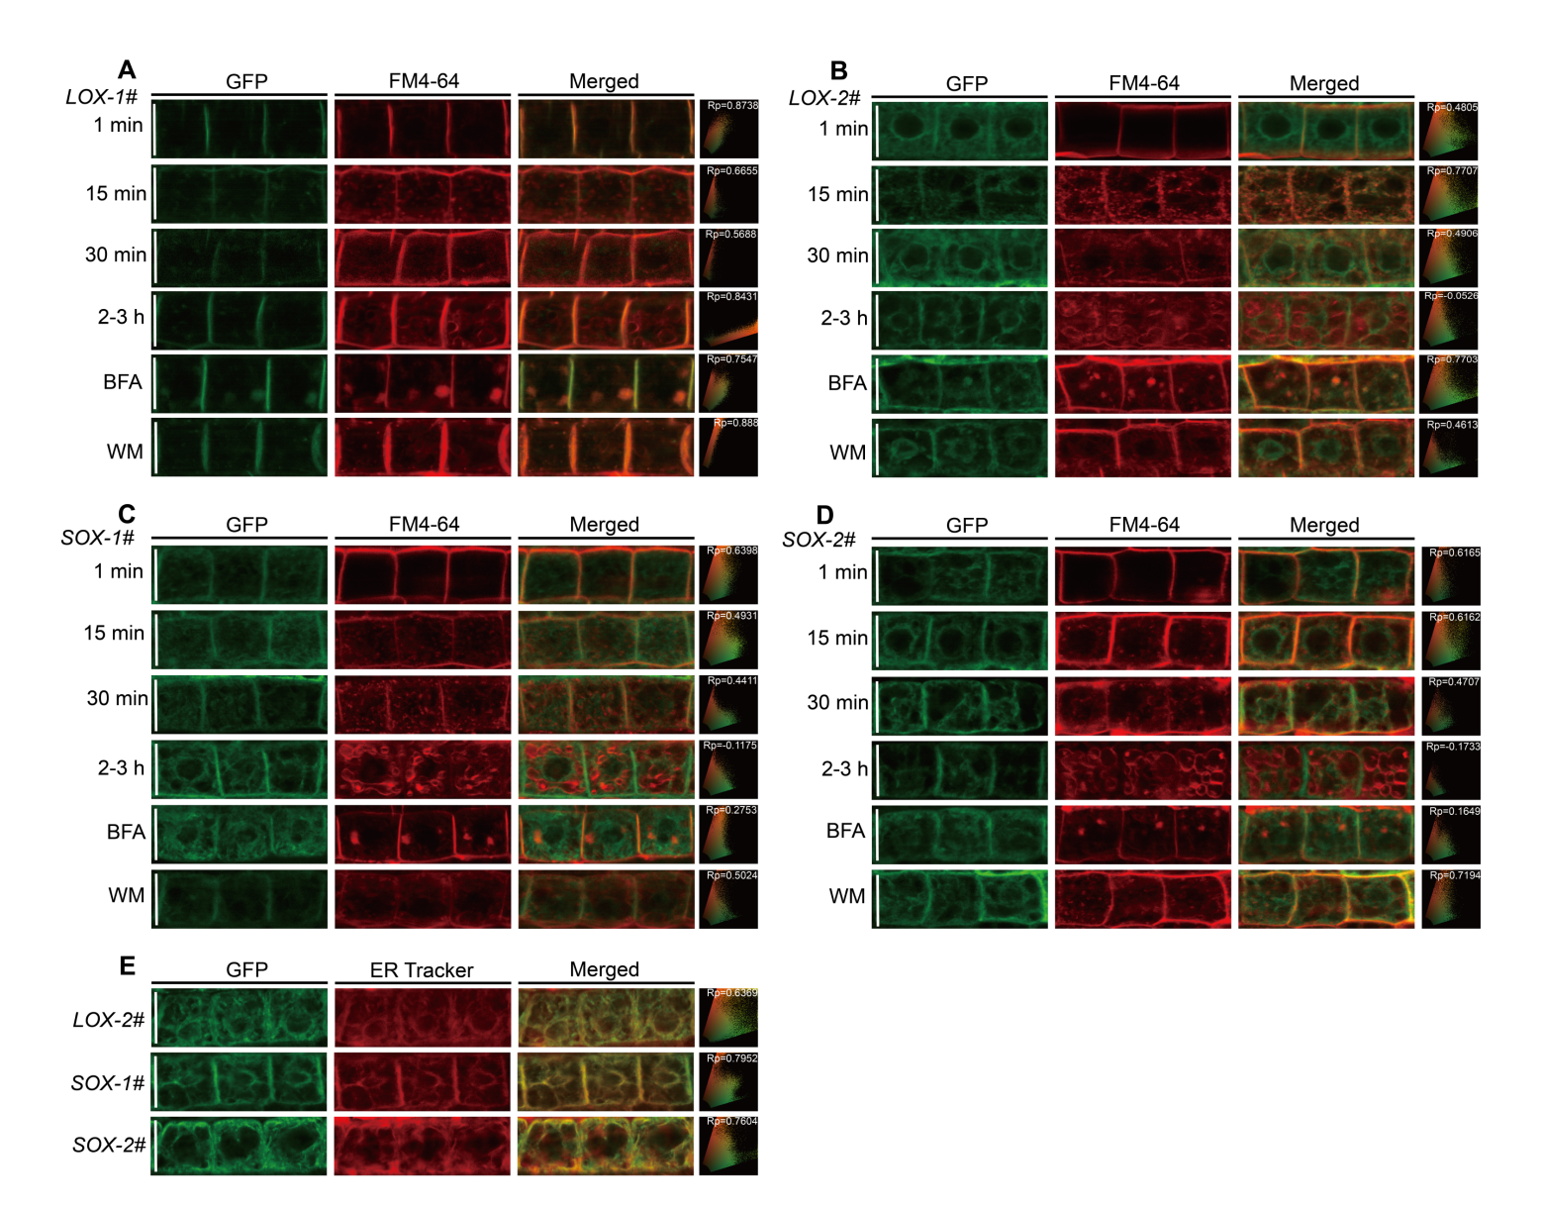
Supplementary Fig. S8 Subcellular localization of SiAAP9L and SiAAP9S in Arabidopsis were pulse labeled with FM4-64.
A-D Roots of four overexpressing SiAAP9 transgenic Arabidopsis lines grown on 1/2 MS medium for 4 days were pulse labeled with FM4-64 for 1 min, 15 min, 30 min or for 2-3 h and followed by BFA treatment for 50 min or WM treatment for 1 h, respectively.
E Seedlings of LOX-2#, SOX-1# and SOX-2# grown on 1/2 MS medium for 4 days were stained with ER Tracker for 1 hour.
A-E Each image shows the corresponding Pearson correlation coefficient (Rp). Bar = 20 μm.

