Fig S1.
MTT assay and flow cytometry were used to detect the effects of F1/F3 on the proliferation and apoptosis of B16 cells in vitro. (A) After constructing a B16 cell injury model, the absorbance levels detected by B16 cells at different concentrations and the IC50 values calculated by the software showed a negative correlation between absorbance and cell proliferation activity; (B) The effect of F1/F3 at IC50 concentration on the apoptosis phenomenon of B16 cells. Data are representative of at least 2 independent experiments and are presented as the mean ± SD. NS, not significant. *P < 0.05; ***P < 0.001 by one-way ANOVA test (B).

Fig S2.
F1/F3 inhibit B16 tumor growth in vivo.4×10⁵ of B16 cells were inoculated into the lateral abdomen of C57BL/6 mice (day 0), on Day 3, 30μg of F1/F3 or a control P3 were injected into the tumor on for 7 consecutive days. (A-D) CD8a⁺ T cells (FVS510⁺CD45.2⁺CD3⁺CD8a⁺), NK1.1 cells (FVS510⁺CD45.2⁺NK1.1⁺), B220⁺ cells (FVS510⁺CD45.2⁺B220⁺), of different treatment groups. Data are representative of at least 2 independent experiments and are presented as the mean ± SD. NS, not significant. ***P < 0.001 by one-way ANOVA test (A-D).

Fig S3.
Successfully depleted corresponding immune cells in mice using in vivo antibodies such as anti-CD4, anti-CD8a, anti-NK1.1, and clodronate. (A). 100 μg of anti-CD4 and anti-CD8a were injected intraperitoneally every 6 days to deplete the above immune cells, CD4 T cells and CD8 T cells were successfully depleted; (B). Intraperitoneal injection of 200 μl Clodronate or Clodronate control or PBS the day before tumor loading, followed by paratumoral injection of 100 μl plus intraperitoneal injection of 200μl Clodronate or Clodronate control or PBS, once every four days to deplete macrophages, macrophages successfully depleted; (C). 100 μg of anti-NK1.1 were injected intraperitoneally every 6 days to deplete the above immune cells, NK cells successfully depleted.

Fig S4.
Construct a mouse tumor bearing treatment model and use WB technology to detect the expression of two phosphorylation sites of STAT1.Separate tumor tissue into single cell suspension and extract protein. (A, B) Perform protein blotting to evaluate the expression of STAT1 (p-STAT1; Ser727/Tyr701). β-Actin was used as an internal load control. Data are representative of at least 2 independent experiences and are presented as the mean ± SD. NS, not significant. *P < 0.05 by one way ANOVA test (A, B).

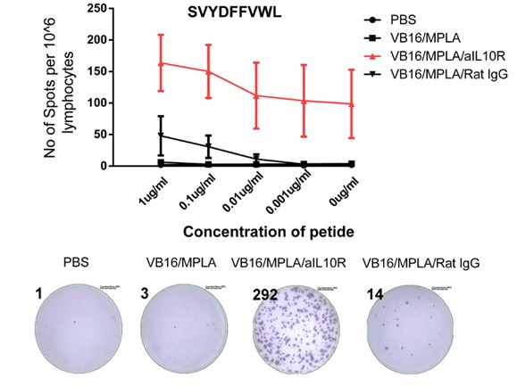
Fig S5.
Single spleen cell suspensions were added to membrane base 96‐well ELISPOT plate (Millipore, Bedford, MA) coated with anti‐IFN‐γ (BD Harlingen, San Diego, CA). B16 CTL epitope SVYDFFVWL was added at various concentrations, and cells were incubated with the peptide overnight at 37°C with 5% CO2. The plate was incubated with detection antibody (a biotinylated anti‐mouse IFN‐γ antibody; BD Harlingen, San Diego, CA) after extensive washing in wash buffer for 2h at room temperature. Antigen‐specific IFN‐γ‐secreting cells were detected by sequential exposure of the plate to avidin–horseradish peroxidase (Sigma‐Aldrich) and DAB (Sigma‐Aldrich). The plate was washed and allowed to air‐dry overnight, and foci of staining were counted by the ELISPOT reader system (CTL, Germany).

