Supporting Information

Molecular interactions between silver ions (Ag⁺) and amyloid-β (Aβ) peptides: binding affinities and structural effects

Amanda L. Lakela^{1,†}, Elina Berntsson^{1,2,3,†}, Faraz Vosough¹, Jüri Jarvet^{1,2,4}, Suman Paul¹, Andreas Barth¹, Astrid Gräslund^{1,2,}*, Per M. Roos^{5,6}, Sebastian K.T.S. Wärmländer^{2,7,}*

¹ Department of Biochemistry and Biophysics, Arrhenius Laboratories, Stockholm University, 10691 Stockholm, Sweden.
² CellPept Sweden AB, Kvarngatan 10B, 11847 Stockholm, Sweden
³ Dept. of Chemistry and Biotechnology, Tallinn University of Technology, 19086 Tallinn, Estonia.
⁴ The National Institute of Chemical Physics and Biophysics, Tallinn, Estonia.
⁵ Institute of Environmental Medicine, Karolinska Institutet, 17177 Stockholm, Sweden.
⁶ University Healthcare Unit of Capio St. Göran Hospital, 11281 Stockholm, Sweden.
⁷ Chemistry Section, Arrhenius Laboratories, Stockholm University, 10691 Stockholm, Sweden.

† These two authors contributed equally and should both be considered first authors.
* Corresponding authors. E.-mail: astrid@dbb.su.se; seb@student.su.se

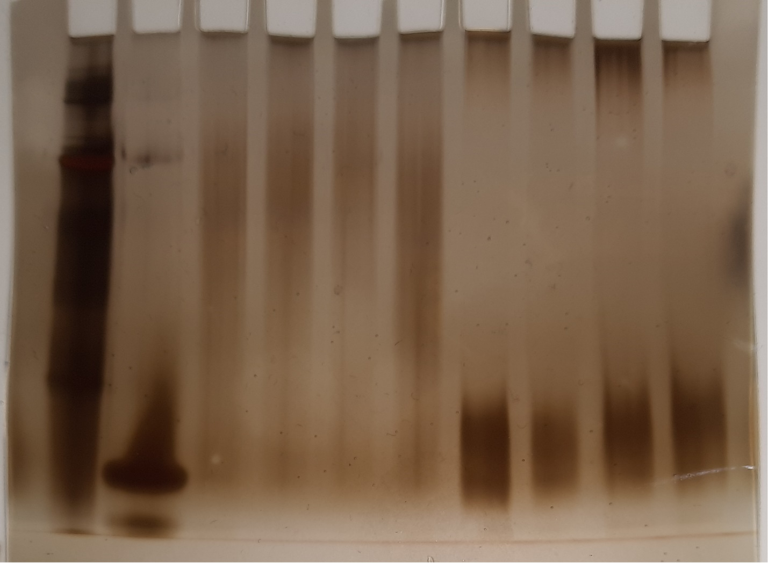
Supp. Fig. S1. Original image of the BN-PAGE gel shown in Fig. 5 in the main manuscript. Lane 1. Ladder with high molecular weight reference proteins from GE Healthcare, USA; Lane 2. Aβ₄₂ monomers; Lanes 3-6. Aβ₄₂ oligomers prepared with 0.05 % SDS and 0, 10, 100, and 500 µM AgNO₃, respectively.; Lanes 7-10. Aβ₄₂ oligomers prepared with 0.2 % SDS and 0, 10, 100, and 500 µM AgNO₃, respectively. Image by F.V.

