Supplementary Information
Closed-Loop Recycling of Tough Epoxy Supramolecular Thermosets Constructed by Hyperbranched Topological Structure
Junheng Zhang^{a,b*}, Can Jiangª, Guoyan Dengª, Mi Luo^{c}, Bangjiao Ye^{c}, Hongjun Zhang^{c*}, Menghe Miao^{d}, Tingcheng Liª, Daohong Zhang^{a,b*}
ªKey Laboratory of Catalysis and Energy Materials Chemistry of Ministry of Education & Hubei Key Laboratory of Catalysis and Materials Science, Hubei R&D Center of Hyperbranched Polymers Synthesis and Applications, South-Central Minzu University, Wuhan 430074, China.
^{b}Guangdong Provincial Laboratory of Chemistry and Fine Chemical Engineering Jieyang Center, Jieyang 515200, China
^{c}State Key Laboratory of Particle Detection and Electronics, University of Science and Technology of China, Hefei 230026, China.
^{d}Department of Mechanical Engineering, The University of Melbourne, Grattan Street, Parkville, Victoria 3010, Australia.
*E-mail: mcjhzhang@gmail.com, hjzhang8@ustc.edu.cn, zhangdh27@163.com
Table of Contents
1. EXPERIMENTAL SECTION
1.1 Materials
1.2 Characterization of vanillin-based hyperbranched epoxy resin
1.3 Characterization of carboxyl terminated epoxy curing agent containing dynamic imine bonds
1.4 Characterization
1.5 All-atom molecular dynamics simulations
2. SUPPORTING FIGURES AND TABLES
1. EXPERIMENTAL SECTION
1.1 Materials
Vanillin, 4-formylbenzoic acid (p-CBA), trimethylolpropane tris[poly(propylene glycol), amine terminated] ether (TTE, M_{n} = 440 g·mol⁻¹), tetrabutylammonium bromide, sodium hydroxide, bisphenol A (BPA), were purchased from Shanghai Macklin Biochemical Co., Ltd. Methanol, ethanol, ethylacetate, epichlorohydrin(ECH), tetrahydrofuran(THF), N,N-dimethylformamide (DMF) and hydrochloric acid (HCl) were purchased from Sinopharm Chemical Reagent Co., Ltd. Diglycidyl ether of bisphenol-A (DGEBA) epoxy resin (a bisphenol epoxy with epoxide equivalent weights 196 g/eq) was provided by Baling Petrochemical Company, Inc. China. All chemicals were used as received unless described below.

1.2 Characterization of vanillin-based hyperbranched epoxy resin
The epoxy value of VanEP was titrated to be 0.27 mol 100 g⁻¹ according to ASTM D1652. FT-IR (KBr, cm⁻¹): 1645 cm⁻¹ (-CH=N-), 915 cm⁻¹ (C-O-C). ¹H NMR (400 MHz, DMSO-D₆) (δ, ppm): 8.19 (s, 1H, -CH=N-), 7.54-7.42 (dd, 2H, Ar-H), 7.34-7.17 (dd, 2H, Ar-H), 7.00-6.90 (dd, 2H, Ar-H), 5.07 (s, 2H, -CH₂-O-), 4.45 (dd, 1H, -O-CH₂-), 4.32 (dd, 1H, -O-CH₂-), 4.05-4.00 (dd, 1H, -O-CH₂-), 3.96-3.91 (dd, 1H, -O-CH₂-), 3.86 (s, 3H, -OCH₃), 3.79-3.76 (m, 1H, -O-CH₂-), 3.44-3.37 (dd, 1H, -CH-), 3.23 (m, 2H, -CH- in oxirane), 2.89-2.83 (m, 2H, -CH₂- in oxirane), 2.74-2.67 (m, 2H, -CH₂- in oxirane), 2.00 (s, 2H, -CH₂-), 1.24-1.12 (m, 3H, -CH₃), 1.02-0.95 (m, 3H, -CH₃).¹³C NMR (400 MHz, DMSO-D₆) (δ, ppm): 159.40 (-CH=N-), 153.72, 150.00, 130.68, 125.83, 112.35, 109.75, 75.18, 70.29, 65.91, 59.76, 55.39 (-OCH₃), 49.54, 43.52, 29.09, 22.94, 17.09, 7.35. The FT-IR, ¹H NMR spectra of VanEP are shown in Figure S1, and the ¹³C NMR spectrum of VanEP is shown in Figure S2.
The epoxy value of VanEHBP was titrated to be 0.18 mol 100 g⁻¹ according to ASTM D1652. FT-IR (KBr, cm⁻¹): 3524 cm⁻¹ (-OH), 1645 cm⁻¹ (-CH=N-), 915 cm⁻¹ (C-O-C). ¹H NMR (400 MHz, DMSO-D₆) (δ, ppm): 8.19 (s, 1H, -CH=N-), 7.51-7.48 (dd, 2H, Ar-H), 7.42-7.38 (dd, 1H, Ar-H), 7.20-7.14 (m, 2H, Ar-H), 7.02-6.99 (dd, 2H, Ar-H), 6.72-6.69 (m, 2H, Ar-H), 4.46-4.43 (dd, 1H, -OH), 4.28-4.25 (dd, 1H, -O-CH₂-), 4.23-4.21 (dd, 1H, -O-CH₂-), 4.11-4.09 (dd, 1H, -O-CH₂-), 3.98-3.96 (dd, 1H, -O-CH₂-), 3.85 (s, 3H, -OCH₃), 3.60-3.57 (m,1H, -O-CH₂-), 3.44-3.41 (dd, 1H, -CH-), 3.30 (m, 2H, -CH- in oxirane), 2.85-2.82 (m, 2H, -CH₂- in oxirane), 1.74 (m, 3H, -CH₃), 1.52 (s, 2H, -CH₂-), 1.43-1.36 (m, 3H, -CH₃), 0.94 (m, 3H, -CH₃). ¹³C NMR (400 MHZ, DMSO-D₆) (δ, ppm): 159.87 (-CH=N-), 156.80, 155.33, 150.00, 130.50, 127.60, 122.88, 114.78, 112.35, 109.58, 75.36, 70.01-70.39, 69.40, 69.28, 69.14, 68.41, 68.25, 67.08, 65.91, 65.91, 58.46 (-OCH₃), 55.21, 46.12, 43.52, 41.09, 28.92, 25.19, 13.19, 7.17. The FT-IR, ¹H NMR spectra of VanEHBP are shown in Figure S1, ¹³C NMR spectrum of VanEHBP is shown in Figure S3 and the GPC trace of VanEHBP is shown in Figure S4.

1.3 Characterization of carboxyl terminated epoxy curing agent containing dynamic imine bonds
The acid value of CBA-TTE was titrated to be 181 mgKOH·g⁻¹ according to ASTMD974. FT-IR (KBr, cm⁻¹): 1633 cm⁻¹ (-CH=N-), 3452 cm⁻¹ (-OH), 1696 cm⁻¹ (C=O). ¹H NMR (400MHZ, DMSO-D₆) (δ, ppm): 10.12 (s, 1H, -COOH), 8.37 (s, 1H, -CH=N-), 8.00-7.97 (m, 2H, Ar-H), 7.81-7.80 (m, 2H, Ar-H), 5.44 (S, 2H, -CH₂-O-), 3.52-3.45 (m, 1H, -O-CH₂-), 3.30-3.20 (dd, 1H, -CH-), 1.18 (S, 2H, -CH₂-), 1.01-0.92 (m, 3H, -CH₃), 0.77-0.62 (m, 3H, -CH₃). ¹³C NMR (400MHZ, DMSO-D₆) (δ, ppm): 169.94 (-COOH), 159.92 (-CH=N-), 142.64, 132.42, 129.68, 126.77, 75.01, 65.62, 53.12, 49.02, 19.15, 17.78, 7.89. The FT-IR, ¹H NMR spectra of FAT are shown in Figure S1, ¹³C NMR spectrum of CBA-TTE is shown in Figure S5.

1.4 Characterization
¹H NMR and ¹³C NMR measurements were conducted on an Avance Ⅲ-400 NMR spectrometer (Bruker corporation, Germany) using DMSO-D₆ as solvent and tetramethylsilane (TMS) as internal standard. The ¹H NMR and ¹³C NMR spectra were recorded at 400 MHz. Fourier transform infrared (FT-IR) spectra were collected on a Vertex 70 FT-IR spectrometer (Bruker corporation, Germany) with the range of 4000-500 cm⁻¹ using the potassium bromide crystal. The epoxy values of epoxy resins were determined by hydrochloric acid-acetone method (ASTM D1652). The molecular weight was measured on a Waters 1525 gel permeation chromatography (GPC) instrument, with DMF as the eluent at 40 °C, after calibration with standard polystyrenes. Injection volume was 15 μL and flow rate was 0.3 mL·min⁻¹. Differential scanning calorimetry (DSC) tests were performed on a DSC 214 (NETZSCH, Germany) under a nitrogen atmosphere at a heating rate of 10 ℃·min⁻¹ from 30 to 200 ℃. Thermogravimetric analysis (TGA) was carried out using a TGA 209 F3 thermogravimetric analyzer (NETZSCH Instruments, Germany) under nitrogen atmosphere at a heating rate of 10 °C min⁻¹ from 30 to 700 °C. Creep, stress-relaxation, T_{v} and dynamic mechanical analysis were carried out on DMA Q800 (TA Instruments, USA) at a frequency of 1 Hz in tension mode. The tests were conducted using single cantilever mode at the temperature range from 30 to 180 ℃, and the specimen dimensions were 20.0 × 4.0 × 1.0 mm³ at heating rate of 3 ℃·min⁻¹. Stress-relaxation tests were conducted on rectangular specimens (20.0 × 4.0 × 1.0 mm³), which were initially aligned by preloading a 0.001 N force, followed by thermal equilibrium at each test temperature for 5 min. The specimens were stretched by 1 %, and the strain was retained during the test. The variation of stress decay profile was recorded as a function of time. The creep TTS test was conducted at temperature between 30 and 100 ℃ in intervals of 10 ℃ with specimen dimensions of 20.0 × 4.0 × 0.5 mm³. During the measurement of each isotherm, a constant force of 3.0 MPa was applied for 5 min followed by a 15 min recovery period. Creep test was conducted at temperature of 80 ℃ with specimen dimensions of 20.0 × 4.0 × 0.5 mm³ by a constant force of 3.0 MPa for 60 min and the time-dependent strain profile was record. Tensile strength was measured using a universal tester (INSTRON 5966, Instron, Norwood, MA) according to ASTM D638 at a crosshead speed of 5 mm·min⁻¹. Each reported value was the average of at least five specimens. AFM imaging was carried out using a SPM-9700HT atomic force microscope (Shimadzu Enterprise Management Co., Ltd. China) operating in tapping mode. Topographic (height) and phase images were recorded simultaneously at ambient conditions. Samples were scanned using high speed scanner on size of 5μm× 5μm. The morphology of fracture surfaces was examined with a scanning electron microscope (SEM) (TALOS F200X, China Thermo Fisher Scientific) operating at 20 kV. Prior to the observation, the samples were sputtered with a 1-3 nm layer of platinum using a rotary-pumped sputter coater (Hitachi E-1045, Japan). GC-MS spectra were carried out on a QP2010 Gas Chromatography-Mass Spectrometer system (GC-MS) (Shimadzu, Japan) using ethyl acetate as the solvent. Positron annihilation lifetime spectroscopy (PALS) was conducted on RGM-1/APBS-2 trap-based slow positron beam system (First Point Inc., USA).Positron annihilation lifetime spectroscopy (PALS) was used to investigate the free volume of epoxy thermosets. The free volume was determined by the following procedure.
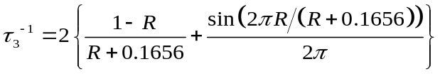 (S1)
Whereτ₃is the positron annihilation lifetime, R is the average radius of small holes, and average volume of each hole was calculated by the following equation:
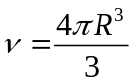 (S2)
Therefore, the free volume can be calculated by the following equation:
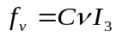 (S3)
where f_{v} is the free volume, I₃ is annihilation intensity, and C is a constant (usually at 0.018).
The cross-linking density (ρ) was calculated by the following equation:
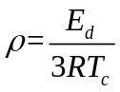 (S4)
where T_{c} is the absolute temperature defined as T_{g} + 30 ℃, E_{d} is storage modulus at the temperature of T_{c}, R is the universal gas constant (8.314 J mol⁻¹ K⁻¹).
Gel fraction of epoxy thermosets was measured by dissolution method. Epoxy thermosets (approximately 800 mg, m₀) was put into a Soxhlet extracted using THF immersing for 24 h followed by drying in a vacuum oven at 80 ℃ until reaching constant weight (m₁). The gel fraction value was calculated using the following equation:
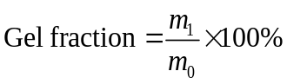 (S5)
The samples (approximately 600 mg, mi) were immersed in different solvents at room temperature for 48 h for swelling. Then the sample was taken out and the solvent on the surface was wiped completely before measuring its weight (mf). The swelling rate was calculated using the following equation:
 (S6)
1.5 All-atom molecular dynamics simulations
Simulations of the structures of the supramolecular thermosets
The molecular dynamics were performed using the software package GROMACS (version 2021.3). The system was constructed by packmol, and concomprised 10 molecules in a cubic box with the edge size of 20 nm, which is large enough for these molecules. The atomic interactions were parameterized by the Generation Amber Force Field (GAFF), and MMFF94 charge obtained from OpenBabel was applied in the calculations. After the energy minimization, the systems were pre-balanced in NPT ensemble with Berendsen method for 5 ns. Then, the production run was carried out in the NVT ensemble at 300 K with the time step of 1 fs. The temperature of the system was controlled by a nose-hoover thermostat (τT=1 ps). After 10 ns of simulation, the hydrogen bond numbers of the systems were analyzed by the toolkits of GROMACS.
Calculation of the cohesive energy
The cohesive energy per chain is defined as the average energy per chain required to separate all the polymer chains in a condensed state into infinite distance from each other. In our systems, the cohesive energy per chain was calculated by the following equation:
$E_{cohesive}=\frac{\left(\sum_{i=1}^{10}{E_{pot}^{isolated}}\left(i\right)-E_{pot}^{10}\right)}{10}$(S7)
where $E_{pot}^{isolated}$ is the average potential energy of an isolated polymer chain in vacuum, $E_{pot}^{10 }$ is the average potential energy of the condensed system consisting of five polymer chains. The potential energies of the isolated polymer chains were calculated by averaging 20 frames in 100 picoseconds after the equilibrium simulation of 1 nanosecond. For the condensed system, the potential energy was calculated via the same method after the annealing simulation.
2. SUPPORTING FIGURES AND TABLES
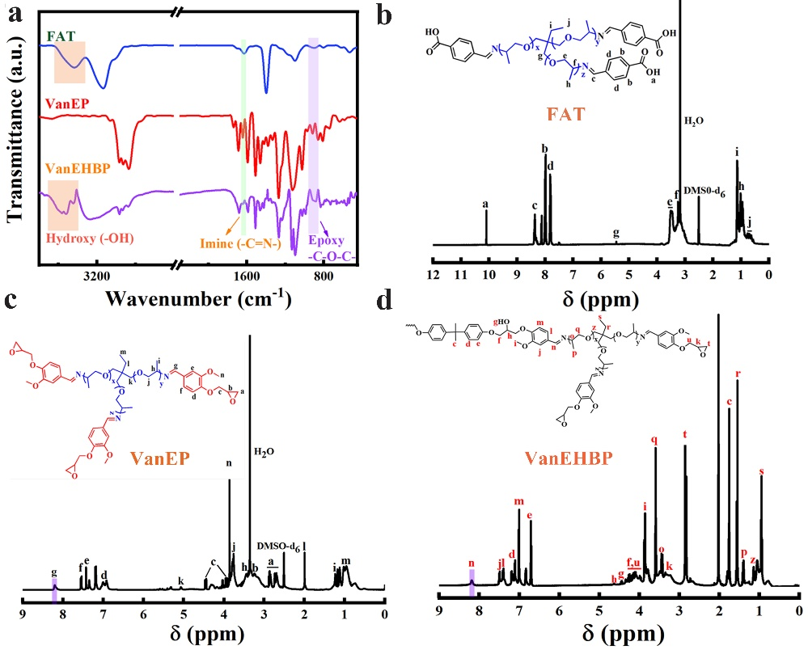
Supplementary Figure 1. (a) FT-IR spectra of CBA-TTE, VanEP and VanEHBP, ¹H NMR spectra of (b) FAT, (c) VanEP, and (d) VanEHBP.
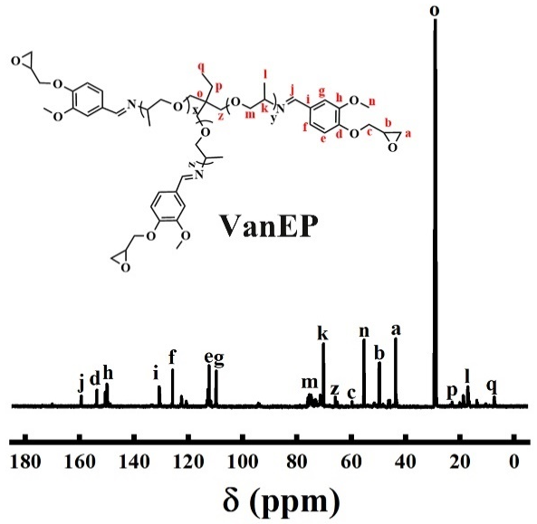
Supplementary Figure 2. ¹³C NMR spectrum of VanEP.

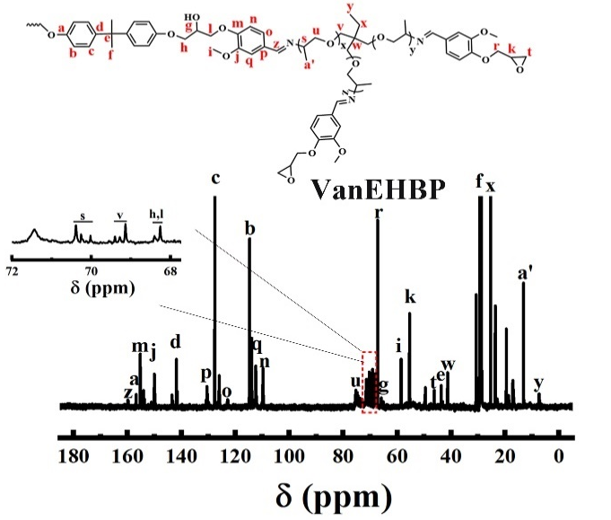
Supplementary Figure 3. ¹³C NMR spectrum of VanEHBP.

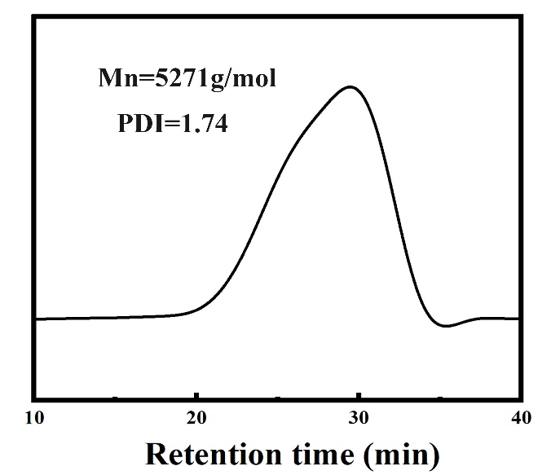
Supplementary Figure 4. GPC curve of VanEHBP.
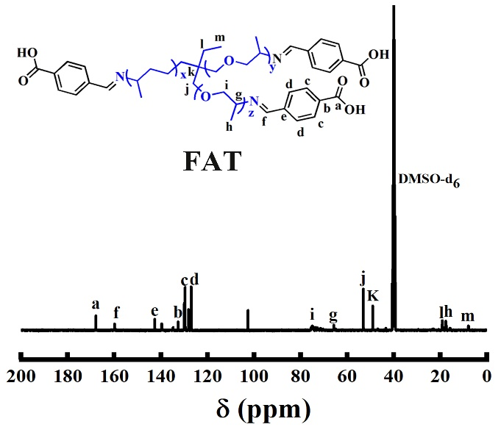
Supplementary Figure 5. ¹³C NMR spectrum of CBA-TTE.

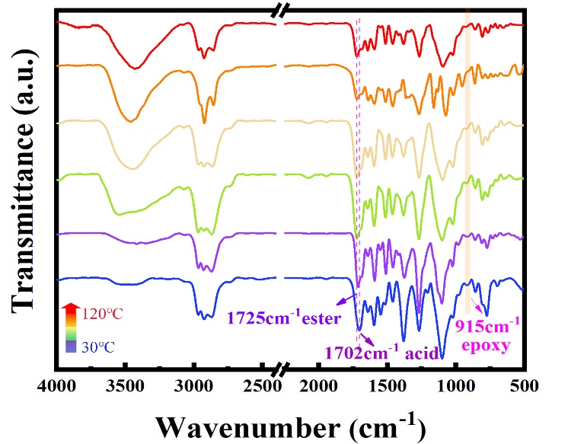
Supplementary Figure 6. Temperature-dependent FT-IR spectra of epoxy thermosets during curing process.
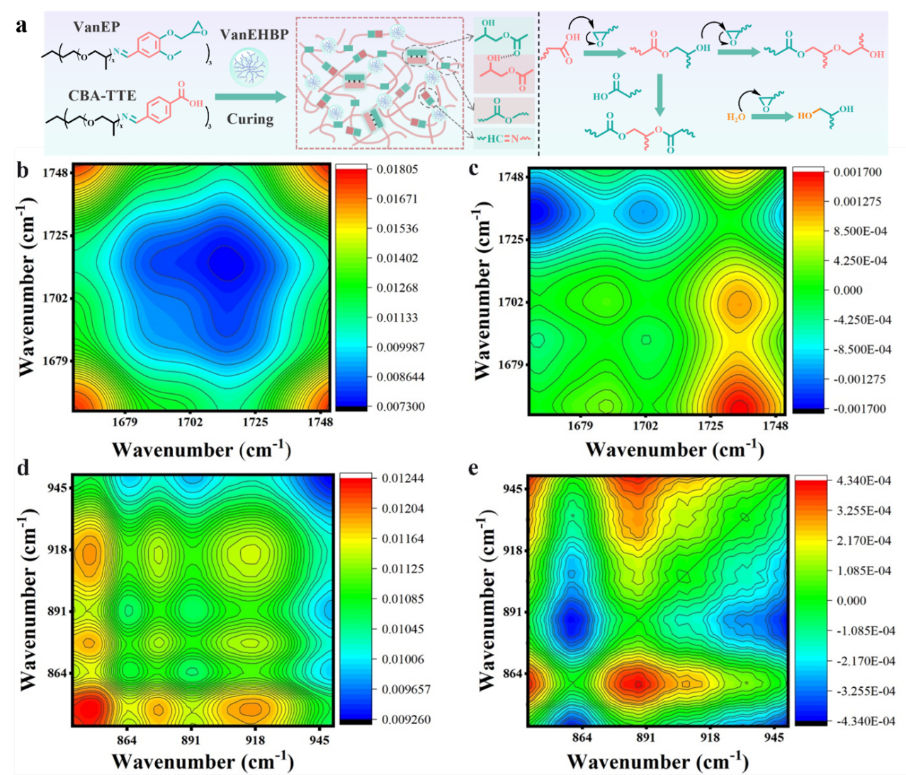
Supplementary Figure 7. (a) Conceptual illustration of crosslinking reaction of epoxy thermosets. Generalized synchronous (b, d) and asynchronous (c, e) 2D correlation spectra of EN-VanEHBP7 calculated from the temperature-dependent FT-IR spectra in the regions of 1660-1750 cm⁻¹ vs. 1660-1750 cm⁻¹ (b and c), and 840-950 cm⁻¹ vs. 840-950 cm⁻¹ (d and e).

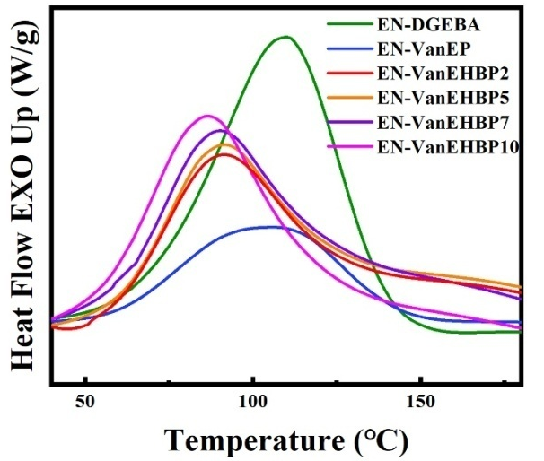
Supplementary Figure 8. DSC curves of epoxy thermosets.

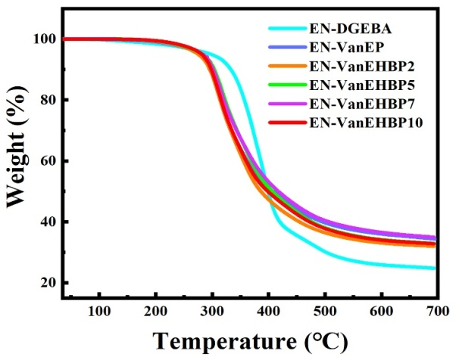
Supplementary Figure 9. TGA curves of epoxy thermosets.

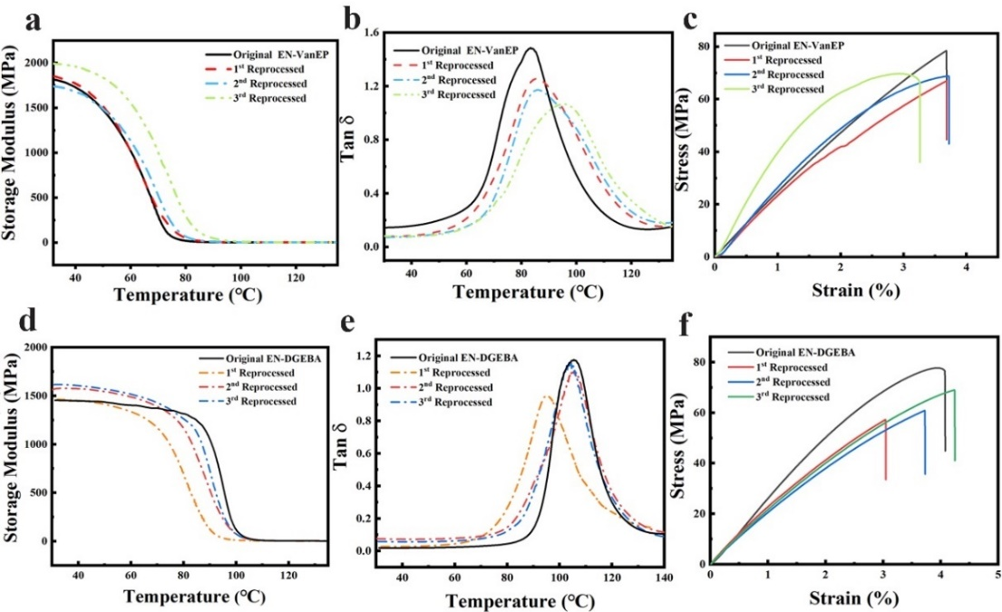
Supplementary Figure 10. Storage modulus (a), tanδ (b) and stress-strain curves (c) of original and reprocessed EN-VanEP. Storage modulus (d), tanδ (e) and stress-strain curves (f) of original and reprocessed EN-DGEBA.

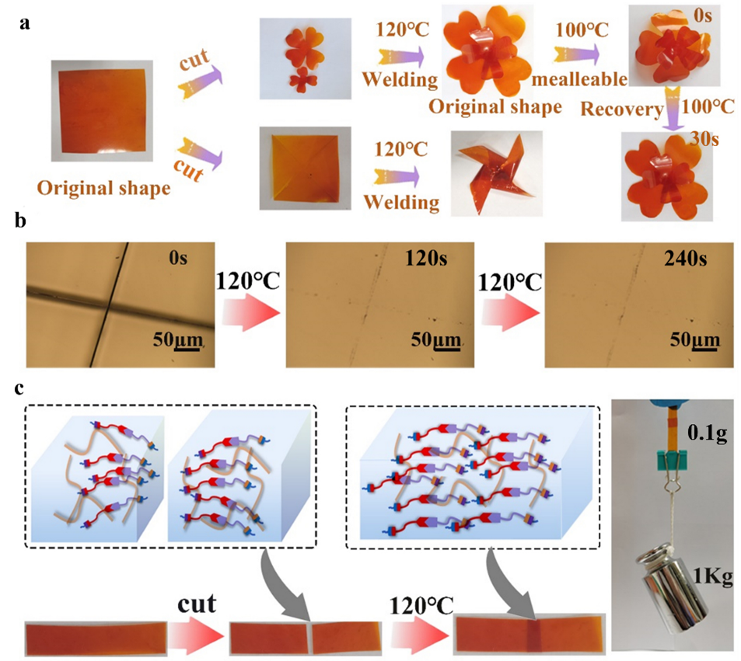
Supplementary Figure 11. (a) Photographs of EN-VanEHBP7 samples deformed at different temperature, followed by the shape recovery at different temperature. (b) Optical microscope images of EN-VanEHBP7 scratch and self-healing experiment at 120 ℃. (c) Welding tests of the EN-VanEHBP7 at 120 ℃.

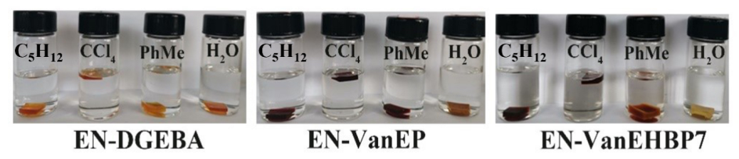
Supplementary Figure 12. Solvent resistance of epoxy thermosets in C₅H₁₂, CCl₄, PhMe and H₂O at room temperature for 72 h.
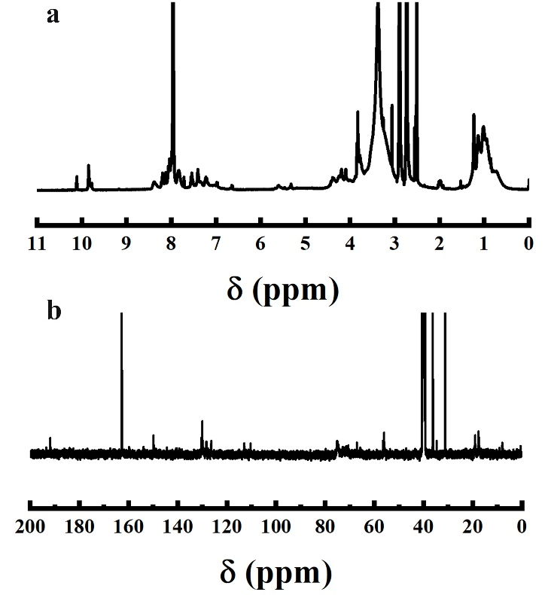
Supplementary Figure 13. (a) ¹H NMR and (b) ¹³C NMR spectra of depolymerized EN-VanEHBP7.

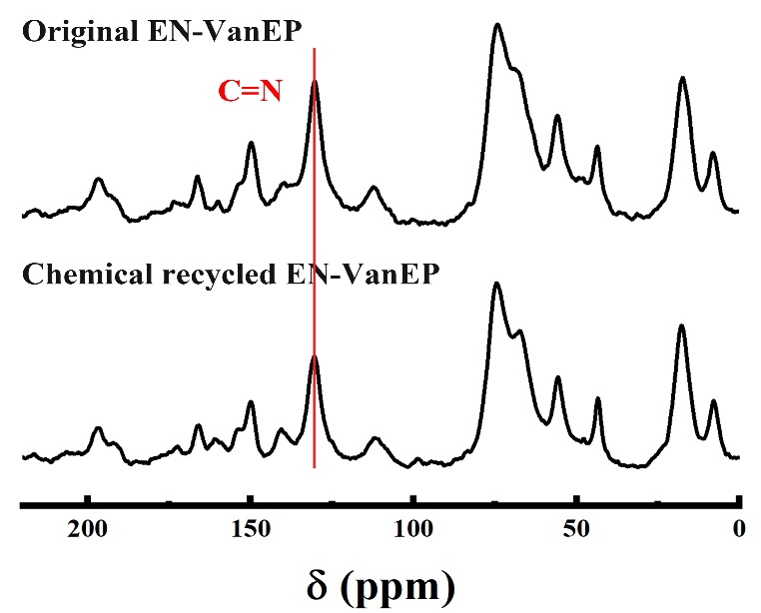
Supplementary Figure 14. Solid-state ¹³C NMR spectra of original and chemical recycled EN-VanEP.
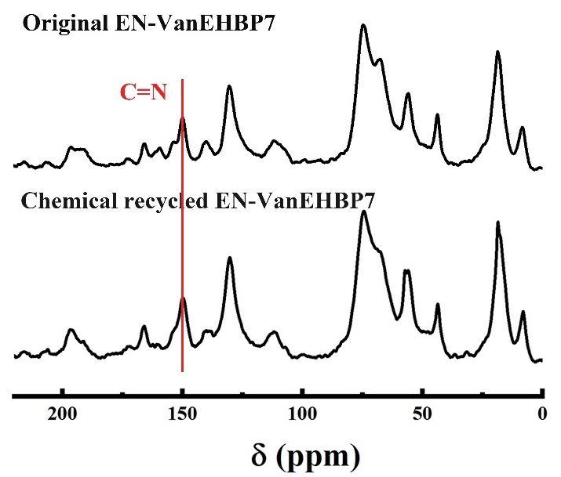
Supplementary Figure 15. Solid-state ¹³C NMR spectra of original and chemical recycled EN-VanEHBP7.

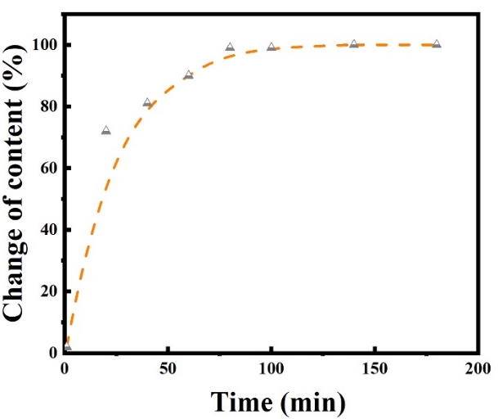
Supplementary Figure 16. The content of aldehyde group as a function of time.

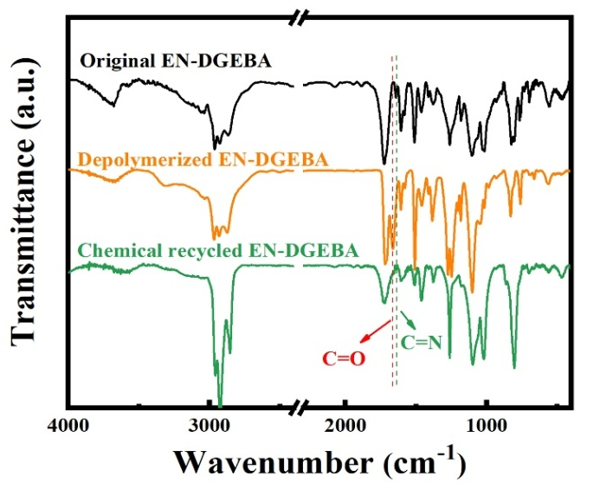
Supplementary Figure 17.The FT-IR spectra of original, depolymerized and chemical recycled EN-DGEBA.

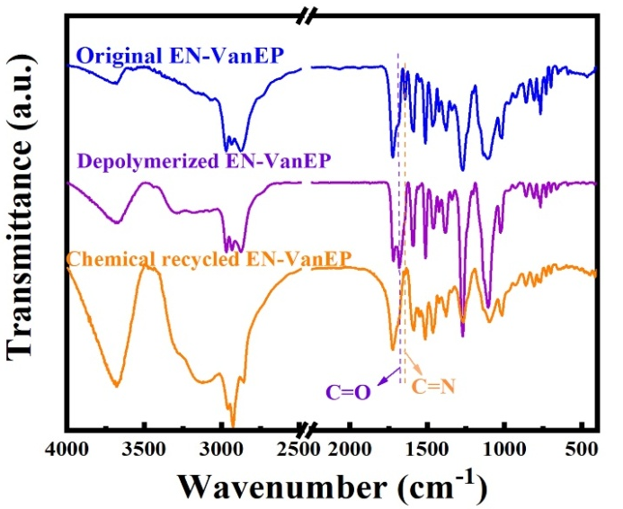
Supplementary Figure 18. The FT-IR spectra of original, depolymerized and chemical recycled EN-VanEP.
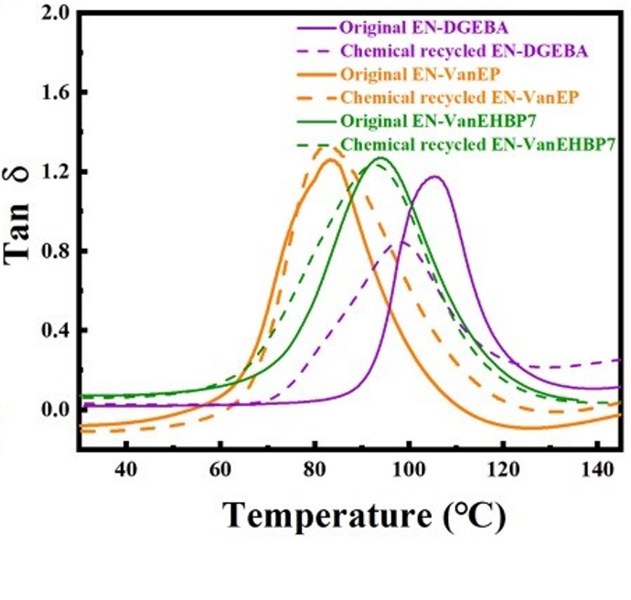
Supplementary Figure 19. Tan δ vs temperature of epoxy thermosets before and after chemical recycling.

Supplementary Table 1. Composition of epoxy thermosets
Samples | DGEBA (g) | VanEP (g) | VanEHBP (g) | FAT (g)
EN-DGEBA | 10.00 | 0.00 | 0.00 | 15.81
EN-VanEP | 0.00 | 10.00 | 0.00 | 8.37
EN-VanEHBP2 | 0.00 | 10.00 | 0.20 | 8.48
EN-VanEHBP5 | 0.00 | 10.00 | 0.50 | 8.65
EN-VanEHBP7 | 0.00 | 10.00 | 0.70 | 8.76
EN-VanEHBP10 | 0.00 | 10.00 | 1.00 | 8.93

Supplementary Table 2. DSC characteristic parameters of epoxy thermosets
Samples | T_{i} (℃)ª | T_{p} (℃)^{b} | ΔH (J•g⁻¹)^{c}
EN-DGENA | 68 | 110 | 282
EN-VanEP | 59 | 106 | 117
EN-VanEHBP2 | 59 | 91 | 140
EN-VanEHBP5 | 59 | 91 | 145
EN-VanEHBP7 | 58 | 89 | 197
EN-VanEHBP10 | 54 | 86 | 204
ªT_{i} is the initial reaction temperature, ^{b}T_{p} is the peak reaction temperature, ^{c}ΔH is reaction activation energy.

Supplementary Table3. TGA data of epoxy thermosets under nitrogen atmosphere
Samples | T_{d5%} (ºC)ª | T_{d10%} (ºC)^{b} | T_{dmax} (ºC)^{c} | Char₇₀₀ (%)^{d}
EN-DGEBA | 298 | 333 | 392 | 25
EN-VanEP | 281 | 298 | 317 | 33
EN-VanEHBP2 | 280 | 296 | 313 | 33
EN-VanEHBP5 | 280 | 297 | 315 | 33
EN- VanEHBP7 | 283 | 302 | 314 | 35
EN- VanEHBP10 | 281 | 298 | 313 | 33
ªT_{d5%} and ^{b}T_{d10%} are the temperature of weight loss of 5% and 10%, respectively, ^{c}T_{dmax} is the temperature of degradation rate reaches a maximum, ^{d}Char₇₀₀ is char yield at 700 ºC.

Supplementary Table 4. Mechanical and thermo-mechanical properties of epoxy thermosets
Samples | Tensile strength  (MPa) | Toughness  (MJ·m⁻³) | E_{c} (GPa)ª | T_{g} (℃)^{b} | E_{d} (MPa)^{c} | ρ (×10⁻³ mol·cm⁻³)^{d}
EN-DGEBA | 71.7±5.4 | 1.72±0.17 | 1.5 | 105 | 2.9 | 0.29
EN-VanEP | 72.6±5.1 | 1.54±0.06 | 1.8 | 83 | 1.3 | 0.14
EN-VanEHBP2 | 84.3±0.9 | 1.83±0.15 | 1.7 | 86 | 1.3 | 0.13
EN-VanEHBP5 | 90.5±0.7 | 2.62±0.09 | 2.4 | 92 | 3.0 | 0.30
EN-VanEHBP7 | 103.9±3.1 | 3.58±0.12 | 2.8 | 95 | 4.6 | 0.46
EN-VanEHBP10 | 85.1±2.6 | 2.10±0.10 | 2.1 | 86 | 2.8 | 0.29
ªE_{c} is the storage modulus at 30 ℃, ^{b}T_{g} is the glass transition temperature, ^{c}E_{d} is the storage modulus at T_{g} + 30 ℃, ^{d}ρ is the crosslinking density of epoxy thermosets.

Supplementary Table 5. PALS data and free volume fraction of epoxy thermosets
Samples | I₃ (%) | R (nm) | f_{v} (%)
EN-DGEBA | 8.74 | 2.72 | 13.42
EN-VanEP | 5.68 | 2.55 | 7.15
EN-VanEHBP2 | 5.81 | 2.73 | 8.96
EN-VanEHBP5 | 6.33 | 2.56 | 8.01
EN-VanEHBP7 | 6.05 | 2.55 | 7.52
EN-VanEHBP10 | 5.32 | 2.23 | 8.14

Supplementary Table 6. Tensile strength of original, reprocessed and chemical recycled epoxy thermosets
Samples | EN-DGEBA | EN-VanEP | EN-VanEHBP7
Original | 71.7±5.4 | 72.6±5.1 | 103.9±3.1
1stReprocessed | 58.7±2.0 | 68.4±1.4 | 94.6±2.8
2ndReprocessed | 58.2±3.8 | 68.7±1.1 | 95.3±4.7
3rdReprocessed | 58.4±4.9 | 69.1±1.5 | 94.3±1.0
Chemical recycled | 58.9±1.3 | 66.2±3.1 | 97.2±2.1

Supplementary Table 7. DMA data of original, reprocessed and chemical recycled EN-DGEBA
Samples | E_{c} (GPa) | T_{g} (℃) | E_{d} (MPa) | ρ (×10⁻³ mol·cm⁻³)
Original | 1.5 | 105 | 2.9 | 0.29
1stReprocessed | 1.5 | 95 | 2.8 | 0.28
2ndReprocessed | 1.6 | 106 | 2.5 | 0.25
3rdReprocessed | 1.6 | 104 | 3.2 | 0.31
Chemical recycled | 1.4 | 99 | 2.0 | 0.20

Supplementary Table 8. DMA data of original, reprocessed and chemical recycled EN-VanEP
Samples | E_{c} (GPa) | T_{g} (℃) | E_{d} (MPa) | ρ(×10⁻³ mol·cm⁻³)
Original | 1.8 | 83 | 1.3 | 0.14
1stReprocessed | 1.8 | 85 | 1.0 | 0.10
2ndReprocessed | 1.7 | 85 | 1.0 | 0.10
3rdReprocessed | 1.9 | 94 | 1.3 | 0.13
Chemical recycled | 1.6 | 82 | 1.0 | 0.10

Supplementary Table 9. DMA data of original, reprocessed and chemical recycled EN-VanEHBP7
Samples | E_{c} (GPa) | T_{g} (℃) | E_{d} (MPa) | ρ(×10⁻³ mol·cm⁻³)
Original | 2.8 | 95 | 4.6 | 0.46
1st Reprocessed | 2.7 | 94 | 3.2 | 0.32
2nd Reprocessed | 2.6 | 90 | 4.2 | 0.43
3rd Reprocessed | 2.6 | 98 | 4.4 | 0.44
Chemical recycled | 2.8 | 93 | 4.5 | 0.45

Supplementary Table 10. The swelling rate and gel fraction of epoxy thermosets
Samples |  | Swelling rate (%) |  |  |  | Gel fraction  (%)
Samples |  | H₂O | EtOH | THF | DMF | Gel fraction  (%)
EN-DGEBA |  | 1.6 | 1.6 | 14.7 | 35.3 | 95.0
EN-VanEP |  | 2.5 | 5.0 | 13.6 | 44.0 | 94.1
EN-VanEHBP7 |  | 1.2 | 4.5 | 12.0 | 30.4 | 95.6

