Supporting Information
Exploring chalcone-sulfonyl piperazine hybrids as anti-diabetes candidates: Design, synthesis, biological evaluation, and molecular docking study
Narges Hosseini Nasab, Hussain Raza, Young Seok Eom, Fahad Hassan Shah, Song Ja Kim*
ª Department of Biological Sciences, Kongju National University, Gongju, Chungnam 32588, Republic of Korea
*Correspondence: ksj85@kongju.ac.kr

Supporting Figure captions:
Fig. S1: ¹H NMR Spectrum of 3
Fig. S2: IR Spectrum of 5a
Fig. S3: ¹H NMR Spectrum of 5a
Fig. S4: ¹³C NMR Spectrum of 5a
Fig. S5: IR Spectrum of 5b
Fig. S6: ¹H NMR Spectrum of 5b
Fig. S7: ¹³C NMR Spectrum of 5b
Fig. S8: IR Spectrum of 5c
Fig. S9: ¹H NMR Spectrum of 5c
Fig. S10: ¹³C NMR Spectrum of 5c
Fig. S11: IR Spectrum of 5d
Fig. S12: ¹H NMR Spectrum of 5d
Fig. S13: ¹³C NMR Spectrum of 5d
Fig. S14: HRMS Spectrum of 5d
Fig. S15: IR Spectrum of 5e
Fig. S16: ¹H NMR Spectrum of 5e
Fig. S17: ¹³C NMR Spectrum of 5e
Fig. S18: HRMS Spectrum of 5e
Fig. S19: IR Spectrum of 5f
Fig. S20: ¹H NMR Spectrum of 5f
Fig. S21: ¹³C NMR Spectrum of 5f
Fig. S22: HRMS Spectrum of 5f
Fig. S23: IR Spectrum of 5g
Fig. S24: ¹H NMR Spectrum of 5g
Fig. S25: ¹³C NMR Spectrum of 5g
Fig. S26: IR Spectrum of 5h
Fig. S27: ¹H NMR Spectrum of 5h
Fig. S28: ¹³C NMR Spectrum of 5h
Fig. S29: IR Spectrum of 5i
Fig. S30: ¹H NMR Spectrum of 5i
Fig. S31: ¹³C NMR Spectrum of 5i
Fig. S32: IR Spectrum of 5j
Fig. S33: ¹H NMR Spectrum of 5j
Fig. S34: ¹³C NMR Spectrum of 5j
Fig. S35: HRMS Spectrum of 5j
Fig. S36: IR Spectrum of 5k
Fig. S37: ¹H NMR Spectrum of 5k
Fig. S38: ¹³C NMR Spectrum of 5k
Fig. S39: HRMS Spectrum of 5k

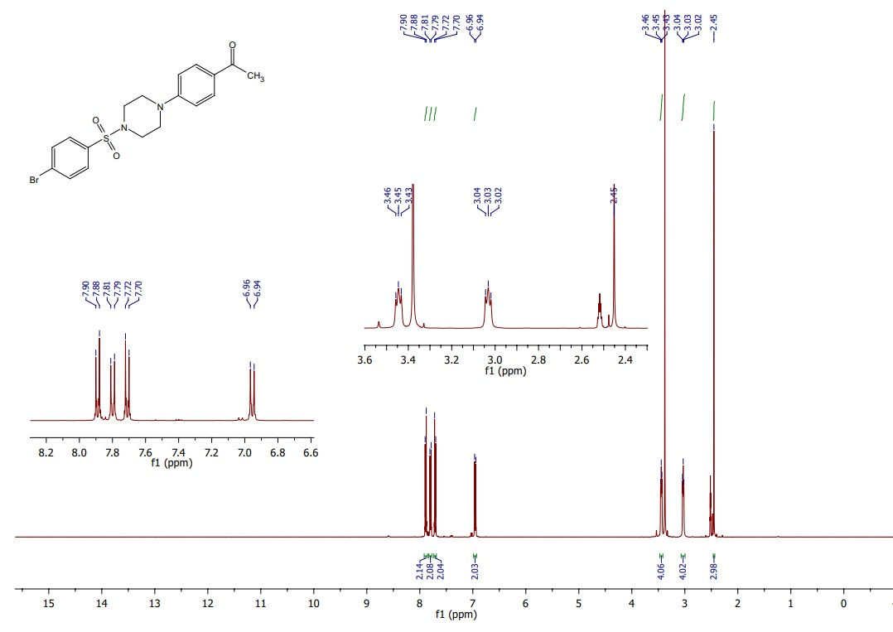
Fig. S1, ES‡

Fig. S2, ES‡

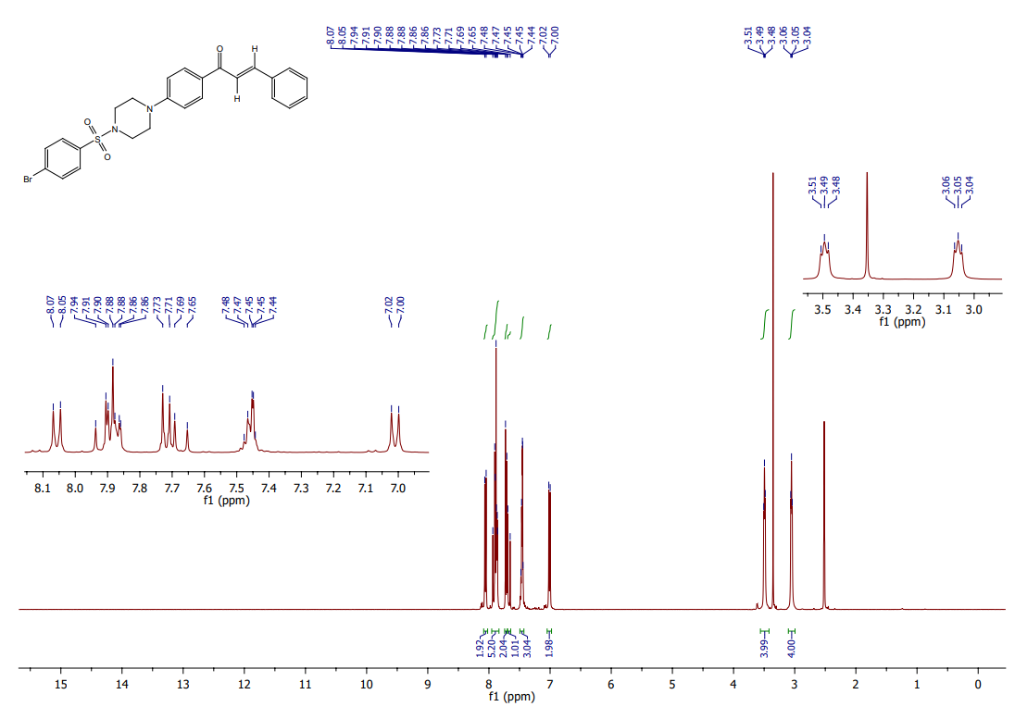
Fig. S3, ES‡

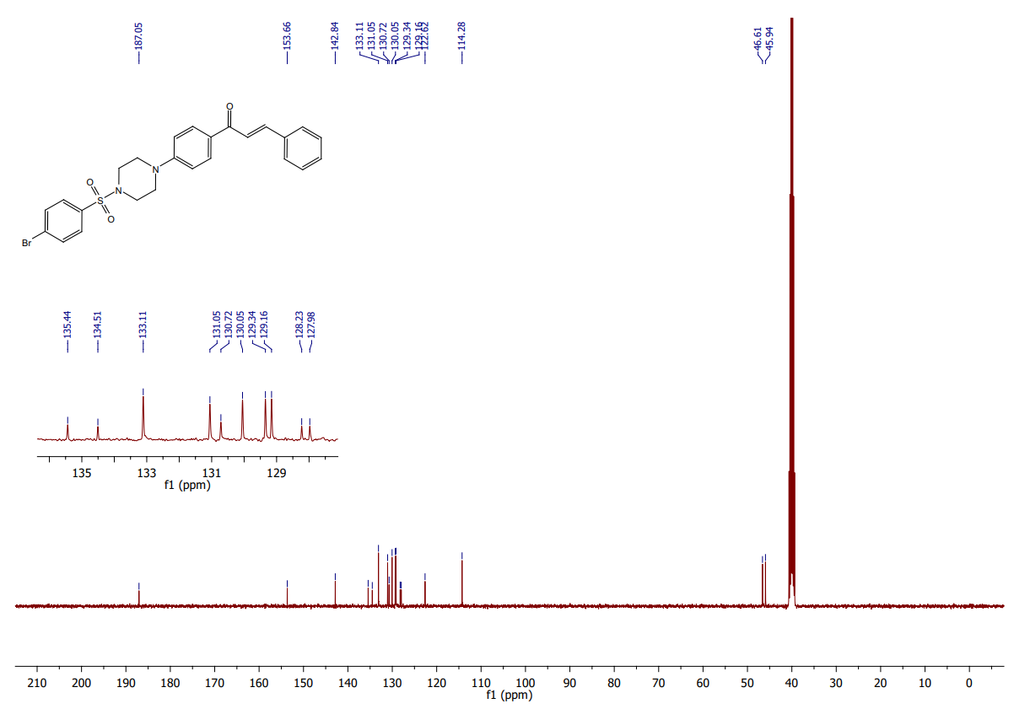
Fig. S4, ES‡

Fig. S5, ES‡

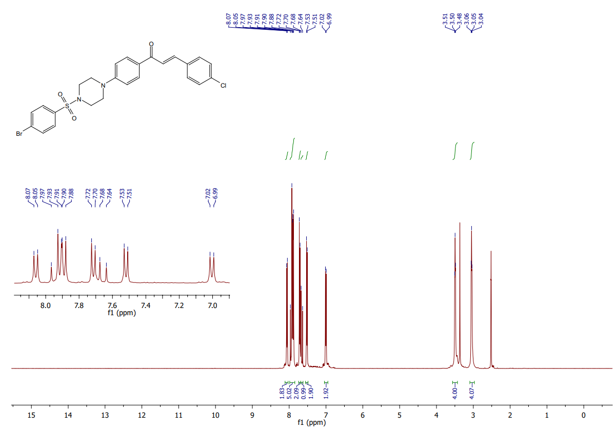
Fig. S6, ES‡

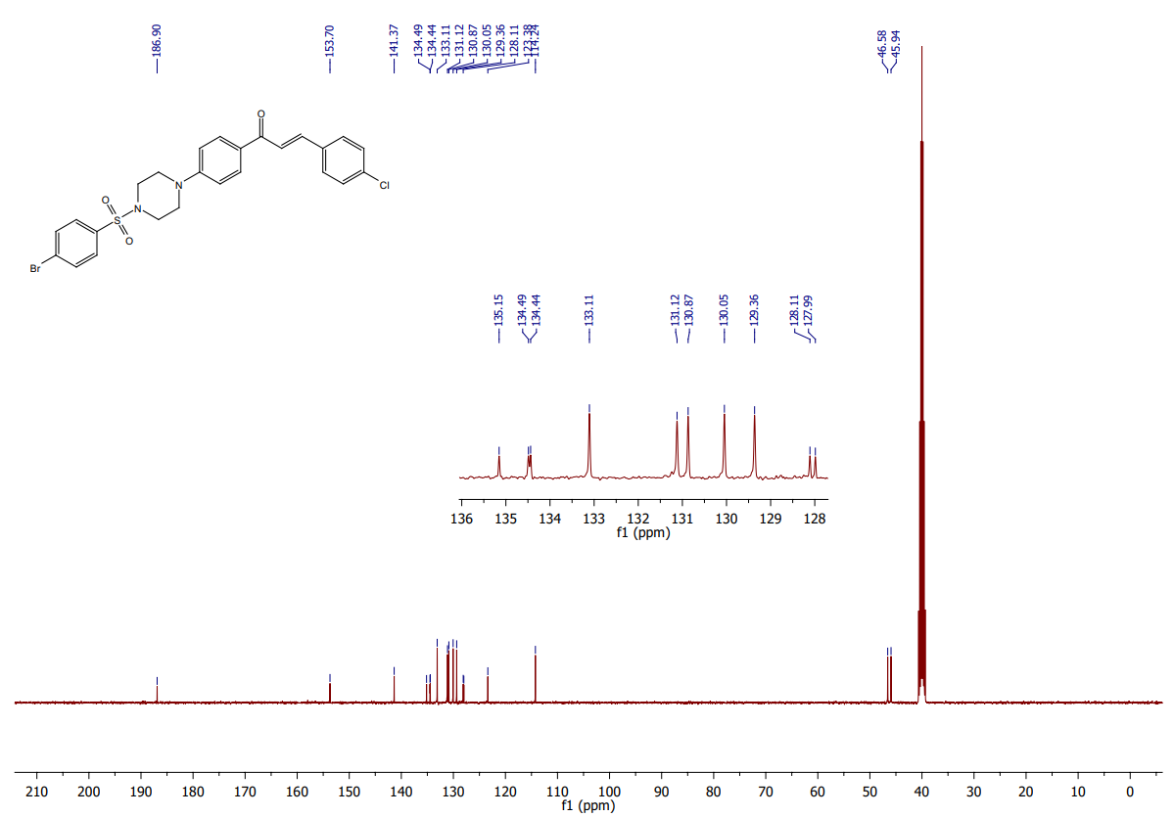
Fig. S7, ES‡

Fig. S8, ES‡

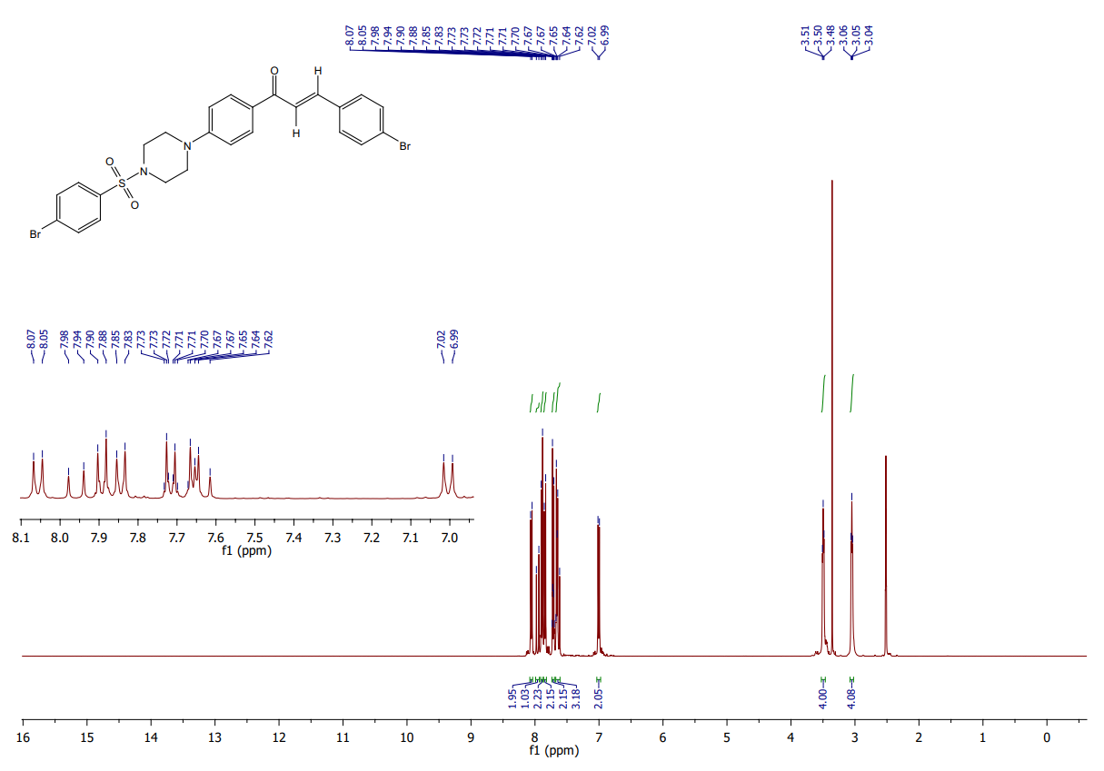
Fig. S9, ES‡

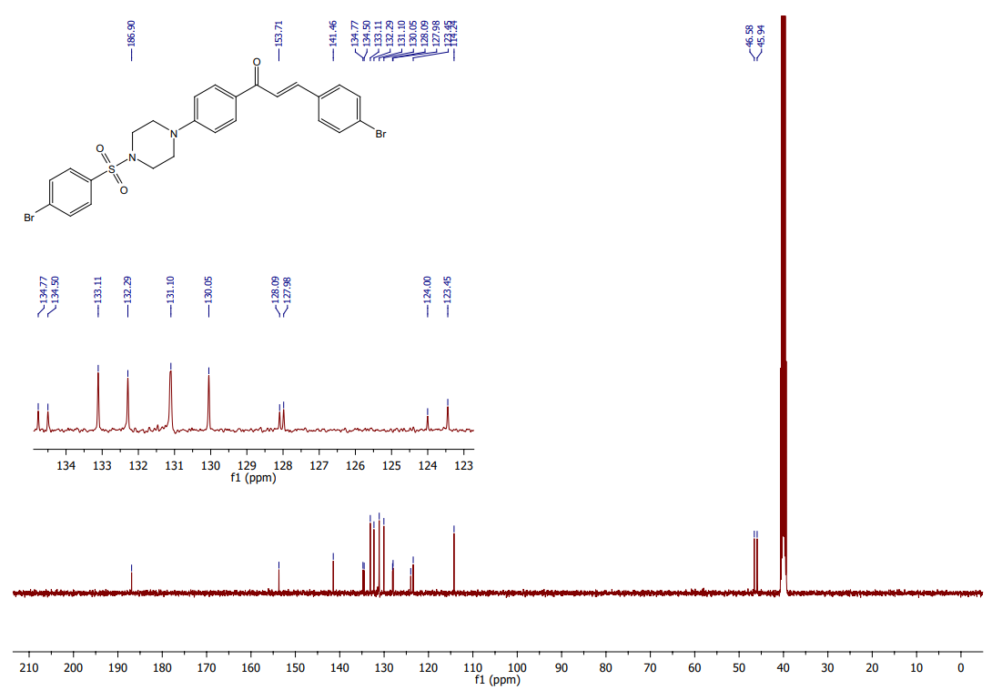
Fig. S10, ES‡

Fig. S11, ES‡

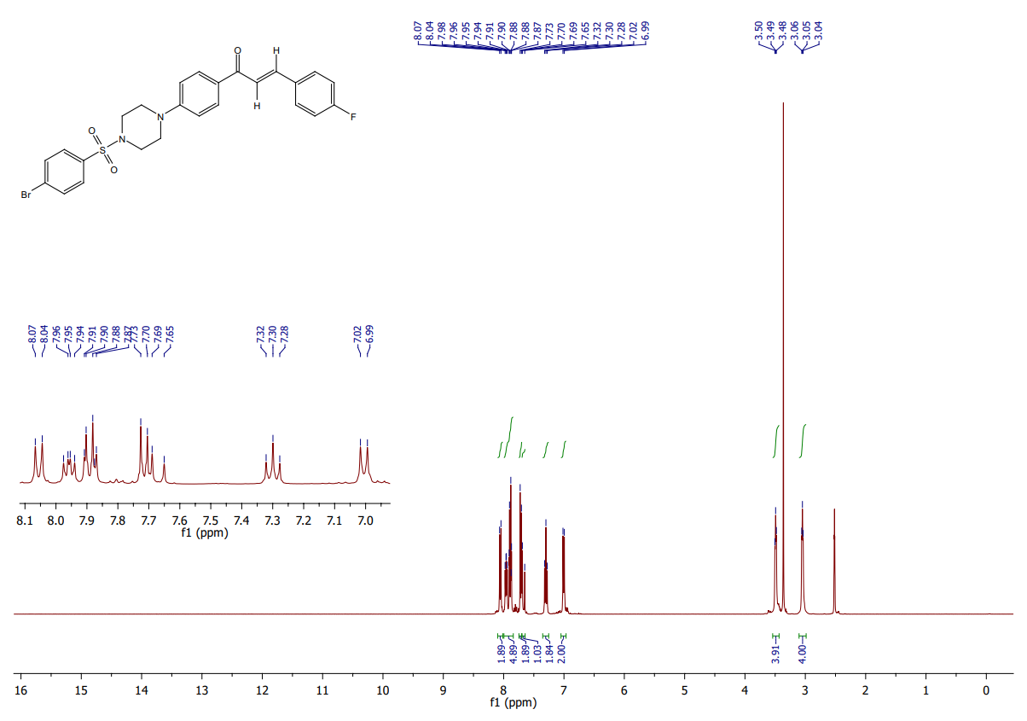
Fig. S12, ES‡

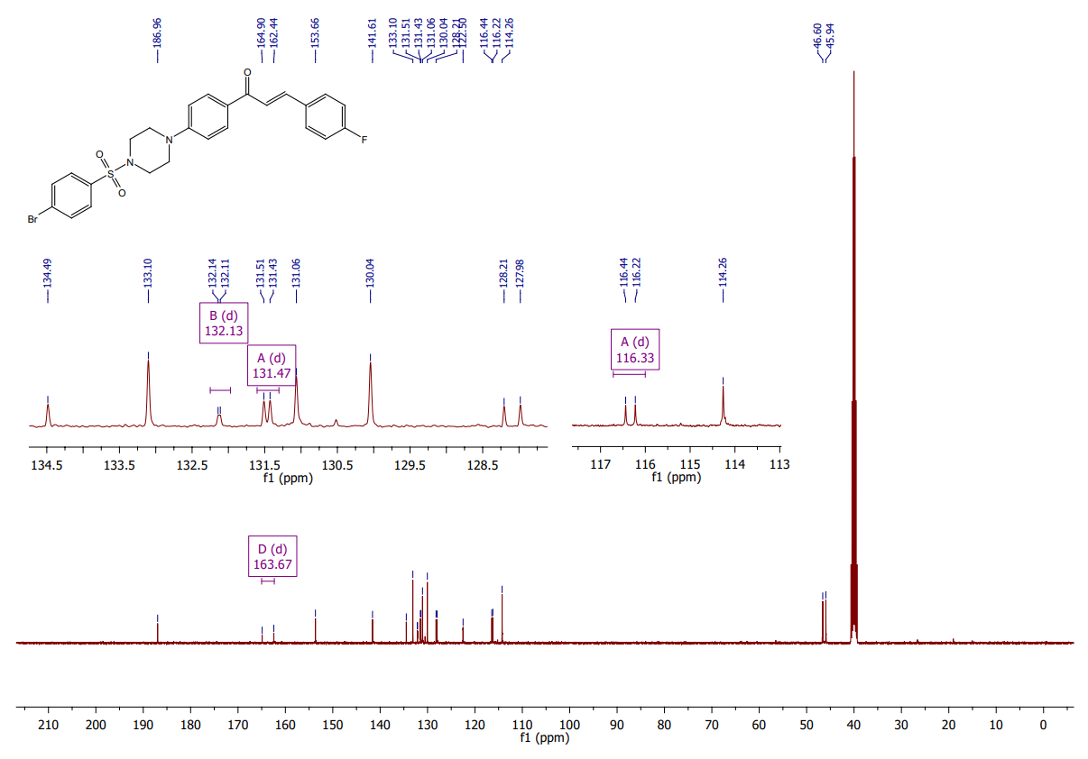
Fig. S13, ES‡

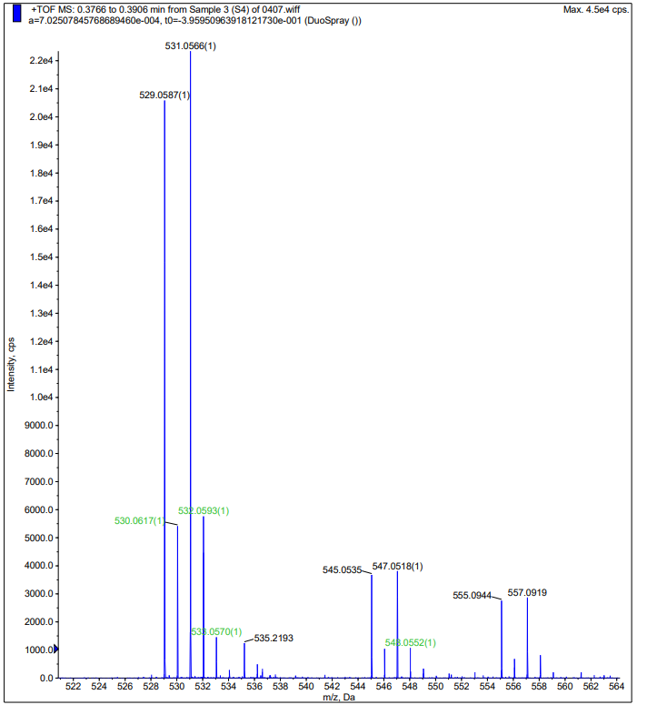
Fig. S14, ES‡

Fig. S15, ES‡

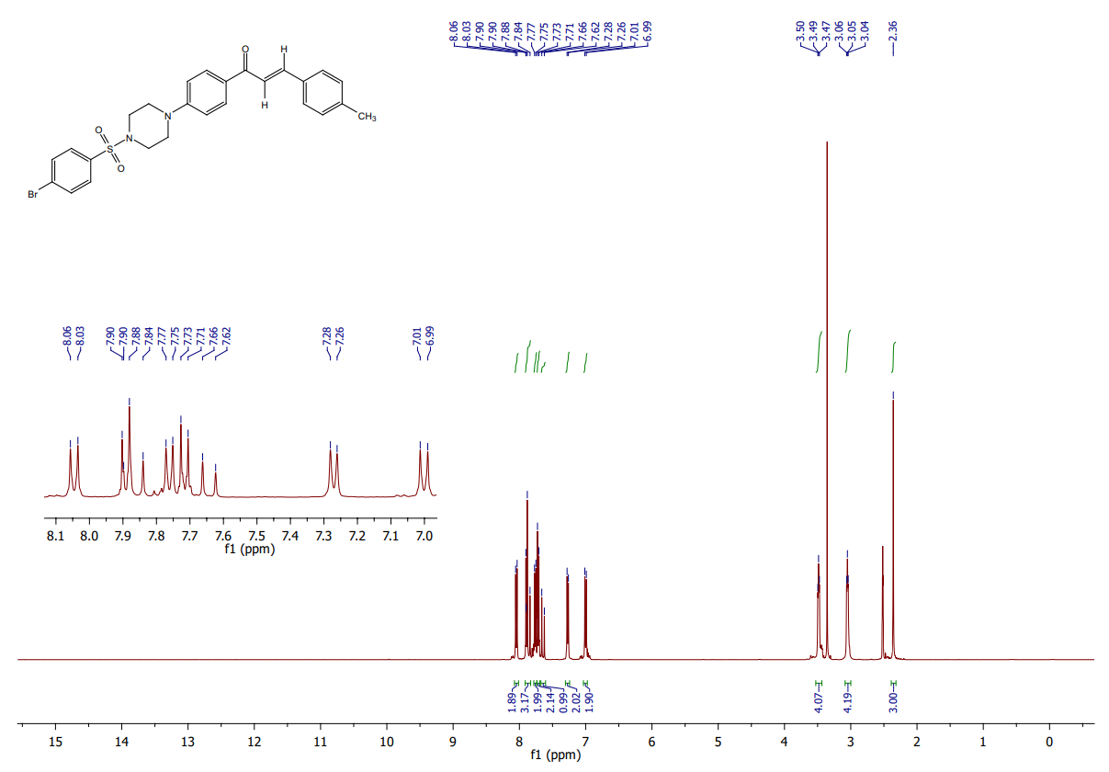
Fig. S16, ES‡

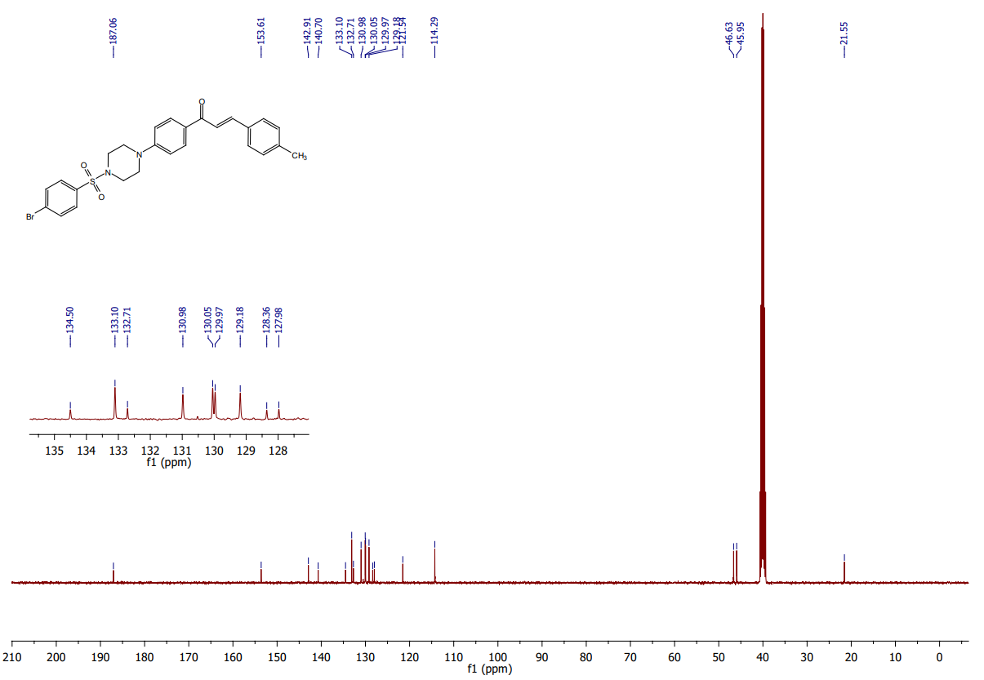
Fig. S17, ES‡

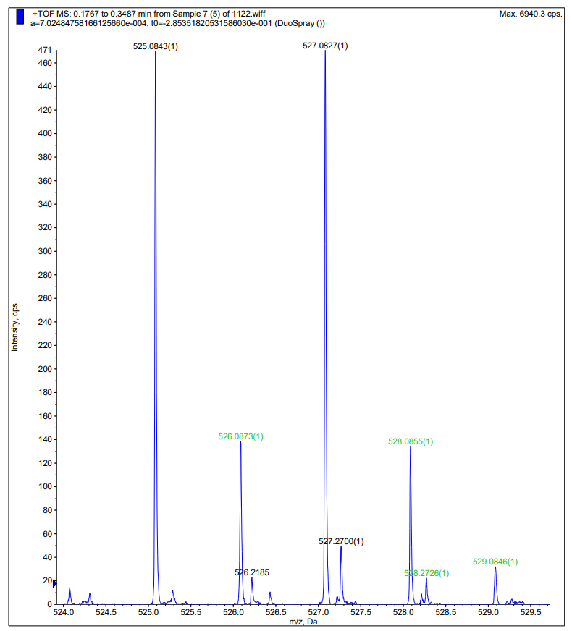
Fig. S18, ES‡

Fig. S19, ES‡

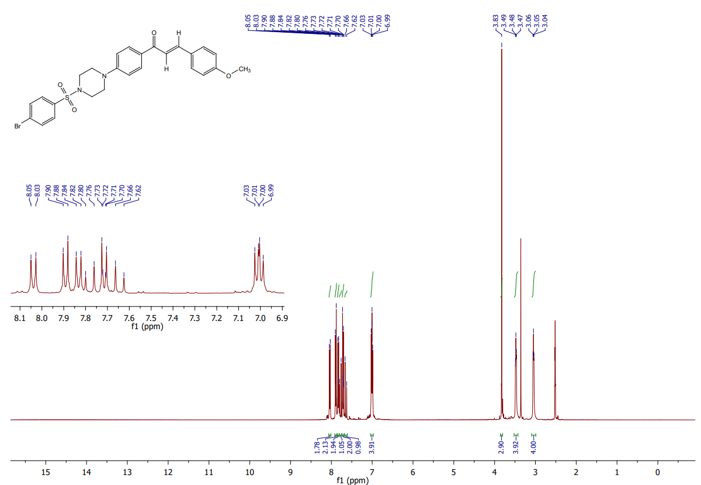
Fig. S20, ES‡

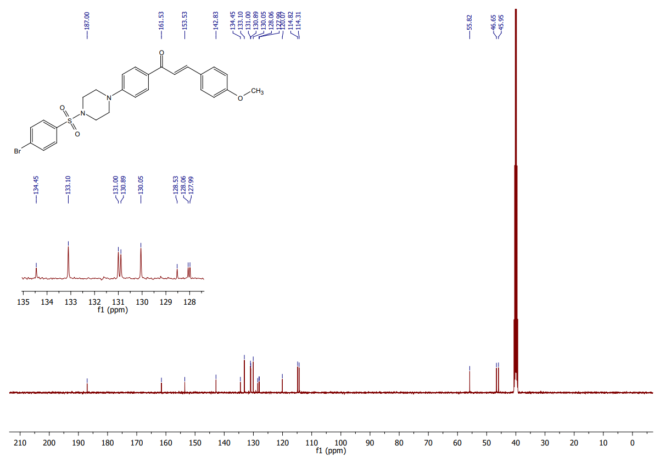
Fig. S21, ES‡

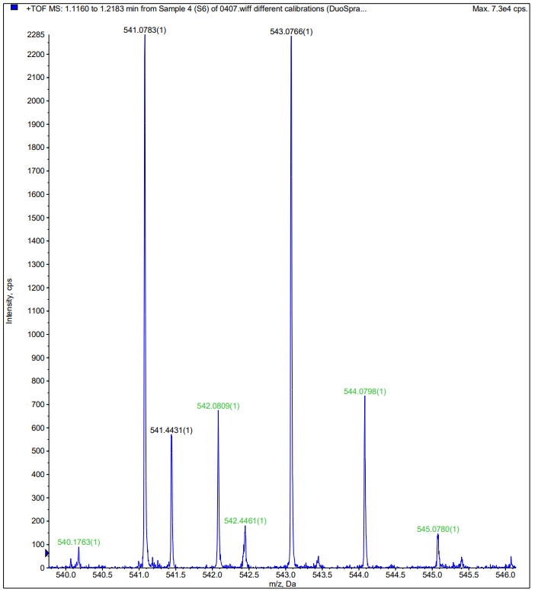
Fig. S22, ES‡

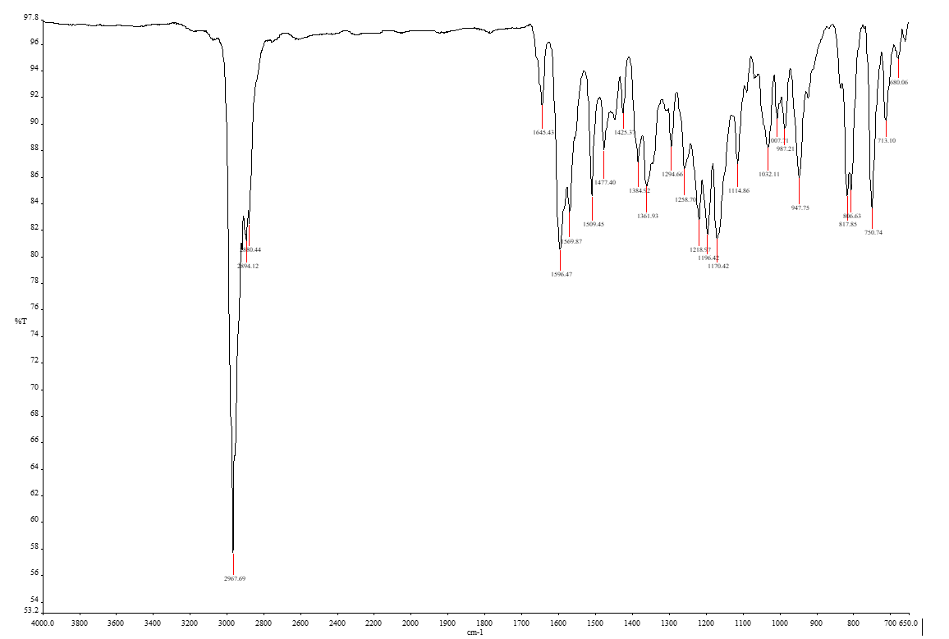
Fig. S23, ES‡

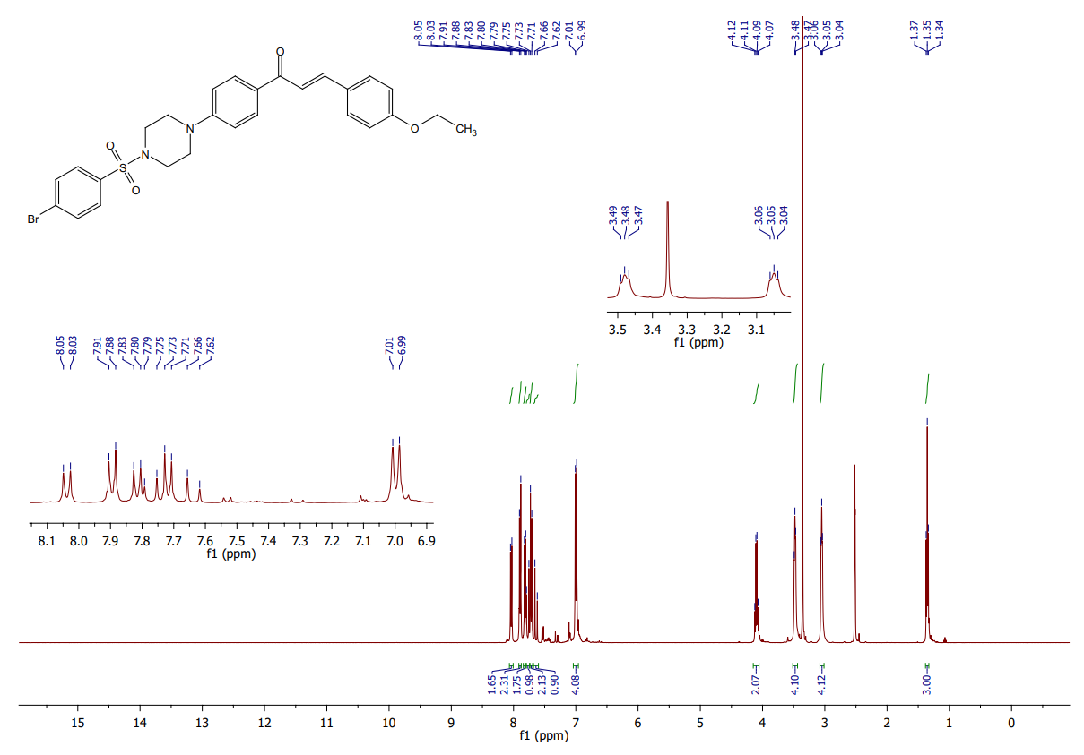
Fig. S24, ES‡

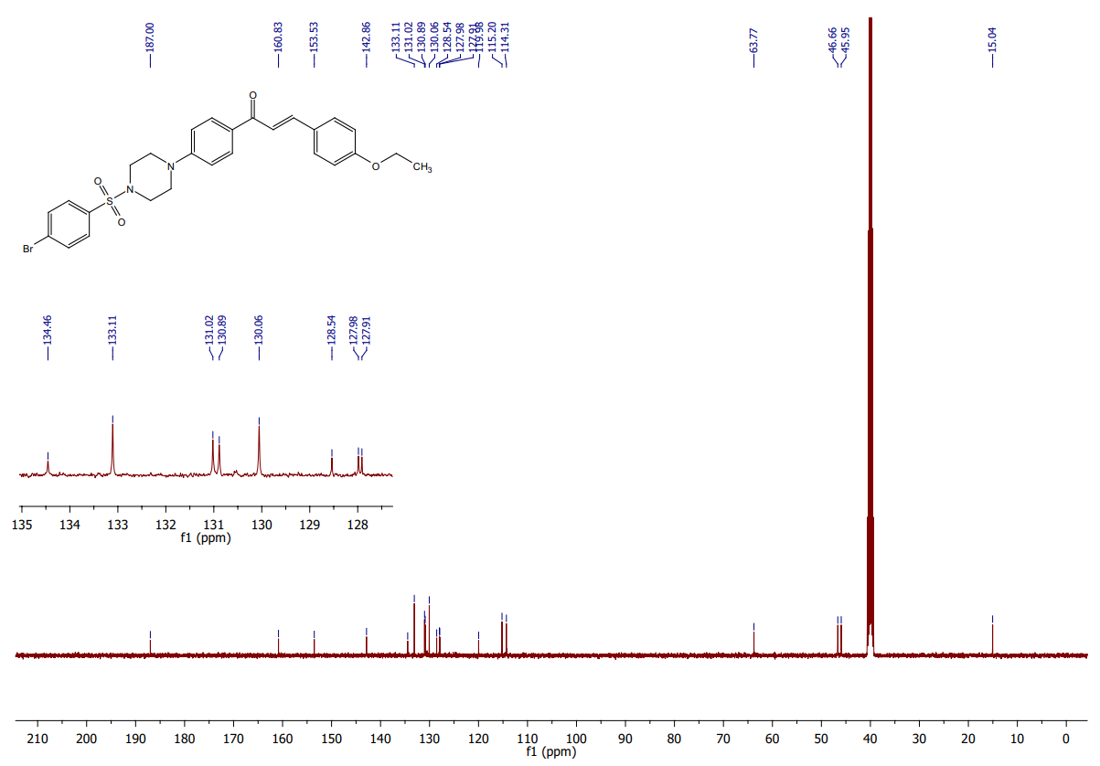
Fig. S25, ES‡

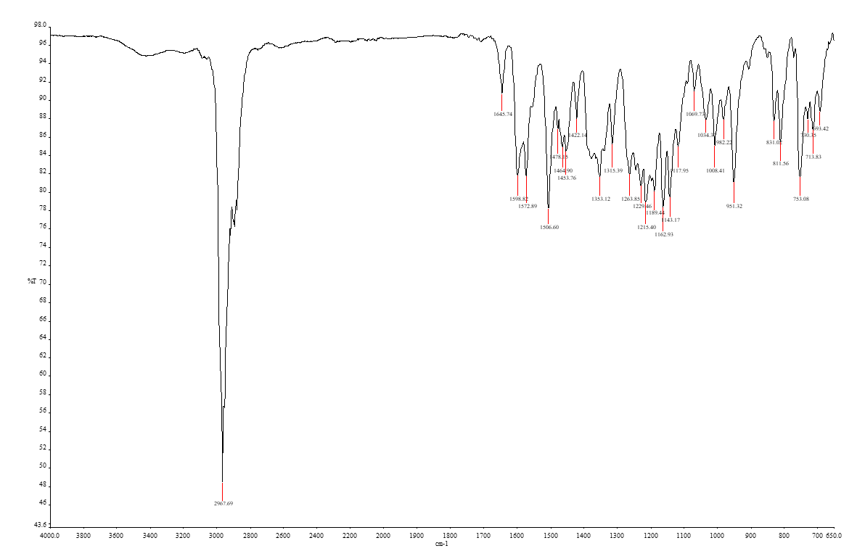
Fig. S26, ES‡

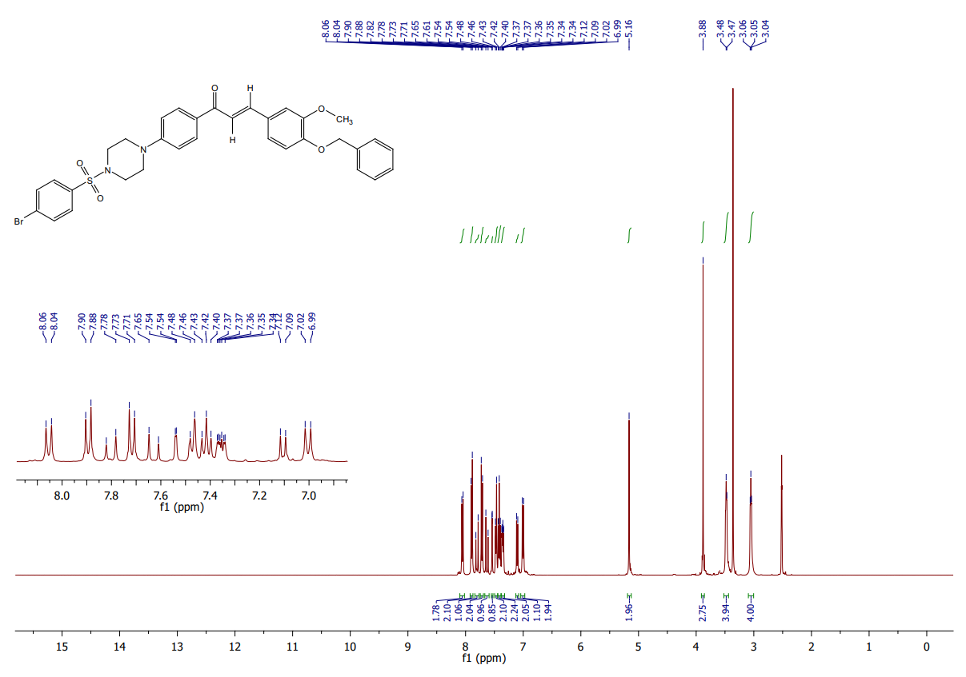
Fig. S27, ES‡

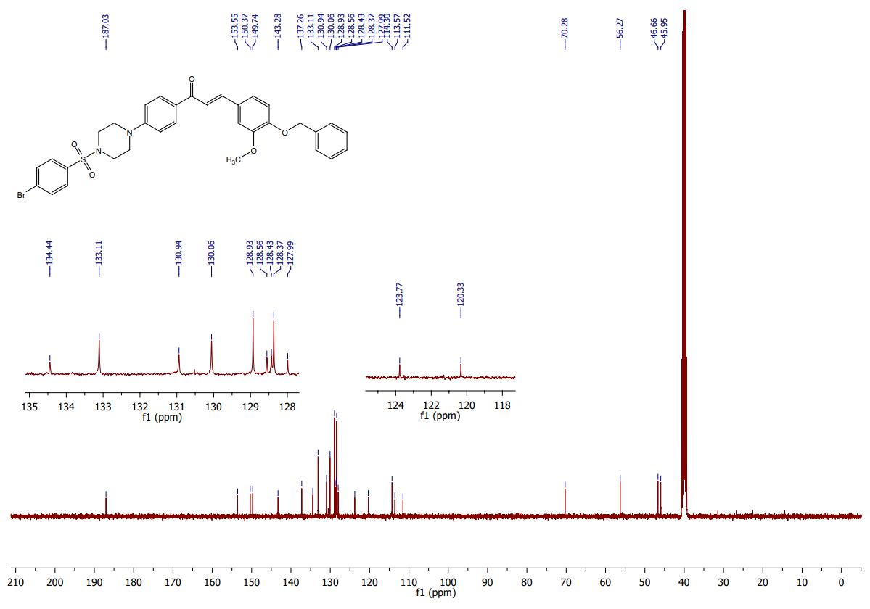
Fig. S28, ES‡

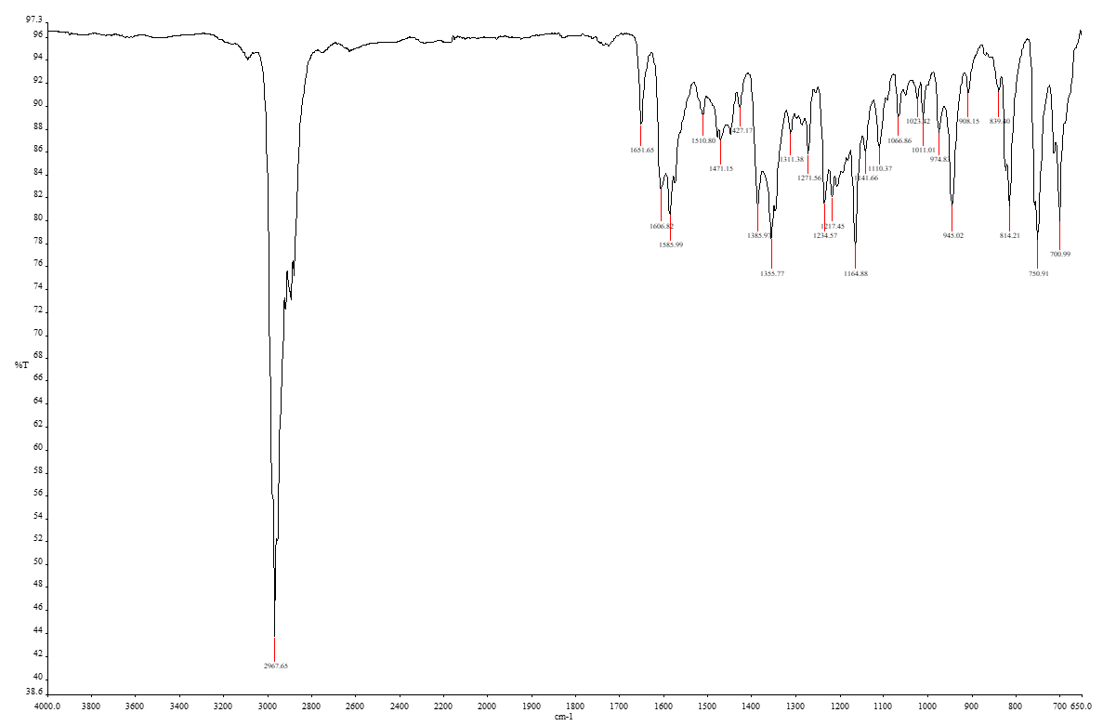
Fig. S29, ES‡

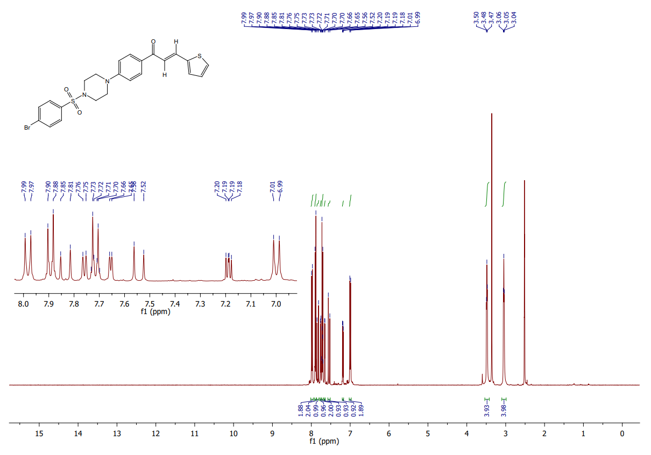
Fig. S30, ES‡

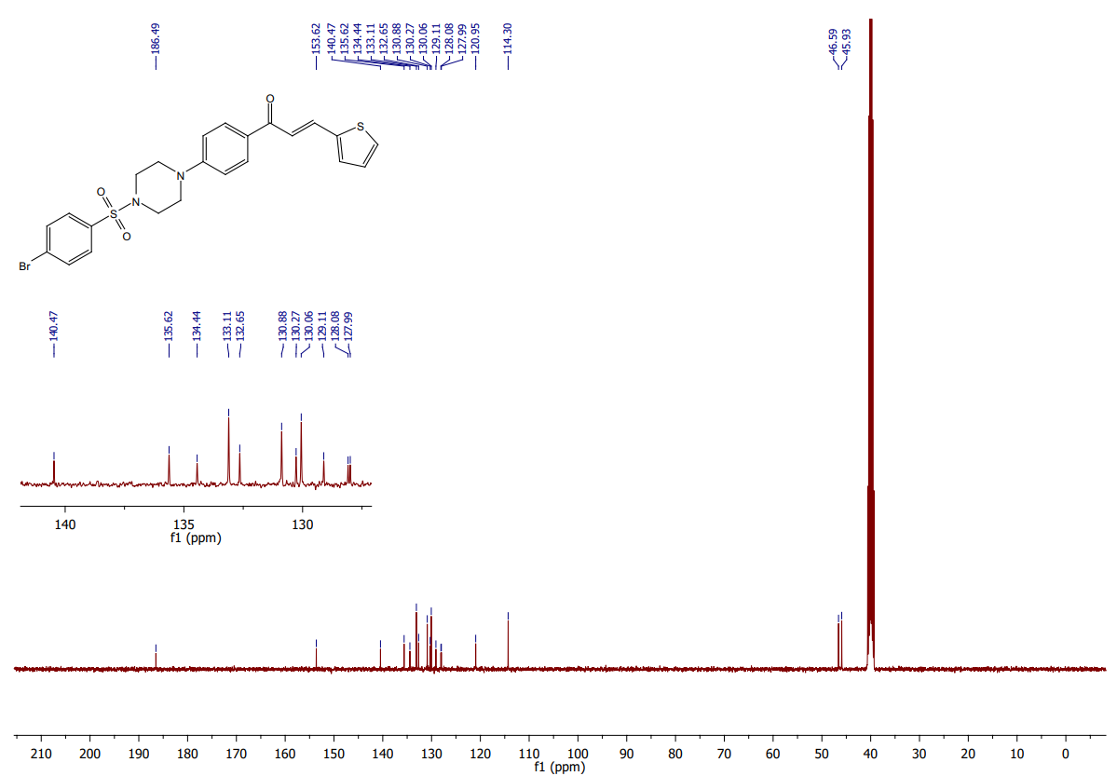
Fig. S31, ES‡

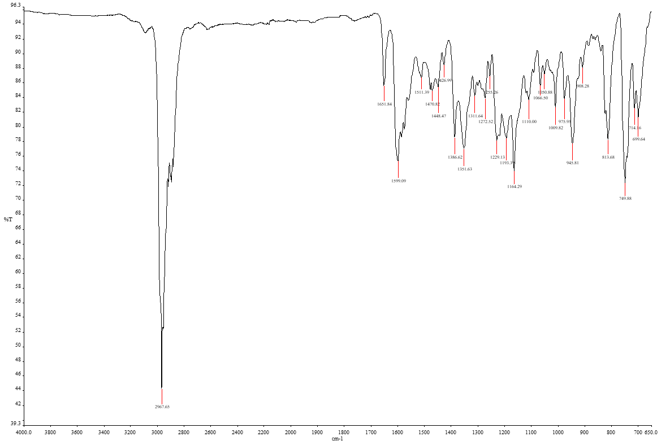
Fig. S32, ES‡

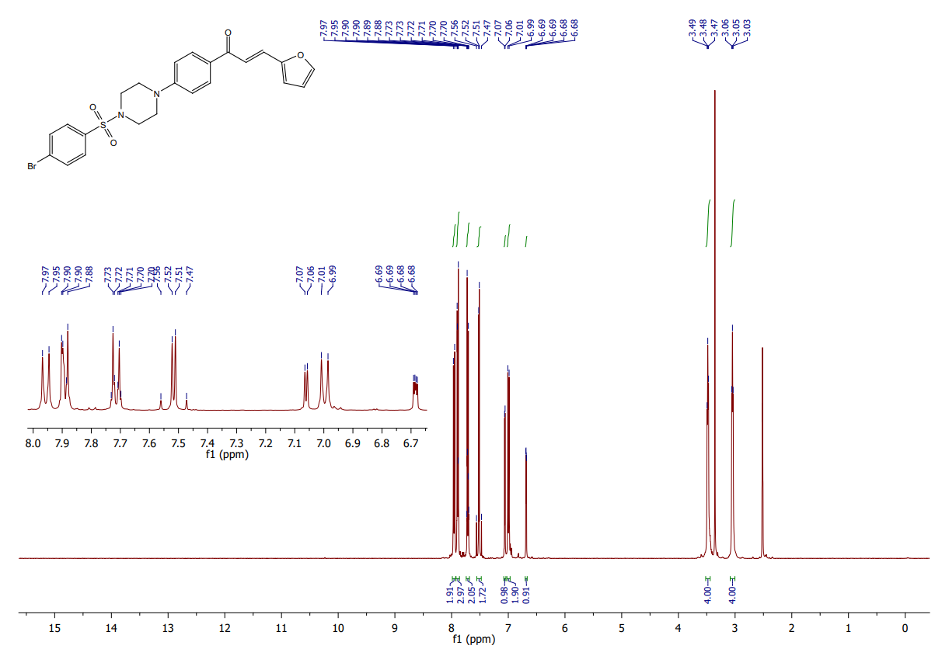
Fig. S33, ES‡

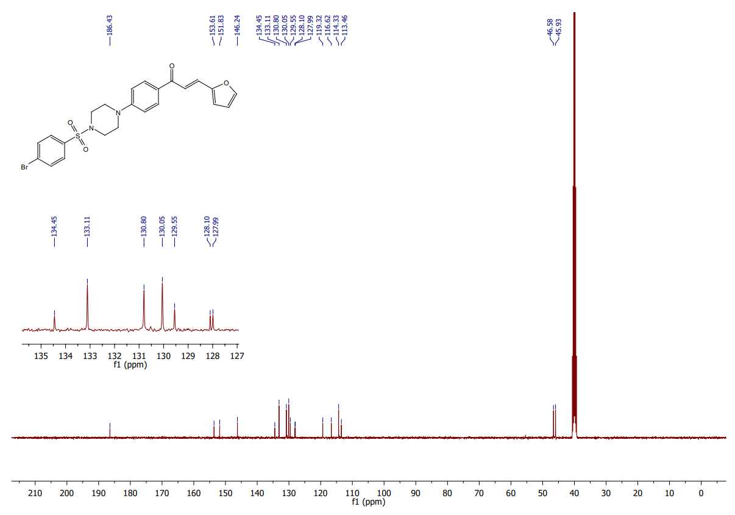
Fig. S34, ES‡

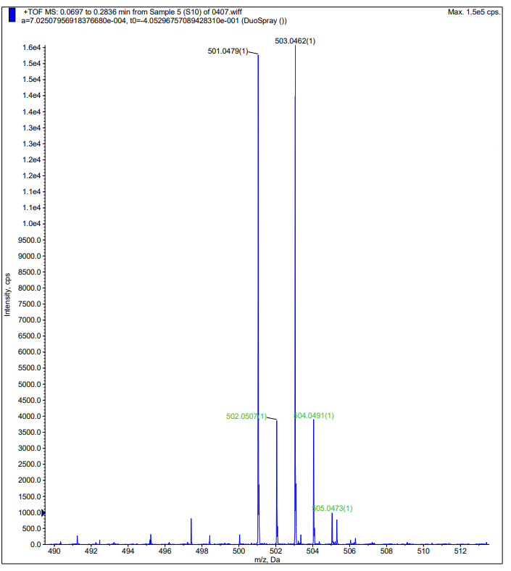
Fig. S35, ES‡

Fig. S36, ES‡

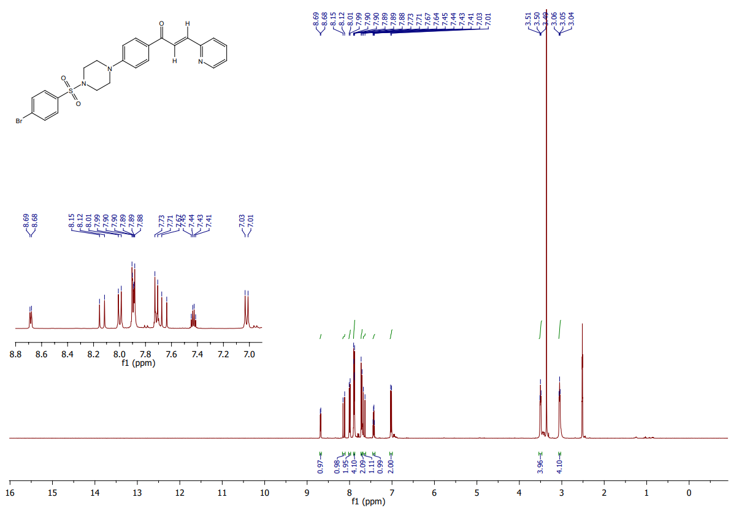
Fig. S37, ES‡

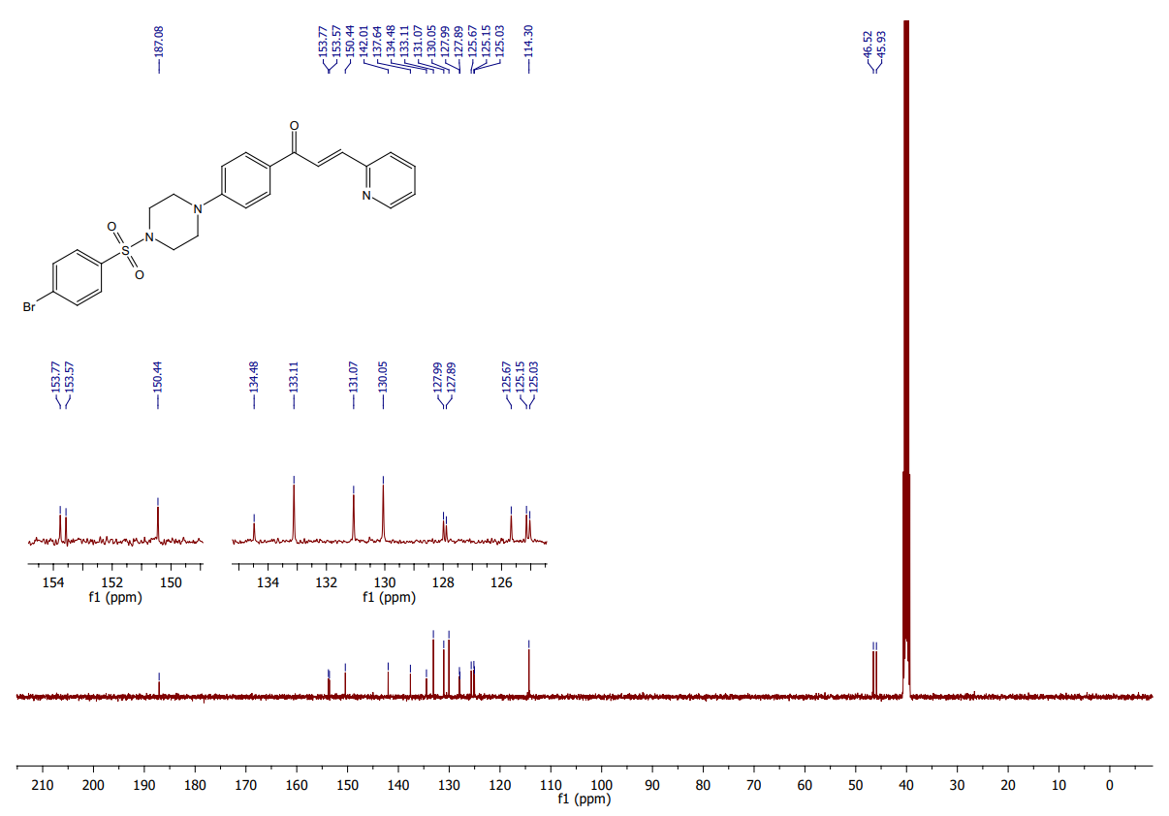
Fig. S38, ES‡

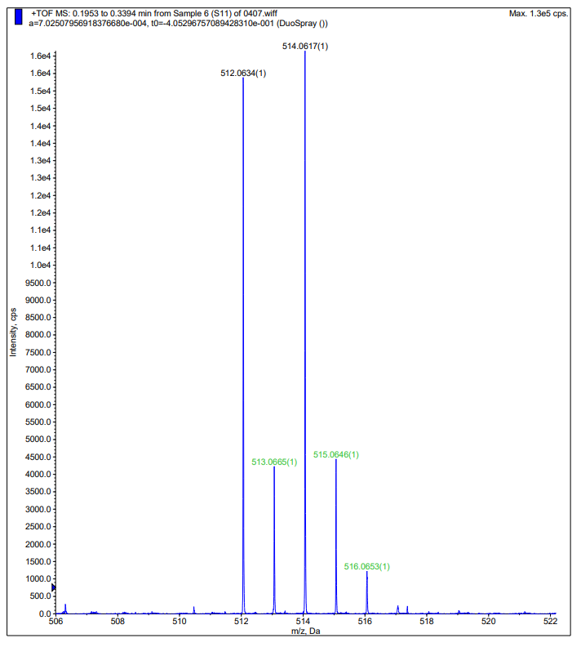
Fig. S39, ES‡

