Supplemental Table 1. Nestling red blood cell sample size by species and year, Seward Peninsula (2014-2019).
Year | Golden Eagles |  | Gyrfalcons |  | Rough-legged Hawks
Year | Individuals | Nests* | Individuals | Nests* | Individuals | Nests*
2014 | 13 | 10 | - | - | - | -
2015 | 12 | 11 | - | - | - | -
2016 | 5 | 4 | 19 | 9 | - | -
2017 | 15 | 9 | 18 | 7 | - | -
2018 | 7 | 6 | 26 | 10 | 10 | 5
2019 | 7 | 4 | 42 | 14 | 15 | 6
Total | 59 | 44 | 105 | 40 | 25 | 11
*These columns indicate the number of nests sampled in each year, which we refer to as nest-years (as the same territory may be occupied in subsequent years).

Supplemental Table 2. Isotopic values and sample sizes of prey muscle tissue samples used in this study. Sample sizes for individual species are shown, and species values were averaged across the prey category they belong to. Shaded rows represent the seven prey categories used as source values for BSIMMs, and the isotopic space each category occupies is visualized in Figure 1.
Species | δ13C ﻿(‰) ± SD | δ15N ﻿(‰) ± SD | n
Arctic Ground Squirrel | -25.20 ± 0.43 | 3.26 ± 1.02 | 35
Arctic Ground Squirrel (Juvenile) | -25.74 ± 0.49 | 2.28 ± 0.76 | 8
Total Arctic Ground Squirrel | -25.30 ± 0.49 | 3.07 ± 1.04 | 43
American Robin | -24.14 ± 1.00 | 5.75 ± 1.66 | 12
Gray-Cheeked Thrush | -25.90 ± 0.50 | 5.35 ± 1.66 | 2
Golden Plover (American or Pacific) | -24.02 ± 1.25 | 5.05 ± 2.26 | 9
White-Crowned Sparrow | -25.11 ± 0.05 | 3.71 ± 0.33 | 3
Western Sandpiper | -24.40 ± 1.44 | 6.56 ± 2.37 | 2
Wilson’s Snipe | -24.09 ± 2.11 | 6.77 ± 2.66 | 6
Total Insectivorous Bird | -24.30 ± 1.31 | 5.59 ± 2.05 | 34
American Widgeon | -25.52 ± NA | 7.63 ± NA | 1
Mallard | -30.16 ± NA | 7.11 ± NA | 1
Northern Pintail | -27.35 ± 1.57 | 7.73 ± 0.30 | 4
Total Waterfowl | -27.51 ± 1.92 | 7.61 ± 0.34 | 6
Alaska Hare | -26.15 ± NA | 2.24 ± NA | 1
Snowshoe Hare | -26.49 ± 0.51 | 1.74 ± 1.35 | 5
Total Hare | -26.43 ± 0.48 | 1.82 ± 1.23 | 6
Northern Collared Lemming | -26.54 ± 0.28 | 2.41 ± 0.65 | 2
North American Brown Lemming | -27.26 ± 2.06 | 3.24 ± 1.78 | 4
Red-Backed Vole | -25.09 ± 0.56 | 3.10 ± 1.12 | 4
Singing Vole | -27.44 ± 0.89 | 0.04 ± 0.61 | 5
Tundra Vole | -26.94 ± 0.70 | 3.16 ± 1.13 | 28
Total Arvicoline Rodent | -26.84 ± 1.04 | 2.77 ± 1.49 | 43
Black-Legged Kittiwake | -19.52 ± NA | 15.89 ± NA | 1
Long-Tailed Jaeger | -23.35 ± 1.78 | 8.36 ± 2.07 | 20
Mew Gull | -22.27 ± 1.76 | 9.96 ± 1.73 | 2
Northern Harrier | -25.06 ± NA | 7.76 ± NA | 1
Short-Eared Owl | -24.74 ± NA | 5.63 ± NA | 1
Total Avian Predator | -23.24 ± 1.88 | 8.66 ± 2.51 | 25
Ptarmigan (unknown species) | -24.32 ± 0.77 | 1.85 ± 0.65 | 41
Rock Ptarmigan | -24.87 ± 0.23 | 0.85 ± 0.55 | 4
Willow Ptarmigan | -24.63 ± 0.4 | 1.95 ± 0.90 | 20
Total Ptarmigan | -24.45 ± 0.67 | 1.82 ± 0.76 | 65

Supplemental Table 3. Proportional diet estimates used for informative priors in BSIMMs from other diet studies on the Seward Peninsula on Golden Eagles (GOEA), Gyrfalcons (GYRF), and Rough-legged Hawks (RLHA). We categorized prey species into seven categories and adjusted for biomass where the author had not done so (Springer 1975). Prey categories are: Ptarmigan (PTAR); Arctic ground squirrels (AGSQ); insectivorous birds (I. Bird); arvicoline rodents (A. Rod); avian predators (Gull/Raptor); waterfowl (Duck); and hares.
Species | PTAR | AGSQ | I. Bird | A. Rod | Gull/Raptor | Duck | Hare | Source
GOEA | 0.20 | 0.52 | 0.02 | 0.00 | 0.01 | 0.16 | 0.08 | Herzog et al. (2019) pellet/prey analysis
GYRF | 0.55 | 0.21 | 0.12 | 0.08 | 0.04 | 0.00 | 0.00 | Robinson et al. (2019) nest camera analysis
RLHA | 0.26 | 0.26 | 0.02 | 0.38 | 0.03 | 0.00 | 0.05 | Springer (1975) pellet/prey analysis

Supplemental Table 4. Subset of Gyrfalcon nest-years used for the comparison of niche estimation methods (Shannon’s Entropy Diversity Index [nest cameras] & Standard Ellipse Area [stable isotopes]). Dietary percentages correspond to nest camera estimates for each prey category: PTAR=ptarmigan; AGSQ=arctic ground squirrel; I.Bird=insectivorous bird; A.Rod=arvicoline rodent; Gull/Raptor=avian predators. The other two groups considered in BSIMMs (hares and waterfowl) did not occur in Gyrfalcon camera data with high enough frequency to factor into this portion of the analysis. Stable isotope values (δ¹³C & δ¹⁵N) are reported here as the mean value for the nestlings measured from that nest-year (n=1–4 nestlings).
Year | Nest | PTAR | AGSQ | I.Bird | A.Rod | Gull/Raptor | Shannon Index | δ13C  ﻿(‰) | δ15 N (‰)
2017 | 1 | 0.569 | 0.045 | 0.367 | 0.019 | 0.000 | 0.423 | -23.547 | 3.770
2017 | 3 | 0.243 | 0.665 | 0.085 | 0.008 | 0.000 | 0.456 | -24.045 | 4.360
2017 | 4 | 0.695 | 0.000 | 0.286 | 0.019 | 0.000 | 0.178 | -23.170 | 3.710
2017 | 5 | 0.580 | 0.156 | 0.247 | 0.017 | 0.000 | 0.761 | -22.890 | 4.457
2017 | 6 | 0.476 | 0.446 | 0.035 | 0.004 | 0.039 | 0.629 | -23.845 | 3.660
2018 | 7 | 0.461 | 0.431 | 0.093 | 0.015 | 0.000 | 0.636 | -23.800 | 3.640
2018 | 8 | 0.605 | 0.135 | 0.219 | 0.032 | 0.010 | 0.969 | -23.350 | 4.210
2018 | 9 | 0.370 | 0.376 | 0.135 | 0.013 | 0.106 | 0.951 | -23.520 | 5.280
2018 | 10 | 0.454 | 0.375 | 0.157 | 0.014 | 0.000 | 0.752 | -23.593 | 3.857
2018 | 4 | 0.766 | 0.000 | 0.216 | 0.005 | 0.014 | 0.302 | -23.302 | 3.822
2019 | 11 | 0.217 | 0.239 | 0.126 | 0.413 | 0.005 | 1.091 | -24.325 | 4.070
2019 | 12 | 0.112 | 0.704 | 0.047 | 0.136 | 0.000 | 0.629 | -24.673 | 4.260
2019 | 1 | 0.834 | 0.000 | 0.119 | 0.047 | 0.000 | 0.504 | -23.850 | 4.065
2019 | 13 | 0.676 | 0.162 | 0.149 | 0.013 | 0.000 | 0.821 | -24.445 | 4.352
2019 | 9 | 0.278 | 0.185 | 0.258 | 0.241 | 0.038 | 1.062 | -23.495 | 4.665
2019 | 5 | 0.105 | 0.467 | 0.030 | 0.398 | 0.000 | 0.838 | -25.065 | 3.355
2019 | 14 | 0.351 | 0.259 | 0.104 | 0.210 | 0.076 | 1.326 | -24.108 | 3.820
2019 | 15 | 0.006 | 0.231 | 0.153 | 0.02 | 0.590 | 1.003 | -24.080 | 7.140
2019 | 16 | 0.524 | 0.228 | 0.094 | 0.153 | 0.000 | 1.061 | -23.860 | 4.740
2019 | 2 | 0.140 | 0.492 | 0.260 | 0.108 | 0.000 | 0.936 | -23.650 | 4.880

Nest camera dietary percentages were calculated for these nest-years as part of another study (Johnson et al. 2020) and a detailed description of nest camera diet methods can be found there. Briefly, motion-activated cameras recorded prey deliveries to nests from when nestlings hatched to when blood samples were taken. Observers identified prey deliveries to species and estimated the biomass of each delivery consumed by nestlings. The resulting biomass values were used to generate proportional diet estimates by category and subsequently estimate Shannon’s index of diet breadth.

Supplemental Table 5. Summary of Gyrfalcon nests used to analyze the relationship between individual specialization and total niche width from nest camera data (Figure 4). Nest camera data reflect the diet during the first half of the brood-rearing period on the Seward Peninsula. TNW=trophic niche width, as calculated by Shannon’s Entropy Diversity Index on proportional diet estimates for each year. E index is a measure of individual specialization, and E Null is the individual specialization metric calculated from randomly drawn data in each year. Proportional diet estimates are presented for seven prey categories: Ptarmigan (PTAR); Arctic ground squirrels (AGSQ); insectivorous birds (I. Bird); arvicoline rodents (A. Rod); avian predators (Gull/Raptor); waterfowl (Duck); and hares.
Year | Nests | TNW | E Index | E Null | PTAR | AGSQ | I.Bird | A.Rod | Gull/Raptor | Duck | Hare
2014 | 7 | 0.52 | 0.14 | 0.05 | 0.82 | 0.07 | 0.10 | 0.00 | 0.00 | 0.00 | 0.00
2015 | 11 | 0.91 | 0.35 | 0.08 | 0.50 | 0.30 | 0.17 | 0.01 | 0.01 | 0.00 | 0.00
2016 | 5 | 0.98 | 0.38 | 0.11 | 0.48 | 0.34 | 0.12 | 0.02 | 0.04 | 0.00 | 0.00
2017 | 8 | 0.91 | 0.31 | 0.08 | 0.54 | 0.26 | 0.19 | 0.01 | 0.01 | 0.00 | 0.00
2018 | 11 | 0.86 | 0.35 | 0.09 | 0.57 | 0.21 | 0.17 | 0.02 | 0.02 | 0.01 | 0.00
2019 | 13 | 1.12 | 0.46 | 0.11 | 0.33 | 0.30 | 0.16 | 0.15 | 0.05 | 0.01 | 0.00

Supplemental Table 6. Opportunistic arvicoline rodent trapping efforts conducted by this study on the Seward Peninsula, 2018-2019. Four-letter codes correspond to different species: TUVO = Tundra Vole; RBVO = Red-Backed Vole; SIVO = Singing Vole; NOCL = Northern Collared Lemming; NABL = North American Brown Lemming. Rodents were trapped at seven locations across the study site during the raptor brood-rearing period.
Year | Total Individuals | Trap Nights | Individuals / Trap Night | TUVO | RBVO | SIVO | NOCL | NABL
2018 | 8 | 840 | 0.0095 | 6 | 1 | 0 | 0 | 1
2019 | 23 | 120 | 0.1917 | 15 | 2 | 4 | 1 | 1

Supplemental Table 7. Diet estimates from BSIMMs (mean ± 1 SD) for each raptor species in each year (sample sizes; Supplemental Table 1). Each column corresponds to one of seven prey categories: Ptarmigan (PTAR); Arctic ground squirrels (AGSQ); insectivorous birds (I. Bird); arvicoline rodents (A. Rod); gulls/raptors; waterfowl (Duck); and hares. BSIMMs were formulated with a TDF_{CAM} and informative priors (Supplemental Table 3), and represent nestling diet for the first half of their brood-rearing period on the Seward Peninsula.
Year | Raptor Species | PTAR | AGSQ | I.Bird | A.Rod | Gull/  Raptor | Duck | Hare
2014 | GOEA | 0.16 ± 0.09 | 0.61 ± 0.14 | 0.00 ± 0.01 | 0.00 ± 0.00 | 0.03 ± 0.02 | 0.01 ± 0.01 | 0.19 ± 0.10
2015 | GOEA | 0.13 ± 0.11 | 0.58 ± 0.21 | 0.01 ± 0.04 | 0.00 ± 0.00 | 0.11 ± 0.07 | 0.01 ± 0.02 | 0.15 ± 0.12
2016 | GOEA | 0.19 ± 0.16 | 0.64 ± 0.22 | 0.00 ± 0.02 | 0.00 ± 0.00 | 0.03 ± 0.04 | 0.01 ± 0.02 | 0.12 ± 0.11
2017 | GOEA | 0.11 ± 0.09 | 0.53 ± 0.21 | 0.01 ± 0.02 | 0.00 ± 0.00 | 0.18 ± 0.10 | 0.03 ± 0.04 | 0.15 ± 0.13
2018 | GOEA | 0.17 ± 0.16 | 0.73 ± 0.21 | 0.00 ± 0.01 | 0.00 ± 0.00 | 0.01 ± 0.02 | 0.01 ± 0.01 | 0.08 ± 0.09
2019 | GOEA | 0.11 ± 0.11 | 0.58 ± 0.21 | 0.01 ± 0.04 | 0.00 ± 0.00 | 0.12 ± 0.09 | 0.01 ± 0.02 | 0.16 ± 0.13
2016 | GYRF | 0.62 ± 0.10 | 0.09 ± 0.05 | 0.20 ± 0.10 | 0.04 ± 0.02 | 0.05 ± 0.04 | 0.00 ± 0.00 | 0.00 ± 0.00
2017 | GYRF | 0.62 ± 0.10 | 0.20 ± 0.10 | 0.12 ± 0.09 | 0.01 ± 0.01 | 0.06 ± 0.05 | 0.00 ± 0.00 | 0.00 ± 0.00
2018 | GYRF | 0.57 ± 0.10 | 0.08 ± 0.07 | 0.18 ± 0.11 | 0.12 ± 0.06 | 0.05 ± 0.05 | 0.00 ± 0.00 | 0.00 ± 0.00
2019 | GYRF | 0.35 ± 0.09 | 0.21 ± 0.16 | 0.11 ± 0.10 | 0.26 ± 0.11 | 0.08 ± 0.05 | 0.00 ± 0.00 | 0.00 ± 0.00
2018 | RLHA | 0.22 ± 0.09 | 0.33 ± 0.13 | 0.01 ± 0.03 | 0.34 ± 0.11 | 0.03 ± 0.03 | 0.00 ± 0.00 | 0.08 ± 0.07
2019 | RLHA | 0.06 ± 0.05 | 0.10 ± 0.08 | 0.01 ± 0.03 | 0.73 ± 0.14 | 0.02 ± 0.02 | 0.00 ± 0.00 | 0.08 ± 0.12

Supplemental Table 8. Diet estimates from BSIMMs (mean ± 1 SD) for each nest-year for each species from 2018-2019. For raptor species: GYRF=Gyrfalcon; GOEA=Golden Eagle; RLHA= Rough-Legged Hawk. Each column corresponds to one of seven prey categories: Ptarmigan (PTAR); Arctic ground squirrels (AGSQ); insectivorous birds (I. Bird); arvicoline rodents (A. Rod); avian predators (Gull/Raptor); waterfowl (Duck); and hares. BSIMMs were formulated with a TDF_{CAM} and informative priors (Supplemental Table 3), and represent nestling diet for the first half of their brood-rearing period on the Seward Peninsula.
Year | Species | Nest-year | AGSQ | I.Bird | Duck | Hare | A. Rod | Gull/Raptor | PTAR
2018 | GYRF | 18_438 | 0.05 ± 0.03 | 0.09 ± 0.03 | 0.00 ± 0.00 | 0.00 ± 0.00 | 0.16 ± 0.03 | 0.06 ± 0.02 | 0.65 ± 0.05
2018 | GYRF | 18_254 | 0.07 ± 0.07 | 0.16 ± 0.12 | 0.00 ± 0.00 | 0.00 ± 0.00 | 0.09 ± 0.05 | 0.11 ± 0.06 | 0.57 ± 0.09
2018 | GYRF | 18_122 | 0.06 ± 0.06 | 0.14 ± 0.10 | 0.00 ± 0.00 | 0.00 ± 0.00 | 0.08 ± 0.05 | 0.10 ± 0.05 | 0.62 ± 0.09
2018 | GYRF | 18_429 | 0.10 ± 0.11 | 0.21 ± 0.14 | 0.00 ± 0.00 | 0.00 ± 0.00 | 0.16 ± 0.07 | 0.12 ± 0.07 | 0.41 ± 0.10
2018 | GYRF | 18_208 | 0.03 ± 0.03 | 0.08 ± 0.06 | 0.00 ± 0.00 | 0.00 ± 0.00 | 0.05 ± 0.03 | 0.07 ± 0.04 | 0.76 ± 0.05
2018 | GYRF | 18_670 | 0.04 ± 0.04 | 0.13 ± 0.12 | 0.00 ± 0.00 | 0.00 ± 0.00 | 0.05 ± 0.03 | 0.15 ± 0.06 | 0.63 ± 0.07
2018 | GYRF | 18_206 | 0.10 ± 0.13 | 0.12 ± 0.08 | 0.00 ± 0.00 | 0.00 ± 0.00 | 0.20 ± 0.07 | 0.06 ± 0.04 | 0.52 ± 0.08
2018 | GYRF | 18_526 | 0.07 ± 0.08 | 0.05 ± 0.03 | 0.00 ± 0.00 | 0.00 ± 0.00 | 0.28 ± 0.05 | 0.03 ± 0.02 | 0.56 ± 0.05
2018 | GYRF | 18_442 | 0.06 ± 0.06 | 0.17 ± 0.13 | 0.00 ± 0.00 | 0.00 ± 0.00 | 0.09 ± 0.05 | 0.15 ± 0.07 | 0.52 ± 0.08
2018 | GYRF | 18_120 | 0.06 ± 0.06 | 0.11 ± 0.08 | 0.00 ± 0.00 | 0.00 ± 0.00 | 0.08 ± 0.05 | 0.07 ± 0.04 | 0.68 ± 0.08
2019 | GYRF | 19_203 | 0.11 ± 0.12 | 0.13 ± 0.08 | 0.00 ± 0.00 | 0.00 ± 0.00 | 0.18 ± 0.06 | 0.08 ± 0.04 | 0.49 ± 0.07
2019 | GYRF | 19_205 | 0.06 ± 0.06 | 0.09 ± 0.06 | 0.00 ± 0.00 | 0.00 ± 0.00 | 0.09 ± 0.04 | 0.05 ± 0.03 | 0.71 ± 0.06
2019 | GYRF | 19_453 | 0.02 ± 0.02 | 0.04 ± 0.04 | 0.00 ± 0.00 | 0.00 ± 0.00 | 0.02 ± 0.01 | 0.04 ± 0.03 | 0.89 ± 0.04
2019 | GYRF | 19_254 | 0.02 ± 0.02 | 0.07 ± 0.06 | 0.00 ± 0.00 | 0.00 ± 0.00 | 0.03 ± 0.02 | 0.07 ± 0.04 | 0.81 ± 0.05
2019 | GYRF | 19_353 | 0.02 ± 0.02 | 0.10 ± 0.16 | 0.00 ± 0.00 | 0.00 ± 0.00 | 0.02 ± 0.01 | 0.18 ± 0.08 | 0.68 ± 0.10
2019 | GYRF | 19_208 | 0.08 ± 0.10 | 0.07 ± 0.05 | 0.00 ± 0.00 | 0.00 ± 0.00 | 0.19 ± 0.05 | 0.04 ± 0.02 | 0.62 ± 0.06
2019 | GYRF | 19_670 | 0.07 ± 0.09 | 0.07 ± 0.05 | 0.00 ± 0.00 | 0.00 ± 0.00 | 0.16 ± 0.06 | 0.04 ± 0.03 | 0.65 ± 0.08
2019 | GYRF | 19_225 | 0.05 ± 0.05 | 0.11 ± 0.08 | 0.00 ± 0.00 | 0.00 ± 0.00 | 0.07 ± 0.03 | 0.08 ± 0.04 | 0.68 ± 0.06
2019 | GYRF | 19_230 | 0.09 ± 0.10 | 0.11 ± 0.07 | 0.00 ± 0.00 | 0.00 ± 0.00 | 0.14 ± 0.05 | 0.06 ± 0.04 | 0.60 ± 0.07
2019 | GYRF | 19_874 | 0.05 ± 0.05 | 0.13 ± 0.10 | 0.00 ± 0.00 | 0.00 ± 0.00 | 0.07 ± 0.04 | 0.10 ± 0.05 | 0.66 ± 0.09
2019 | GYRF | 19_520 | 0.09 ± 0.09 | 0.23 ± 0.16 | 0.00 ± 0.00 | 0.00 ± 0.00 | 0.13 ± 0.07 | 0.19 ± 0.09 | 0.37 ± 0.09
2019 | GYRF | 19_873 | 0.08 ± 0.08 | 0.17 ± 0.11 | 0.00 ± 0.00 | 0.00 ± 0.00 | 0.11 ± 0.05 | 0.12 ± 0.06 | 0.53 ± 0.08
2019 | GYRF | 19_886 | 0.07 ± 0.08 | 0.10 ± 0.06 | 0.00 ± 0.00 | 0.00 ± 0.00 | 0.11 ± 0.04 | 0.06 ± 0.03 | 0.66 ± 0.06
Year | Species | Nest-year | AGSQ | I.Bird | Duck | Hare | A. Rod | Gull/Raptor | PTAR
2019 | GYRF | 19_212 | 0.05 ± 0.06 | 0.04 ± 0.03 | 0.00 ± 0.00 | 0.00 ± 0.00 | 0.62 ± 0.05 | 0.03 ± 0.02 | 0.26 ± 0.06
2018 | GOEA | 18_082 | 0.44 ± 0.24 | 0.01 ± 0.04 | 0.02 ± 0.02 | 0.28 ± 0.18 | 0.00 ± 0.00 | 0.06 ± 0.05 | 0.19 ± 0.17
2018 | GOEA | 18_183 | 0.73 ± 0.28 | 0.01 ± 0.06 | 0.01 ± 0.02 | 0.13 ± 0.18 | 0.00 ± 0.00 | 0.04 ± 0.05 | 0.08 ± 0.15
2018 | GOEA | 18_345 | 0.46 ± 0.27 | 0.01 ± 0.03 | 0.01 ± 0.02 | 0.18 ± 0.15 | 0.00 ± 0.00 | 0.06 ± 0.05 | 0.27 ± 0.23
2018 | GOEA | 18_491 | 0.44 ± 0.24 | 0.01 ± 0.03 | 0.02 ± 0.03 | 0.33 ± 0.20 | 0.00 ± 0.00 | 0.06 ± 0.05 | 0.13 ± 0.12
2018 | GOEA | 18_860 | 0.44 ± 0.25 | 0.01 ± 0.03 | 0.01 ± 0.02 | 0.27 ± 0.18 | 0.00 ± 0.00 | 0.06 ± 0.05 | 0.21 ± 0.18
2018 | GOEA | 18_F046 | 0.40 ± 0.27 | 0.01 ± 0.05 | 0.01 ± 0.02 | 0.11 ± 0.09 | 0.00 ± 0.00 | 0.12 ± 0.10 | 0.34 ± 0.26
2019 | GOEA | 19_345 | 0.23 ± 0.13 | 0.02 ± 0.08 | 0.02 ± 0.04 | 0.12 ± 0.08 | 0.00 ± 0.00 | 0.48 ± 0.10 | 0.12 ± 0.10
2019 | GOEA | 19_491 | 0.47 ± 0.22 | 0.02 ± 0.04 | 0.03 ± 0.04 | 0.24 ± 0.15 | 0.00 ± 0.00 | 0.10 ± 0.06 | 0.15 ± 0.12
2019 | GOEA | 19_912 | 0.62 ± 0.25 | 0.01 ± 0.05 | 0.02 ± 0.03 | 0.16 ± 0.16 | 0.00 ± 0.00 | 0.11 ± 0.09 | 0.08 ± 0.07
2019 | GOEA | 19_927 | 0.42 ± 0.24 | 0.01 ± 0.03 | 0.02 ± 0.02 | 0.34 ± 0.20 | 0.00 ± 0.00 | 0.06 ± 0.04 | 0.15 ± 0.14
2018 | RLHA | 18_204 | 0.28 ± 0.17 | 0.06 ± 0.06 | 0.00 ± 0.00 | 0.01 ± 0.02 | 0.42 ± 0.09 | 0.00 ± 0.00 | 0.22 ± 0.07
2018 | RLHA | 18_277 | 0.54 ± 0.27 | 0.07 ± 0.07 | 0.00 ± 0.00 | 0.02 ± 0.03 | 0.19 ± 0.00 | 0.00 ± 0.01 | 0.19 ± 0.12
2018 | RLHA | 18_443 | 0.14 ± 0.17 | 0.01 ± 0.02 | 0.00 ± 0.00 | 0.06 ± 0.11 | 0.30 ± 0.10 | 0.00 ± 0.00 | 0.49 ± 0.13
2018 | RLHA | 18_534 | 0.26 ± 0.20 | 0.03 ± 0.03 | 0.00 ± 0.00 | 0.02 ± 0.04 | 0.26 ± 0.08 | 0.00 ± 0.00 | 0.42 ± 0.12
2018 | RLHA | 18_666 | 0.45 ± 0.27 | 0.06 ± 0.06 | 0.00 ± 0.00 | 0.01 ± 0.02 | 0.23 ± 0.10 | 0.00 ± 0.00 | 0.25 ± 0.13
2019 | RLHA | 19_214 | 0.06 ± 0.05 | 0.02 ± 0.03 | 0.00 ± 0.00 | 0.01 ± 0.01 | 0.87 ± 0.06 | 0.00 ± 0.00 | 0.04 ± 0.03
2019 | RLHA | 19_277 | 0.29 ± 0.16 | 0.06 ± 0.06 | 0.00 ± 0.00 | 0.02 ± 0.03 | 0.51 ± 0.08 | 0.00 ± 0.00 | 0.12 ± 0.07
2019 | RLHA | 19_453 | 0.12 ± 0.08 | 0.02 ± 0.02 | 0.00 ± 0.00 | 0.02 ± 0.04 | 0.75 ± 0.08 | 0.00 ± 0.00 | 0.10 ± 0.06
2019 | RLHA | 19_635 | 0.21 ± 0.16 | 0.10 ± 0.09 | 0.00 ± 0.00 | 0.01 ± 0.03 | 0.59 ± 0.09 | 0.00 ± 0.00 | 0.08 ± 0.06
2019 | RLHA | 19_669 | 0.10 ± 0.08 | 0.02 ± 0.02 | 0.00 ± 0.00 | 0.02 ± 0.05 | 0.77 ± 0.09 | 0.00 ± 0.00 | 0.09 ± 0.06
2019 | RLHA | 19_TSK | 0.29 ± 0.22 | 0.15 ± 0.12 | 0.00 ± 0.00 | 0.01 ± 0.02 | 0.46 ± 0.10 | 0.00 ± 0.01 | 0.09 ± 0.06

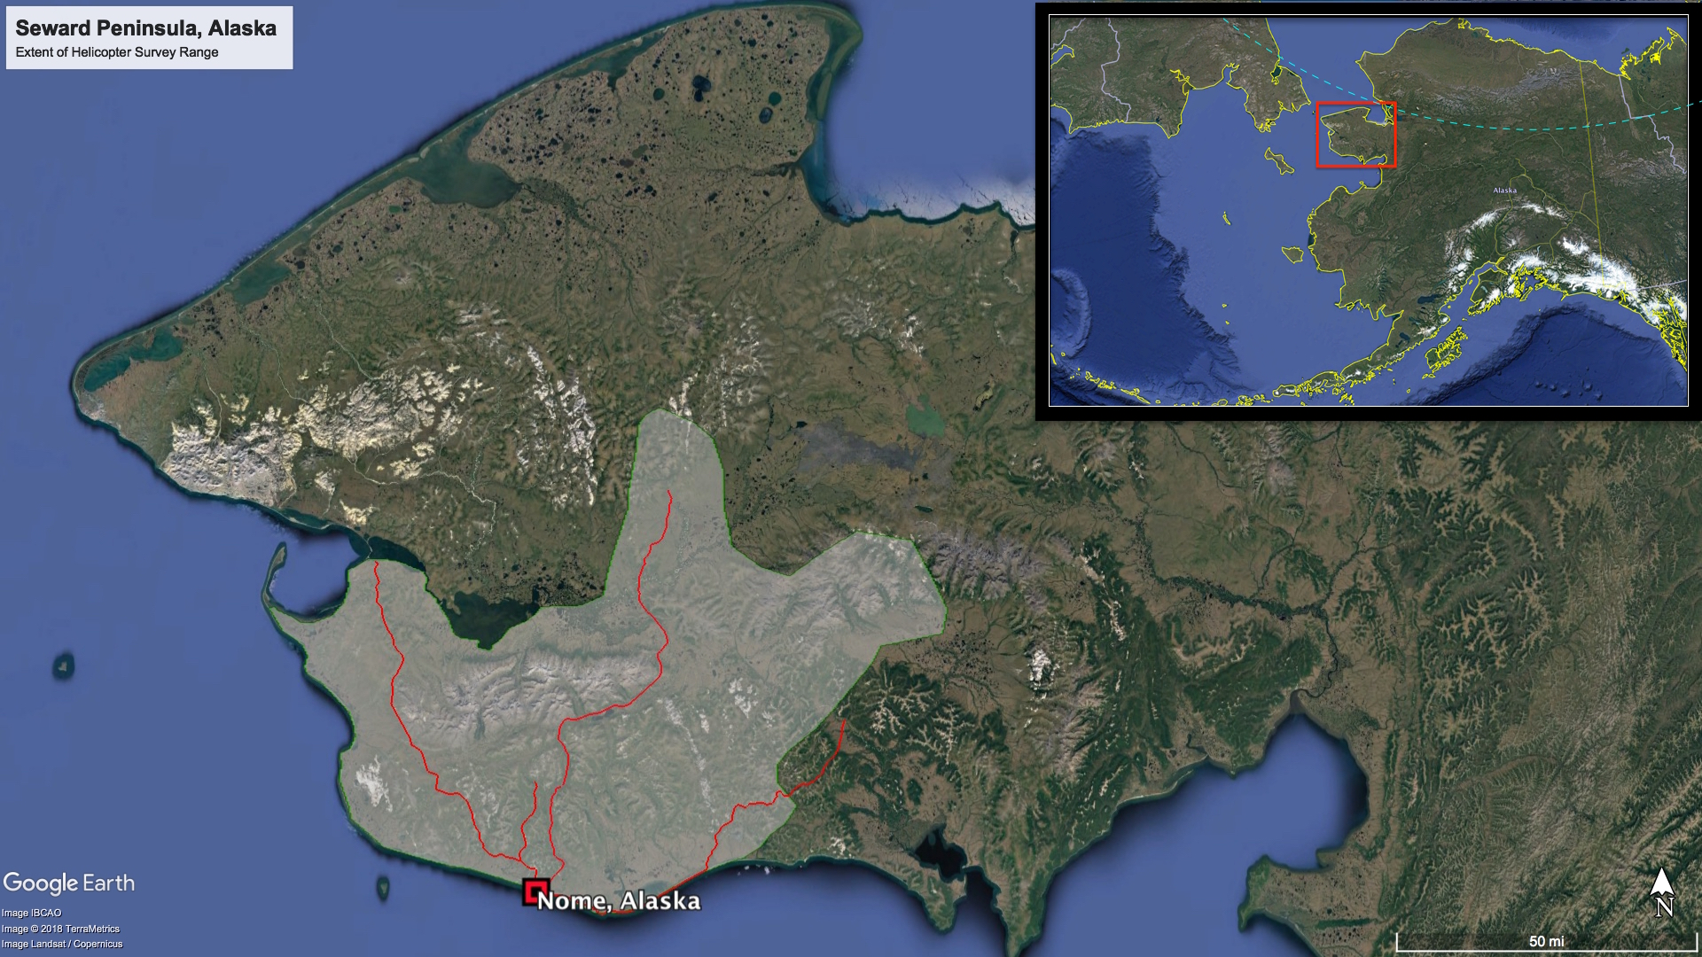
Supplemental Figure 1. Map of Alaska’s Seward Peninsula. Gray shaded areas constitute the extent of helicopter surveys conducted for gyrfalcon nests within the study area. Red lines indicate roads by which territories are accessed. Blue dashed line in Alaska inset represents the Arctic Circle.

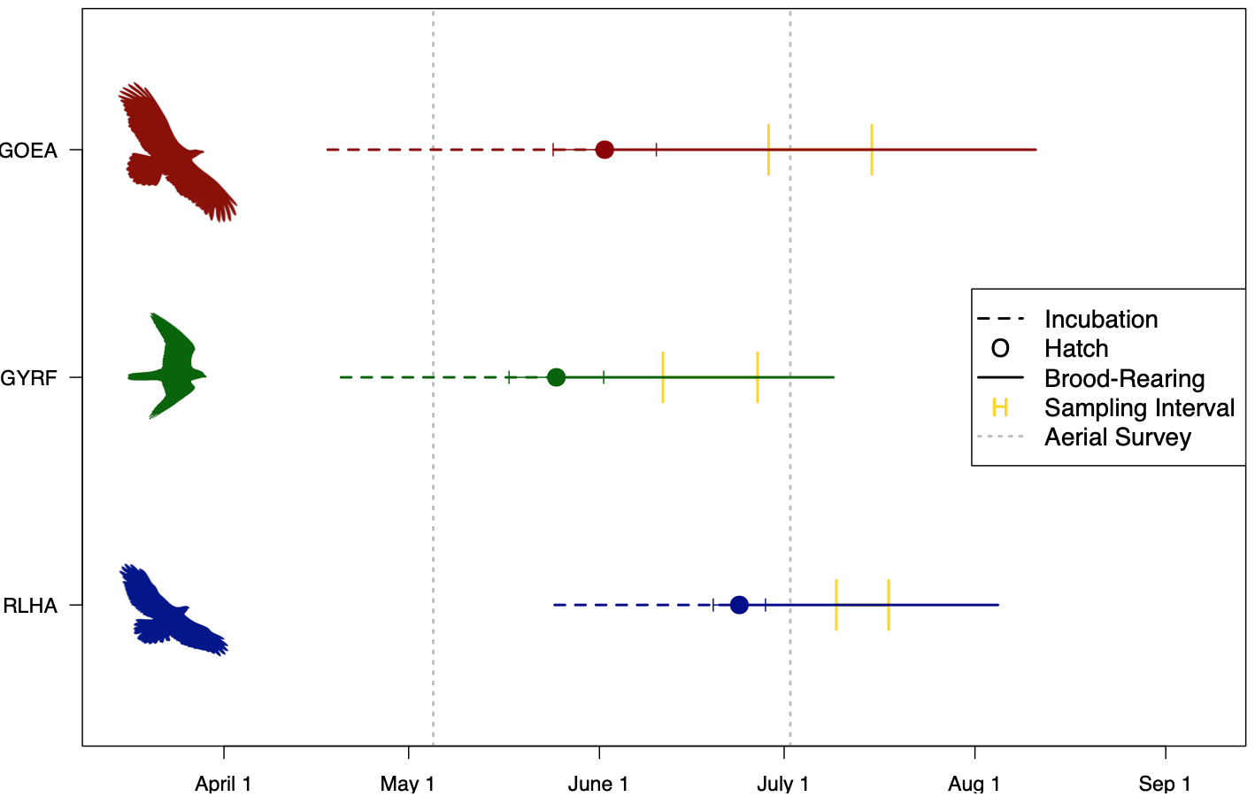

Supplemental Figure 2. Breeding phenology for Rough-legged Hawks (RLHA), Gyrfalcons (GYRF), and Golden Eagles (GOEA) on the Seward Peninsula 2014-2019. Data are based on forward and backward projections of mean hatch dates (filled circles, error bars ± 1 SD) and average incubation (dashed line) and hatch-fledge (solid line) intervals for each species. Hatch date data correspond to the individual nest-years sampled for stable isotope analysis (sample sizes; Supplemental Table 1) and were estimated using an aging guide (Anderson et al. 2017) or by expert observers. Gray dotted lines indicate average aerial survey dates throughout the course of the study, and yellow bars indicate sampling intervals for each species. Horizontal dashed lines begin with egg-laying, thus sites are likely occupied for several weeks prior to the pictured phenological timelines for the pre-laying interval (nest building/selection, courtship, copulation and egg development are not included in this figure).

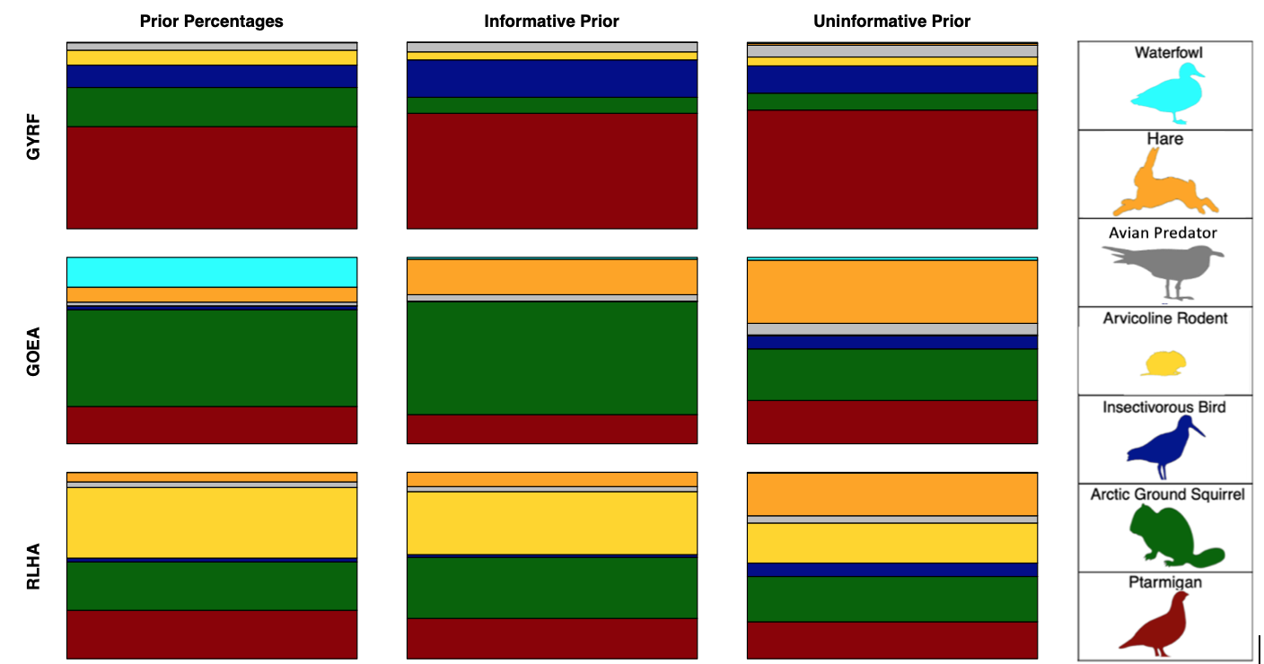
Supplemental Figure 3. Mean BSIMM output (diet estimates) for Gyrfalcons (GYRF), Golden Eagles (GOEA), and Rough-Legged Hawks (RLHA) using an informative vs uninformative prior. Dietary percentages of each informative prior applied are displayed in the column on the left and detailed in Supplemental Table 3. Colors correspond to one of seven prey categories. All models were formulated with the same Gyrfalcon TDFcam and source groups; sample sizes are all individuals for each raptor species detailed in Supplemental Table 1.

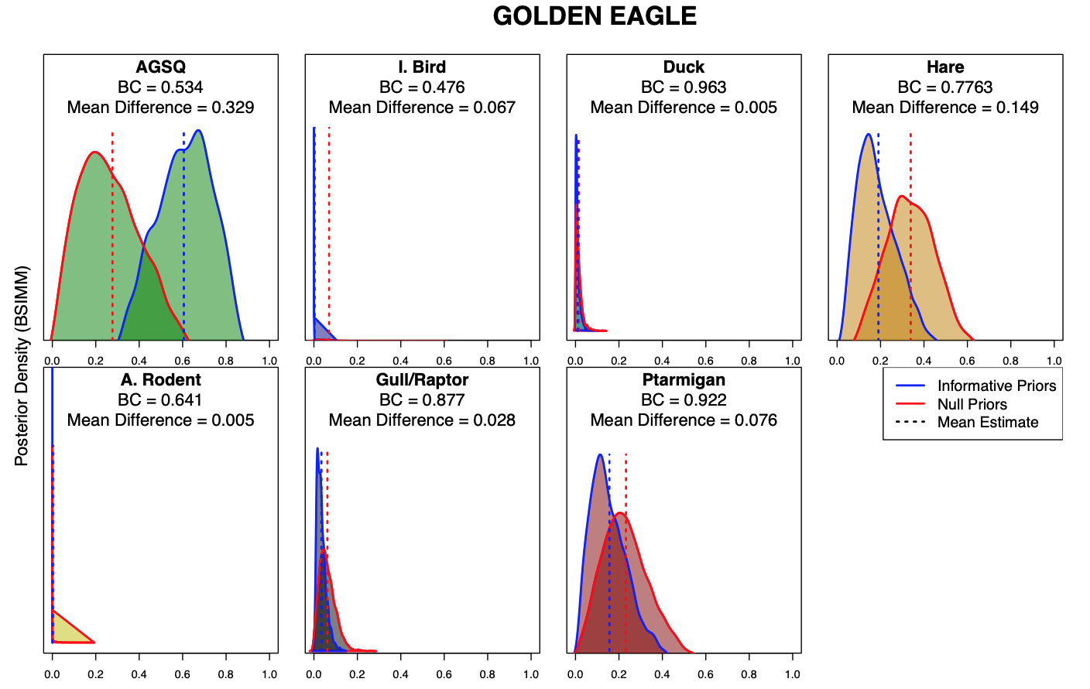
Supplemental Figure 4. Posterior density distributions from Golden Eagle BSIMM output comparing diet estimates for each prey group using informative (blue outline; Supplemental Table 4) vs uninformative (red outline) priors. BSIMMs both formulated on 59 golden eagle nestlings (2014-2019); 219 prey samples from 7 categories; and a TDFcam calculated for Gyrfalcon nestlings. Vertical dotted lines indicate mean estimates for each model and BC=Bahattacharyya’s Coefficient. For prey group abbreviations: AGSQ=Arctic ground squirrel; I.Bird=insectivorous bird; A.Rodent=arvicoline rodent.

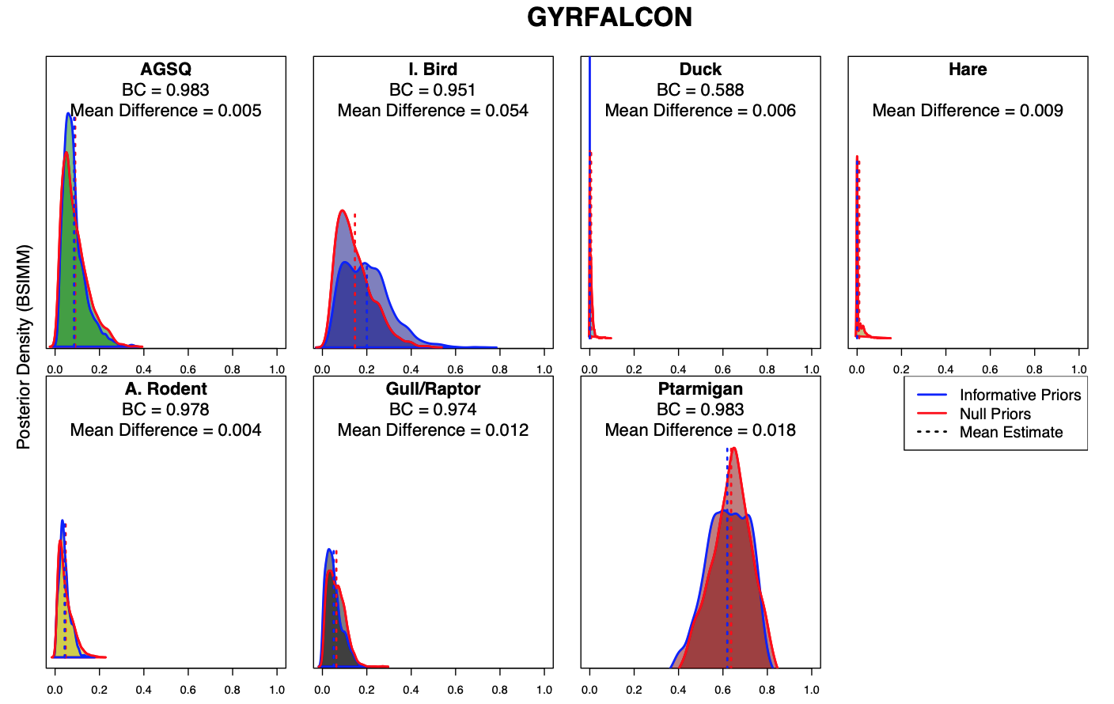
Supplemental Figure 5. Posterior density distributions from Gyrfalcon BSIMM output comparing diet estimates for each prey group using informative (blue outline; Supplemental Table 4) vs uninformative (red outline) priors. BSIMMs both formulated on 105 gyrfalcon nestlings (2016-2019); 219 prey samples from 7 categories; and a TDFcam calculated for gyrfalcon nestlings. Vertical dotted lines indicate mean estimates for each model and BC=Bahattacharyya’s Coefficient. For prey group abbreviations: AGSQ=Arctic ground squirrel; I.Bird=insectivorous bird; A.Rodent=arvicoline rodent.

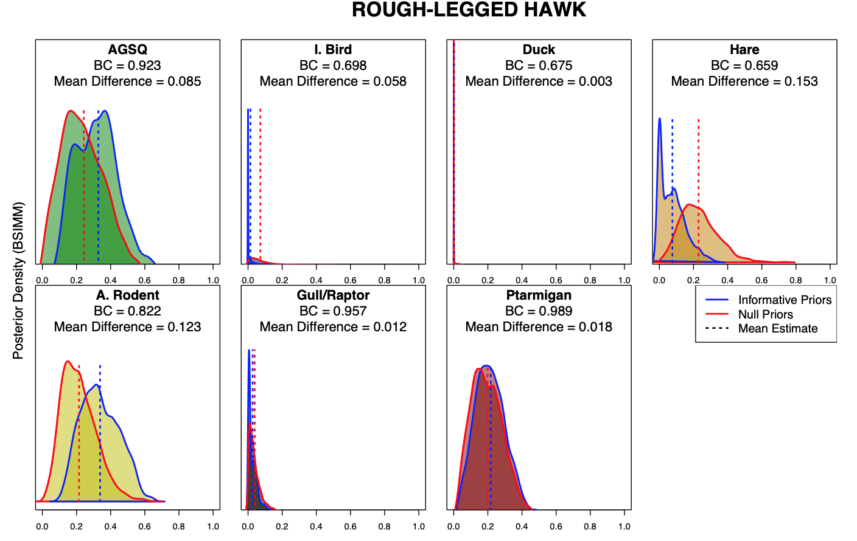
Supplemental Figure 6. Posterior density distributions from Rough-Legged Hawk BSIMM output comparing diet estimates for each prey group using informative (blue outline; Supplemental Table 4) vs uninformative (red outline) priors. BSIMMs both formulated on 25 rough-legged hawk nestlings (2018-2019); 219 prey samples from 7 categories; and a TDFcam calculated for gyrfalcon nestlings. Vertical dotted lines indicate mean estimates for each model and BC=Bahattacharyya’s Coefficient. For prey group abbreviations: AGSQ=Arctic ground squirrel; I.Bird=insectivorous bird; A.Rodent=arvicoline rodent.

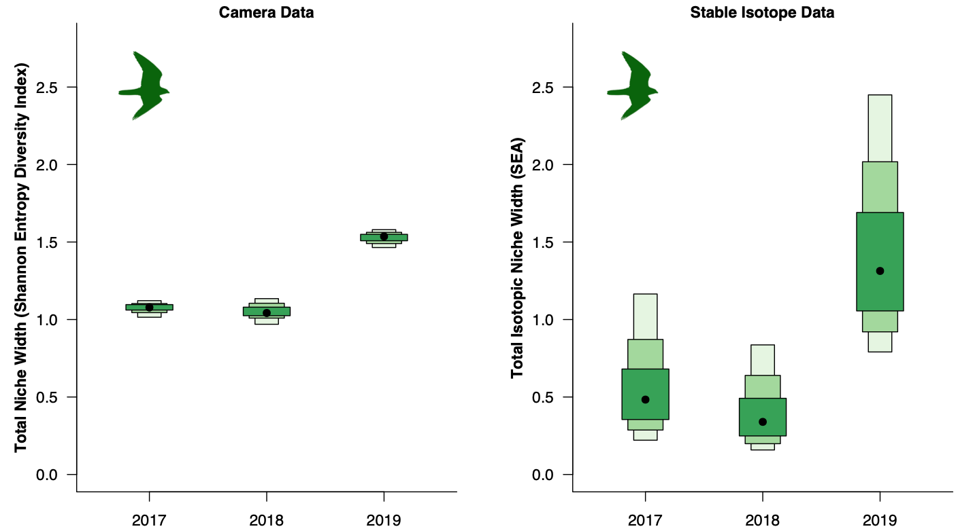
Supplemental Figure 7. Comparison of niche width estimation methods from 20 Gyrfalcon nest-years (2017-2019; Seward Peninsula; Supplemental Table 3). Diet breadth (left) was calculated from proportional diet estimates generated from nest cameras. SEA (right) was calculated from raw stable isotope data (δ¹³C and δ¹⁵N) of nestling red blood cell samples. The two estimates of niche width (Y-axes) are on different scales but reflect a similar trend. Points indicate mean estimates and colored boxes correspond to 50%, 75%, and 90% credible intervals respectively.

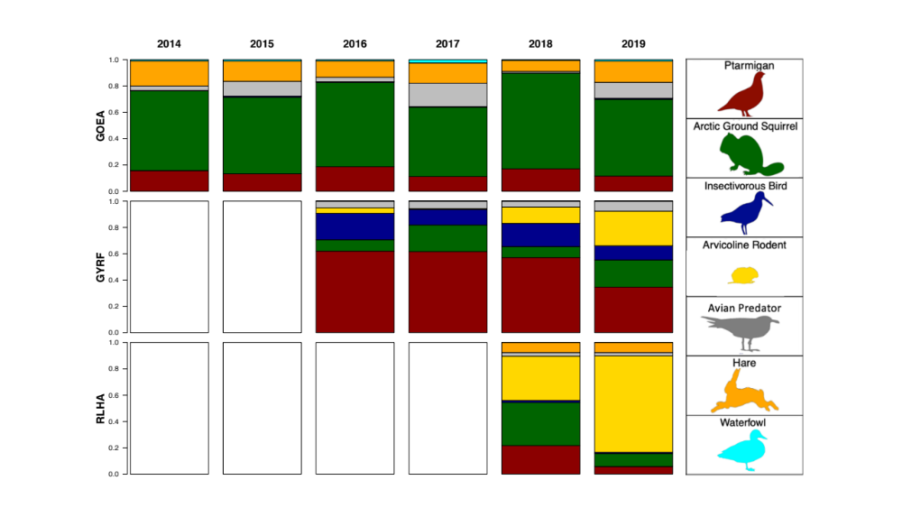
Supplemental Figure 8. Mean proportional diet estimates for each of the three focal raptor species in each year, as inferred from BSIMM output (sample sizes, Supplemental Table 1; diet estimates with credible intervals; Supplemental Table 7). Data reflect the diet of raptor nestlings during brood-rearing on the Seward Peninsula. Each column is a different year (2014-2019), and each row is a different raptor species (GOEA = Golden Eagle, GYRF = Gyrfalcon, RLHA = Rough-legged Hawk). Colors correspond to the seven prey categories as indicated in the legend. White rectangles indicate years without stable isotope data for that species

References
Anderson D. L., K. K. Burnham, Ó. K. Nielsen, and B. W. Robinson (2017). A photographic and morphometric guide to aging Gyrfalcon nestlings. Pages 265–282 in D.L. Anderson, C.J.W. McClure, and A. Franke, editors. Applied raptor ecology: essentials from Gyrfalcon research. The Peregrine Fund, Boise, Idaho, USA. doi: 10.4080/are.2017/app1

