Measuring Source Control Efficacy of Different Fitted Masks for Sub-Micron Aerosols: Supplementary Materials

Supun Pieris¹, Rachel Leung¹, Sean D. Peterson¹, Serhiy Yarusevych¹, Ram Duriseti^{2,*}
¹Mechanical and Mechatronics Engineering, University of Waterloo; Waterloo, Ontario, Canada
²Emergency Medicine, Stanford School of Medicine; Stanford, California, USA
*Corresponding author. Email: ram1@stanford.edu

Materials and Methods
Experiments were carried out in the Fluid Mechanics Research Laboratory at the University of Waterloo. An overview of the experimental setup used for characterization of filtration efficiency is shown in Fig. S1. For the test model, a medium NIOSH head form with a silicone elastomer skin with a shore hardness of 00-30 was used to simulate a realistic interface between masks and human skin. The headform is outfitted with both custom nasal tubes and an ISO 16900-5 trachea with the latter used for all tests herein. The headform was placed upright in a 0.635 m $×$ 0.914 m $×$ 0.635 m sealed measurement chamber with approximately 0.635 m distance between the front of the face and the furthest wall of the box to allow aerosol dispersion.
A custom breathing apparatus (Fig. S1) was connected to the headform trachea. The apparatus comprised a piston connected to a high precision mechanical linear actuator traveling inside a cylinder with a prescribed sinusoidal tidal breathing pattern. The instantaneous position of the piston was measured using a laser displacement sensor. The tidal volume and breathing rate were representative of an average adult male at rest (28, 29); the relevant physiological parameters are listed in Table S1. The main difference between the employed breathing system and human breathing was that inhalation did not occur at the headform but rather at the piston and the thermal effects of a typical human head were not modeled.
Sub-micron olive oil aerosol particles with a particle sizes between approximately 0.2 to 1 $μ$m were produced using a Laskin nozzle style atomizer (30). Olive oil was used as it produces a poly-disperse particle distribution approximating that produced during tidal breathing (31,32,33). Furthermore, olive oil has a residence time representative of SARS-CoV-2 (34) and is compatible with the particle analyzer used for concentration measurements. Particles were injected into the piston chamber during the inhalation stroke using a normally-closed solenoid valve positioned downstream of the atomizer outlet. Triggering of the solenoid valve and synchronization to the piston motion was facilitated using limit switches at piston position extrema. The solenoid was opened 0.25 s after the start of the inhalation stroke and was held open for one second. The rate of particle generation was controlled by a pressure regulator connected upstream of the atomizer set to 2.87 psi for all tests, which was below the cracking pressure of the check valves used to limit backflow. The regulator pressure was monitored and logged during all tests and was always within 3% of the setpoint when the solenoid was closed.
Three mask types were tested: (i) ASTM Level 3 surgical masks, (ii) unvalved KN95 masks, and (iii) 3M N95 masks as shown in Fig. S2. Tests were also conducted without a mask to serve as a baseline. The masks were affixed to the head form using ear loops for the surgical and KN95 masks and head and neck straps for the N95 masks, without modification of mask straps in all cases. A minimum of nine trials were conducted for each mask type using parameters listed in Table S1 and individual trials were ensemble averaged to estimate average filtration efficiencies.
Before each test, the masked headform was placed inside the measurement chamber and connected to the breathing system. The box was then sealed and evacuated using a blower system. During evacuation, an inlet valve with a HEPA filter with particle filtration efficiency of 99% down to five micron particles was opened to bring in filtered ambient air into the box. The number of total particles was measured to be less than five particles per second, which is nearly two orders of magnitude below the particle counts at steady state during testing. Once the measurement chamber was evacuated, the breathing system was operated for an additional 10 minutes (approximately 142 breaths) and the number of total particles was monitored to ensure that the initial particle counts remained below five particles per second. After the onset of particle introduction, the system was run for approximately two hours ensuring that the particle counts within the sealed chamber were at a steady state for at least 30 minutes. During each test, the instantaneous piston position, providing both an estimate of breathing rate and tidal volume, along with atomizer pressure were sampled using a PCIe-6323 National Instruments DAQ, operated using the LabVIEW application interface in Matlab. Particle distributions were measured using a Palas Promo 2000 control unit and a Welas 2070 sensor. During each trial, the particle analyzer continuously measured the flow within the sealed chamber via a separate closed loop with a measurement interval of 10 seconds. The measurement range of the particle analyzer was set to 0.2 to 10 $μ$m with 128 logarithmically arranged data channels with increasing bin size, resulting in a particle size resolution of 0.006 $μ$m for the smallest measurement bin (0.2 - 0.206 $μ$m) and 0.02 $μ$m for the bin centered about 1 $μ$m.
To supplement the particle size distribution measurements, particle leakages were qualitatively examined using flow visualization, with a modified setup shown in Fig. S3. For these tests, the headform was removed from the measurement chamber and connected directly to the breathing system output port. A plenum connected to the inlet of the breathing system was filled with atomized olive oil at higher seeding density than for the sizing measurements to enable effective flow visualization. Tests were conducted for the no mask case and all three masks (Fig. S2). Front and side views were captured using a 5.5 Mpx LaVision Imager sCMOS CLHS camera outfitted with a Nikon 50 mm lens. Flow around the head was primarily illuminated through the use of a 50 W LED array position behind the headform directly in line with the camera. Two additional 50W LED lights were positioned as needed to completely illuminate the flow surrounding the headform. Images were acquired at 50 Hz and up to 2000 images were captured, which is equivalent to approximately 21 breathing cycles. Since the breathing cycles used per flow visualization trial were limited, the same mask was used for front and side views to ensure the original mask fit remained undisturbed. After 21 breathing cycles, olive oil deposition on the mask was found to be negligible and is not expected to affect its filtering or leakage characteristics. Synchronization of the camera and breathing system was facilitated by a LaVision High Speed V2 controller and DaVis 10 software. The latter was also used to improve the image quality through background subtraction. The camera was synchronized to the breathing system by the way of a limit switch positioned at the piston position corresponding to the end of an inhalation stroke and image acquisition was automatically triggered at the start of the first exhalation stroke. After each acquisition, the test area was cleared using a ventilation system for five minutes and the plenum was refilled with atomized olive oil.
The calculation of $η_{FE}$ is based on the steady state particle counts of each test (18) $η_{FE}=100×(\frac{c_{sat,NM}-c_{sat,i}}{c_{sat,NM}})$, where $c_{sat,NM}$ is the steady state particle concentration of the NM group, and $c_{sat,i}$ is the steady state particle concentration of each intervention group. Cohorts of three intervention and no intervention cases are used to estimate a cohort filtration efficiency, which is averaged when estimating particle filtration efficiencies in Fig. 3.
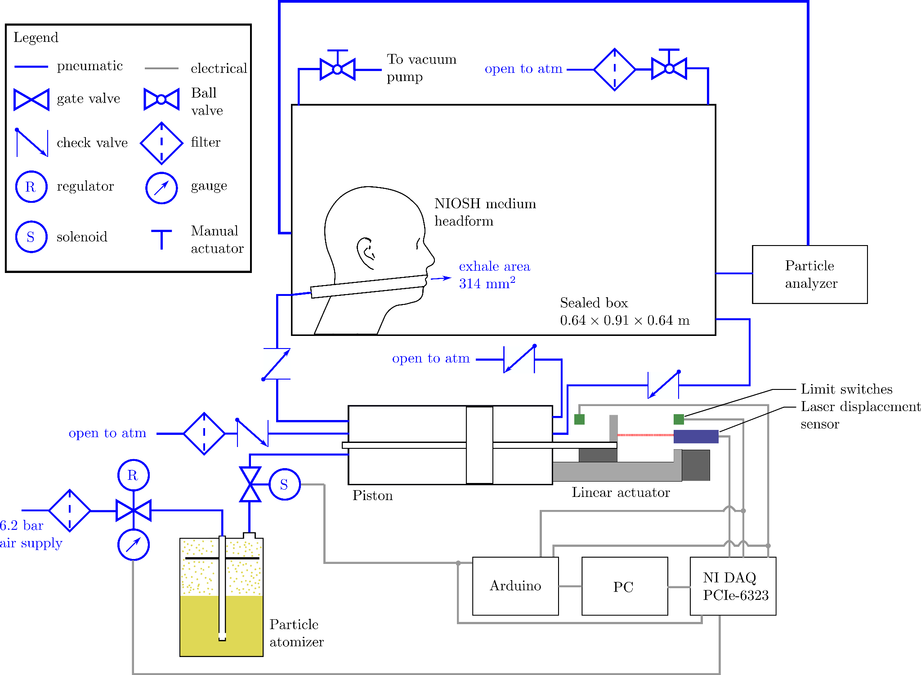
Figure S1. Experimental setup used for filtration efficiency tests (not to scale).
Table S1: Breathing and aerosol production parameters (95% confidence interval)
Parameter | Value | Unit
Respiratory rate | 14.30 +/- 0.03 | breaths/min
Respiratory period | 4.20 +/- 0.01 | seconds
Tidal volume | 586.6 +/- 0.5 | mL

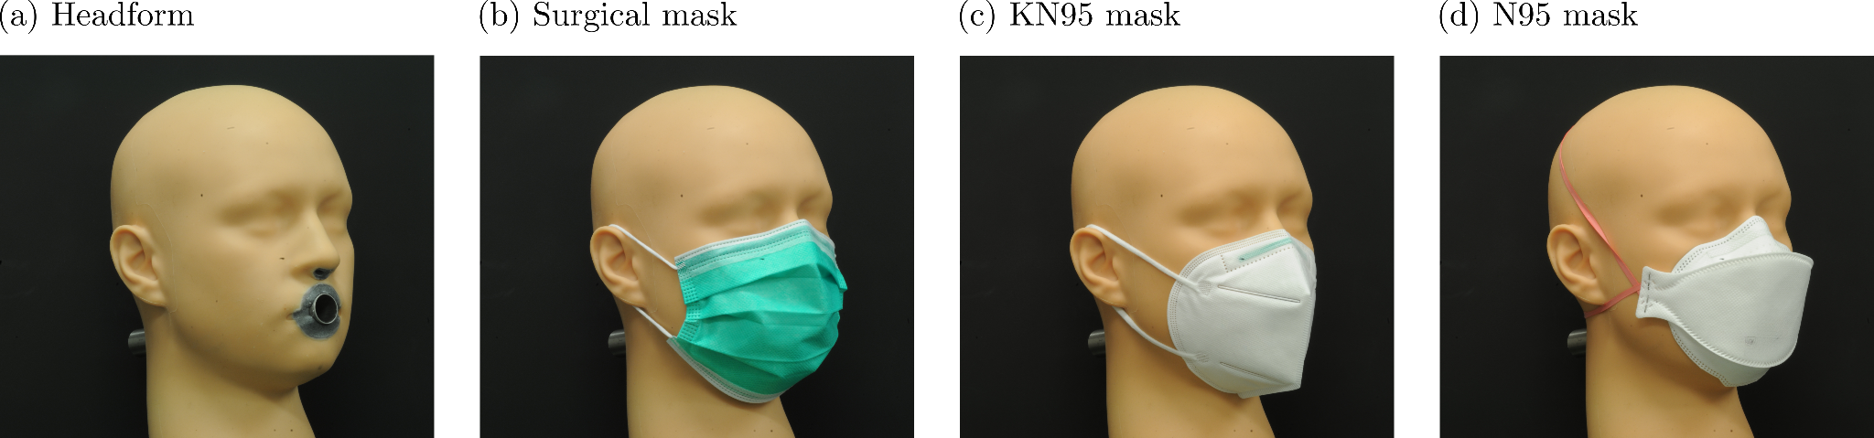
Figure S2: Isometric views of the Medium NIOSH headform and masks used in this study. (a) Headform without a mask, (b) Surgical mask, (c) KN95 mask, and (d) N95 mask.
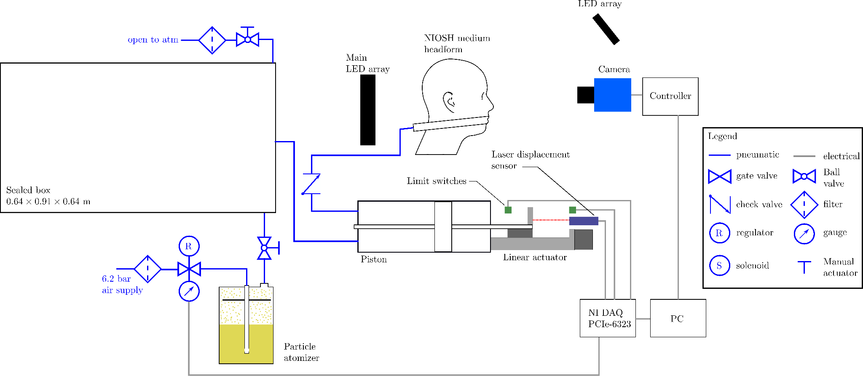
Figure S3: Experimental setup used for flow visualization tests where modifications are made to the particle measurement setup in Fig. S1 to produce highly seeded flow (not to scale).

