Supplementary Material
Energy recovery from the wastes collecting from a biorefining process for butyrate production

Jianzheng Li¹, Jiazhi Liu¹, Zhen Pan¹, Wenlin Gao¹, Yupeng Zhang¹, Jia Meng^{1,}*, Jiuling Li²
¹State Key Laboratory of Urban Water Resource and Environment, School of Environment, Harbin Institute of Technology, Harbin 150090, China
²Australian Centre for Water and Environmental Biotechnology, The University of Queensland, St. Lucia, Brisbane QLD 4072, Australia
*Corresponding author, E-mail address: jiameng@hit.edu.cn

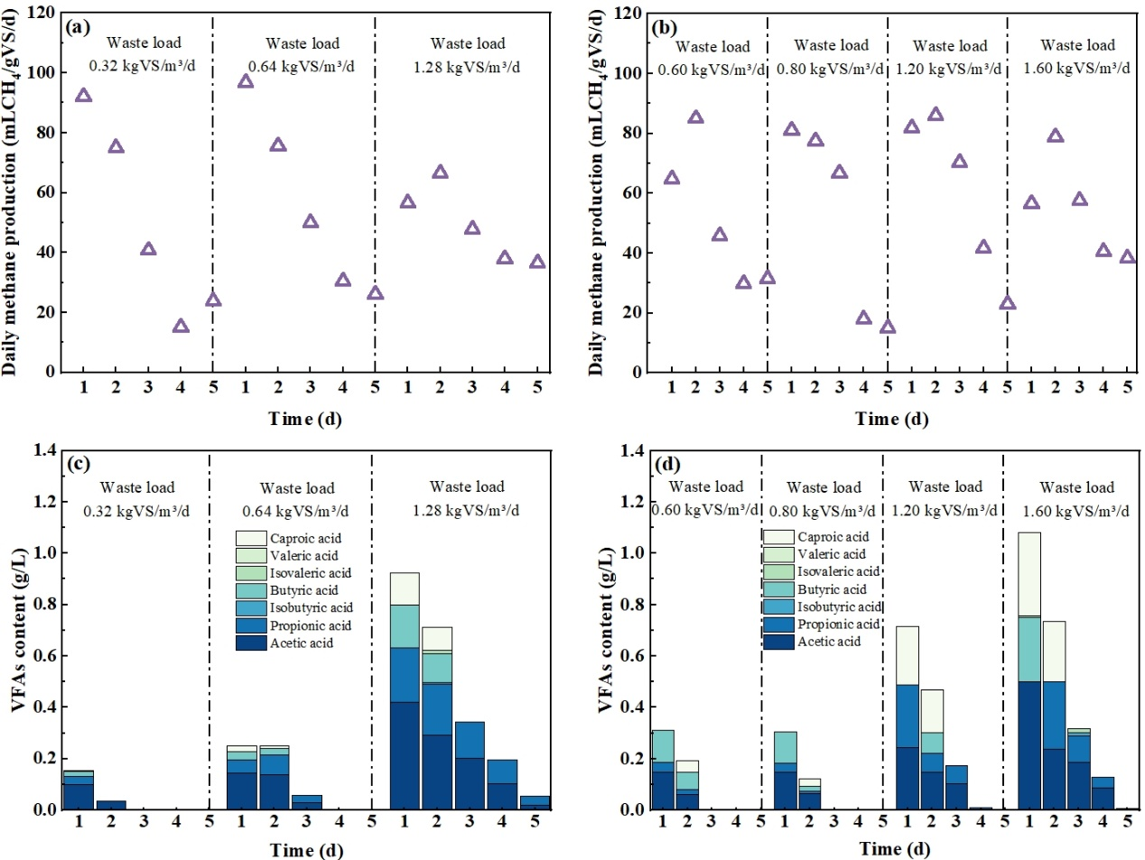
Fig. S1 Daily methane production and VFAs production in one cycle of each phase of R1 (a,c) and R2 (b,d) during the sequencing batch fermentation process.

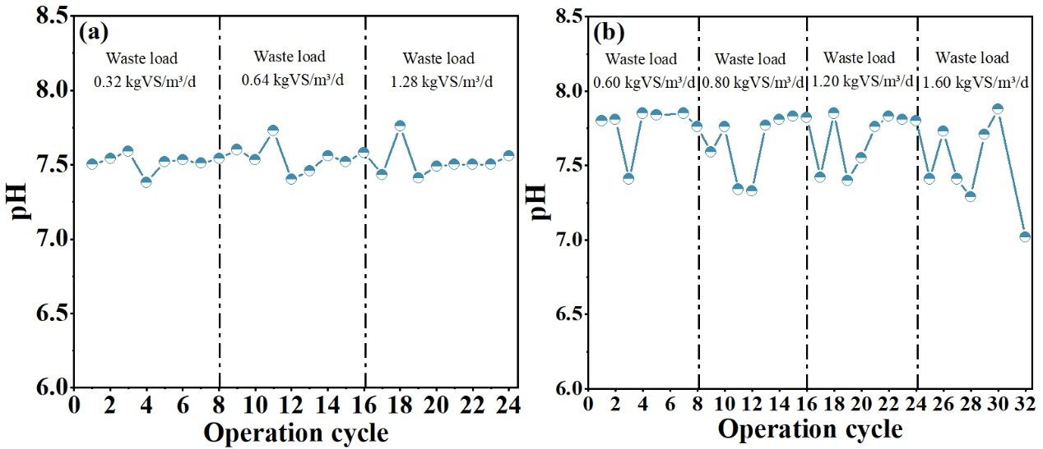
Fig. S2 pH value of R1 (a) and R2 (b) during the sequencing batch fermentation process.

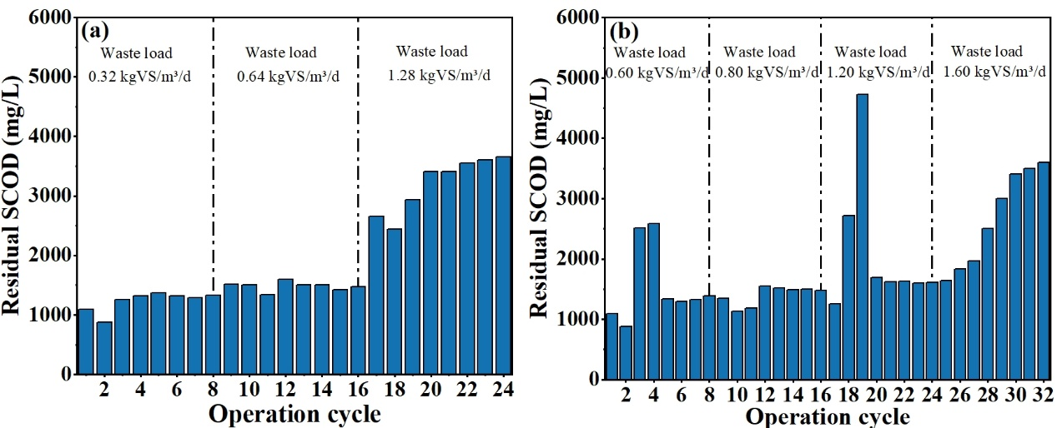
Fig. S3 Residual SCOD in R1 (a) and R2 (b) during the sequencing batch fermentation process.

