Additional file 1
Supplementary Information. Evaluating survey designs for targeting preventive chemotherapy against Schistosoma haematobium and S. mansoni across Sub-Saharan Africa: a geostatistical analysis and modelling study

Figure S1. Distribution of prevalence from sampled schools
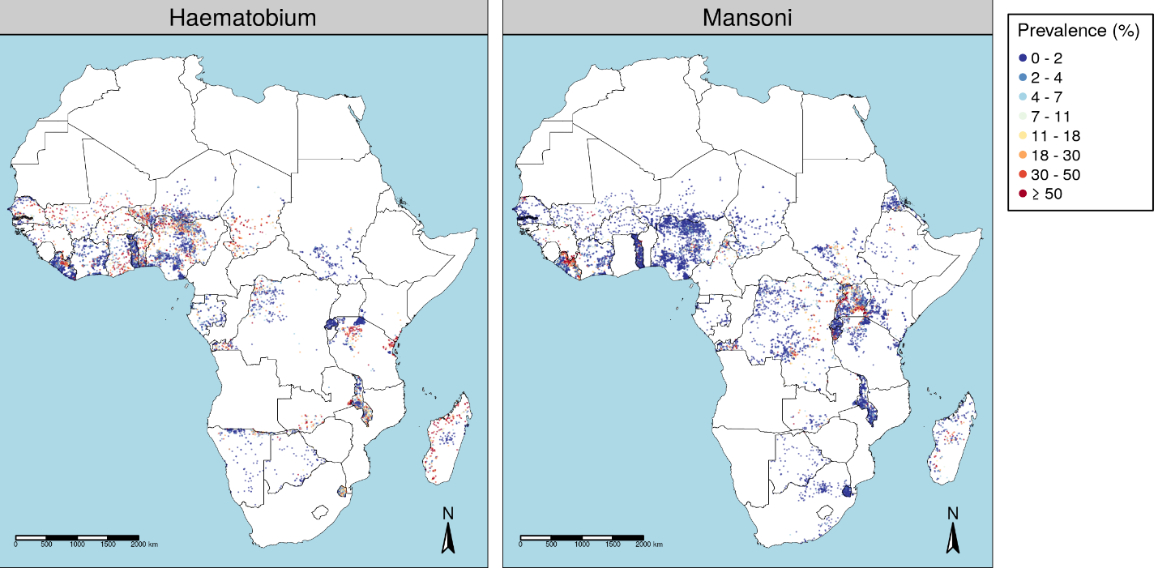

Table S1. Monte Carlo maximum likelihood estimates for geostatistical model parameters for A) S. haematobium and B) S. mansoni
A.
Country | n | µ | σ² | φ | τ²
Benin | 358 | 0.088 | 3.386 | 18.199 | 1.872
Botswana | 93 | 0.013 | 0.307 | 28.206 | 1.827
Burkina Faso | 101 | 0.119 | 3.621 | 8.826 | 0.000
Chad | 241 | 0.108 | 3.663 | 79.820 | 0.857
Congo (Kinshasa) | 387 | 0.015 | 4.185 | 78.600 | 2.580
Cote D'Ivoire | 476 | 0.006 | 5.188 | 60.096 | 1.164
Gabon | 199 | 0.011 | 1.484 | 89.428 | 0.632
Ghana | 166 | 0.079 | 4.036 | 110.629 | 1.695
Guinea | 64 | 0.053 | 10.428 | 69.858 | 1.825
Kenya | 104 | 0.055 | 11.519 | 31.712 | 4.489E⁻⁴
Liberia | 1238 | 0.010 | 6.751 | 90.541 | 0.814
Madagascar | 259 | 0.140 | 6.924 | 135.904 | 1.097
Malawi | 858 | 0.046 | 1.331 | 76.750 | 1.615
Mali | 164 | 0.128 | 4.900 | 91.911 | 1.647
Niger | 825 | 0.021 | 1.891 | 138.990 | 5.138
Nigeria | 1838 | 0.035 | 3.736 | 87.865 | 1.880
Rwanda | 158 | 0.007 | 0.005 | 5.179 | 0.001
Senegal | 218 | 0.022 | 5.629 | 86.692 | 3.927
South Sudan | 225 | 0.004 | 1.380 | 44.596 | 0.463
Swaziland | 251 | 0.056 | 1.673 | 41.355 | 0.520
Tanzania (Mainland) | 587 | 0.033 | 10.075 | 146.441 | 0.571
The Gambia | 195 | 0.108 | 0.804 | 0.074 | 2.795E⁻¹²
Togo | 931 | 0.017 | 2.416 | 31.370 | 0.615
Zambia | 92 | 0.207 | 1.094 | 19.365 | 0.842

B.
Country | n | µ | σ² | φ | τ²
Botswana | 111 | 0.001 | 1.910 | 372.268 | 0.346
Burkina Faso | 89 | 0.004 | 1.094 | 110.351 | 1.00E⁻¹³
Burundi | 246 | 0.020 | 7.264 | 45.854 | 5.341
Cameroon | 116 | 0.047 | 3.040 | 10.800 | 8.70E⁻¹²
Chad | 232 | 0.003 | 3.941 | 696.132 | 0.423
Congo (Kinshasa) | 1391 | 0.007 | 8.377 | 163.319 | 1.316
Cote D'Ivoire | 479 | 0.014 | 4.876 | 106.220 | 1.086
Eritrea | 329 | 0.003 | 1.868 | 56.097 | 1.066
Ethiopia | 65 | 0.007 | 6.034 | 249.102 | 5.525
Gabon | 86 | 0.005 | 0.294 | 7.118 | 5.75E⁻¹²
Guinea | 64 | 0.099 | 6.989 | 85.362 | 1.943
Kenya | 788 | 0.001 | 13.183 | 47.460 | 0.593
Liberia | 1193 | 0.066 | 4.352 | 58.822 | 0.570
Madagascar | 226 | 0.008 | 7.898 | 55.156 | 1.196
Malawi | 857 | 0.007 | 0.891 | 44.406 | 1.250
Mali | 182 | 0.001 | 9.250 | 87.455 | 2.202
Niger | 358 | 0.004 | 0.389 | 64.458 | 0.646
Nigeria | 2230 | 0.004 | 1.851 | 88.454 | 0.424
Rwanda | 158 | 0.004 | 2.840 | 9.615 | 6.03E⁻¹⁴
Senegal | 221 | 0.000 | 9.277 | 233.162 | 0.883
South Africa | 180 | 0.002 | 0.006 | 0.005 | 0.209
South Sudan | 393 | 0.006 | 8.251 | 164.494 | 0.663
Swaziland | 251 | 0.006 | 0.120 | 1.187 | 3.97E⁻¹²
Tanzania (Mainland) | 553 | 0.005 | 4.171 | 88.247 | 0.781
The Gambia | 222 | 0.008 | 0.023 | 4.941 | 0.032
Togo | 1052 | 0.007 | 3.355 | 33.755 | 0.382
Uganda | 1233 | 0.040 | 4.723 | 49.332 | 1.652
Zambia | 101 | 0.029 | 5.407 | 124.995 | 1.955

Figure S2. Simulated country and distributions of districts, subdistricts and schools
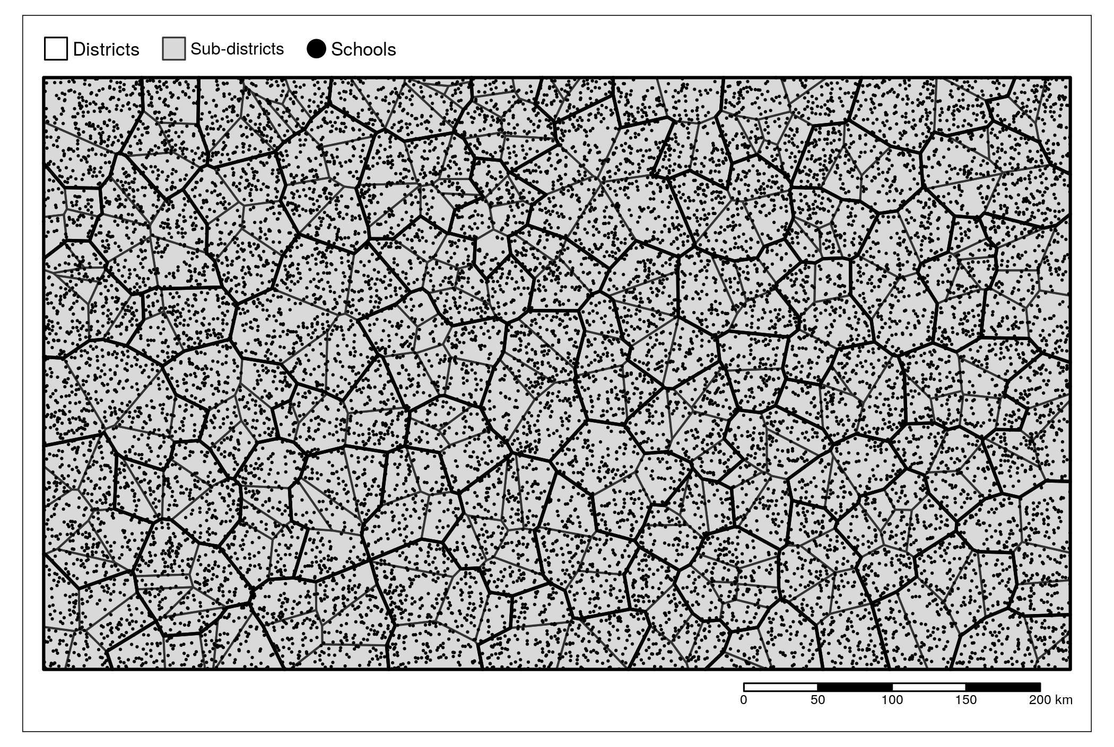

Table S2. Consumable and equipment costs included for sampling 50 children using A) urine filtration and B) Kato Katz stool analysis; life expectancy and quantity needed per team is included for capital items
A.
Item |  | Quantity per school | Life expectancy (years)
Consumables
 | Nucleopore membrane filter (13mm and pore size 12µm) | 50
 | Masking tape | 2.5 rolls
 | Detergent | 100g
 | Bleach (1% hypochlorite solution) | 50ml
 | Gloves | 0.2 boxes
 | Toilet tissue | 2.5 rolls
 | Hemostix reagent strips | 50
 | Lugol’s iodine (5% solution) | 20ml
 | Slide boxes | 0.2 box
Capital items
 | Filter holders | 60 | 4
 | Gaskets | 60 | 4
 | Microscopes with removable mirrors | 5 | 5
 | Pencils | 9 | 2
 | Pens | 9 | 2
 | Fine tip permanent marker | 1 | 2
 | Notepad | 3 | 2
 | Old newspapers | 5kg | 2
 | Scissors | 1 | 5
 | Large plastic buckets with lids | 1 | 5
 | Rubber washing gloves | 1 pair | 2
 | Generator (powers up to 6 microscopes) | 1 | 5
 | Urine sample pots (20ml) | 60 pots | 5
 | Forceps/ tweezers | 1 | 5
 | Pipettes | 1 | 2
 | Syringe (10ml) | 1 | 2
 | Hand tally counter | 1 | 5
 | Microscopy glass slides | 60 | 5
Additional costs*

* Calculated as 5% of additional survey costs including purchase of packing containers, power extension cable, large plastic bowls, small plastic bowls with lids, water container, toothbrushes, water brushes, antibacterial hand wash, hand sanitiser, disposable plastic aprons, cotton towels, kitchen roll, saline solution (0.9% NaCl), distilled water, Malachite green (or methylene blue), glycerol, wooden applicator, slide labels, and tissue for microscope

B.
Item |  | Quantity per school | Life expectancy (years)
Consumables
 | Cellophane (sheets) | 2.1 sheets
 | Masking tape | 2.5 rolls
 | Detergent | 100g
 | Bleach (1% hypochlorite solution) | 50ml
 | Gloves | 0.2 box
 | Toilet tissue | 2.5 rolls
 | Stool sample container (polyethene squares) | 0.02m²
 | Slide boxes (for 10% of slides) | 0.45 box
 | Insecticide spray | 0.1 bottle
 | Biohazard waste bins | 1 bin
Capital items
 | Metal sieve (Endocott sieve, 200-250µm mesh size) | 1 sieve | 3
 | Kato Katz plastic templates (6mm hole and 1.5mm thick, 41.7mg) | 0.5 box | 4
 | Microscopes with removable mirrors | 3 | 5
 | Pencils | 9 | 2
 | Pens | 9 | 2
 | Fine tip permanent marker | 9 | 2
 | Notepad | 3 | 2
 | Old newspapers | 5kg | 2
 | Scissors | 1 | 5
 | Large plastic buckets with lids | 1 | 5
 | Rubber washing gloves | 1 pair | 2
 | Generator (powers up to 6 microscopes) | 1 | 5
Additional costs*

* Calculated as 5% of additional survey costs including purchase of packing containers, power extension cable, large plastic bowls, small plastic bowls with lids, water container, toothbrushes, water brushes, antibacterial hand wash, hand sanitiser, disposable plastic aprons, cotton towels, kitchen roll, saline solution (0.9% NaCl), distilled water, Malachite green (or methylene blue), glycerol, wooden applicator, slide labels, and tissue for microscope

Table S3. Total survey mapping costs per school sampling 50 children

Item | Total cost in USD, median (IQR)
Personnel (per diems for survey staff) | 205.30 (201.90 – 226.60)
Transport (fuel and vehicle maintenance) | 46.65 (34.19 – 51.75)
Consumables and equipment – urine filtration | 465.40 (464.40 – 468.30)
Consumables and equipment – Kato Katz | 58.85 (57.85 – 60.66)

Table S4. Mean survey costs per school sampling 50 children by country, year and diagnostic method

Country | Survey Year | Diagnostic Method | Total cost in USD
Malawi | 2017 | Kato Katz and urine filtration | 807.71
Uganda | 2017 | Kato Katz and urine filtration | 696.71
Malawi | 2018 | Kato Katz and urine filtration | 828.18
Tanzania | 2018 | Kato Katz and urine filtration | 779.92
Uganda | 2018 | Kato Katz and urine filtration | 770.34
Malawi | 2017 | Urine filtration | 749.86
Uganda | 2017 | Urine filtration | 636.05
Malawi | 2018 | Urine filtration | 769.33
Tanzania | 2018 | Urine filtration | 708.84
Uganda | 2018 | Urine filtration | 714.03
Malawi | 2017 | Kato Katz | 342.27
Uganda | 2017 | Kato Katz | 228.43
Malawi | 2018 | Kato Katz | 363.77
Tanzania | 2018 | Kato Katz | 286.99
Uganda | 2018 | Kato Katz | 308.28

