Supplementary figures
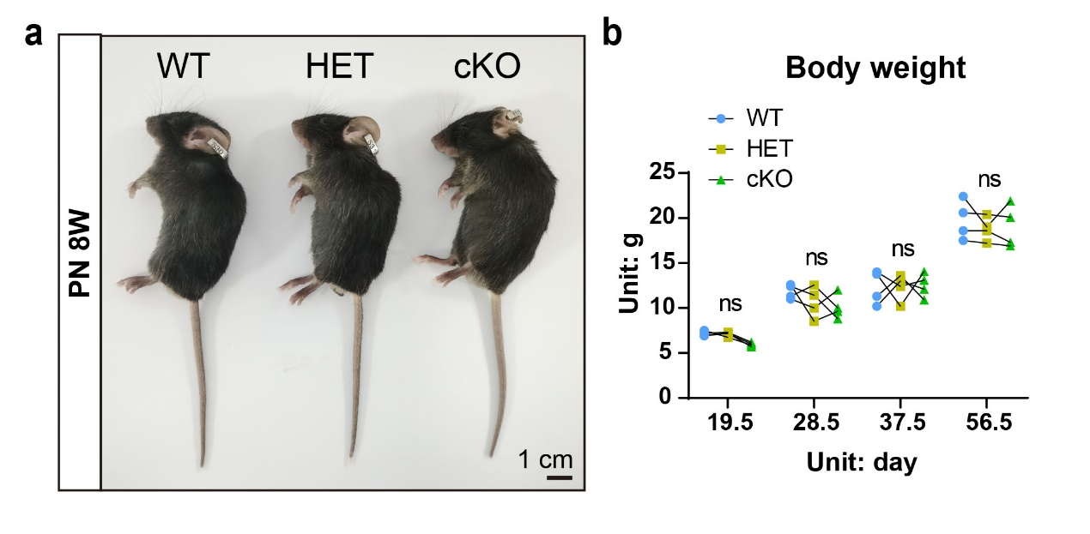
Fig. S1 No significant differences in body size or weight were observed among WT, heterozygous mice (HET), and cKO mice. n = 4. ns, not significant, p > 0.05.

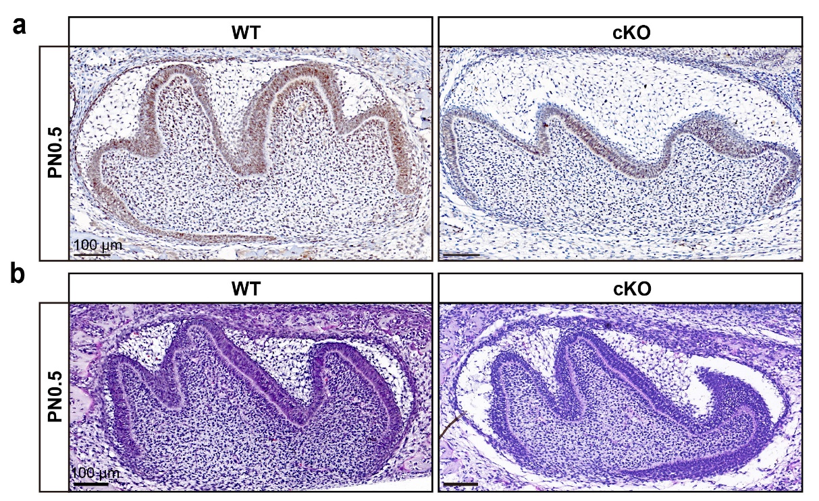
Fig. S2 Conditional deletion of Creb3l1 in the neural crest lineage revealed no difference in the first molar of PN0.5 mice. a The deletion of CREB3L1 in cKO mice odontoblasts was validated by IHC in mandibular first molars sections of PN0.5 mice. Scale bar = 100 μm. b HE staining was performed on the first molar of PN0.5 WT and conditional knockout mice. Scale bar = 100 μm.

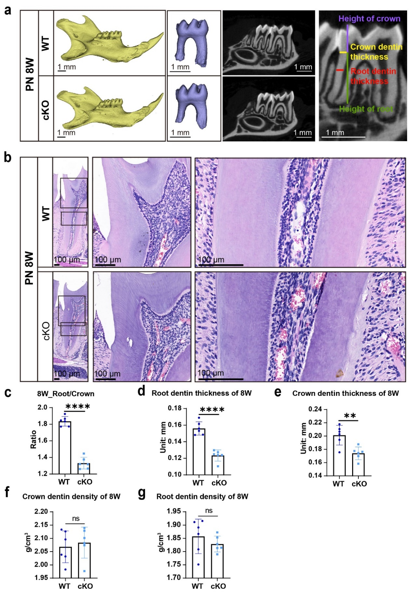
Fig. S3 Conditional deletion of Creb3l1 in the neural crest lineage led to a reduction in both root length and dentin thickness. a micro-CT scanning was performed to measure the mandibular first molar of PN 8W. Scale bar = 1 mm. b HE staining was performed on WT and cKO mandibular first molars of PN 8W mice. Scale bar = 100 μm. c The quantitative data of the root-to-crown ratio from PN 8W mice. d The quantitative data of root dentin thickness from PN 8W mice. e The quantitative data of crown dentin thickness from PN 8W mice. f The quantitative data of crown dentin density from PN 8W mice. g The quantitative data of root dentin density from PN 8W mice. Scale bar = 50 μm. n ≥ 6. ns, not significant, p > 0.05; **p < 0.01; ****p < 0.0001.

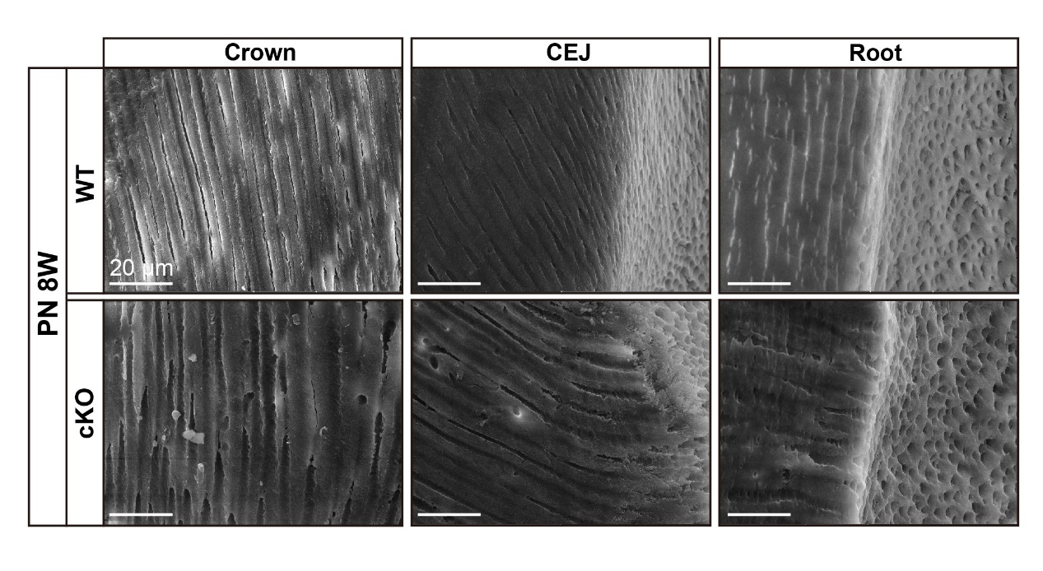
Fig. S4 No significant difference in dentinal tubule between WT and cKO. Scanning electron microscope (SEM) of dentin revealed no significant difference in dentinal tubule between WT and cKO. Scale bar = 20 μm. CEJ, cementoenamel junction.

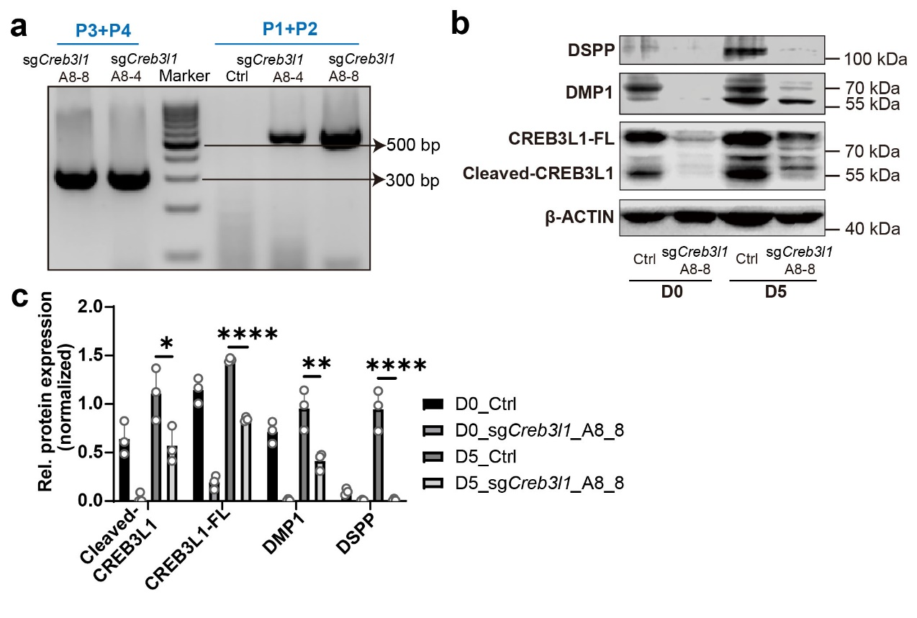
Fig. S5 Downregulation of Creb3l1 impaired the odontoblastic differentiation ability of mDPCs. a Genotyping results for two heterozygote monoclonal cell lines with Creb3l1 knockdown, sgCreb3l1_A8-4 and sgCreb3l1_A8_8. b The expression of the full length of CREB3L1 (CREB3L1-FL), Cleaved-CREB3L1, DMP1, and DSPP were decreased in sgCreb3l1_A8-8 during differentiation induction. c Quantification of the relative protein expression levels of (b). n = 3. *p < 0.05; **p < 0.01; ****p < 0.0001.

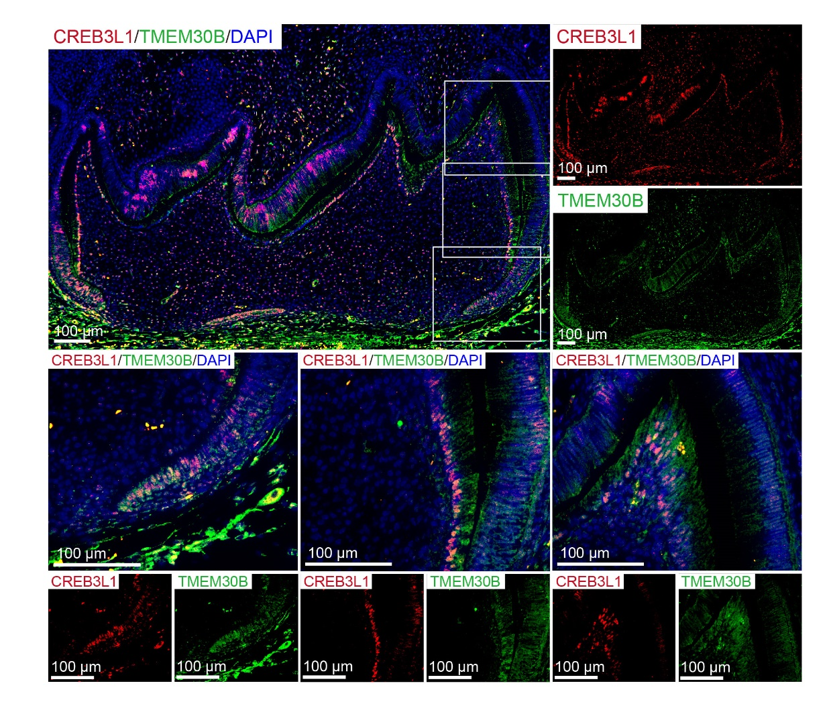
Fig. S6 The expression of TMEM30B was detected in cells expressing CREB3L1. The expression of TMEM30B and CREB3L1 in the first molar of PN2.5 WT mice. Scale bar = 100 μm.

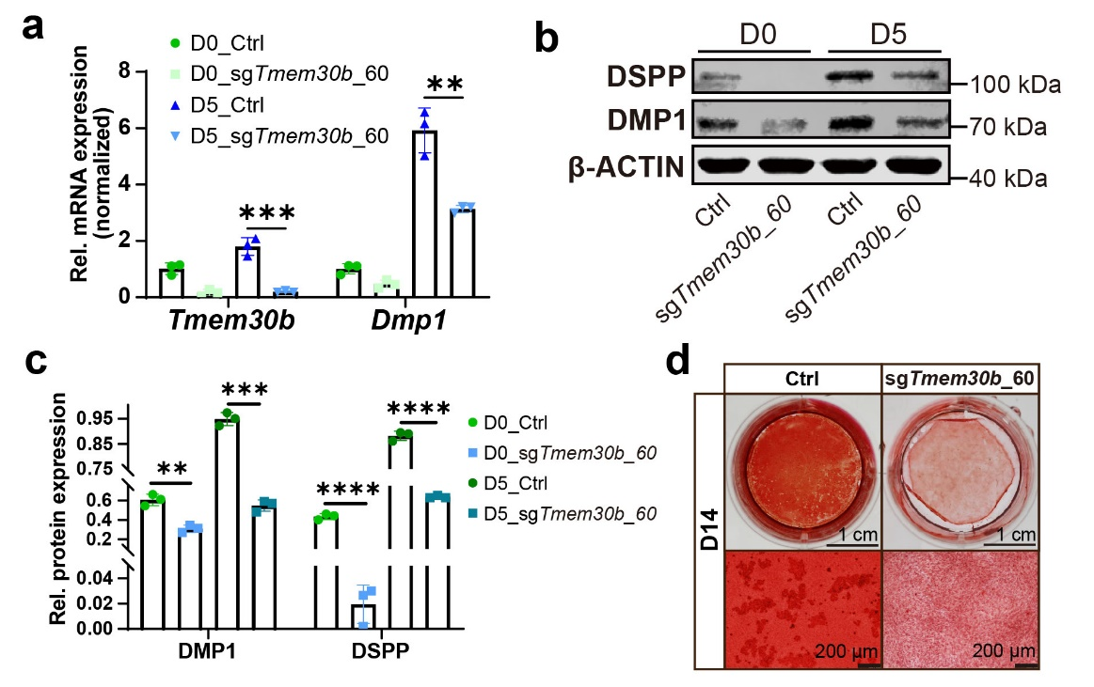
Fig. S7 Deficiency of Tmem30b impaired the odontoblastic differentiation capability of mDPCs. a During the induction of differentiation, the mRNA of Tmem30b and Dspp was decreased by Tmem30b deficiency (sgTmem30b_60) compared to the Ctrl group. b During the induction of differentiation, the expression of DMP1 and DSPP was decreased in the sgTmem30b_60 group compared to the Ctrl group. c Quantification of the relative levels of protein expression in (b). d Alizarin red S staining was performed to visualize the calcium nodules in Ctrl and sgTmem30b_60 after 14 days of differentiation induction. Scale bar = 1 cm, scale bar = 200 μm. n = 3. **p < 0.01; ***p < 0.001; ****p < 0.0001.

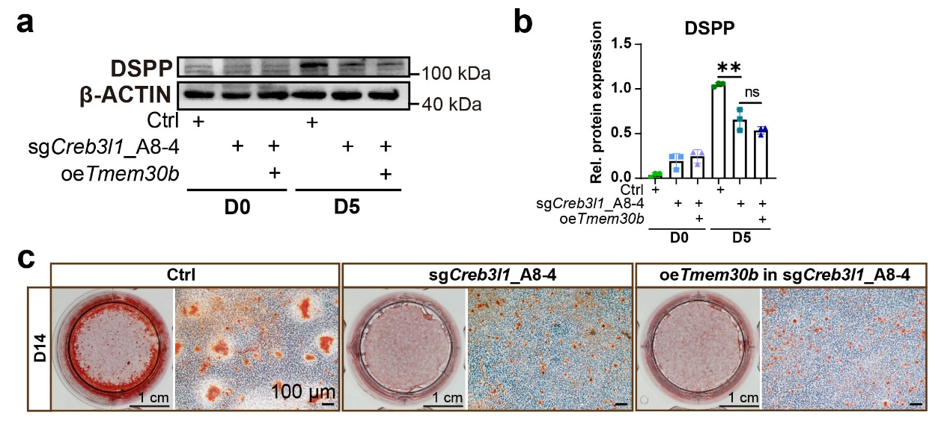
Fig. S8 The attenuated odontoblastic differentiation capability caused by CREB3L1 deficiency cannot be rescued by overexpression of TMEM30B. a The level of DSPP remained unchanged between the sgCreb3l1_A8-4 group and the sgCreb3l1_A8-4 group treated with oeTmem30b after 5 days of differentiation induction. b Quantification of the relative levels of protein expression in (a). c Alizarin red S staining was performed to visualize the calcium nodules in Ctrl, sgCreb3l1_A8-4, and sgCreb3l1_A8-4 treated with oeTmem30b group after 14 days of differentiation induction. Scale bar = 1 cm, scale bar = 100 μm. n = 3. ns, not significant, p > 0.05; **p < 0.01.

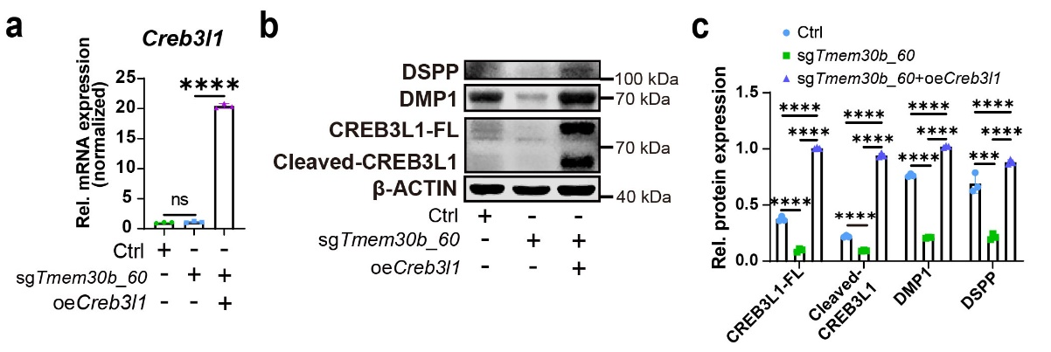
Fig. S9 Overexpression of CREB3L1 in TMEM30B-deficient mDPCs elevated the expression of DMP1 and DSPP. a The mRNA level of Creb3l1 was increased in the sgTmem30b_60 treated with Creb3l1 overexpression lentivirus (oeCreb3l1) group compared to sgTmem30b_60 group. b The levels of CREB3L1-FL, Cleaved-CREB3L1, DMP1, and DSPP proteins were all upregulated in sgTmem30b_60 treated with oeCreb3l1 group compared to Ctrl and sgTmem30b_60 groups. c Quantification of the relative levels of protein expression in (b). n = 3. ns, not significant, p > 0.05; ***p < 0.001; ****p < 0.0001.

