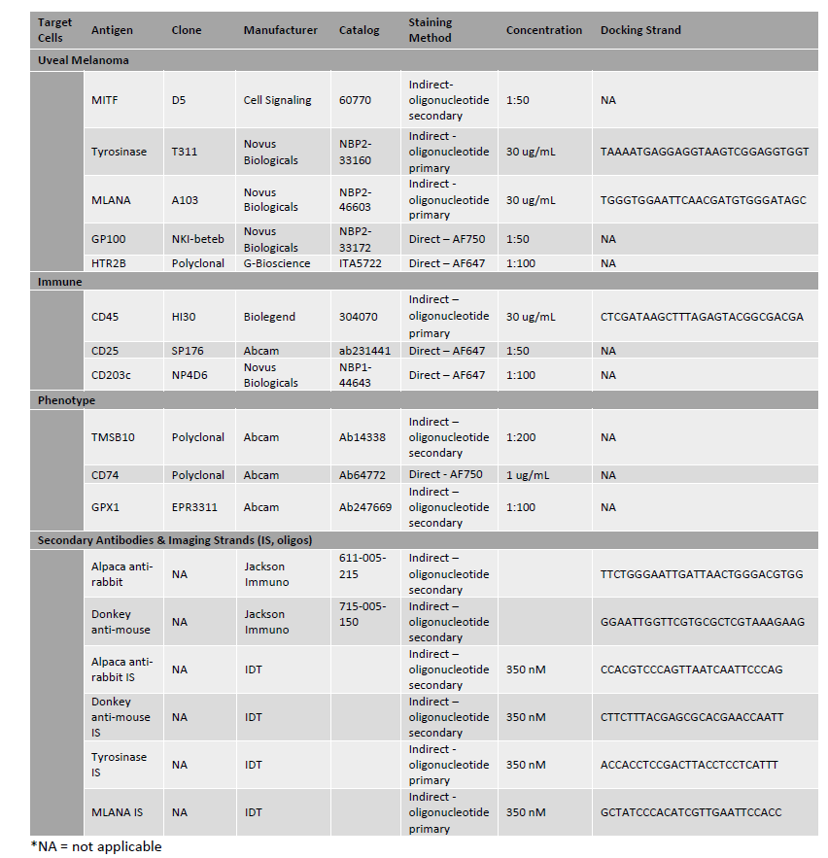
Supplemental Table 1: Antibody information for hybrid cell identification in UM FFPE sections and peripheral blood using cyCIF. (8, 26-29)
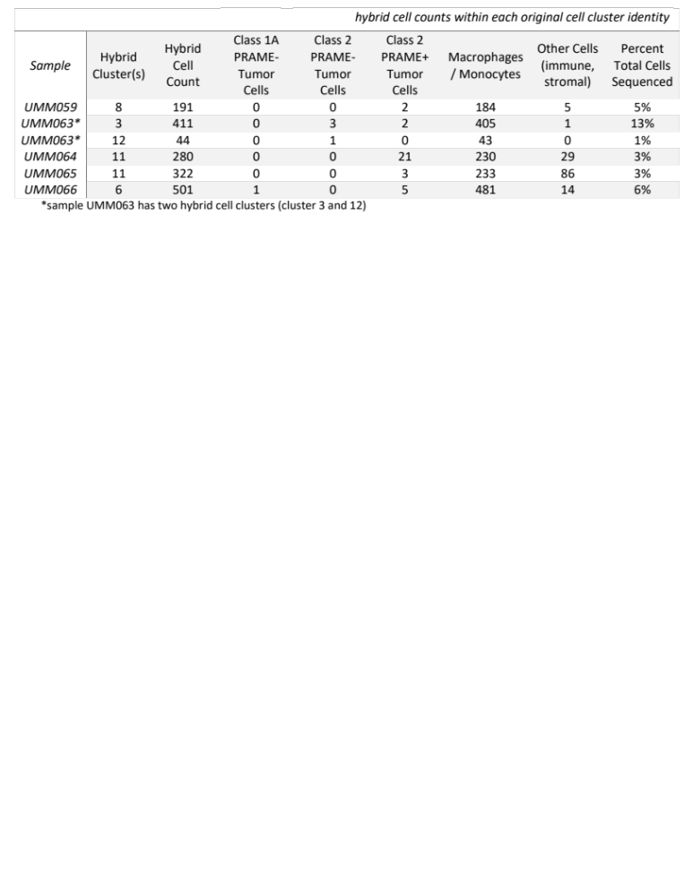Supplemental Table 2: Hybrid cell counts from each patient sample within each original cluster identity as defined by Durante et al. (13)

