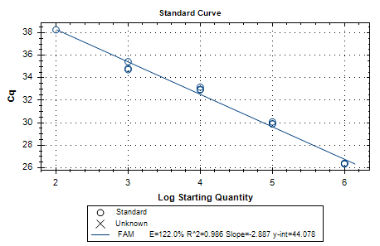
a)
10² 10³ 10⁴ 10⁵ 10⁶
Y = -2.887X+44.078
R² = 0.986
E = 122.0% (2.21)

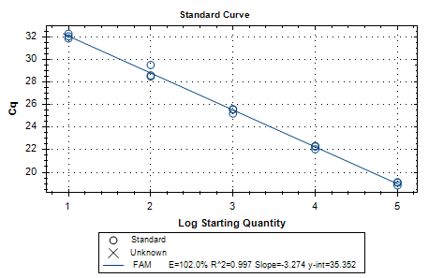
10² 10³ 10⁴ 10⁵ 10⁶
Y = -3.274X+35.352
R² = 0.997
E = 102.0% (2.02)
b)

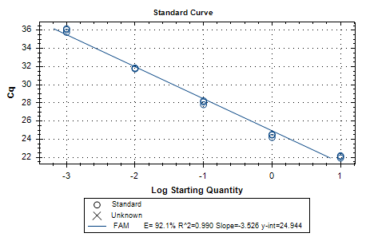
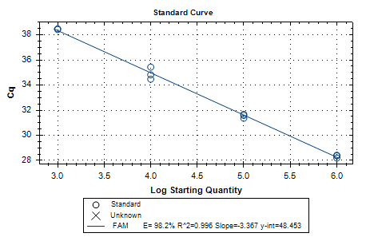
10² 10³ 10⁴ 10⁵ 10⁶
Y = -3.526X+24.944
R² = 0.990
E = 98.2% (1.98)
Tubulin
10³ 10⁴ 10⁵ 10⁶
Tef2
Y = -3.364X+48.935
R² = 0.996
E = 98.3% (1.98)

c)

d)

Supplementary Figure 1. Standard curves of the reference genes a) NAD5, b) EF1, c) TEF2, and d) Tubulin, generated from the serial dilution of positive control samples used for calculation of reaction efficiency in this study.

