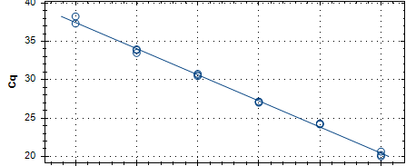
Y= -3.404X+40.862
R²=0.996
1:10000000
1:1000000
1:100000
1:10000
1:1000
1:100
1:10,000,000 1:1,000,000 1:100,000 1:10,000 1:1,000 1:100

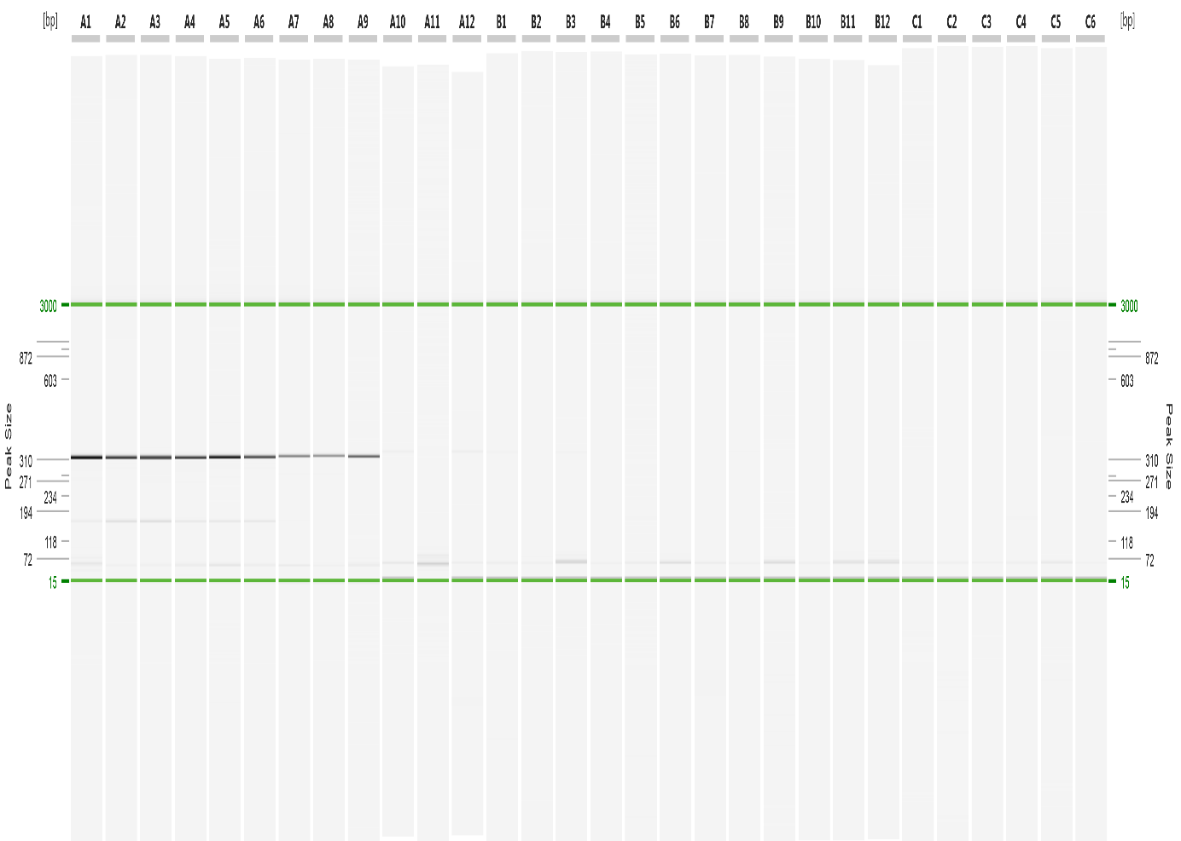
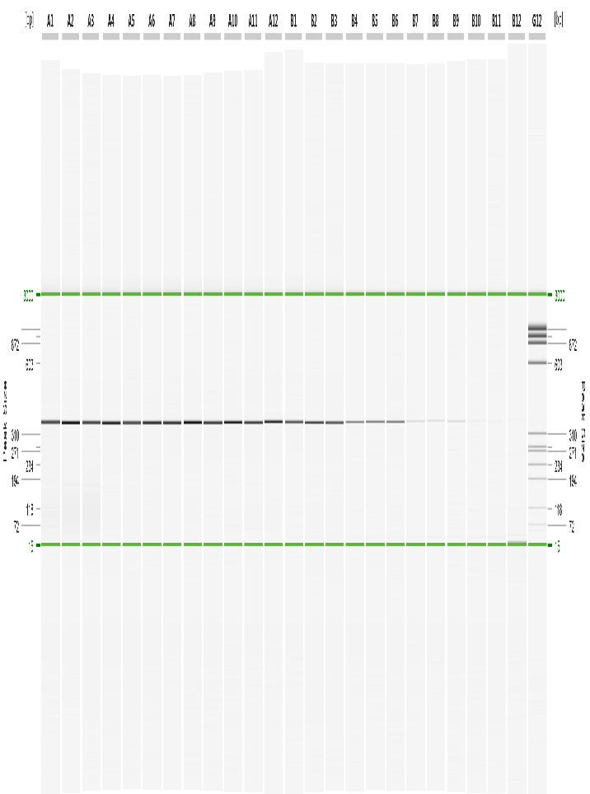
1:100 1:1000 1:10000 1:100000 1:1000000 1:10000000
324 bp
3 kb
603 bp
310bp
118 bp
15 bp

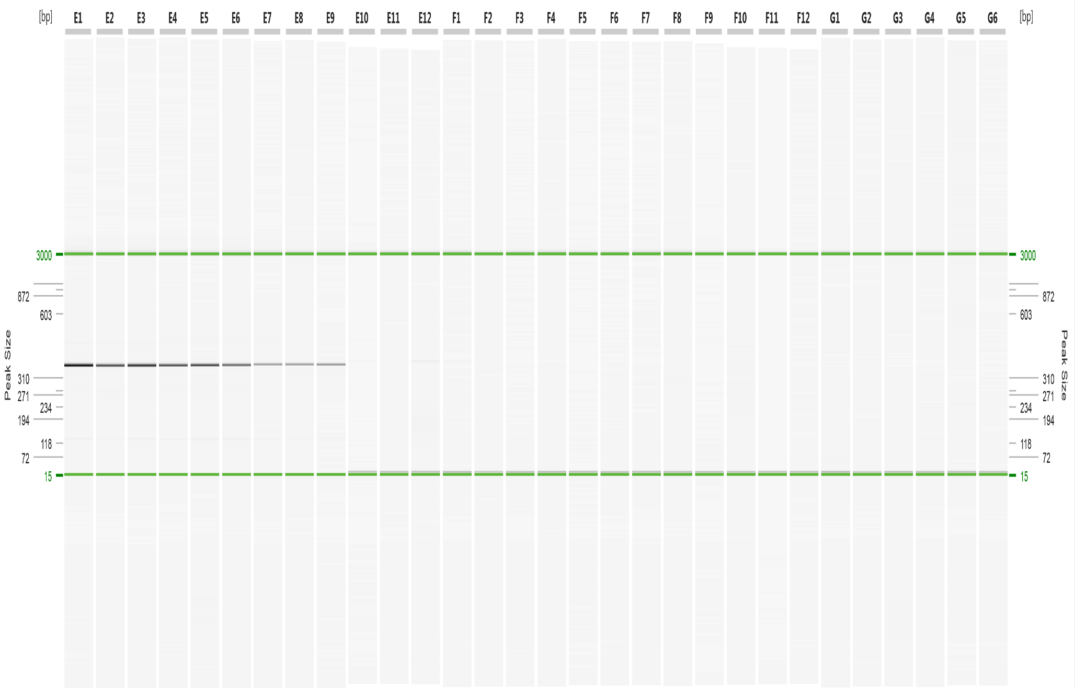
1:10000000
1:1000000
1:100000
1:10000
1:1000
348 bp
603 bp
310 bp
118
15 bp
3 kb
1:100

Supplementary Figure 3: Sensitivity comparison between RT-qPCR developed in this study and two current RT-PCR for the detection of Tobacco ringspot virus (TRSV) using a serial dilution of total RNA extracted from an isolate positive for TRSV in water covering a range from 1:100 to 1:10,000,000. Top: RT-qPCR dilution series curves for TRSV. Middle and bottom, capillary gel electrophoresis analysis of the products obtained by RT-PCR, 324 bp (Fuch et al.), 348 bp (324). A 15 bp – 3 kb alignment marker and a 118 – 603 bp DNA size maker were used in the capillary gel electrophoresis analysis of the RT-PCR products.

