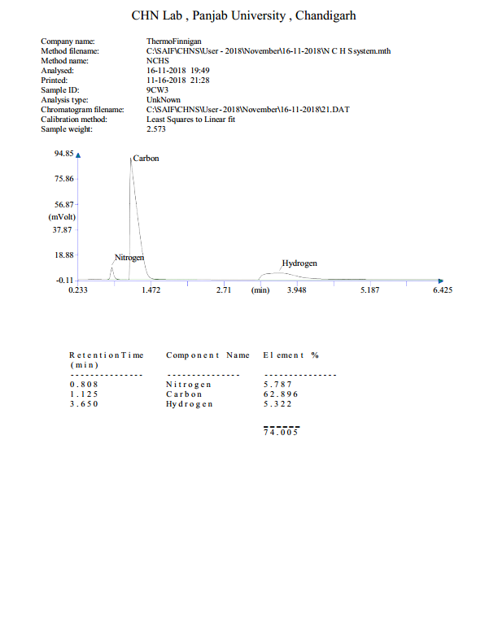 S1 Fig. CHN analysis of compound (4b)

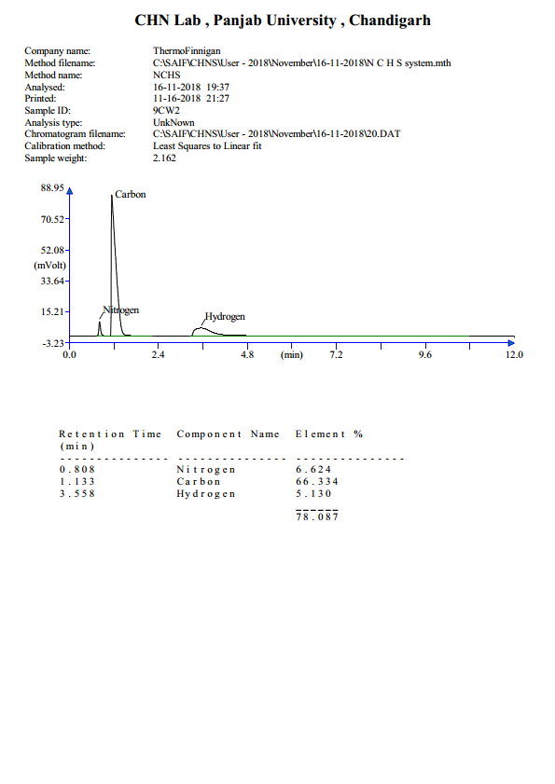

S2 Fig. CHN analysis of compound (4c)

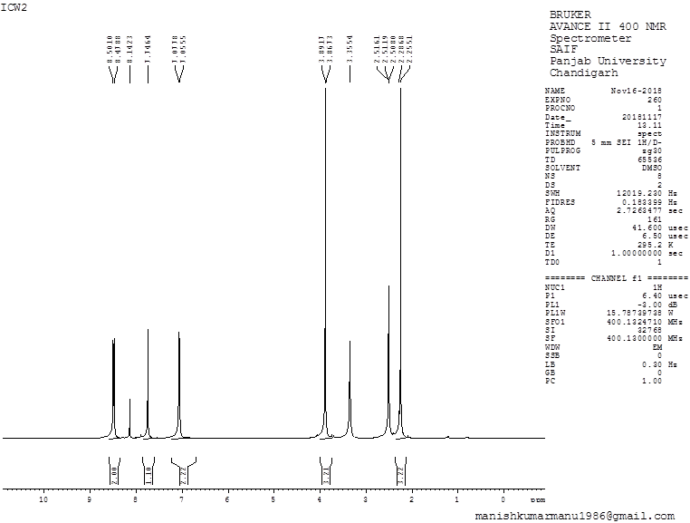
S3 Fig. 1HNMR spectrum of compound (4c)
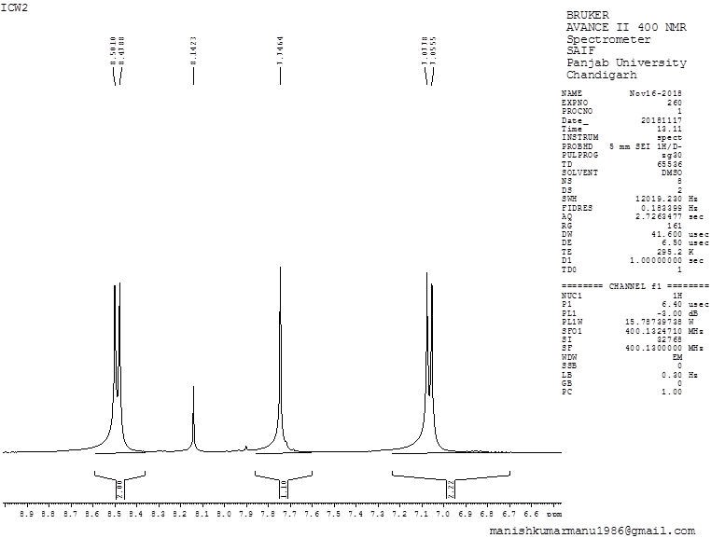
S4 Fig. 1HNMR spectrum of compound (4c) (Expanded form 1)
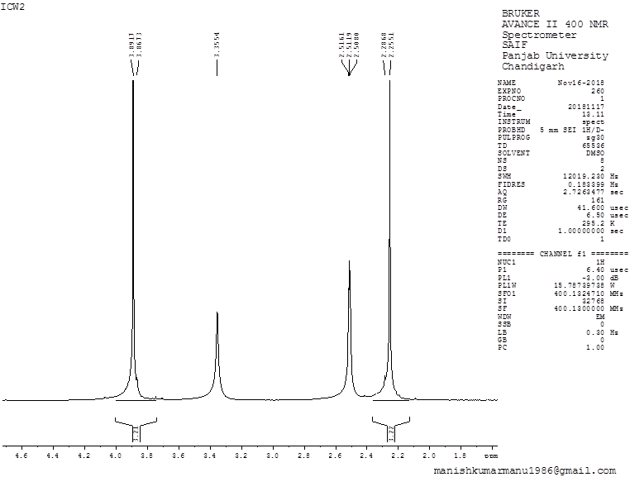
S5 Fig. 1HNMR spectrum of compound (4c) (Expanded form 2)
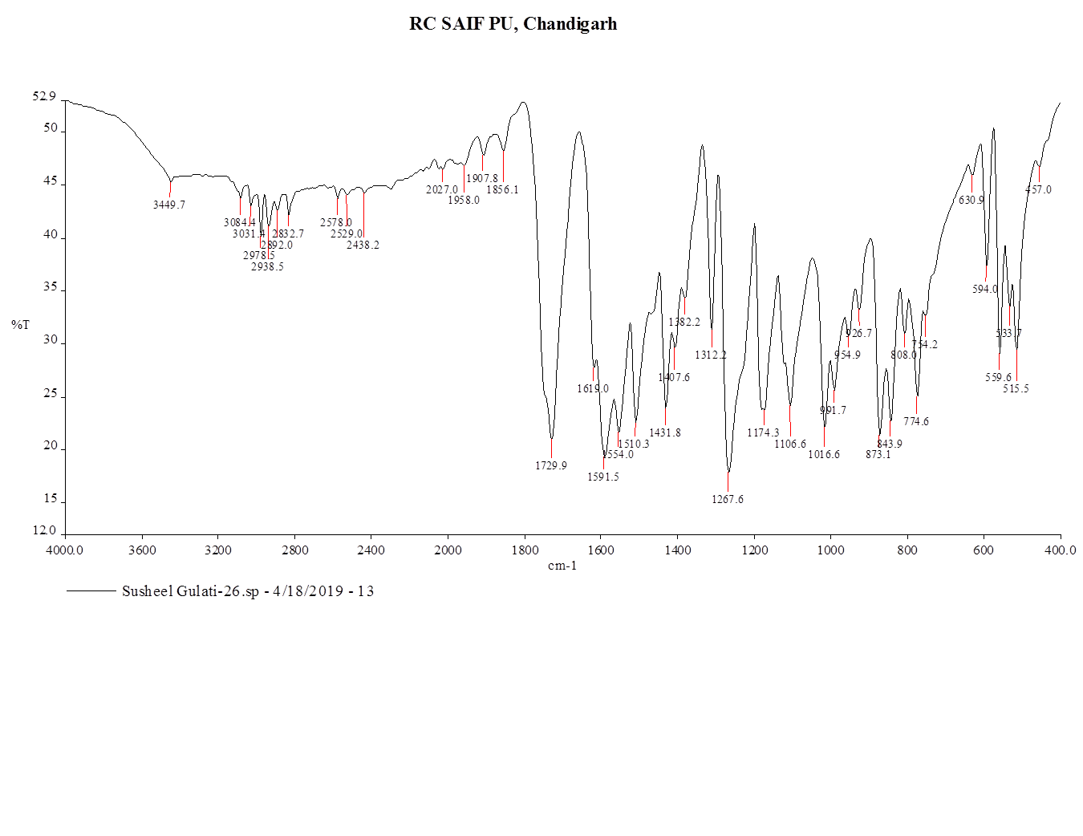
S6 Fig. FTIR spectrum of compound (4c)
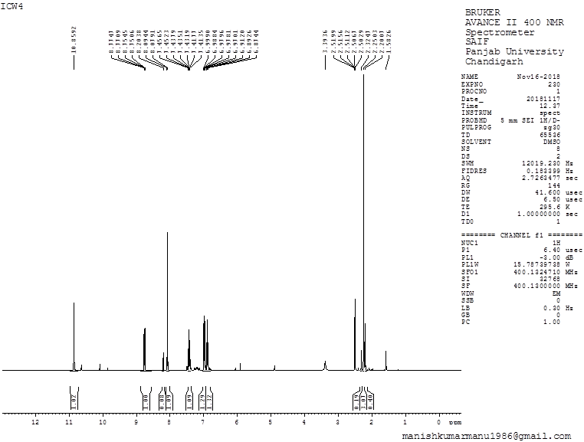
S7 Fig. 1HNMR spectrum of compound (4e)
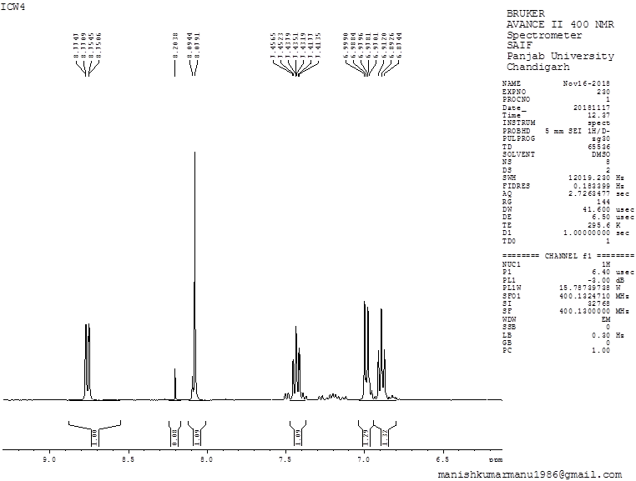
S8 Fig. 1HNMR spectrum of compound (4e) (Expanded form 1)
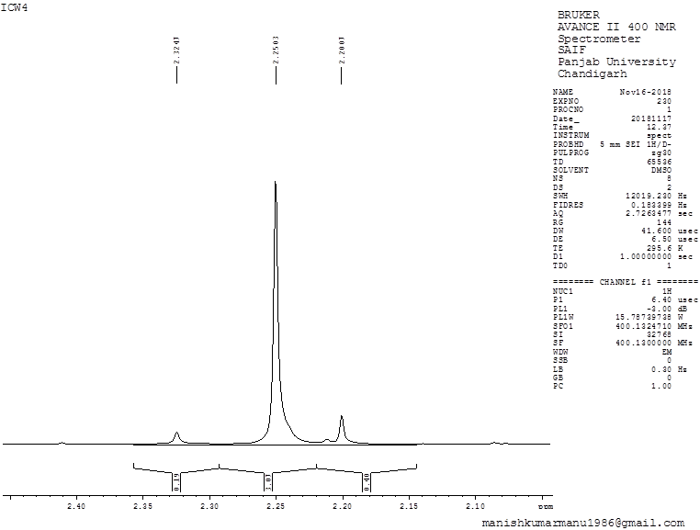
S9 Fig. 1HNMR spectrum of compound (4e) (Expanded form 2)
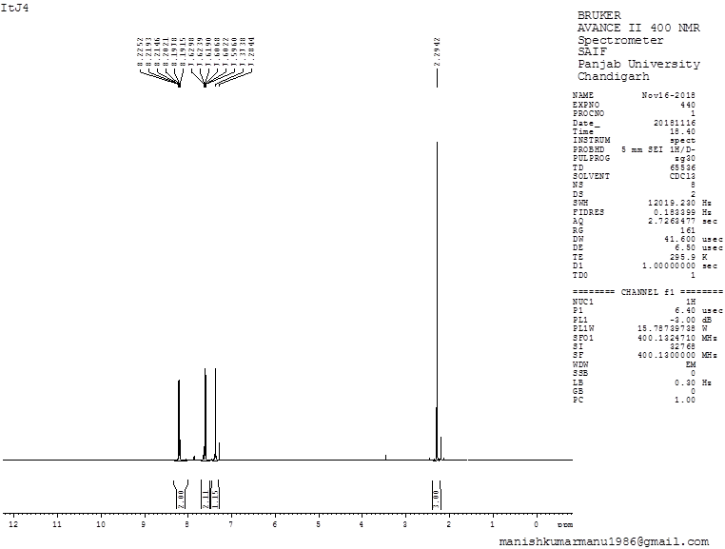
S10 Fig. 1HNMR spectrum of compound (4f)
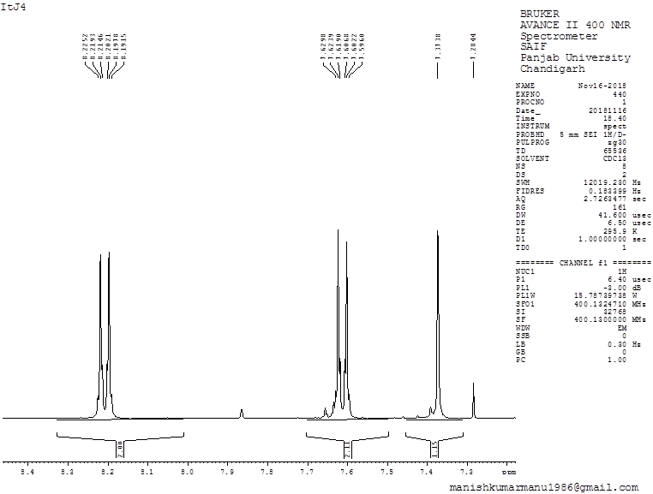
S11 Fig. 1HNMR spectrum of compound (4f) (Expanded form 2)

