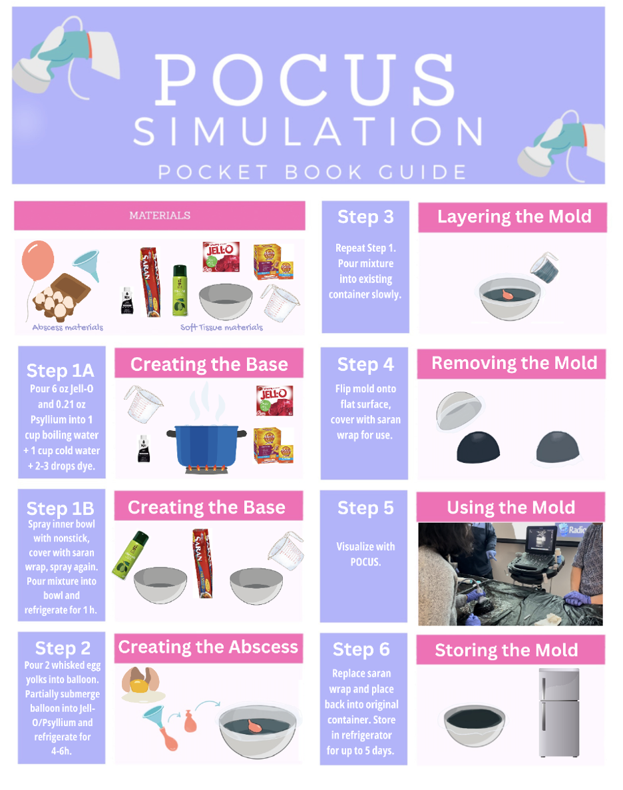

Supplementary Data, Figure 1. POCUS Simulation step-by-step picture guide to be used in conjunction with steps outlined in results.

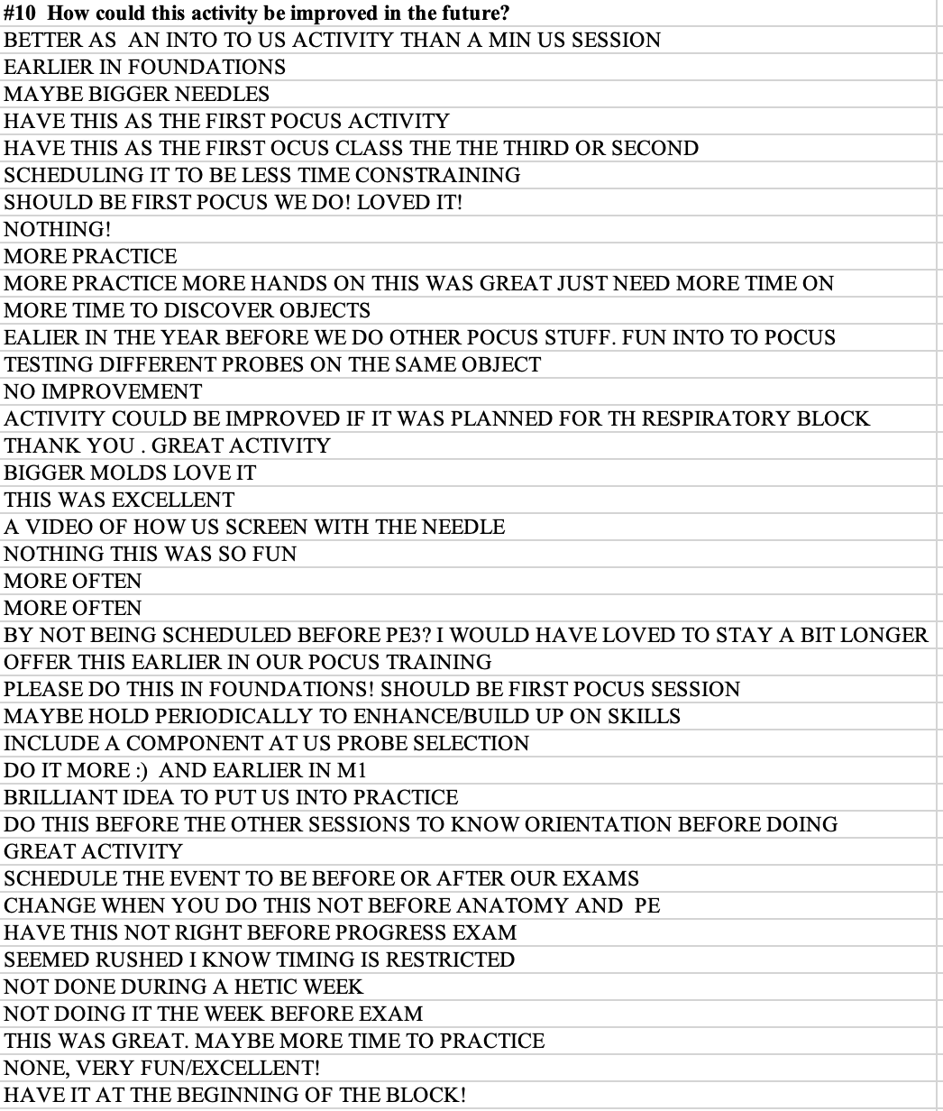
Supplementary Data, Table 1. Free response text to optional question of post-workshop survey.

