APPENDICES
Appendix I. Preparation of Feedstock Raw Materials
Appendix 1.1: Preparation of Filter Cake (a) Fresh Filter cake, (b) Sun dried Filter cake,
(c) Grinded Filter cake and (d) Sieved and labeled filter cake
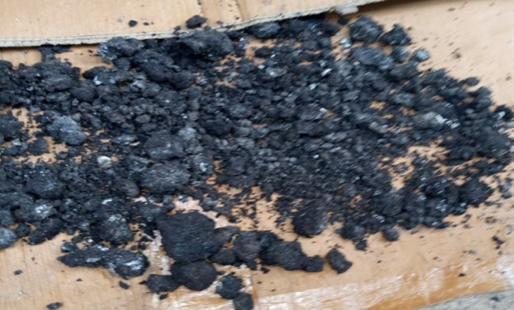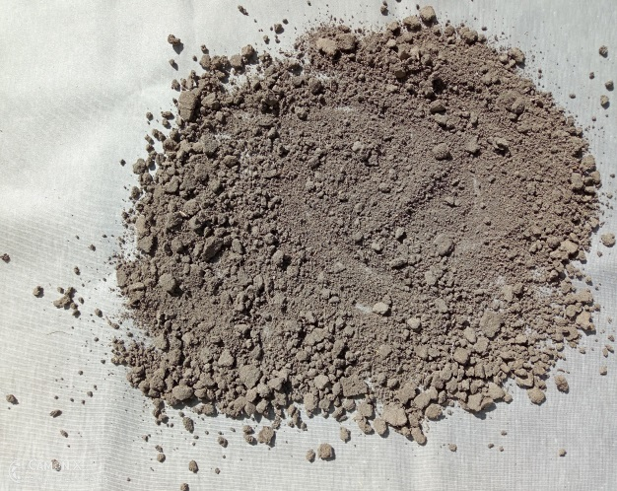
- (b)
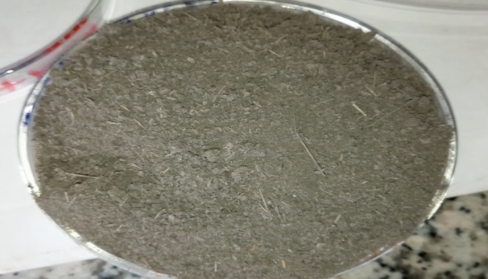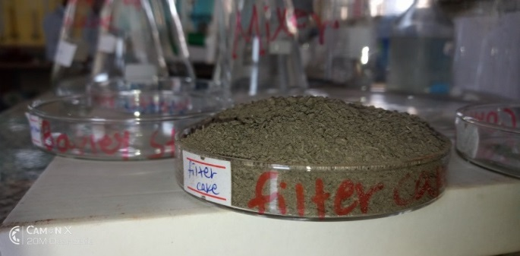
- (d)
Appendix 1.2:Preparation of Teff Straw (a) Mechanically chopped and grinded teff straw, (b) grinded sieving teff straw, (c) Sieved teff straw and (d) Labeled teff straw
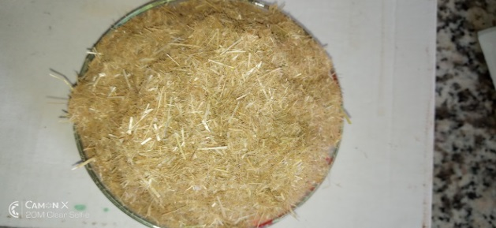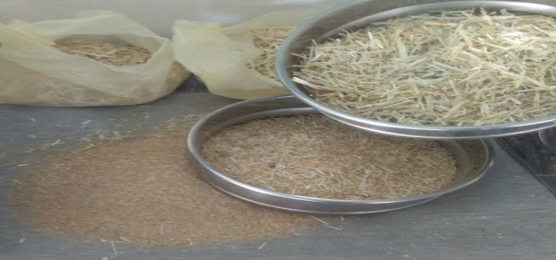
- (b)
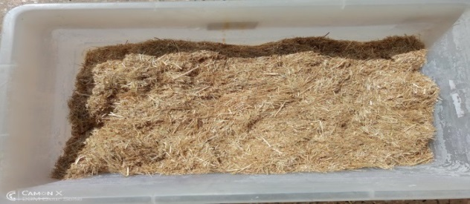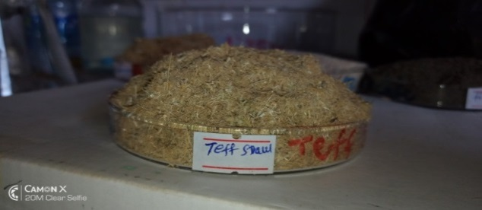
(c) (d)
Appendix 1.3: Preparation of Barely Straw(a) Barley straw at the farm, (b) Grinded and sieving of barely straw, (c) Sieve separated barely straw and (d) Labeled barely straw
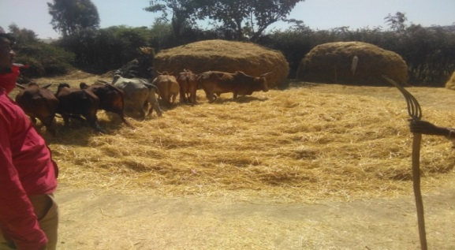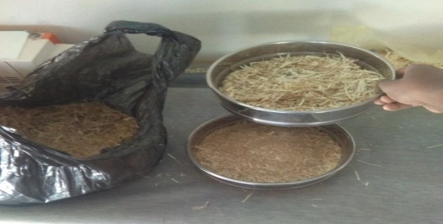
- (b)
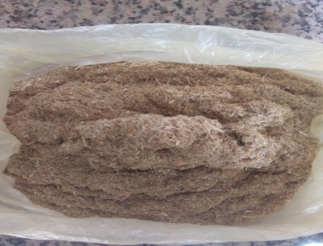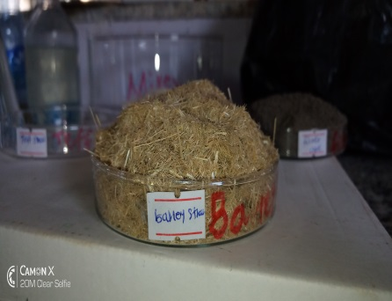
- (d)
Appendix 1.4:Preparation of Corncob (a) Corn cob sample, (b) Chopped corn cob, (c) Grinded corn cob, (d) Sieved corn cob and (e) Labeled Corn cob
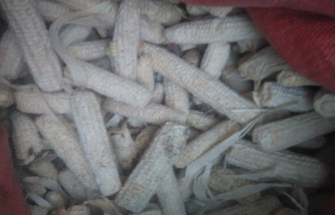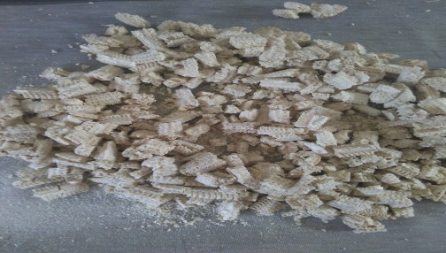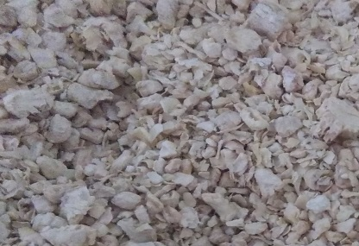
- (b) (c)
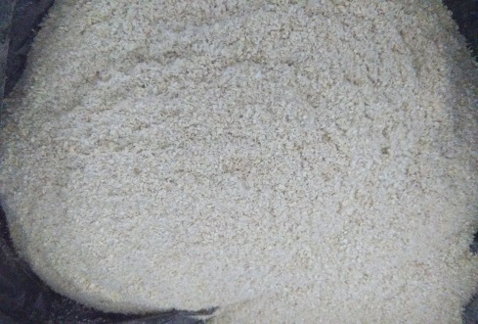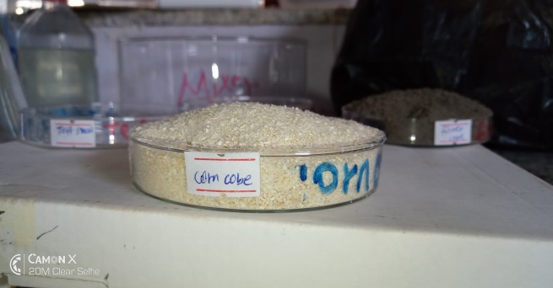
(d) (e)
Appendix 2: The Calibration Graph of each of Metals of interest

Appendix 3: Crude Fat determination (a) Soxthlet extraction (Crud Fat extraction) and (b) Rotary Evaporator (for crud fat separation)
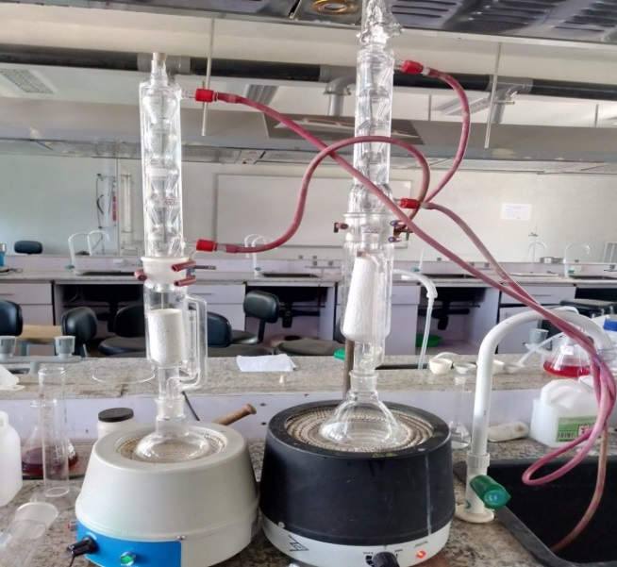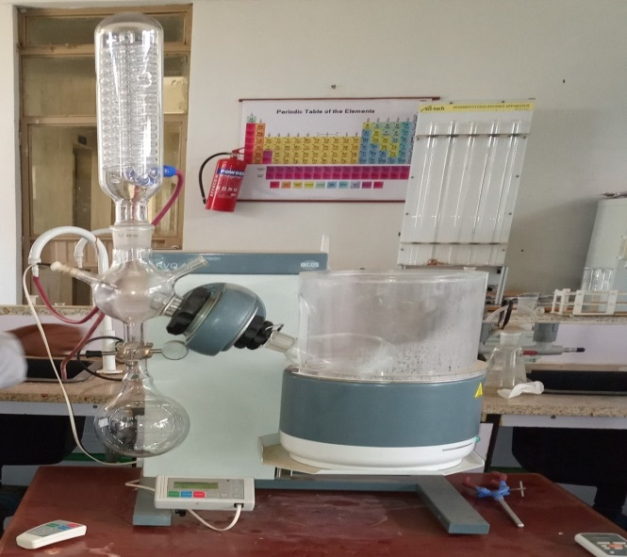
- (b)

