Supplementary Information
Application of seasonal climate forecasts in predicting winter chill for specialty crops of California
Prakash Kumar Jha¹, Tapan B. Pathak^{1,2*}
¹ Division of Agriculture and Natural Resources, University of California, 2801 2nd St., Davis, CA 95618
² Department of Civil and Environmental Engineering, University of California, Merced, 5200 N. Lake Rd. Merced, CA 95343

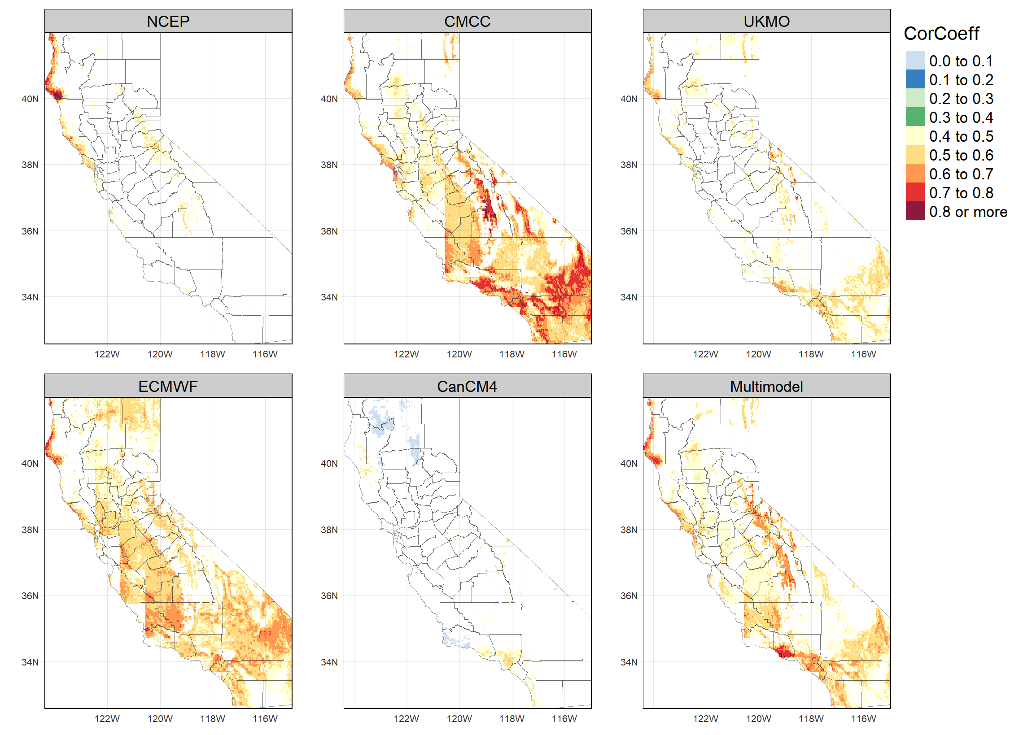

Fig. S1 same as Fig. 1 in the main text but for the forecasts from two-month lead time, i.e., forecasts of NDJF from September.
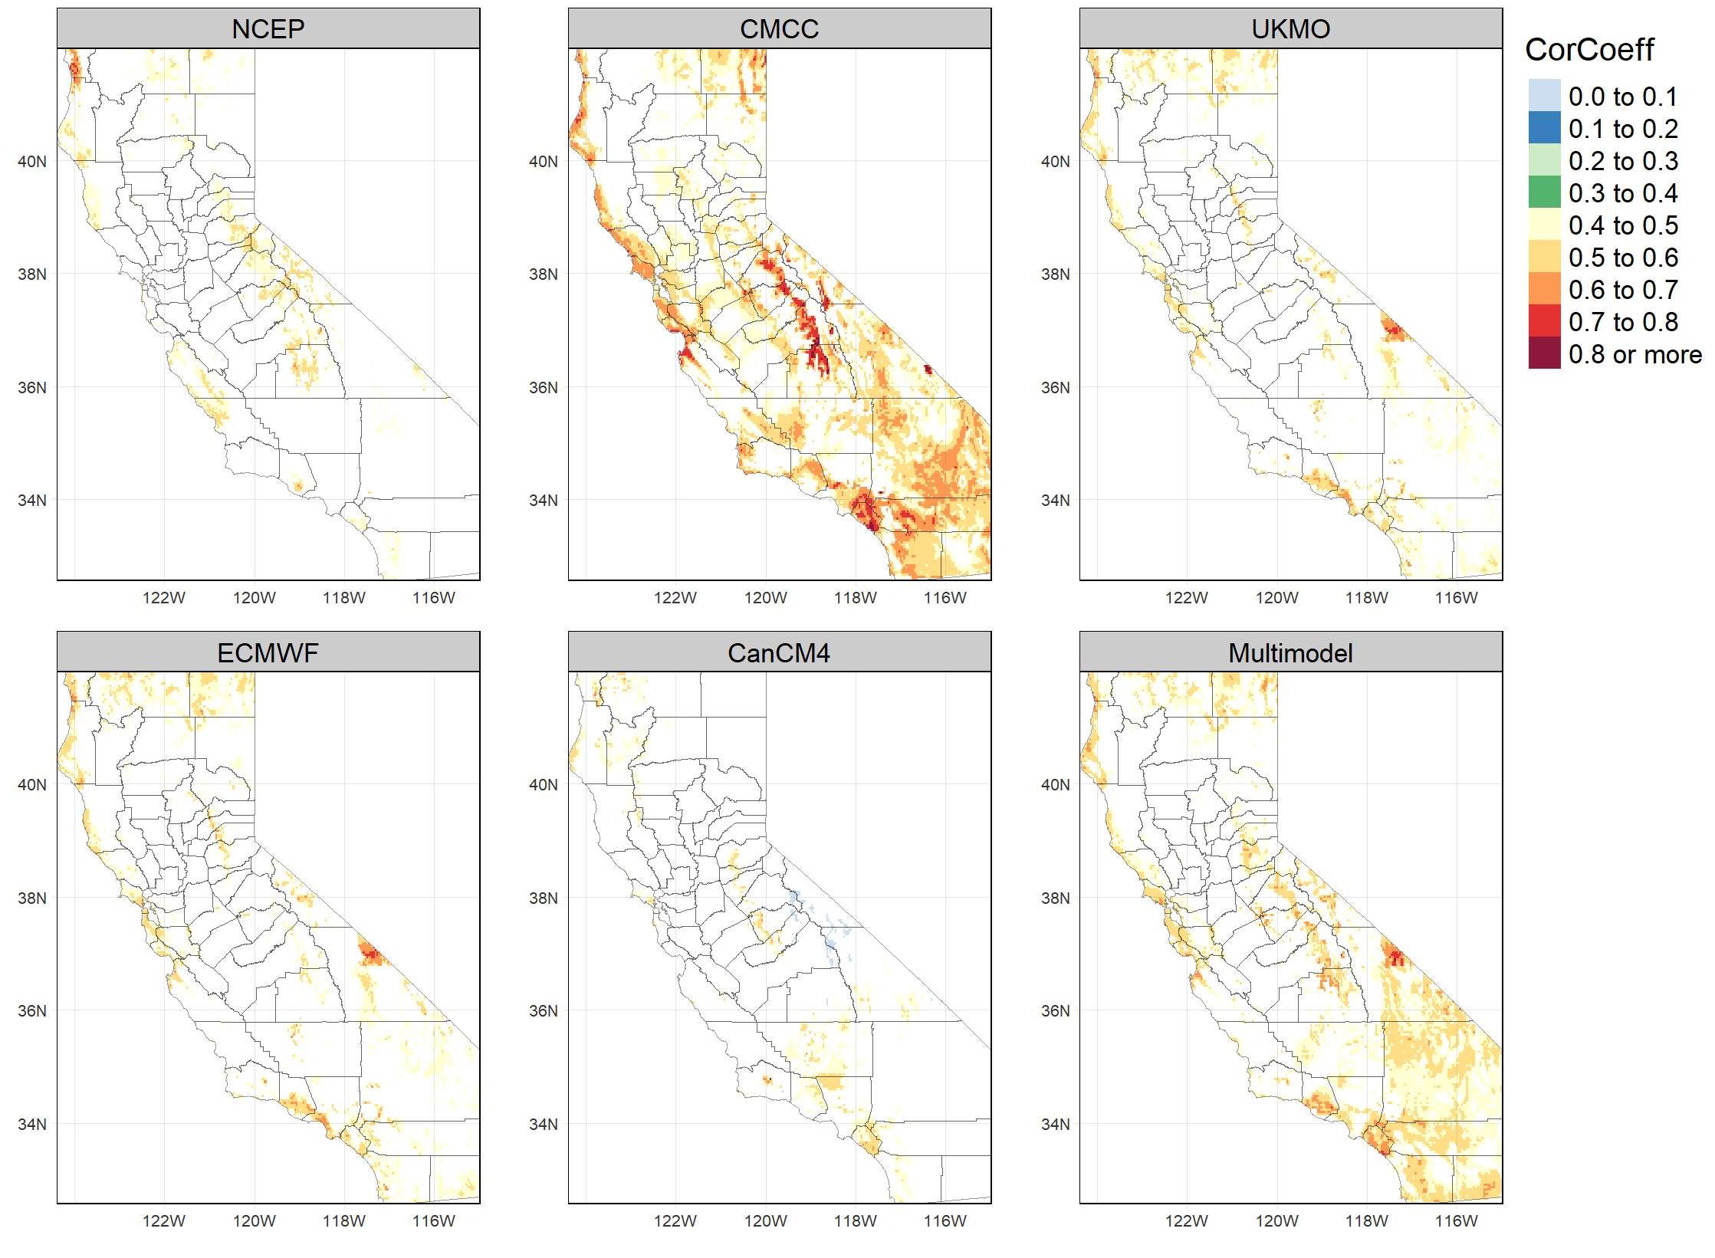

Fig. S2 same as Fig. 2 in the main text but for the forecasts from two-month lead time, i.e., forecasts of NDJF from September.
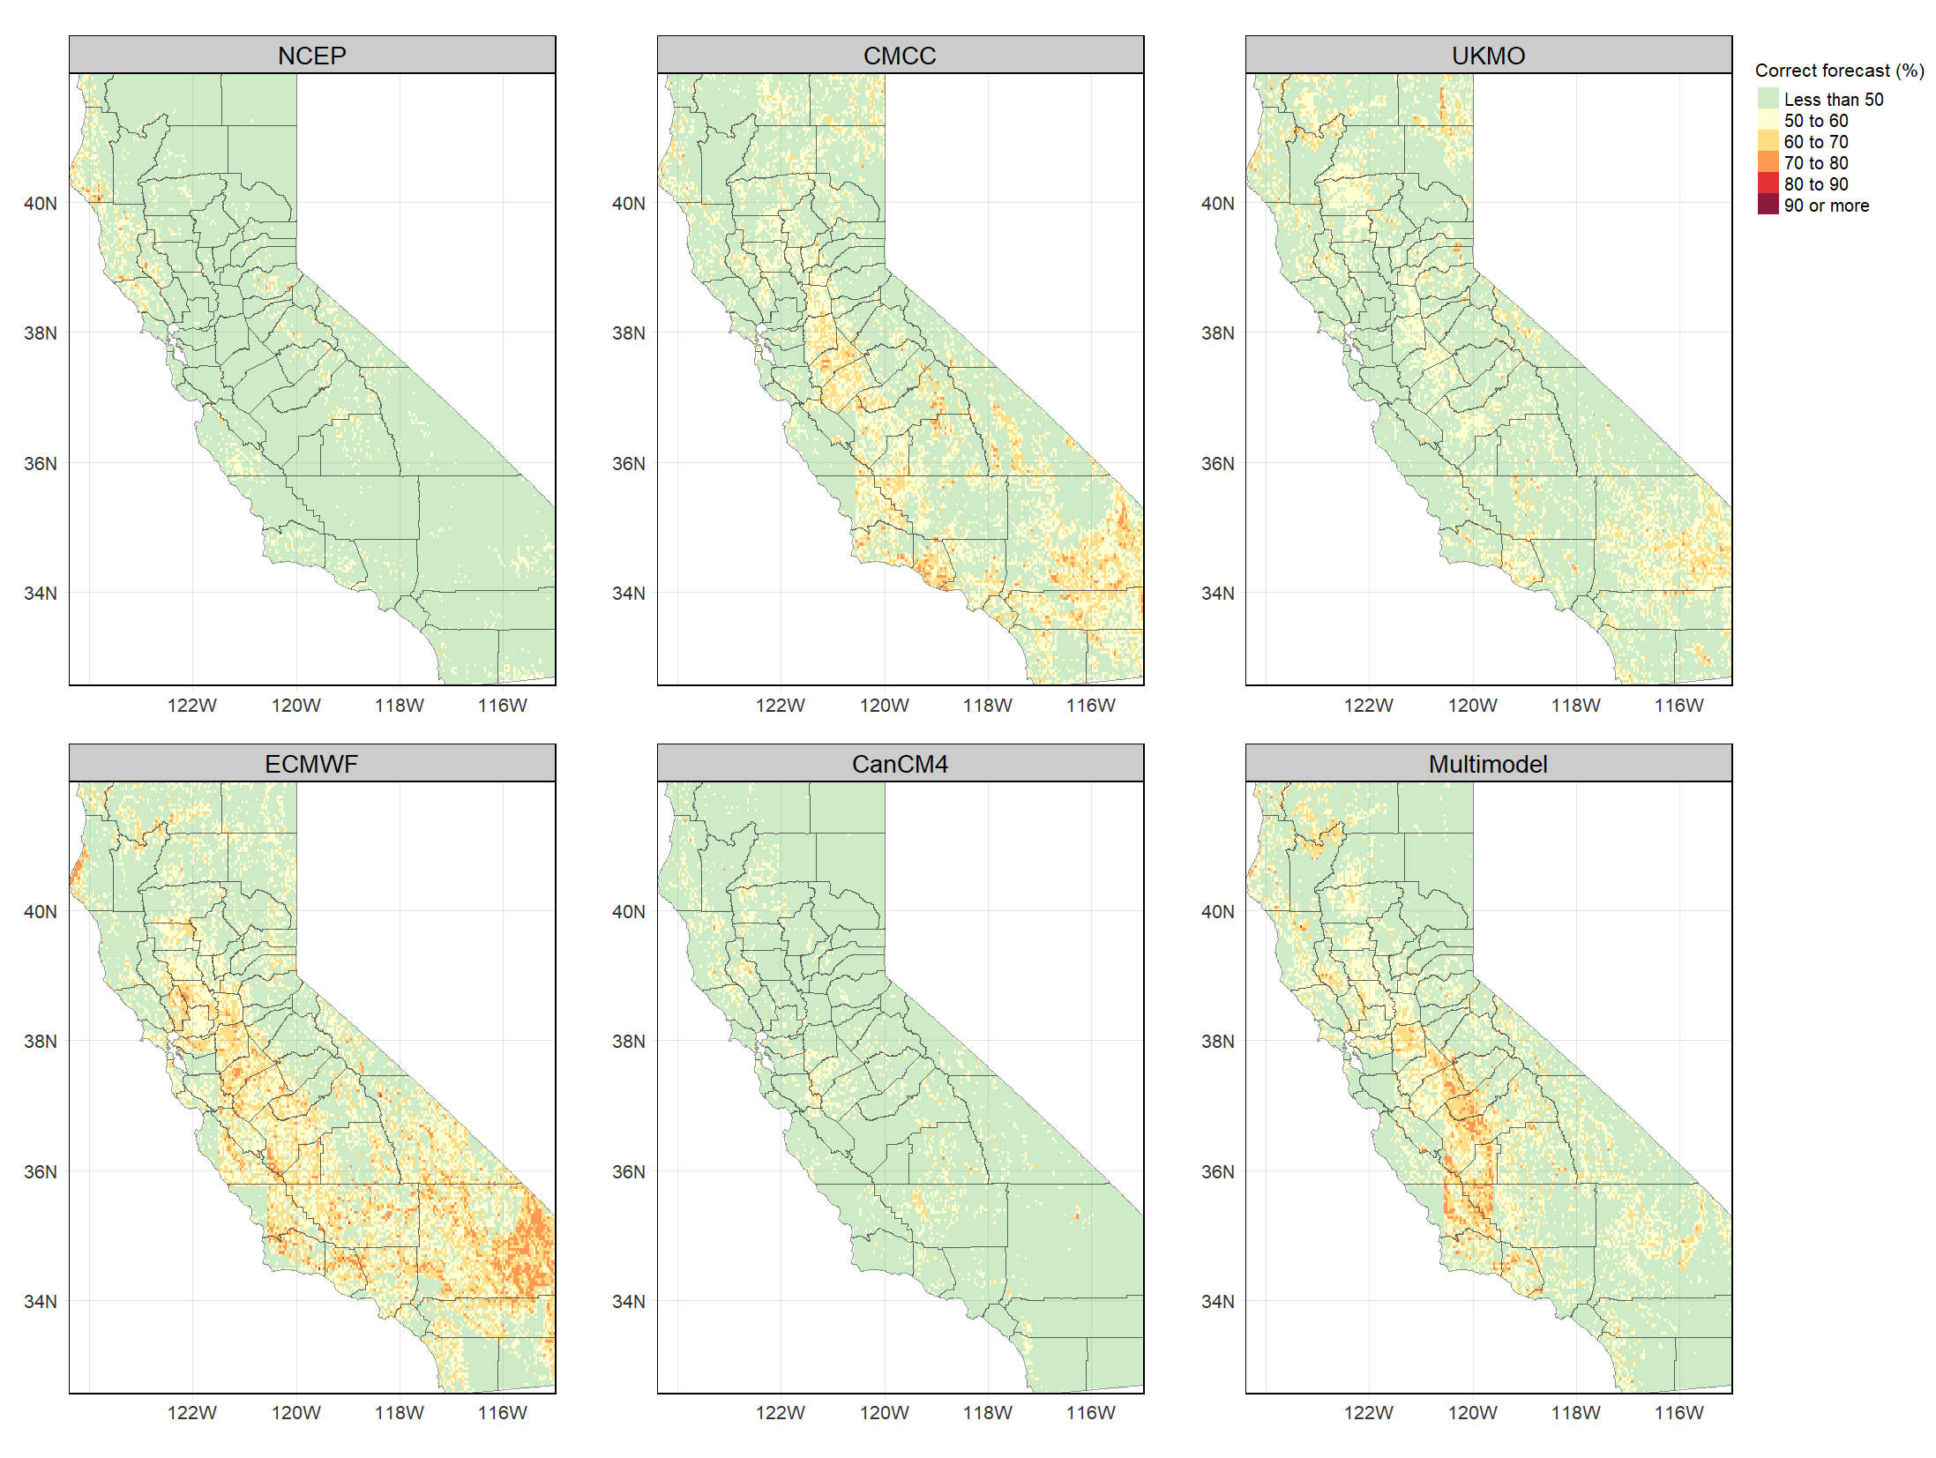

Fig. S3 same as Fig. 3 but for two-month lead forecast (forecast of NDJF from September).
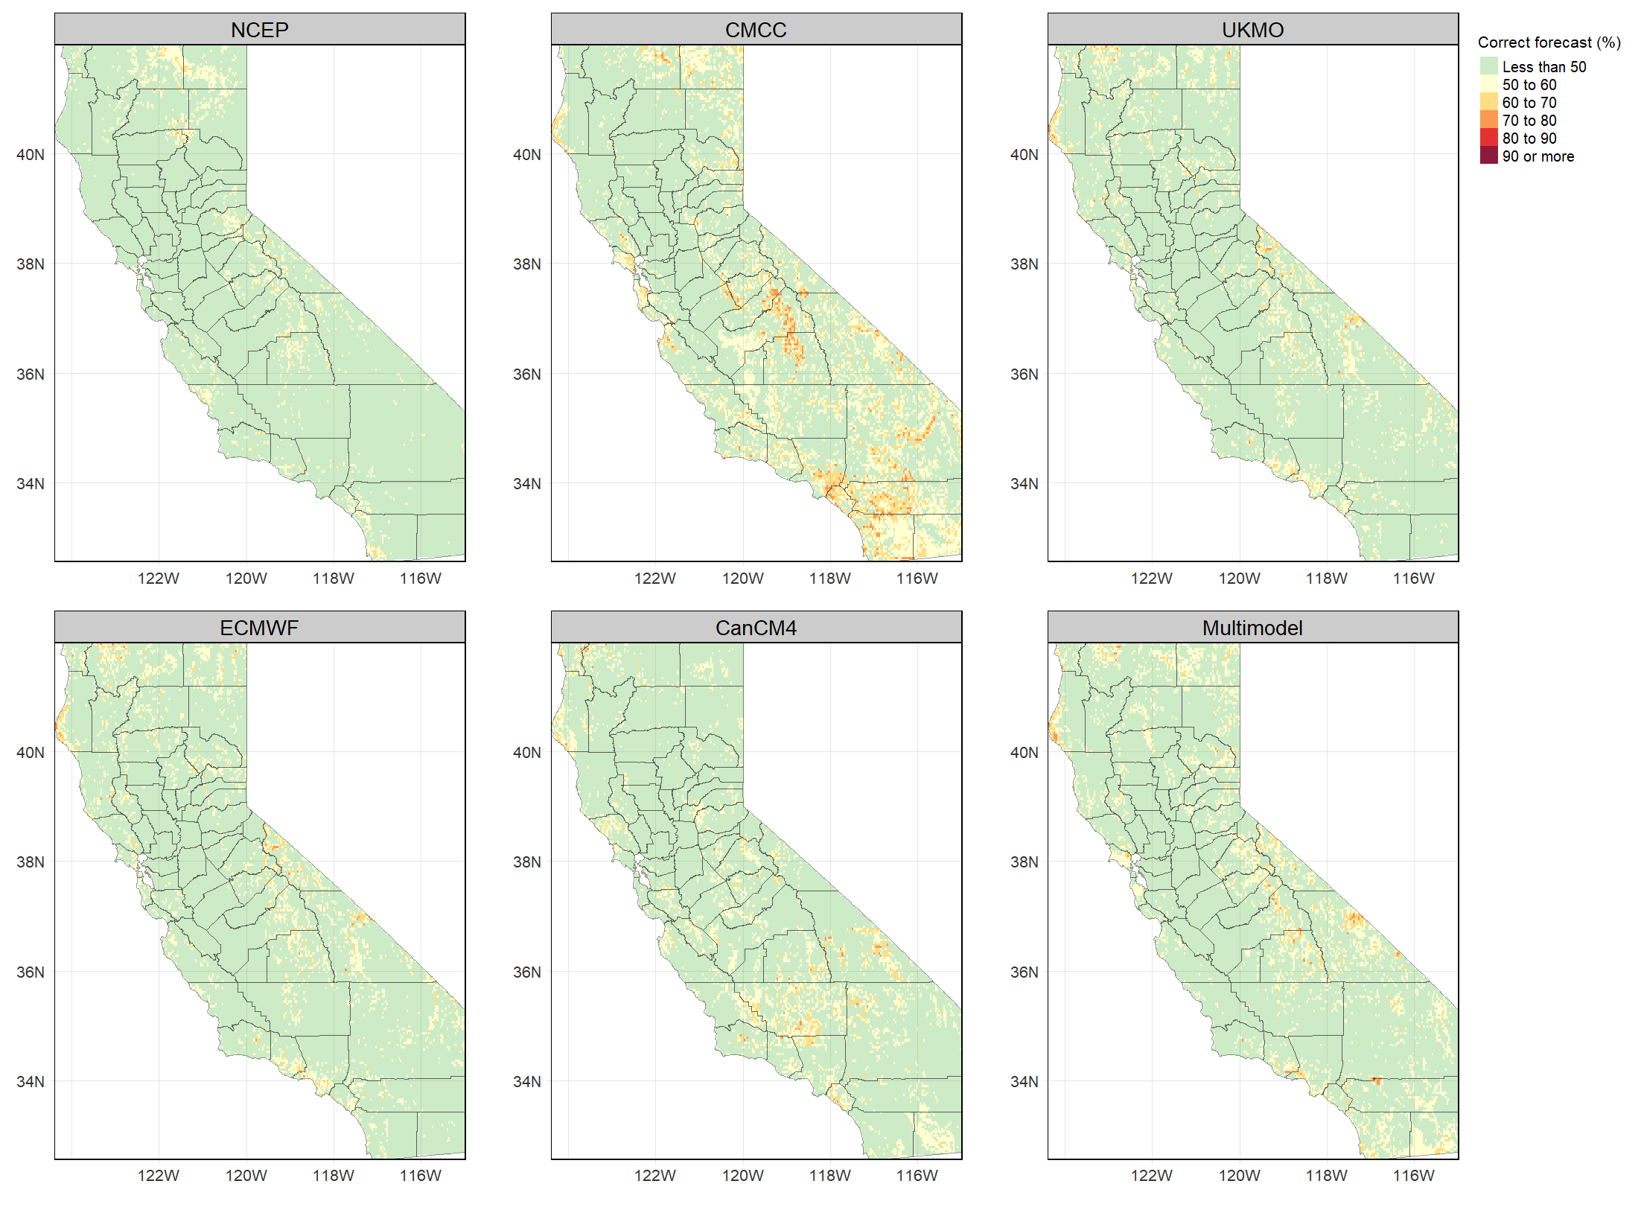

Fig. S4 same as Fig. 4 but for two-month lead forecast (forecast of NDJF from September).

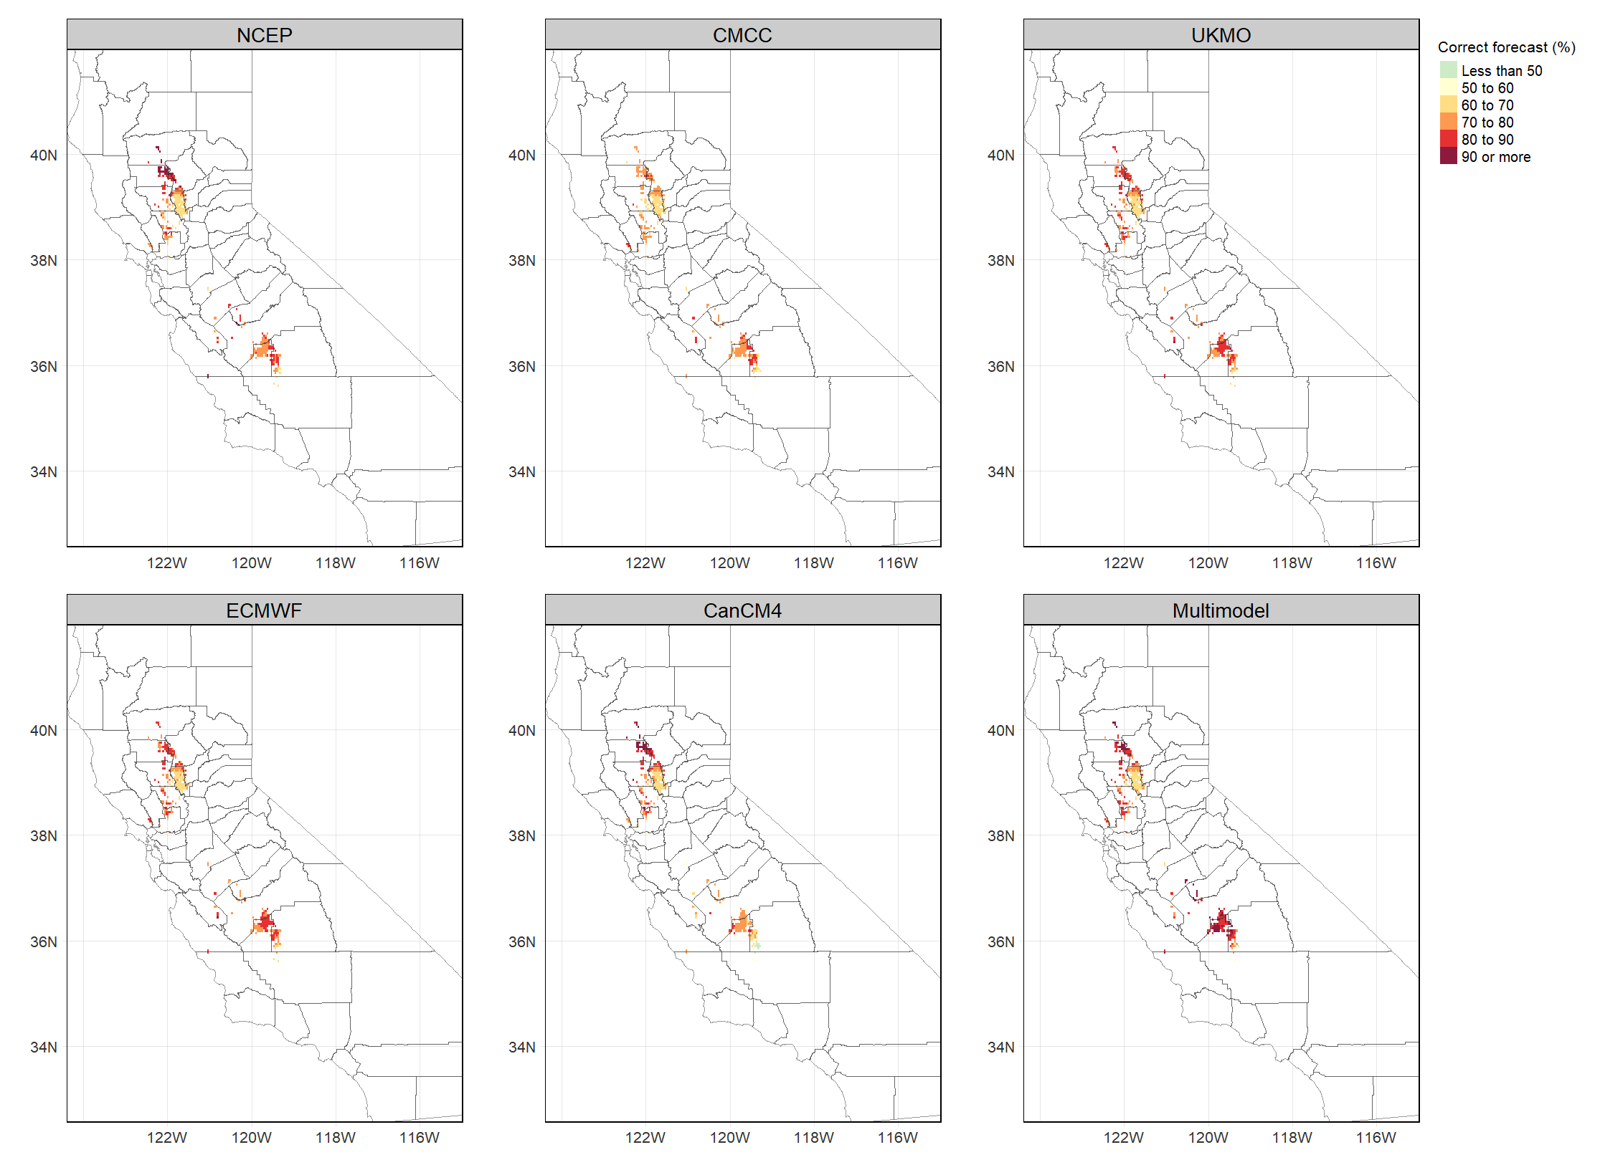

Fig. S5 same as Fig. 5 but for plums in one-month lead forecasts.
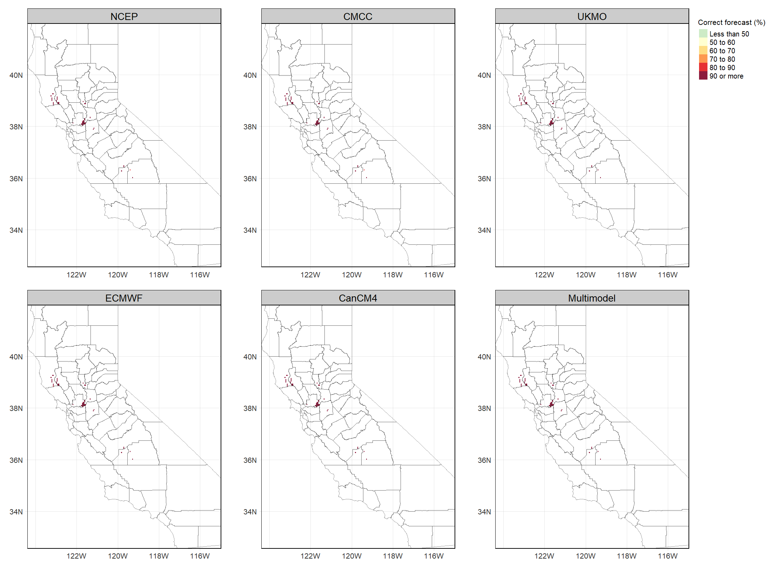

Fig. S6 same as Fig. 5 but for pears in one-month lead forecasts.
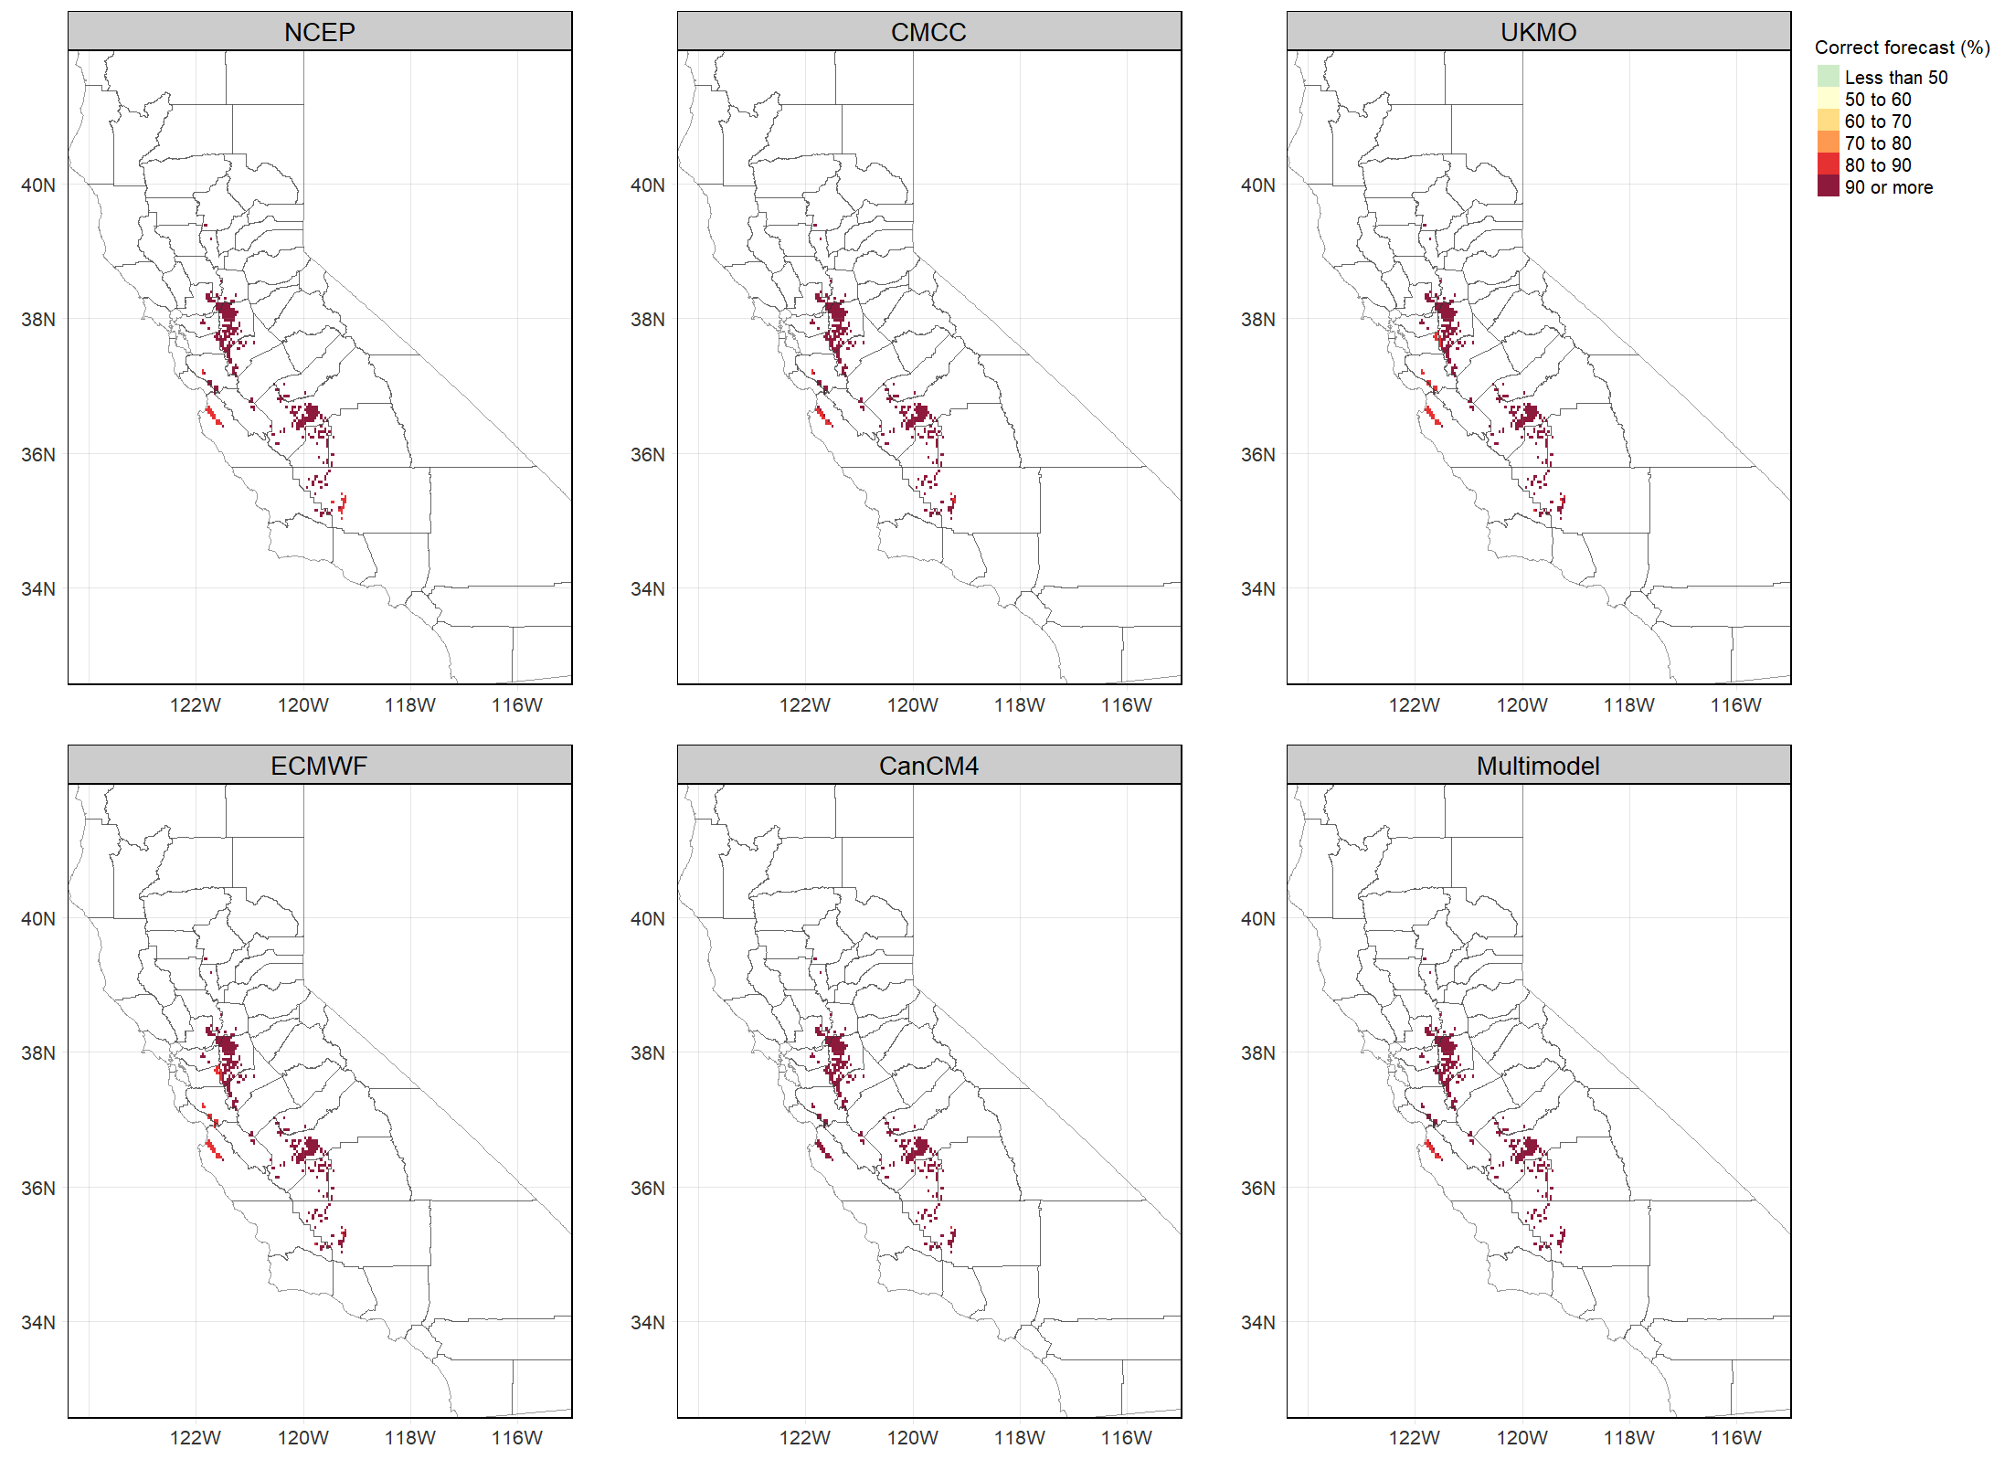

Fig. S7 same as Fig. 5 but for cherries in one-month lead forecasts.
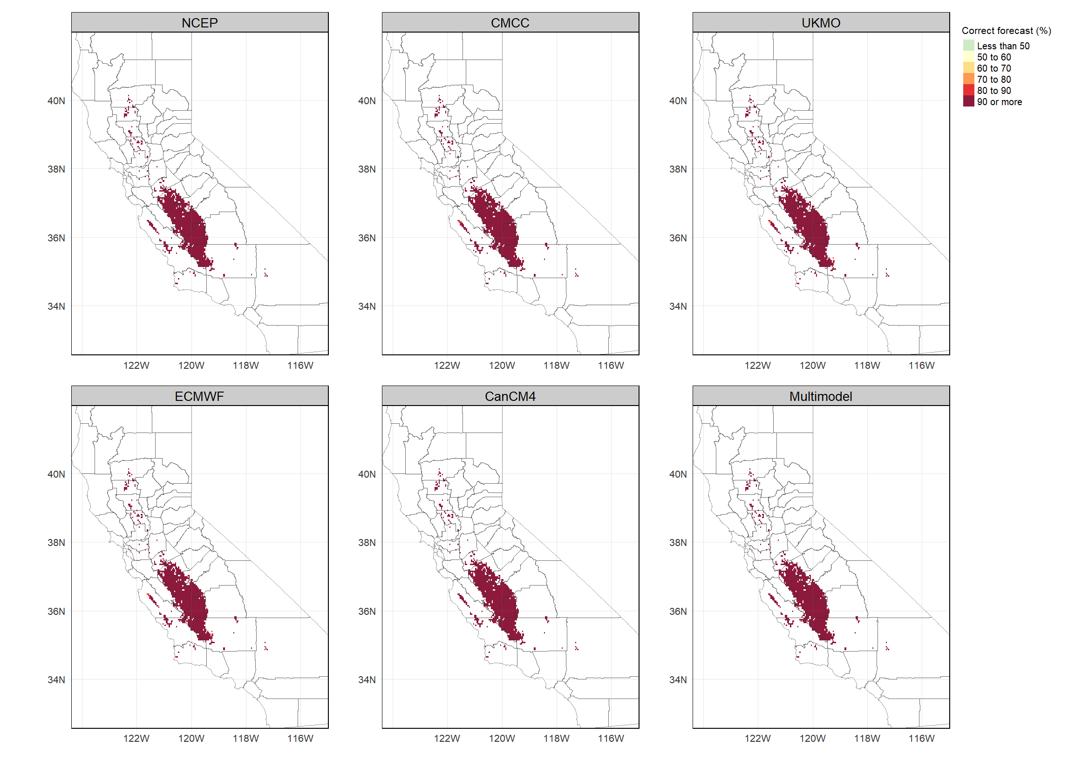

Fig. S8 same as Fig. 5 but for pistachio in two-month lead forecasts.

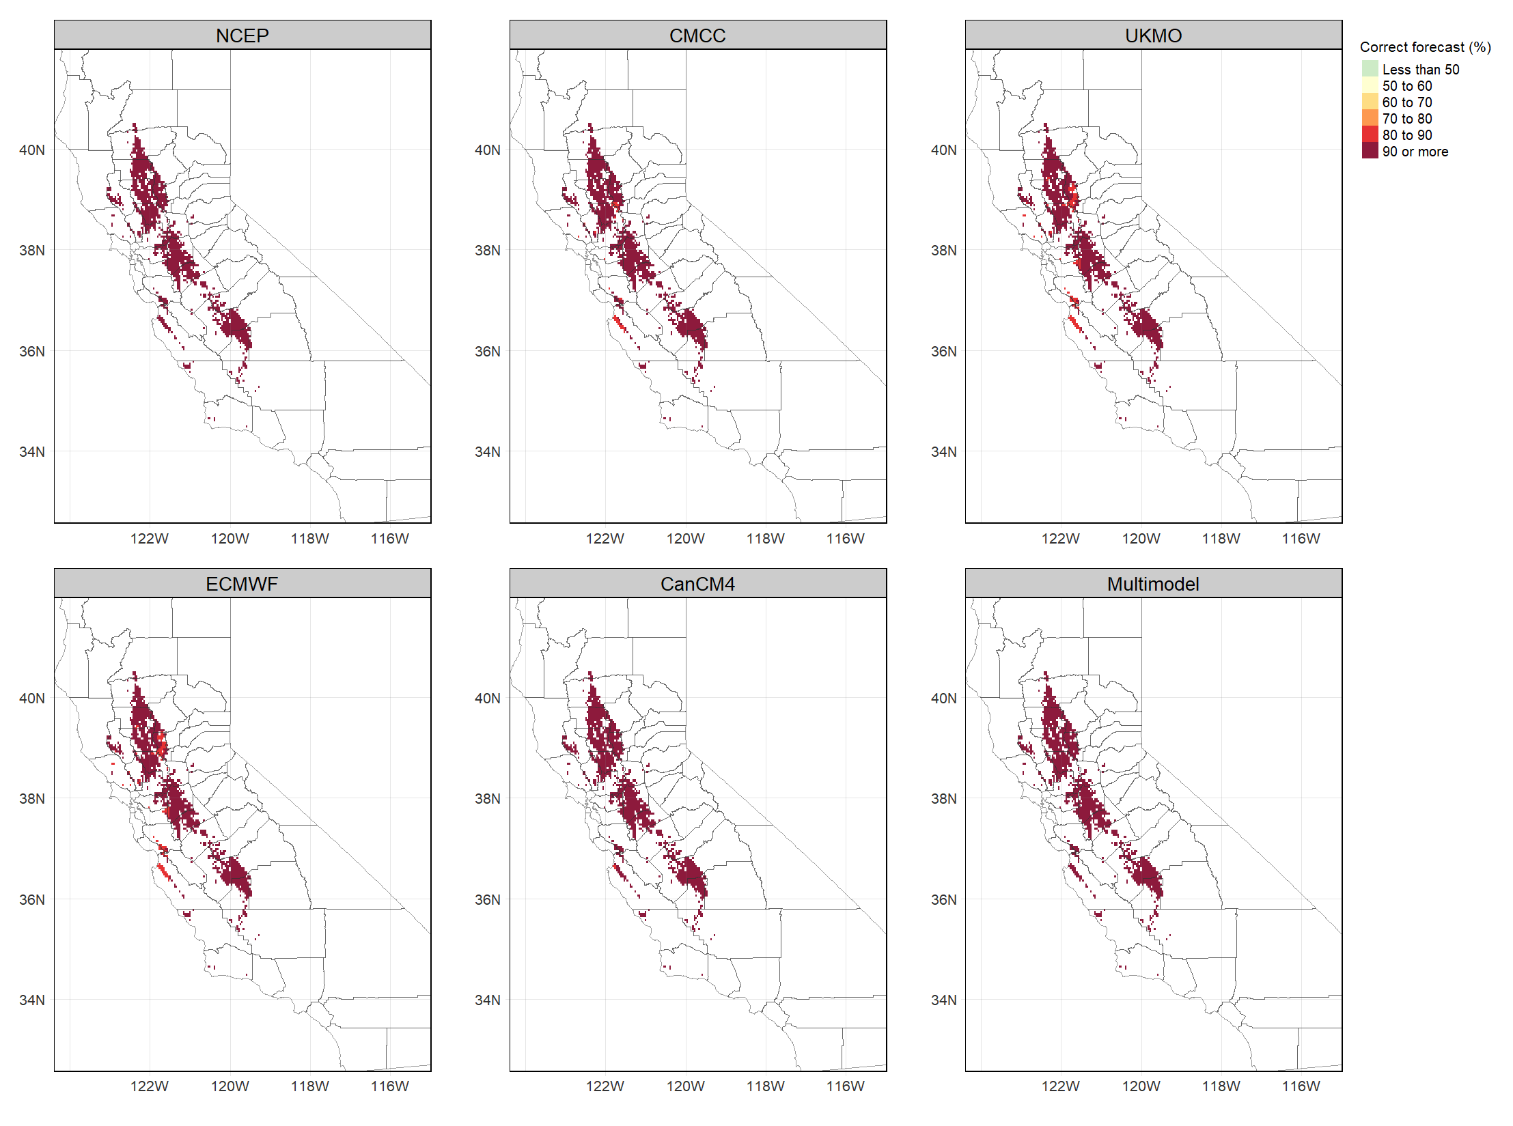

Fig. S9 same as Fig. 5 but for walnuts in two-month lead forecasts.
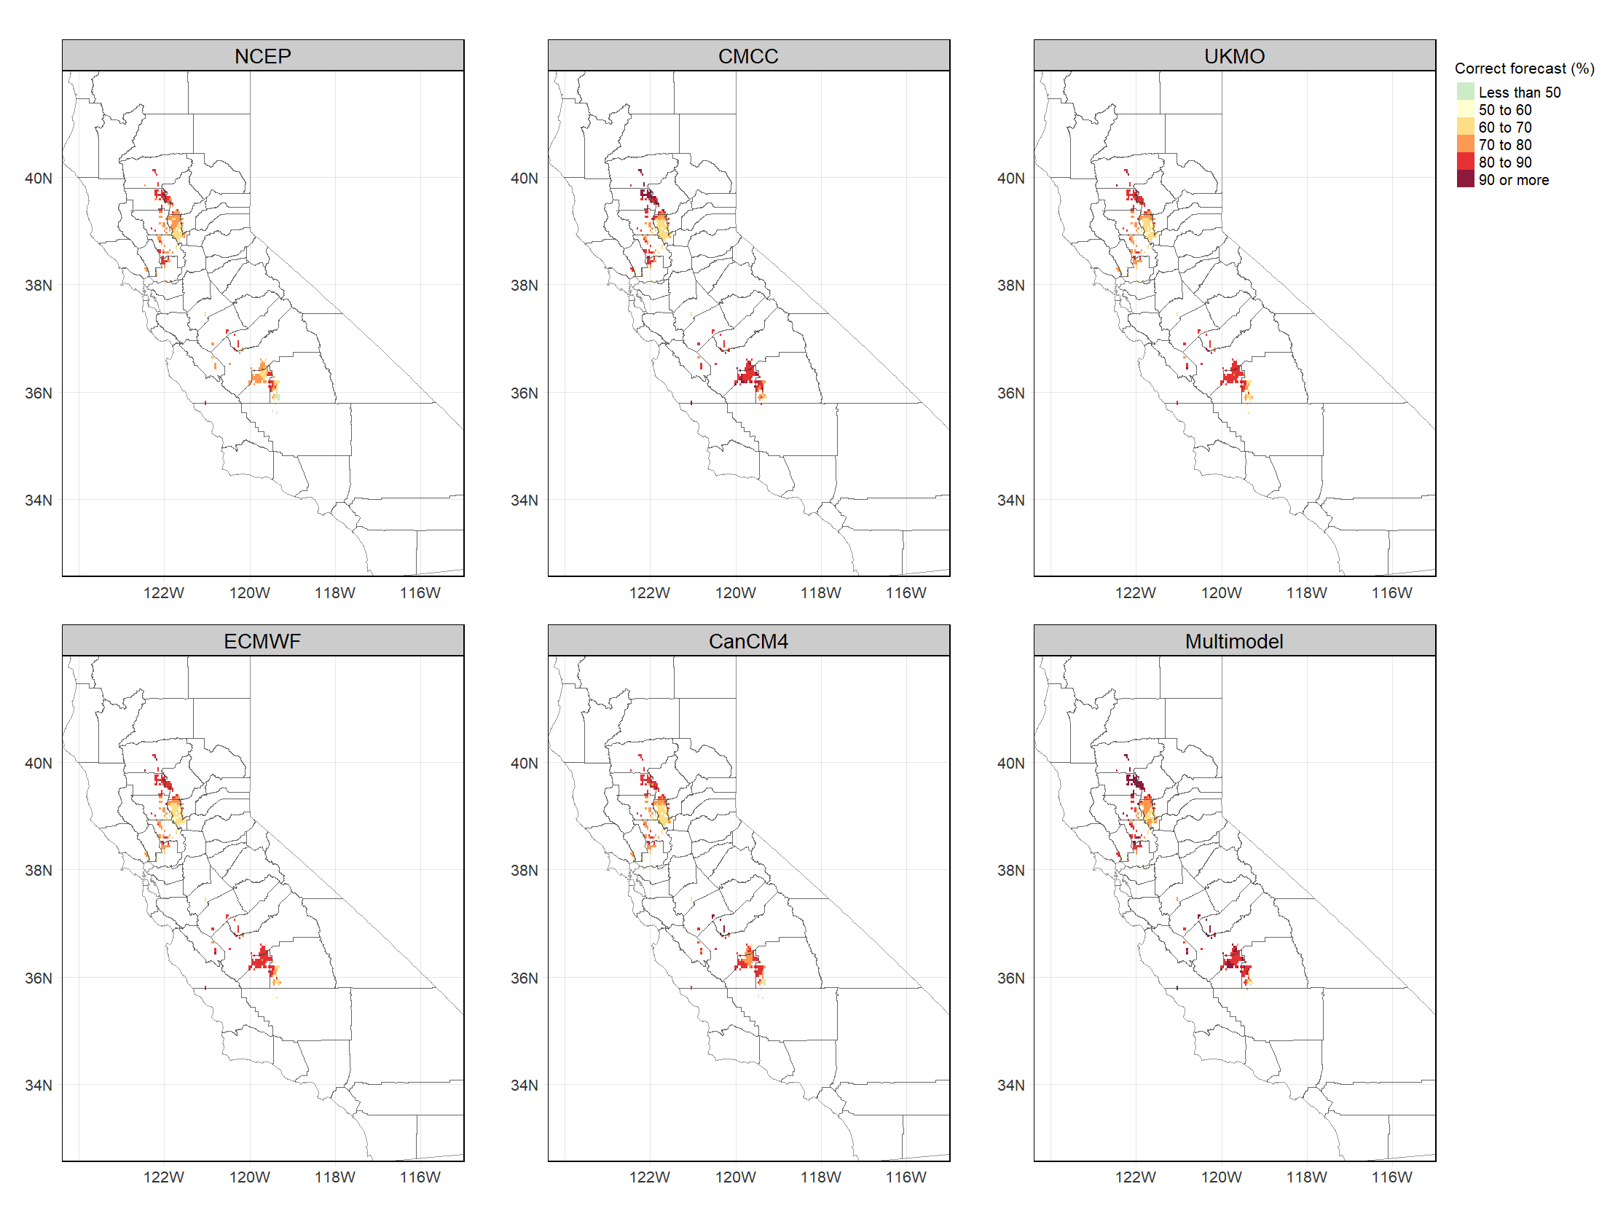

Fig. S10 same as Fig. 5 but for plums in two-month lead forecasts.

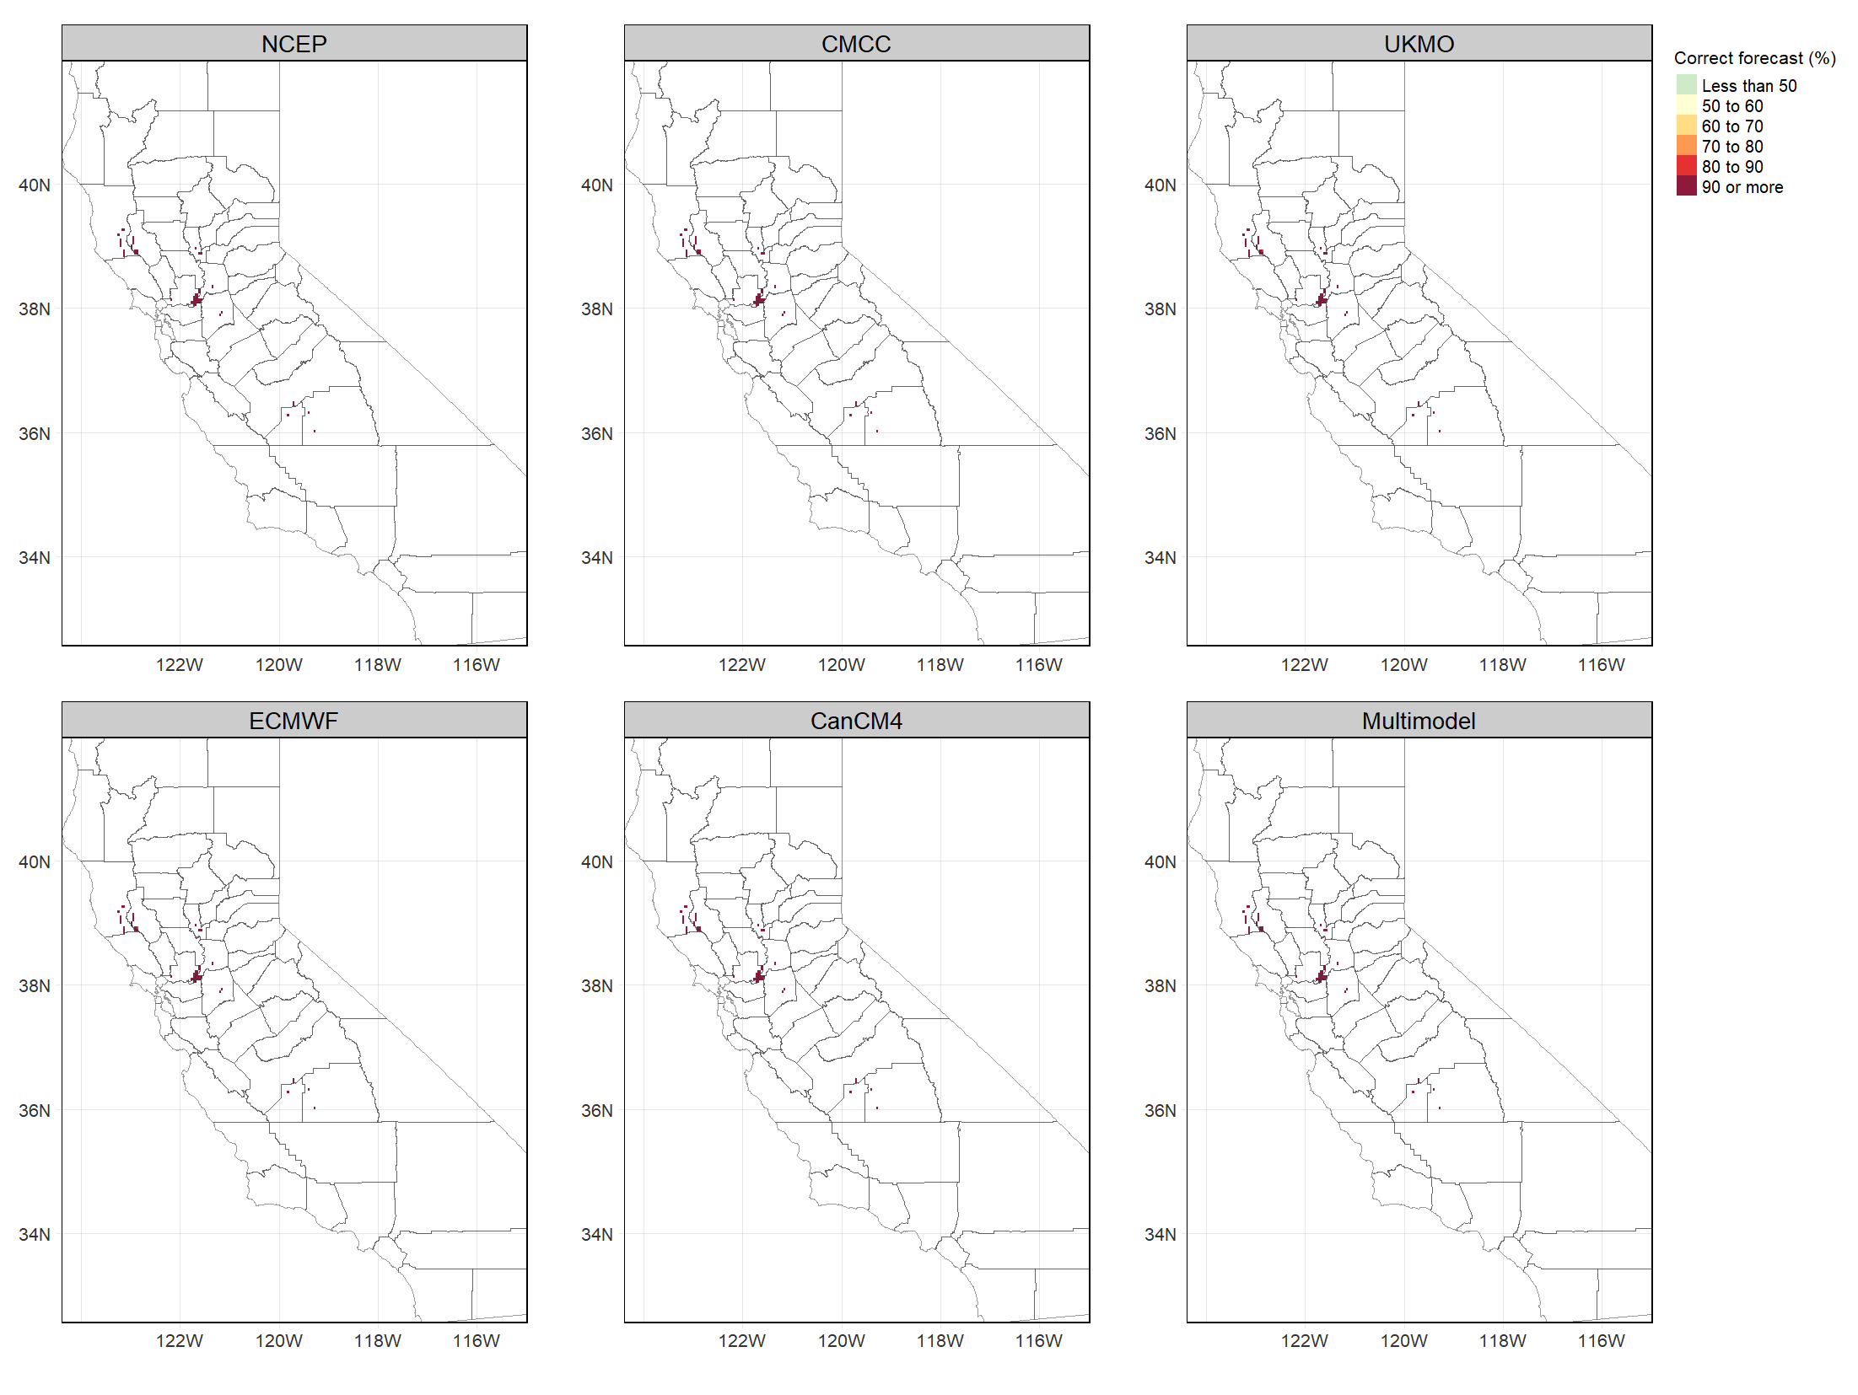

Fig. S11 same as Fig. 5 but for pears in two-month lead forecasts.
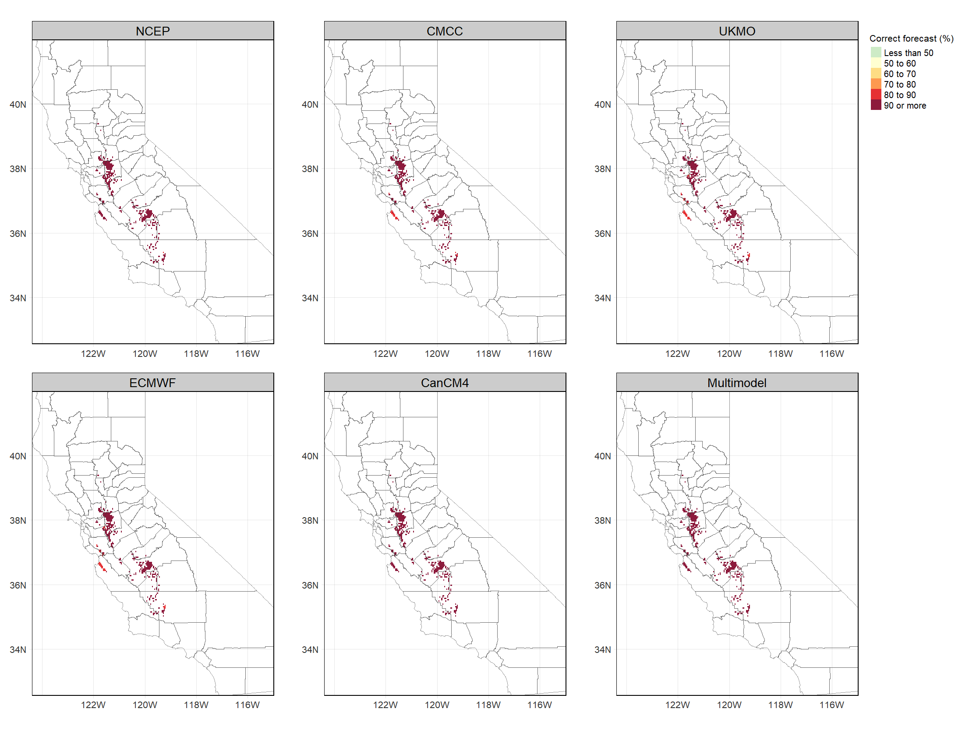

Fig. S12 same as Fig. 5 but for cherries in two-month lead forecasts.

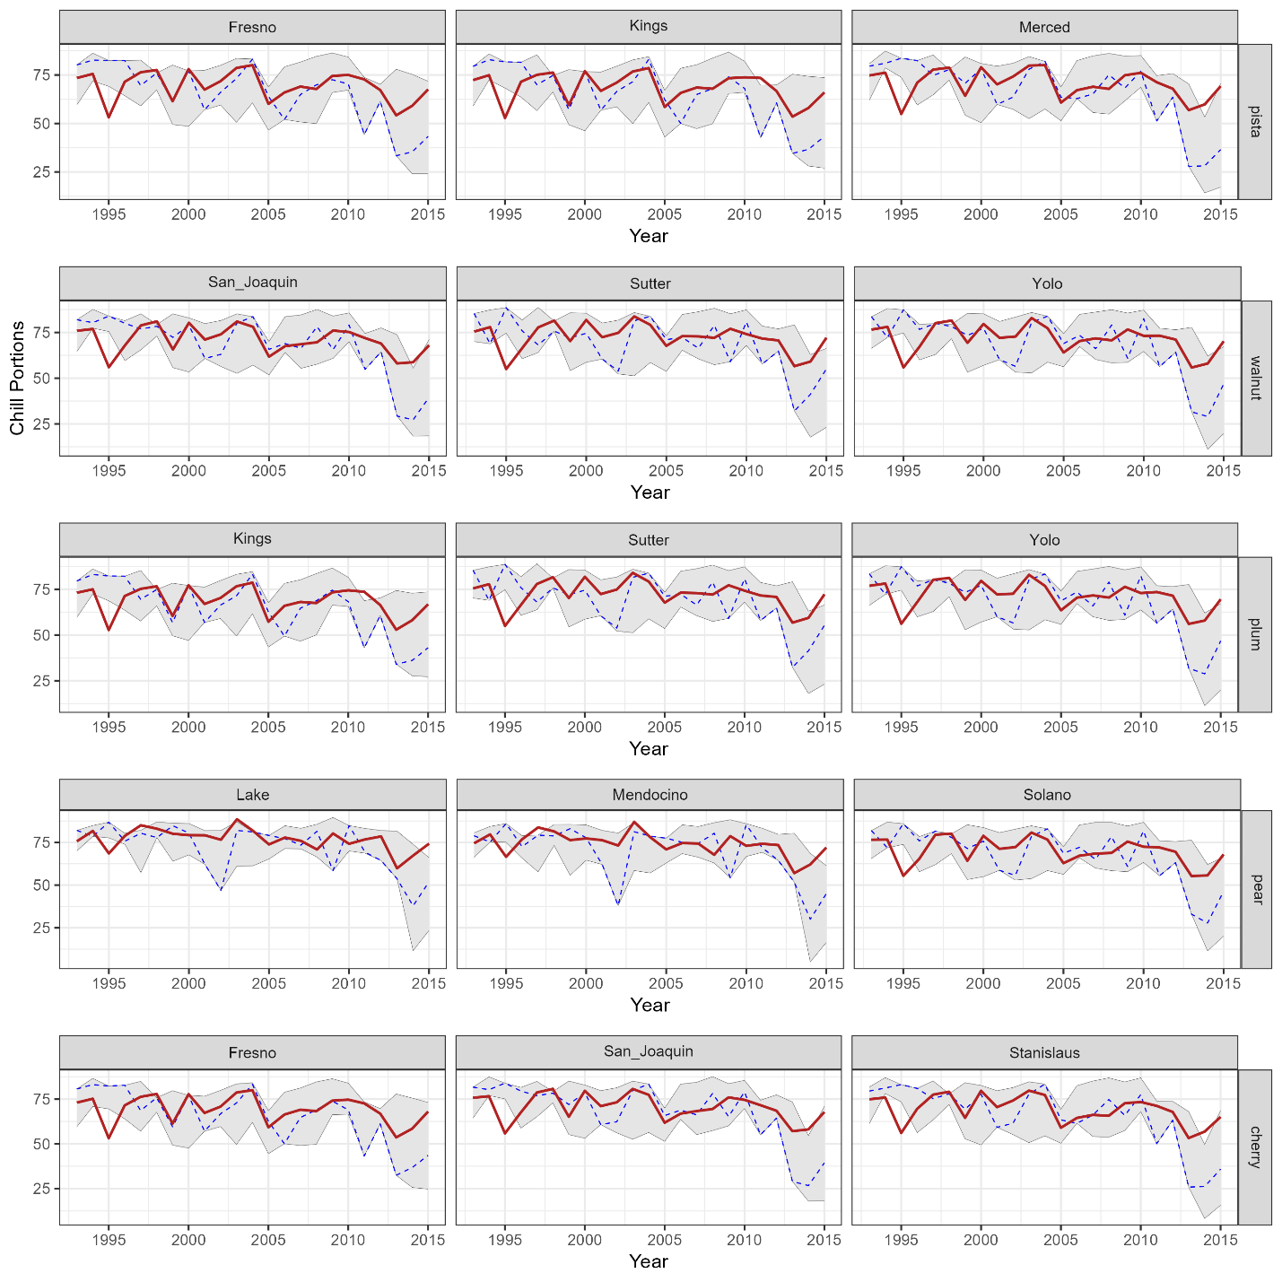
Fig. S13 same as Fig. 7 but for two-month lead.

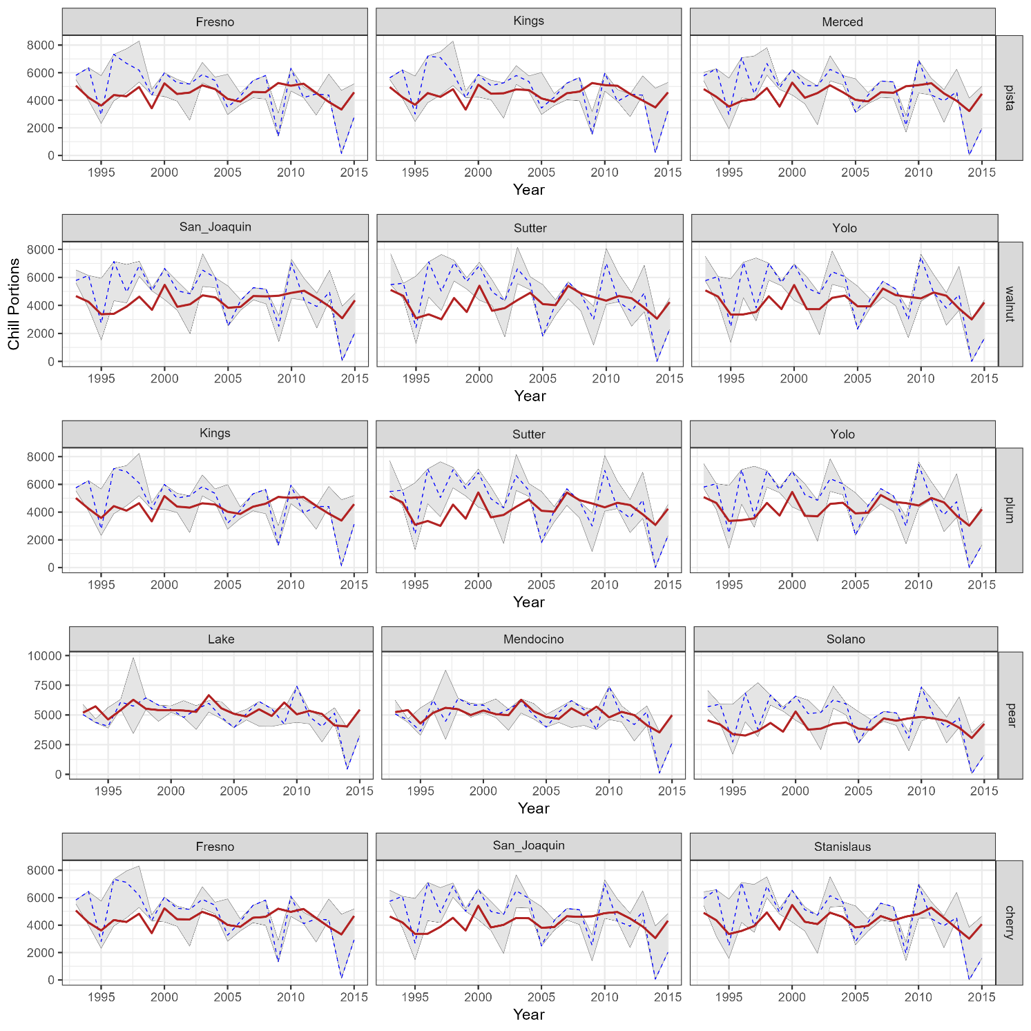
Fig. S14 same as Fig. 7 but for Chill Hours and for the prediction from one-month lead time.

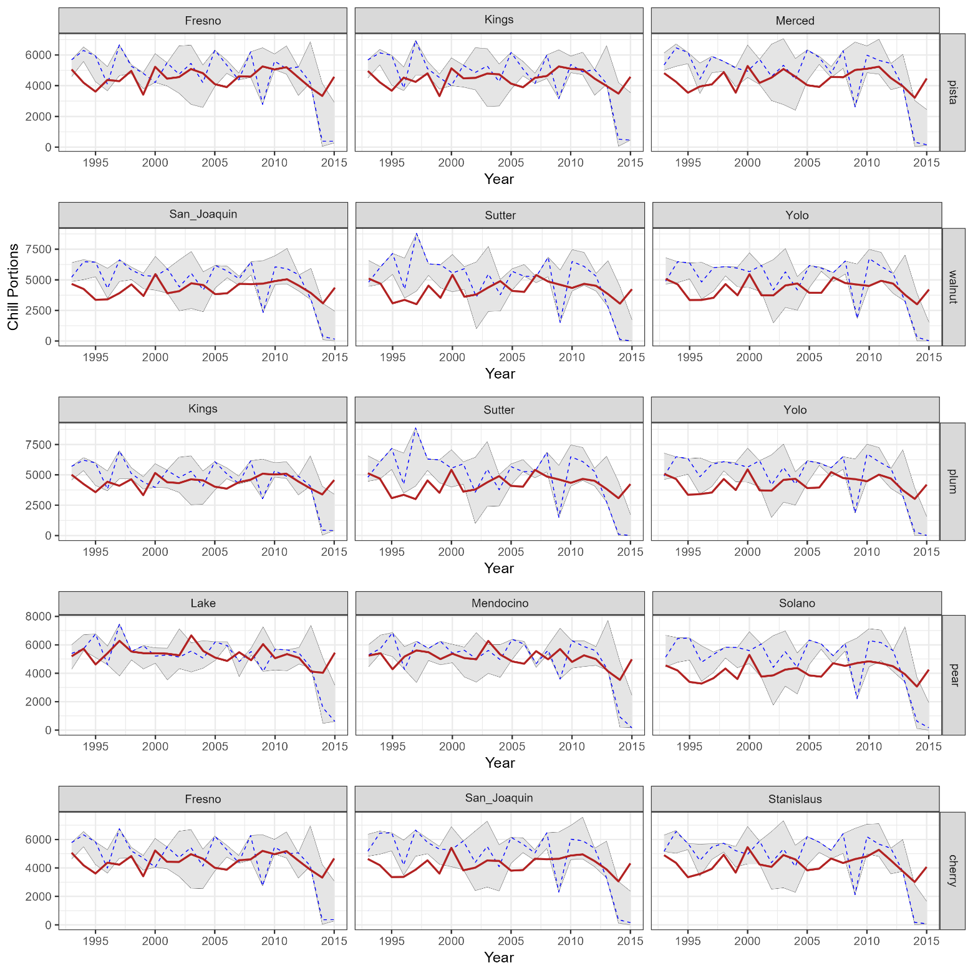

Fig. S15 same as Fig. 7 but for Chill Hours and for prediction from 2-month lead time.

