Supplementary material;
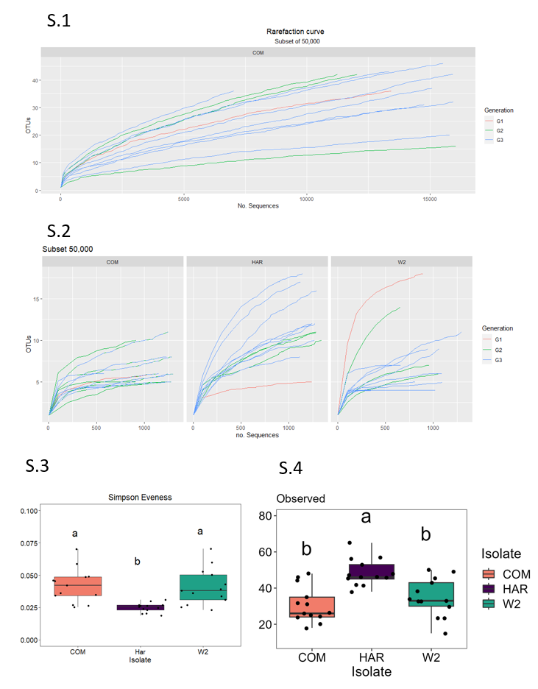
Within the Mothur analysis we first subset just the FON2 COM isolate samples, through rarfaction curve (S1) we observed that at 50,000 sequences would provide equal coverage to all samples tested. We reanalyzed at a subset of 50,000 sequences with all samples and produced a rarefaction curve to confirm adequate depth to all samples. Alpha diversity indices from our isolates were analyzed to with Simpson evenness found COM and W2 to have significantly similar evenness while HAR isolates did not.

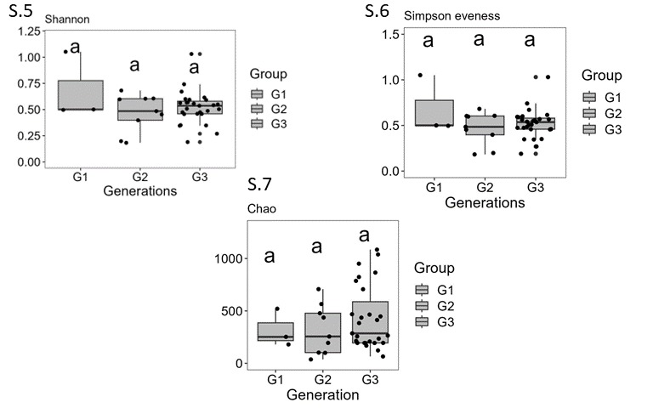
Alpha diversity was utilized to compare differences among the generations. Using Shannon (S.5), Simpson evenness (S.6) and Chao (S.7) found no differences among the diversity, abundance and evenness of the generations of all FON2 hyphosphere communities.

