Table 1.

Country | Total Participants | Female Participants | Male Participants | Minimum Age | Maximum Age
United States | 242 | 163 | 79 | 18 | 51
Canada | 71 | 52 | 19 | 18 | 45
Mexico | 29 | 29 | 0 | 20 | 31
South Africa | 11 | 8 | 4 | 18 | 27
Egypt | 10 | 5 | 5 | 25 | 48
Russia | 10 | 9 | 2 | 18 | 19
Turkey | 5 | 5 | 0 | 19 | 53
United Kingdom | 4 | 3 | 1 | 18 | 37
Ukraine | 4 | 4 | 0 | 28 | 45

Note: Demographic Data for Males, Females, and Age Range

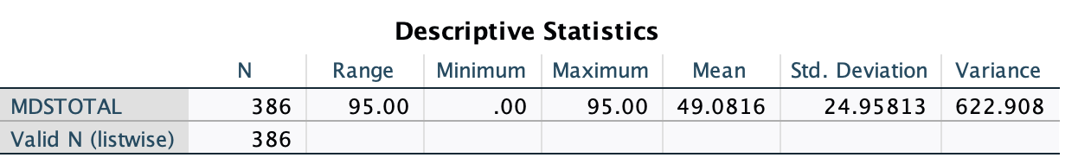
Table 2.
Note: Number, Range, Minimum,Maximum, Mean, Standard Deviation, and Variance for MDSTOTAL.
Table 3

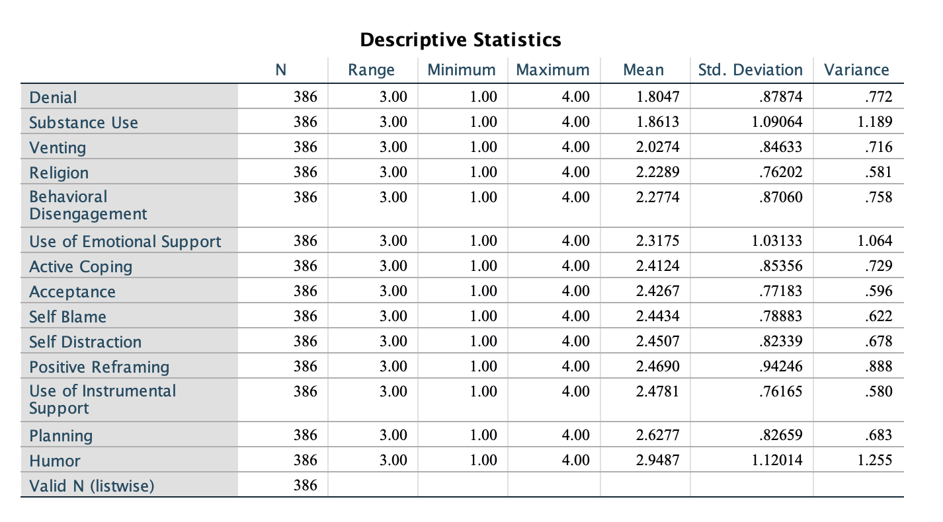

Note: Number, Range, Minimum,Maximum, Mean, Standard Deviation, and Variance for Coping Styles.

Table 4.
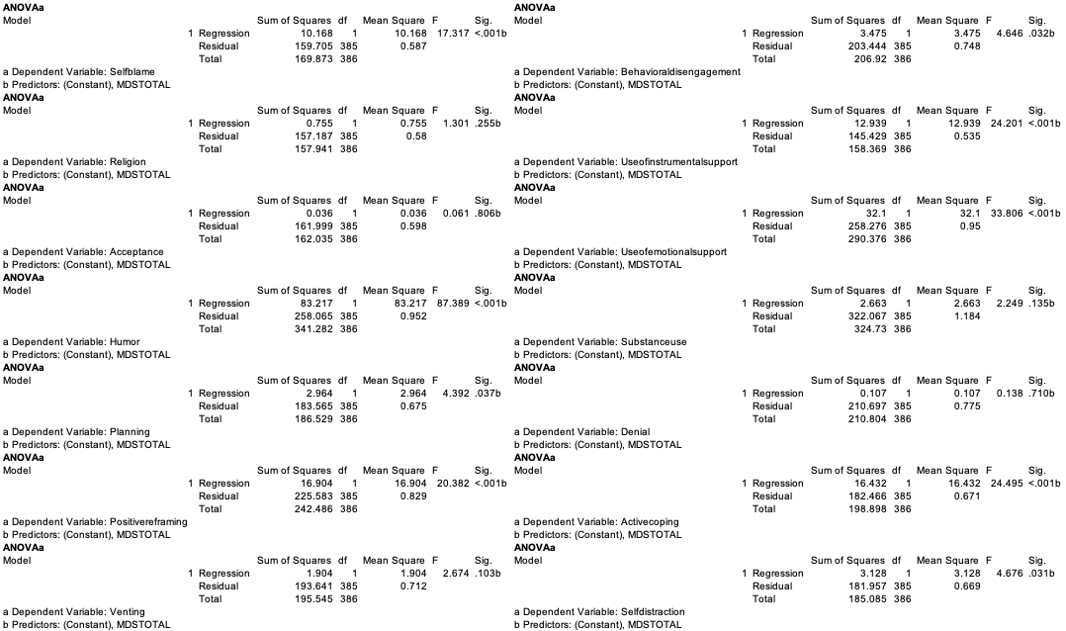

Note: Regression for Maladaptive Daydreaming and Self-distraction, Denial, Substance Use, Behavioral disengagement, Emotional Support, Venting, Humour, Acceptance, Self-Blame, Religion, Active Coping, Use of Instrumental Support, Positive Reframing, and Planning.

