3.4.3 Cross sectional profiles
Eight cross-sectional profiles were represented connecting the VES'es perpendicular to the coastline. The profiles are A-A', B-B', C-C', D-D', E-E', F-F', G-G' and H-H'. The profiles indicates variations in apparent resistivity across the coast from beach to landward direction. The profile A-A' indicate the presence of high resistive zone in the seaward direction. Low resistive saline zone is indicated towards east and also shows a thickening trend.
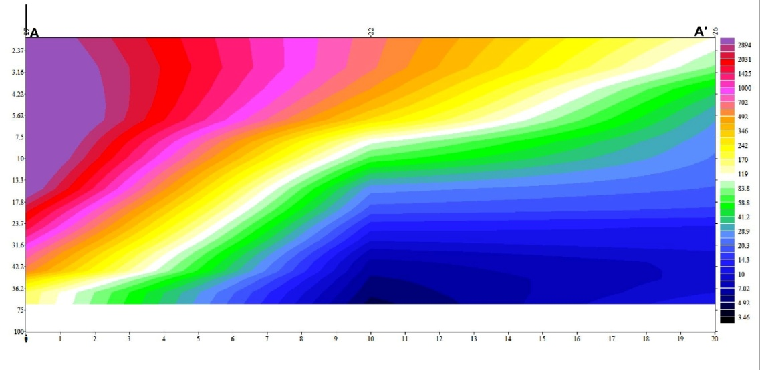
The profile B-B' shows a similar trend with high resistive zone in the shoreward direction and low resistive zone in the landward direction. The presence of freshwater lens in the shoreward region and saline wedge in the landward region is prominent.
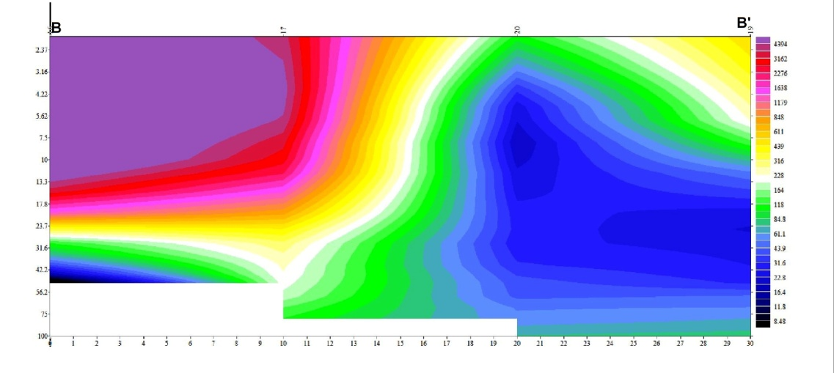
The profile C-C' indicate the presence of high resistive freshwater zone in the western side in the shoreward zone and low resistive zone towards the landward side. Low resistive saline wedge is seen towards depth.
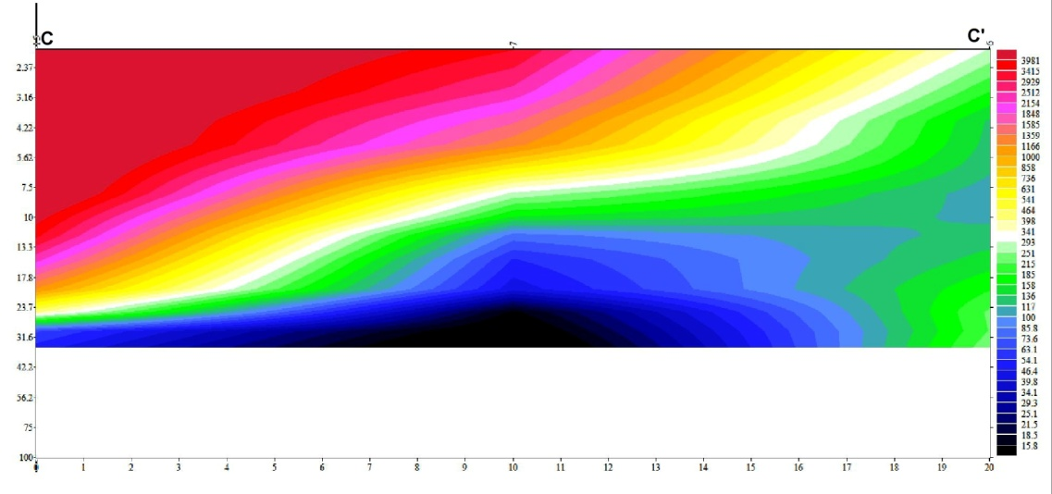

In the profile D-D', the high resistive zone is seen in the shoreward side with a saline wedge in the bottom extending towards landward side towards east.

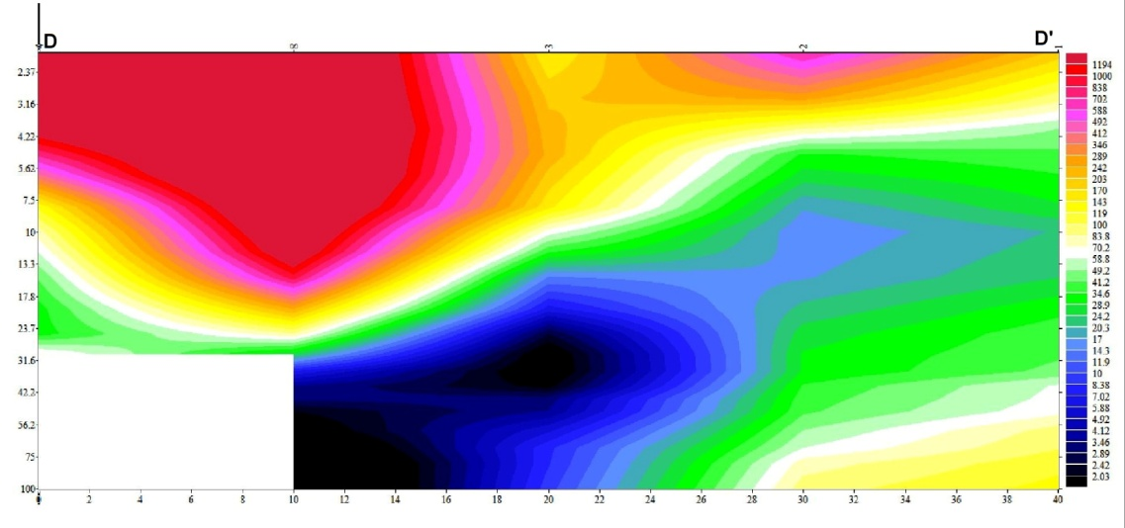
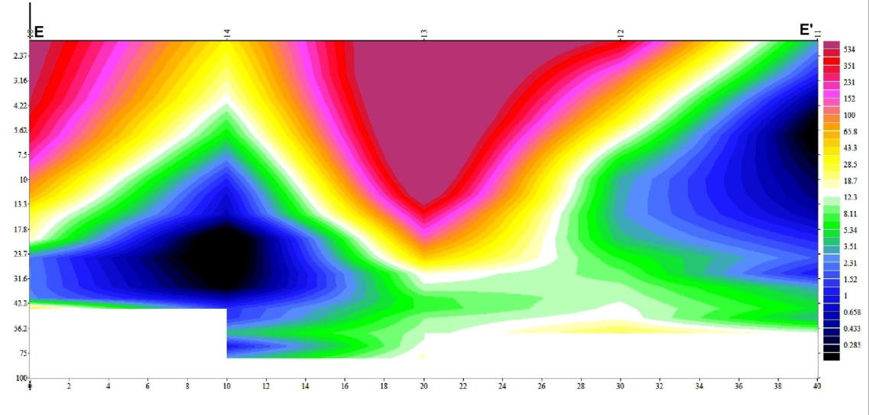

The profile E-E' shows the high resistive freshwater lens in the middle of the land area and low resistive zones in the eastward and westward direction. The saline wedge is at depth in the shoreward direction.

In the profile F-F', a clear high resistive freshwater zone is found in the landward side whereas the low resistive saline zones are seen towards the shoreward direction.

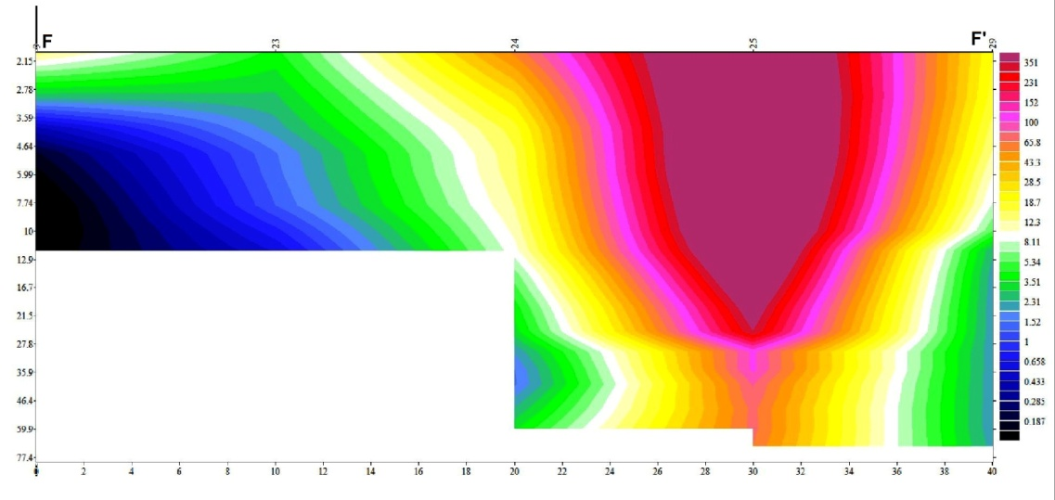
In the profile G-G' high resistive zones are seen in the topmost portions and towards east. Saline zones are seen towards depth and in the shoreward direction.
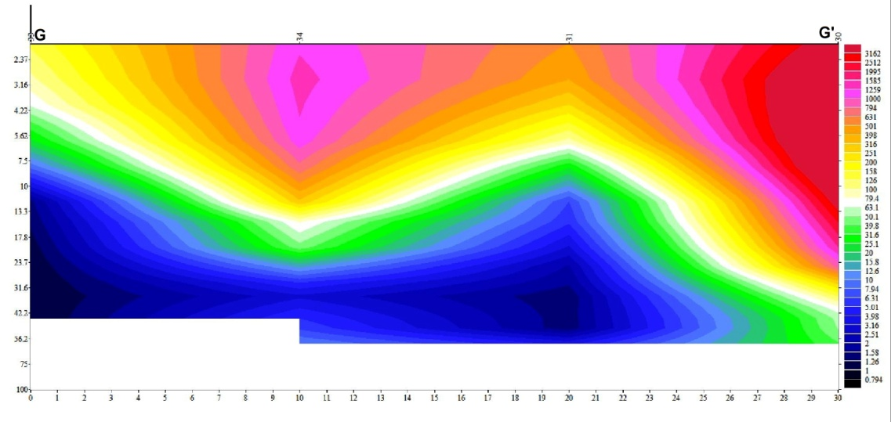

In the profile H-H'. high resistive zones are seen in the western side into the middle and is thinning towards east. Saline wedge is seen in the bottom and towards the eastern parts.
