Supporting Information

Cation-ordering in low-temperature niobium-rich NbWO bronzes: New anodes for high rate Li-ion batteries
Supreeth Nagendran¹, Amoghavarsha Mahadevegowda^{2, 3}, Sundeep Vema^{1,3}, Mohsen Danaie⁴, Weixin Song^{3,5}, Bo Wen⁶, Caterina Ducati^{2, 3}, Clare P. Grey^{1,3}
Fig. 1 Fig. 2 Fig. 3 Fig. 4 Fig. 5.

Table of Contents
Supplementary Figures
- Original NWO Phase diagram
Fig. S1 Modified “high temperature” niobium tungsten oxide phase diagram, based on that of Roth and Waring.

- Additional Experimental Data
Fig. S2 SEM and SEM-EDS maps of Nb1 precursor synthesized by microwave method.
Fig. S3 STEM-HAADF image of Nb1, Nb2, and Nb3 along the c-axis and the corresponding FFTs.
Fig. S4 STEM-HAADF of Nb1 and the ordering of PCs.
Fig. S5 PXRD patterns of NWO with different Nb:W ratio.
Fig. S6 A closer view of the Rietveld fit of the PXRD pattern of Nb2 and STEM images and model depicting the antiphase boundary.
Fig. S7 Comparison of the PXRD pattern of Nb2 and Nb3 phases.
Fig. S8 PXRD pattern of the TTB phases Nb1, Nb2, and Nb3 calcined at 800 °C for 30 days.
Fig. S9 SEM images of the Nb1 phase calcined at 800° C for 30 days.
Fig. S10 SEM images of the Nb2 phase calcined at 800° C for 30 days.
Fig. S11 SEM images of the Nb3 phase calcined at 800° C for 30 days.
Fig. S12 PXRD pattern of Nb1 calcined at 1200 °C.
Fig. S13 SEM images of Nb1 calcined at 1200 °C.
Fig. S14 PXRD patterns of W-rich NWO with different Nb:W ratio.
Fig. S15 High-resolution STEM-HAADF image of a NbWO particle of W2, and W3 along the c-axis.
Fig. S16 TEM-BF image of a lamella extracted from a secondary particle of Nb2 phase.
Fig. S17 TEM-BF image of an amorphous ‘bridge’ connecting two crystalline regions in a Nb2 lamella.

- Comparison of the structures of Nb1 and Nb2 and comparison to the known NbWO bronzes
- Classification and structure of known bronzes
- α-Nb₂WO₈ vs β-Nb₂WO₈ vs NbWO_{5.5}
Fig. S18 Comparison of the crystal structures of the Nb1 and Nb2 phases.
Fig. S19 Crystal structures of α−Nb₂WO₈, Nb₈W₉O₄₇, and Nb₄W₇O₃₁.
Fig. S20 Crystal structures of bronze phases drawn so as to compare the PCs and ordering of W cations in the lattice in NbWO_{5.5}, β-Nb₂WO₈, and α-Nb₂WO₈.
Fig. S21 Modified NbWO phase diagram including the low temperature NbWO bronzes.

Supplementary Tables
Table S1 Comparison of Nb:W ratio determined by SEM-EDS and X-Ray Fluorescence microscopy.
Table S2 Refined atomic position parameters of Nb1 phase deduced from the Rietveld refinement of combined X-ray and neutron diffraction patterns.
Table S3 Summary of occupancy of PCs across the unit cells in the STEM-HAADF image of Nb1
Table S4 Refined atomic position parameters of Nb2 phase deduced from the Rietveld refinement of combined X-ray and neutron diffraction patterns.
Table S5 List of reflections in the PXRD pattern of Nb3 in addition to those found for the Nb2 phase.
Table S6 Unit cell parameters and cell volume of NbWO_{5.5}, α-Nb₂WO₈ and β- Nb₂WO₈.

- Original NWO Phase diagram
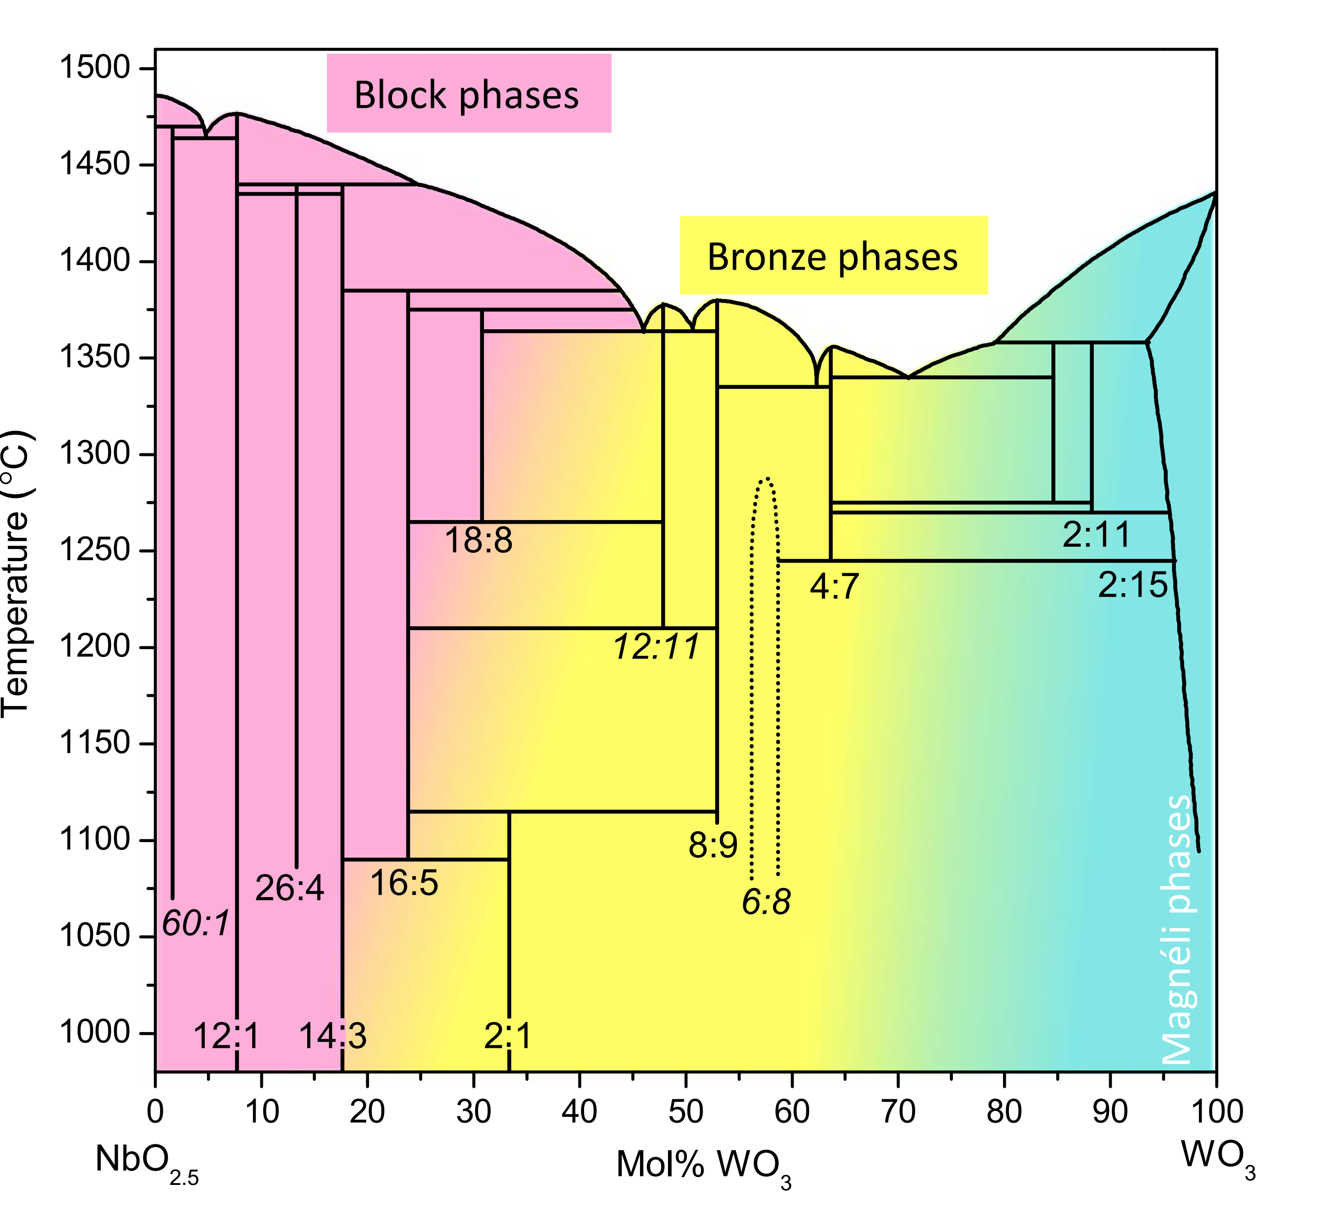
Fig. S1 Modified “high temperature” niobium tungsten oxide phase diagram, based on that of Roth and Waring.¹³

- Additional Experimental Data

Fig. S2 (a) SEM and SEM-EDS maps, (b) Nb and (c) W of Nb1 precursor synthesized by microwave method.

Table S1 Comparison of Nb:W ratio determined by SEM-EDS and X-Ray Fluorescence microscopy.
Nb:W ratio | SEM-EDS |  |  |  | XRF
Nb:W ratio | Precursor |  | Product |  | Product
Nb:W ratio | Nb | W | Nb | W | Nb | W
1:1 | 1 | 0.71 | 1 | 0.87 | 1 | 0.95
2:1 | 2 | 0.92 | 2 | 0.95 | 2 | 0.96
3:1 | 3 | 0.98 | 3 | 0.90 | 3 | 0.95

Table S2 Refined atomic position parameters of Nb1 phase deduced from the Rietveld refinement of combined X-ray and neutron diffraction patterns.
Cell parameters: a = 12.22232(8), c = 3.93814(3)
Space group: P4/mbm
atom | Wyckoff position | x | y | z | U_{iso} (Å²) | occupancy
O1 | 8j | 0.9965(5) | 0.3484(5) | 0.5 | 0.02341 | 1
O2 | 8j | 0.1454(5) | 0.0684(7) | 0.5 | 0.06265 | 1
O3 | 8i | 0.0766(5) | 0.2033(4) | 0 | 0.02309 | 1
O4 | 4h | 0.2102(4) | 0.2898(4) | 0.5 | 0.0038 | 1
O5 | 2d | 0.5 | 0 | 0 | 0.03127 | 1
O6 | 4g | 0.1701(13) | 0.6701(13) | 0 | 0.0038 | 0.313(12)
Nb1 | 2c | 0.5 | 0 | 0.5 | 0.02586 | 0.315(3)
Nb2 | 8j | 0.07512(14) | 0.20563(14) | 0.5 | 0.01653 | 0.462(16)
Nb3 | 4h | 0.1691(6) | 0.6691(6) | 0.5 | 0.03344 | 0.339(4)
W1 | 2c | 0.5 | 0 | 0.5 | 0.02586 | 0.685(2)
W2 | 8j | 0.07512(14) | 0.20563(14) | 0.5 | 0.01653 | 0.538(13)

Fig. S3 STEM-HAADF image of (a) Nb1, (b) Nb2, (c) Nb3 along the c-axis and the corresponding FFTs in (d), (e) and (f) respectively. The lattice parameter obtained from the FFT for Nb1, Nb2 and Nb3 were a₁ ~13, a₂ ~18, and a₃ ~18 Å respectively.
Fig. S4 (a) STEM-HAADF image of Nb1, (b) a closer view of (a), the green and pink circles in (b) highlighting partially and almost completely occupied PCs respectively. In c) the octahedral sites and PCs are identified in the image of (a) marked with yellow and magenta dots, respectively, to illustrate their relative orientations. In (d), blue lines have been added to separate the unit cells, while (e) colour codes each cell according to the number and orientation of the occupied PCs. (f) Statistical distribution of unit cells with varying occupancy of cation columns in PCs, with the inset illustrating the colours used in (e) to differentiate the various unit cells with differently occupied PC arrangements. The color-coded unit cells in (e), reflecting the number and orientation of occupied PCs, illustrate a lack of long-range ordering, with only local ordering observed for a maximum of 2-6 unit cells in a row. The plot in Fig. S4f and Table S3 summarizes the number and orientation of occupied PCs in Fig. S4e, based on an analysis of 255 unit cells (15×15) containing a total of 900 PCs. Of these, 350 PCs are either fully or partially occupied, resulting in approximately one-third of the PCs being filled.
Table S3 Summary of the number and orientation of the occupied PCs across the unit cells in the STEM-HAADF image of Nb1 in Fig. S4e.
Occupancy of PCs in each unit cell and its orientation |  | No. of unit cells | Total no. of PCs occupied
0 |  | 14 | 0
1 |  | 10 | 10
1 |  | 16 | 16
1 |  | 27 | 27
1 |  | 34 | 34
2 |  | 3 | 6
2 |  | 5 | 10
2 |  | 8 | 16
2 |  | 9 | 18
2 |  | 39 | 78
2 |  | 48 | 96
3 |  | 1 | 3
3 |  | 2 | 6
3 |  | 3 | 9
3 |  | 3 | 9
4 |  | 3 | 12
 |  | 225 | 350

Fig. S5 (a) PXRD patterns of NWO with different Nb:W ratio, and (b) a closer view of (a) between 18 – 34° 2θ. The black rectangle highlights the peaks corresponding to the T-Nb₂O₅ phase.

Table S4 Refined atomic position parameters of Nb2 phase deduced from the Rietveld refinement of combined X-ray and neutron diffraction patterns.
Cell parameters: a = 17. 37873(14), c = 3.94367(4)
Space group: P4/m
atom | Wyckoff position | x | y | z | U_{iso} (Å²) | occupancy
O1 | 4k | 0.0494(10) | 0.1471(7) | 0.5 | 0.00642 | 1
O2 | 4k | 0.0450(12) | 0.3912(11) | 0.5 | 0.03344 | 1
O3 | 4k | 0.1769(13) | 0.1781(12) | 0.5 | 0.03982 | 1
O4 | 4k | 0.1791(10) | 0.3190(9) | 0.5 | 0.0022 | 1
O5 | 4k | 0.2504(11) | 0.0463(7) | 0.5 | 0.00579 | 1
O6 | 4k | 0.2559(10) | 0.4692(6) | 0.5 | 0.00616 | 1
O7 | 4k | 0.3293(16) | 0.1641(13) | 0.5 | 0.04905 | 1
O8 | 4k | 0.3399(9) | 0.3338(12) | 0.5 | 0.0145 | 1
O9 | 4k | 0.4730(18) | 0.0911(15) | 0.5 | 0.07254 | 1
O10 | 4k | 0.4601(10) | 0.3895(7) | 0.5 | 0.00774 | 1
O11 | 4j | 0.1327(10) | 0.0699(9) | 0 | 0.00031 | 1
O12 | 4j | 0.0775(6) | 0.2461(8) | 0 | 0.00329 | 1
O13 | 4j | 0.1587(12) | 0.4287(15) | 0 | 0.06472 | 1
O14 | 4j | 0.2630(8) | 0.2542(15) | 0 | 0.0266 | 1
O15 | 4j | 0.3666(12) | 0.0662(13) | 0 | 0.03175 | 1
O16 | 4j | 0.3551(9) | 0.4400(11) | 0 | 0.0127 | 1
Nb1 | 4k | 0.1427(11) | 0.0725(15) | 0.5 | 0.04275 | 1
Nb2 | 4k | 0.3616(13) | 0.0711(11) | 0.5 | 0.04384 | 1
Nb3 | 4k | 0.0739(9) | 0.2567(12) | 0.5 | 0.04933 | 1
Nb4 | 4k | 0.1419(13) | 0.4500(11) | 0.5 | 0.0515 | 1
W5 | 4k | 0.2700(7) | 0.2531(15) | 0.5 | 0.0089 | 1
W6 | 4k | 0.3578(11) | 0.4337(12) | 0.5 | 0.00083 | 1

Fig. S6 Comparison of a closer view of Rietveld fit of the PXRD pattern of Nb2 (Fig. 4a), (a) without and (b) with selective broadening of hk0 family of reflections where h+k=odd. The reflections indexed in (c) corresponds to the hk0 family of reflections where h+k=odd, (c) HR-STEM image of Nb2 revealing the antiphase boundary marked by green dashed line, and (d) the corresponding schematic model. The unit cells are shaded in yellow and red to show their relationship at the antiphase boundary.

Fig. S7 Comparison of the PXRD pattern of Nb2 and Nb3 phases. The red astrisks marks the additional reflections in Nb3. In the inset is a closer view of the pattern from 34 – 41° 2θ with blue arrows pointing towards the unindexed peaks.
Table S5 List of reflections in the PXRD pattern of Nb3 in addition to those found for the Nb2 phase.
2θ | d | hkl
23.67 | 3.76 | 111
24.80 | 3.59 | 021
35.39 | 2.53 | -
39.14 | 2.30 | -
44.43 | 2.04 | 380
47.60 | 1.91 | 122
54.45 | 1.68 | 252
Fig. S8 PXRD pattern of the TTB phases calcined at 800 °C for 30 days, (a) Nb1, (b) Nb2, (c) Nb3. The major peaks are marked with symbols (*, ~, @, and $) to identify the different phases formed during decomposition. (d) again shows the PXRD pattern of Nb3 phase after calcining for 30 days, but now with a different 2θ range and the the Bragg positions of the decomposition products marked for clarity.

Fig. S9 SEM images of the Nb1 phase calcined at 800° C for 30 days at different magnification.
Fig. S10 SEM images of the Nb2 phase calcined at 800° C for 30 days at different magnification. The yellow arrows point towards the micron sized particles, likely the decomposition products, Nb₁₄W₃O₄₄ and α-Nb₂WO₈.
Fig. S11 SEM images of the Nb3 phase calcined at 800° C for 30 days at two different magnifications.
Fig. S12 PXRD pattern of Nb1 calcined at 1200 °C with the Bragg positions of the decomposition products marked.

Fig. S13 SEM images of Nb1 calcined at 1200 °C.

Fig. S14 (a) PXRD patterns of W-rich NWO with different Nb:W ratios, and (b) a closer view of (a) between 21 – 25° 2θ. The dashed lined mark the peaks corresponding to WO₃ phase.

Fig. S15 (a) High-resolution STEM-HAADF image of a NbWO particle of W2 along the c-axis, (b) A closer view of the region highlighted by a red square in (a) showing the ReO₃ type structure. (c) High-resolution STEM-HAADF image of a NbWO particle W3 along the c-axis, (d) A closer view of the region highlighted by a red square in (a) showing the ReO₃ type structure.

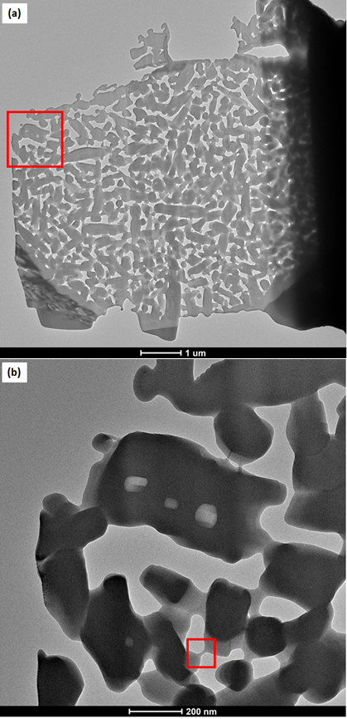
Fig. S16 TEM-BF image (a) of a lamella extracted from a secondary particle of Nb2 phase. The region highlighted by a red square in (a) is magnified in the image (b), which shows the ‘bridges’ connecting relatively small crystals of NbWO. A red square in (b) shows one such ‘bridge’ and is further probed in Fig. S17.
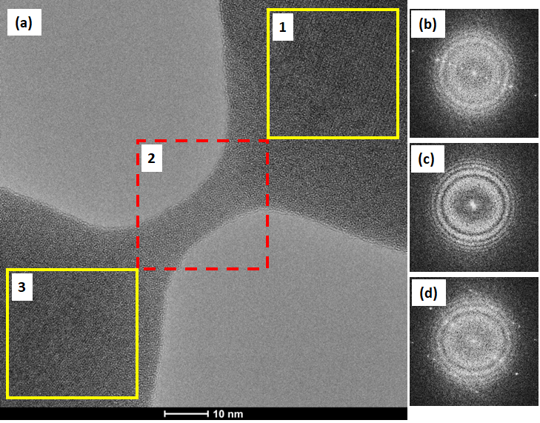
Fig. S17 TEM-BF image (a) of an amorphous ‘bridge’ (highlighted by a dashed red square, #2) connecting two crystalline regions (highlighted by two yellow squares, #1 and #3) in a Nb2 lamella shown in Fig. S16. The FFTs shown in (b), (c), and (d) are from the regions #1, #2, and #3 respectively. The FFT (c) from the bridge (#2) showed amorphous rings as opposed to the FFTs (b and d) that showed spots corresponding to the crystalline regions in #1 and #3.

- Comparison of the structures of Nb1 and Nb2 and comparison to the known NbWO bronzes
Fig. S18 Comparison of crystal structures of Nb1 and Nb2 phases. (a) 1×2 unit cells of NbWO_{5.5} (teal cell edges), and (b) 2×2 unit cells of β−Nb₂WO₈ (orange cell edges), which is the supercell of NbWO_{5.5}. Within the supercell, smaller TTB unit cells, similar to those in Nb1, are highlighted in teal and shaded in yellow and purple to distinguish between the cells containing empty PCs and those with occupied PB sites, respectively.
Fig. S19 Crystal structures of (a) α−Nb₂WO₈, (b) Nb₈W₉O₄₇, and (c) Nb₄W₇O₃₁. In these structures, the Nb and W cations are randomly distributed within octahedra (green) and the PB sites (pink), while the unit cells are marked in red. The blue-shaded region represents the simple TTB unit cell, which is a subunit of Nb₈W₉O₄₇. Nb₄W₇O₃₁ also exhibits a simple TTB structure (blue squares) on all the four sides, surrounding the central 4×4 block of octahedra (orange squares).

Fig. S20 Crystal structures of bronze phases drawn so as to compare the PCs and ordering of W cations in the lattice in (a) NbWO_{5.5}, (b) β-Nb₂WO₈, and (c) α-Nb₂WO₈. Red circles are drawn to highlight the four connected MO₆ octahedra; these also cut through the pentagonal channels. W octahedra ordering in (d) NbWO_{5.5}, (e) β-Nb₂WO₈, and (f) α-Nb₂WO₈. The W rich sites and Nb rich sites are shown in magenta and cyan. The pentagonal bipyramidal sites are represented in blue cage to be distinguished from octahedral sites. The corners of the red squares in (d) correspond to W-rich octahedra and (e) corresponds to W-only sites. In (e), a blue square is drawn to differentiate the W ordering around the occupied PCs as opposed to empty PCs shown in red. The corners of the red parallelogram in (f) is a W-rich octahedra. The average W-W distance in all the three structures is ~8.6 - 8.7 Å given in Table S6.

Discussion of Structure Types and Evolution:
- Classification and structure of known bronzes
All the known NbWO phases with PCs /PB sites are classified as bronzes. There are at least five known bronze NbWO phases with compositions α−Nb₂WO₈¹⁹, Nb₁₈W₁₆O₉₃³⁰, Nb₈W₉O₄₇³¹, Nb₇W₁₀O_{47.5}¹⁵, and Nb₄W₇O₃₁.³² Among these, only the Nb-excess phases α−Nb₂WO₈ and Nb₁₈W₁₆O₉₃ fall within the range of Nb:W ratios where bronzes are reported in this work: at 800 °C, the W rich amorphous precursors form WO₃ along with Nb1 (β−Nb₂WO₈) (Fig. S14). α−Nb₂WO₈ exhibits a distorted structure that crystallizes in an orthorhombic cell (a = 3.946 Å, b = 17.616 Å, c = 16.617 Å, space group, Pbcm) where the MO₇ PB polyhedra are surrounded by edge-sharing MO₆ octahedra (Fig. S19a). The unit cell comprises four such units, with no vacant PC channels. The W rich bronze, Nb₈W₉O₄₇, is the most stable bronze phase and it adopts an 3a×a (a =12.3 Å, a parameter of the simple TTB cell) supercell structure where 4 of the available 12 PCs are filled by strings of –O-M-O- (Fig. S19b). Similarly, the phases Nb₁₈W₁₆O₉₃, and Nb₇W₁₀O_{47.5} (also known by the compositions Nb₇W₁₀O₄₇ and Nb_{6.7}W_{10.3}O₄₇) possess a structure akin to Nb₈W₉O₄₇, but are always found to crystallize with domains of other bronzes and block phases, likely resulting in the ambiguity in their reported compositions.^{16,33,34} Another W-rich bronze phase, Nb₄W₇O₃₁, consist of a block of 4×4 corner sharing octahedra, that is coherently integrated in the TTB framework where 4 of the 12 PCs are filled by –O-M-O- strings (Fig. S19c). ³² The different domains in Nb₈W₉O₄₇ and Nb₄W₇O₃₁ bronzes were separated by antiphase boundaries (APBs) as observed by Iijima and coworkers using HRTEM.³² They also used atomic-resolution (S)TEM-EDS to demonstrate the preferential occupancy of Nb in one third of the PB sites in the Nb₈W₉O₄₇ and Nb₄W₇O₃₁ phases.²² These structures exhibit a certain degree of cation mixing within the lattice, and cation ordering is established based on the relative preference of cations occupying specific sites over the others. The other less explored domains of bronzes, which include Nb₁₂W₁₁O₆₃ and Nb₆W₈O₃₉, are subject to debate within the scientific literature and have structures that are much less well determined.¹²
The diffraction data of a phase Nb₂W₃O₁₄, synthesized between 1100-1150 °C, were indexed using the unit cell parameters of a simple TTB structure, as used here to describe Nb1.^{35,36} Single crystal data revealed additional reflections with d-spacings of 7.25, 6.85 and 6.37 Å in the hk0 photographs, indicating a superstructure with twice the a parameter.³⁷ However, the crystal structure of Nb₂W₃O₁₄ was not provided. To the best of our knowledge, our study reports the first report of a NbWO phase with a simple TTB structure time and its position in the phase diagram is shown in Fig. S21.
Fig. S21 Modified NbWO phase diagram including the low temperature NbWO bronzes. The known bronze phases Nb₁₈W₁₆O₉₃ (800 °C³⁸ to 1200 °C³⁹) and Nb₇W₁₀O₄₇ (1250 °C⁴⁰) / Nb₇W₁₀O_{47.5} (1200 °C⁴¹) are included along with the new phases discovered in work reported in this paper Nb1, Nb2, and Nb3 to extend the phase diagram to lower temperatures. The end member Nb₂O₅ forms a series of metastable phases at temperatures even lower than shown on this new phase diagram, suggesting that more metastable phase may exist at higher Nb contents than explored in this work: on heating NbO₂, the poorly crystalline bronze phase TT-Nb₂O₅^{42–44} first forms, followed by the more ordered bronze phase T-Nb₂O₅.⁴⁵ The latter remained stable until 600 °C, the B-Nb₂O₅ phase⁴⁶ beginning to forming at 650 °C. The block H- Nb₂O₅ phase⁴⁷ emerges at 900 °C.⁴⁸

- α-Nb₂WO₈ vs β-Nb₂WO₈ vs NbWO_{5.5}
The Nb2 and Nb3 phases crystallize in a √2a×√2a supercell of a simple TTB structure classified as S-2TTB type. This structure type was first reported in alkali metal cation containing niobium-based oxides such as KNb₁₂O₂₉F₃,⁴⁹ and NaNb₅WO₁₆.⁵⁰ In NbWO, the formation of a √2a×√2a supercell was first observed by heating Nb₇W₁₀O₄₇ in an in-situ gas reaction cell (filled with O₂, He or H₂) fitted to a transmission electron microscope, generating a plasma that resulted in the partial evaporation of W.⁵¹ This process led to the formation of small domains of the Nb rich √2a×√2a supercell, which were considered kinetically stable rather than thermodynamically stable. Two possible compositions were proposed for the supercell: (i) Nb₇W₅O₃₂ based on the composition of the starting material, and (ii) Nb₂WO₈ where the cations are fully oxidized.
The α-Nb₂WO₈ exhibits a unit cell volume similar to that of β- Nb₂WO₈ (Table S6), but it differs in the arrangement of PCs within the lattice. In case of NbWO_{5.5} (depicted in Fig. S20a) and β- Nb₂WO₈ (shown in Fig. S20b) the PCs are formed by a 45° rotation of a 2×2 block of octahedra, as described in the introduction to the main text (see Fig. 1b). In α-Nb₂WO₈, the rotating 2×2 block of octahedra is positioned adjacent to each other within a row. Consequently, two out of the four pentagonal and trigonal channels recombine to create square channels, retaining only two pentagonal and trigonal channels (depicted in Fig. S20c). In comparison to the bronze phases discussed in this paper, α-Nb₂WO₈ contains completely filled PCs. (Note that we suggest that this is reason for the poor electrochemical performance of this phase in comparison to the new bronze polymorph β- Nb₂WO₈). Notably, NbWO_{5.5} and α and β- Nb₂WO₈ also share a similarity in which the WO₆-rich octahedra are ordered and arranged in a square pattern in NbWO_{5.5} and β- Nb₂WO₈ and while maintaining a nearly square pattern in α-Nb₂WO₈ as shown in Fig. S20d-f. Further details including the average W-W distances in these three structures can be found in Table S6.

Table S6 Unit cell parameters and cell volume of NbWO_{5.5}, α-Nb₂WO₈ and β- Nb₂WO₈.

 | NbWO_{5.5} | β-Nb₂WO₈ | α-Nb₂WO₈
a (Å) | 12.2223 | 17.3787 | 3.946
b (Å) | 12.2223 | 17.3787 | 17.616
c (Å) | 3.9381 | 3.9438 | 16.617
volume (Å³) | 588.292 | 1191.103 | 1155.093
Average W-W distance | 8.64 Å | 8.70 Å | 8.61 Å

