Supplementary data
Title: Distinct Epigenetic Modulation of Differentially Expressed Genes in the Adult Brain Following Prenatal Exposure to Low-Dose Bisphenol A

Journal: Cell Biology and Toxicology

Authors: Jie Weng^{1†}, Yue-yan Zhu^{1†}, Li-yong Liao¹, Xin-tong Yang², Yu-hao Dong¹, Wei-da Meng³, Dai-jing Sun¹, Yun Liu³, Wen-zhu Peng^{1*}, Yan Jiang^{1*}

¹Institutes of Brain Science, State Key Laboratory of Medical Neurobiology and MOE Frontier Center for Brain Science, Fudan University, 200032, Shanghai, China.
²Shanghai Medical college, Fudan University, 200032, Shanghai, China.
³The MOE Key Laboratory of Metabolism and Molecular Medicine, Department of Biochemistry and Molecular Biology, School of Basic Medical Sciences, Fudan University, 200032, Shanghai, China.

†JW and YZ contributed equally to this work
*WP and YJ are co-senior authors
Correspondence: Yan Jiang, Yan_jiang@fudan.edu.cn
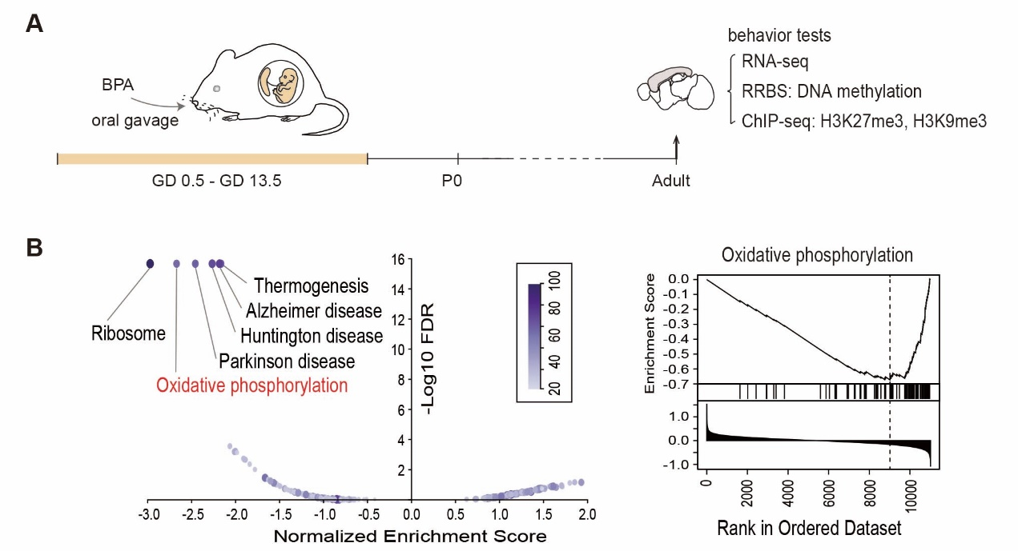
Supplementary Figure 1: Decreased OXPHOS pathway in adult cortex after prenatal low-dose BPA exposure. (A) Schematic timeline of experimental procedure. Pregnant mice were administrated with corn oil (Ctrl) or 40 ug/kg bw/day BPA by oral gavage from GD0.5 to GD13.5. The effects of prenatal exposure to BPA in the adult offspring were detected through behavioral tests and transcriptional and epigenomic profiling. (B) Dot plot of GSEA KEGG pathway enrichment (BPA vs. Ctrl) shows the significantly enriched pathways. Color key for number of genes in each pathway (Left). Enrichment score (ES) plots for oxidative phosphorylation (Right).
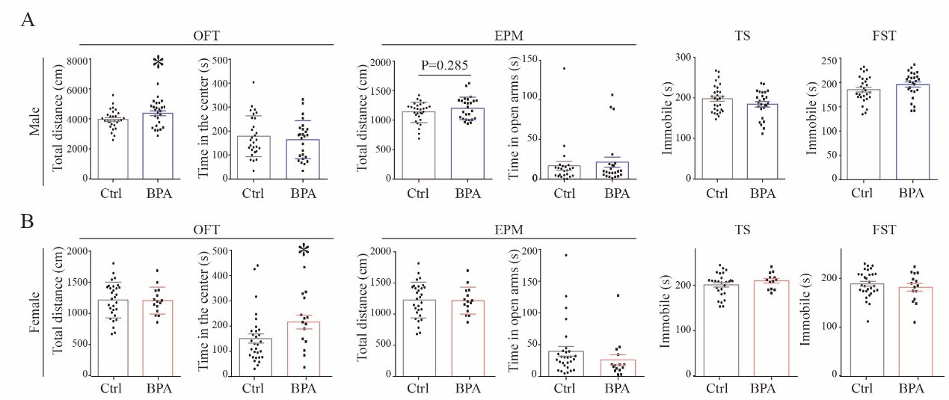
Supplementary Figure 2: Behavioral performance of adult offspring following prenatal BPA exposure. (A) Behavioral performance of male offspring. Total distance in open field was increased in the BPA group. n = 26~29/group. Mean± SEM. *P < 0.05, Unpaired t test, two-tailed. No significant difference was detected in the elevated plus maze test, tail suspension test and forced swimming test. n = 26~29/group. Mean± SEM. (B) Behavioral performance of female offspring. Female mice spent more time in the center. n = 15~30/group. Mean± SEM. * P < 0.05, Unpaired t test, two-tailed. No significant difference was detected in the elevated plus maze test, tail suspension test and forced swimming test. n = 15~30/group. Mean± SEM.

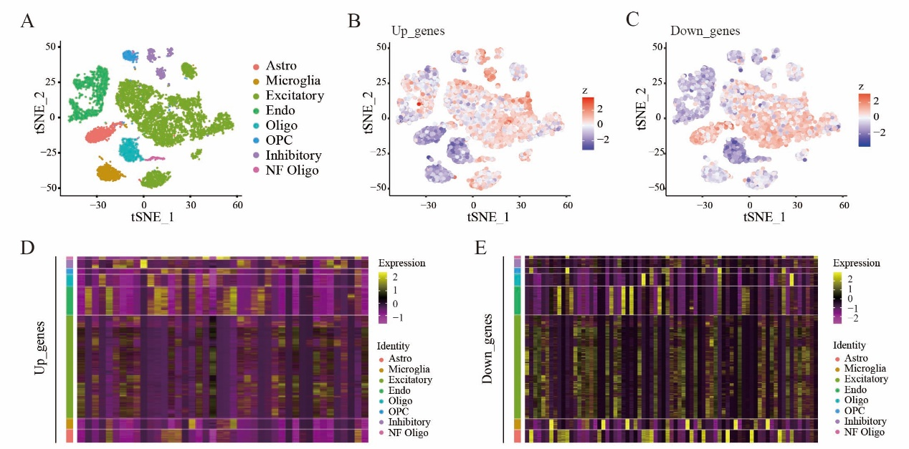
Supplementary Figure 3: Enrichment of differentially expressed genes in different cell types. (A) Scatterplots visualize the 8 clusters of cell types in the t-SNE map of published scRNA-seq data. Scatterplots visualize the expression and distribution of “Up_genes” (B) and “Down_genes” (C) in the t-SNE map. Seurat’s DoHeatmap shows the individual gene expression level of “Up_genes” (D) and “Down_genes” (E) in each cell of the published scRNA-seq. Only genes detected in scRNA-seq were shown.

