Supplementary material
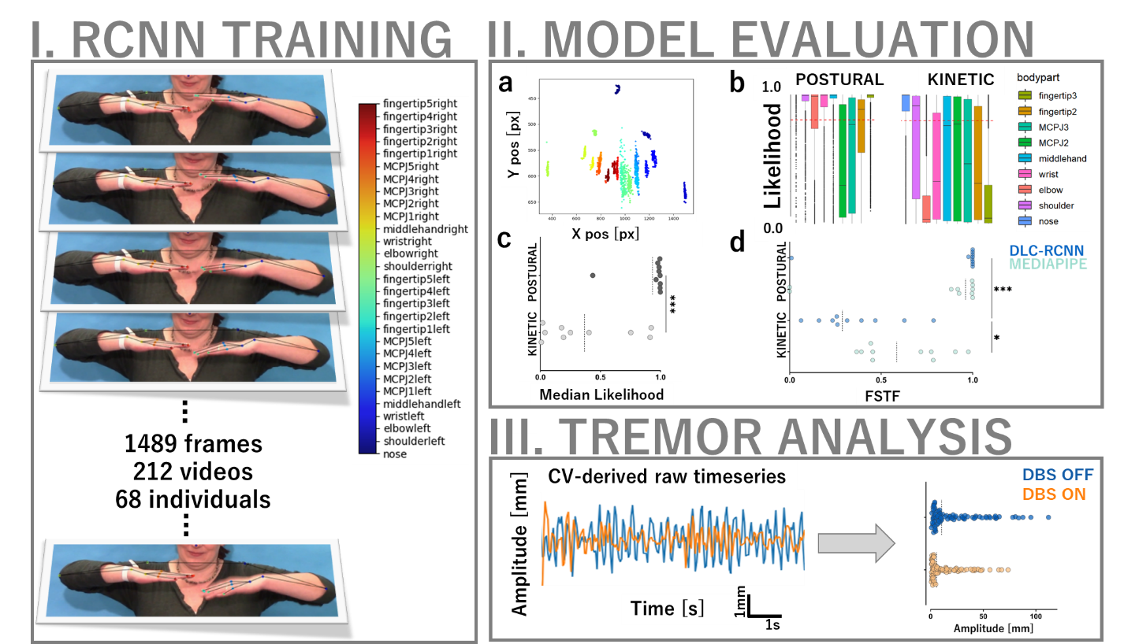
Supplementary Figure 1 - Tuning a disease-specific visual perceptive deep learning model. A residual convolutional neural network, RCNN, is fine-tuned for limb tracking by annotating 1489 frames from 212 videos of 68 individuals with essential tremor across different task and neurostimulation conditions. Multifaceted model evaluation shows plausible tracking of bilateral keypoints in an aggregated plot, averaging each keypoint’s framewise 2D coordinates over time (a). Tracking confidence however varies as a function of anatomical keypoint position such as the hand metacarpophalangeal joints (MCPJ) (b) and task condition, i. e. postural or kinetic tremor assessment (b-c). While both DLC-RCNN and the benchmark hand tracking algorithm, Mediapipe, achieve a similar ”fraction of successfully tracked frames” (FSTF, defined as confidence > 0.8) in postural tremor assessments, DLC-RCNN largely fails to track the limbs in the kinetic tremor condition (Friedman χ2= 16.2, p= .001, post-hoc test significant in kinetic tremor condition (p= .012). (d). Raw 2D coordinate time series extracted by both computer vision frameworks are transformed into metric tremor amplitudes using a patient- and video-specific calibration procedure based on real-world ground truth dimensions derived from neuroimaging.

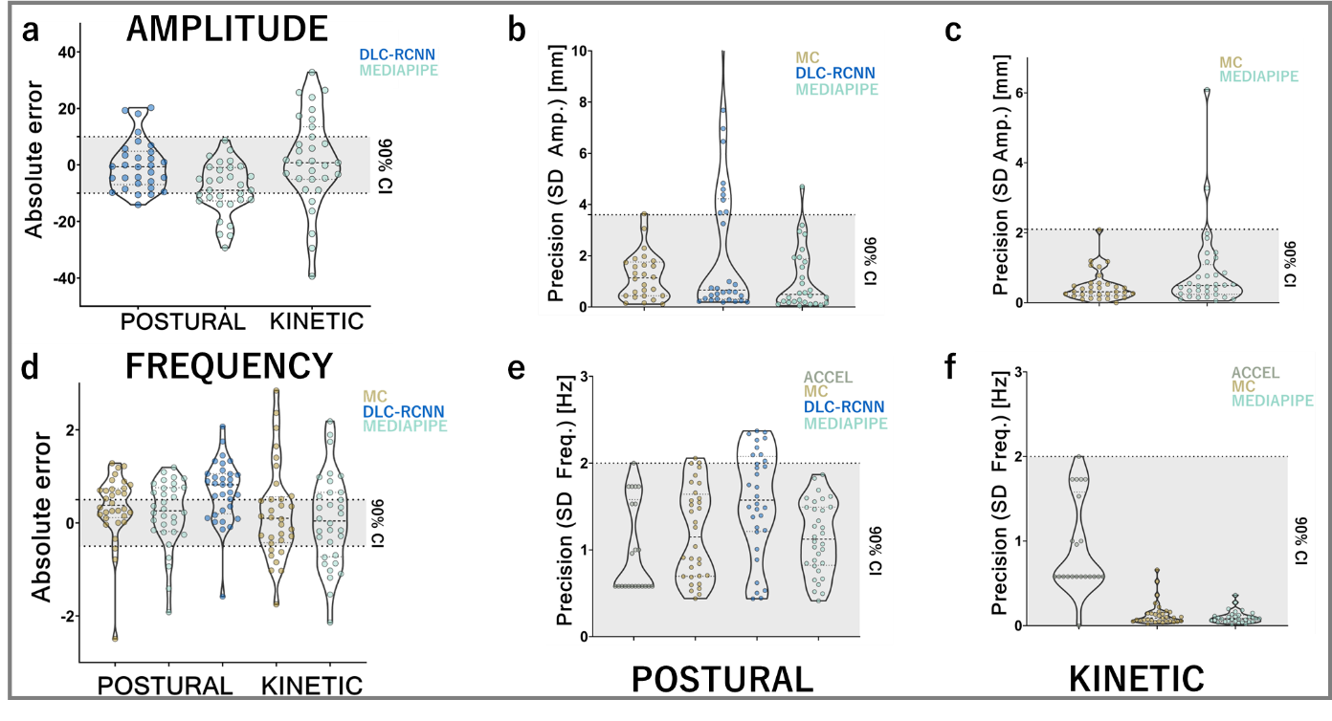
Supplementary Figure 2. Accuracy and precision assessments in the prospective cohort. a Within the a priori defined boundaries of 10 mm, both computer vision algorithms’ accuracy in amplitude assessments are equivalent to motion capture (DLC-RCNN: upper limit T(31)= -6.43, lower limit T(31)= 11.3, p< .001, Mediapipe: upper limit T(31)= -14.1, lower limit T(31)= 9.36, p< .001, kinetic: upper limit: T(29)= -4.33, p< .001, lower limit T(29)= 2.57, p= .008). b Precision values of postural tremor amplitude measurements of DLC-RCNN and Mediapipe fall within the equivalence boundaries defined by minimal motion capture precision (DLC-RCNN: upper bound T(25)= -13.3, lower bound T(25)= 11.0; Mediapipe: upper bound T(25)= -25.8, lower bound T(25)= 31.5, all p< .001). c Mediapipe’s precision of kinetic tremor amplitude measurements falls within the equivalence boundaries of motion capture (upper bound T(31)= -10.5, lower bound T(31)= 7.13, p< .001). d Mediapipe, but not motion capture and DLC-RCNN show equivalent accuracy to accelerometry in measuring postural tremor frequency (MP: upper bound T(31)= -5.47, p< .001, lower bound T(31)= 2.33, p= .013, DLC-RCNN: upper bound T(31)= -9.9, p< .001, lower bound T(31)= -1.54, p= .930; motion capture: upper bound T(31)= -6.69, p< .001, lower bound T(31)= 1.27, p= .011). Mediapipe-derived kinetic tremor frequencies are equivalently accurate (MP: upper bound T(31)= -3.2, p= .002, lower bound T(31)= 2.52, p= .009). This was not the case for motion capture (upper bound T(31)= -4.0, p< .001, lower bound T(31)= 1.53, p= .068). e Within the boundaries derived from the minimal accelerometry precision, motion capture, DLC-RCNN and Mediapipe exhibit equivalent precision in postural tremor frequency measurements (MC: upper bound T(21)= -17.3, lower bound T(21)= 14.83; DLC-RCNN: upper bound T(21)= -18.0, lower bound T(21)= 9.62, MP: upper bound T(21)= -16.4, lower bound T(21)= 14.62, all p< .001). f Motion capture and Mediapipe exhibit equivalent precision in kinetic tremor frequency measurements (motion capture: upper bound T(21)= -1.66, lower bound T(21)= 14.9; Mediapipe: upper bound T(21)= -9.7, lower bound T(21)= 23.1, all p< .001).
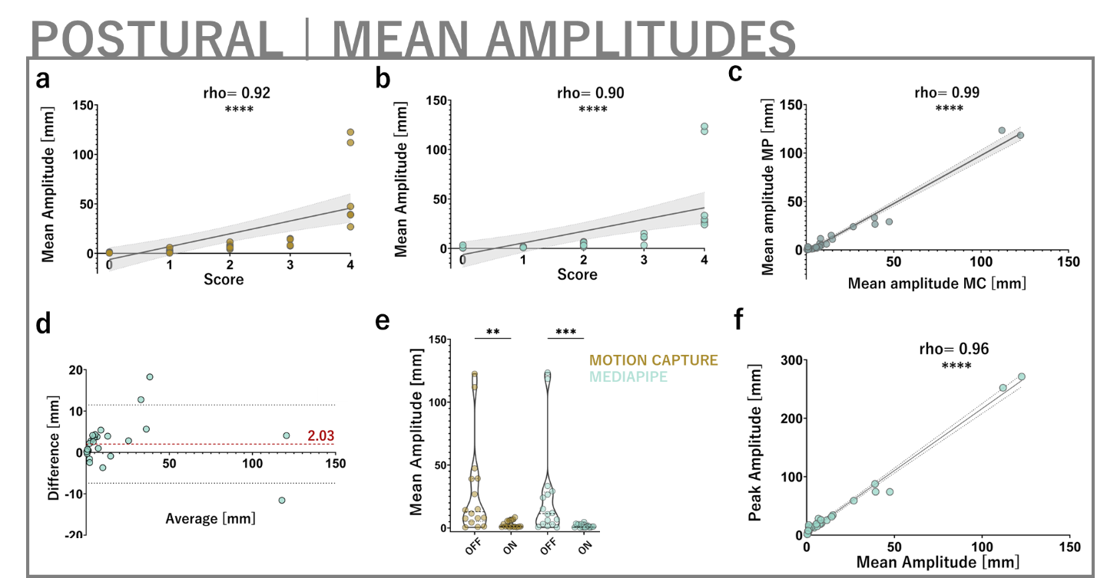
Supplementary Figure 3. A-b Repeating postural tremor amplitude analyses using mean instead of peak amplitude measurements yields similarly strong convergent clinical validity and c, intermethodological agreement. D Bland-Altman analysis demonstrates a mean absolute error of 2.03mm of Mediapipe-derived mean postural tremor amplitudes. E Mediapipe-derived mean postural tremor amplitude is responsive to DBS effects (effect size 1.0 Mediapipe, 0.94 motion capture, p< .01). F Mediapipe-derived peak and mean postural amplitude measurements are strongly correlated.
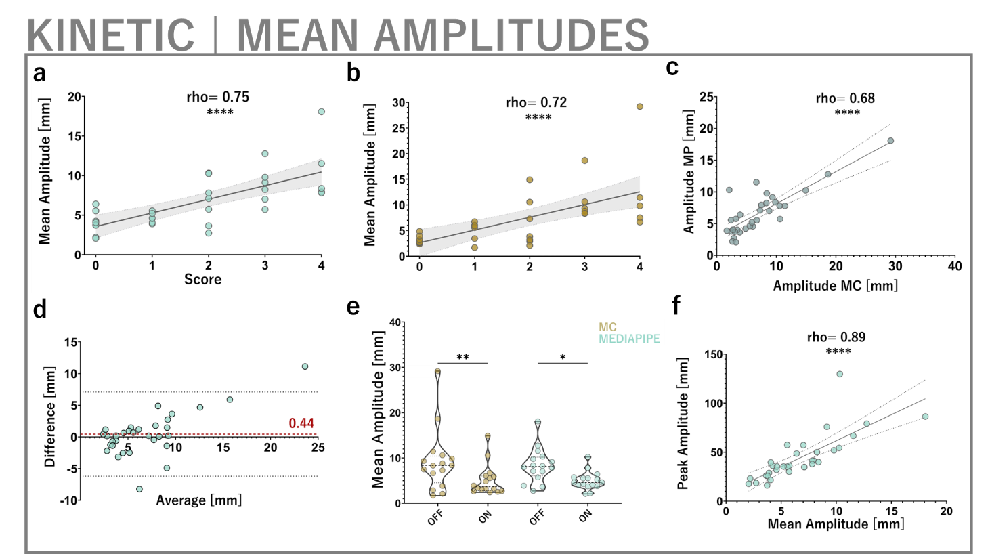
Supplementary Figure 4. A-b Repeating kinetic tremor amplitude analyses using mean instead of peak amplitude measurements yields similar (if not higher) convergent clinical validity (MP: rho= 0.75, MC: rho= 0.72, both p< .001) and c, intermethodological agreement (rho= 0.68, p< .001). D Bland-Altman analysis demonstrates a mean absolute error of 0.44mm of Mediapipe-derived mean kinetic tremor amplitudes. E Mediapipe-derived mean kinetic tremor amplitude is responsive to DBS effects (effect size 0.86 Mediapipe, 0.89 motion capture, p< .05). F Mediapipe-derived peak and mean kinetic amplitude measurements are strongly correlated (0.89, p< .001).

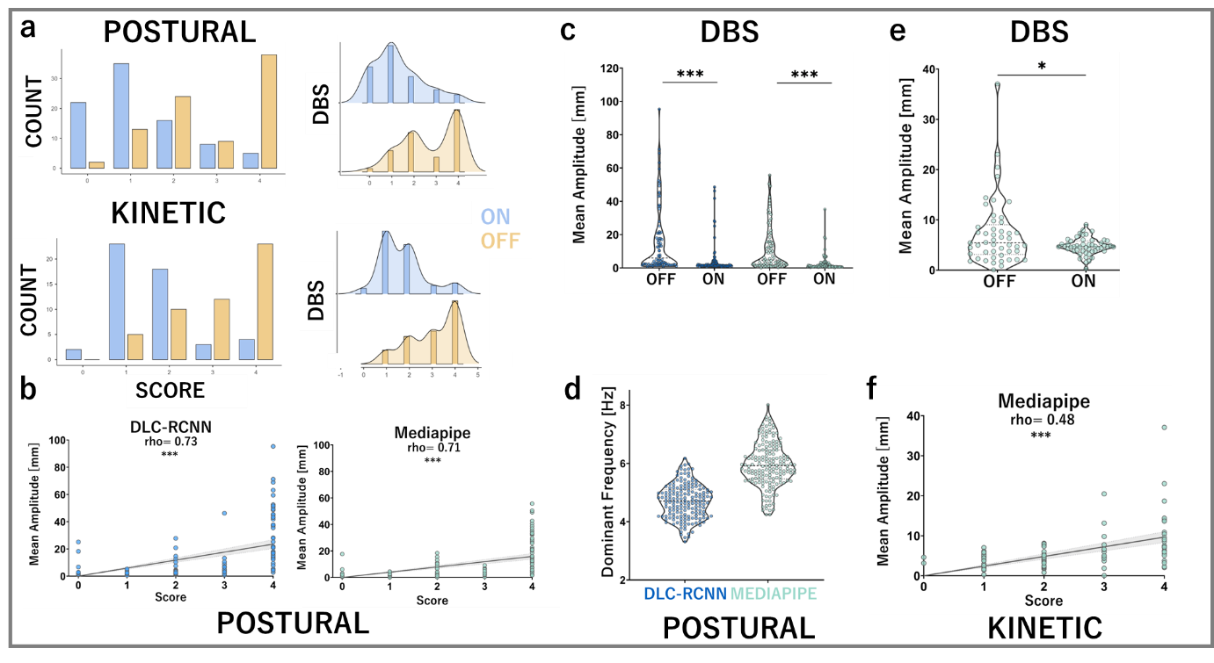
Supplementary Figure 5. Additional analyses in the retrospective cohort. a Tremor score distributions broken down into experimental and treatment conditions. b Mean postural tremor amplitudes are significantly and strongly correlated to clinical scores (DLC-RCNN: rho= 0.73, p< .001, MP: rho= 0.71, p< .001), and c responsive to DBS effect ((DLC-RCNN: p< .001, r= 0.57 (95% CI [0.45, 0.68], MP: p< .001, r= 0.76 (95% CI [0.43, 0.91]). d DLC-RCNN-derived tremor frequencies are lower compared to Mediapipe. e. Mean kinetic tremor amplitudes are responsive to DBS (W= -435, p= .03, r= 0.36 (95% CI [0.11, 0.70]) and moderately correlated to respective clinical scores (rho= 0.48, p< .001, f)

Cohort characteristics

Retrospective cohort
Video material was available for a total of n= 58 individuals. All patients received therapeutic deep brain stimulation (DBS) to the ventral intermediate nucleus (VIM) of the thalamus. 14 patients underwent DBS surgery at Wuerzburg University Hospital between 2016 and 2017 and the remaining 44 patients at Kiel University Hospital between 2003 and 2015^{14,71,72}. All patients had received a diagnosis of essential tremor based on the 1998 consensus criteria of the Movement Disorders Society⁷³. Post-operative follow-up examinations were conducted after a mean of 25.8 ± 20.8 months postoperatively at each patient’s optimal clinical stimulation settings. Participants were video recorded whilst seated in a clinic room with standard ambient lighting. All videos were collected using various consumer grade, handheld or tripod mounted cameras in the context of standard clinical care to document the severity of postural and kinetic tremor components. Spatiotemporal video resolution was at least 25 Hz and 320 x 238 pixels (px), respectively. The Fahn-Tolosa-Marin Tremor Rating Scale (FTM) was formally administered by movement disorders specialists, as described in the original publications of the cohorts^{14,71,72,74}. Separate video segments showing the assessment of postural tremor (arms in front of chest, “wing-beating position”, fingertips facing each other but not touching) and kinetic tremor (minimum of three repetitions of finger-to-nose-test on both sides) were identified. Clinical score distributions are shown in Supplementary Figure 5A.

Video quality criteria
Video quality criteria were utilized to optimally balance standardization, robustness and broad applicability. Videos were excluded for computer vision analysis if the hands left the frame and if excessive camera movements or zooming were present. These criteria reflect a practical consensus synthesized from previous work in computer vision for movement analysis^{23,27,28,33} as well as exploratory pilot experiments preceding this study. Based on these criteria, n= 15 patients had to be excluded for postural and n= 33 patients for kinetic tremor tracking, leaving videos of n= 43 and n= 25 individuals for subsequent computer vision-based hand tracking in postural and kinetic conditions, respectively.

Prospective cohort
In order to validate the computer vision approaches across cohorts and methods, a cohort of n= 8 patients (age 54-83, mean, 4 female, 4 male) with a diagnosis of essential tremor based on the aforementioned consensus criteria as well as active VIM-DBS were recruited from the movement disorders clinics at the University Hospital Wuerzburg, department of Neurology, in 2021. Postoperative intervals to VIM-DBS implantation were 53.6 ± 33.3 months.

Motion capture and accelerometery setup
A six-camera optoelectronic motion capture system (SMART-DX, BTS, Italy) operating at a temporal resolution of 100 Hz was used to track retroreflective markers placed bilaterally on the upper limbs’ ulnar styloid, lateral epicondyle of the humerus and the acromion, as previously described¹⁵. Two additional markers were placed on the middle and index fingertips’ dorsal heads for the assessment of postural and kinetic tremor, respectively. The signals for postural and kinetic tremors were computed from the middle and index fingertips’ signals and exported for subsequent computation of tremor characteristics. During all recording sessions, two inertial measurement units (Opal, APDM, USA; dimensions: 48.5x36.5x13.5 mm; size: 22 g) were placed on the dorsum of both wrists. Tri-axial accelerometer data were used to measure tremor frequencies (sampling frequency: 128 Hz). To avoid potential interference of retroreflective markers with computer vision tracking, experiments were repeated without markers for sequential analysis, as previously described²⁷.

Fine-tuning a residual convolutional neural network for limb tracking
Utilizing the open-source computer vision framework DeepLabCut (DLC)⁴⁴, a convolutional neural network (CNN) based on a residual network architecture (ResNet 50) was fine-tuned to track a total of 29 key anatomical landmarks of the upper body such as finger tips, ulnar styloid, radial epicondyle of the humerus and shoulder. In an iterative process, frames were extracted from a total of 202 clinical videos from 58 retrospective patients as well as 10 videos from 10 healthy controls performing the finger-to-nose test. These videos were deliberately taken in diverse video settings (perspective, lighting, background) to model variance typical to medical videography^{27,75}. To further broaden the coverage of variability in regards to anthropomorphic, pose, lighting, background and other technical factors²⁷, a k-Means algorithm was utilized for frame extraction from videos. Extracted frames were subsequently labelled by a trained annotator (AJR) and validated by an expert annotator (MF). In order to minimize labelling errors interfering with training efficiency, the labelled frames were plotted and checked for accuracy and plausibility before the annotated frame sets were passed into neural network training using 95% of data, leaving the remainder as a test set for performance evaluation.
Moreover, a subset of 10 retrospective clinical videos was held back for an additional out-of-sample validation. Importantly, no videos of the prospective cohort were included in CNN training in order to maintain strict separation between training, test and validation datasets across the study arms. In a total of 13 consecutive iterations, the CNN was initialized with ResNet-50 weights and trained using both default and imgaug augmentation approaches. To ensure sufficient convergence of the loss function, the maximum iterations were varied between 500,000 and 1,030,000.

Calculation of canonical tremor features

Preprocessing of deep learning-derived time series
As previously reported²⁷, an inverse relationship of the DLC-RCNN’s tracking performance and spatial resolution of the videos was observed. Therefore, videos were resampled to 1280x720 px. This value offered the optimal trade-off of spatial information for landmark tracking and favourable tracking performance.
Kinematic analysis of limb movements was implemented in Python 3.9 using standard scientific analysis packages (pandas, sklearn, numpy, scipy) and a custom analysis pipeline. Two-dimensional coordinate time series were conditioned by removing low likelihood marker data points (confidence/likelihood < 0.5, default setting in MediaPipe). Mediapipe outputs three-dimensional marker coordinates, but for fair comparison to the two-dimensional DLC-RCNN, only the x and y coordinates were used. The missing points were then interpolated using a linear filter. Furthermore, a high pass filter was implemented to remove remaining low frequency components associated with slow arm drifts unrelated to tremor frequency. Given its consistency at successful tracking across videos and its clinical relevance we tracked the middle finger’s distal phalanx for postural tremor analysis (Mediapipe marker “middle finger tip”) and tracked the index finger’s distal phalanx (Mediapipe marker “index finger tip”) for kinetic tremor quantification. A bandpass filter was implemented (postural: low cut = 1 Hz, high cut = 10 Hz), removing both high frequency noise (such as “prediction jitter” introduced by frame-to-frame tracking variability or, failure) and low frequency large-scale movements (such as slow arm drifts unrelated to tremor frequency). To correct for occasional poor tracking, an additional spiking threshold was applied that identified markers that differed from the previous marker coordinates by over 100px and removed them prior to linear interpolation (this was only relevant in a minority of kinetic tremor videos).
For pixel-to-metric conversion, an individual scaling factor was calculated for each retrospective clinical video in which no systematic calibration information (i. e. checkerboard) was available. To this end, the interpupillary distance (IPD, pupil center to pupil center) was used, as previously described²⁷. The ground truth metric IPD was derived from each individual’s preoperative structural T1w-MRI scans (averaged over three measurements) using Suretune 3 (Medtronic Inc., Minneapolis, MN, USA). A patient specific scaling factor was then calculated by the real IPD (in mm) divided by the video IPD (in px) measured with the open-source software GIMP 2.8.22 (GNU Image Manipulation Program). In the prospective videos, a ChArUco board was used for pixel-to-metric conversion. Using these scaling factors and the known temporal video resolution, the time series could be spatiotemporally transformed to facilitate meaningful comparisons with clinical tremor scores, which mainly rely on tremor amplitude estimates, as well as previous tremor research.

Computation of canonical tremor features from motion capture and computer vision
Amplitude was calculated by first computing a spectrogram of the tremor signal which describes the power density of frequencies of a signal as it varies with time. The frequency bin with the maximum power is identified for each frame and the associated amplitude and frequency for that frame is stored. Finally, resulting feature time series were collapsed per experimental condition (i. e. task, DBS status) into their aggregated mean and peak values. In accordance with the clinical scoring assessing maximal amplitude, peak values were primarily used for subsequent comparisons and correlations. Of note, all main results were reproducible using mean instead of peak amplitudes (Supplementary Figures 3-4).

Computation of tremor frequency from wrist-worn accelerometer
Firstly, the axis with the highest range of variation in acceleration was identified for further analysis. The data underwent pre-processing, involving bandpass filtering between 1-10 Hz using a 5th order Butterworth filter. The trials were then segmented based on the type of tremor. Postural tremor trials were segmented by means of synchronized video recordings (VIXTA, BTS, Italy), by excluding any initial or final voluntary arm movements. Kinetic tremor trials were segmented by thresholding the moving average of the absolute value of the signal. For both types of tremor, power spectral density (PSD) of the accelerometric signal was calculated using the pwelch method with a rectangular window of 1 s duration and a 0.5 s overlap. Frequency peaks in the PSD were identified, and average values and standard deviations across trials were calculated for each patient and condition.

Computation of advanced diagnostic features from motion capture and computer vision

To further characterize the nature of the tremor, we analyzed harmonics based on the spectrograms derived from each method. Beyond the dominant frequency, we identified additional peaks, indicative of potential harmonics. To determine the nature of these harmonics, we focused on the second most prominent peak in the spectrogram. The frequency of this second peak was divided by the dominant frequency to determine the harmonic relationship. A resulting value of 2 would indicate that the second peak is an even-numbered harmonic, which has previously been reported to be differential diagnostically relevant⁵¹. Also, we analyzed the inter-limb coherence between the tremor signals of both hands. Inter-limb coherence provides a measure of the synchrony or similarity between the tremor oscillations in the two hands. For essential tremor, a diagnostic feature is the presence of non-coherent tremors between the two hands, as previously described⁵². To quantitatively determine the coherence, we calculated the coherence value between the tremor signals of the two hands, derived from both motion capture and computer vision. Based on the length of the time series data, a significance threshold of 0.15 was established. Coherence values below this threshold were considered as non-coherent, consistent with essential tremor, while values above this threshold suggested coherent tremor activity between the hands.

Equivalence testing
The smallest effect size of interest (SESOI)^{46,76} for the definition of equivalence boundaries was oriented on the anchor intervals used in the Tremor scale. We reasoned that the minimal clinically relevant difference of tremor amplitudes most likely corresponds to the boundary between score 0, “no tremor” and score 1, “slight tremor”. However, no amplitude estimate is used as an anchor for this differentiation in the Tremor scale. Based on the 20 mm intervals used to differentiate the subsequent score levels 2-4, which align with our clinical experience in terms of tremor relevance to everyday life, as well as previous technical validations of sensor-based tremor amplitude measurements achieving accuracies ±10 mm⁷⁷, a SESOI of 10 mm was empirically derived. Half of the Tremor score anchor interval, this value was intended to reflect a rather conservative estimate of the minimally clinical important difference. For tremor frequency, a SESOI of 0.5 Hz was chosen in accordance with similar previous work²³. For precision metrics, no a priori information was available. In line with previous work²⁷, the respective SESOI was anchored at the minimum precision calculated from gold standard, accelerometry. To exclude significant confounding by potential outliers, equivalence boundaries were empirically lowered to determine a hypothetical minimum given the data. Equivalence was assessed with the two one-sample t-test (TOST) method as implemented in JAMOVI Version 2.2.5.0.

LOOCV analysis
Leave-One-Out Cross-Validation (LOOCV) was used to evaluate the performance of the logistic regression model for DBS outcome prediction. We used kinematic features and the binarized outcome variable based on a ≥30% kinetic tremor amplitude increase for analysis. The LOOCV procedure involved iteratively training the model on all samples except one, which was then used as the test set. This process was repeated for each sample, resulting in multiple rounds of training and testing. Performance metrics, such as accuracy, precision, recall, F1-score, AUROC, balanced accuracy, and the confusion matrix, were calculated to assess the model's predictive capability. Additionally, we performed a Wald test to determine the significance of each selected feature as an independent predictor of the outcome. The LOOCV and associated performance evaluation were executed using Python and various libraries, including scikit-learn, statsmodels, and seaborn, to support the analysis and generate high-resolution plots for visualization.

