Supplementary Figure
Figure S1
Figure S1. Quantile-Quantile(Q-Q) plots of pleiotropy analyses for (A)BC-HF,(B)EC-HF,(C)KC and HF. The Q-Q plot depicts a scatter plot between the expected -log10P value (X-axis) and the observed actual -log10P value (Y-axis).

Figure S2
Figure S2.(A)BC and HF, (B) EC and HF.Summary of basic information for each genomic risk locus (This histogram shows the size of the genomic risk locus, the number of candidate SNPS, the number of preferred genes, and the number of genes physically located within the genomic locus)

Figure S3
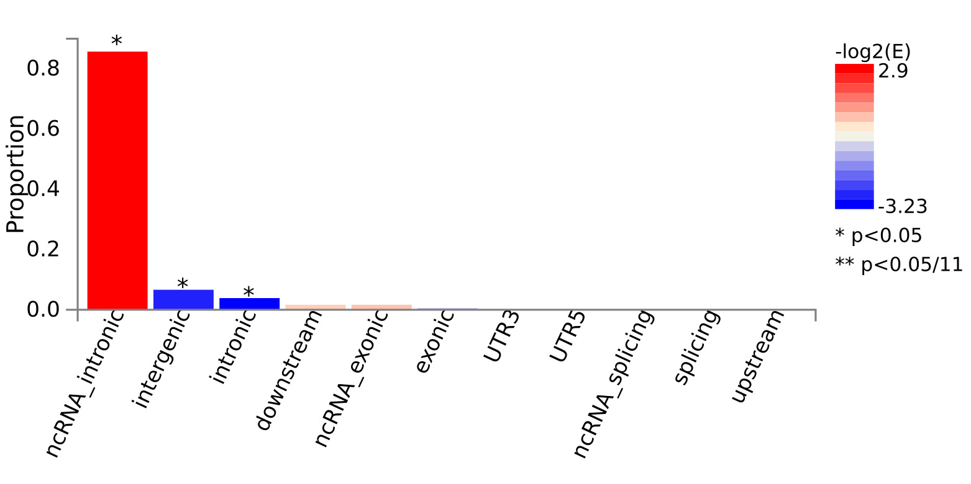
Figure S3. Functional effect of pleiotropic SNPs on genes (BC and HF) (This is a histogram of the number of SNPS for each gene function. * represents significance of 0.05; ** represents significance level after multiplicity correction)

Figure S4
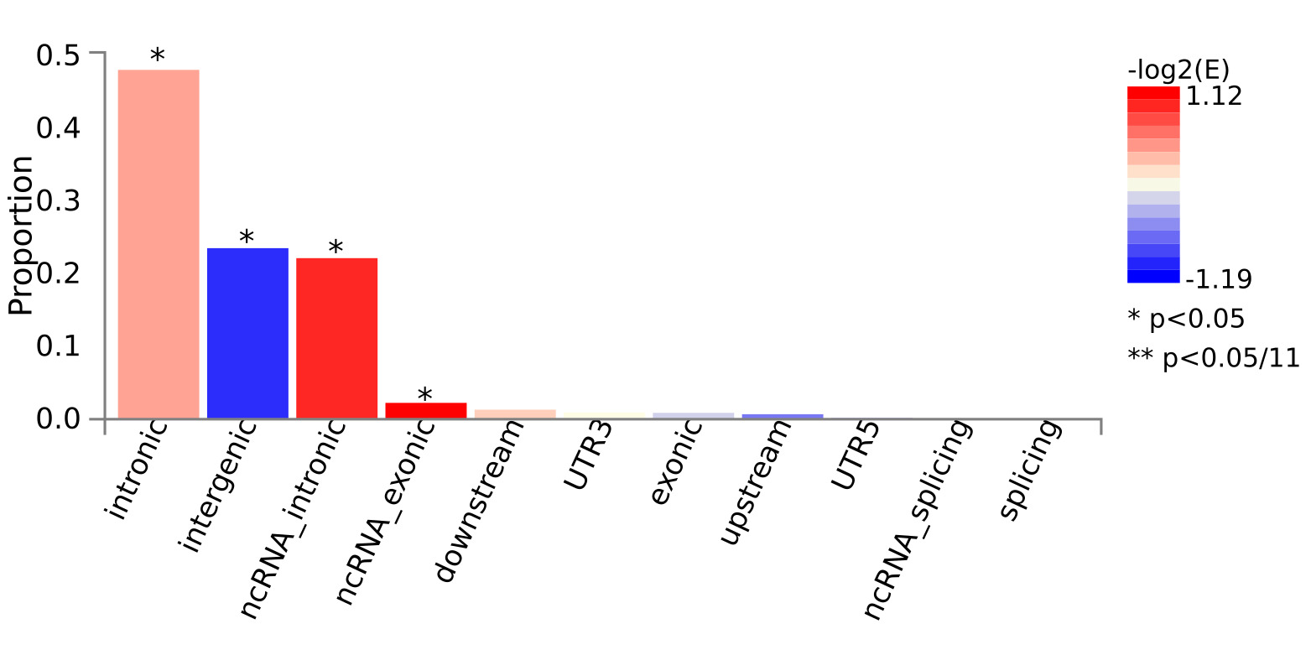
Figure S4. Functional effects of pleiotropic SNPs on genes (EC and HF) (This is a histogram of the number of SNPS for each gene function. * represents significance of 0.05; ** represents significance level after multiplicity correction)

Figure S5
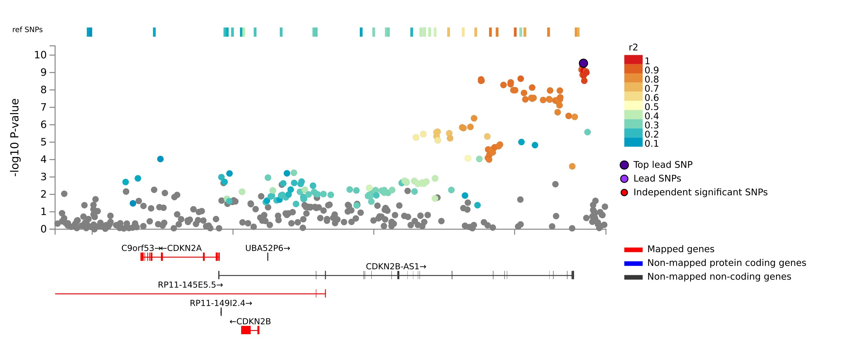
Figure S5. Regional plot of the pleiotropic locus (rs10757277). Purple dots indicate the strongest association SNP (Lead SNP). The main purpose of this plot is to compare the strength of the association signal between SNPS within the region. The red line represents the location of the baseline coverage

Figure S6 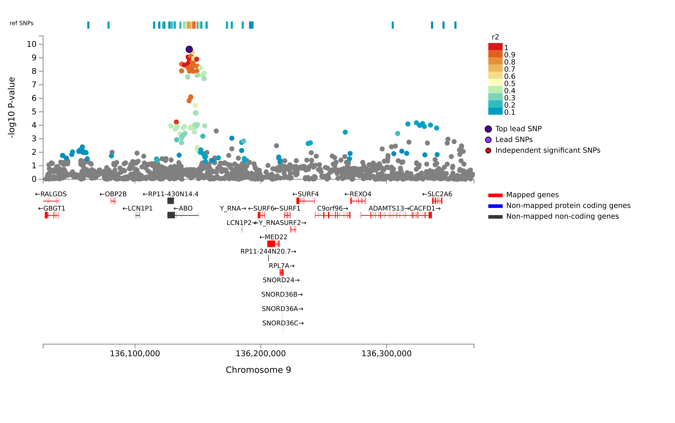Figure S6. Regional plot of the pleiotropic locus (rs543968) purple dots are the SNP with the strongest association (Lead SNP). The main purpose of this plot is to compare the strength of association signals between SNPS within this region. The red line represents the location of the baseline coverage.
Figure S7
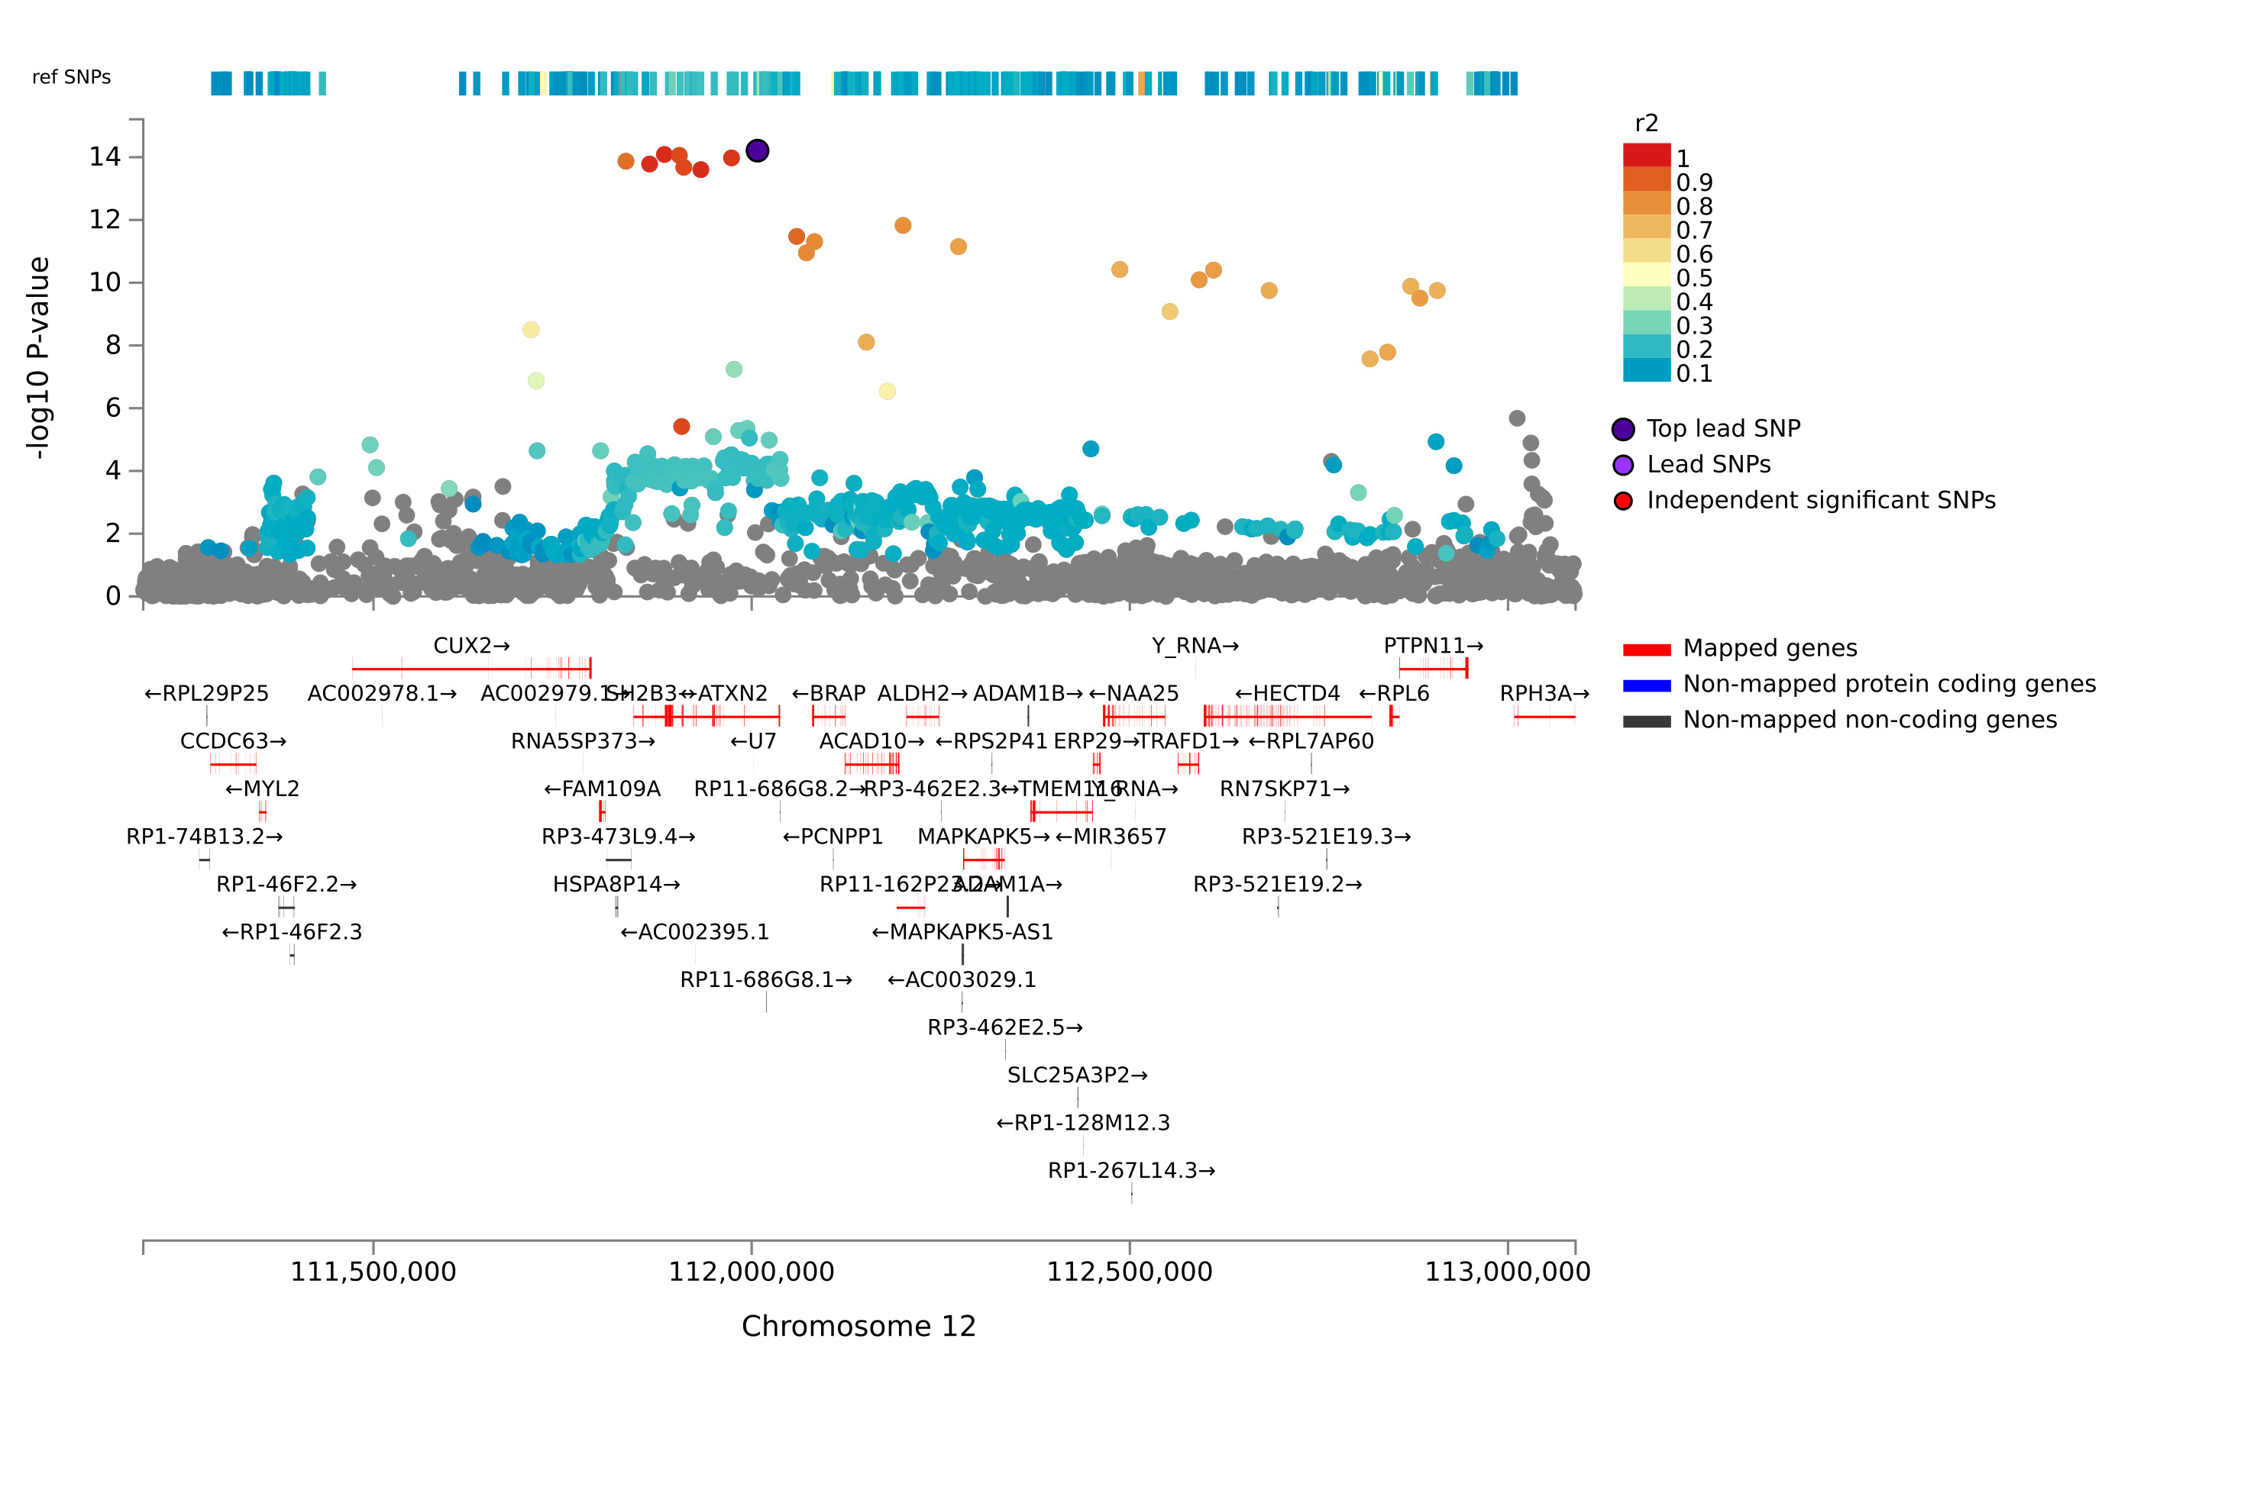
Figure S7. Regional plot of the pleiotropic locus (rs653178) Purple dots are the SNP with the strongest association (Lead SNP). The main purpose of this plot is to compare the strength of the association signal between SNPS within this region. The red line represents the location of the baseline coverage.

Figure S8
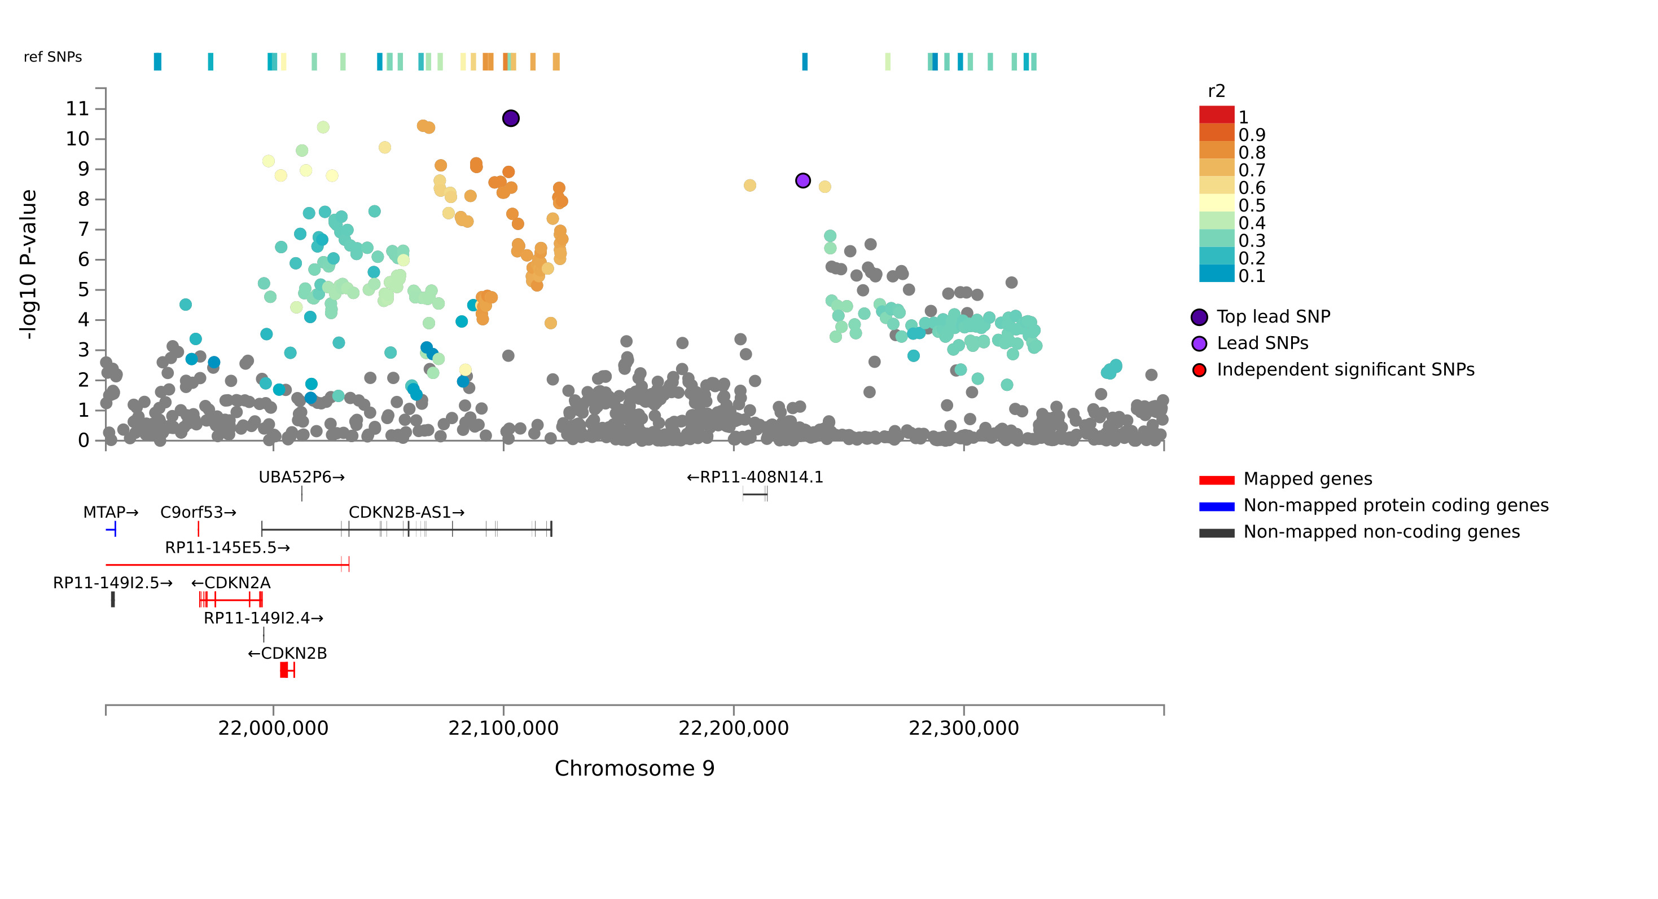
Figure S8. Regional plot of pleiotropic locus (rs1537372) Purple dots are the SNP with the strongest association (Lead SNP). The main purpose of this plot is to compare the strength of association signals between SNPS in this region. The red line represents the location of the baseline coverage.

Figure S9
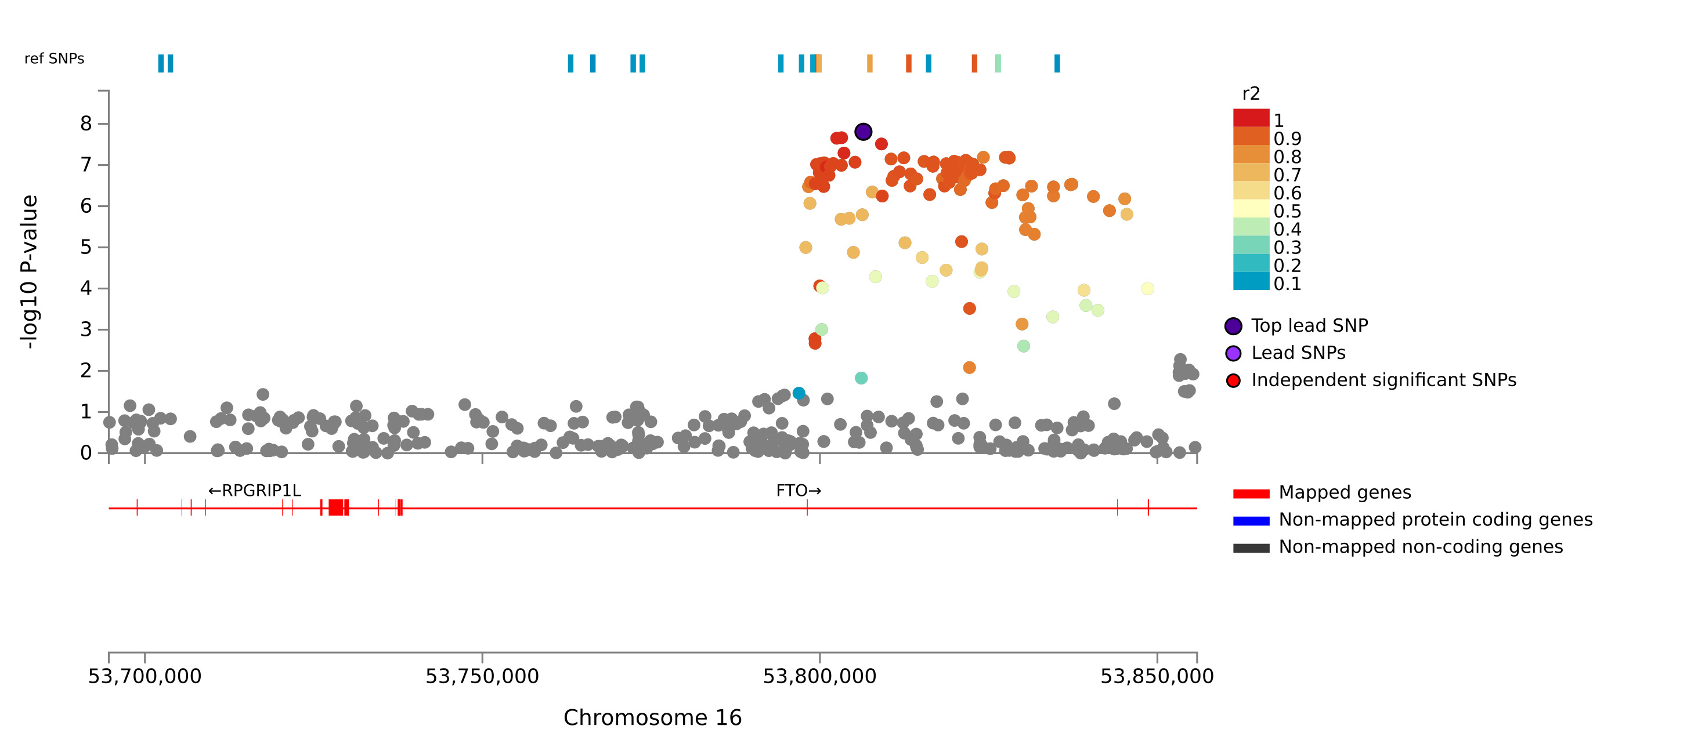
Figure S9. Regional plot of the pleiotropic locus (rs56094641) Purple dots indicate the strongest association SNP (Lead SNP). The main purpose of this plot is to compare the strength of association signals between SNPS in this region. The red line represents the location of the baseline coverage.

Figure S10
Figure S10. MAGMA Tissue-specific Analysis Based on genome-wide pleiotropy. (A) BC and HF, (B) EC and HF,(C) KC and HF. 54 different tissues are shown on the abscismal, and the significance level of tissue-specific enrichment (-log10 (P)) is shown on the ordinate.

Figure S11
Figure S11. Q-Q plot of (A) BC and HF, (B) EC and HF,(C) KC and HF MAGMA gene analysis.

Figure S12
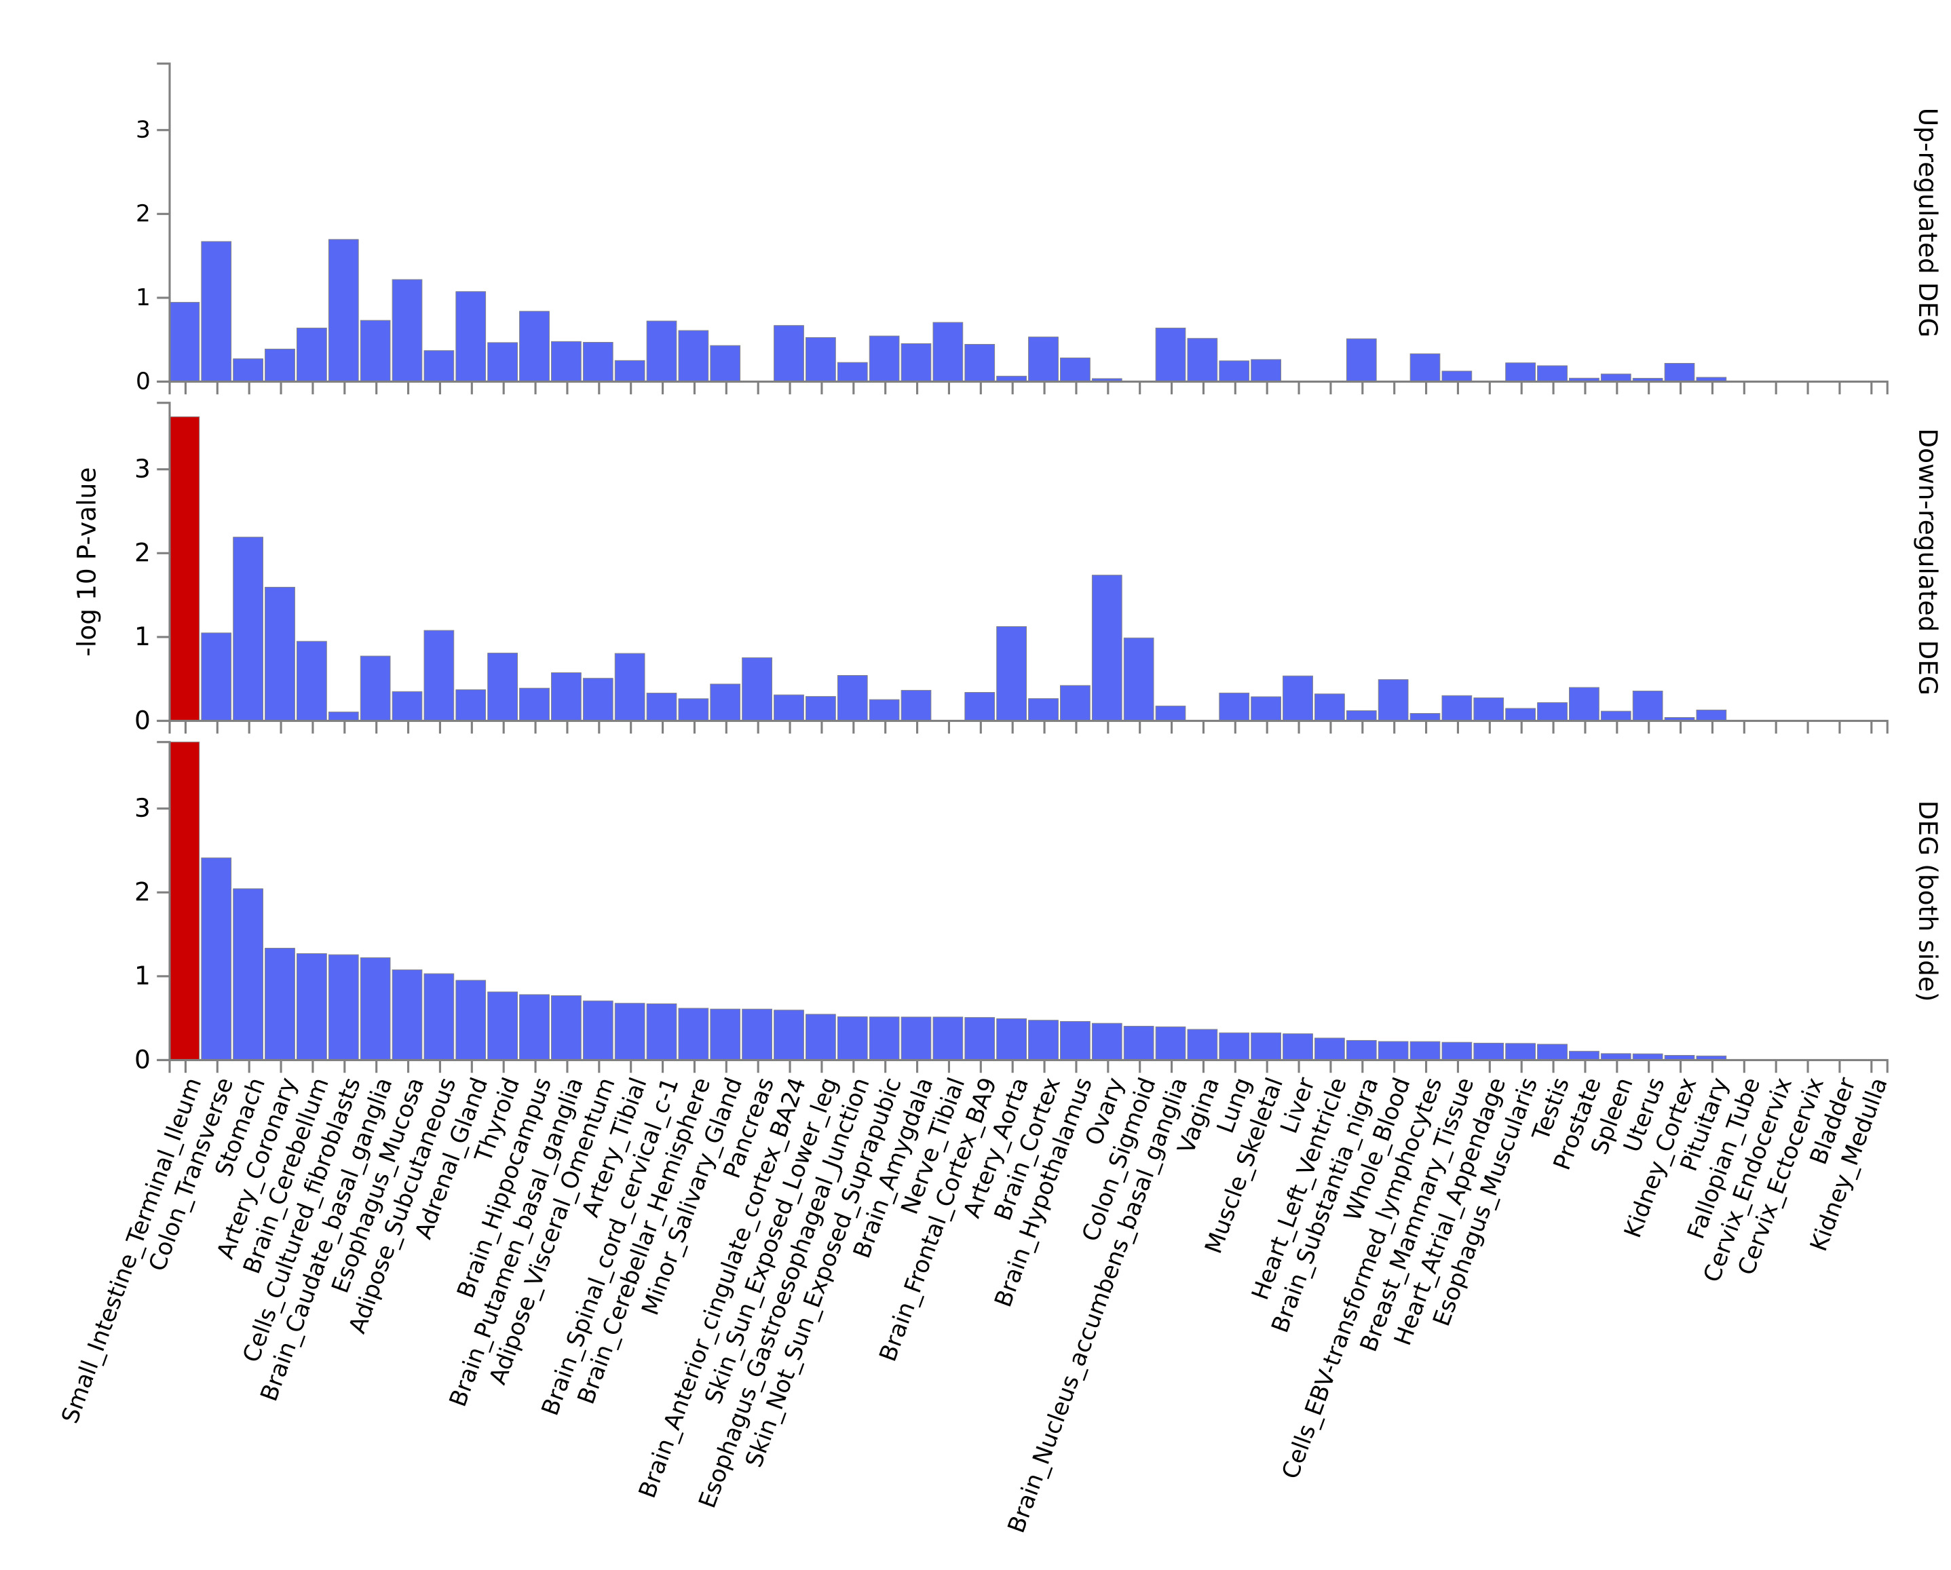
Figure S12. Enrichment of pleiotropic genes (Magma) in different tissues; The abscismal is 54 different tissues, and the ordinate is the significance level of tissue-specific enrichment (-log10 (P)). Red represents tissues that are significant after multiple correction.

Figure S13
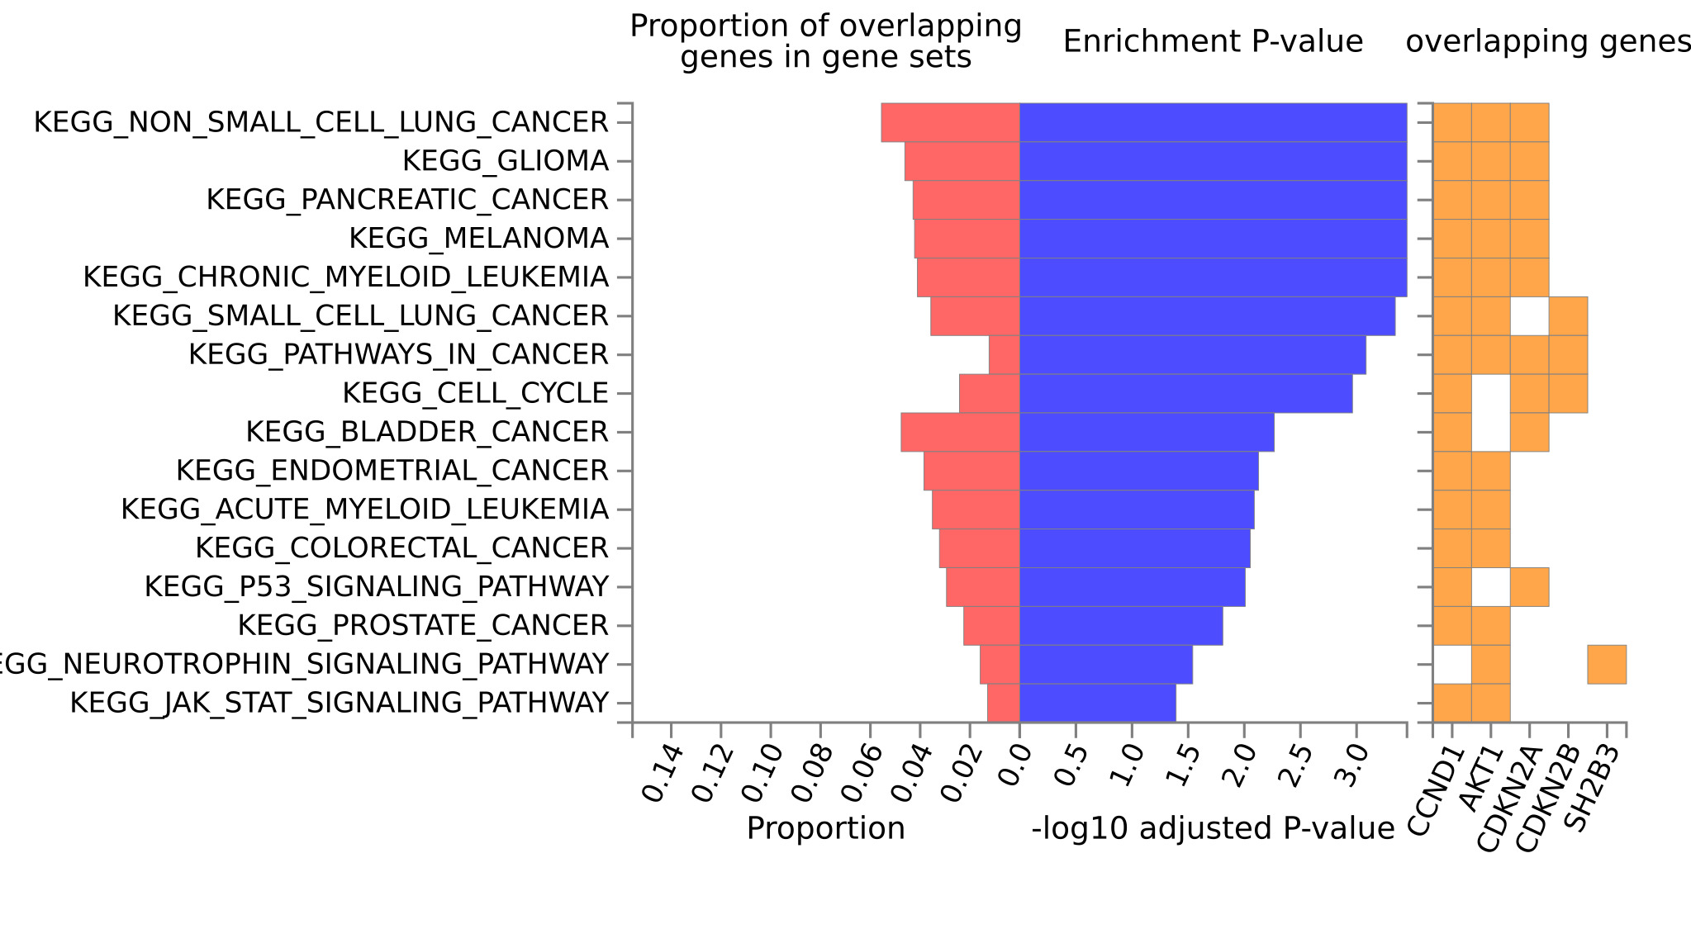
Figure S13. Enrichment of pleiotropy genes (Magma) in pathways (KEGG). The abscissa includes the proportion of genes in the gene set, the significance level and the information of overlapping genes. The ordinate is the different gene sets.

Figure S14
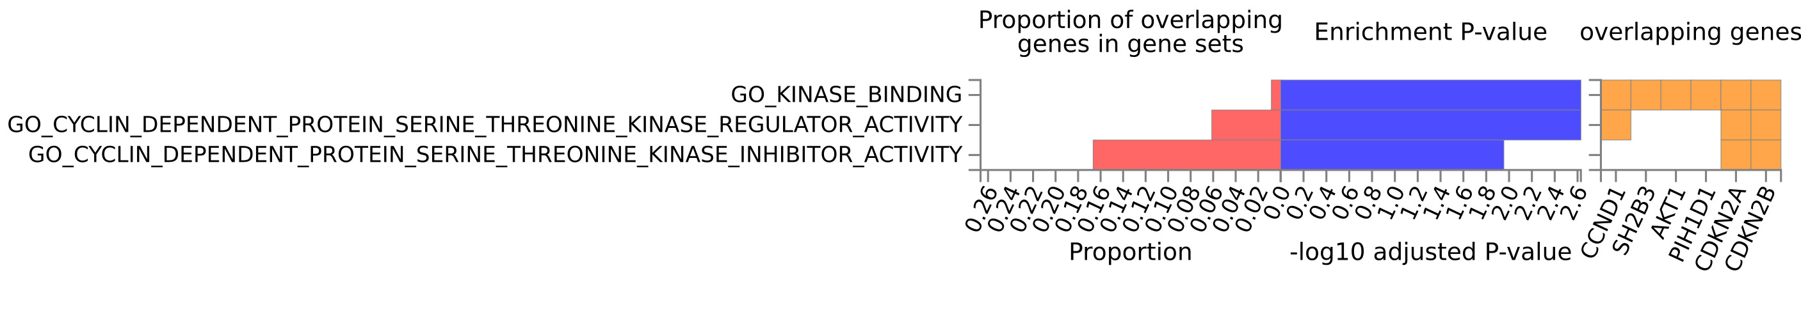
Figure S14. Enrichment of pleiotropy genes (Magma) in the Biological Process(BP) pathway. The abscissa includes the proportion of genes in the gene set. The significance level and the information of overlapping genes. The ordinate is the different gene sets.

Figure S15
Figure S15. Enrichment of pleiotropy genes (Magma) in the Molecular Function (MF) pathway. The abscissa includes information on the proportion of genes in the gene set, significance level, and overlapping genes, respectively. The ordinate is the different gene sets.

Figure S16
Figure S16. Protein interaction network analysis (PPI) of pleiotropy genes (Magma).

Figure S17
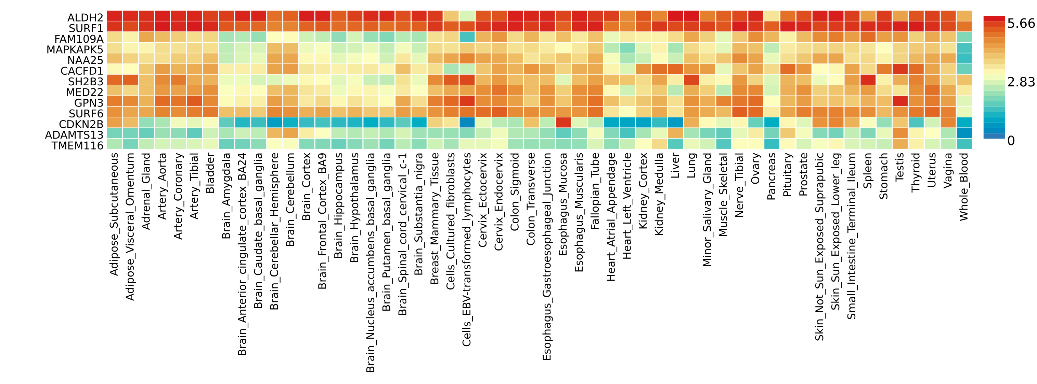
Figure S17. Expression of pleiotropy genes (eQTL) in different tissues: 54 different GTEx tissues on the abscordinate and different genes on the ordinate; The color and depth of squares represent the strength of expression; Red indicates high expression and blue indicates low expression.

Figure S18
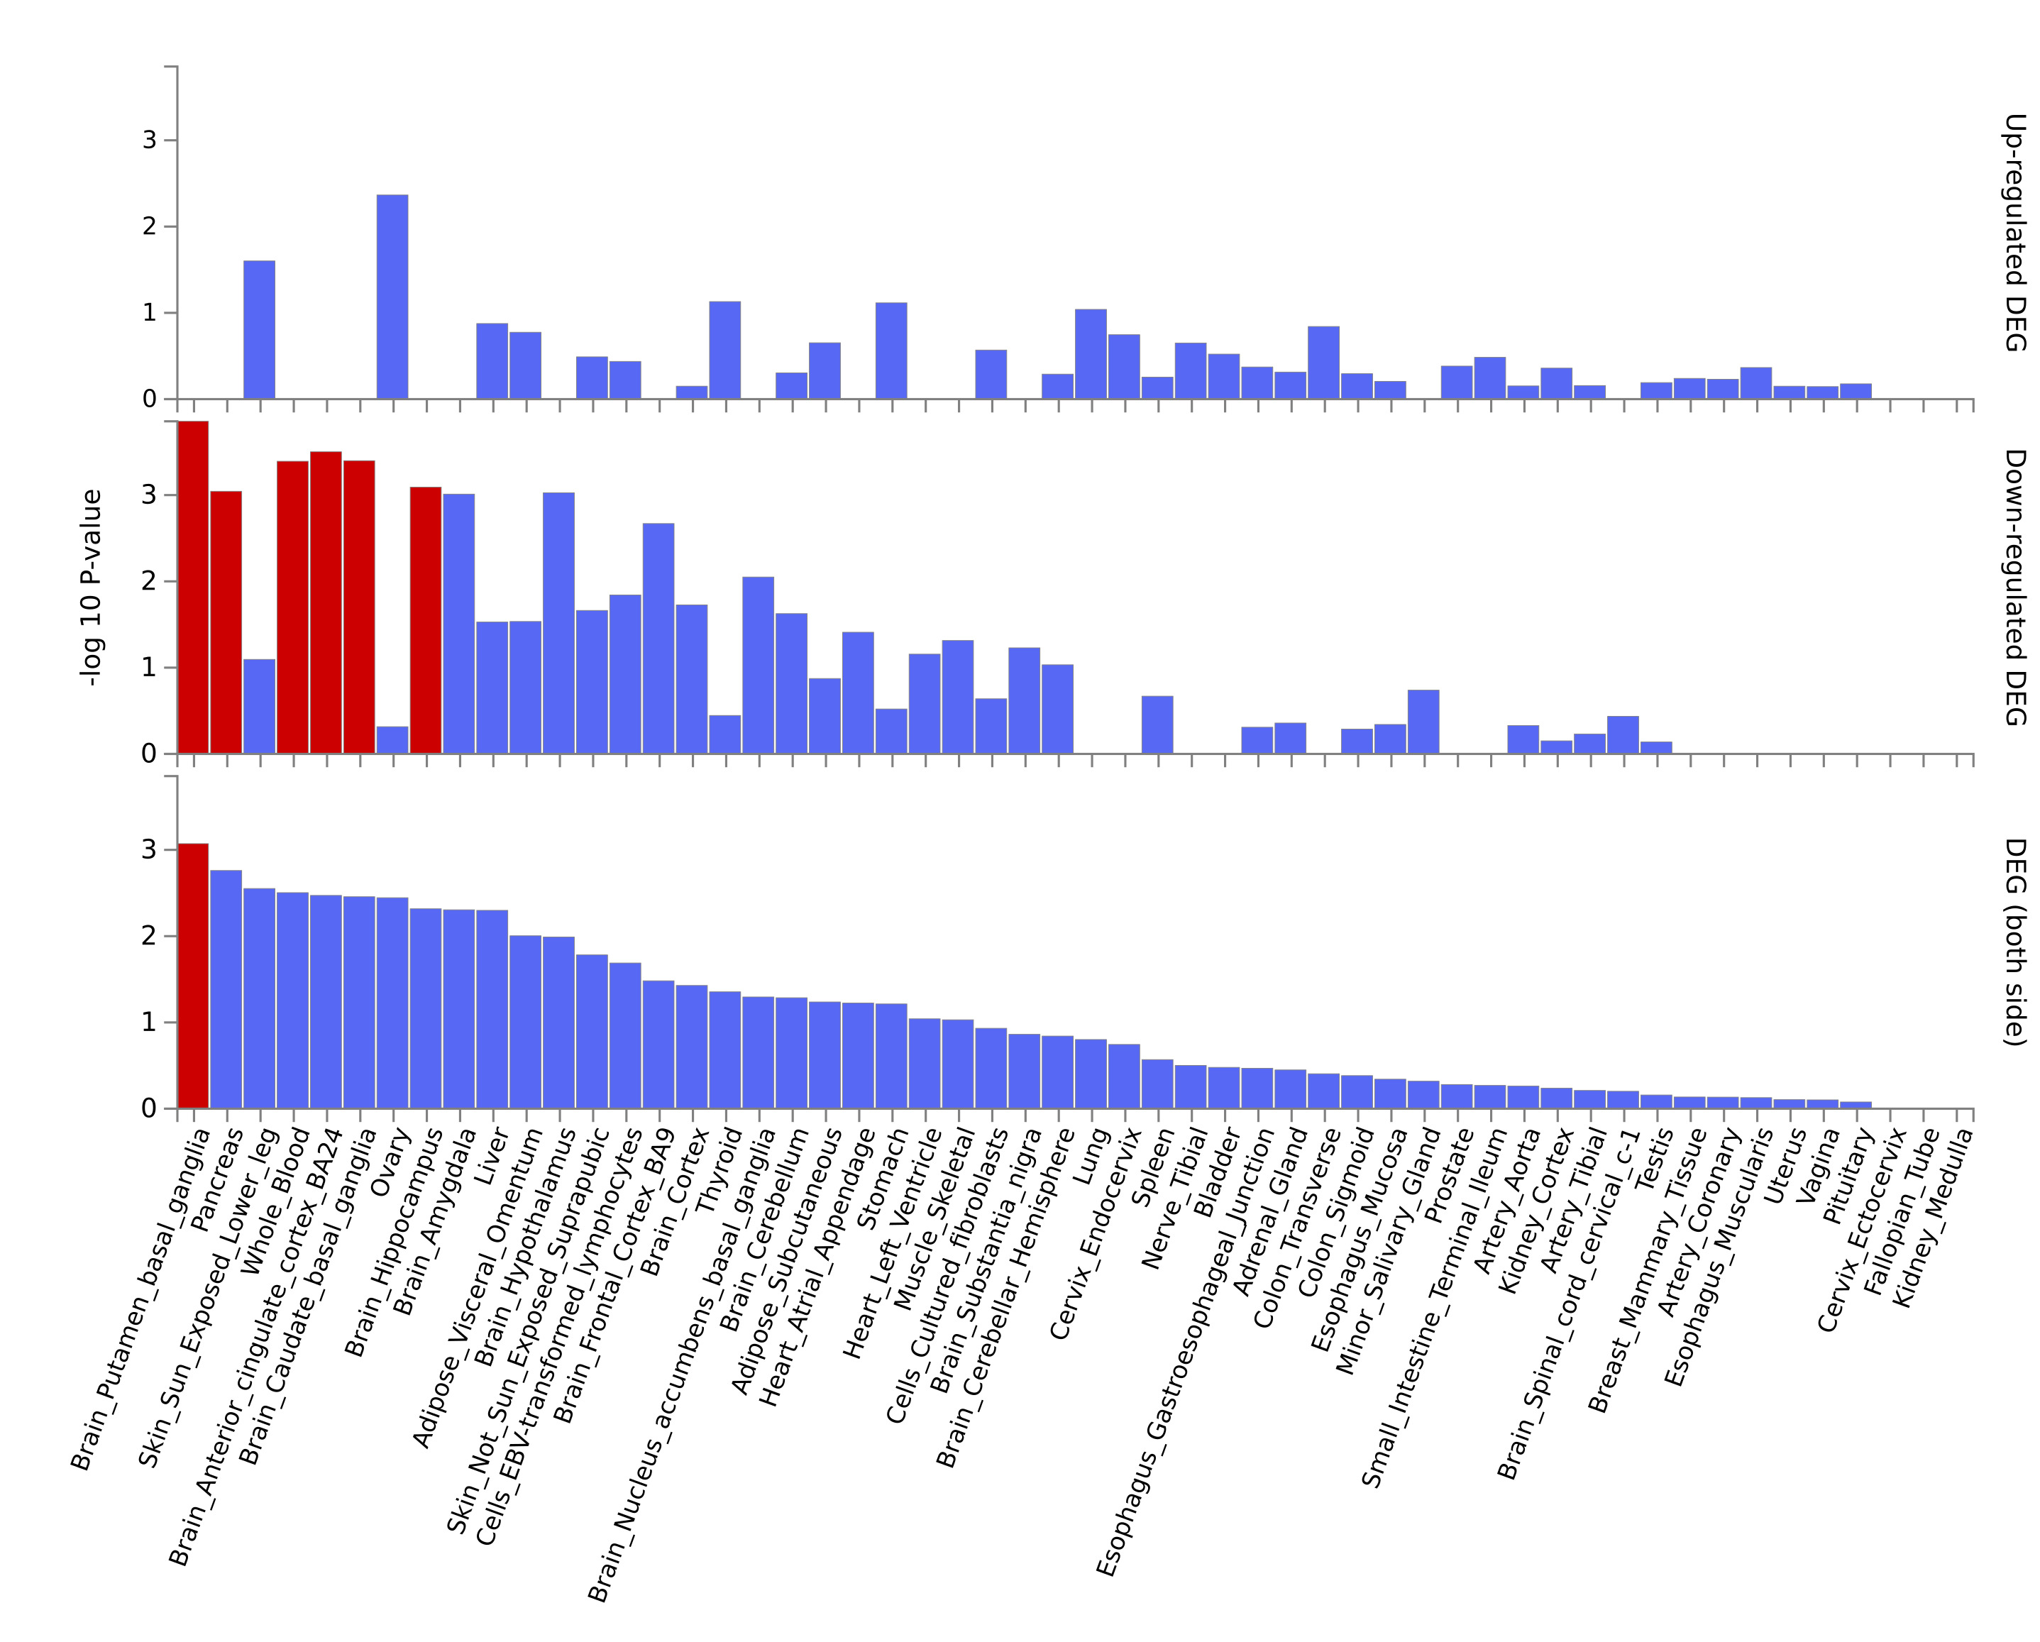
Figure S18. Tissue enrichment analysis of pleiotropic genes (eQTL). 54 different tissues are shown on the abscismal, and the significance level of tissue-specific enrichment (-log10 (P)) is shown on the ordinate. Red represents tissues that are significant after multiple correction.

