Figure. S1 Gene expression level of 11 IRGs contained in IRGPI (based on Oncomine database).
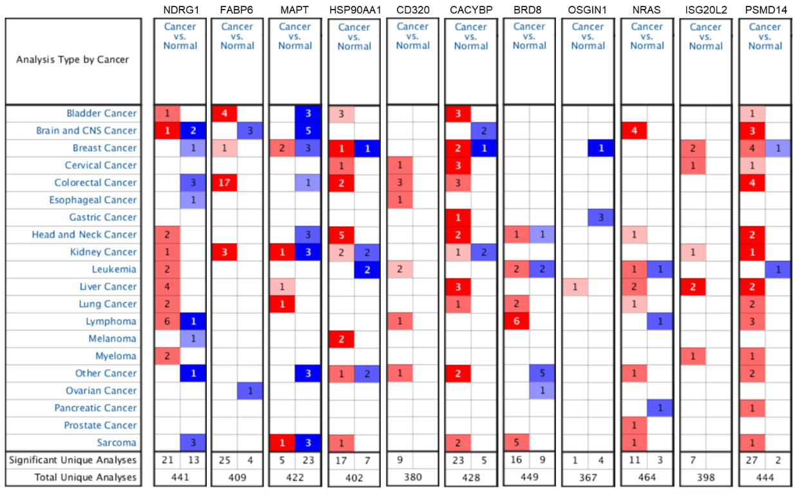

Figure. S2 The relationship between the IRGPI and tumor mutation burden (TMB). Mutation profile of the high-risk group (A), the low-risk group (B). The co-occurence and exclusive associations across mutant genes in the high-risk group (C), the low-risk group (D). (E) The relationship between the IRGPI and TMB. (F) The relationship between TMB and OS.

Table. S1 Patient demographics and clinical characteristics of the included datasets.
Variables |  | Group | Entire TCGA cohort (n = 365) | TCGA training set (n=183) | TCGA validating set (n=182) | GSE14520 cohort (n = 221)
Survival time(days) |  |  | 788±37.81 | 828±54.23 | 748±52.67 | 1213±43.55
Vital status |  | Alive | 239 (65%) | 118 (64%) | 121 (66%) | 136 (62%)
 |  | Dead | 126 (35%) | 65 (36%) | 61 (34%) | 85 (38%)
Gender |  | Female | 119 (33%) | 60 (33%) | 59 (32%) | 30 (14%)
 |  | Male | 246 (67%) | 123 (67%) | 123 (68%) | 191 (86%)
Age |  | <=65 | 227 (62%) | 122 (67%) | 105 (58%) | 200 (90%)
 |  | >65 | 138 (38%) | 61 (33%） | 77 (42%） | 21 (10%)
Cancer status |  | Tumor free | 231 (63%) | 113 (62%) | 118 (65%)
 |  | With tumor | 108 (30%) | 59 (32%) | 49 (27%)
 |  | Unknown | 26 (7%) | 11 (6%) | 15 (8%)
Tumor grade |  | G1 | 55 (15%) | 26 (14%) | 29 (16%)
 |  | G2 | 175 (48%) | 90 (49%) | 85 (47%)
 |  | G3 | 118 (32%) | 60 (33%) | 58 (32%）
 |  | G4 | 12 (3%) | 3 (2%) | 9 (5%)
 |  | GX | 5 (1%) | 4 (2%) | 1 (1%)
Pathological stage |  | Stage I | 170 (47%) | 86 (47%） | 84 (46%)
 |  | Stage II | 84 (23%) | 44 (24%) | 40 (22%)
 |  | Stage III | 83 (23%) | 35 (19%) | 48 (26%)
 |  | Stage IV | 4 (1%) | 4 (2%) | 0 (0%）
 |  | Unknown | 24 (7%) | 14 (8%) | 10 (5%)
T stage |  | T1 | 180 (49%) | 91 (50%） | 89 (49%）
 |  | T2 | 91 (25%) | 49 (27%) | 42 (23%)
 |  | T3 | 78 (21%) | 34 (19%) | 44 (24%）
 |  | T4 | 13 (4%) | 7 (4%) | 6 (3%)
 |  | TX | 3 (1%) | 2 (1%) | 1 (1%)
M stage |  | M0 | 263 (72%) | 130 (71%） | 133 (73%)
 |  | M1 | 3 (1%) | 3 (2%) | 0 (0%)
 |  | MX | 99 (27%) | 50 (27%） | 49 (27%)
N stage |  | N0 | 248 (68%) | 126 (69%) | 122 (67%)
 |  | N1 | 4 (1%) | 2 (1%) | 2 (1%)
 |  | NX | 113 (31%） | 58 (32%) | 55 (30%)
ALT |  | <=50U/L |  |  |  | 130 (59%)
 |  | >50U/L |  |  |  | 91 (41%)
Main tumor size |  | <=5 cm |  |  |  | 140 (63%)
 |  | >5 cm |  |  |  | 80 (36%)
 |  | Unknown |  |  |  | 1 (0.5%)
Multinodular |  | No |  |  |  | 176 (80%)
 |  | Yes |  |  |  | 45 (20%)
Cirrhosis |  | No |  |  |  | 18 (8%)
 |  | Yes |  |  |  | 203 (92%)
TNM staging |  | I |  |  |  | 93 (42%)
 |  | II |  |  |  | 77 (35%)
 |  | III |  |  |  | 49 (22%)
 |  | Unknown |  |  |  | 2 (1%）
BCLC staging |  | 0 |  |  |  | 20 (9%)
 |  | A |  |  |  | 148 (67%)
 |  | B |  |  |  | 22 (10%)
 |  | C |  |  |  | 29 (13%)
 |  | Unknown |  |  |  | 2 (1%)
CLIP staging |  | 0 |  |  |  | 97 (44%）
 |  | 1 |  |  |  | 74 (33%)
 |  | 2 |  |  |  | 35 (16%)
 |  | 3 |  |  |  | 9 (4%)
 |  | 4 |  |  |  | 3 (1%)
 |  | 5 |  |  |  | 1 (0.5%)
 |  | Unknown |  |  |  | 2 (1%)
AFP |  | <=300ng/ml |  |  |  | 118 (53%)
 |  | >300ng/ml |  |  |  | 100 (45%)
 |  | Unknown |  |  |  | 3 (1%)

