Extended Data
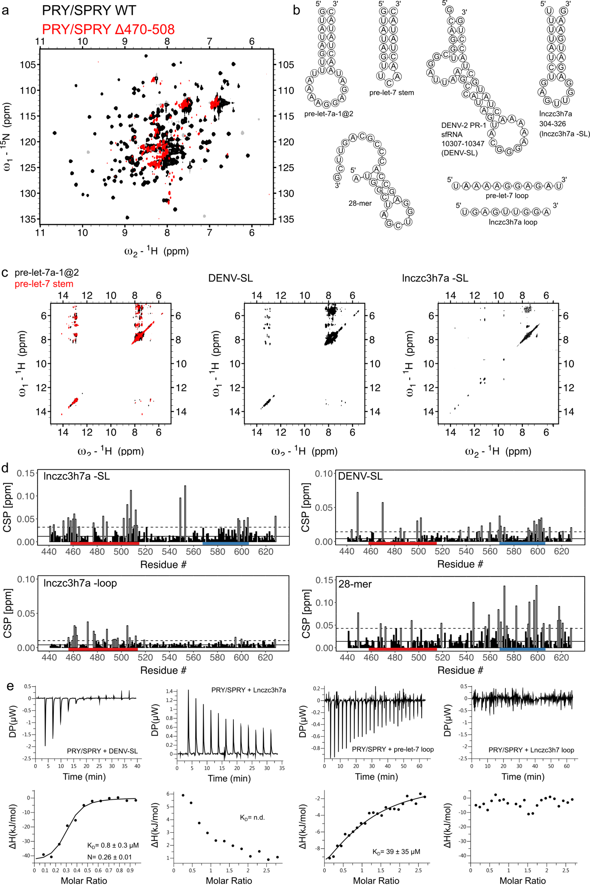
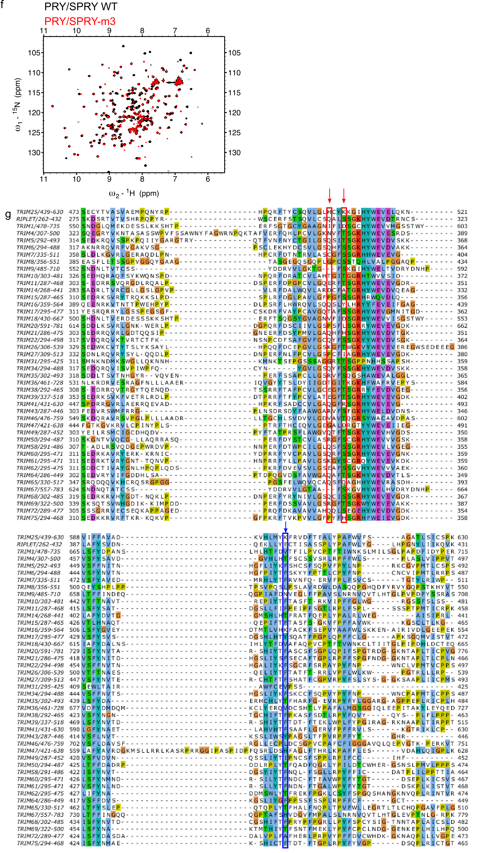
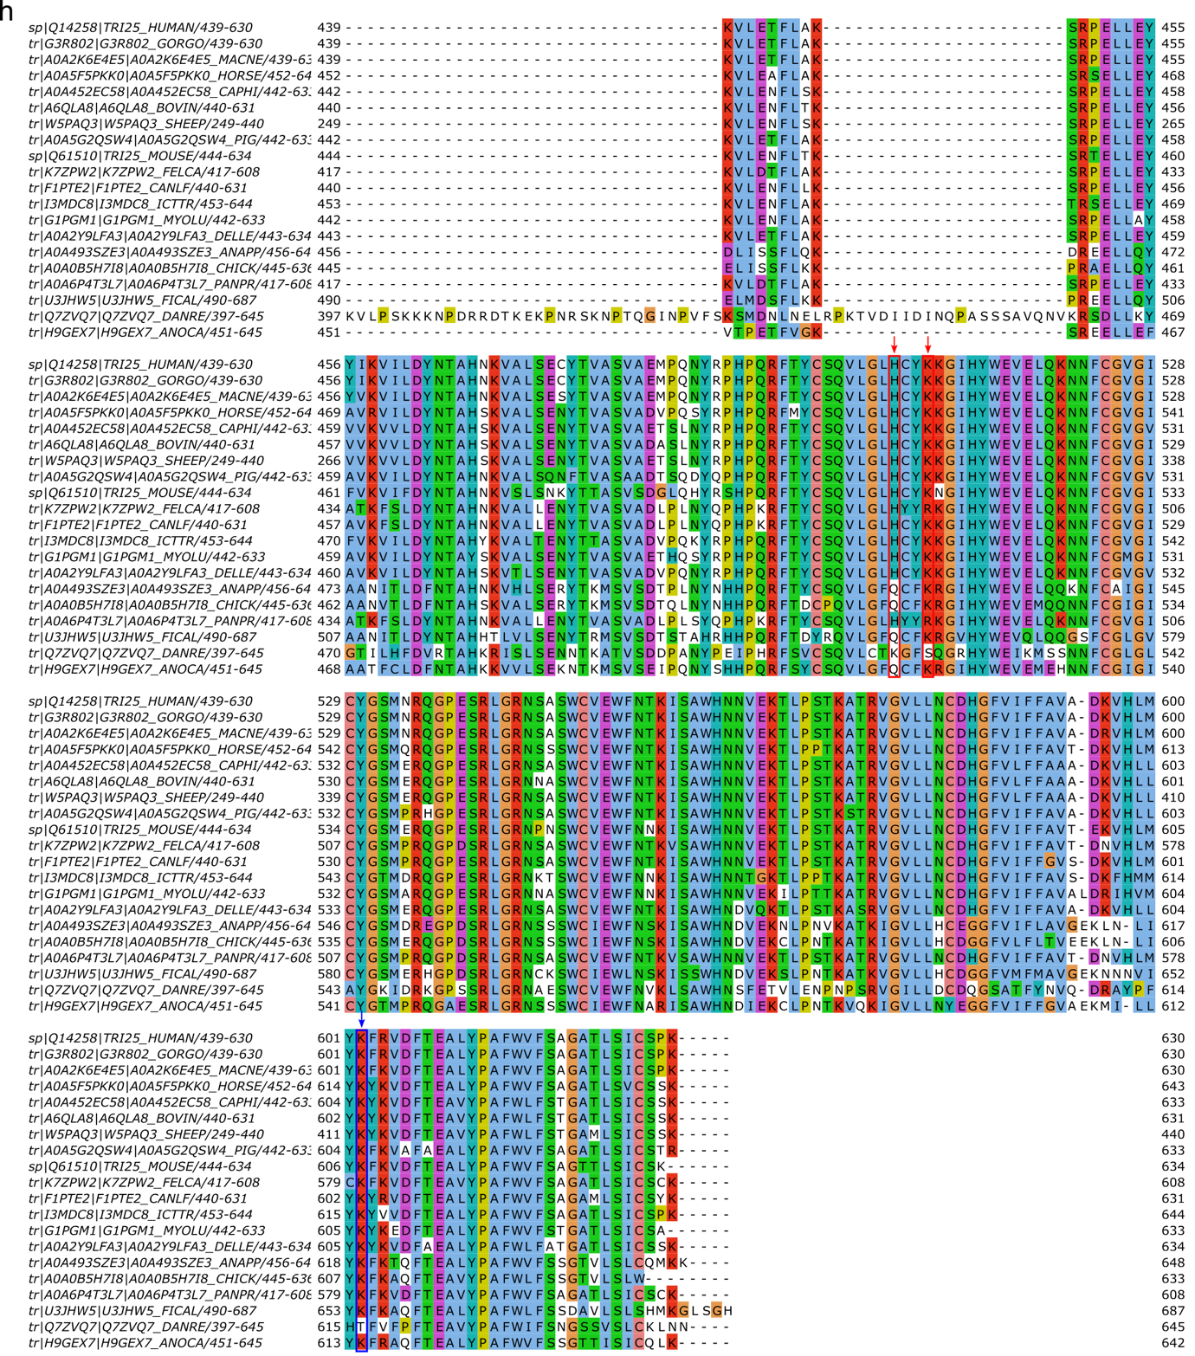

Extended Data Figure 1 (a) The ¹H/¹⁵N-HSQC of the previously described Δ470-508 deletion in the PRY/SPRY domain (ΔRBD by Choudhury et al. 2017¹) shows that the deletion construct is unfolded and prone to aggregation. (b) Predicted structures of the RNAs used in this study. All RNA structures were predicted using the RNAfold webserver.⁴⁸ (c) The observation of peaks in the imino region (10-15 ppm) in ¹H/¹H-2D-NOESYs confirm that stem-loops used in this study form double-stranded regions. Overlay of the NOESYs of pre-let-7a-1@2 and the truncated pre-let-7 stem show very similar imino-regions indicating that both constructs form double-stranded RNA with similar structures. (d) NMR titrations with different RNAs: The Dengue virus subgenomic stem-loop DENV-SL, the long non-coding RNA lnczc3h7a and a 28-mer duplex RNA show CSPs in binding site 1 and 2. The loop region of lnczc3h7a binds selectively to binding site 1 on the PRY/SPRY, similar to pre-let-7-loop, but with weaker affinity. (e) Binding isotherms of TRIM25 PRY/SPRY titrated by DENV-SL, lnczc3h7a, pre-let-7-loop and lnczc3h7a-loop. The value shown in the figure is the average of the different replicates. All experimental setups and ITC measurements including replicates can be found in Supplementary Table 1. (f) The ¹H/¹⁵N-HSQC of the PRY/SPRY-m3 described here is very similar to the wildtype with only minor chemical shift perturbations of peaks corresponding to residues neighboring the mutation site. This indicates that structural changes are small and local. (g) Global alignment of the PRY/SPRY domain of all human TRIM proteins belonging to group IV⁹ and Riplet (RN135). The amino acid colour code used is the Clustal X colour scheme from Jalview, where hydrophobic residues are shown in blue, positive charges in red, negative charges in magenta, polar residues in green, cysteines in pink, glycines in orange, prolines in yellow and aromatic residues in cyan. The red arrows show the conservation of residues H505 and K508, belonging to binding site 1, and the blue arrow shows the conservation of K602, belonging to binding site 2. (h) Global alignment of the PRY/SPRY domain of TRIM25 proteins from 20 different species obtained from ENSEMBL (See material and methods for more information and Supplementary File Table 2 for details regarding the species). Conservation of sequence features of the PRY/SPRY domains within TRIM25 from different species. Residues responsible for RNA binding are shown in red or blue, depending on the binding site to which they belong. The height of the stack of letters at each position indicates the degree of conservation.

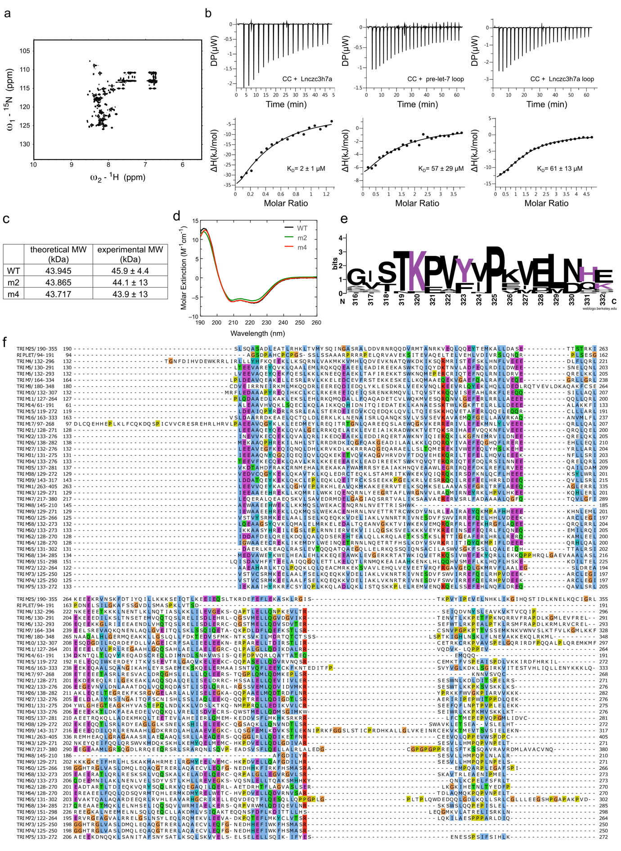
Extended Data Figure 2 (a) The ¹H/¹⁵N-HSQC spectrum of the CC domain shows only peaks corresponding to residues of the flexible termini due to its elongated conformation and large size. Therefore, NMR is not suitable for identifying RNA binding residues. (b) Binding isotherms of TRIM25 CC domain titrated with lnczc3h7a, pre-let-7 loop and lnczc3h7a-loop. The value shown in the figure is the average of all replicates. All experimental setups and ITC measurements including replicates are listed in Supplementary Table 1. (c) SEC-MALS molecular weight determination for the CC WT domain and its mutants. These results show that CC-WT and mutants are dimers in solution. (d) Circular dichroism spectroscopy curves for CC-WT and mutants showing no prominent changes in secondary structure content upon mutation. (e) Conservation of sequence features of residues within the CC domain peptide detected as RNA binding by CLIR-MS/MS experiments of TRIM25 from 18 different species (See material and methods for more information and Supplementary File Table 2 for details regarding the species). Residues responsible for RNA binding are shown in purple. The height of the letter stack at each position indicates the degree of conservation. (f) Global alignment of the CC domain of all human TRIM proteins belonging to group IV⁹ and Riplet (RN135). The amino acid colour code used is the Clustal X colour scheme from Jalview, where hydrophobic residues are shown in blue, positive charges in red, negative charges in magenta, polar residues in green, cysteines in pink, glycines in orange, prolines in yellow and aromatic residues in cyan.

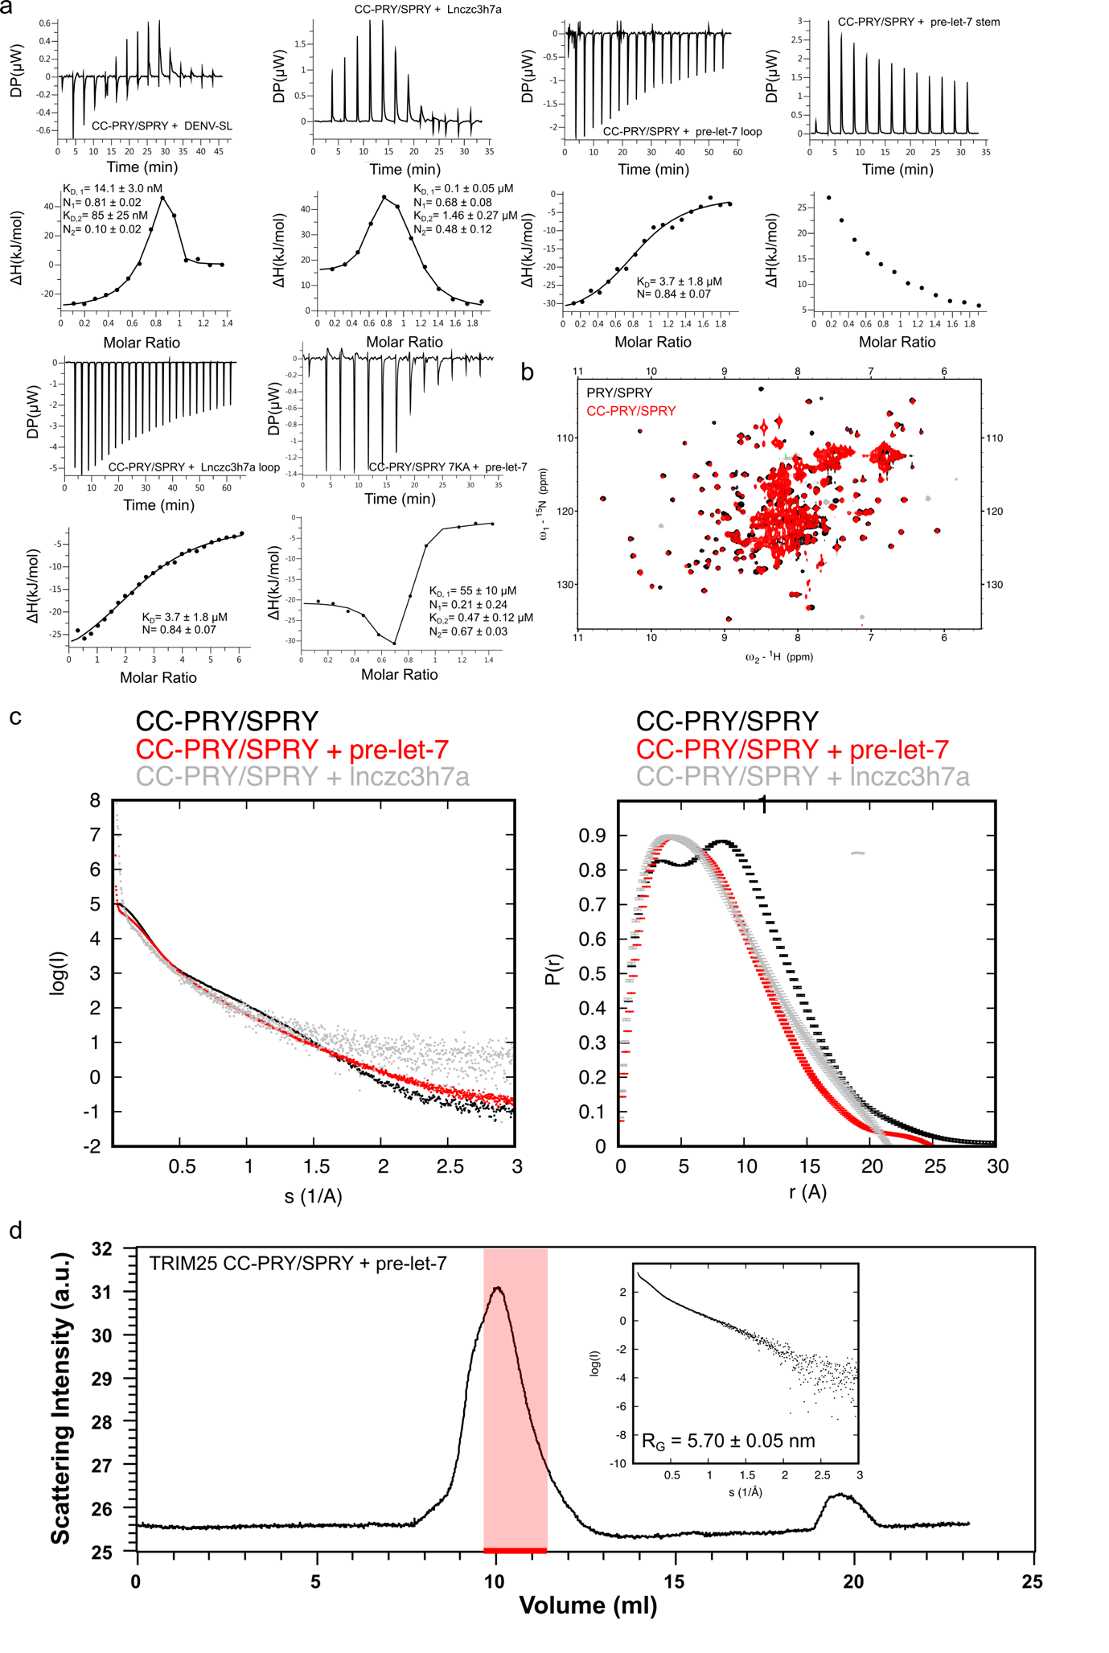
Extended Data Figure 3 (a) Binding isotherms of TRIM25 CC-PRY/SPRY domain titrated by DENV-SL, lnczc3h7a, pre-let-7 loop, pre-let-7 stem and lnczc3h7a loop and for TRIM25 CC-PRY/SPRY 7KA titrated by pre-let-7. The value shown in the figure is the average of all replicates. All experimental setups and the results of all ITC measurements including replicates can be found in Supplementary Table 1. (b) Overlay of the ¹H,¹⁵N-HSQC spectra of TRIM25 PRY/SPRY and CC-PRY/SPRY shows excellent overlap for the dispersed peaks corresponding to folded regions. However, the signal intensity for these peaks is much weaker for CC-PRY/SPRY than for PRY/SPRY at the same concentration. Together with the absence of CSPs, this suggests that only the unbound state of PRY/SPRY is observed, while the state of PRY/SPRY bound to CC is not. (c) Binding of lnczc3h7a-SL leads to a similar reduction in radius of gyration and similar changes in the pairwise distribution function in SAXS as pre-let-7, indicating that stem-loop binding generally leads to the formation of a more compact complex, where the PRYSPRY is bound via RNA to the CC domain. (d) This is also confirmed by SEC-SAXS data showing that this reduction is not due to the presence of free RNA or aggregation artefacts.

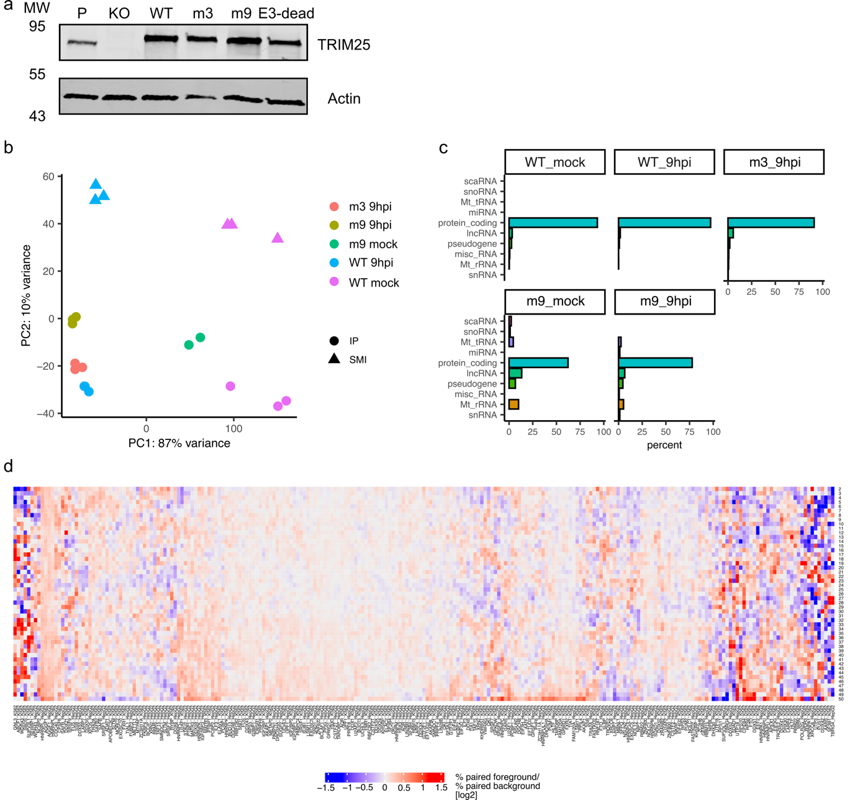
Extended Data Figure 4 (a) Western blot showing the parental cell line (P, HEK293), TRIM25 knockout (KO) and TRIM25 KO cells rescued with TRIM25-WT, TRIM25-m3, TRIM25-m9 and TRIM25-E3 ligase dead mutants. The presence or absence of protein bands in these lanes highlights the successful rescue by the different mutants and their effect on protein expression. (b) PCA of the different iCLIP2 sequencing data. (c) Bar plots showing the biotypes of RNAs identified by iCLIP2. (d) Percentage of paired and unpaired sequences across binding sites from the eCLIP bed files downloaded from the ENCODE database.

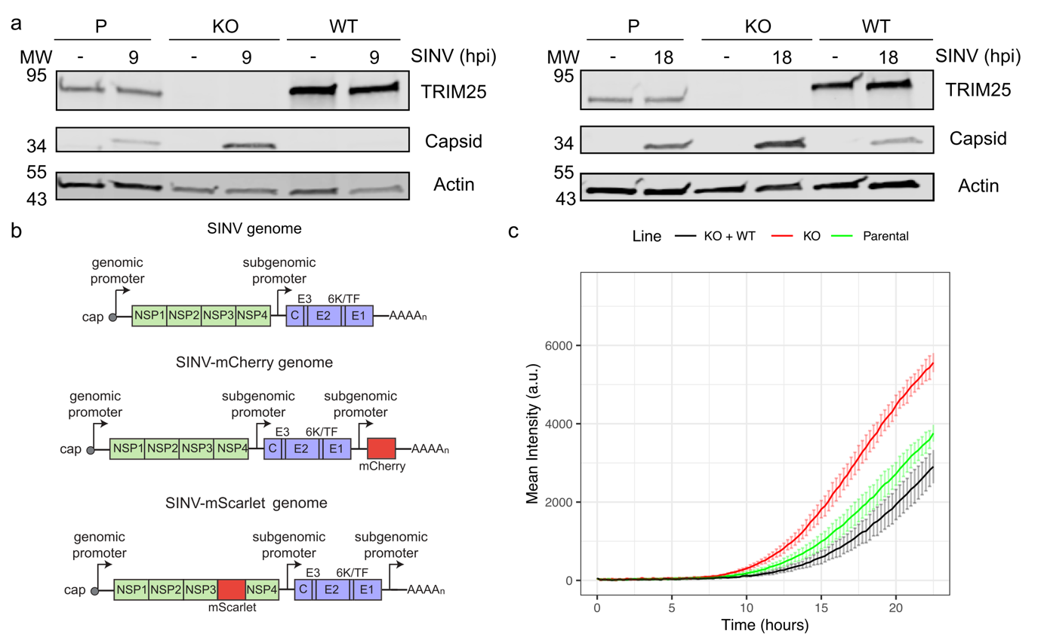
Extended Data Figure 5 (a) Western blot analysis of SINV capsid protein accumulation in displaying the parental cell line (P, HEK293), TRIM25 knockout (KO), and the cell line with protein rescue using TRIM25-WT infected with SINV for 9 or 18 h. (b) Schematic representation of SINV and chimeric SINV-mCherry and SINV-nsp3-scarlet genomes. (c) Red fluorescence signal in the parental cell line (P, HEK293), the TRIM25 knockout (KO), and the cell line rescued using TRIM25-WT infected with SINV-nsp3-scarlet. Fluorescence was measured every 15 min in a plate reader with atmospheric control (5% CO₂ and 37C). The fluorescence is shown as the mean ± SD of six independent infections.

