GENOMIC PREDICTIONS FOR FILLET YIELD AND FIRMNESS IN RAINBOW TROUT USING REDUCED-DENSITY SNP PANELS

Rafet Al-Tobasei¹, Ali Ali², Andre L. S. Garcia³, Daniela Lourenco³, Tim Leeds⁴, and Mohamed Salem²

¹Computational Science Program, Middle Tennessee State University, Murfreesboro, TN 37132, U.S.
²Department of Animal and Avian Sciences, University of Maryland, College Park, Maryland 20742 U.S.
³Department of Animal and Dairy Science, University of Georgia, Athens, GA 30602, U.S.
⁴National Center for Cool and Cold Water Aquaculture, Agricultural Research Service, United States Department of Agriculture Kearneysville, WV, U.S.

Corresponding author: Mohamed Salem
E-mail: mosalem@umd.edu

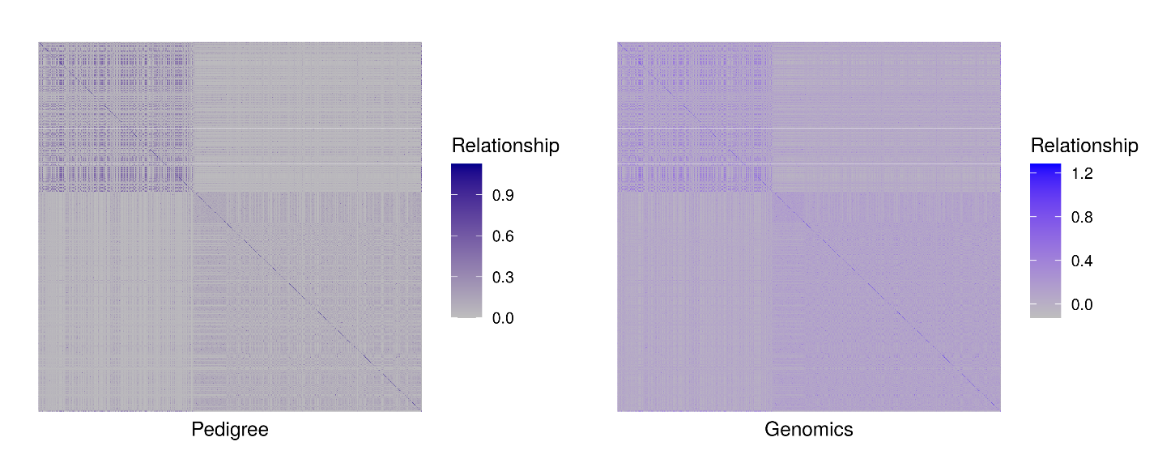
Figure S1: A heat map for Pedigree matrix (A22) and Genomic matrix (G) where the color density reflects the relationship between individuals used in this study.

Table S1: Genetic parameters of fillet yield and fillet firmness using ssGBLUP.
Phenotype | σ²_{a} (SE) | σ²_{c} (SE) | σ²_{e} (SE) | h² (SE)
Fillet yield | 1.22 (0.361) | 0.61 (0.192) | 2.67 (0.228) | 0.27 (0.073)
Fillet firmness | 2579.40 (653.13) | 84.25 (222.73) | 4049 (380.51) | 0.38 (0.082)

