Volborthite and Its Composite with g-C₃N₄ for Oxytetracycline Removal: Their Adsorption and Photocatalysis Properties

Wei Qing Wee, Lan Ching Sim¹, Kah Hon Leong, Azrina Abdul Aziz

Adsorption Kinetic Models
Four kinetic model were fitted in order to identify the most suitable model and their model is expressed by Eq. 1 – 4:
- Pseudo-first order (PFO) assumes the reaction is behaved like a first-order reaction.
- Pseudo-second order (PSO) assumes that the rate of adsorption is proportional to the available active sites on the adsorbent.
- Elovich model predict the mass and surface diffusion, as well as the activation and deactivation energy of the system.
- Intra-particle diffusion (IPD) model assumes the adsorption of solute in a solution involves mass transfer of adsorbate (film diffusion), surface diffusion, and pore diffusion.
Pseudo first-order (PFO) | $$q_{t}=q_{e}(1-\exp{(k_{1}t))}$$ | (1)
Pseudo second-order (PSO) | $$q_{t}=\frac{q_{e}^{2}k_{2}t}{1+k_{2}q_{e}t}$$ | (2)
Elovich model | $$q_{t}=\frac{1}{b}\ln{(1+abt)}$$ | (3)
Intra-particle diffusion model (IPD) | $$q_{t}=k_{p}t^{\frac{1}{2}}+C$$ | (4)
where q_{t} is adsorption capacity of adsorbent at time t (mg/L) and is expressed by Eq. (5). For PFO reaction, q_{e} is the equilibrium adsorption capacity (mg/L) and is assumed to be the adsorption capacity at 360 mins, k₁ is the apparent rate of reaction (min⁻¹). For PSO reaction, k₂ is the apparent rate of reaction (g·mg⁻¹·min⁻¹). For Elovich model, a is the initial adsorption rate (g·mg⁻¹·min⁻¹) and b is the Elovich constant (g·mg⁻¹). For IPD model, k_{p} is the rate of reaction (mg·g⁻¹·min^{-1/2}) and C is the IPD constant.
$$q_{e}=\frac{\left(C_{0}-C_{e}\right)V}{m}$$ | (5)
where C₀ and C_{e} are the initial and final concentration of OTC, V is the volume of the setup and m is the mass of CuVA used.
Adsorption Isotherm Models
To evaluate the adsorption isotherms, adsorption process was repeated using the best parameter obtained from the effect of pH and temperature while varying the initial pollutant concentration of OTC to 100, 250, 500, 750 and 1000 mg/L. With the data obtained, isotherm with single parameter (Eq. 6), two-parameter (Eq. 7-10) and three-parameter (Eq. 11) model were applied to identify the most suitable model.
Henry’s : q_{e} = KC_{e} | (6)
Freundlich : q_{e} = K_{F}C_{e}^{1/n} | (7)
Langmuir : q_{e} = q_{m}K_{L}C_{e}/(1+K_{L}C_{e}) | (8)
Temkin : q_{e} = RT/b * ln (AC_{e}) | (9)
Dubinnin-Radushkevich (D-R) : q_{e} = q_{mDR} * exp(-K_{DR}ε²)  ε = RT * ln(C_{s}/C_{e}) | (10)
Redlich-Peterson: q_{e} = K_{RP}C_{e}/1+ɑ_{RP}C_{e}^{g} | (11)
where q_{e} is the equilibrium adsorption capacity (mg/g), C_{e} is the equilibrium concentration (mg/L), q_{m} are the maximum adsorption capacity (mg/g) of respective model, K are the respective model constant, A, b, ɑ are the constants, C_{s} is the solubility of adsorbates and g is the Redlich-Peterson model exponent (0 = g ≤ 1).
Thermodynamic Analysis
To understand the temperature dependence of the reaction, pseudo-first order and pseudo-second order rate law equations were employed and fitted to obtain the reaction rate from adsorption kinetic model. With the reaction rate from rate law, activation energy of the reaction can be obtained using Arrhenius equation:
Arrhenius equation : ln k_{app} = ln A - (E_{a}/R)*(1/T) | (12)
where k_{app} is the apparent rate constant (1/min) obtained from fitted kinetic models, A is the pre-exponential factor, E_{a} is the activation energy for the reaction (J/mol), R is the gas constant (8.314 J mol⁻¹ K⁻¹) and T is temperature (K).
Gibbs free energy (J mol⁻¹) can be obtained by fitting Van’t Hoff equation to understand the thermodynamic process of the system:
$$K_{e}=\exp{(\frac{Δ_{r}S}{R}-\frac{Δ_{r}H}{RT})}$$ | (13)
$$Δ_{r}G=Δ_{r}H-TΔ_{r}S$$ | (14)
where K_{e} is the thermodynamic equilibrium constant (g·mg⁻¹·min⁻¹), $Δ_{r}S$ is the standard reaction entropy, $Δ_{r}H$ is the standard reaction enthalpy and are assumed to be unchanged at different temperature.

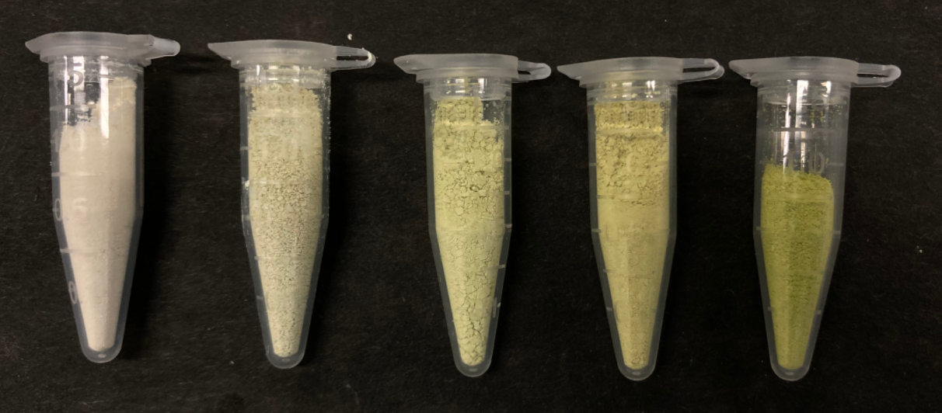
Figure S1 Physical appearance of (from left) pristine g-C₃N₄, C10, C30, C50, CuVA

Table S1 Weight distribution of elements obtained by EDX analysis.
Sample | Element (wt%)
Sample | C | N | O | V | Cu
g-C₃N₄ | 37.96 | 55.94 | 6.06 | - | -
C10 | 38.74 | 46.93 | 13.28 | 0.21 | 0.84
C30 | 34.50 | 48.71 | 12.98 | 1.11 | 2.70
C50 | 28.42 | 39.83 | 19.83 | 3.73 | 8.19
CuVA | 11.09 | - | 28.22 | 19.60 | 41.09

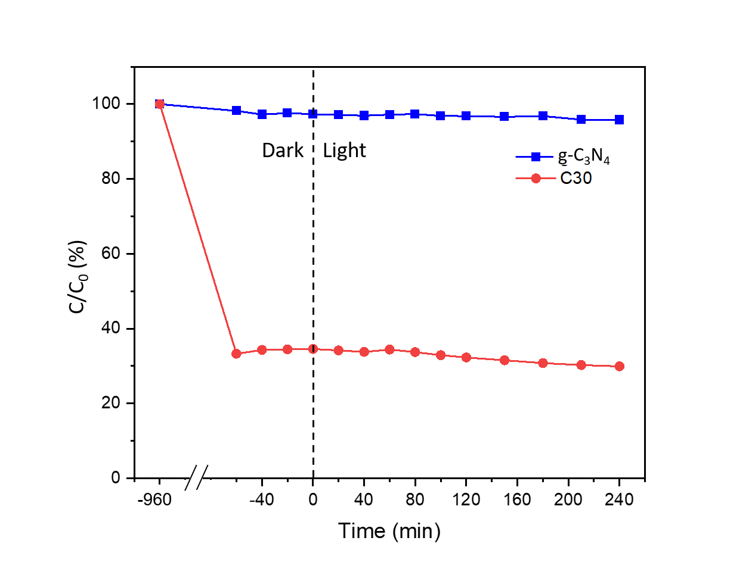
Figure S2 Photocatalytic-adsorption performance curves for removal of OTC in the dark and under light irradiation.

Figure S3 OTC removal performance curves of CuVA in the dark and under light irradiation.

Table S2 Correlation coefficient and chi-square of the respective model in fitting the dataset from removal of OTC using CuVA at 42 °C.
Model | R² | χ²
Pseudo first-order | 0.98874 | 50.58
Pseudo second-order | 0.99924 | 2.52
Elovich model | 0.99692 | 11.74
Intra-particle diffusion | 0.68402 | 1954.92

Table S3 PSO rate of reaction of removal of OTC using CuVA at different temperature.
Temperature (°C) | PSO rate of reaction (g·mg⁻¹·min⁻¹)
22 | 3.20 x 10⁻⁵
27 | 6.33 x 10⁻⁵
32 | 8.34 x 10⁻⁵
37 | 2.27 x 10⁻⁴
42 | 5.33 x 10⁻⁴

Table S4 Summary table for R² and χ² of selected isotherm models.
Type | Isotherm | R² | χ²
Single-Parameter | Henry | 0.8038 | 36017.16
Two-Parameter | Temkin | 0.9661 | 6223.87
Two-Parameter | Freundlich | 0.9812 | 3451.37
Two-Parameter | Dubinin-Radushkevich | 0.9857 | 2624.56
Two-Parameter | Langmuir | 0.9726 | 5027.25
Three-Parameter | Redliche-Peterson | 0.9824 | 3225.58

Table S5 Gibbs free energy of adsorption of OTC using CuVA at various temperature.
Temperature (°C) | Temperature (K) | $Δ_{r}G$ (kJ/mol)
17.35* | 290.50* | 0*
22 | 295.15 | -1.14
27 | 300.15 | -2.36
32 | 305.15 | -3.58
37 | 310.15 | -4.81
42 | 315.15 | -6.03

Table S6 Life cycle assessment of CuVA towards OTC for 5 cycles and its respective apparent and adjusted adsorption capacity.
Cycle | C/C₀ (%) | Apparent Adsorption Capacity (mg/g) | Adjusted Adsorption Capacity (mg/g)
1 | 13.57 | 171.3575 | 171.3575
2 | 23.62 | 151.2360 | 177.1515
3 | 31.35 | 133.9077 | 180.5757
4 | 36.11 | 126.2677 | 193.0740
5 | 46.93 | 103.9207 | 178.9679

Correspondence: Lan Ching Sim simcl@utar.edu.my; Tel.: +60 03 90860288 Department of Chemical Engineering, Lee Kong Chian Faculty of Engineering and Science, Universiti Tunku Abdul Rahman, Jalan Sungai Long 9, Bandar Sungai Long, 43000 Kajang, Selangor, Malaysia; simcl@utar.edu.my (L.C.S.); wwqing@1utar.my (W.Q.W.)
Department of Environmental Engineering, Faculty of Engineering and Green Technology, Universiti Tunku Abdul Rahman, Kampar, Perak, Malaysia; khleong@utar.edu.my (K.H.L.)
Faculty of Civil Engineering Technology, Universiti Malaysia Pahang Al-Sultan Abdullah, 26300 Kuantan, Pahang, Malaysia (A.A.A)

