Derivation, validation, and transcriptomic assessment of pediatric septic shock phenotypes identified through latent profile analyses: Results from a prospective multi-center observational cohort.
Mihir R. Atreya, MD, MPH^{1,2}; Min Huang, BS³; Andrew R. Moore, MD⁴; Hong Zheng, PhD^{4,5}; Yehudit Hasin-Brumshtein, PhD⁶; Julie C. Fitzgerald, MD, PhD⁷; Scott L. Weiss, MD⁸; Natalie Z. Cvijanovich, MD⁹; Michael T. Bigham, MD¹⁰; Parag N. Jain, MD¹¹; Adam J. Schwarz, MD¹²; Riad Lutfi, MD¹³; Jeffrey Nowak, MD¹⁴; Neal J. Thomas, MD¹⁵; Michael Quasney, MD¹⁶; Mary K. Dahmer, PhD¹⁶; Torrey Baines, MD^{17;} Bereketeab Haileselassie, MD¹⁸; Andrew J. Lautz, MD^{1,2}; Natalja L. Stanski, MD^{1,2}; Stephen W. Standage, MD^{1,2}; Jennifer Kaplan, MD, MS,^{1,2}; Basilia Zingarelli, MD, PhD^{1,2}; Timothy E. Sweeney, MD, PhD^{6;} Purvesh Khatri, PhD^{4,5}; L. Nelson Sanchez-Pinto, MD, MBI^{19,20}; and pRishikesan Kamaleswaran, PhD.^{21,22}

Author Affiliations:
- Division of Critical Care Medicine, Cincinnati Children’s Hospital Medical Center, Cincinnati, OH, 45229, USA.
- Department of Pediatrics, University of Cincinnati College of Medicine, Cincinnati, OH, 45627, USA.
- Department of Biomedical Informatics, Emory University School of Medicine, Atlanta, GA, USA.
- Stanford Institute for Immunity, Transplantation and Infection, Stanford University School of Medicine, Stanford, CA,
- Center for Biomedical Informatics Research, Department of Medicine, Stanford University School of Medicine, Stanford, 94305, CA.
- Inflammatix, Sunnyvale, CA, 94085, USA.
- Children’s Hospital of Philadelphia, Philadelphia, PA, 19104, USA.
- Nemours Children’s Health, Wilmington, DE, 19803, USA.
- UCSF Benioff Children’s Hospital Oakland, Oakland, CA, 94609, USA.
- Akron Children’s Hospital, Akron, OH, 44308, USA.
- Texas Children’s Hospital, Baylor College of Medicine, Houston, TX, 77030, USA.
- Children’s Hospital of Orange County, Orange, CA, 92868, USA.
- Riley Hospital for Children, Indianapolis, IN, 46202, USA.
- Children’s Hospital and Clinics of Minnesota, Minneapolis, MN, 55404, USA.
- Penn State Hershey Children’s Hospital, Hershey, PA, 17033, USA.
- C.S Mott Children’s Hospital, University of Michigan, Ann Arbor, MI, 48109, USA.
- University of Florida Health Children’s Hospital, Gainesville, FL, 32610, USA.
- Lucile Packard Children’s Hospital Stanford, Palo Alto, CA, 94304, USA.
- Department of Pediatrics, Northwestern University Feinberg School of Medicine, Chicago, 60611, IL, USA.
- Department of Health and Biomedical Informatics, Northwestern University Feinberg School of Medicine, Chicago, 60611, IL, USA.
- Department of Biomedical Informatics, Emory University School of Medicine, Atlanta, 30322, GA, USA.
- Department of Biomedical Engineering, Georgia Institute of Technology, Atlanta, 30322, GA, USA.
Corresponding author:
Mihir R Atreya, MD, MPH
Cincinnati Children’s Hospital Medical Center
Division of Critical Care Medicine, MLC2005
3333 Burnet Avenue
Cincinnati, OH, 45229, USA
Tel: 513-636-1627
Email: Mihir.Atreya@cchmc.org

Index:
- Supplementary Methods………………………………………………………………4
- Supplementary Tables………………………………………………………………..10
- Supplementary Figure Legend………………………………………………………18
- Supplementary Figures……………………………………………………...............20
- References…………………………………………………………………………….32

Supplementary methods:

Study design and patient selection:
The study protocol was approved by Institutional Review Boards (IRBs) of the primary site (Cincinnati Children’s Hospital IRB, Study Title: ‘Genomic Analysis of Pediatric Systemic Inflammatory Syndrome’, IRB ID: 2008-0558, Initial Approval 5/9/2002, Most Recent Approval: 6/22/2023) as well as the 13 participating institutions. Informed consent was obtained from parents or guardians of patients. All study procedures involving human participants were per the ethical standards of the institutional review boards of participating institutions and consistent with the 1964 Helsinki Declaration and its later amendments or comparable ethical standards. The overview of the study is detailed in Supplementary Figure 1.
Inputs for derivation of phenotypes: Vital sign data (heart rate, respiratory rate, systolic-, diastolic-, and mean arterial- pressure) collected within 24 hours of meeting study criteria were available in all patients. Given the significant variability in vital signs across the pediatric age spectrum, we measured deviation of patient vital sign from the median for age and sex for heart- and respiratory- rates, (1) systolic-, diastolic-, and mean arterial- blood pressures. (2) We calculated peak vasoactive inotropic score (VIS) on day 1.(3) Laboratory data were collected at the discretion of treating physicians including arterial or venous blood gases: pH, pCO2 (mmHg), and base excess (BE); serum lactate, sodium (Na), potassium (K), chloride (Cl), bicarbonate (HCO3), glucose (Gluc), blood urea nitrogen (BUN), creatinine (Cr), serum glutamic pyruvic transaminase (SGPT), serum glutamic-oxaloacetic transaminase (SGOT), hematocrit (HCt), platelet count, international normalized ratio (INR), all measured on day 1. Biomarker data were previously measured using multiplex Luminex assays (R&D Biosystems) in serum specimens collected on day 1 and included interleukin-8 (IL-8), intercellular adhesion molecule-1 (ICAM-1), soluble thrombomodulin (sTM), angiopoietin-1 (Angpt-1), angiopoietin-2 (Angpt-2), and tyrosine kinase with immunoglobulin-like loops and epidermal growth factor homology domains-2 (Tie-2). (4–7) We calculated Angpt-2/Angpt-1 and Angpt-2/Tie-2 ratios. Biomarkers were log₂ transformed prior to analyses to reduce skewness.
Latent profile analysis (LPA) is a Gaussian Finite Mixture Modeling method that attempts to identify clusters of individuals based on responses to a series of continuous variables. It assumes that there are unobserved latent profiles that generate patterns of responses on indicator items. Unlike latent class analyses (LCA), LPA only uses continuous variables. LPA is a probabilistic model, which means that it models the probability of a case belonging to a profile. This is thought to be a superior approach such as K-means clustering, which uses distance algorithms. The R package mclust performs various types of model-based clustering and dimensionality reduction. It requires complete data. For this reason, we used python package “Datawig”, that uses deep learning feature extraction with automatic hyperparameter tuning to impute missing values.
Selection of optimal model: Bayesian Information Criteria (BIC) was used to select the optimal number of latent profiles in the derivation set. BIC for all models is shown in Supplementary Figure 2. The output describes the geometric characteristics of the profiles. The summary (BIC) function in mclust identified the top three models, shown in Supplementary Table 1. We used additional criteria including the Integrated Complete-data Likelihood (ICL) criterion, which penalizes solutions with greater entropy or classification uncertainty. The summary (ICL) function identified the top three models, shown in Supplementary Table 2. The ICL for all models are shown in Supplementary Figure 3. Additionally, we generated LPA plots of models with 3, 4, and 5 profiles, shown in Supplementary Figures 4-6. It is evident that the difference between groups was less clear with an increasing number of profiles. Thus, we chose the two-profile model presented in the manuscript.
Support vector machine (SVM) classifier: Using the phenotypic assignment in the derivation set, we trained a SVM classifier to assign phenotypes in the hold-out validation set. We used python program “scikit-learn” to develop a non-probabilistic binary linear classifier to distinguish phenotypes. Briefly, grid search was used to obtain optimal parameters including linear kernel and a regularization parameter C of 0.1. The comparison between demographic, patient characteristics, and outcomes between phenotypes in the derivation and validation sets, presented in Table 1 of the manuscript, which demonstrates the reproducibility of our SVM classifier. As detailed in the Supplementary Table 5, the ‘inflamed’ phenotype was associated with substantially higher risk of 7- and 28-day mortality as well as complicated course upon adjusting for multiple confounders. Comparison of key clinical, laboratory, and biomarkers distinguishing phenotypes in the validation set with exclusion of imputed data shown in Supplementary Figure 7. These data show that patient phenotypes are biologically distinct. Furthermore, a subset of patients in the cohort had biomarker data on interleukin-6 (IL-6) and soluble tumor necrosis factor receptor (sTNFr). While we did not include these data in the derivation of phenotypes due to high missingness, we compared differences in biomarkers between phenotypes. Consistent with latent class phenotypes among several studies of critical illness, these biomarkers were significantly higher among patients with an ‘inflamed’ phenotype in compared to those ‘uninflamed’. These data are shown in Supplementary Figure 8.
Transcriptomic analyses: Bulk messenger RNA sequencing data were available from a subset of the cohort recruited between 2019 and 2023 with RNA processed from whole blood collected in PAXgene® tubes on day 1 of septic shock. We used ComBat_seq function from the sva package (v.3.46.0), a negative binomial regression method, to eliminate batch effects in the transcriptomic data. We used DESeq2 (v.1.38.3) to identify differentially expressed genes (DEGs) between the phenotypes identified across derivation and validation sets. DEGs were selected based on ≥log2 fold change value cutoff of ±1, and adjusted p value of 0.05. We conducted Reactome pathway analyses with a Benjamin Hochberg false discovery rate (FDR) < 0.05 to identify enriched biological pathways and CIBERSORT analyses, a bulk deconvolution approach, to determine differences in cell subsets between phenotypes. The volcano plot, results of REACTOME pathway and CIBERSORT analyses are shown in Supplementary Figure 9-11.
Inference of cell subsets using publicly available single-cell data:
Deconvolution approaches have several important limitations including the fact that most algorithms are based on differences in cell types in tissue homogenates rather than whole blood and often lack data on cell specific markers in disease states. Thus, we sought to gain a granular insight at a single-cell level into immune cell subpopulations associated with latent profile phenotypes. To achieve this, we first identified three single-cell RNA sequencing datasets, which included data on neutrophil subsets among critically ill adults, a vast majority of whom had COVID19. (8–10). The characteristics of these datasets are detailed in Supplementary Table 4. Briefly, RNAseq gene expression-data from these datasets were integrated using the Seurat (v4.0.5), and cells were analyzed by Uniform Manifold Approximation and Projection (UMAP) and nearest neighbors algorithms demonstrating distinct cell types. We evaluated the cellular origin of the up-regulated and down-regulated genes identified at the bulk transcriptome level based on the differentially expressed gene (DEG) analysis comparing phenotypes. A composite gene score was calculated as the geometric mean of available up-regulated genes minus the geometric mean of down-regulated genes and mapped at the single cell level using UMAP. The major cell subsets that were inferred to be significantly different between patients with an ‘inflamed’ and ‘uninflamed’ phenotypes and the level of significance is shown in Supplementary Table 5. The scaled composite gene score referenced against the cell subsets of the integrated single-cell dataset is shown in Supplemental Figure 12.
Established gene-expression endotypes: Using a customized multiplexed panel of 100 genes, reflective of the adaptive immune response and glucocorticoid receptor signaling, mRNA expression was directly quantified by the NanoString nCounter platform. (11) The panel included 4 housekeeping genes including b-2-microglobulin, folylpolyglutamate synthase, 2,4-dienoyl coenzyme A reductase 1, and peptidylprolyl isomerase B. Image analysis of gene-expression mosaics generated using gene-expression dynamics investigator (GEDI) were previously used to assign pediatric septic shock endotypes - A and B in a subset of the cohort.(11)
Overlap between these established gene-expression endotypes and newly derived latent profile phenotypes are shown in Supplementary Table 6. The number-at-risk in Kaplan Meier Survival Curves detailed in Figure 2 of the manuscript according to established gene-expression endotype, latent profile phenotype, and integrated endophenotype subclassification scheme is shown in Supplementary Table 7. The relative risk of 28-day mortality comparing ‘endophenotypes’ based on Cox regression analyses relative to reference group with the lowest mortality is shown in Supplementary Table 8.

Supplementary table 1.
The top 3 models and number of latent profiles based on maximum Bayesian Information Criteria (BIC), ordered from best model from left to right, in the derivation set.
 | VEV, 2 | VEI, 5 | EEV, 2
BIC | -127603.7 | -129076.5 | -1290270.9
BIC diff | 0.0 | -1472.72 | -1667.124

VEV: ellipsoidal, equal shape.
VEI: diagonal, varying volume, equal shape.
EEV: ellipsoidal, equal volume, and equal shape.
The number of optimal profiles is indicated next to each model.

Supplementary table 2.
The top 3 models and number of latent profiles based on maximum Integrated Completed Likelihood (ICL) criterion, ordered from best model from left to right, in the derivation set.
 | VEV, 2 | VEI, 9 | VEI, 8
ICL | -127607.0 | -128215.3 | -128334.7
ICL diff | 0 | -608.2161 | -727.6905

VEV: ellipsoidal, equal shape.
VEI: VEI: diagonal, varying volume, equal shape.
The number of optimal profiles is indicated next to each model.
Supplementary Table 3. Multi-variable logistic regression to test association between latent profile phenotypes across derivation and validation sets and pediatric septic shock outcomes.

Variable | Adjusted OR | P value
7-day mortality
Era of enrollment | 1.35 (0.74, 2.45) | 0.321
Age | 0.99 (0.97, 1.02) | 0.709
PRISM-III | 1.04 (1.02, 1.05) | <0.001
Co-morbidity | 1.11 (0.72, 1.72) | 0.625
Immunocompromised | 1.13 (0.61, 2.10) | 0.692
Phenotype (Inflamed vs. Uninflamed) | 5.56 (3.62, 8.56) | <0.001
28-day mortality
Era of enrollment | 1.32 (0.78, 2.20) | 0.301
Age | 0.99 (0.97, 1.03) | 0.860
PRISM-III | 1.04 (1.02, 1.06) | <0.001
Co-morbidity | 1.19 (0.82, 1.74) | 0.349
Immunocompromised | 2.07 (1.27, 3.38) | 0.004
Phenotype (Inflamed vs. Uninflamed) | 4.41 (3.01, 6.45) | <0.001
Complicated Course
Era of enrollment | 1.89 (1.28, 2.80) | 0.001
Age | 0.97 (0.94, 0.98) | 0.001
PRISM-III | 1.05 (1.03, 1.07) | <0.001
Co-morbidity | 0.97 (0.73, 1.28) | 0.829
Immunocompromised | 1.48 (0.97, 2.26) | 0.070
Phenotype (Inflamed vs. Uninflamed) | 3.93 (2.80, 5.53) | <0.001

Supplementary Table 4.
Characteristics of the single-cell transcriptomic datasets which were integrated and served as a refence map to infer differences in cell subset abundance when differentially expressed genes comparing ‘inflamed’ and ‘uninflamed’ phenotypes.

Dataset ID | Accession | Condition | Healthy Samples (cell #) | Critically ill Samples (cell #) | Bacterial ARDS Samples (cell #)
wilk2021 | GSE174072 | COVID-19, Healthy | 8 (51,032) | 33 (104,277 | -
sinha2021 | GSE157789 | COVID-19, Bacterial ARDS, Healthy | 5 (19,845) | 21 (78,015) | 9 (35,745)
schrepping2020 | EGAS0000  -1004571 | COVID-19, Healthy | 29 (51,064) | 66 (135,016) | -

Supplementary Table 5:
Major cell subsets that were inferred to be substantially different between ‘inflamed’ and ‘uninflamed’ phenotypes based on reference mapping against the integrated single-cell dataset with level of significance, as shown in Supplementary Figure 12.

Cell Type | Significance
Developing Neutrophils | <2e-16 across all cell types
Neutrophils | <2e-16 across all cell types
Proliferating T/NK | <2.8e-11 across all cell types
NK | <2.9e-7 across all cell types except PB and CD8

PB: Plasmablasts
CD8: CD8 positive T lymphocytes.

Supplementary Table 6:
Table showing overlap of established gene-expression pediatric septic shock endotypes and latent profile phenotypes in a subset of the cohort.
 | Inflammed (n=35) | Uninflammed (n=198) | Χ² p-value
Endotype A (n=79) | 16 | 63 | 0.079
Endotype B (n=154) | 19 | 135

Supplementary Table 7:
Number-at-risk in Kaplan Meier Survival Curves by established gene-expression endotype, latent profile phenotype, and integrated endophenotype subclassification scheme.
Study day | 0 | 7 | 14 | 21 | 28
Number-at-risk by gene-expression endotype
Endotype A | 79 | 70 | 67 | 66 | 65
Endotype B | 154 | 152 | 152 | 148 | 146
Number-at-risk by latent profile phenotype
Inflamed | 35 | 28 | 27 | 27 | 26
Uninflamed | 198 | 192 | 192 | 187 | 185
Number-at-risk by endophenotype
Endotype A & Inflamed | 16 | 12 | 11 | 11 | 10
Endotype B & Inflamed | 19 | 17 | 17 | 17 | 16
Endotype A & Uninflamed | 63 | 59 | 57 | 56 | 55
Endotype B & Uninflamed | 135 | 135 | 133 | 132 | 130

Supplementary Table 8:
Relative risk of 28-day mortality comparing endophenotypes relative to reference group with the lowest mortality.
Subclass | Relative risk | P value
Endotype A & Inflamed | 12.5 (3.8, 41.2) | <0.0001
Endotype B & Inflamed | 4.8 (1.2, 20.1) | 0.032
Endotype A & Uninflamed | 3.6 (1.2, 11.1) | 0.024

*Risk Relative to Endotype B/Uninflamed phenotype.

Supplementary Figure Legend:
Figure 1. Overview of study including inclusion and exclusion criteria, number of patients across the derivation and validation set, and various analytic approaches used to characterize latent profile phenotypes of pediatric septic shock.
Figure 2. Bayesian information criteria (BIC) for selection of number of latent profile phenotypes. The y-axis shows the BIC with high numbers at the top and lower numbers at the bottom. The x-axis shows change in BIC with increasing number of profiles from 1 to 9. The 14 models are named based on the geometric characteristics of the profiles. Legend: (a) "EII" spherical, equal volume, (b) "VII" spherical, unequal volume, (c) "EEI" diagonal, equal volume and shape, (d) "VEI" diagonal, varying volume, equal shape, (e) "EVI" diagonal, equal volume, varying shape, (f) "VVI" diagonal, varying volume and shape, (g) "EEE" ellipsoidal, equal volume, shape, and orientation, (h) "EVE" ellipsoidal, equal volume and orientation, (i) "VEE" ellipsoidal, equal shape and orientation (*), (j) "VVE" ellipsoidal, equal orientation, (k) "EEV" ellipsoidal, equal volume and equal shape, (l) "VEV" ellipsoidal, equal shape, (m) "EVV" ellipsoidal, equal volume, (n) "VVV" ellipsoidal, varying volume, shape, and orientation. The VEV model with 2 profiles had the highest BIC and was chosen for derivation of phenotypes.
Figure 3. Integrated Completed Likelihood (ICL) for selection of number of latent profile phenotypes. The y-axis shows the ICL with high numbers at the top and lower numbers at the bottom. The x-axis shows change in ICL with increasing number of profiles from 1 to 9. The 14 models are named based on the geometric characteristics of the profiles. Legend: (a) "EII" spherical, equal volume, (b) "VII" spherical, unequal volume, (c) "EEI" diagonal, equal volume and shape, (d) "VEI" diagonal, varying volume, equal shape, (e) "EVI" diagonal, equal volume, varying shape, (f) "VVI" diagonal, varying volume and shape, (g) "EEE" ellipsoidal, equal volume, shape, and orientation, (h) "EVE" ellipsoidal, equal volume and orientation, (i) "VEE" ellipsoidal, equal shape and orientation (*), (j) "VVE" ellipsoidal, equal orientation, (k) "EEV" ellipsoidal, equal volume and equal shape, (l) "VEV" ellipsoidal, equal shape, (m) "EVV" ellipsoidal, equal volume, (n) "VVV" ellipsoidal, varying volume, shape, and orientation. The VEV model with 2 profiles had the highest ICL and was chosen for derivation of phenotypes.
Figure 4. Standardized mean (z-scores) for continuous class predicting variables in the derivation set based on three latent profiles.
Figure 5. Standardized mean (z-scores) for continuous class predicting variables in the derivation set based on four latent profiles.
Figure 6. Standardized mean (z-scores) for continuous class predicting variables in the derivation set based on five latent profiles.
Figure 7. Differences in clinical, laboratory, and biomarker data between latent profile phenotypes in the validation set after exclusion of imputed data demonstrate that the phenotypes retained biological distinctiveness.
Figure 8. Differences in interleukin-6 (IL-6) and soluble tumor necrosis factor receptor 4 (sTNFR-1) among phenotypes across derivation and validation sets.
Figure 9. Volcano plot showing differentially expressed genes among patients with an ‘inflamed’ phenotype relative to those ‘uninflamed’ using a log2(fold change) threshold of ± 1 and adjusted p value of 0.05. Overexpressed genes are shown in red. Underexpressed genes are shown in blue. The top 10 most differentially expressed genes are labeled including: matrix metallopeptidase-15 (MMP15), chemokine ligand 20 (CCL20), proteinase 3 (PRTN3), neutrophil expressed elastase (ELANE), cathepsin G (CTSG), defensin 3 (DEFA3), defensin 4 (DEFA4), chemokine ligand 4 (CCL4), scratch family transcriptional repressor 2 (SCRT2), and adhesion G protein-couple receptor E3 (ADGRE3).
Figure 10. Biologically enriched pathways among patients with an ‘inflamed’ phenotype relative to those ‘uninflamed’. The y-axis represents the REACTOME pathways enriched for the significantly overexpressed genes. The x-axis represents the gene-ratio (%). The size of the circle indicates gene counts. The darker hue of color indicates a lower adjusted p-value.
Figure 11. Results of CIBERSORT deconvolution analyses. The y-axis represents proportion of cells attributed to each cell type among patients with an ‘inflamed’ (shown in orange) and ‘uninflamed’ (shown in brown) phenotype. The x-axis shows the various cell types as determined by CIBERSORT. The proportion of neutrophils was found to be statistically significantly lower among patients with an ‘inflamed’ phenotype as compared to those with an ‘uninflamed’ phenotype.
Figure 12. Scaled composite gene score calculated by subtracting the geometric mean of under-expressed genes from overexpressed genes based on results of differentially expressed gene (DEG) analyses comparing ‘inflamed’ and ‘uninflamed’ phenotypes is shown on the y-axis. These data were referenced against the signatures of 14 cell subsets identified in the integrated single-cell dataset. As shown in Supplementary Table 5, these gene-expression data strongly suggest that developing neutrophils (pink), proliferating T lymphocyte/natural killer (NK) cells (aqua), and NK cells (light teal) were overrepresented and those of mature neutrophils (red) were underrepresented among patients with an ‘inflamed’ phenotype. Legend: Devep Neut: Developing neutrophils; Neutrophils: Mature neutrophils; CD14: Cluster differentiation 14 positive cells; CD16: Cluster differentiation 16 positive cells; cDC: Classic dendritic cells; pDC: Plasmacytoid dendritic cells; B: B lymphocytes; PB: Plasmablasts ;CD4: Cluster differentiation 4 positive T lymphocytes; CD8: Cluster differentiation 8 positive T lymphocytes; NK: Natural killer cells; Pro NK/T: Pro natural killer/T lympocytes

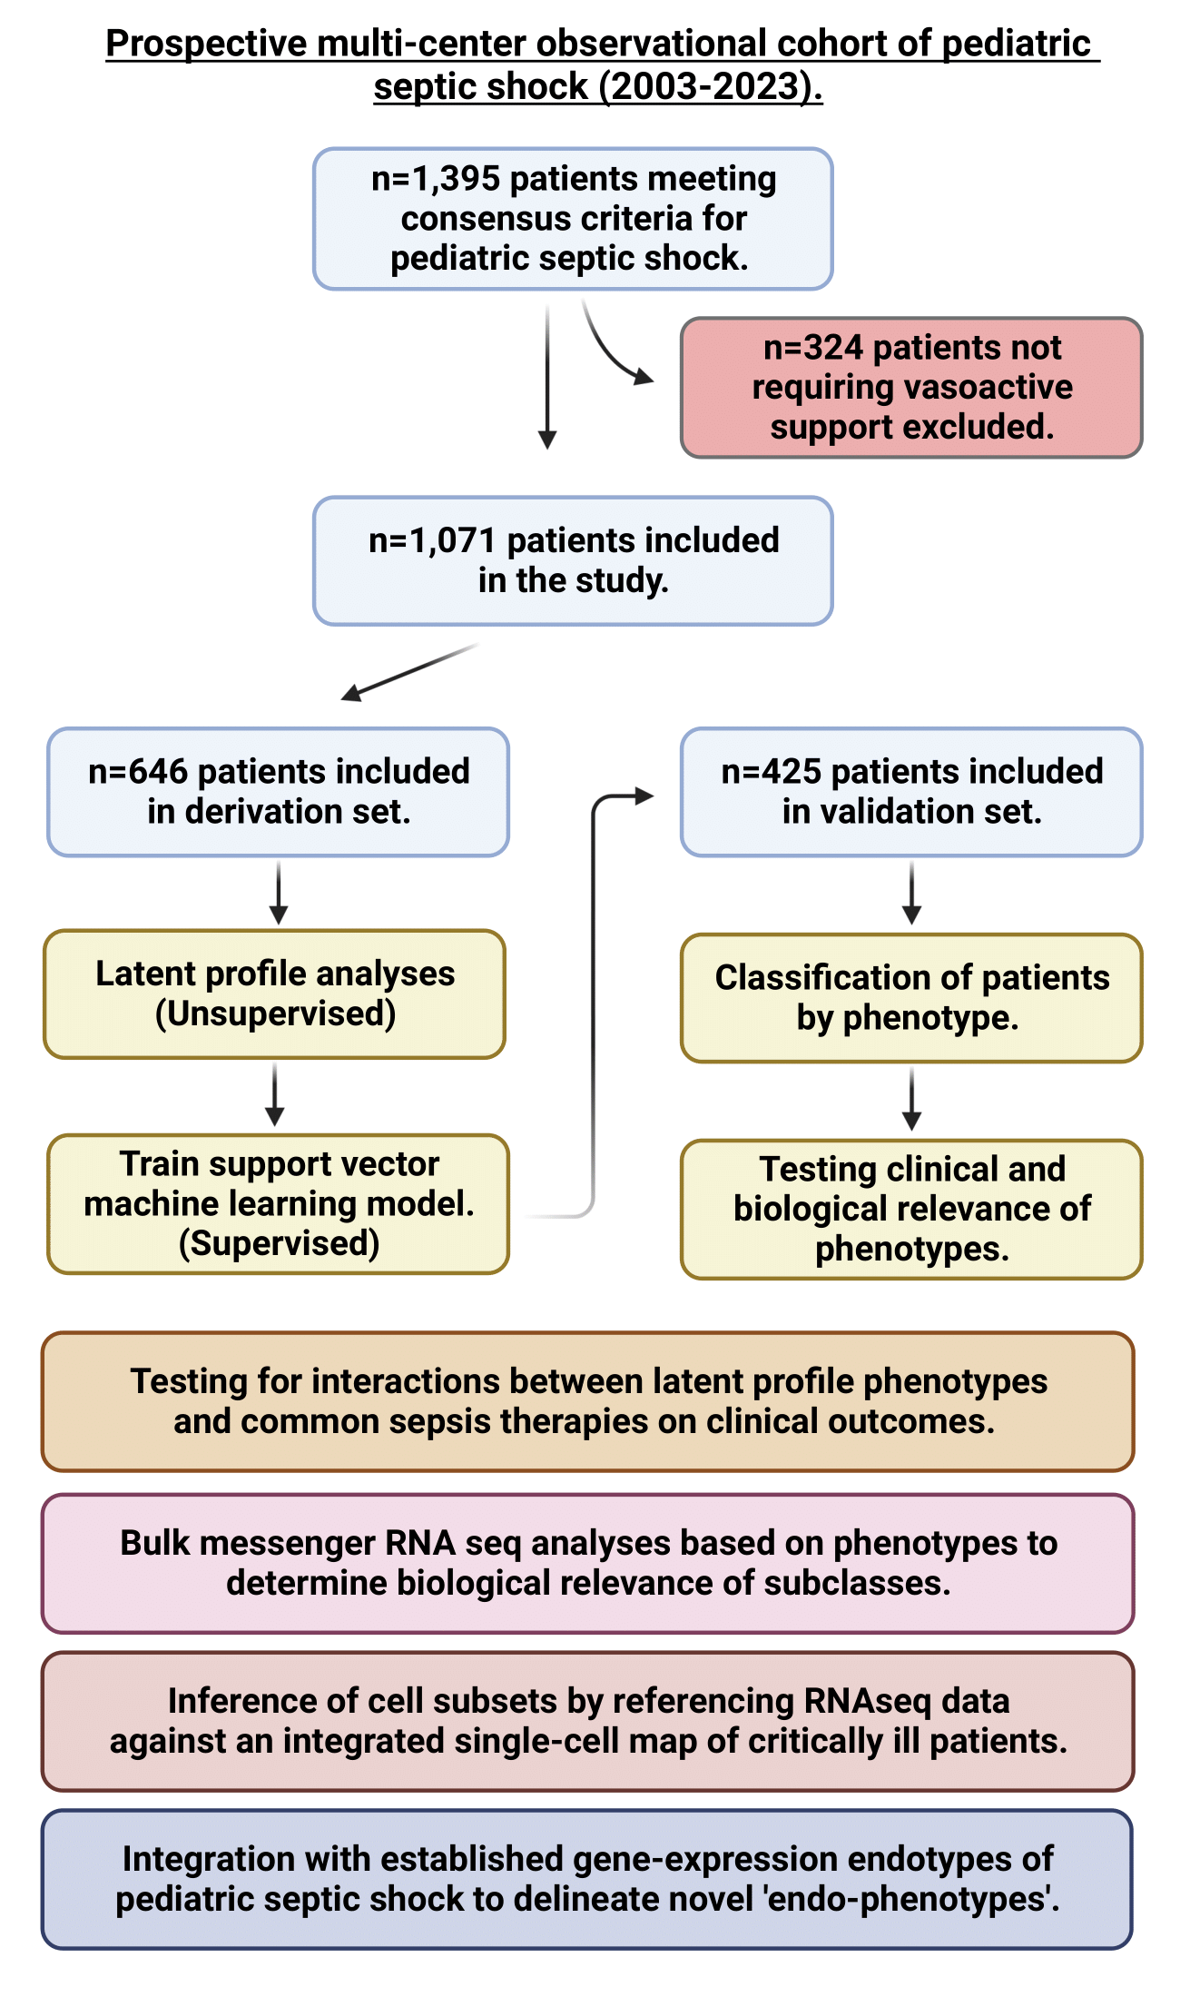
Supplementary Figure 1.

Supplementary Figure 2.
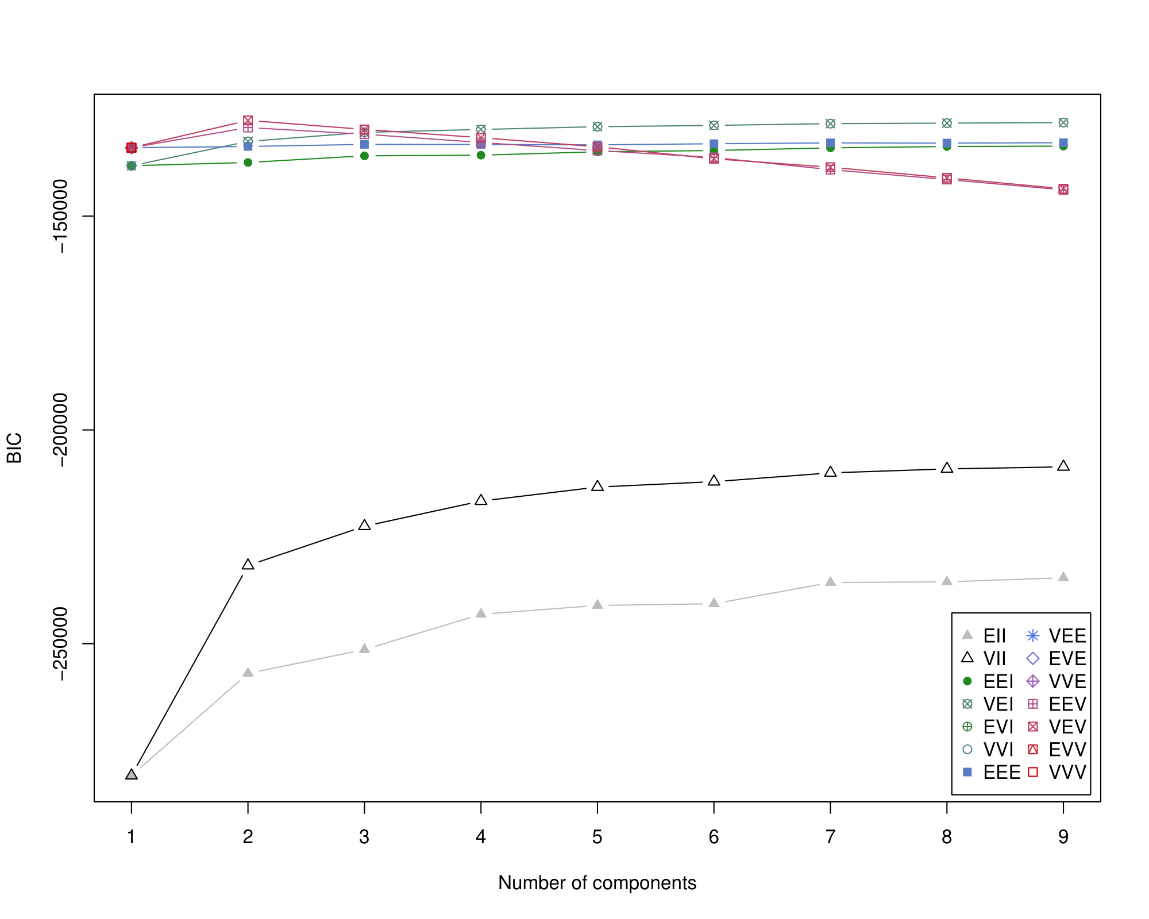

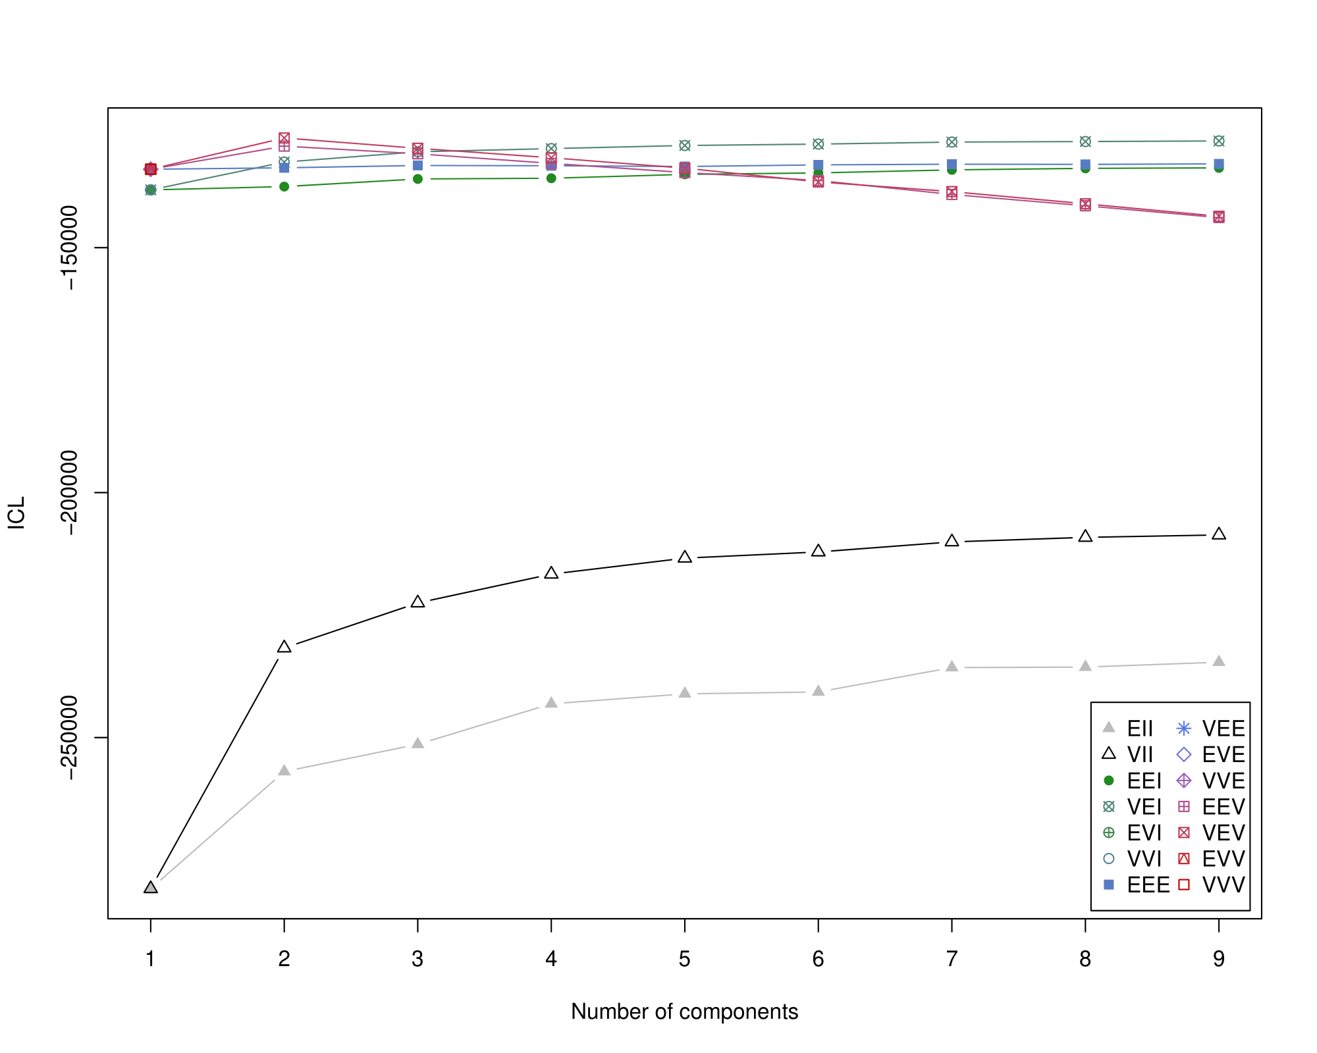
Supplementary Figure 3.

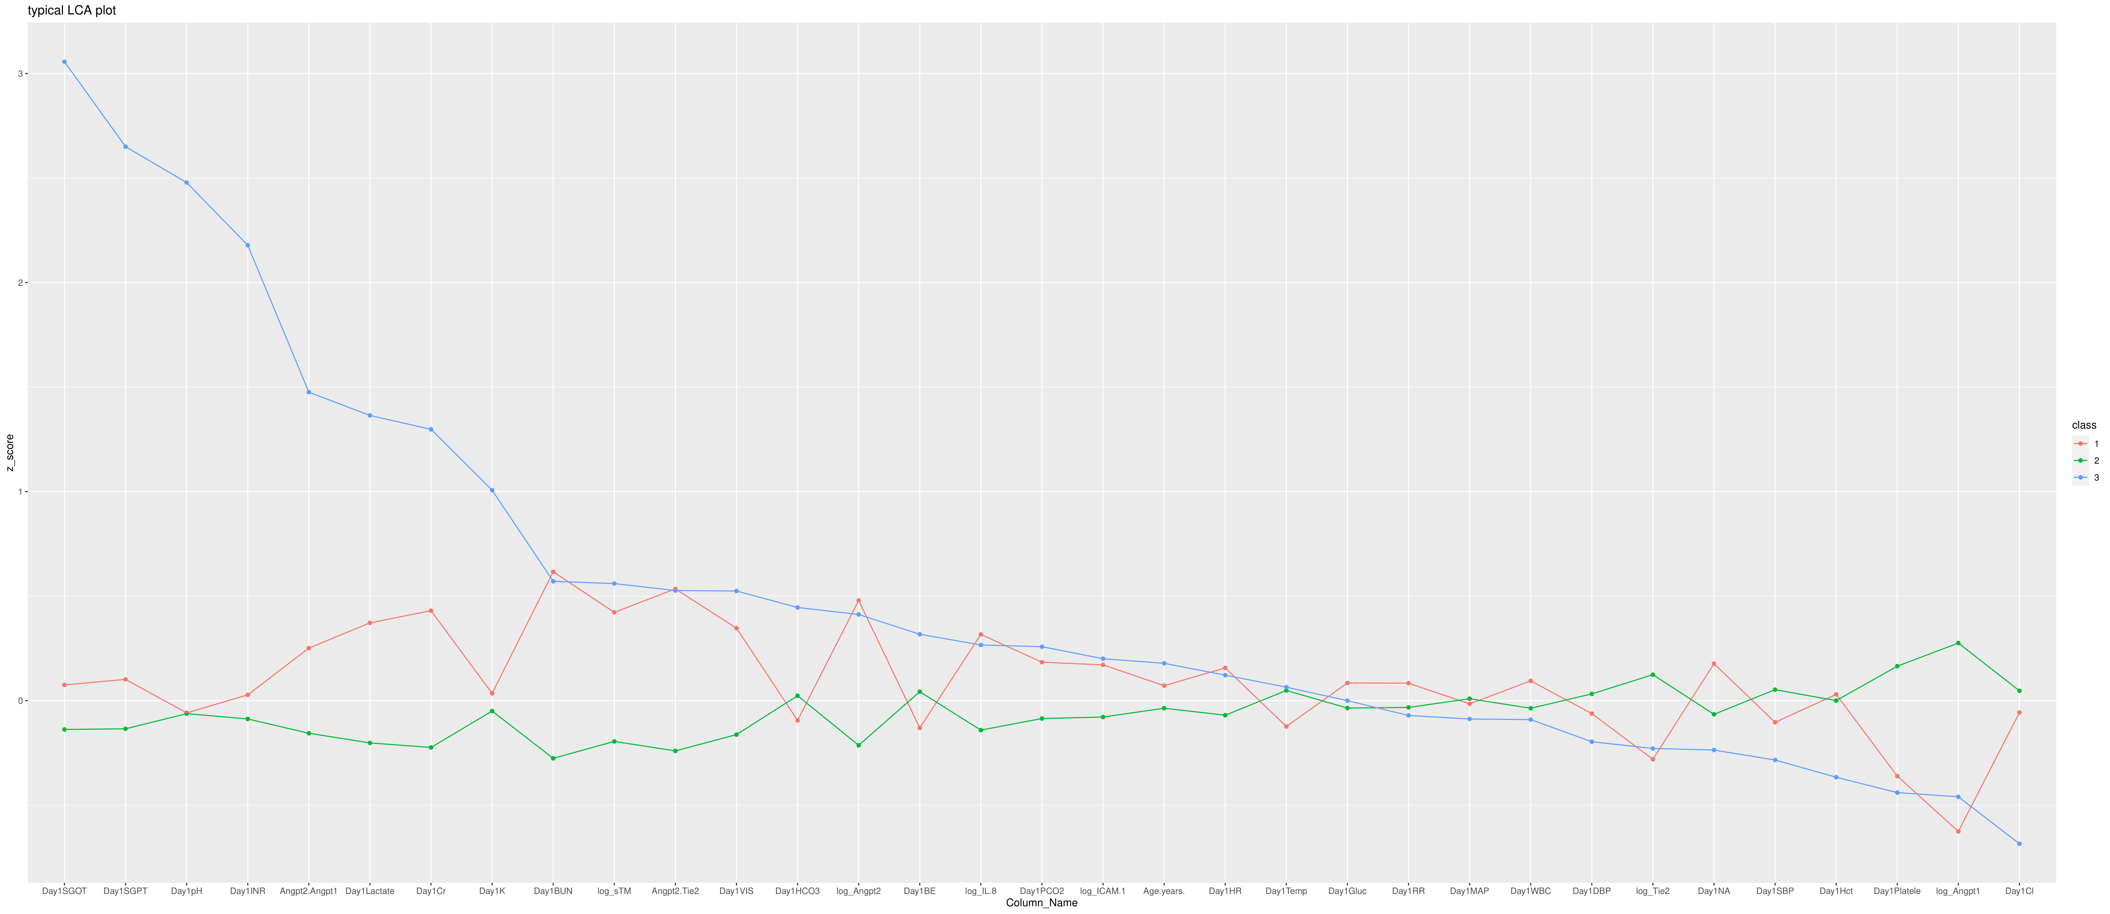
Supplementary Figure 4.
Supplementary Figure 5.
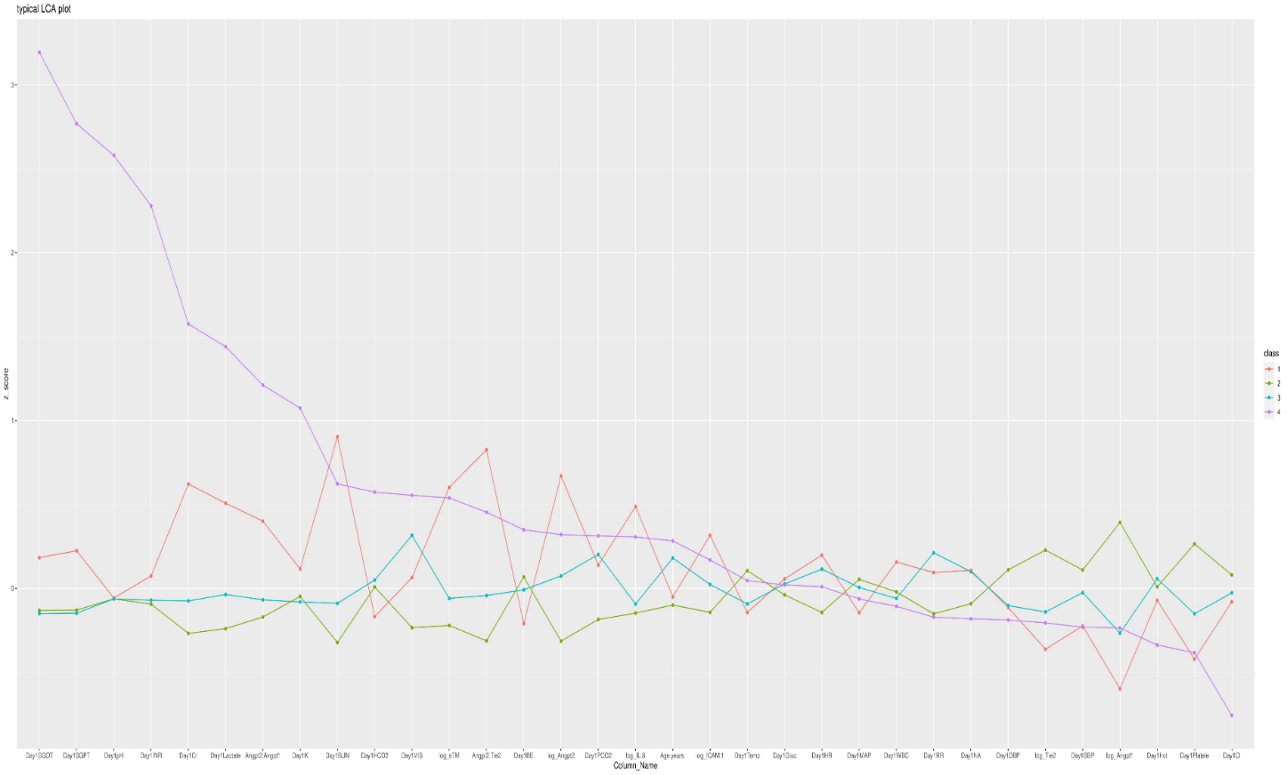
Supplementary Figure 6.

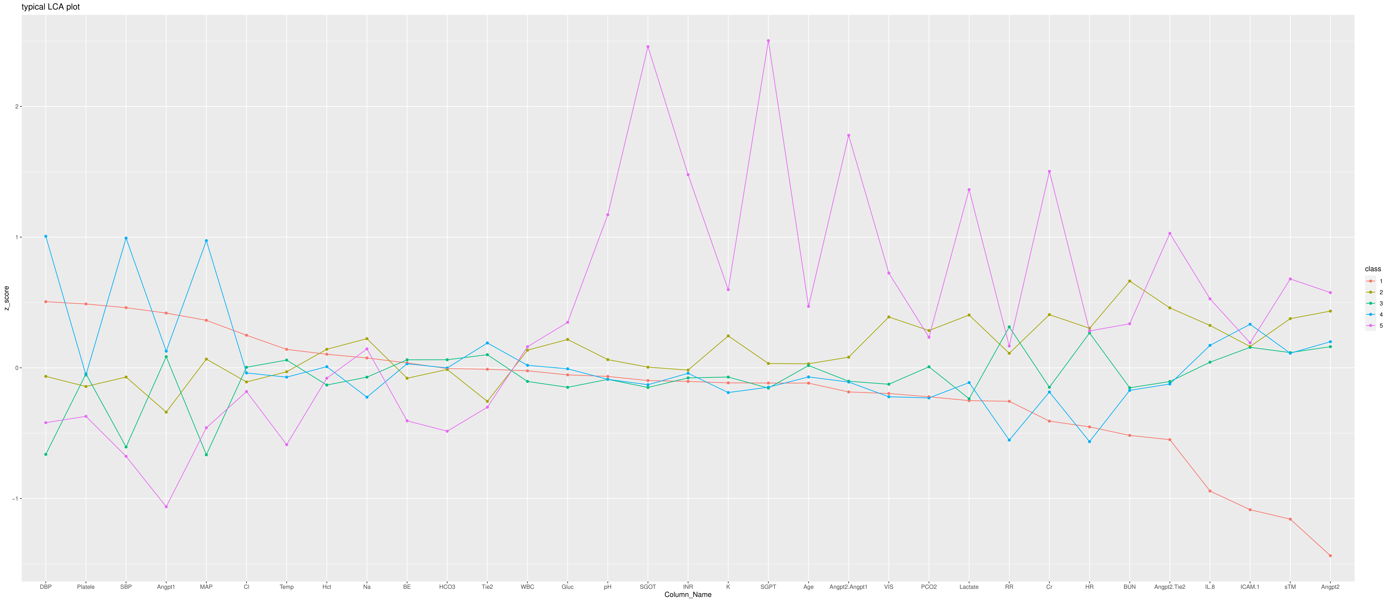
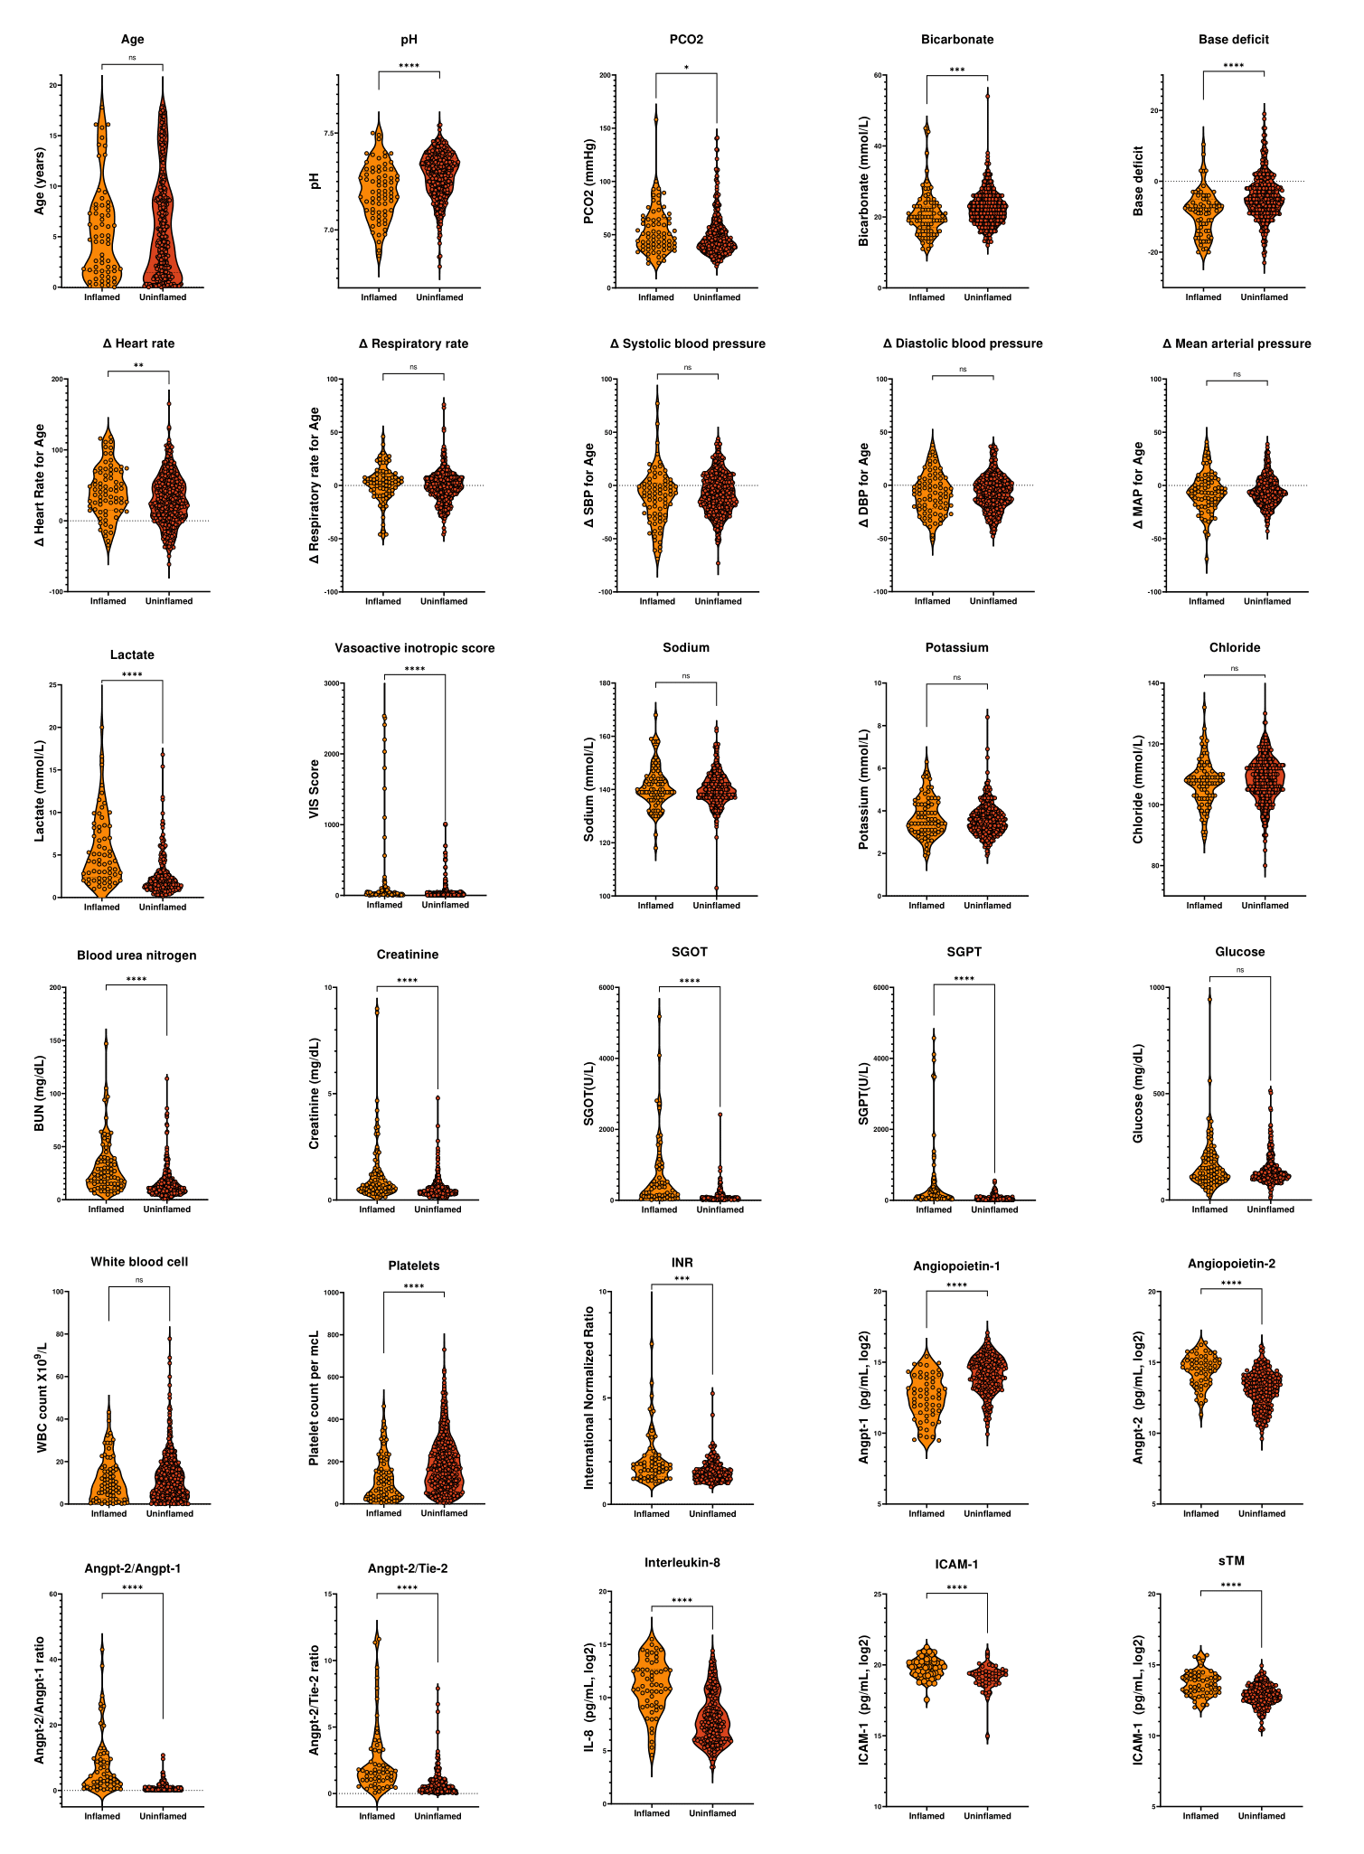
Supplementary Figure 7.
Supplementary Figure 8.
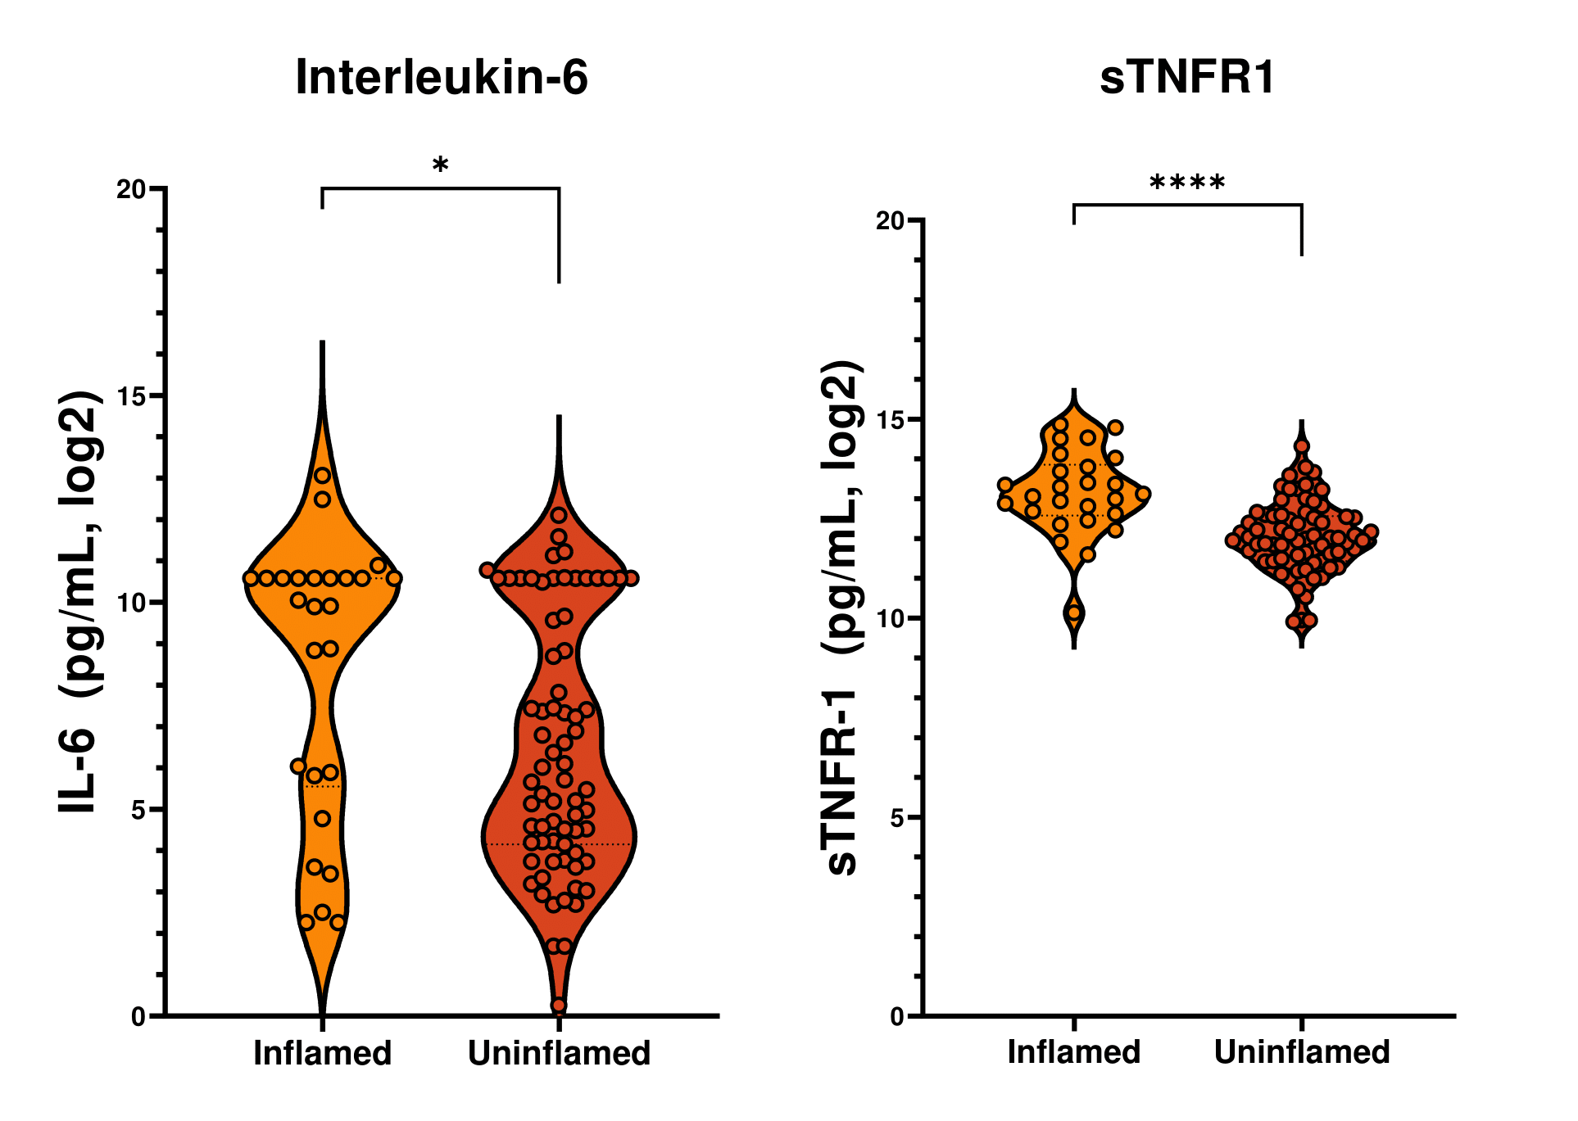

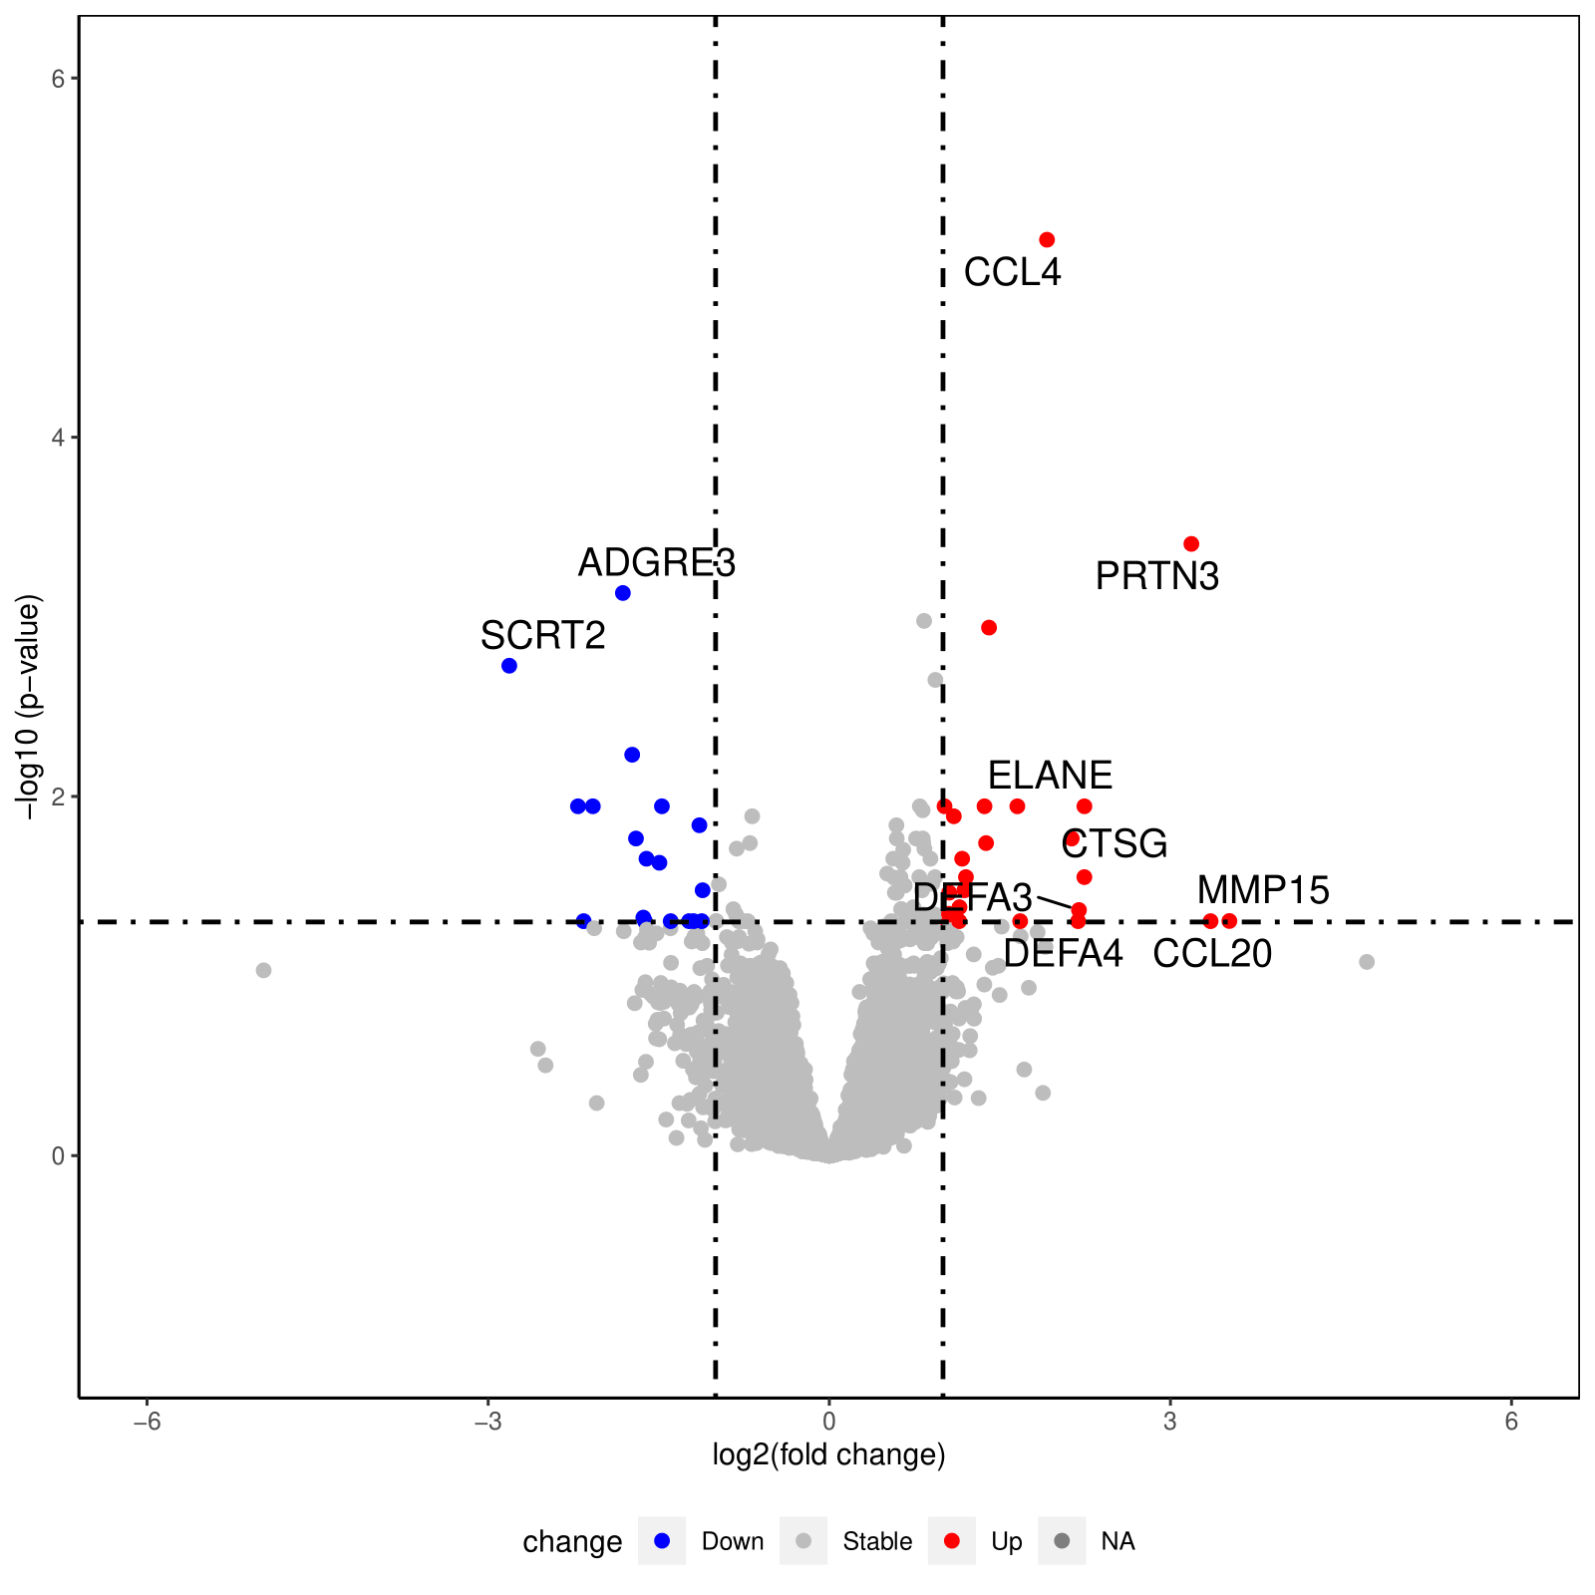
Supplementary Figure 9.

Supplementary Figure 10.
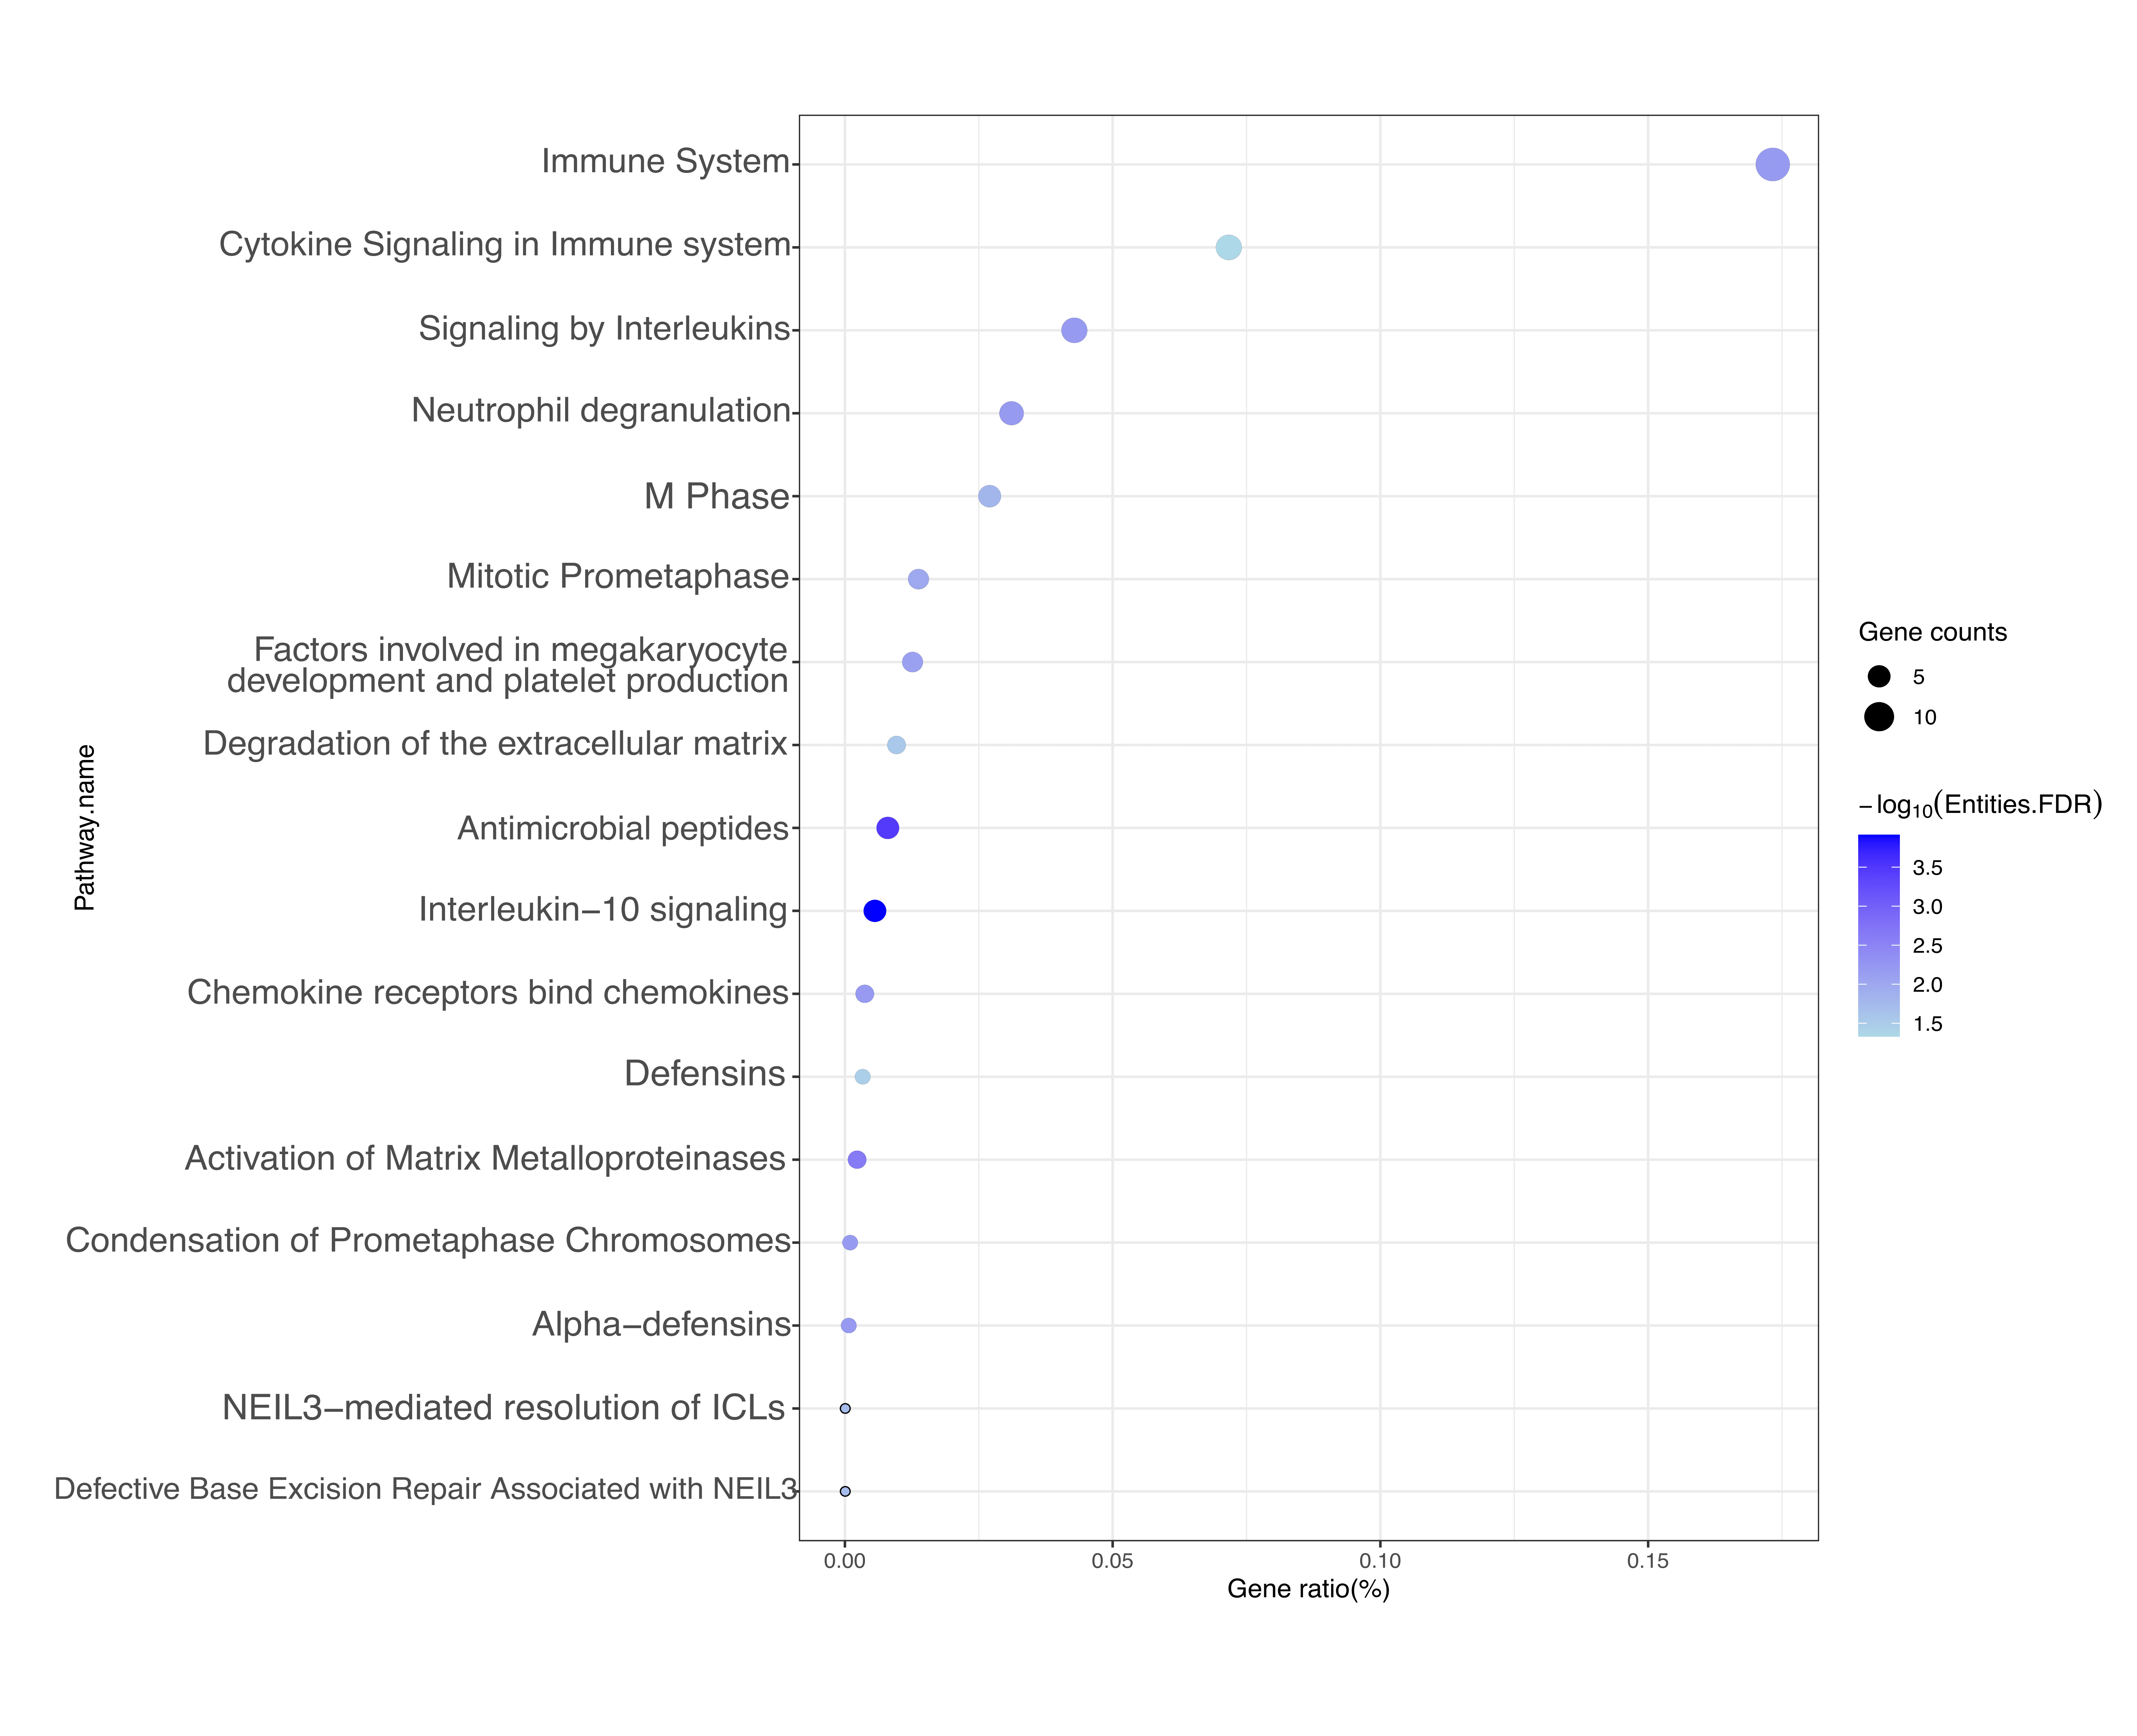

Supplementary Figure 11.
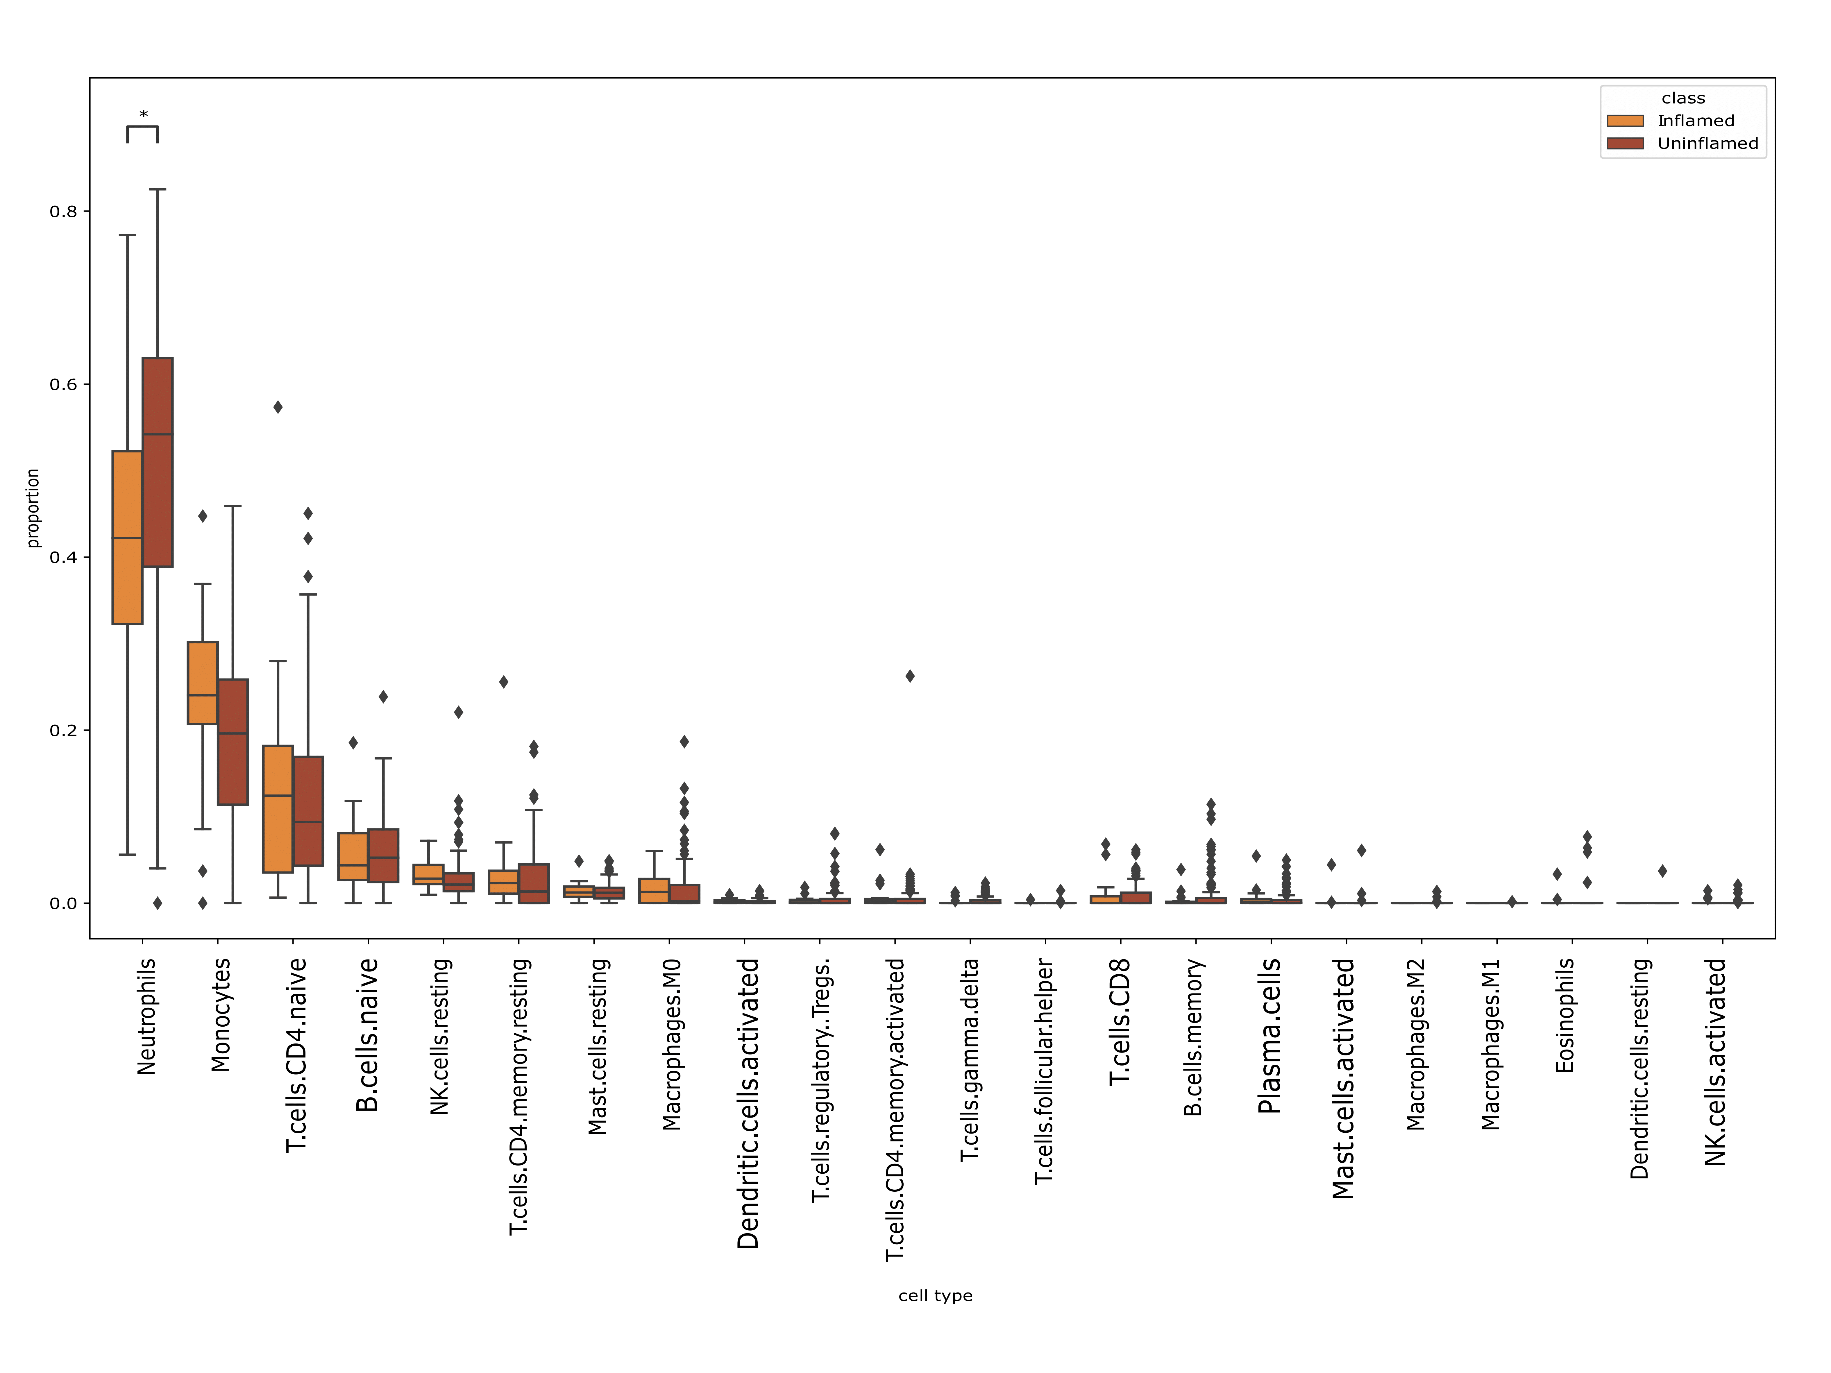

Supplementary Figure 12.
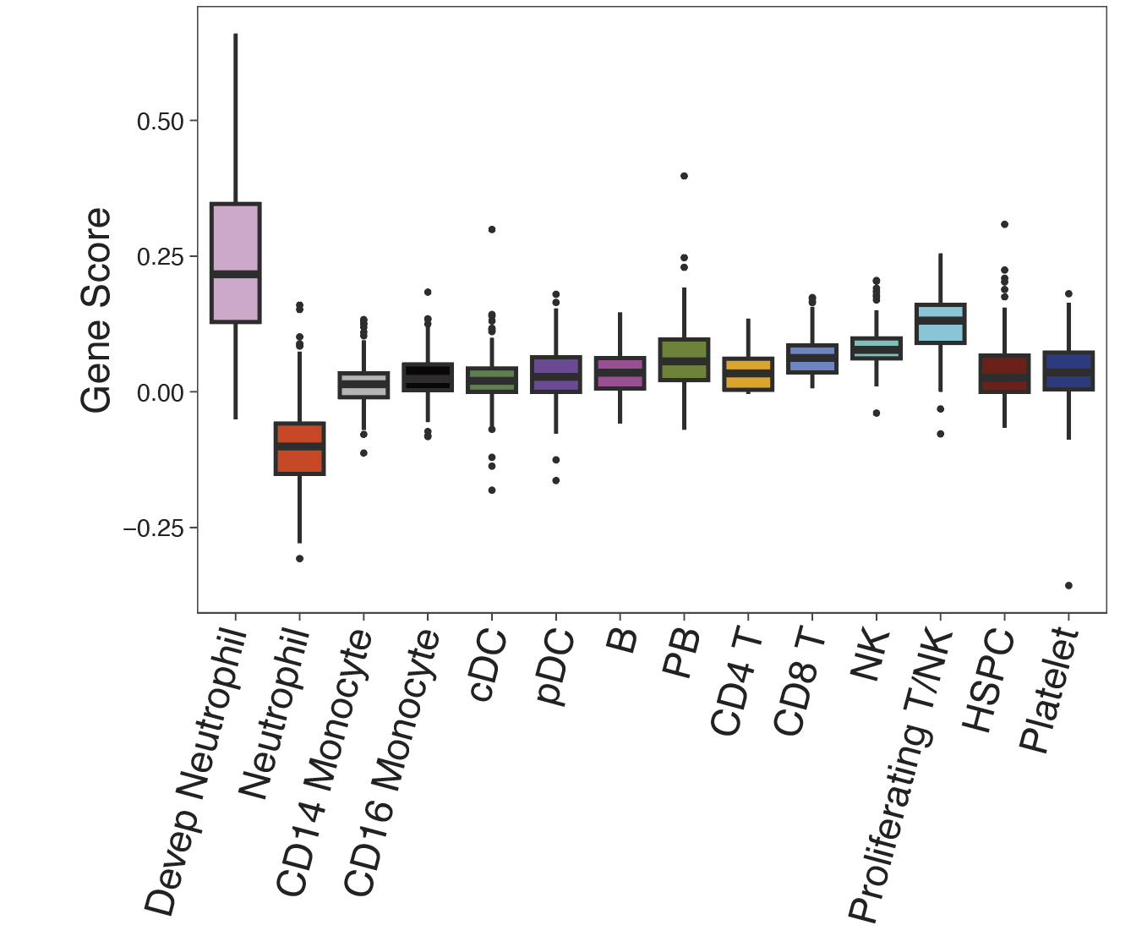

References:
1. Fleming S, Thompson M, Stevens R, Heneghan C, Plüddemann A, Maconochie I, et al. Normal ranges of heart rate and respiratory rate in children from birth to 18 years of age: a systematic review of observational studies. The Lancet. 2011 Mar 19;377(9770):1011–8.
2. National High Blood Pressure Education Program Working Group on High Blood Pressure in Children and Adolescents. The fourth report on the diagnosis, evaluation, and treatment of high blood pressure in children and adolescents. Pediatrics. 2004 Aug;114(2 Suppl 4th Report):555–76.
3. McIntosh AM, Tong S, Deakyne SJ, Davidson JA, Scott HF. Validation of the Vasoactive-Inotropic Score in Pediatric Sepsis*. Pediatr Crit Care Med. 2017 Aug;18(8):750–7.
4. Wong HR, Cvijanovich NZ, Anas N, Allen GL, Thomas NJ, Bigham MT, et al. PERSEVERE-II: Redefining the pediatric sepsis biomarker risk model with septic shock phenotype. Crit Care Med. 2016 Nov;44(11):2010–7.
5. Wong HR, Caldwell JT, Cvijanovich NZ, Weiss SL, Fitzgerald JC, Bigham MT, et al. Prospective clinical testing and experimental validation of the Pediatric Sepsis Biomarker Risk Model. Sci Transl Med [Internet]. 2019 Nov 13 [cited 2021 Mar 15];11(518). Available from: https://www.ncbi.nlm.nih.gov/pmc/articles/PMC7720682/
6. Atreya MR, Cvijanovich NZ, Fitzgerald JC, Weiss SL, Bigham MT, Jain PN, et al. Integrated PERSEVERE and endothelial biomarker risk model predicts death and persistent MODS in pediatric septic shock: a secondary analysis of a prospective observational study. Critical Care. 2022 Jul 11;26(1):210.
7. Atreya MR, Cvijanovich NZ, Fitzgerald JC, Weiss SL, Bigham MT, Jain PN, et al. Prognostic and predictive value of endothelial dysfunction biomarkers in sepsis-associated acute kidney injury: risk-stratified analysis from a prospective observational cohort of pediatric septic shock. Crit Care. 2023 Jul 3;27(1):260.
8. Schulte-Schrepping J, Reusch N, Paclik D, Baßler K, Schlickeiser S, Zhang B, et al. Severe COVID-19 Is Marked by a Dysregulated Myeloid Cell Compartment. Cell. 2020 Sep 17;182(6):1419-1440.e23.
9. Wilk AJ, Lee MJ, Wei B, Parks B, Pi R, Martínez-Colón GJ, et al. Multi-omic profiling reveals widespread dysregulation of innate immunity and hematopoiesis in COVID-19. J Exp Med. 2021 Aug 2;218(8):e20210582.
10. Sinha S, Rosin NL, Arora R, Labit E, Jaffer A, Cao L, et al. Dexamethasone modulates immature neutrophils and interferon programming in severe COVID-19. Nat Med. 2022 Jan;28(1):201–11.
11. Wong HR, Cvijanovich NZ, Anas N, Allen GL, Thomas NJ, Bigham MT, et al. Developing a clinically feasible personalized medicine approach to pediatric septic shock. Am J Respir Crit Care Med. 2015 Feb 1;191(3):309–15.

