Table 1.γ-H2AX foci counts in mouse hepatocytes. The number of foci per cell is shown (n = 10 mice/group).

Table 2. Number of micronuclei per 1,000 polychromatic erythrocytes (MNPCE) per mouse. Mitomycin C was used as a positive control.
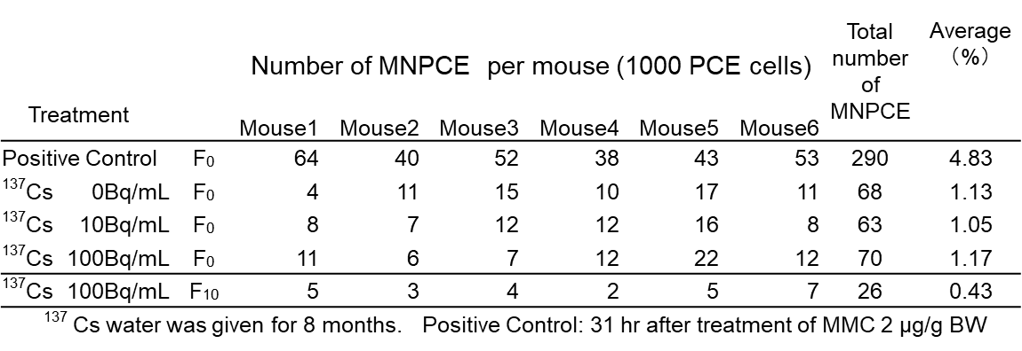

Table 3. The number of metaphases analyzed and chromosome aberrations common to all cells.
Table 4. Comparison of single nucleotide variant (SNV) rates in exon, intron, and intergenic regions between the Cesium-137 and control groups of A/J mice. SNV rates are shown in mice after 16 generations (G16) in the low-purity line (Origin–F15) and after 18 generations (G18) in the high-purity line (F20–F38). SNV: the number of single nucleotide variants. Frequency: The frequency of SNVs was calculated based on the number of base pairs analyzed in G16 or G18, respectively. Error bars: 95 % CI by Poisson distribution.

Table 5. The number of single nucleotide variants related to oxidative stress. (a) After 15 generations (G16) in the low-purity line (Origin–F15). (b) After 18 generations (G18) in the high-purity line (F20–F38).

Table 6. The number of base insertions and deletions (InDel) in the 18th generation (G18; F20–F38) of A/J mice with chronic internal exposure to Cesium-137 water (100 Bq/mL). InDel indicates the total number of insertion and deletion locations, while Del (%) indicates the number of occurrences of deletions and the percentage within InDel. The spectrum of single base deletions and the number of occurrences of 1 base deletion to 7 or more are shown.

Table 7. Frequency of single nucleotide variants (SNVs) in exon, intron, intergenic regions, and the total genome between the 1st, 2nd, 5th, 18th, and 25th generations of the Cesium-137 and control groups.
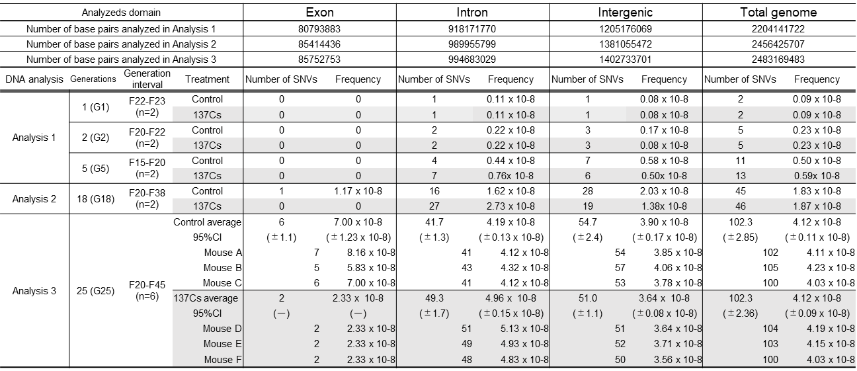
Table 8. Frequency of bases insertion and deletion (InDel) in Exon, Intron, Intergenic, and total genome between the 1st, 2nd, 5th, 18th, and 25th generations of the Cesium-137 and control groups.
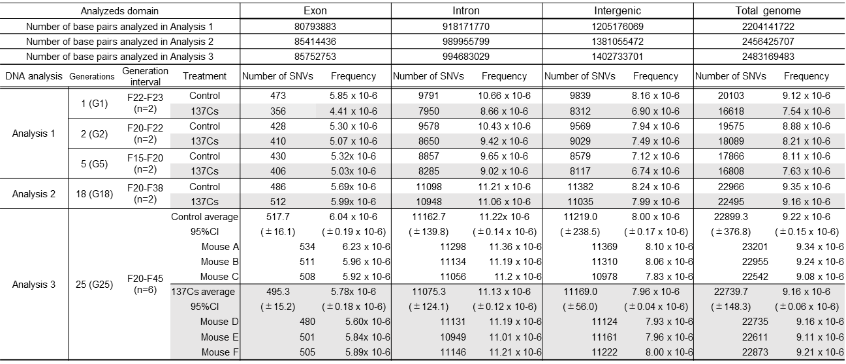

Table 9. The ratios of cytokine levels in the Cesium-137 group compared to the control group. From the ratio calculated, one was subtracted to obtain the excess cytokine level in the Cesium-137 group. Excess cytokine level = (Cesium-137 cytokine level/Control cytokine level) - 1. The sum of the respective excess cytokine levels for each month was then taken as the total excess level in (a) Th1 and (b) Th2 of the Cesium-137 group.

Table 10. The internal exposure dose assessment method was used to calculate the dose rate and the total exposure dose per generation.

