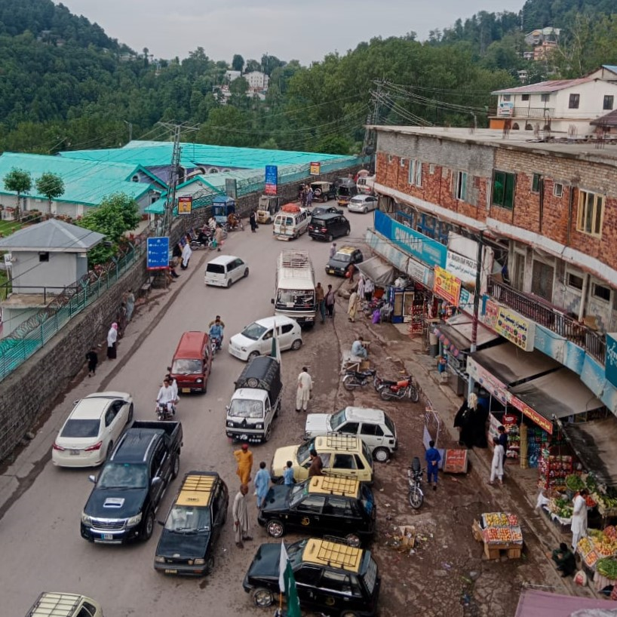
Figure S1 Panoramic view of one of the sampling sites S13 (Sani-bank).

Table S1 Experimental conditions of ICP-OES
Parameter | Value
RF Power | 1150 W
Pump Rate | 50 rpm
Auxiliary Gas Flow | 0.5 L/min
Nebulizer Gas Flow | 0.5 L/min
Coolant Gas Flow | 12 L/min
Purge Gas Flow | Normal
Viewing Plasma Height | 14mm

Table S2 RFD and CSF values for different metals for three exposure pathways.
Metals | RFD ING | RFD INH | RFD DER | CSF ING | CSF INH | CSF DER
Cu | 4.00$×$10⁻² | 4.02$×$10⁻² | 1.20$×$10⁻² | - | - | -
Pb | 3.50$×$10⁻³ | 3.25$×$10⁻³ | 5.25$×$10⁻⁴ | 0.0085 | - | 0.042
As | 3.00$×$10⁻⁴ | 3.00$×$10⁻⁴ | 1.23$×$10⁻⁴ | 1.5 | 1.5 | 1.5
Ni | 2.00$×$10⁻² | 2.06$×$10⁻² | 5.40$×$10⁻⁴ | - | 8.4 | -
Cr | 3.00$×$10⁻³ | 2.86$×$10⁻⁵ | 6.00$×$10⁻⁵ | 0.5 | - | 41
Mn | 1.40$×$10⁻¹ | 1.40$×$10⁻¹ | 1.80$×$10⁻³ | - | - | -
Ba | 7.00$×$10⁻² | 1.43$×$10⁻⁴ | 4.90$×$10⁻³ | - | - | -
Zn | 3.00$×$10⁻¹ | 3.00$×$10⁻¹ | 6.00$×$10⁻² | - | - | -
Co | 3.00$×$10⁻⁴ | 5.71$×$10⁻⁶ | 1.60$×$10⁻² | - | 9.8 | -

Table S3 Elemental concentration in mg/kg of soil samples collected from Industrial area of Islamabad with RSD ≤ 2% on dry weight basis.
Elements | I9-1 | I9-2(a) | I9-2(b) | I9-2(c) | I9-3 | I9-4 | I8-1 | I8-2 | I8-3 | I10-1 | I10-2 | I10-3
Al | 55049 | 49294 | 61972 | 19602 | 51656 | 41583 | 54994 | 56117 | 53112 | 61509 | 69218 | 62696.0
As | 5.17 | 3.13 | 3.89 | 73.91 | - | - | - | 2.29 | 2.63 | 5.36 | 2.76 | 7.5
Ba | 192 | 177 | 227 | 106 | 205 | 229 | 194 | 187 | 191 | 222 | 256 | 261.0
Ca | 64258 | 61825 | 52753 | 14014 | 81725 | 52785 | 63591 | 60242 | 37851 | 62914 | 41413 | 21078.0
Cd | 0.59 | 0.55 | 0.9 | - | - | 0.62 | 0.43 | 0.62 | - | 0.45 | 0.29 | 0.5
Co | 9.81 | 11.7 | 14.02 | 28.83 | 8.27 | 8.71 | 8.77 | 9.62 | 8.27 | 10.35 | 10.84 | 9.5
Cr | 69.3 | 142 | 165 | 446 | 66.6 | 74.7 | 63 | 65.44 | 55.88 | 63.47 | 72.11 | 54.1
Cu | 46.83 | 215 | 260 | 1720 | 68 | 50 | 27.7 | 27.61 | 21.34 | 32.13 | 25.98 | 24.2
Fe | 32298 | 68816 | 75034 | 139258 | 31912 | 31267 | 29579 | 31446 | 27517 | 33516 | 35029 | 28512.0
K | 29480 | 24348 | 26781 | 7311 | 22301 | 21161 | 24098 | 28123 | 25541 | 29971 | 32291 | 32395.0
Li | 22.22 | 18.15 | 21.29 | 20.5 | 15.17 | 15.8 | 16.82 | 22.72 | 16.83 | 22.99 | 22.11 | 20.8
Mg | 11409 | 9483 | 10987 | 3197 | 10696 | 9005 | 10708 | 10886 | 9020 | 12885 | 12476 | 8596.0
Mn | 634 | 896 | 1337 | 2018 | 651 | 547 | 601 | 596 | 541 | 656 | 645 | 567.0
Mo | 1.13 | 5.61 | 5.76 | 53 | 1.35 | 0.83 | 0.57 | 0.73 | 0.56 | 0.67 | 1.13 | 0.4
Na | 8773 | 8427 | 12225 | 2742 | 12133 | 8085 | 11274 | 7025 | 9120 | 10178 | 12578 | 11585.0
Ni | 27.4 | 47.6 | 47.8 | 207.5 | 20.2 | 23.7 | 20.64 | 25.46 | 19.48 | 26.26 | 27.06 | 22.4
P | 1164 | 610 | 561 | 415 | 653 | 3255 | 839 | 1245 | 575 | 854 | 826 | 401.0
Pb | 35.81 | 45.96 | 75.33 | 1090.83 | 52 | 44 | 39.22 | 23.48 | 23.99 | 29.58 | 21.23 | 17.4
S | 254 | 178 | 361 | 2674 | 152 | 758 | 153 | 327 | 138 | 149 | 35.73 | 57.1
Sb | 5.48 | 5.86 | 7.76 | 40.12 | 4.34 | 4.46 | 4.33 | 3.81 | 3.99 | 3.9 | 4.47 | 4.5
Sn | 3.26 | 14.3 | 16.9 | 173.09 | 5 | 3.29 | 2.23 | 1.1 | 1.29 | 1.79 | 1.84 | 1.6
Sr | 335 | 212 | 316 | 201 | 435 | 253 | 348 | 308 | 222 | 282 | 225 | 168.0
Ti | 2765 | 2692 | 3407 | 1345 | 2747 | 2244 | 2752 | 2999 | 2986 | 3163 | 3441 | 3624.0
V | 87 | 69.4 | 94.6 | 159 | 77.9 | 67.22 | 85.08 | 84.82 | 72.19 | 87.24 | 99.75 | 78.5
Zn | 284 | 406 | 540 | 2143 | 229 | 431 | 160 | 146 | 103 | 135 | 174 | 91.0
Zr | 64.64 | 68.8 | 101 | 37 | 76.8 | 91.14 | 66.72 | 106 | 84 | 89.81 | 84.11 | 105.0

- Below detection limit
% Values expressed in %

Table S4 Extracted eigen values for PCA.
Principal Components | Eigenvalues | % Variance | Cumulative %
PC1 | 12.98412 | 86.56% | 86.56%
PC2 | 1.72632 | 11.51% | 98.07%
PC3 | 0.24785 | 1.65% | 99.72%
PC4 | 0.02999 | 0.20% | 99.92%
PC5 | 0.00983 | 0.07% | 99.99%

Table S5 Pearson's correlation matrix for elements.
Elements | Al | As | Ba | Ca | Co | Cr | Cu | Fe | K | Mg | Mn | Ni | P | Pb | S | Ti | V | Zn
Al | 1.0
As | 0.3 | 1.0
Ba | 0.9 | 0.4 | 1.0
Ca | -0.2 | -0.6 | -0.2 | 1.0
Co | 0.5 | 0.8 | 0.5 | -0.7 | 1.0
Cr | 0.1 | 0.8 | 0.3 | -0.5 | 0.7 | 1.0
Cu | -0.5 | -0.1 | -0.2 | 0.3 | -0.1 | 0.0 | 1.0
Fe | 0.8 | 0.58 | 0.7 | -0.5 | 0.8 | 0.5 | -0.5 | 1.0
K | 0.7 | 0.8 | 0.8 | -0.6 | 0.8 | 0.5 | -0.2 | 0.7 | 1.0
Mg | 0.9 | 0.1 | 0.7 | -0.1 | 0.3 | 0.1 | -0.6 | 0.8 | 0.4 | 1.0
Mn | 0.4 | 0.4 | 0.4 | -0.1 | 0.5 | 0.4 | 0.1 | 0.5 | 0.3 | 0.5 | 1.0
Ni | 0.4 | 0.7 | 0.5 | -0.8 | 0.8 | 0.8 | -0.4 | 0.7 | 0.6 | 0.4 | 0.2 | 1.0
P | -0.4 | 0.1 | -0.3 | 0.3 | -0.1 | 0.0 | 0.3 | -0.3 | -0.3 | -0.3 | 0.5 | -0.3 | 1.0
Pb | -0.7 | 0.1 | -0.5 | 0.4 | -0.2 | 0.1 | 0.6 | -0.4 | -0.4 | -0.6 | 0.2 | -0.4 | 0.6 | 1.0
S | -0.3 | -0.3 | -0.2 | 0.8 | -0.5 | -0.2 | 0.2 | -0.4 | -0.5 | -0.1 | 0.2 | -0.5 | 0.7 | 0.5 | 1.0
Ti | 0.5 | 0.7 | 0.5 | -0.6 | 0.9 | 0.5 | -0.1 | 0.8 | 0.6 | 0.5 | 0.7 | 0.5 | 0.1 | -0.1 | -0.3 | 1.0
V | 0.5 | 0.6 | 0.5 | -0.4 | 0.9 | 0.5 | 0.0 | 0.8 | 0.6 | 0.5 | 0.6 | 0.5 | 0.0 | -0.1 | -0.3 | 0.9 | 1.0
Zn | -0.2 | 0.2 | -0.1 | 0.4 | -0.2 | 0.3 | 0.0 | -0.1 | -0.2 | 0.0 | 0.4 | -0.1 | 0.7 | 0.5 | 0.8 | -0.1 | -0.2 | 1.0

Table S6 Carcinogenic risk calculated for various metals for three exposure pathways.
 |  |  | Adults |  |  |  |  |  | Children
Metals | CRLE_{Ing} | CRLE_{Inh} |  | CRLE_{Der} | CRLE_{Total} |  | Cancer Risk | CRLE_{Ing} |  | CRLE_{Inh} | CRLE_{Der} |  | CRLE_{Total} | Cancer  Risk
Cu | - | - |  | - | - |  | - | - |  | - | - |  | - | -
Pb | 2$×$10⁻⁷ | - |  | 5$×$10⁻⁹ | 2$×$10⁻⁷ |  | No | 2$×$10⁻⁶ |  | - | 4$×$10⁻⁹ |  | 2$×$10⁻⁶ | No
As | 4$×$10⁻⁶ | 7$×$10⁻¹¹ |  | 6$×$10⁻⁷ | 5$×$10⁻⁶ |  | No | 5$×$10⁻⁵ |  | 3$×$10⁻⁹ | 5$×$10⁻⁷ |  | 4$×$10⁻⁵ | No
Ni | - | 1$×$10⁻⁶ |  | - | 1$×$10⁻⁶ |  | No | - |  | 1$×$10⁻⁷ | - |  | 1$×$10⁻⁷ | No
Cr | 2$×$10-⁵ | - |  | 9$×$10⁻⁶ | 4$×$10⁻⁵ |  | No | 3$×$10⁻⁴ |  | - | 8$×$10⁻⁶ |  | 3$×$10⁻⁴ | YES
Mn | - | - |  | - | - |  | - | - |  | - | - |  | - | -
Ba | - | - |  | - | - |  | - | - |  | - | - |  | - | -
Zn | - | - |  | - | - |  | - | - |  | - | - |  | - | -
Co | - | 9$×$10⁻ |  | - | 9$×$10⁻¹⁰ |  | No | - |  | 4$×$10⁻⁸ | - |  | 4$×$10⁻⁸ | No

Table S7 Correlation matrix for radionuclides.
Radionuclides | Th-232 | Ra-226 | K-40 | Cs-137
Th-232 | 1.000 | 0.458 | 0.548 | 0.108
Ra-226 | 0.458 | 1.000 | 0.567 | -0.038
K-40 | 0.548 | 0.567 | 1.000 | 0.152
Cs-137 | 0.108 | -0.038 | 0.152 | 1.000

Table S8 Health hazard indices for exposure from radionuclides.
Sites | Ra_{eq} (Bq/kg) | D_{out}  (nGy /h) | D_{in} (nGy/h) | E_{out} (mSv/y) | E_{in} (mSv/y) | E_{out}+ E_{in} (mSv/y) | LCR_{out} ×10⁻³ | LCR_{in}  ×10⁻³ | LCR _{total}×10⁻³
S1 | 32.9 | 35 | 67.3 | 0.04 | 0.33 | 0.37 | 0.14 | 1.09 | 1.23
S2 | 38.6 | 45.8 | 87.8 | 0.06 | 0.43 | 0.49 | 0.18 | 1.42 | 1.61
S3 | 38.6 | 43.1 | 82.6 | 0.05 | 0.41 | 0.46 | 0.17 | 1.34 | 1.51
S4 | 41.9 | 48.9 | 94 | 0.06 | 0.46 | 0.52 | 0.2 | 1.52 | 1.72
S5 | 39.3 | 40.1 | 77 | 0.05 | 0.38 | 0.43 | 0.16 | 1.25 | 1.41
S6 | 45.4 | 50.1 | 96.3 | 0.06 | 0.47 | 0.53 | 0.2 | 1.56 | 1.76
S7 | 41.5 | 46.7 | 89.1 | 0.06 | 0.44 | 0.49 | 0.19 | 1.44 | 1.63
S8 | 43.1 | 45.4 | 88.1 | 0.06 | 0.43 | 0.49 | 0.18 | 1.43 | 1.61
S9 | 37.9 | 41.8 | 80.1 | 0.05 | 0.39 | 0.44 | 0.17 | 1.30 | 1.46
S10 | 34.2 | 38.7 | 74.1 | 0.05 | 0.36 | 0.41 | 0.16 | 1.20 | 1.36
S11 | 34.2 | 41.2 | 79.2 | 0.05 | 0.39 | 0.44 | 0.17 | 1.28 | 1.45
S12 | 29.6 | 33.7 | 63.6 | 0.04 | 0.31 | 0.35 | 0.13 | 1.03 | 1.16
S13 | 36.4 | 43.3 | 82.7 | 0.05 | 0.41 | 0.46 | 0.17 | 1.34 | 1.51
S14 | 32.8 | 44.2 | 84.5 | 0.05 | 0.41 | 0.47 | 0.18 | 1.37 | 1.55
S15 | 48.5 | 55.3 | 105.3 | 0.07 | 0.52 | 0.59 | 0.22 | 1.71 | 1.93
Mean | 38.2 | 43.5 | 83 | 0.05 | 0.41 | 0.46 | 0.18 | 1.35 | 1.53
World Average (UNSCEAR, 2000) | 129 | 84 | 59 | 0.07 | 0.41 | 0.52 | 0.29 | 1.16 | 1.45

