Supplementary files

Supplementary table 1
Supplementary Table 1. Baseline characteristics by calendar periods for patients undergoing mitral valve surgery with mitral regurgitation as a primary diagnosis within a year prior to surgery and mitral stenosis diagnosis.
 | Calendar period  2001-2005  N=104 |  |  | Calendar period  2006-2010  N=79 |  |  | Calendar period  2011-2015  N=66 |  |  |  | Calendar period  2016-2021  N=66
Demographics
Male sex (%) | 28 |  | (26.9%) | 18 |  | (22.8%) | 11 |  | (16.7%) |  | 19 |  | (28.8%)
Age median years (IQR) | 61.7 |  | (49.4-68.9) | 63.0 |  | (48.5-72.1) | 58.0 |  | (50.4-69.0) |  | 60.9 |  | (53.9-71.3)
Duration of admission
Days | 14.0 |  | (10.0-25.0) | 15 |  | (9.0-24.0) | 13.0 |  | (9.0-29.0) |  | 13.5 |  | (9.0-27.0)
Diagnosis of rheumatic mitral valve disease prior to surgical intervention
 | 70 |  | (67.3%) | 43 |  | (54.4%) | 35 |  | (53.0%) |  | 30 |  | (45.5%)
Type of mitral valve surgery
Repair | 0 |  | (0%) | 0 |  | (0%) | 0 |  | (0%) |  | 0 |  | (0%)
Replacement | 104 |  | (100%) | 79 |  | (100%) | 66 |  | (100%) |  | 66 |  | (100%)
Balloon mitral valvotomy
 | 0 |  | (0%) | 0 |  | (0%) | 0 |  | (0%) |  | 0 |  | (0%)
Other heart surgery performed on the day of MS surgery
CABG | 15 |  | (14.4%) | 9 |  | (11.4%) | 5 |  | (7.6%) |  | 4 |  | (6.1%)
Aortic valve surgery | 21 |  | (20.2%) | 16 |  | (20.3%) | 14 |  | (21.2) |  | 11 |  | (16.7%)
Tricuspid valve surgery | 4 |  | (3.9%) | 9 |  | (11.4%) | 8 |  | (12.1%) |  | 12 |  | (18.2%)
Prior cardiac surgery
 | <3 |  |  | 3 |  | (3.8%) | <3 |  |  |  | 6 |  | (9.1%)
Other heart valve diseases
Aortic regurgitation | 25 |  | (24.0%) | 18 |  | (22.8%) | 14 |  | (21.2%) |  | 21 |  | (31.8%)
Aortic stenosis | 20 |  | (19.2%) | 13 |  | (16.5%) | 10 |  | (15.2%) |  | 10 |  | (15.2%)
Comorbidities
Stroke | 12 |  | (11.5%) | 7 |  | (8.9%) | 7 |  | (10.6%) |  | 8 |  | (12.1%)
Bleeding | 16 |  | (15.4%) | 9 |  | (11.4%) | 16 |  | (24.2%) |  | 10 |  | (15.2%)
Heart failure | 50 |  | (48.1%) | 30 |  | (38.0%) | 27 |  | (40.9%) |  | 20 |  | (30.3%)
Hypertension | 60 |  | (57.7%) | 43 |  | (54.4%) | 31 |  | (47.0%) |  | 41 |  | (62.1%)
Ischaemic heart disease | 23 |  | (32.9%) | 28 |  | (35.9%) | 18 |  | (38.3%) |  | 17 |  | (27.9%)
Atrial fibrillation | 62 |  | (59.6%) | 44 |  | (55.7%) | 37 |  | (56.1%) |  | 38 |  | (57.6%)
COPD | 13 |  | (12.5%) | 13 |  | (16.5%) | 16 |  | (24.2%) |  | 13 |  | (19.7%)
Liver disease | <3 |  |  | <3 |  |  | 6 |  | (9.1%) |  | 4 |  | (6.1%)
Chronic renal failure | 5 |  | (4.8%) | 3 |  | (3.8%) | 10 |  | (15.2%) |  | 9 |  | (13.6%)
Diabetes | 7 |  | (6.7%) | 16 |  | (20.3%) | 9 |  | (13.6%) |  | 15 |  | (22.7%)
Malignancy | 6 |  | (5.8%) | 11 |  | (13.9%) | 6 |  | (9.1%) |  | 12 |  | (18.2%)
Medications
Calcium channel blockers | 11 |  | (10.6%) | 6 |  | (7.6%) | 11 |  | (16.7%) |  | 16 |  | (24.2%)
RAS inhibitors | 27 |  | (26.0%) | 26 |  | (32.9%) | 14 |  | (21.2%) |  | 24 |  | (36.4%)
Loop diuretics | 60 |  | (57.7%) | 44 |  | (55.7%) | 38 |  | (57.6%) |  | 42 |  | (63.6%)
Aspirin | 22 |  | (21.2%) | 23 |  | (29.1%) | 21 |  | (31.8%) |  | 10 |  | (15.2%)
OAC | 67 |  | (64.4%) | 51 |  | (64.6%) | 36 |  | (54.5%) |  | 42 |  | (63.6%)
Statin | 14 |  | (13.5%) | 28 |  | (35.4%) | 27 |  | (40.9%) |  | 31 |  | (37.0%)
Beta blockers | 41 |  | (39.4%) | 34 |  | (43.0%) | 28 |  | (42.4%) |  | 30 |  | (45.5%)
Digoxin | 46 |  | (44.2%) | 28 |  | (35.4%) | 17 |  | (25.8%) |  | 13 |  | (19.7%)
Geographic region
Denmark | 84 |  | (80.8%) | 49 |  | (62.0%) | 45 |  | (68.2%) |  | 45 |  | (68.2%)
Europe (DK excluded) | 4 |  | (3.9%) | 9 |  | (11.4%) | 3 |  | (4.6%) |  | 4 |  | (6.1%)
Asia | 14 |  | (13.5%) | 15 |  | (19.0%) | 16 |  | (24.2%) |  | 15 |  | (22.7%)
Rest of the world | <3 |  |  | 6 |  | (7.6%) | <3 |  |  |  | <3

Supplementary table 2 – This table shows the incidence rate pr million inhabitants of surgical intervention for Mitral stenosis in patients with and without Danish origin

 | Calendar period  2001-2005 |  | Calendar period 2006-2010 |  | Calendar period 2011-2015 |  | Calendar period 2016-2021
 | N | IR pr 1 million | N | IR pr 1 million | N | IR pr 1 million | N | IR pr 1 million
Danish origin | 43 | 8.42 | 50 | 9.81 | 31 | 6.03 | 41 | 7.90
Other origin | 27 | 97.82 | 28 | 73.49 | 16 | 34.71 | 20 | 33.84

Supplementary figure 1. Incidence of surgical intervention in patients with mitral stenosis and mitral regurgitation
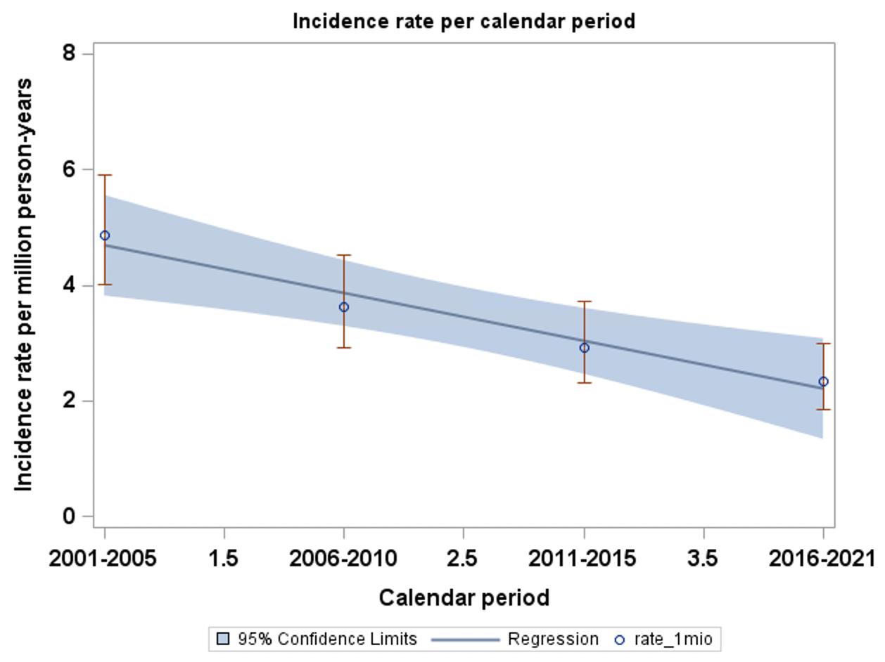
This figure shows the incidence of surgical intervention per million person-years according to calendar periods in patients with mitral stenosis and with mitral regurgitation as a primary diagnosis within a year prior to surgery.

