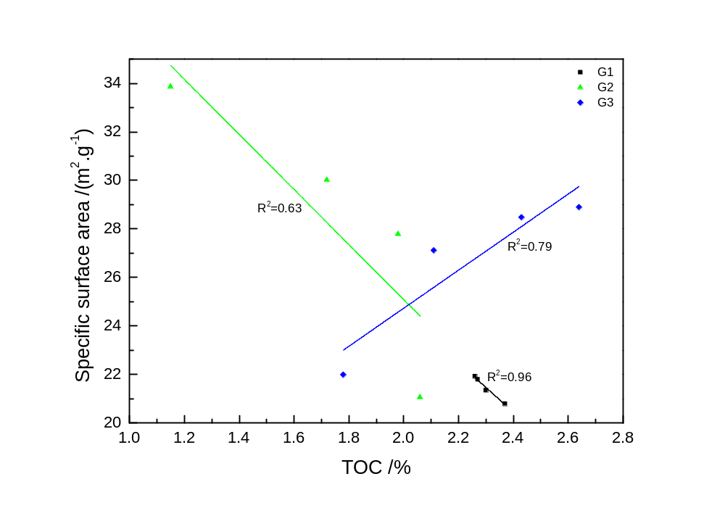
Fig.1 The correlation of TOC content alteration and specific surface area evolution of black shale samples in different group.
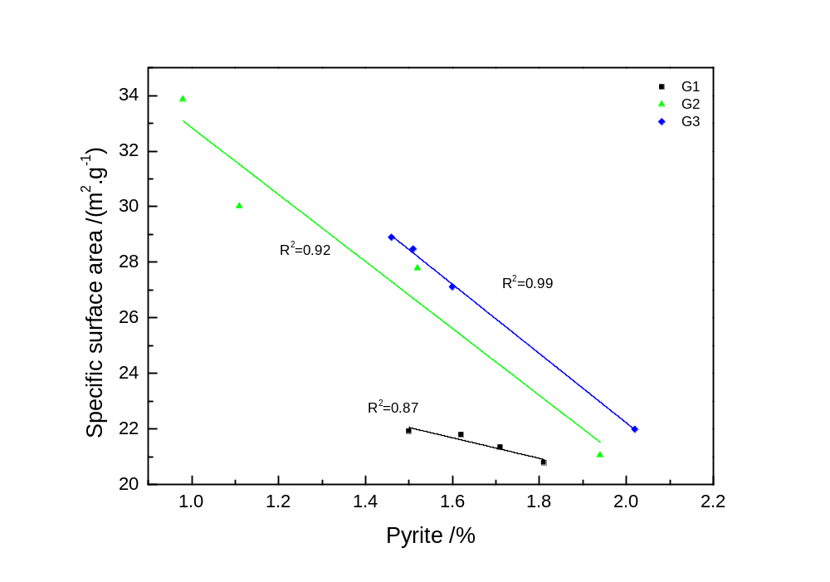
Fig.2 The correlation of pyrite content alteration and specific surface area evolution of black shale samples in different group.
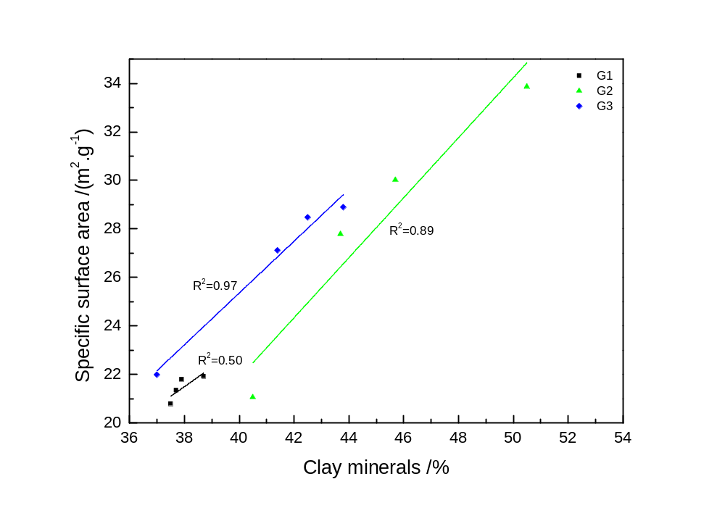
Fig.3 The correlation of clay minerals content alteration and specific surface area evolution of black shale samples in different group.

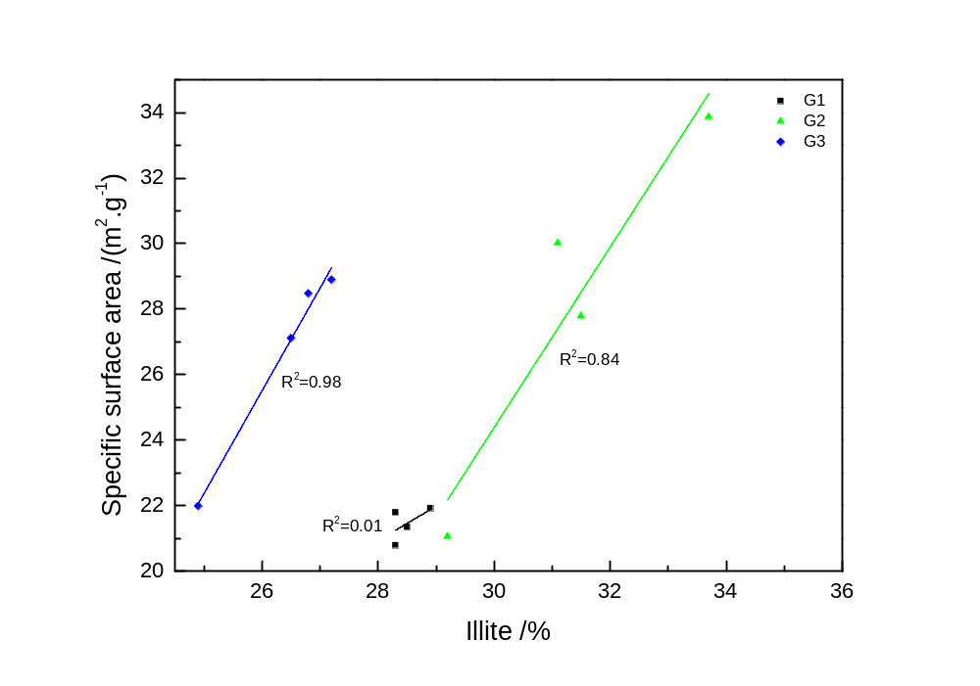
Fig.4 The correlation of illite content alteration and specific surface area evolution of black shale samples in different group.

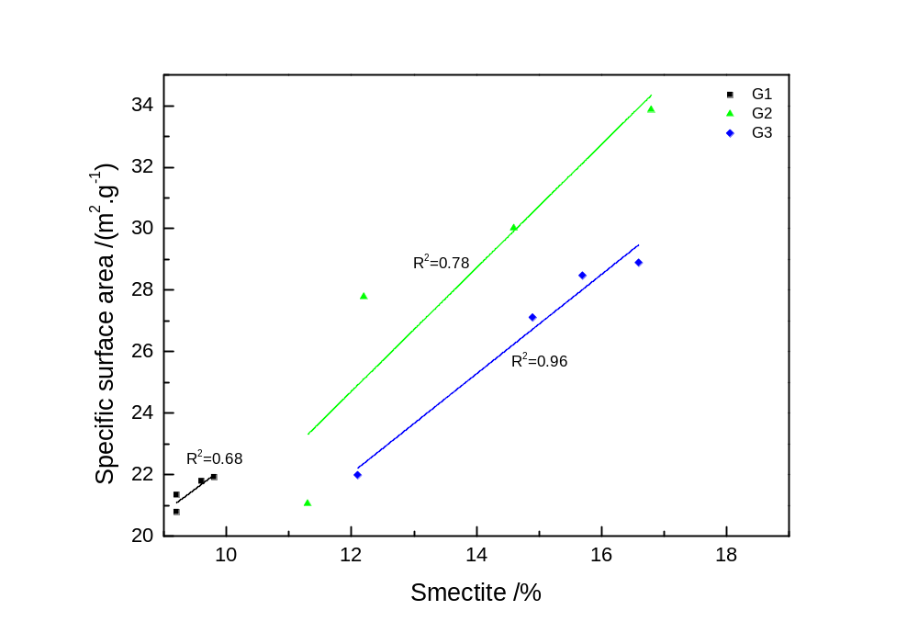
Fig.5 The correlation of smetite content alteration and specific surface area evolution of black shale samples in different group.

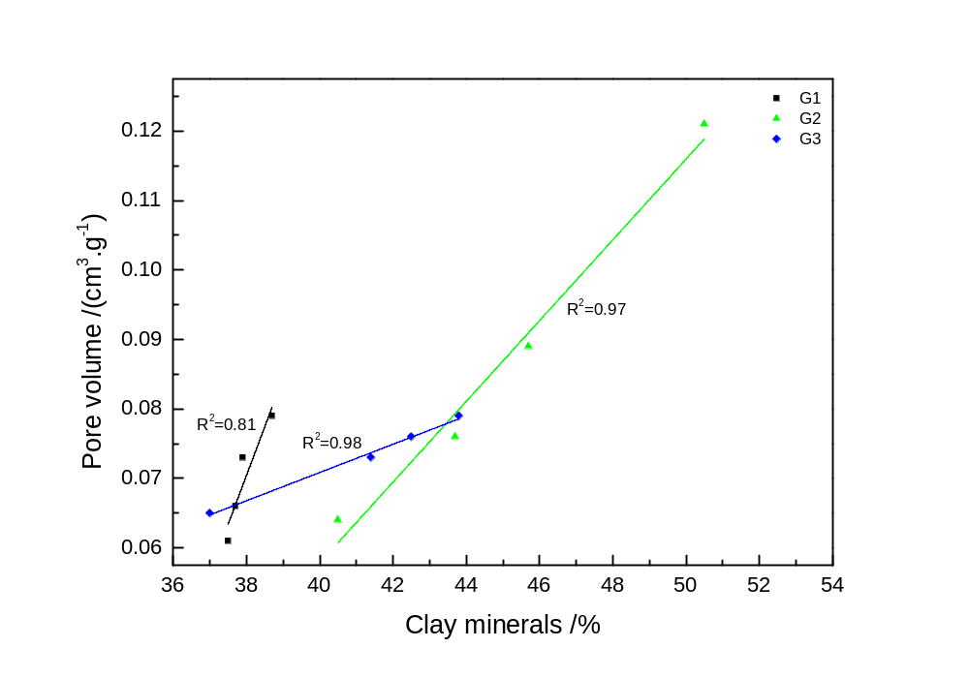
Fig. 6 The correlation of clay minerals content alteration and pore evolution of black shale samples in different group.

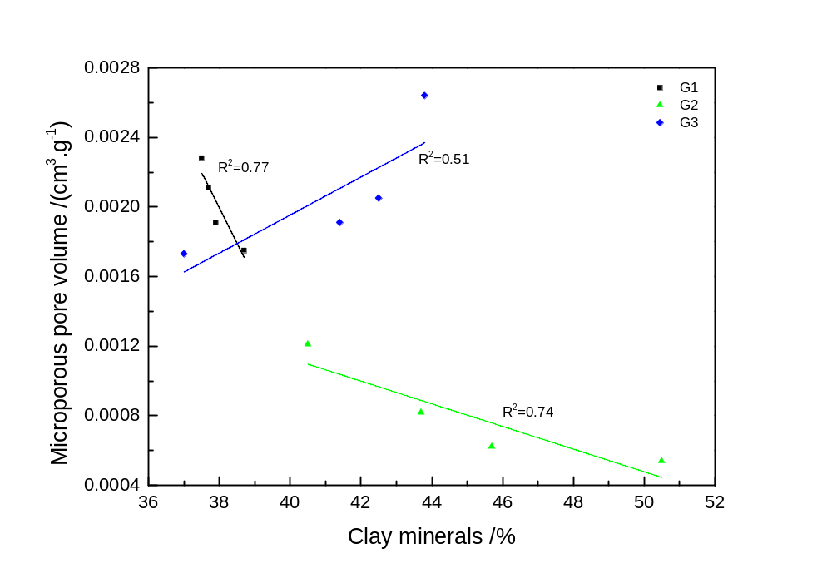
Fig. 8 The correlation of clay minerals content alteration and micro-pores evolution of black shale samples in different group.

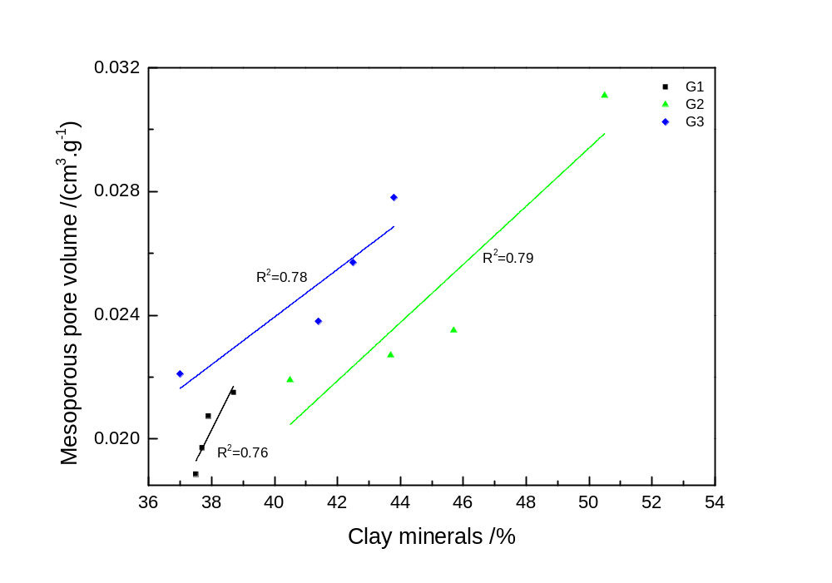
Fig. 9 The correlation of clay minerals content alteration and meso-pores evolution of black shale samples in different group.

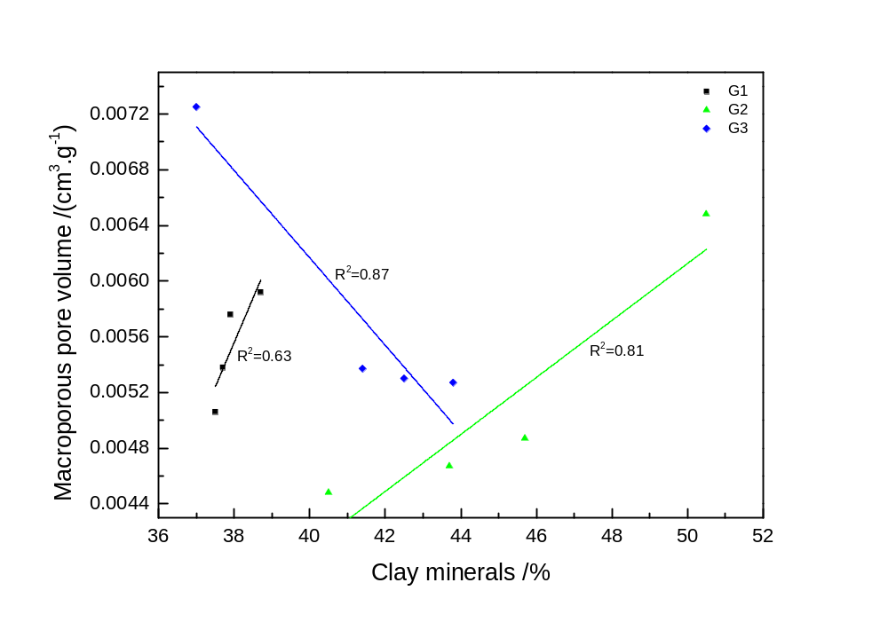
Fig. 10 The correlation of clay minerals content alteration and macro-pores evolution of black shale samples in different group.

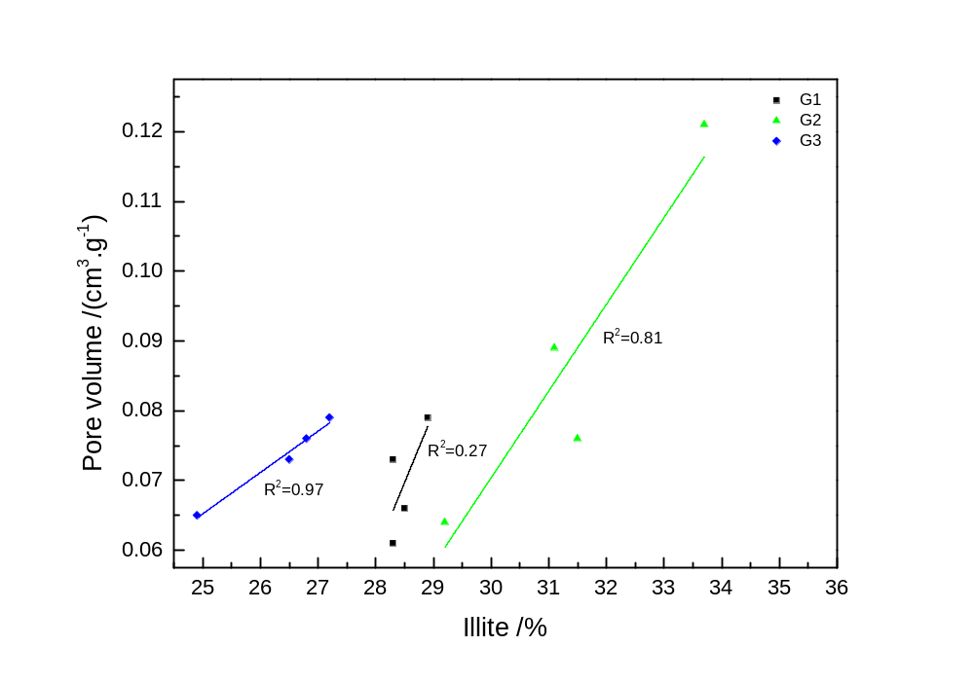
Fig. 11 The correlation of illite content alteration and pore evolution of black shale samples in different group.

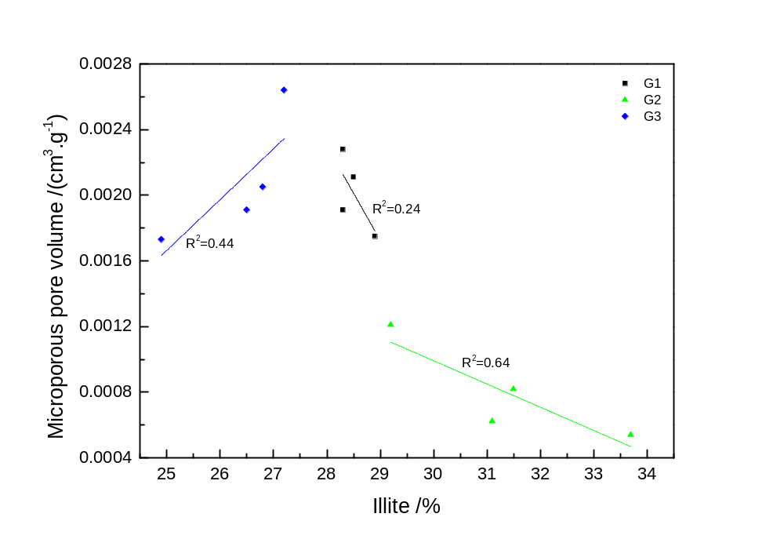
Fig. 12 The correlation of illite content alteration and micro-pores evolution of black shale samples in different group.

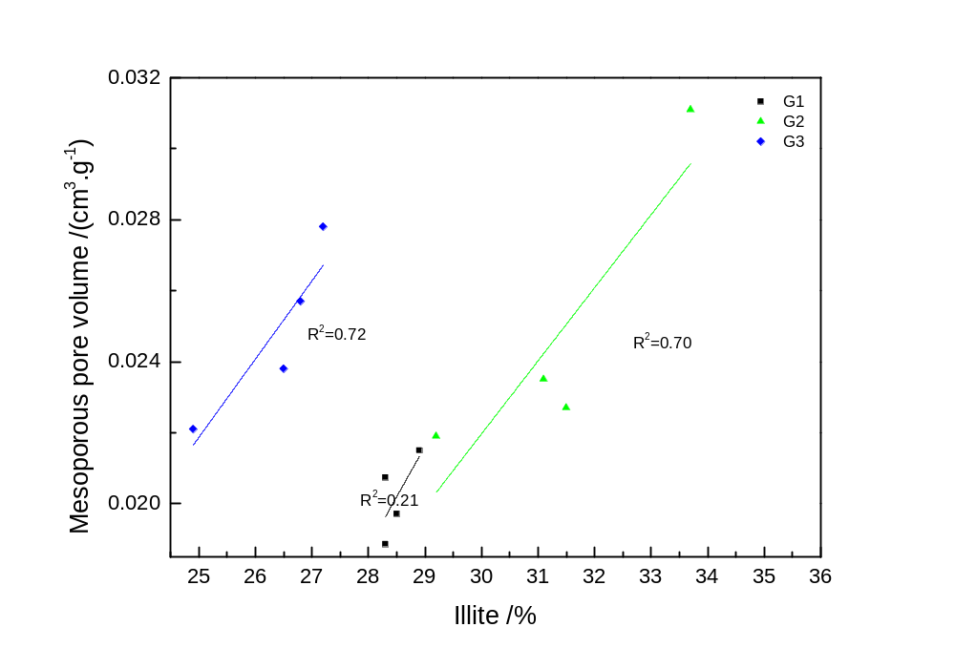
Fig. 13 The correlation of illite content alteration and meso-pores evolution of black shale samples in different group.

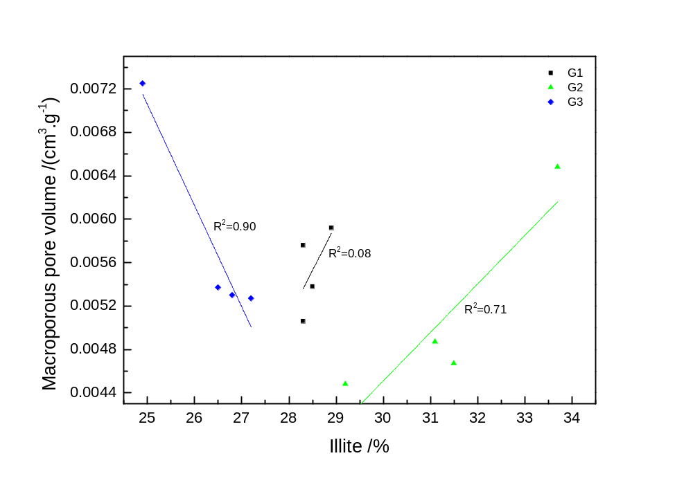
Fig. 14 The correlation of illite content alteration and macro-pores evolution of black shale samples in different group.

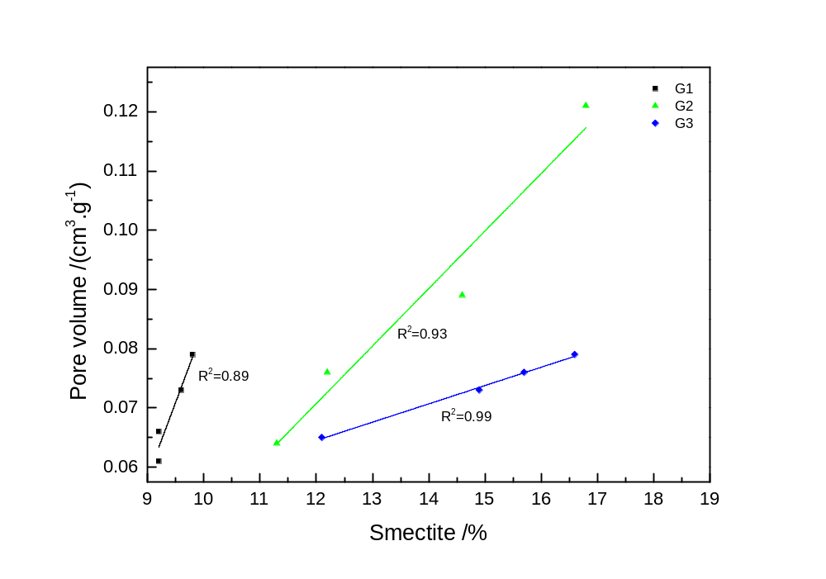
Fig. 15 The correlation of smectite content alteration and pore evolution of black shale samples in different group.

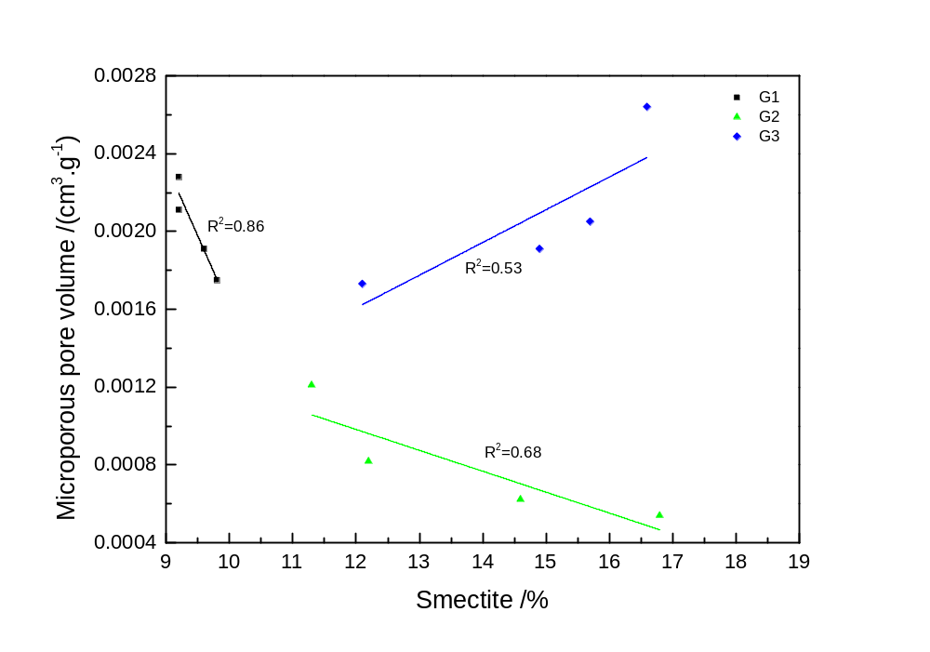
Fig. 16 The correlation of smectite content alteration and micro-pores evolution of black shale samples in different group.

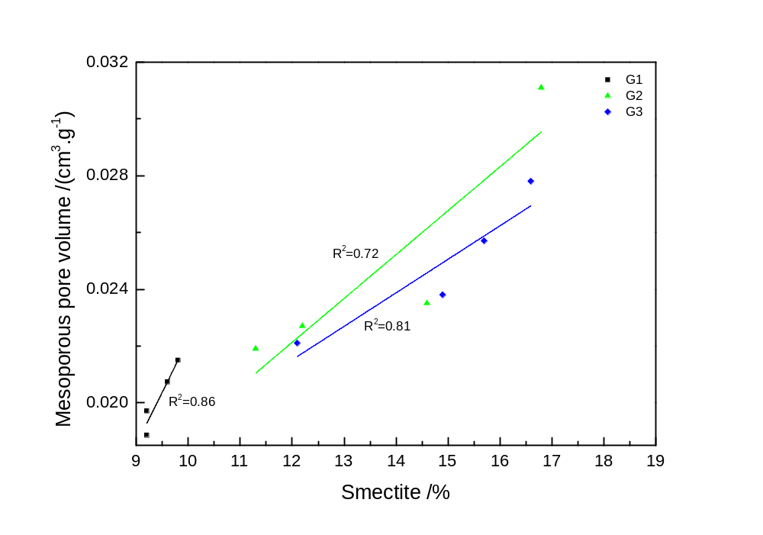
Fig. 17 The correlation of smectite content alteration and meso-pores evolution of black shale samples in different group.

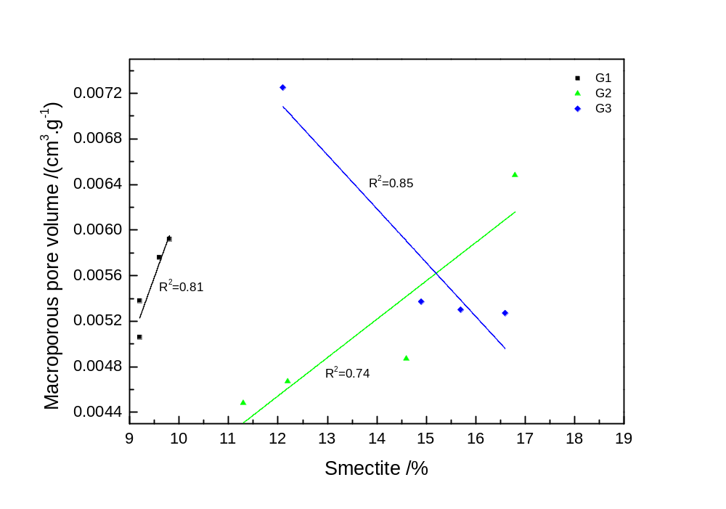
Fig. 18 The correlation of smectite content alteration and macro-pores evolution of black shale samples in different group.

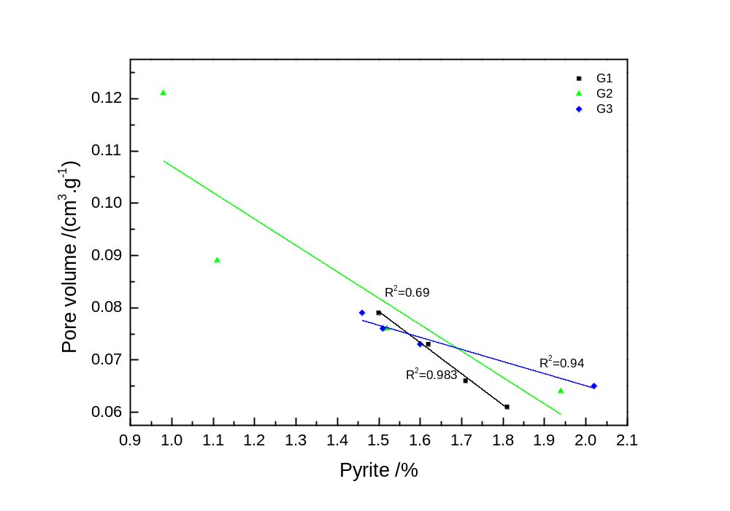
Fig. 19 The correlation of pyrite content alteration and pore evolution of black shale samples in different group.

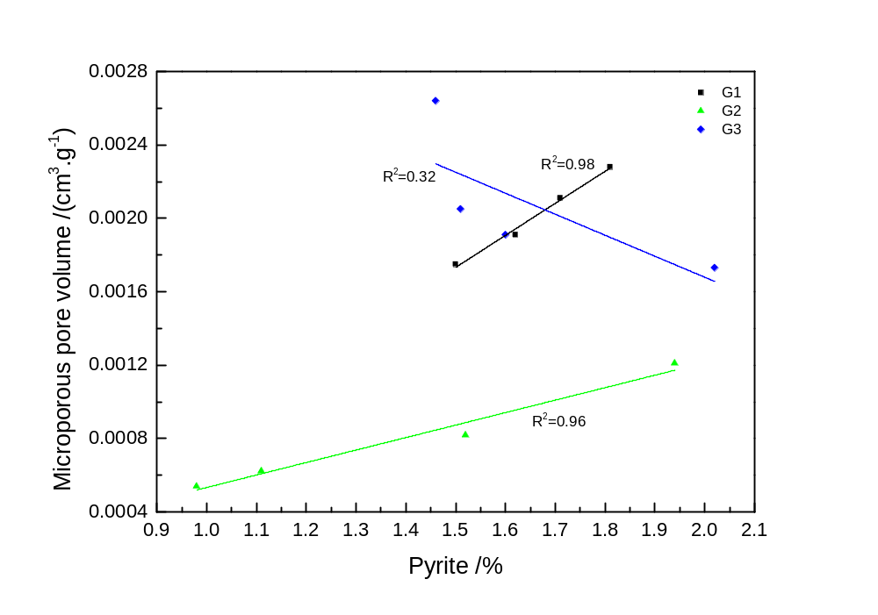
Fig. 20 The correlation of pyrite content alteration and micro-pores evolution of black shale samples in different group.

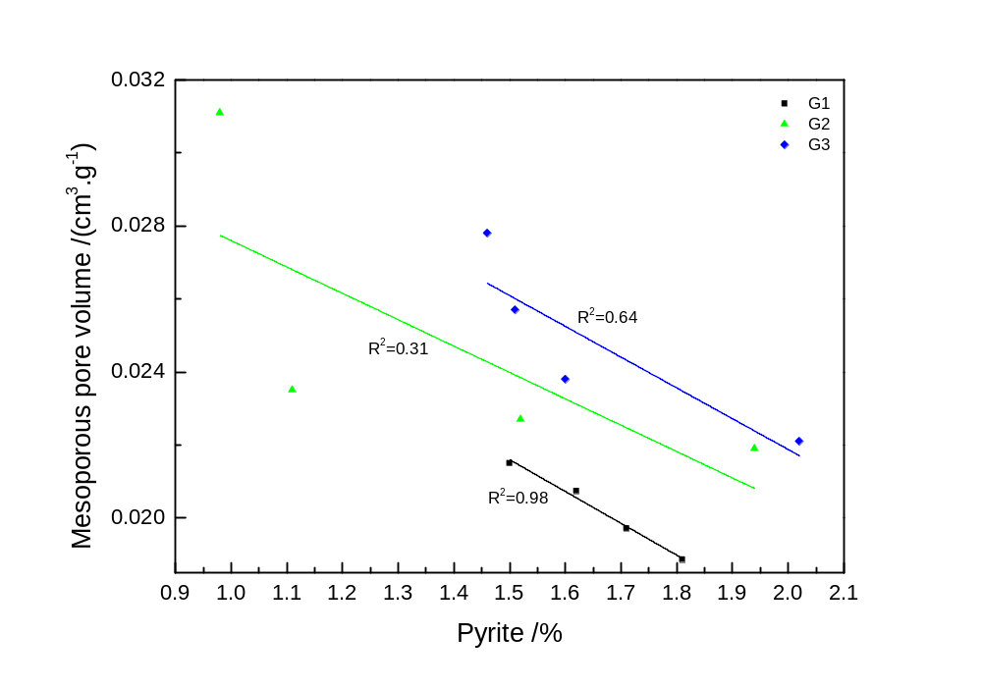
Fig. 21 The correlation of pyrite content alteration and meso-pores evolution of black shale samples in different group.

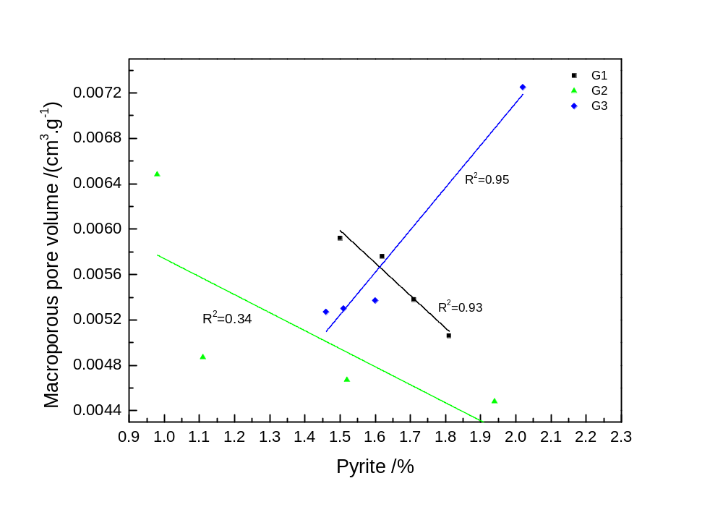
Fig. 22 The correlation of pyrite content alteration and macro-pores evolution of black shale samples in different group.

