Supplementary Materials for
Hyper-recombination in ribosomal DNA is driven by resection-independent RAD51 loading
Zita Gal et al.
*Dorthe Helena Larsen. Email: dhl@cancer.dk

This PDF file includes:
Figs. S1 to S5

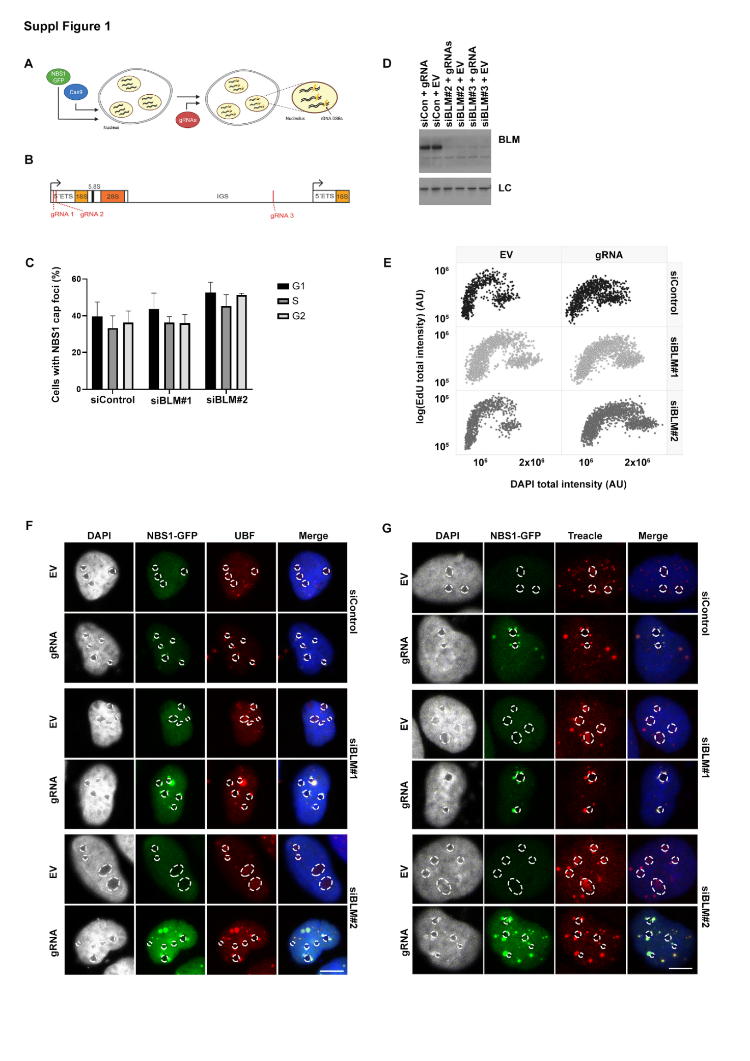
Fig. S1. (A) Schematic illustration of the U2OS-Cas9 cell model. U2OS cells constitutively expressing GFP conjugated NBS1 and Cas9 nuclease. rDNA DSBs are induced by supplementing Cas9 with gRNAs targeting the rDNA. Created with BioRender.com. (B) Schematic illustration of the rDNA repeat unit. The gRNA cut sites are indicated in red. (C) Cell cycle distribution of the cells showing at least one NBS1 cap foci after rDNA DSBs induction. Cells were transfected with siRNAs for 24h followed by transfection of gRNA plasmids for 6h, and cell cycle distribution was analyzed by QIBC based on DAPI. The graph depicts averages of three experiments (n>345 cells/condition/experiment). (D) Western blot analysis of BLM expression levels in U2OS-Cas9 cells. U2OS-Cas9 cells were treated with siRNA for 24h and subsequently transfected with EV or gRNA plasmids. Western blot analysis was performed with antibodies against BLM and importin-β (loading control, LC). (E) Cell cycle analysis of cells treated as (D). Cells were labeled with EdU 1h before fixation and then stained with DAPI. Total EdU intensity per cell was determined by QIBC (n>666 cells/condition). (F) Analysis of UBF localization. Cells were treated as in (D) and were immunostained with antibody against UBF. (G) Analysis of Treacle localization. Cells were treated as in (A) and were immunostained with antibody against Treacle. Statistical significance is depicted with stars (* p<0.05, ** p<0.01, *** p< 0.001), and no legend: not significant. (QIBC: quantitative image-based cytometry, EV: empty vector, LC: loading control).

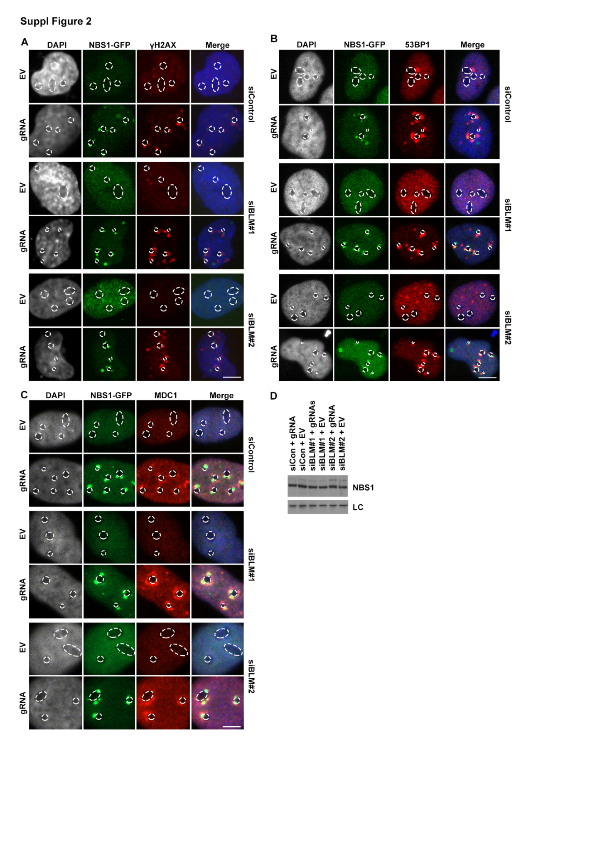
Fig. S2. (A) γH2AX recruitment to nucleolar caps. U2OS-Cas9 cells were treated with siRNA for 24h and subsequently transfected with EV or gRNA plasmids for 6h, and immunostained with antibody against γH2AX. (B) 53BP1 recruitment to nucleolar caps. Cells were treated as in (A) and were immunostained with antibody against 53BP1. (C) MDC1 recruitment to nucleolar caps. Cells were treated as in (A), and immunostained with antibody against MDC1. (D) Western blot analysis of NBS1 expression level of cells in (A), using NBS1 antibody and importin-β as LC. (EV: empty vector, LC: loading control).

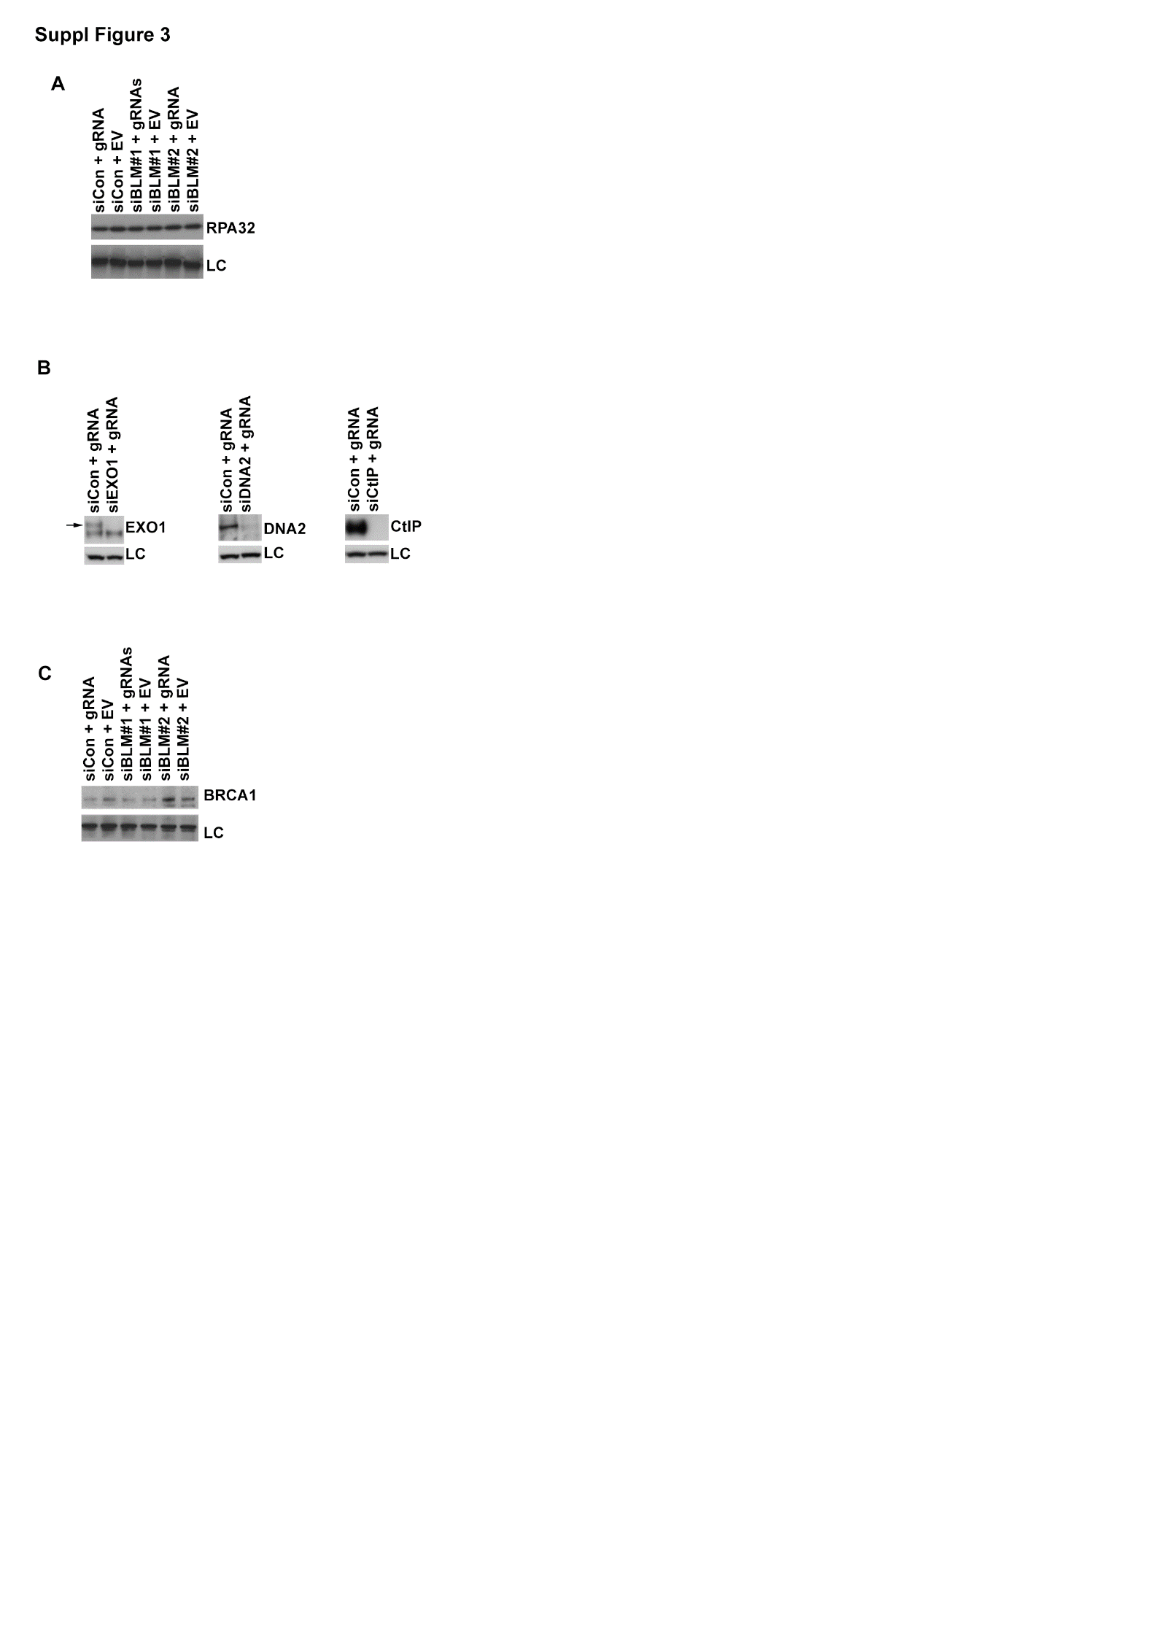
Fig. S3. (A) Western blot analysis of RPA32 expression level using RPA32 antibody and SMC1 as LC. U2OS-Cas9 cells were treated with siRNA for 24h and subsequently transfected with EV or gRNAs for 6h. (B) Western blot analysis of EXO1, DNA2 and CtIP knock-down. Cells were treated as in (A). LC: α-tubulin. (C) Western blot analysis of BRCA1 expression level of cells in treated as in (A), using BRCA1 antibody and SMC1 as LC. (EV: empty vector, LC: loading control).

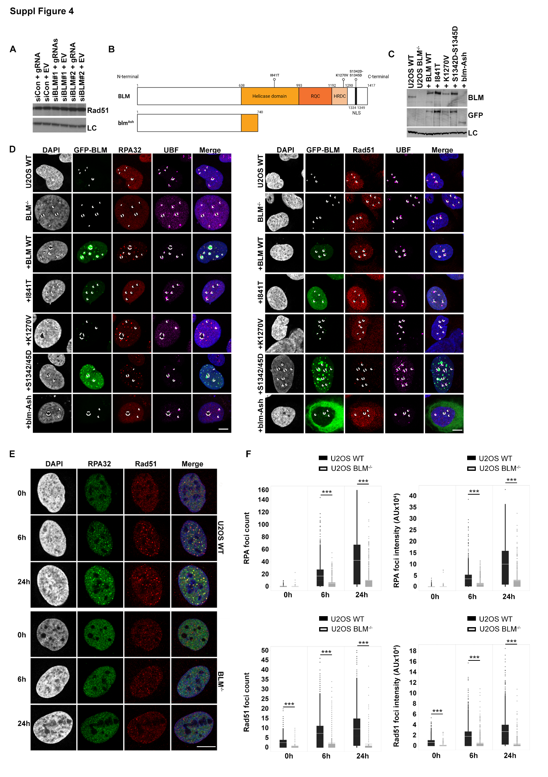Fig. S4. (A) Western blot analysis of RAD51 expression level, using RAD51 antibody and GAPDH as LC. Cells were treated with siRNA for 24h and subsequently transfected with EV or gRNA plasmids for 6h. (B) Schematic overview of the BLM mutants used for reconstitution. RQC: RecQ C-terminal domain, HDRC: RNaseD C-terminal domain. (C) Western blot analysis of reconstruction efficiency, using BLM and GFP antibodies and α-tubulin as LC. Cells were transfected with the corresponding plasmids and harvested after 48h. (D) Recruitment of RPA32 (left panel) & RAD51 (right panel) in EV treated BLM^{-/-} cells after reconstruction with GFP-BLM WT or mutant plasmids. Cells were transfected with the corresponding plasmids, and 48h later rDNA damage was induced by Cas9-gRNA RNP transfection for 6h. Scale bars 10 μm. (E) Images of RPA and RAD51 foci in U2OS WT and BLM^{-/-} cells treated with 5 Gy of IR. After 0-6-24h of recovery, cells were fixed, and immunostained with antibody against RPA32 and RAD51. (F) Quantification of RPA and RAD51 foci number (left) and RPA and RAD51 foci intensity (right) in U2OS WT and BLM^{-/-} cells treated with 5 Gy of IR. Cells were processed as in E. The graphs show one representative out of three experiments (n>330 cells/ condition). Statistical significance is depicted with stars (* p<0.05, ** p<0.01, *** p< 0.001), and no legend: not significant. (EV: empty vector/scaffold, LC: loading control).

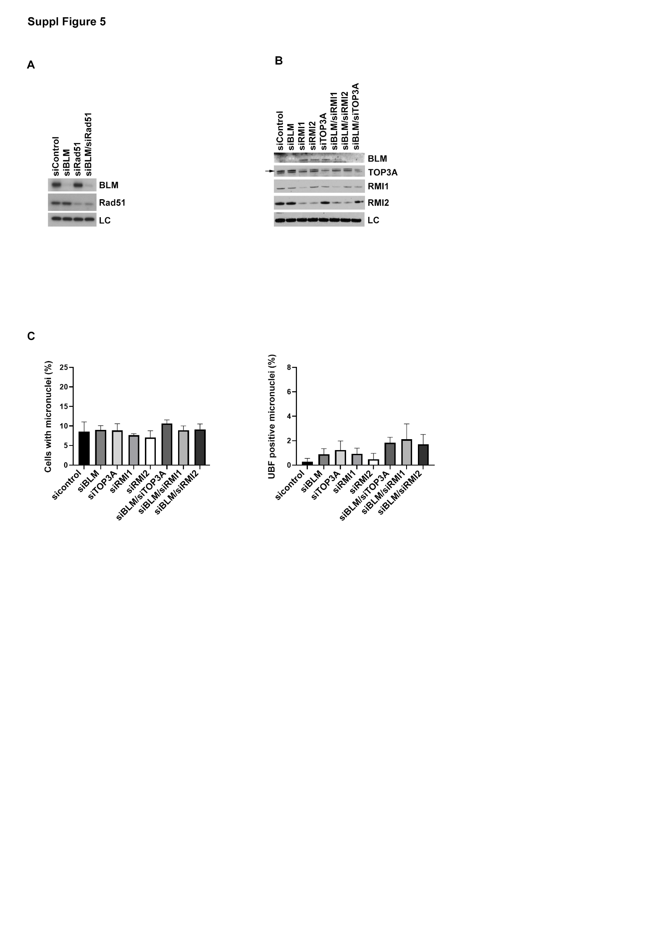
Fig. S5. (A) Western blot analysis of BLM and RAD51 expression level, using BLM and RAD51 antibody and α-tubulin as LC. Cells were treated with siRNA for 24h. (B) Western blot analysis of siRNA knock-down efficiency of siRNAs targeting BLM, TOP3A, RMI1 and RMI2. α-tubulin was used as a LC. Cells were treated with siRNA for 24h. (C) Quantification of micronuclei (left) and rDNA (UBF) containing micronuclei (right) in bi-nucleated cells from Figure 5.C, D, treated with EV plasmid. The graph depicts averages of three experiments (n>49 binucleated cells/condition/experiment). Statistical significance is depicted with stars (* p<0.05, ** p<0.01, *** p< 0.001), and no legend: not significant. (EV: empty vector, LC: loading control).

