Supplementary

Orbital-scale Dynamics of the Eastern Asian Summer Monsoon
Nitesh Sinha^{1,2}, Axel Timmermann^{1,2}, Sun-Seon Lee^{1,2}, Kyoung-Nam Jo³, Jasper Wassenburg^{1,2}, Daniel M. Cleary^{1,2}, Kyoung-Sook Yun^{1,2}

¹Center for Climate Physics, Institute for Basic Science, Busan, Republic of Korea Pusan ²National University, Busan, Republic of Korea
³Kangwon National University, Chuncheon, Gangwon-do, South Korea

Corresponding author: nitesh@pusan.ac.kr

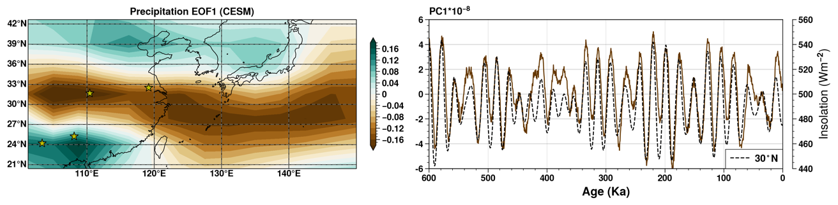
Figure S1: First empirical orthogonal function (EOF1) for annual mean precipitation (shaded, left panel) and corresponding principal component (PC1) (red curve, right panel) for Eastern Asia using 2Ma transient simulation, last 600 kyr are used for the EOF calculation. Major studied caves in China are marked by a green star symbol (left panel). The black dashed curve represents summer insolation at 30°N (right panel).

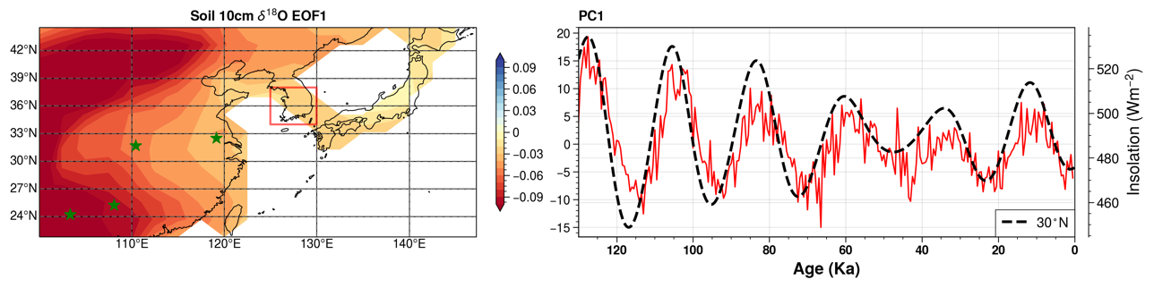
Figure S2: First empirical orthogonal function (EOF1) for annual mean Soil-10cm δ¹⁸O (shaded, left panel) and corresponding principal component (PC1) (red curve, right panel) for Eastern Asia using iCESM’s 130 kyr transient simulation. The green star symbol marks major studied caves in China. The black dashed curve represents summer insolation at 30°N.

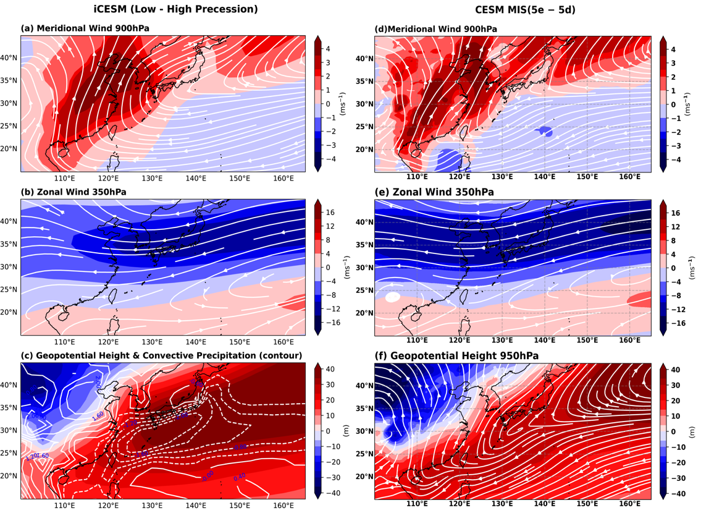
Figure S3: Left panel: iCESM summer average for Low (Pmin) – High (Pmax) (a) meridional (v-component) wind at 900 hPa and streamlines, (b) zonal (u-component) wind at 350 hPa and streamlines, and (c) geopotential height 950 hPa and convective rainfall (contours). Right panel: from CESM high-resolution MIS5e – MIS5d; (d) and (e) same as (a) and (b) respectively, and (f) geopotential height 950 hPa and streamlines.

Figure S4: Summer-average wind shear depicted by difference between 350hPa and 950hPa zonal winds for (a) low (Pmin), (b) high (Pmax), and (c) low (Pmin) – high (Pmax) in iCESM simulations. Similar patterns of zonal winds from MIS 5e and 5d simulations (not shown).
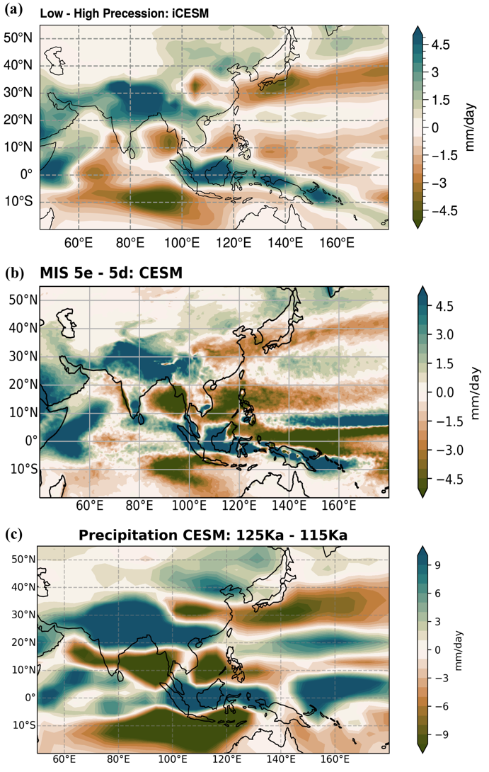
Figure S5: Summer mean precipitation differences for (a) Low – High precession from iCESM simulation, (b) MIS5e – MIS5d from CESM high-resolution simulations, and (c) time slices for 125 ka – 115 ka from 2Ma transient simulation.

___________________________________________________________________________
Section S1: Changes in moisture source surface conditions on a precessional scale

The simulated d-excess values show a change of more than 3‰ on a precessional scale (Figure 5). Therefore, surface conditions of moisture source and their control on d-excess are examined in the paleoclimate (130 ka) simulation. D-excess is sensitive to conditions over the moisture source region^{1,2}, and one of the crucial parameters is the relative humidity near-surface (RH)³. RH changes may be due to vertical or lateral wind changes, as the temperature response might not be significant over the tropical region on a precessional scale⁴. We calculated RH variability over three major moisture source regions, which may influence d-excess over Asia (Figure S6). For the southern Indian and north Pacific Oceans, the second mode of EOF (EOF2) shows precessional-scale variability in RH and is in phase (see PC2). The northwest (NW) continent also exhibits a robust precessional-scale variability in RH, demonstrated by the first mode of EOF (EOF1). However, the NW continent and oceanic source regions are opposite in phase on a precessional timescale.

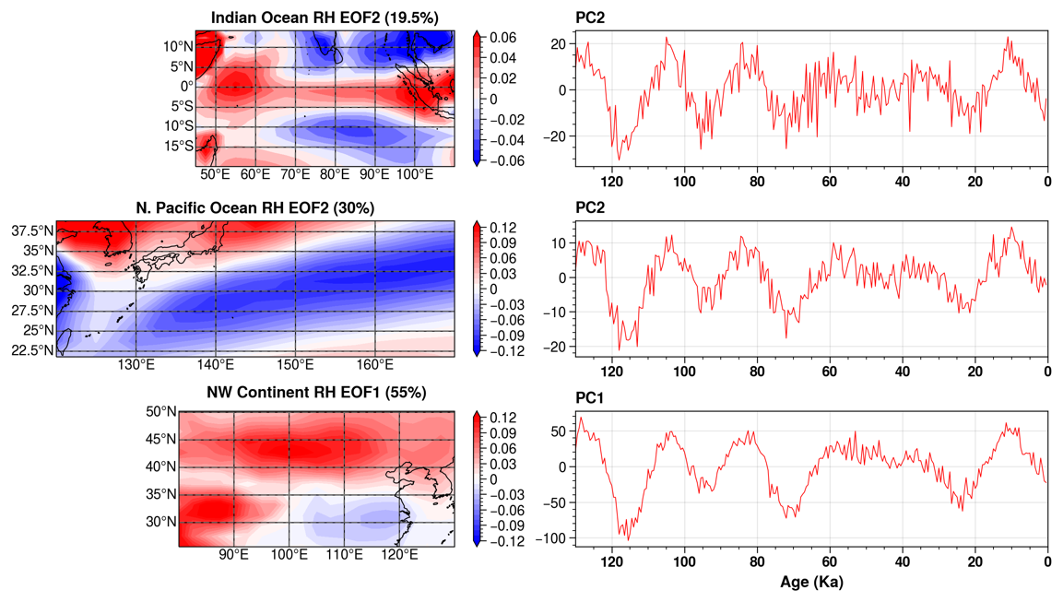
Figure S6: Empirical orthogonal function (EOF) for annual mean surface relative humidity (shaded, left panel) and corresponding principal component (PC1) (red curve, right panel) for (a) Indian Ocean, (b) North Pacific Ocean, and (c) Northwest (NW) Asian continent.
In 130 ka transient simulation, RH shows a 3-4% change over the oceanic regions and ~20% over the NW continent (opposite in phase) for extreme orbital states (Figure S7). In modern-day observations, the empirical relation between RH and d-excess (vapor) shows −0.43‰ per 1% change in RH³. We have checked the characteristics of RH and d-excess and their relationship in the present-day simulation. Firstly, the change in ocean water d-excess may cause changes in vapor d-excess. However, seawater d-excess in the present condition shows no spatial gradient (Figure S8 (a)) over the source regions for ISM (southern Indian Ocean, SIO) and EASM (northwest Pacific Ocean). Secondly, we evaluated the relationship between RH and d-excess in the precipitation (Figure S8 b)). For regression analysis, the RH over the red box in SIO (10-15°S; 80-90°E, where the EOF shows strong precessional-scale variability, Figure S6-1 (a)) was chosen, which also represents ISM’s moisture origin region^{5–7}. The model shows that a 1% change in RH may define an approximate change of 1-2‰ in the d-excess (See scatter plot for Indian region, Figure S9). Thus, the model simulated d-excess changes on a precessional scale may correspond to differences in RH over the moisture source regions.
To summarize Figure 5, the high (low) values of d-excess for P_{min} (P_{max}) over the Indian and South China regions may result from the change in RH over the SIO on a precessional scale (Figure S9). However, we found that the precessional signals in d-excess over central China are dampened, possibly due to moisture contributions from the NW continent (d-excess precessional-scale variation are opposite in phase). The low (high) value of d-excess for P_{min} (P_{max}) over the Korean peninsula is consistent with our hypothesis. The d-excess variability in the Korean peninsula elucidates Pacific (NW continental) moisture dominance for low (high) precession.

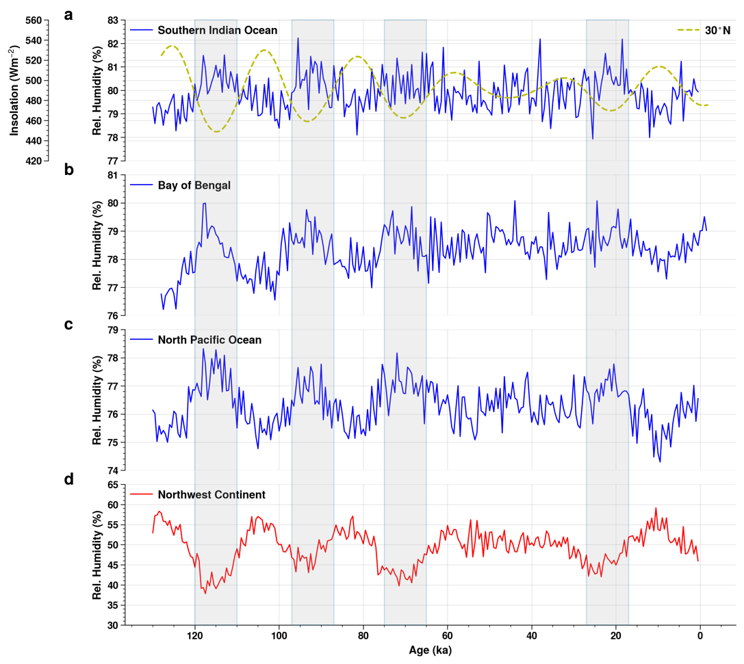
Figure S7: Annual mean surface relative (Rel.) humidity for 130 ka transient simulation on iCESM for oceanic (a, b, and c) and continental (d) regions. The yellow dashed curve in (a) represents summer insolation at 30°N.

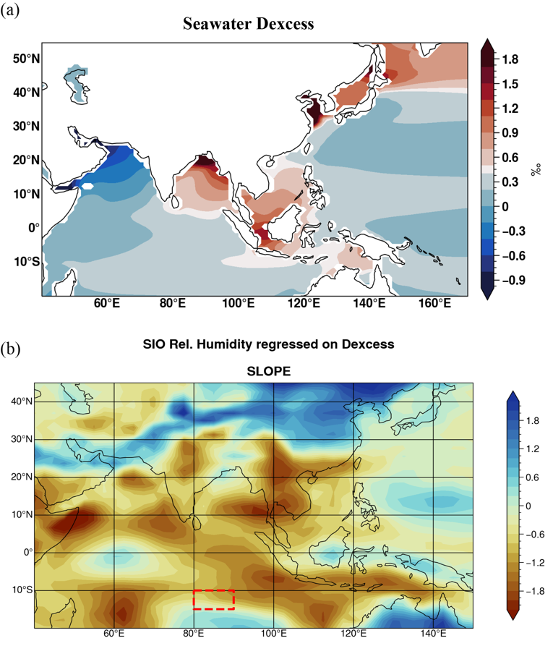
Figure S8: (a) Seawater d-excess spatial variation over the Oceanic source regions in iCESM present day simulation. (b) Slope for surface relative (rel.) humidity and d-excess relationship under present conditions, red box (10-15°S; 80-90°E) rel. humidity regressed over spatial d-excess values.

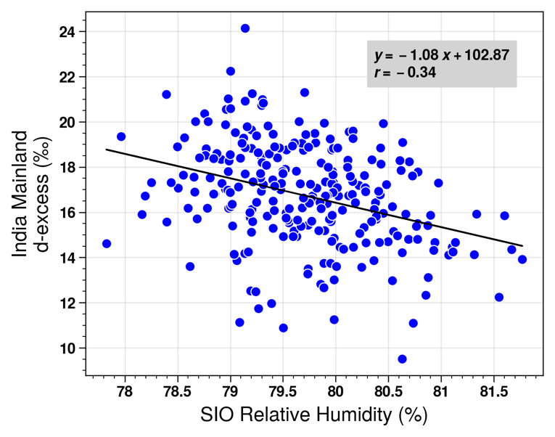
Figure S9: Scatter plot between Southern Indian Ocean, SIO (9-13°S; 80-90°E) rel. humidity and India mainland (16-25°N, 75-80°E) d-excess values for 130 ka transient simulation.
___________________________________________________________________________

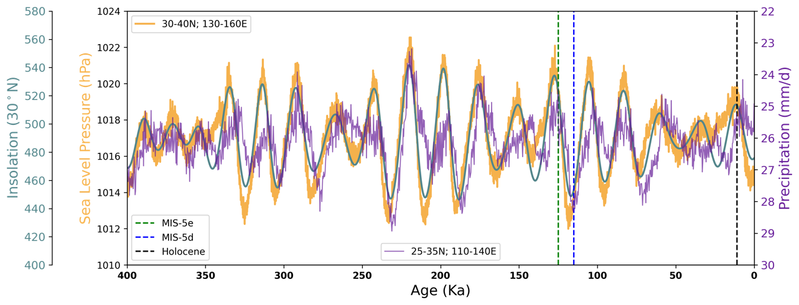
Figure S10: Comparison of Eastern Asia precipitation (inverse scale) and sea level pressure variations over NPSH on orbital scales simulated on CESM, forced by time-varying orbital, GHG, and ice sheet forcings. Latitude-longitude boxes for extracting the time series are mentioned over the plot, and the vertical dashed lines indicate MIS-5e, MIS-5d, and Holocene periods, respectively.

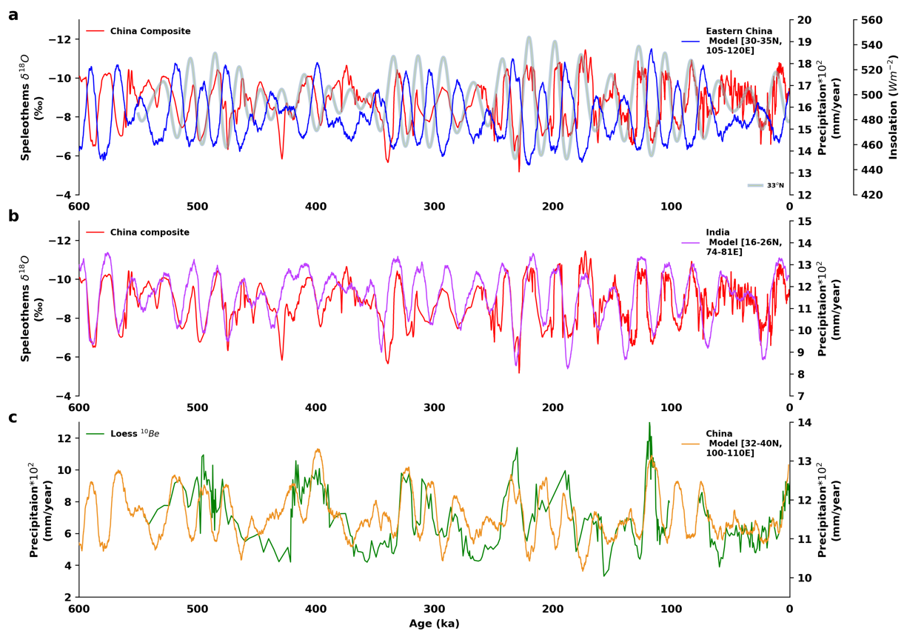
Figure S11: Comparison of simulated precipitation change by 2Ma transient simulation (only last 600 kyr are show here) and proxies (a) Eastern Asia and China speleothem-δ¹⁸O composite record, (b) India and China speleothem-δ¹⁸O composite record, and (c) China and Loess ¹⁰Be record (Note: For comparison, the Loess record ages had shifted by 6 kyr; see main text). Summer insolation at 33°N is shown in the panel a.
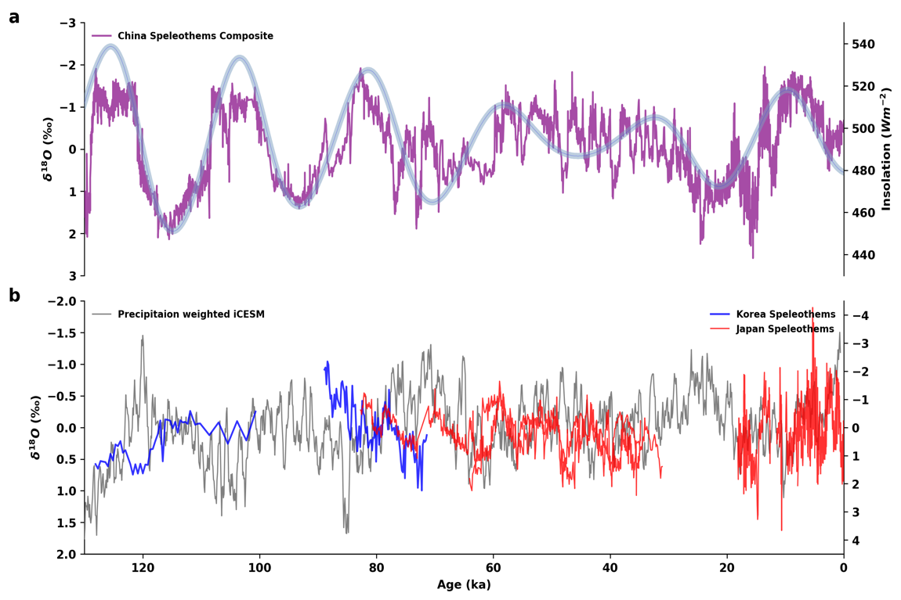
Figure S12: Validation of simulated precipitation-δ¹⁸O east-west dipole pattern with proxies: (a) Speleothem-δ¹⁸O composite record from China (western pole) and (b) Speleothem-δ¹⁸O records from Korea and Japan (eastern pole); simulated precipitation weighted δ¹⁸O is also shown for the comparison. Summer insolation at 33°N is shown by light blue curves in the background (panel a).

Speleothem-δ¹⁸O records
 | ~ Ages (kyr) | Location (°N/°E) | Reference
Korea
1. Eden cave (ED1) | 100 – 128, 184 – 209, 397 – 442, 498 – 530 | 37.10/128.50 | ^{8–10}
2. Gwaneum cave (GE1) | 71 – 89 | 37.32/129.03 | ^{8–10}
3. Daeya Cave (DY2) | 205-241, 290-405 | 37.12/128.55 | This Study
China
1. Composite | 0 − 640 | several | ¹¹
Japan
1. Maboroshi Cave (Hiro-1) | 4 − 18 | 34.82/133.21 | ¹²
2. Kiriana Cave (KA03) | 30 − 83 | 34  .61/136  .76 | ¹³
3. Ohtaki cave (OT02) | 34 − 64 | 35  .73/136  .98 | ¹³

Table S1: Speleothem-δ¹⁸O records used in this study.

References

1. Merlivat, L. & Jouzel, J. Global climatic interpretation of the deuterium-oxygen 18 relationship for precipitation. J. Geophys. Res. 84, 5029 (1979).
2. Pfahl, S. & Wernli, H. Air parcel trajectory analysis of stable isotopes in water vapor in the eastern Mediterranean. J. Geophys. Res. 113, D20104 (2008).
3. Pfahl, S. & Sodemann, H. What controls deuterium excess in global precipitation? Clim. Past 10, 771–781 (2014).
4. Clement, A. C., Hall, A. & Broccoli, A. J. The importance of precessional signals in the tropical climate. Climate Dynamics 22, 327–341 (2004).
5. Jalihal, C., Bosmans, J. H. C., Srinivasan, J. & Chakraborty, A. The response of tropical precipitation to Earth’s precession: the role of energy fluxes and vertical stability. Clim. Past 15, 449–462 (2019).
6. McGrath, S. M., Clemens, S. C., Huang, Y. & Yamamoto, M. Greenhouse Gas and Ice Volume Drive Pleistocene Indian Summer Monsoon Precipitation Isotope Variability. Geophys Res Lett 48, (2021).
7. Tabor, C. R. et al. Interpreting Precession‐Driven δ ¹⁸ O Variability in the South Asian Monsoon Region. J. Geophys. Res. Atmos. 123, 5927–5946 (2018).
8. Jo, K. et al. Textural and carbon isotopic evidence of monsoonal changes recorded in a composite-type speleothem from Korea since MIS 5a. Quat. res. 74, 100–112 (2010).
9. Jo, K. et al. Holocene and Eemian climatic optima in the Korean Peninsula based on textural and carbon isotopic records from the stalagmite of the Daeya Cave, South Korea. Quaternary Science Reviews 30, 1218–1231 (2011).
10. Jo, K. et al. Mid-latitude interhemispheric hydrologic seesaw over the past 550,000 years. Nature 508, 378–382 (2014).
11. Cheng, H. et al. The Asian monsoon over the past 640,000 years and ice age terminations. Nature 534, 640–646 (2016).
12. Kato, H. et al. “Influences of temperature and the meteoric water δ18O value on a stalagmite record in the last deglacial to middle Holocene period from southwestern Japan”. Quaternary Science Reviews 253, 106746 (2021).
13. Mori, T. et al. Temperature and seawater isotopic controls on two stalagmite records since 83 ka from maritime Japan. Quaternary Science Reviews 192, 47–58 (2018).

